Cory Gilliam

Web 335: Assignment 3.3

Nov 1, 2019

**Normalized ORD**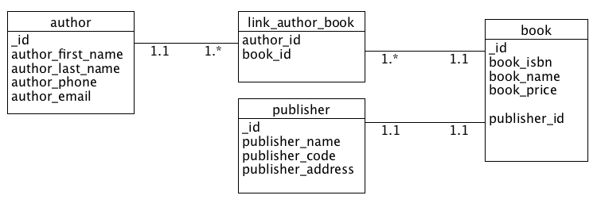

**NoSQL document diagram**

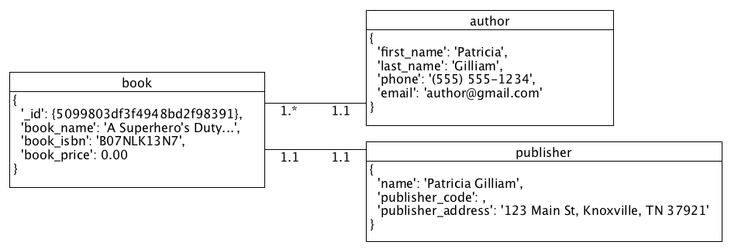

**NoSQL data structure**

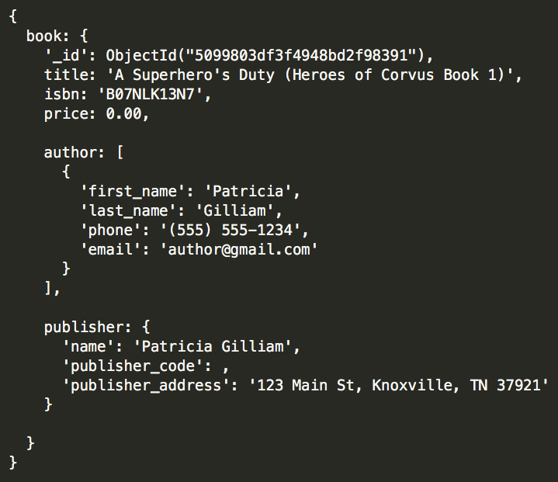

**Business rules**

