Cory Gilliam

Web 335: Exercise 4.2 MongoDB Installation

Nov 1, 2019

**Instillation screen:**

The installer placed a folder with the bn files in my Download folder, I had to manually copy the files to my /usr/local/bin folder.

So I have no confirmation window of the instillation.

**MongoDB Running:**

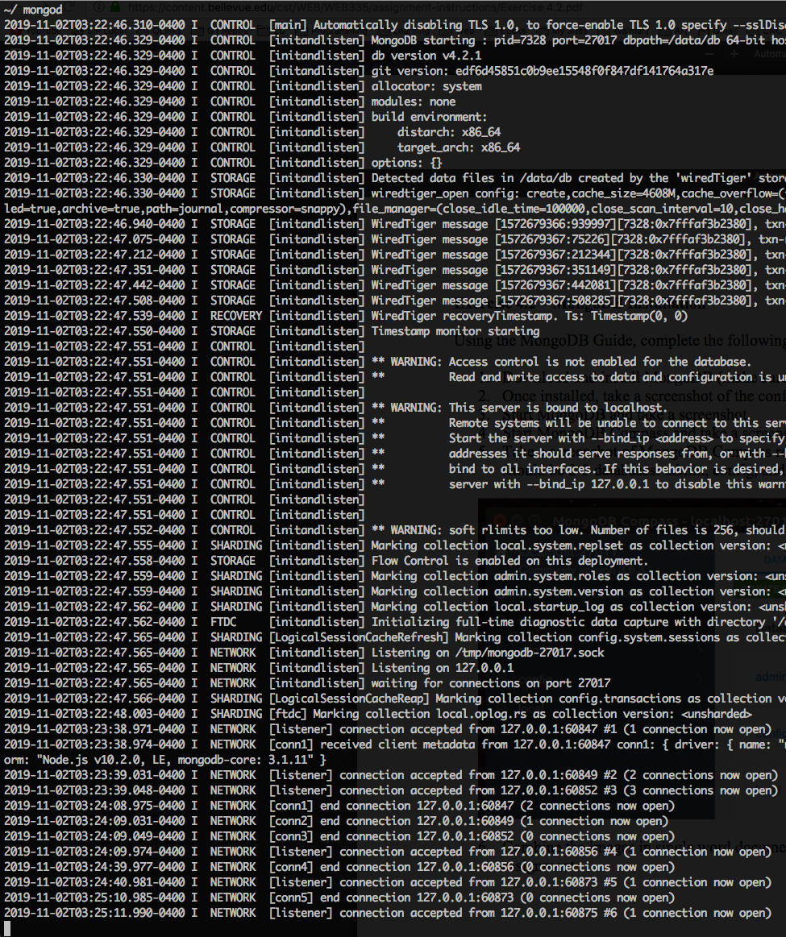

**MogoDB Compass**

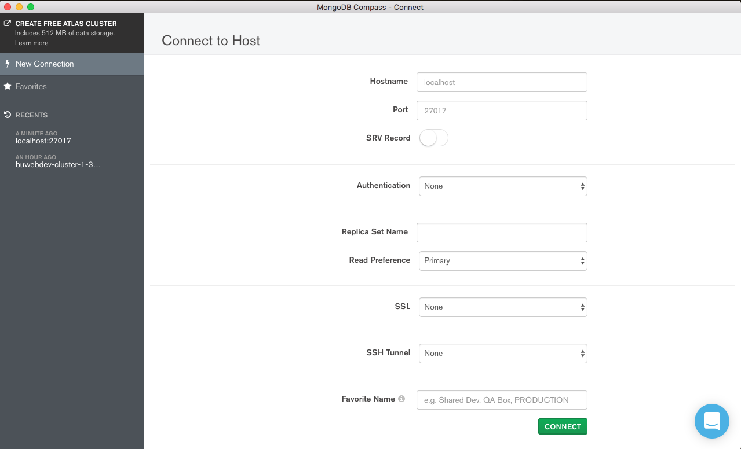

**MogoDB Compass: localhost**

