Cory Gilliam

Web 335: Exercise4.3–MongoDBShell

Nov 2, 2019

**helloWorld function**

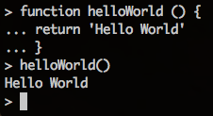

**myWorld function**

