Cory Gilliam

Web 335: Assignment 4.4–MongoDB in Action

Nov 2, 2019

**Result of creating web335 from MongoDB shell**

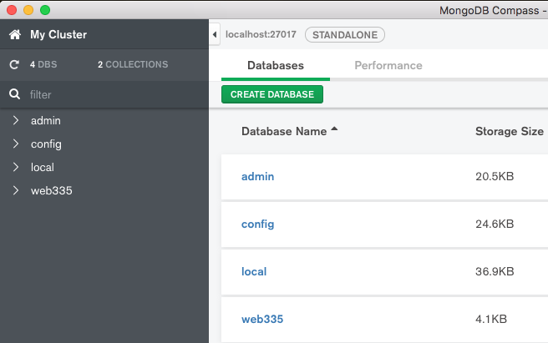

**Create a new database**

**Create a new collection**

**Using MongoDB shell to four new user documents**

*(First user separate, users two – four as bulk insert)*