*Group:* **1**

*Team Name:* **Rogue Meme**

*Team Captain:* **Cory Gilliam**

*Team Developers:*

**Cory Gilliam, Tyler Librandi, Thip Rattanavilay and Loren Wetzel**

*Business rules*

*ORD*

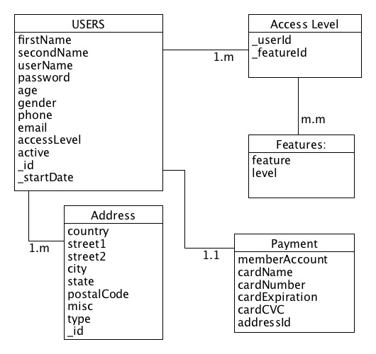

*Document Model*

*JSON*

