NODEFLIX - Rogue Meme – Group 1  
Executive Summary/Business Proposal

# Introduction

Nodeflix is a streaming service that allows customers to watch TV shows, movies, documentaries, and prerecorded sporting events through internet-connected devices. Nodeflix is a subscription-based model, offering its members three levels of access.

Basic

* Unlimited movies
* Unlimited TV shows
* One active streaming connection at a time
* Limited commercials

Plus

* Unlimited movies
* Unlimited TV shows
* Pre-recorded sporting events
* Two active streaming connections at a time
* No commercials

Premium

* Unlimited movies
* Unlimited TV shows
* Pre-recorded sporting events
* Up-to-four streaming connections at a time
* No commercials
* DVR
* Two (2) premium channels

Recently Nodeflix decided to rebuild their application using modern web technologies (Node.js, Angular with TypeScript, MongoDB, and Express). Your company has been contracted to review the existing product line and design a more robust / scalable solution.

## The Objective

Nodeflix is packed full of the latest Nodeflix features and services — fully optimized for the web.

View modes

* **Full Screen Mode:** Full Screen expands your window to fill the entire screen with what you’re watching. Enable this feature during playback by selecting the Full Screen icon from the lower right section of the player bar. To disable it, click the Exit Full Screen **icon from the same spot**.
* **Picture-in-Picture:** During playback, click on Minimize to shrink your current stream into a small, moveable window.

Settings

* **AutoPay:** AutoPay automatically queues up and plays the next available episode or related show when what you’re currently watching is coming to an end. Select the Settings (gear wheel icon) during playback to enable AutoPay.
* **Captions:** You can manage your closed captions preferences, including preferred language and visual formatting, in the player Settings (gear wheel icon) under Subtitles.
* **Playback Quality:** You can adjust video quality during playback by clicking on Settings (gear wheel icon) and then quality.

Nodeflix Plans and features

**The Nodeflix Basic Plan ($4.99)**

* No HD
* No Ultra HD
* You can only watch one screen at any one time
* You can watch programming on your laptop, phone and tablet
* You do get unlimited movies
* You can cancel anytime
* You get the first month free, as part of the trial period offer

**The Nodeflix Plus Plan ($7.99)**

* HD Available
* No Ultra HD
* You can watch two screens at the same time
* You can watch programming on your laptop, phone and tablet
* You get unlimited movies
* You can cancel anytime
* You get the 14 days free, as part of the trial period offer

**The Nodeflix Premium Plan ($9.99)**

* HD Available
* Ultra HD Available
* You can watch four screens at the same time.
* You get unlimited movies
* You can cancel anytime
* You get 14 days free, as part of the trial period offer

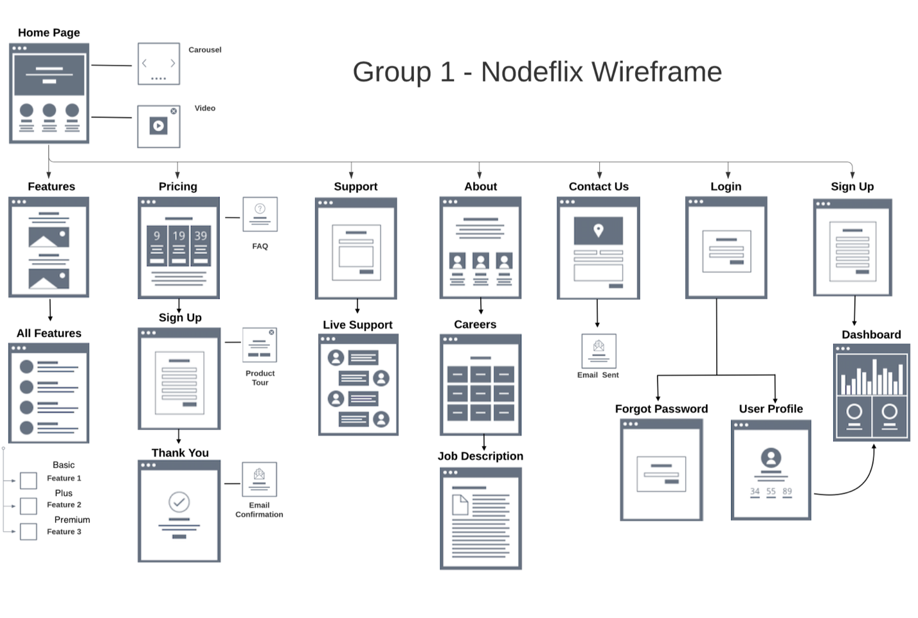

The Core Goal

* Accessibility
* Ease of use
* Trial period
* Content on demand
* Reasonable tier cost
* Share my subscription with a family member
* Multi-connection watch party option
* Better search options
* Search results with sort options

5 User types:

User 1:

Name: Kelly Berry

Age Group: 26 - 35

Gender: Female

Income Level: $30 – 35 K

Access Level: Basic

User 2:

Name: Kevin Stone

Age Group: 18 - 25

Gender: male

Income Level: $25 - 30 K

Access Level: Basic

User 3:

Name: Laura Fox

Age Group: 36 - 45

Gender: Female

Income Level: $45 – 50 K

Access Level: Plus

User 4:

Name: James Ward

Age Group: 36 - 45

Gender: Male

Income Level: $40 – 45 K

Access Level: Plus

User 5:

Name: Emily Wilson

Age Group: 35

Gender: Female

Income Level: $60-70 K

Access Level: Premium

## ORD and Business rules

ORD

Business Rules

Document Model

## Sample Query Results

***Record inserted***

***Subscription Plan Upgrades***

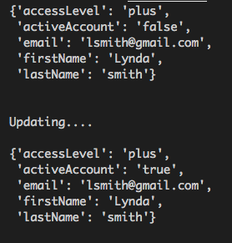   
***Subscription Reactivated***

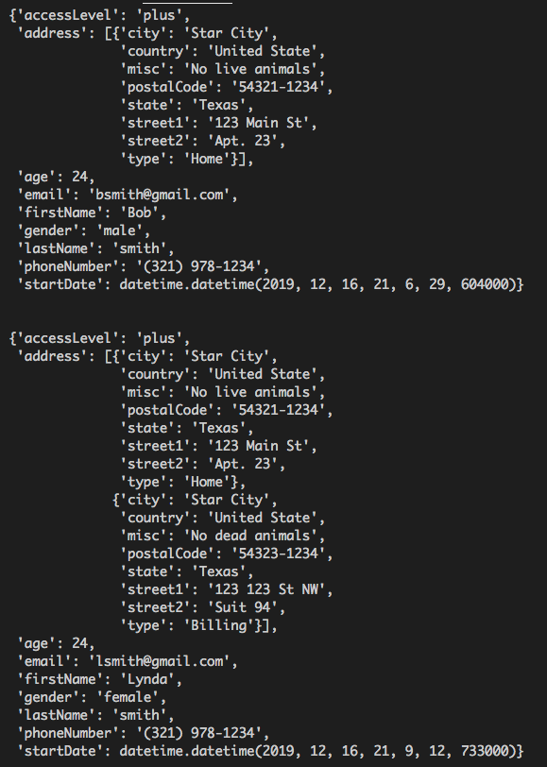   
***Listing All Active Users***

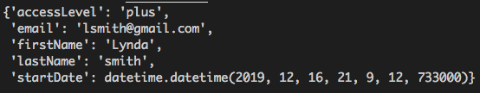   
***List by Username***

# Our Proposal

## Rogue MEME has a well-deserved reputation for quality web development services. However, faced with changes in how websites are responsive and creative in the new age. Rogue MEME faces the possibility of redesigning Nodeflix and provide a three-tier pricing plan for its services to its customers.

## We have developed solutions to help Nodeflix stay ahead of customer satisfaction trends and propose that Rogue MEME implement a solution focused on user management and delivery a beautiful website. Our solution easily integrates with a wide range of systems like MongoDB and can enable Nodeflix to fully realize the benefits of improved productivity throughout the entire website life cycle. Most importantly, we provide the training and support for this new solution that ensures your staff can ramp up quickly and realize concrete improvements in sales, customer satisfaction, and sales metrics.

## Execution Strategy

## Our execution strategy incorporates proven methodologies, extremely qualified personnel, and a highly responsive approach to managing deliverables. Following is a description of our project methods, including how the project will be developed, a proposed timeline of events, and reasons for why we suggest developing the project as described.

## Timeline for Execution

|  |  |  |  |
| --- | --- | --- | --- |
| Description | Start Date | End Date | Duration |
| Project Start | 12/3/2019 |  | 1 Week |
| Milestone 1 | 12/4/2019 |  | 1 Week |
| Milestone 2 | 12/3/2019 | 12/9/2019 | 1 Week |
|  |  |  |  |
| Milestone 3 | 12/10/2019 | 12/13/2019 | 1 Week |
| Milestone 4 | 12/13/2019 | 12/16/2019 | 1 Week |
| Project End | TBD | TBD | TBD |
|  |  |  |  |
|  |  |  |  |
|  |  |  |  |

# Conclusion

We look forward to working with Rogue MEME and supporting your efforts to improve your sales cycle with integration, inventory management, and training and support services. We are confident that we can meet the challenges ahead and stand ready to partner with you in delivering an effective web development solution.

If you have questions on this proposal, feel free to contact Rogue Meme at your convenience by email at Email address or by phone at Telephone. We will be in touch with you next week to arrange a follow-up conversation on the proposal.

Thank you for your consideration,

Team Name: Tyler Librandi, Loren Wetzel, Thip Rattanavilay, Cory Gilliam

Company name: Rogue Meme