Cory Gilliam

Web 420: Assignment 3.4

Nov 1, 2019

**Project Pane**

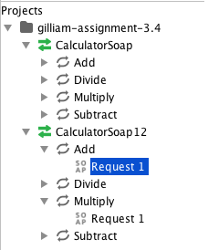

**Request Pane**

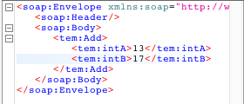

**Response Pane**

