Cory Gilliam

Web 420: Assignment 4.3

Nov 4, 2019

**My Solution**

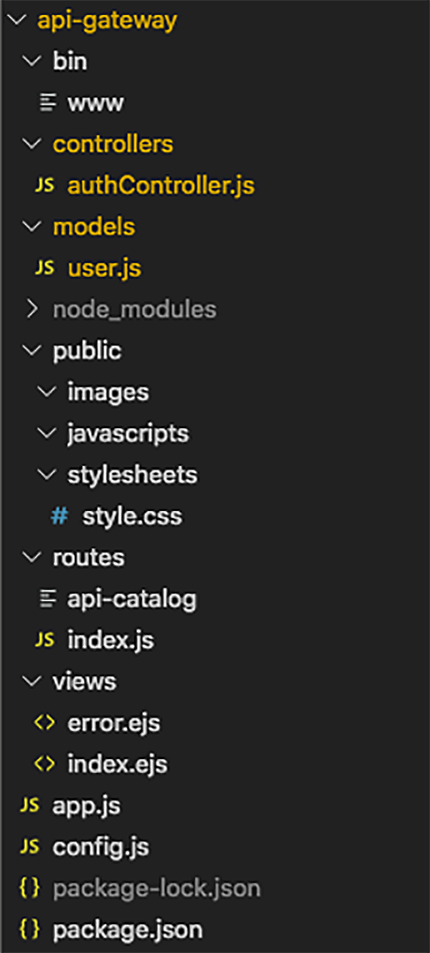

**My Solution**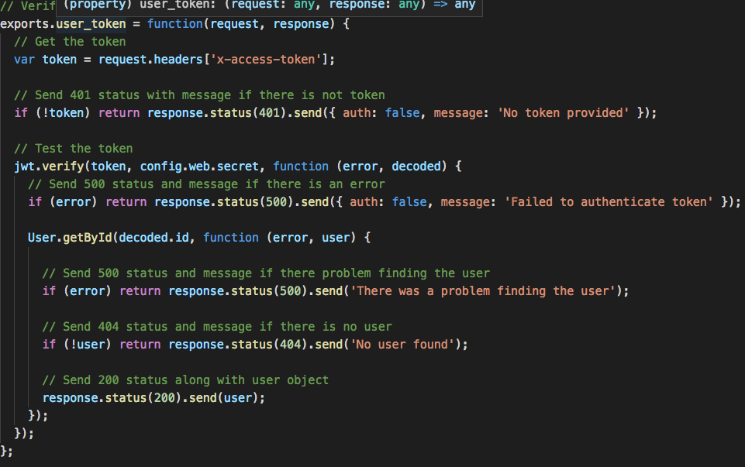

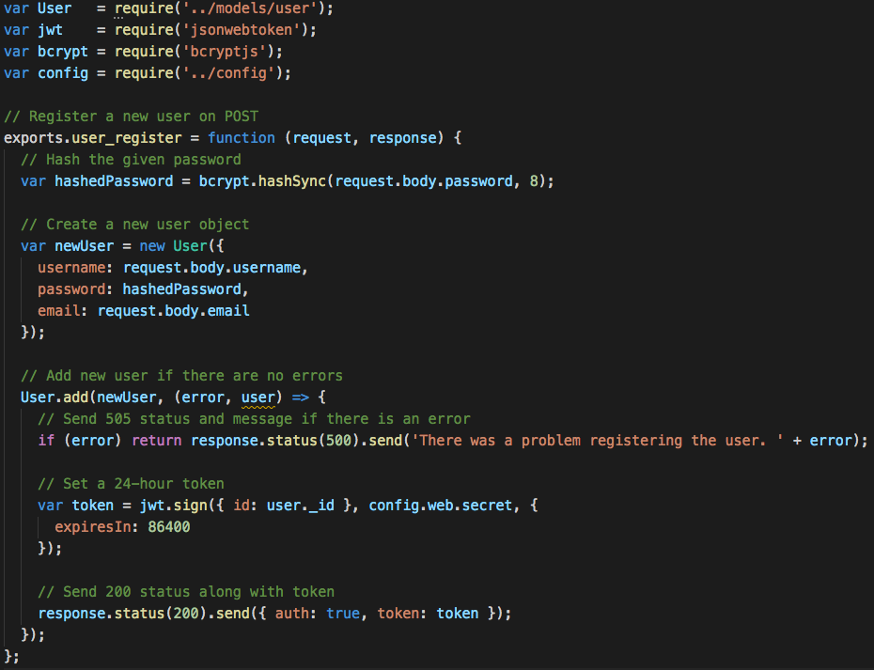

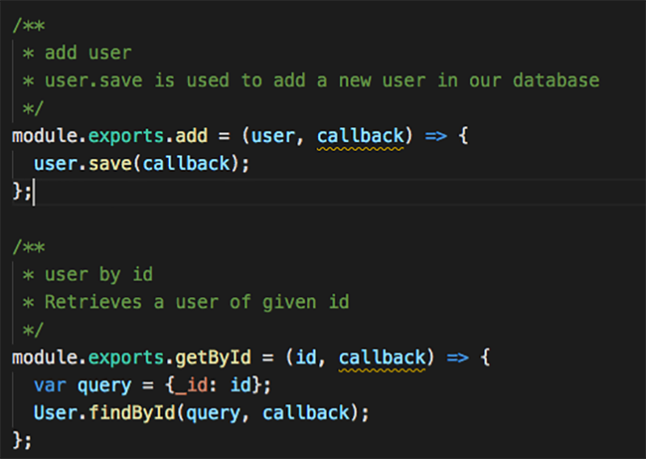

**CLI: API Gateway Running**

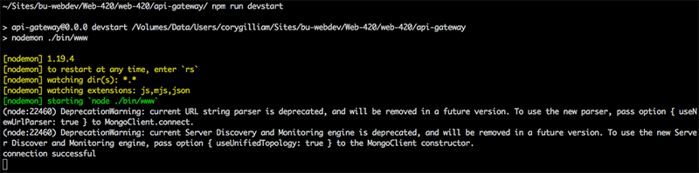

**Browser: API Gateway Running** 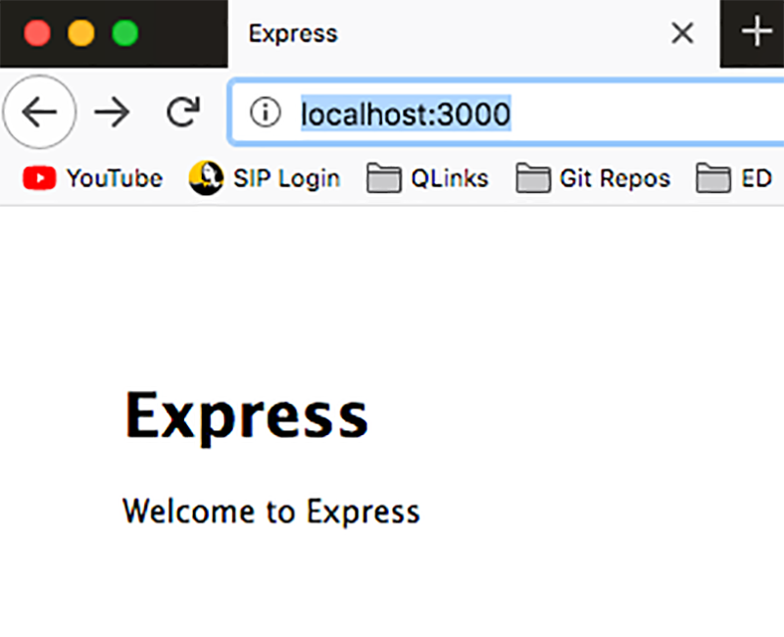

**Browser: API Gateway – Token Request**

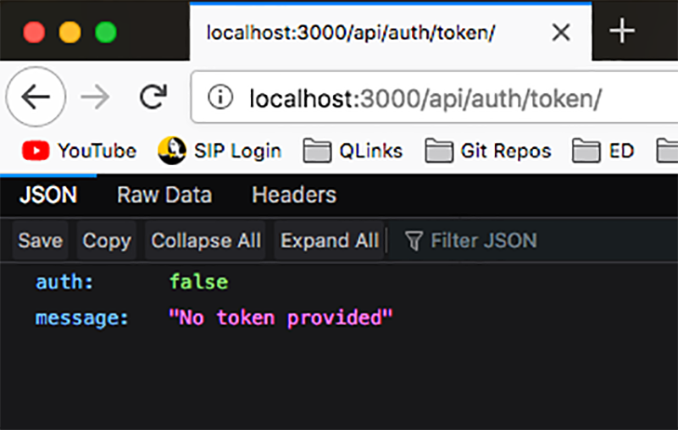

**CLI: API Gateway – Token Request**

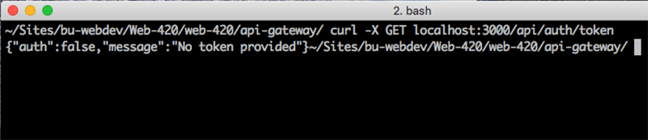

**CLI: API Gateway – Messages from Morgan**

