Cory Gilliam

Web 420: Assignment 5.4

November 12, 2019

**Terminal (CLI window)**

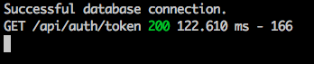

**Response**

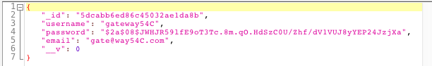

**Original record in mLab (MongoDB)**

