Cory Gilliam

Web 420: Exercise 5.2

November 13, 2019

**WSDL URL**

http://webservices.oorsprong.org/websamples.countryinfo/CountryInfoService.wso?WSDL

**HttpGet request**

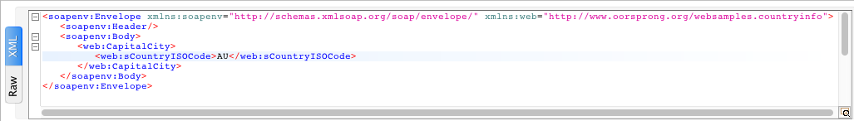

**HttpGet response**

