Cory Gilliam

Web 420: Exercise 5.3 –Unit Test 02

Nov 7, 2019

JSON Request

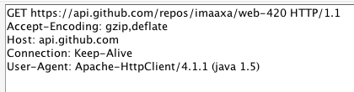

JSON Request

