Cory Gilliam

Assignment 6.3 – API Gateway Part IV

November 22, 2019

Login

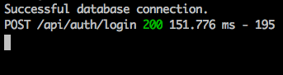

Logout

My Solution

Running in browser

