To: Legacy Corporation

From: Cory Gilliam

Date: 1 December 2019

Subject: From Legacy to SOA

Every business has to deal with the ever-expanding demands of their legacy systems. The more the business grows, the more applications that get added to the pool of applications. Over time, this legacy system become unwieldy and unstable. The IT department gets tasked with the job of overseeing each new addition into the whole. At some point, the cost of new integrations will outweigh the benefits.

Sometime before the company reaches this point, the prospects of migrating over to a service-oriented architecture (SOA) becomes a realistic plan for evaluating your current infrastructure. This could turn the integration cost into an ROI on the investment. “Development and ownership costs as well as implementation risks are reduced. SOA is both an architecture and a programming model, a way of thinking about building software. (Channabasavaiah, Tuggle, Holley, 2003)”

“Now you find more complex environments. Legacy systems must be reused rather than replaced, because with even more constrained budgets, replacement is cost-prohibitive. (Channabasavaiah, Tuggle, Holley, 2003)”

http://content.bellevue.edu/cst/WEB/WEB420/Legacy%20Corporation.pdfThe Legacy Corporation currently consists of 10 (ten) independent systems:

Figure Legacy Corporation, Bellevue University

* Employee
* Training
* Payroll
* Recruiting
* Budget
* Active Directory
* Service Desk
* GitLab
* Procurement
* Contract

“Service-Oriented Architecture (SOA) is a style of software design where services are provided to the other components by application components, through a communication protocol over a network. Its principles are independent of vendors and other technologies. (Community, 2019)”

The conversion from the current legacy system over to a SOA is complicated, but some of the work has already happened. The first pre-phase task we will do is take an inventory of what is already here. If there is anything that can be reused or repurposed, we will plan around it.

The next pre-phase task will be to create a thorough list of needed types that will be required. This will be done in order to ensure that the SOA will be able to provide a unified user experience. The communication gateway between applications will work with whatever type of application needed to be added to the system in the future.

The next pre-phase task will be to map out how each piece of the SOA will need to work in order to ensure that the flow control function as needed. This will help us determine in which order the applications should be converted in each of the conversion phases. This process will be as streamlined as possible.

Phase I will move all needed legacy systems under an Active Directory secured traffic/flow control layer. The users will be able to access the legacy applications from here once they have been authenticated by Active Directory.

Phase II will proceed with converting each of the employee centric applications to use the SOA architecture. Functions or shared API components that can be used by more than one application will be added to the Shared Function & Configuration API and Database. These applications will include: Employee, Training, Payroll, and Recruiting.

Phase III will entail converting the project centric applications to use the SOA architecture. Functions or shared API components that can be used by more than one application will be added to the Shared Function & Configuration API and Database. These applications will include: Budget, Contract, Procurement, and GitLabs.

Phase IV will entail building an overall ticket system for the applications to use the SOA architecture. Functions that can be used by other applications will be added to the Shared Function & Configuration API and Database. These applications will include: Service Desk.

Phase V will be to do a final evaluation on the system, perform a comprehensive system integration test and address any processes that were missed and make possible recommendations on any future needs.

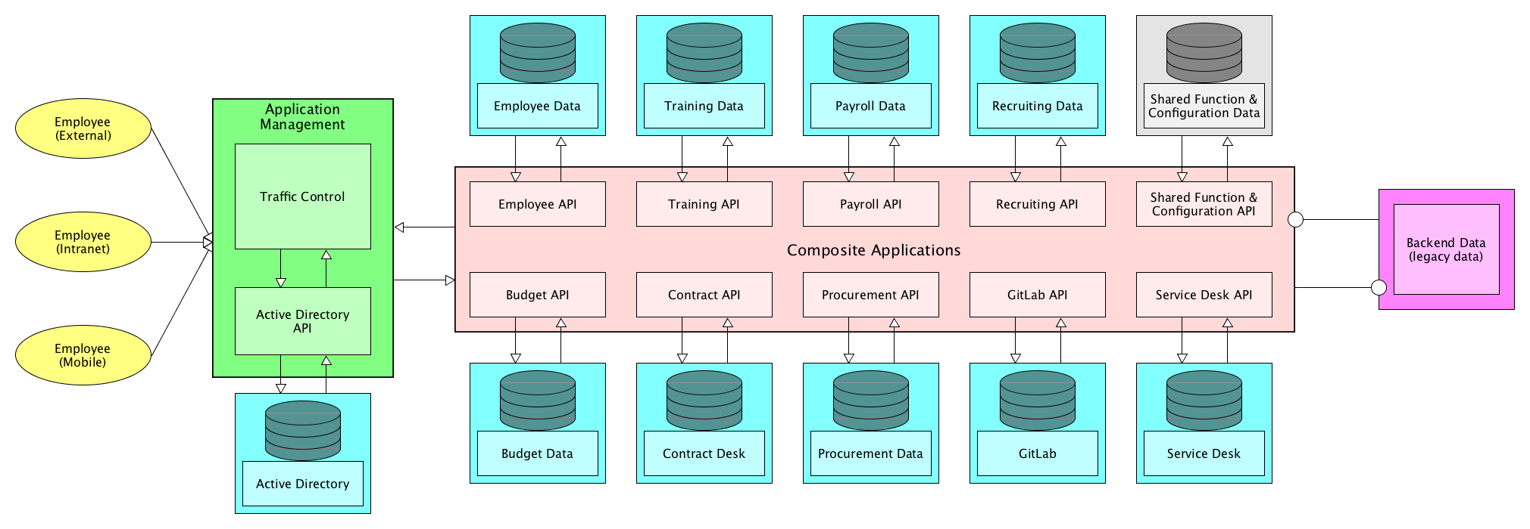

Figure SOA System Layout, Cory Gilliam

“When it comes to implementing service-oriented architecture (SOA), there is a wide range of technologies that can be used, depending on what your end goal is and what you’re trying to accomplish. (Community, 2019)”

References

Channabasavaiah, K., Tuggle, E., & Holley, K. (2003, December 16). *Migrating to a service-oriented architecture, Part 1*. Retrieved November 30, 2019, from https://www.ibm.com/developerworks/library/ws-migratesoa/#N1009E.

Channabasavaiah, K., Tuggle, E., & Holley, K. (2003, December 16). *Migrating to a service-oriented architecture, Part 2*. Retrieved November 30, 2019, from <https://www.ibm.com/developerworks/library/ws-migratesoa2/>.

Community, S. D. (2019, February 13). *What Is Service-Oriented Architecture?* Retrieved December 1, 2019, from https://medium.com/@SoftwareDevelopmentCommunity/what-is-service-oriented-architecture-fa894d11a7ec.