Cory Gilliam

December 21, 2019

Assignment 1.4 – TypeScript

Transpile Command

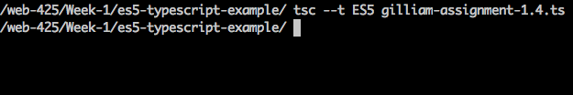

Folder Structure

Outputted Message

