Transcriptomic effect of miR-551b inhibition in acute myeloid leukaemia cells, and the behaviour of a ciliary/centrosomal gene set and a curated interaction network
Abhishek
[Affiliation] · Analysis performed end-to-end with the open transcriptomics pipeline
Abstract. Cilia and centrosomal genes have been proposed as candidate markers in cancer, and miR-551b is an oncogenic microRNA in several solid tumours. We tested whether inhibiting miR-551b reshapes the transcriptome of acute myeloid leukaemia (AML) cells and, in particular, whether it perturbs a curated 683-gene cilia/ciliopathy set or a 25-gene STRING-style interaction network (dopaminergic, innate-immune, autophagy, iron and ciliary genes). Eight single-end RNA-seq runs (BioProject PRJNA1513000; primary AML blasts and the KG1a cell line, each treated with LNA or ZIP anti-miR against miR-551b versus a control oligonucleotide) were processed from raw reads: multi-connection download from the SRA AWS Open-Data mirror, Salmon selective-alignment quantification against GENCODE v44 (72-83% mapping), and DESeq2 differential expression. Using a paired, block design (adjusting for cell type and antisense chemistry), only three genes were significant (FDR<0.05; all down-regulated: TCF7, IGKC and one unannotated locus). The cilia set showed no significant gene (0/563) and was in fact less variable than the transcriptome background (mean |log2FC| 0.185 vs 0.321); the interaction network showed no significant gene (0/17 expressed; the eight dopaminergic members were not detectably expressed in AML). Analysed separately, primary AML samples yielded 33 significant genes dominated by T- and B-lymphocyte markers (TRBC1, ZAP70, LCK, IGKC, IGHM) - a signature attributable to differing immune-cell content between samples rather than to miR-551b - while the clean KG1a line yielded essentially none. We conclude that, in this dataset, miR-551b inhibition produces a minimal and non-reproducible transcriptional footprint in AML cells and does not engage ciliary/centrosomal genes. This is a negative result and should be read against a clear power limitation: the design provides only one biological unit per unique condition, with the two chemistries used as pseudo-replicates.

1 Introduction
Primary cilia and the centrosomal/basal-body apparatus coordinate signalling (Hedgehog, Wnt, PDGFR) and cell-cycle progression, and their gene programme has been proposed as a candidate axis in tumour biology. Whether this programme is relevant to acute myeloid leukaemia (AML) is far from obvious: haematopoietic cells are largely non-ciliated, so any signal is more plausibly centrosomal than motile-ciliary. miR-551b, in turn, is an oncogenic microRNA amplified in ovarian and gastric cancers; antisense inhibition of miR-551b has been used to probe its downstream programme.
Here we ask a focused question: does inhibiting miR-551b in AML cells change the expression of (i) a curated 683-gene cilia/ciliopathy set and (ii) a 25-gene interaction network (assembled from a STRING-style neighbourhood spanning dopaminergic signalling, innate immunity, autophagy, iron handling and two core ciliary genes, IFT88 and ARL13B)? We processed the data end-to-end from raw reads and treat any result as hypothesis-level, given the study's limited replication.

2 Methods

2.1 Data
Eight single-end Illumina HiSeq 2000 RNA-seq runs were obtained from NCBI BioProject PRJNA1513000 (runs SRR40166669-SRR40166676). The design is a balanced 2x2x2: cell context (primary AML blasts vs the KG1a AML cell line) x antisense chemistry (LNA vs ZIP) x treatment (anti-miR-551b vs control oligonucleotide). No processed count matrix was deposited (no linked GEO series), so raw reads were used. Because the archive throttles single-stream transfers, reads were fetched at full depth (13-25 million reads/run) from the SRA AWS Open-Data mirror with a 16-connection downloader.

2.2 Quantification
Reads were quantified with Salmon 2.5.1 in selective-alignment mode against a GENCODE v44 transcriptome index (251,955 transcripts); transcript estimates were summed to gene level (tximport-style). Mapping rates were 71.8-72.7% for primary-AML samples and 80.7-82.9% for KG1a, consistent with cleaner cell-line input. The gene x sample matrix contained 60,883 genes; 25,994 passed a total-count >= 10 filter and were tested.

2.3 Differential expression and gene sets
Differential expression used DESeq2 (pyDESeq2). The primary model was a paired/blocked design, ~ cell_type + chemistry + treatment, testing anti-miR-551b vs control and thereby removing both the cell-context and chemistry axes; secondary per-cell-type models (~ chemistry + treatment; n=2 vs 2) were also fit. Significance was Benjamini-Hochberg FDR < 0.05. Two gene sets were intersected with the results by gene symbol: a user-supplied 683-gene cilia/ciliopathy set and the 25-gene interaction network. Software: Python 3.12, Salmon, pyDESeq2, gseapy, pandas, scikit-learn, matplotlib.

3 Results

3.1 Sample structure
Principal-component analysis (Figure 1) is dominated by cell context: primary-AML and KG1a samples separate completely, which is why cell type is a blocking term in the model. Within each block the anti-miR-551b and control samples do not form a clear separate axis.
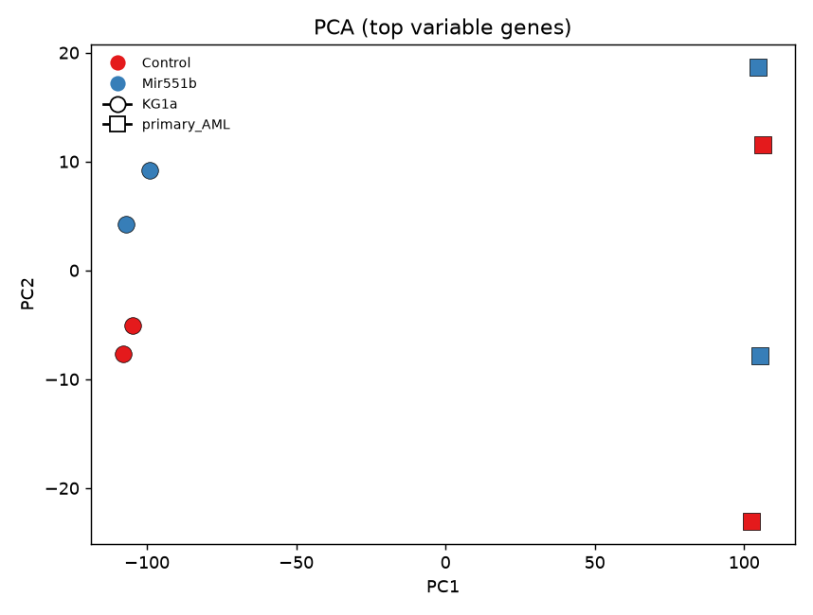
Figure 1. PCA of the eight samples (DESeq2-normalised, log-scaled counts). Colour = treatment (anti-miR-551b vs control); the dominant split is cell context (primary AML vs KG1a).

3.2 Genome-wide differential expression (paired model)
Adjusting for cell type and chemistry, only three genes were significant at FDR<0.05, all down-regulated upon miR-551b inhibition (Table 1, Figure 2). The strongest annotated hits were TCF7 (a Wnt/T-cell transcription factor) and IGKC (an immunoglobulin constant region); the third is an unannotated locus. This is a near-null genome-wide response.
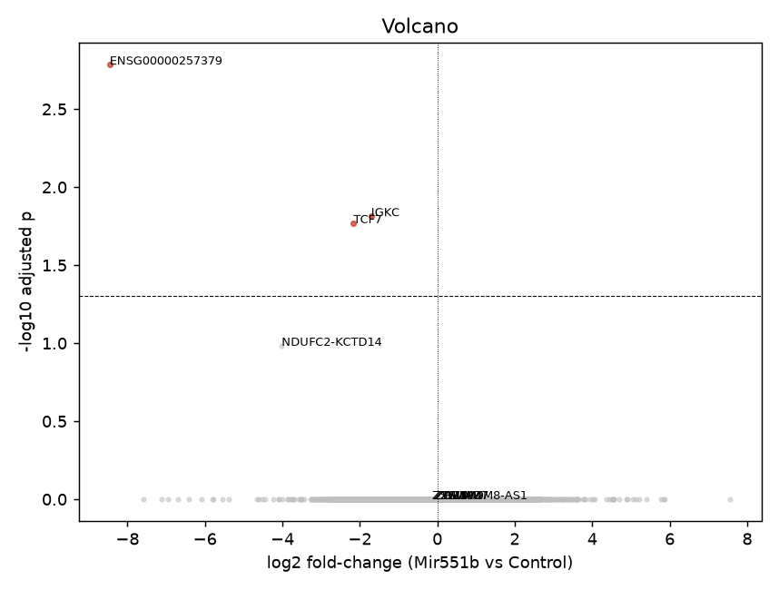
Figure 2. Volcano plot, anti-miR-551b vs control (paired model). Red points are the three FDR-significant genes; the bulk of the transcriptome is unchanged.
Table 1. All genome-wide significant genes (paired model, FDR<0.05).
Gene | log2FC | Adj. p
ENSG00000257379 | -8.46 | 1.6e-3
IGKC | -1.71 | 1.5e-2
TCF7 | -2.16 | 1.7e-2

3.3 The cilia/centrosomal set does not respond
Of the 683-gene cilia set, 563 genes were expressed and testable; none reached FDR<0.05 (Figure 3). Beyond simple non-significance, cilia-set genes were less variable than the transcriptome as a whole (mean absolute log2 fold-change 0.185 vs 0.321 background) - i.e. they are among the more stable genes under miR-551b inhibition. The most-shifted cilia genes by nominal p (Table 2) are unremarkable and do not survive multiple-testing correction.
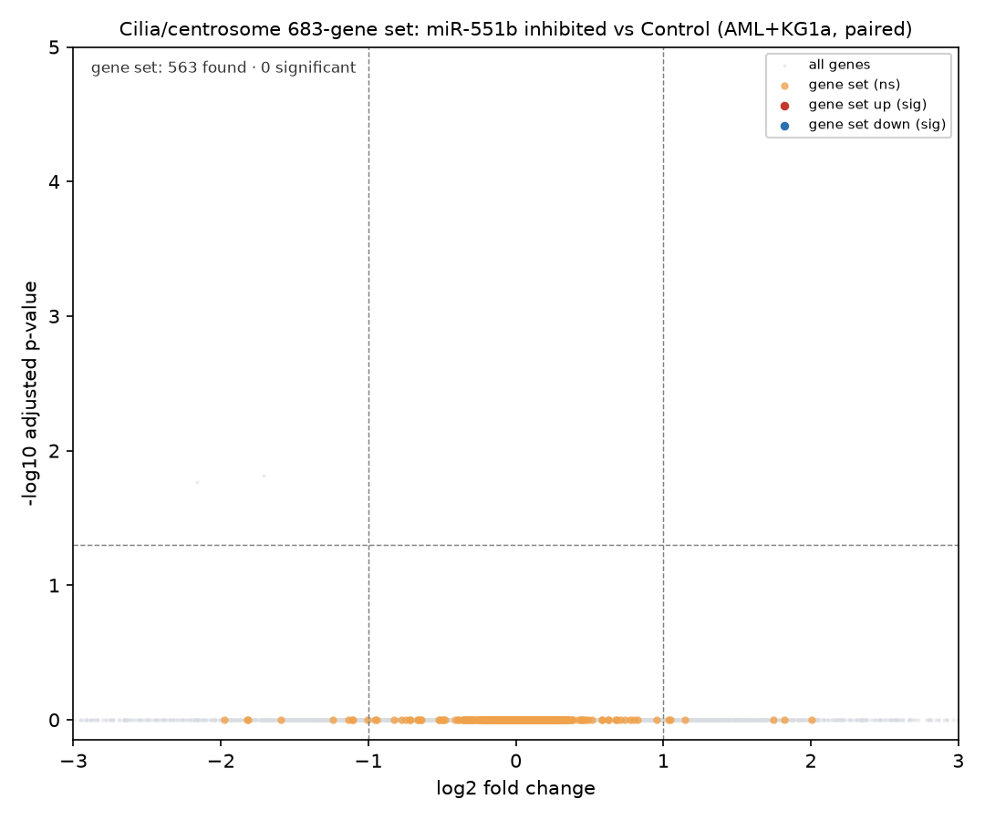
Figure 3. Volcano plot with the 683-gene cilia set overlaid (orange). No cilia gene is significant; the set sits within the unperturbed central cloud.
Table 2. Most-shifted cilia-set genes by nominal p-value (none FDR-significant).
Gene | log2FC | Nominal p | Adj. p
SYNE1 | -0.52 | 0.012 | 1.00
CENPF | +0.59 | 0.035 | 1.00
HAVCR1 | -1.11 | 0.050 | 1.00
RP1 | +2.01 | 0.062 | 1.00
KIF14 | +0.58 | 0.063 | 1.00
GSK3B | -0.28 | 0.082 | 1.00

3.4 The interaction network does not respond
Seventeen of the 25 network genes were expressed in AML; none was significant (Table 3, Figure 4). The eight non-detected members were exactly the dopaminergic module (SLC6A3, DBH, ANKK1, DRD5, PPP1R1B, DRD1, DRD2) plus IL13 - neurotransmitter genes not expressed in myeloid cells, as expected. The two ciliary members that anchored the network, IFT88 (-0.04) and ARL13B (+0.21), were flat, as were the innate-immune (TLR2/TLR4, NFKB1, JAK2), autophagy (ATG7, LAMP2, HSPA8) and iron (FTL, FTH1) members.
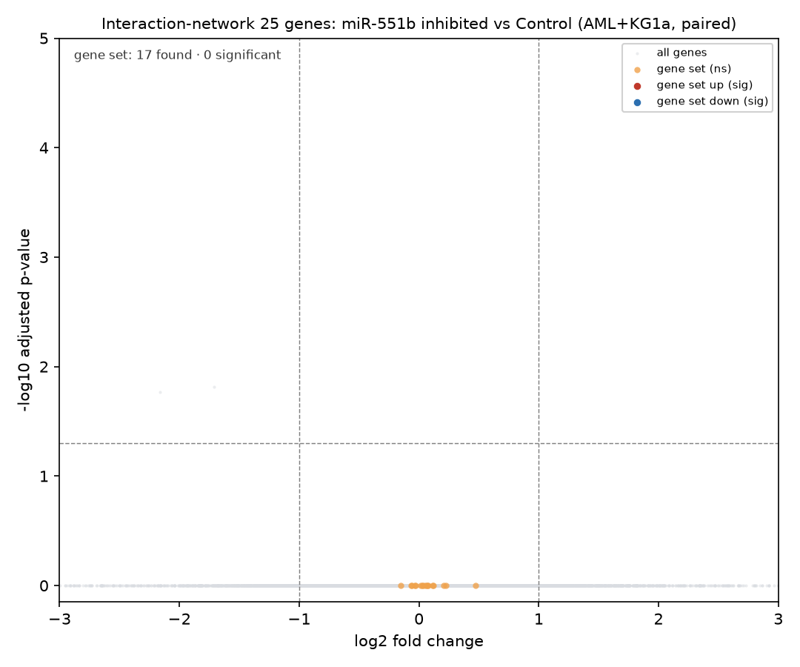
Figure 4. Volcano plot with the 25-gene interaction network overlaid (orange). All expressed members are non-significant.
Table 3. Interaction-network genes, ranked by |log2FC| (paired model; all FDR non-significant).
Gene | log2FC | Adj. p
TLR4 | +0.47 | ~1
GYPE | +0.23 | ~1
ARL13B | +0.21 | ~1
TRAF6 | -0.15 | ~1
HSPA8 | +0.12 | ~1
IFT88 | -0.04 | ~1

3.5 Per-cell-type analysis reveals a composition confound
Analysed separately, the two contexts diverge sharply. Primary AML gave 33 significant genes (8 up, 25 down), but the leading hits are overwhelmingly lymphocyte markers - TRBC1, ZAP70, LCK (T-cell), IGKC, IGHM (B-cell), plus RORA and TCF7. Because these are patient samples with variable normal immune-cell content, and each unique condition is n=1, this signature most plausibly reflects differing T-/B-cell contamination between the anti-miR and control samples rather than a miR-551b programme. The clean KG1a line gave only three hits, dominated by read-through/unannotated loci - i.e. essentially no reproducible effect. The pooled paired model (Section 3.2) is therefore the trustworthy read-out, and it is near-null.

4 Discussion
Across a genome-wide paired analysis, a clean-cell-line analysis, and two curated gene sets, inhibition of miR-551b left the AML transcriptome largely unchanged, and specifically did not engage ciliary/centrosomal genes - which were, if anything, more stable than average. For the cilia-in-AML hypothesis this is a clear negative: miR-551b is not an upstream regulator of the ciliary programme in these cells, and the curated interaction network is likewise unresponsive.
The one apparently strong signal - 33 genes in primary AML - is best read as a cautionary tale about cell composition in bulk RNA-seq of patient material: an immune-cell-content difference between single samples masquerades as a treatment effect. It is exactly the kind of result that replication and deconvolution, not deeper sequencing, would resolve.
Limitations. (1) The dominant limitation is replication: the 2x2x2 design provides one biological unit per unique condition, with the LNA and ZIP chemistries used as pseudo-replicates; power to detect modest effects is low. (2) miRNA inhibition often acts translationally, so a small mRNA footprint does not exclude a proteomic effect. (3) Primary-AML samples carry variable normal-cell content, confounding the per-sample contrast. (4) Quantification was alignment-free (selective alignment) rather than genome alignment. (5) Gene-set matching was by symbol; the cilia set mixes motile- and primary-cilia genes and is not myeloid-tailored. (6) No competitive set-level enrichment test was applied (with 0 hits, over-representation is uninformative).

Future directions
A replicated design (biological triplicates per condition), computational immune-cell deconvolution of the primary-AML samples, and a miR-551b target-site-aware analysis (e.g. testing predicted targets as a set) would convert this negative screen into a definitive test. If the centrosomal angle is of interest, a ciliated/centrosome-resolved model system would be more informative than bulk myeloid RNA-seq.

Data and code availability
Data: NCBI BioProject PRJNA1513000 (runs SRR40166669-SRR40166676). Reference: GENCODE v44. Analysis code: the open-source transcriptomics pipeline (github.com/imabbi47/transcriptomics); all scripts, designs and result tables for this analysis are under cilia_aml/.

References
1. Love MI, Huber W, Anders S. Moderated estimation of fold change and dispersion for RNA-seq data with DESeq2. Genome Biology 2014;15:550.
2. Patro R, Duggal G, Love MI, Irizarry RA, Kingsford C. Salmon provides fast and bias-aware quantification of transcript expression. Nature Methods 2017;14:417-419.
3. Muzellec B, Telenczuk M, Cabeli V, Andreux M. PyDESeq2: a Python package for bulk RNA-seq differential expression analysis. Bioinformatics 2023.
4. Reiter JF, Leroux MR. Genes and molecular pathways underpinning ciliopathies. Nature Reviews Molecular Cell Biology 2017;18:533-547.
5. NCBI BioProject PRJNA1513000 - RNA-seq of primary AML and KG1a cells with LNA/ZIP anti-miR-551b.

