
PLATFORM FOR SKILLED LABOUR IN QARDHO, SOMALIA
SUBMITTED BY
ABDIAZIZ ALI AINAB
REG, NO: 22-QAR-BCS-155
ABDIRAHMAN ABDIKARIM
REG, NO: 22-QAR-BCS-247
ABDULAHI MUSE ABDI
REG, NO: 22-QAR-BCS-176
ZAKARIYE MOHAMED MUUSE
REG, NO: 22-QAR-BCS-239
MOHAMED SAID MOHAMED
REG, NO: 22-QAR-BCS-224

A PROJECT THESIS PRESENTED TO THE FACULTY OF COMPUTER SCIENCE IN PARTIAL FULFILLMENT OF THE REQUIREMENT FOR BACHELAR DEGREE’S IN COMPUTER SCIENCE IN EAST AFRICA UNIVERSITY GARDO
PUNTLAND - SOMALIA
AUG 2026

DECLARATION
We hereby declare that this project work is the result of our personal effort under the supervision of Abdifatah Said Jama of the department of Computer Science, East Africa University Gardo, as part of the requirements for the award of bachelor degree of computer science, and has not been submitted elsewhere for this purpose, all sources of information are explicitly acknowledged by means of reference.

SIGNATURE …………………………………….
DATE ……………………………

APPROVAL
We hereby confirm that the work presented in this research proposal has been conducted under our close supervision and professional guidance. Throughout the development of this proposal, we have provided continuous academic support, oversight, and direction to ensure that the study meets the required scholarly standards of the Department of Computer Science.
Having thoroughly reviewed the content and verified that it adheres to the expected ethical, methodological, and academic guidelines, we grant our full approval for its submission as part of the requirements for the Bachelor’s Degree program.

Abdifatah Said Jama
Signature: ______________
Date: 2026-8

DEDICATION
This dedication belongs foremost to God Almighty, our Creator, the owner and Controller of our lives, who granted us the ability and wisdom to complete this work. We bear witness that no skill, effort, or personal perseverance would have allowed us to reach this point without the grace and mercy of God accompanying us every single moment. He has been the Alpha and the Omega of our academic journey, and He eased every challenge we faced. All praise is due to God.
We respectfully offer special dedication to our beloved parents—our mother and Father. This is a dedication of perpetual remembrance and gratitude for the immense sacrifices you made, the unwavering love you showered upon us, and the energy you used to encourage us throughout these demanding years of university study.
To all our esteemed Teachers and Educators: We acknowledge with profound gratitude your dedication, passion, and unwavering commitment to nurturing intellect and fostering academic rigor. Your lectures provided the foundation, and your encouragement fueled our curiosity, transforming complex challenges into achievable milestones. This work is a testament to the knowledge and wisdom you imparted within the halls of our institution.
Most especially, we offer our deepest respect and sincere dedication to our exceptional Supervisor, Abdifatah said Jama. Your professional guidance, critical insights, and exemplary patience were the cornerstone of this project's success. Your mentorship transcended mere instruction; it was a continuous lesson in scholarly integrity, methodological precision, and professional excellence. Thank you for investing your time and expertise, transforming our potential into tangible achievement.
This book stands as a humble tribute to your influential contributions to our academic and professional development.

To God Be All the Glory and Honor!

ACKNOWLEDGEMENT
All praise is due to Allah, whose blessings, guidance, and strength have sustained me throughout the preparation and completion of this research. His divine support has been the foundation upon which this work has been built.
It is both an honor and a sincere responsibility to acknowledge the many individuals who have contributed to the successful completion of this study. Although the list of those who offered assistance is too extensive to recognize each person individually, I cannot refrain from mentioning a few whose support and contributions were particularly invaluable.
To all who contributed in ways both great and small, I extend my heartfelt gratitude.

TABLE OF CONTENTS

DECLARATION I
APPROVAL II
DEDICATION III
ACKNOWLEDGEMENT IV
TABLE OF CONTENTS V
LIST OF FIGURES VII
LIST OF ABBREVIATIONS VIII
CHAPTER ONE: INTRODUCTION 1
1.0 Introduction 1
1.1 Background of Study 1
1.2 Problem Statement 3
1.3 Purpose of the Study 4
1.4 Specific Objectives 4
1.5 Research Questions 5
1.6 Scope of the Study 5
1.6.1 Theoretical Scope 5
1.6.2 Geographical Scope 5
1.6.3 Time Scope 6
1.7 Significances of the Study 6
1.7.1 Government (Puntland State of Somalia) 6
1.7.2 Society 6
1.7.3 Companies and Employers 7
1.8 Definition of Key Terms 8
CHAPTER 2: LITERATURE REVIEW 9
2.1 Theoretical Review: 9
2.1.1 Overview of a Platform for Skilled Labor 9
2.1.2 Traditional Approaches 9
2.1.3 Challenges and Costs of the Available Solutions 10
2.1.4 Emerging Tech 10
2.1.5 Need and Growth of Emerging Tech 11
2.2 Related Studies 11
2.3 Summary of Gaps: 14
Chapter 3: Methodology 15
3.0 Introduction 15
3.1 Hardware Requirement 15
3.2 Software Requirement 15
3.3 Algorithms 16
3.4 Flowchart 18
3.5 User Interface Design 19
3.6 UX Research 23
3.6.1 UX Research Design 23
3.6.2 Sample Size 24
3.6.3 Sampling Procedures 25
3.6.4 Research Validity 25
3.6.5 Research Reliability 26
3.6.6 Data Collection/ Research Instrument 27
3.6.7 Data Analysis 27
3.6.8 Ethical Considerations 27

LIST OF FIGURES
Figure 1 This is a flowchart 18
Figure 2 Home Page 19
Figure 3 Service Category 19
Figure 4 Skilled Professionals 20
Figure 5 Platform landing interface and service search functionality. 20
Figure 6 Classification of skilled labor categories and professional services. 21
Figure 7 Operational workflow for user engagement and service acquisition. 21
Figure 8 Organizational structure, service taxonomy, and support infrastructure. 22
Figure 9 Front End Error! Bookmark not defined.
Figure 10 GitHub Page Settings Error! Bookmark not defined.
Figure 11 Responsive mobile screen Error! Bookmark not defined.
Figure 12 Responsive desktop screen Error! Bookmark not defined.
Figure 13 Performance Error! Bookmark not defined.
Figure 14 Light house Error! Bookmark not defined.
Figure 15 Network Error! Bookmark not defined.

LIST OF ABBREVIATIONS

ILO International Labor Organization Used in the context of literacy and education rates in Somalia.
SSD Solid State Drive Used in the 3.1 Hardware Requirement section (Storage component).
CPU Central Processing Unit Used in the 3.1 Hardware Requirement section (Processing component).
RAM Random-Access Memory Used in the 3.1 Hardware Requirement section (Memory component).
OS Operating System Used in the 3.2 Software Requirement section.
VS Code Visual Studio Code Used in the 3.2 Software Requirement section (Code Editor).
AI Artificial Intelligence Used in the 2.1.4 Emerging Tech section for recruitment tools.

CHAPTER ONE:
INTRODUCTION

1.0 Introduction
This chapter discusses the background of the study, problem statement, Purpose of the study, specific objectives, research question, scope of the study, significance of the study, definition of key terms.

1.1 Background of Study
Employment plays a crucial role in economic growth, poverty reduction, and social stability. In developing countries such as Somalia, the labor market faces significant challenges that limit employment opportunities, particularly for young people and women. Despite having a large and youthful population, Somalia continues to experience high unemployment rates, labor market inactivity, and widespread skills shortages that hinder national development and economic progress.
The current state of Somalia's labor market is characterized by low labor force participation and limited employment opportunities. According to the World Bank (2021), only about half of Somalia's working-age population actively participates in the labor market, while the remaining population is economically inactive. Youth and women are among the most disadvantaged groups, experiencing lower participation rates and greater barriers to employment. Furthermore, more than one-third of Somali youth are classified as Not in Education, Employment, or Training (NEET), which reduces their future earning potential and limits human capital development (World Bank, 2021).
Youth unemployment remains a major concern across the country. Ali et al. (2022) observed that unemployment among young people in Somalia, particularly in urban areas such as Baidoa, is intensified by both natural and human-made challenges, including recurring droughts, insecurity, and economic instability. The authors further noted that younger individuals face greater risks of unemployment than older youth due to limited work experience and fewer opportunities for skill development.
A significant factor contributing to unemployment in Somalia is the mismatch between labor market requirements and the skills possessed by job seekers. Mohamed (2016) argued that employers increasingly demand skilled and competent workers, while much of the Somali workforce lacks the necessary education and vocational training. Similarly, Ali et al. (2022) identified inadequate education and limited technical skills as major causes of youth unemployment. As a result, many unemployed individuals perceive vocational training and entrepreneurship support programs as more valuable pathways to employment than traditional formal education.
Socio-political factors also play a substantial role in shaping employment opportunities. According to Ali et al. (2022), corruption and tribalism are widely perceived as barriers to fair access to jobs and career advancement. In addition, cultural norms continue to limit women's participation in the workforce. The World Bank (2021) reported that many Somali women remain engaged primarily in unpaid domestic work, contributing to one of the lowest female labor force participation rates in Sub-Saharan Africa. These challenges often force vulnerable populations into informal and low-quality employment.
Technological development and digital inclusion have emerged as important drivers of economic growth and employment creation. Hilowle (2024) emphasized that technology contributes to Somalia's economic development by enhancing financial inclusion, supporting innovation, and creating employment opportunities through digital platforms and technology hubs. Likewise, Obsie et al. (2025) found that internet access and digital literacy significantly influence employment outcomes, as individuals who have never used the internet are more likely to be unemployed. Therefore, investments in digital infrastructure and digital skills development are increasingly viewed as essential strategies for improving employment prospects.
The growth of the gig economy has introduced new opportunities for employment through online freelance platforms such as Fiverr and Upwork. Green et al. (2018a) explained that Fiverr enables individuals to offer services to a global market, creating flexible income-generating opportunities and potentially reducing unemployment. Similarly, Green et al. (2018b) noted that Upwork allows organizations to hire skilled professionals remotely, increasing access to employment for workers worldwide. Despite these opportunities, gig work presents several challenges, including income instability, intense competition, and the lack of traditional employment benefits such as health insurance, paid leave, and retirement plans (Green et al., 2018a; Green et al., 2018b).
Given these challenges and opportunities, understanding the factors influencing labor market participation and employment outcomes in Somalia is essential. Examining issues related to skills development, digital inclusion, socio-political barriers, and emerging forms of work can provide valuable insights for policymakers, educational institutions, and development organizations seeking to improve employment opportunities and promote sustainable economic growth in Somalia.

1.2 Problem Statement
Qardho, like many towns in Puntland State of Somalia, faces significant challenges in connecting skilled workers with potential employers. Although many individuals possess valuable technical and vocational skills such as carpentry, plumbing, electrical installation, masonry, and mechanics, there is no centralized digital platform through which these workers can effectively showcase their abilities and access employment opportunities. As a result, recruitment and service acquisition largely depend on informal methods such as personal networks, word-of-mouth referrals, and local community contacts.
Evidence from studies conducted in Somalia indicates that unemployment remains a major socioeconomic challenge, particularly among young people. Furthermore, employers often experience difficulties in identifying qualified workers, while skilled individuals struggle to find suitable employment despite possessing relevant competencies. This mismatch between labor supply and labor demand reduces labor market efficiency and limits economic productivity.
The consequences of this problem are substantial. Many skilled workers remain unemployed or underemployed, leading to reduced income, increased poverty, and decreased motivation to develop professional skills. At the same time, businesses and individuals seeking skilled services spend considerable time and resources searching for reliable workers, which can negatively affect productivity and service quality. The continued reliance on informal recruitment methods also limits transparency, accessibility, and equal employment opportunities.
Therefore, there is a need for a dedicated digital platform that can bridge the gap between skilled workers and employers in Qardho. Such a platform would provide a centralized environment where workers can create professional profiles, showcase their skills, and connect with potential employers, while enabling businesses to efficiently identify and recruit qualified personnel. By improving access to employment opportunities and enhancing labor market efficiency, the platform can contribute to economic development and poverty reduction within the region.

1.3 Purpose of the Study
The purpose of this study is to develop a localized digital platform for skilled labor services in Qardho, Puntland State of Somalia. The system focusses on connecting service seekers and local skilled workers.

1.4 Specific Objectives
- To analyze the user requirements, technical constraints, and localized challenges inherent in developing a service-matching web ecosystem.
- To design and implement a robust scalable architectural framework that facilitates secure, real-time user interactions and localized data management.
- To evaluate the performance, usability, and operational efficiency of the developed platform against established industry benchmarks.

1.5 Research Questions
- What user requirements, technical constraints, and localized challenges must be considered in the development of a digital platform for skilled labor services in Qardho, Somalia?
- How can a secure, scalable, and user-friendly digital platform be designed and implemented to effectively connect skilled workers with employers in Qardho?
- To what extent does the developed platform improve the process of connecting skilled workers with employers in terms of usability, performance, and operational efficiency?

1.6 Scope of the Study

1.6.1 Theoretical Scope
The theoretical foundation of this study is primarily to analyze and frame the problem of labor skills and productivity, underscoring the economic value inherent in the education, training, and experience of the skilled workers targeted in Qardho. This framework justifies the creation of a platform designed to efficiently monetize and match these attributes.
The study will focus its evaluation on user perceptions of Perceived Ease of Use and Perceived Usefulness of the platform by both skilled workers and potential employers in the Qardho market.

1.6.2 Geographical Scope
This study is geographically limited to Qardho, Puntland State of Somalia. The data collection for requirement analysis (interviews, surveys) will specifically target skilled workers and businesses operating within the Qardho administrative area. The subsequent deployment and initial efficacy assessment of the developed digital platform will also be confined exclusively to this region, utilizing local users and employers.

1.6.3 Time Scope
The time scope of this study spans from September 2025 to August 2026. During this period, all research activities were conducted, including requirement gathering, system design, development, testing, data collection, data analysis, and the preparation of the final report

1.7 Significances of the Study
This study, focused on developing a dedicated skilled labor platform in Qardho, holds substantial significance for multiple stakeholders by directly addressing the challenges of unemployment and economic inefficiency outlined in the background.

1.7.1 Government (Puntland State of Somalia)
The platform offers several benefits to governmental bodies concerned with economic stability and development
Economic Stabilization and Growth: By streamlining the matching process, the platform contributes to reducing the pervasive youth unemployment rate and increasing the overall efficiency of the labor market. This directly supports the government's objectives for poverty reduction, promoting stability, and driving sustained economic growth through higher labor productivity.
Digital Infrastructure Development: The successful deployment and adoption of this digital service demonstrate the feasibility of leveraging to enhance public services and economic activity, potentially serving as a model for scaling similar digital solutions across other regions.

1.7.2 Society
The primary beneficiaries of the platform are the citizens, particularly the skilled workforce.
Improved Livelihoods and Poverty Reduction: The platform provides skilled workers with visibility and direct access to formal employment or service contracts, minimizing the need for expensive intermediaries. This access to stable, decent jobs (a central goal in unstable regions) increases household income, resilience, and contributes directly to reducing poverty.
Skill Recognition and Empowerment: Workers gain a verifiable digital profile to showcase their abilities, experience, and credentials, giving them more leverage and control in the job negotiation process. This system formalizes and acknowledges the value of practical and technical skills, encouraging further human capital development.
Enhanced Service Accessibility: By creating a centralized database of verified skilled individuals (e.g., plumbers, electricians, mechanics), the platform makes it easier for the general public and small households to find reliable, quality services quickly and efficiently.

1.7.3 Companies and Employers
Businesses are the key demand side of the labor market, and they benefit from improved efficiency:
Reduced Hiring Time and Cost: The platform provides employers with a streamlined, targeted mechanism for identifying and contacting pre-qualified skilled workers, drastically reducing the time and resources typically spent searching through informal networks or unqualified applicants.
Improved Labor Productivity: By ensuring a better match between job requirements and worker competencies, companies can hire employees who are immediately more productive. This helps small industries, where the structure of labor is crucial to productivity to achieve greater efficiency and output.
Access to a Wider Talent Pool: The digital nature of the platform overcomes geographical limitations within Qardho, allowing businesses to access a wider, more diverse pool of skilled talent that might otherwise be hidden in informal sectors or distant neighborhoods.

1.8 Definition of Key Terms
Skilled Labor/Skilled Worker: An individual possessing specific technical, vocational, or practical competencies (e.g., masonry, plumbing, electrical work, carpentry) acquired through formal education, apprenticeship, or experience, enabling them to perform tasks requiring specialized knowledge or dexterity.
Digital Platform: Operationally, this refers to the specific web and mobile-accessible application developed in this study, designed to serve as an intermediary market connecting registered skilled workers with businesses or individuals posting service requirements and job vacancies.
Supply-Demand Mismatch: The disparity in the labor market where the available skilled workers do not meet the specific skill requirements or quality standards demanded by employers, or where employers cannot efficiently locate existing skilled talent.
Qardho, Puntland State: Geographically, this refers to the administrative region in northeastern Somalia that serves as the exclusive location for the study's data collection, platform deployment, and initial efficacy assessment.

CHAPTER 2:
LITERATURE REVIEW

2.1 Theoretical Review:

2.1.1 Overview of a Platform for Skilled Labor
The concept of a platform for skilled labor is becoming increasingly essential in today's dynamic economy, particularly in underserved areas such as Qardho, Puntland. These platforms serve as intermediaries, connecting skilled workers with potential employers, thereby creating an efficient recruitment ecosystem. They embody digital marketplaces that facilitate the exchange of skills, making it easier for job seekers to find opportunities that align with their expertise. Such platforms can empower local communities by providing access to jobs that may not have been available otherwise, thus promoting economic development.
In Qardho, a skilled labor platform could cater to various sectors, including construction, technology, healthcare, and education. The growing reliability on technology and the gig economy has permitted these platforms to flourish by enabling real-time connections between skilled workers and employers. However, despite their potential, these platforms often face specific challenges that need to be addressed for their successful implementation and growth in local contexts like Puntland.

2.1.2 Traditional Approaches
Historically, the recruitment and management of skilled labor in Qardho and similar regions have relied on conventional approaches, such as word-of-mouth referrals, community bulletin boards, and local recruitment agencies. These methods are often time-consuming and inefficient, leading to mismatches between skill sets and job requirements. Employers would advertise positions without access to comprehensive databases or screening tools, relying heavily on local networks, which could be biased and limit opportunities for those outside immediate communities.
Furthermore, these traditional methods may not effectively leverage technology to streamline the recruiting process. Manual workflows can result in delays in recruitment, inadequate assessment of applicants, and ultimately wasted resources. Workers seeking opportunities may find themselves trapped in cycles of unemployment or underemployment due to a lack of visibility into job openings.
The role of unregulated informal work channels also complicates the landscape, creating challenges related to job security and fair compensation. Traditional methods fail to provide mechanisms for performance evaluations or feedback systems that are crucial for developing trust between employers and workers. This inefficiency has persisted, necessitating new solutions for the evolving labor market in Qardho.

2.1.3 Challenges and Costs of the Available Solutions
The challenges associated with traditional recruitment methods extend beyond inefficiencies; they bear financial implications as well. Employers often incur costs related to training and onboarding when they hire unsuitable candidates, resulting from inadequate skill matches. Additionally, the lack of standardized practices in recruitment can lead to legal repercussions, especially if implicit biases affect hiring decisions.
Moreover, the fragmentation in the hiring process limits the geographic reach of opportunities available to skilled workers. Many individuals in rural areas may not have access to adequate job listings, making it difficult for them to secure employment that utilizes their skills. Consequently, this perpetuates a cycle of economic stagnation within regions like Qardho, where local talent may remain underutilized.
There is also a growing need for transparency in hiring practices, as the traditional methods seldom promote fair evaluations or equitable hiring. This can frustrate job seekers and deter them from applying for available positions, thereby contributing to high unemployment rates. The absence of technological solutions creates a gap that could be effectively addressed by modern platforms.

2.1.4 Emerging Tech
Emerging technologies have transformed the way skilled workers and employers connect. Web-based platforms, mobile applications, cloud computing, and digital communication tools have improved access to employment opportunities and service delivery. These technologies enable users to create professional profiles, search for jobs, communicate efficiently, and access services in real time.
Mobile-friendly platforms are particularly important in regions where smartphones are the primary means of accessing the internet. By leveraging these technologies, skilled labor platforms can enhance accessibility, usability, and overall user engagement.

2.1.5 Need and Growth of Emerging Tech
The need for emerging technologies in skilled labor platforms is becoming increasingly pressing, especially in regions like Qardho where traditional methods have proven inadequate. A significant demographic shift is occurring, with younger generations entering the workforce—individuals who are more comfortable with technology-driven solutions. Research indicates that about 60% of job seekers in emerging markets prefer digital platforms for employment opportunities, highlighting a clear trend toward the adoption of technology.
Furthermore, global trends show that online work and freelance opportunities have surged during recent years, with an estimated 40% of the global workforce engaging in gig work. This statistic underscores the critical need for efficient platforms that will enable local economies to fully harness their skilled workforce while providing flexibility in employment. Innovations in supply chain logistics, online payment systems, and skills verification are all essential components contributing to the growth of skilled labor platforms.
The growth of the gig economy has further increased the demand for digital labor platforms. The gig economy refers to a labor market characterized by short-term contracts, freelance work, and task-based employment rather than permanent jobs. Digital platforms enable skilled workers to offer their services directly to clients, increasing flexibility, income opportunities, and market access. In developing regions such as Qardho, gig economy platforms can help reduce unemployment by connecting skilled workers with customers who require specific services on demand.
In conclusion, as communities like Qardho strive for economic development and resilience, the incorporation of emerging technologies into skilled labor platforms is crucial. They not only address existing gaps but also establish ecosystems where both workers and employers can thrive in a mutually beneficial manner.

2.2 Related Studies
The current state of the Somali labor market is defined by high levels of inactivity and a severe lack of employment opportunities, particularly for the younger population. Ali et al. (2022) highlight that youth unemployment in cities like Baidoa is a challenging global phenomenon exacerbated by natural and man-made catastrophes, such as recurring droughts and insecurity.
Similarly, the World Bank (2021) reports that only half of Somalia’s working-age population is actively engaged in the labor market, with the remainder being economically inactive.
This inactivity is coupled with high disparities against women and youth, who are the least likely to participate in the labor force.
A dominant theme in the literature is the "youth bulge" and the resulting prevalence of young people who are "Not in Education, Employment, or Training" (NEET). The World Bank (2021) indicates that over 36% of Somali youth hold NEET status, leading to a decrease in life-long earning potential and human capital formation.
Their analysis suggests that younger individuals face higher unemployment risks compared to older youth, who benefit from maturation and increased experience.
Education and the resulting "skills mismatch" are identified as primary determinants of labor demand and employment success. Mohamed (2016) identifies education as a crucial factor, noting that while firms demand highly skilled and competent workers, the majority of the workforce in Somalia lacks the required training.
Ali et al. (2022) corroborate this, stating that inadequate education and a lack of skills are root causes of unemployment among the youth in Baidoa.
This is further complicated by the fact that many unemployed Somalis view vocational training and business start-up support as more essential than completing traditional formal education.
Socio-political barriers, specifically corruption and tribalism, significantly hinder equitable access to jobs. Ali et al. (2022) report that a majority of youth believe that eliminating tribalism and corruption is vital to overcoming the unemployment crisis.
Furthermore, gendered social norms represent a substantial barrier; the World Bank (2021) notes that entrenched cultural expectations relegate many Somali women to unpaid domestic work, resulting in the lowest female labor force participation rates in Sub-Saharan Africa.
These barriers often trap vulnerable groups in low-quality, precarious, and informal employment.
The role of technology and digital inclusion has emerged as a key theme for driving economic growth and employment. Hilowle (2024) emphasizes that technology has transformative impacts on economic development in Somalia by improving financial inclusion and fostering job creation through tech hubs and incubators.
Obsie et al. (2025) further demonstrate that digital access is a significant predictor of employment status, as youth who have never used the internet face substantially higher odds of being unemployed. Consequently, promoting digital literacy and investing in telecommunications infrastructure are seen as necessary strategies for national development.
The "gig economy" presents a new frontier for work, offering both opportunities and risks for global freelancers. Green et al. (2018a) describe Fiverr.com as a digital platform that enables "lean entrepreneurs" to connect with a global marketplace, potentially decreasing unemployment rates by providing low-cost services. Simultaneously, Green et al. (2018b) highlight Upwork.com as a tool for online outsourcing that allows companies to fill specific needs with skilled professionals such as coders and web developers, bypassing costly traditional hiring processes. These platforms provide a flexible alternative to traditional "nine-to-five" jobs, which is particularly attractive to younger generations. However, the shift toward freelancing and the gig economy brings significant challenges regarding worker protections and income stability.
Green et al. (2018a) point out that gig workers often lack essential benefits such as health insurance, sick leave, and retirement plans. Furthermore, Green et al. (2018b) observe that intense global competition can lead to an oversupply of labor, causing market prices to plummet and leaving freelancers with insignificant income. Legal issues also abound, as traditional labor laws have not kept pace with the rapid evolution of digital platforms and the classification of workers as independent contractors.

2.3 Summary of Gaps:
The reviewed literature demonstrates that labor skills, training, technology adoption, and effective labor market mechanisms play a significant role in improving employment opportunities and productivity. However, most existing studies focus on labor productivity, workplace conditions, and employment challenges rather than the development of localized digital platforms that directly connect skilled workers with employers.
Furthermore, limited research has been conducted on digital skilled labor platforms within the context of Puntland, particularly in Qardho. Existing recruitment practices continue to rely heavily on informal methods such as personal networks, referrals, and word-of-mouth communication, which often limit access to employment opportunities and qualified workers.
Therefore, this study seeks to address this gap by designing and developing a localized digital platform that enables skilled workers to showcase their skills and connect efficiently with employers in Qardho. The platform aims to improve accessibility, transparency, and labor market efficiency while supporting local economic development.

Chapter 3:
Methodology

3.0 Introduction
System methodology represents a vital and foundational stage in the development lifecycle of any software project. It serves to establish a clear understanding of the problem domain, precisely identify the functional and non-functional requirements of the end-users, and define the structured process by which the proposed technological solution will be conceived and executed.
This chapter details the methodology adopted for the analysis, design, and implementation of the Skilled Labor Management and Booking Platform. It commences with an analysis of the current state of practices within the skilled labor sector, focusing on the inherent limitations and inefficiencies associated with manual service brokering and unstandardized labor management. The chapter then formally introduces the proposed computerized platform, substantiating its necessity by highlighting how it is designed to enhance operational efficiency, increase transparency, and overcome the specific shortcomings of conventional, informal approaches.

3.1 Hardware Requirement
- Laptop (CPU: Core i7, RAM: 32GB Storage: 500GB SSD )
- A high internet speed
- Another Desktop/ laptop and mobile device for testing the cross platform feature
- A printer to print some reports

3.2 Software Requirement
- Operating System: Windows 11
- Word Processor: Microsoft Word
- Figma: UI Design
- IDE (VS Code): for coding
- Software Ideas Modeler: app.diagrams.net (For Flowcharts)
- GitHub: for version control, code management and collaboration
- Debugging: Google Dev Tool
- Artificial Intelligence: ChatGPT (For Correcting Academic Writing), Lovable (for System Design), Poe(For Literature review)

3.3 Proposed System Architecture & Core Features
The operational logic and user journey of the platform are structured into five core phases to ensure a seamless, secure, and intuitive experience for all users.
Phase 1: Platform Access & Authentication
- Step 1.0 (Start): The process begins with the user accessing the platform via their mobile device or web browser.
- Step 1.1 (Log in): The user provides their credentials.
  - Condition A: If the user is new, they proceed to Account Creation.
  - Condition B: If they already have an active account, they authenticate and proceed directly to Login.
Phase 2: Onboarding & Role Selection
- Step 2.0 (Basic Information Capture): The user initializes their account by providing universal baseline details required for all profiles (e.g., Full Name, Phone Number, Age).
- Step 2.1 (Role Decision): The user explicitly selects their primary platform role to proceed: either a "Job Seeker" or a "Job Poster".
- Step 2.2 (Path A - Job Seeker Setup): If "Job Seeker" is selected, the worker completes their profile by inputting specific skills, past experience, and certifications.
- Step 2.3 (Path B - Job Poster Setup): If "Job Poster" is selected, the employer sets up their profile by inputting individual or company details.
- Step 2.4 (Role Switching Capability): Post-registration, the system allows the user to seamlessly toggle between the "Job Seeker" and "Job Poster" interfaces via their account settings, sharing the baseline data provided in Step 2.0 without requiring the creation of a secondary account.
Phase 3: The Dashboard, Feeds & Job Creation
- Step 3.0 (Main Hub): The user logs in and enters the main dashboard. The main navigation bar displays two primary feeds: "Workers" and "Jobs".
- Step 3.1A (Seeker View - "Jobs" Feed): The Job Seeker browses the public "Jobs" feed to view available vacancies, detailed task descriptions, and employer requirements.
- Step 3.1B (Poster View - "Workers" Feed): The Job Poster browses the public "Workers" feed to view the profiles, verified skills, and past experience of local professionals.
- Step 3.2 (Job Creation): The Job Poster navigates to the "Create Post" interface to publish a new job vacancy, filling out a form with a detailed task description, required skills, and location. Upon submission, this job is instantly populated into the public "Jobs" feed for Seekers to view.
Phase 4: Interaction, Resolution & Job Closure
- Step 4.0A (Seeker Action - Apply): A Job Seeker evaluates a job listing and clicks "Apply". This action instantly sends a system notification to the Job Poster.
- Step 4.0B (Poster Action - Connect): A Job Poster evaluates a worker's profile and clicks "Connect". This action instantly sends a system notification to the Job Seeker.
- Step 4.1 (Review & Decision): The receiving party (either the Poster reviewing an application, or the Seeker reviewing a connection request) opens their notifications. They evaluate the request and explicitly choose to either "Approve" or "Reject" the offer.
- Step 4.2 (Resolution & Contact Exchange): If Rejected: The request is closed, and personal contact information remains permanently hidden.
  - If Approved: The system automatically reveals the verified contact information (e.g., phone numbers and full names) to both parties simultaneously, allowing them to finalize the service agreement and payment terms off-platform (e.g., via direct phone call or WhatsApp).
- Step 4.3 (Job Closure): Once a connection is approved and contact information is exchanged, the Job Poster marks the specific job listing as "Closed" or "Completed," automatically removing it from the public Jobs feed to prevent further applications.
Phase 5: Session Management & Profile Maintenance
- Step 5.0 (Profile Editing): At any time, the user can navigate to their "Settings" module to update their basic information, add newly acquired skills, or modify their contact details.
- Step 5.1 (End Session): The user explicitly logs out of the platform, terminating their active digital session to ensure account security.

3.4 Algorithms
- Start.
- The process begins when the user accesses the platform through a mobile device or web browser.
- The system prompts the user to log in or create a new account.
- If the user is new, they register by providing the required basic information, such as full name, phone number, and age.
- If the user already has an account, they log in using their credentials.
- The user selects a primary role, either Job Seeker or Job Poster.
- If the user selects Job Seeker, they complete their profile by entering skills, experience, and certifications.
- If the user selects Job Poster, they complete their profile by entering individual or company details.
- The system displays the main dashboard with two feeds: Workers and Jobs.
- If the user is a Job Seeker, they browse the Jobs feed to view available vacancies, task descriptions, and employer requirements.
- If the user is a Job Poster, they browse the Workers feed to view worker profiles, verified skills, and experience.
- If the Job Poster wants to publish a vacancy, they open the Create Post form and enter the job description, required skills, and location.
- After submission, the job is displayed in the public Jobs feed.
- If the Job Seeker finds a suitable vacancy, they click Apply.
- If the Job Poster finds a suitable worker, they click Connect.
- The receiving party reviews the notification and decides whether to Approve or Reject the request.
- If the request is rejected, the process ends without revealing contact information.
- If the request is approved, the system reveals verified contact information to both parties.
- The Job Poster finalizes the agreement and marks the job as Closed or Completed.
- The system removes the closed job from the public feed.
- The user may update profile information, skills, or contact details at any time through the settings module.
- The user logs out to end the session.
- End.

3.4 Flowchart
Log in & Onboarding
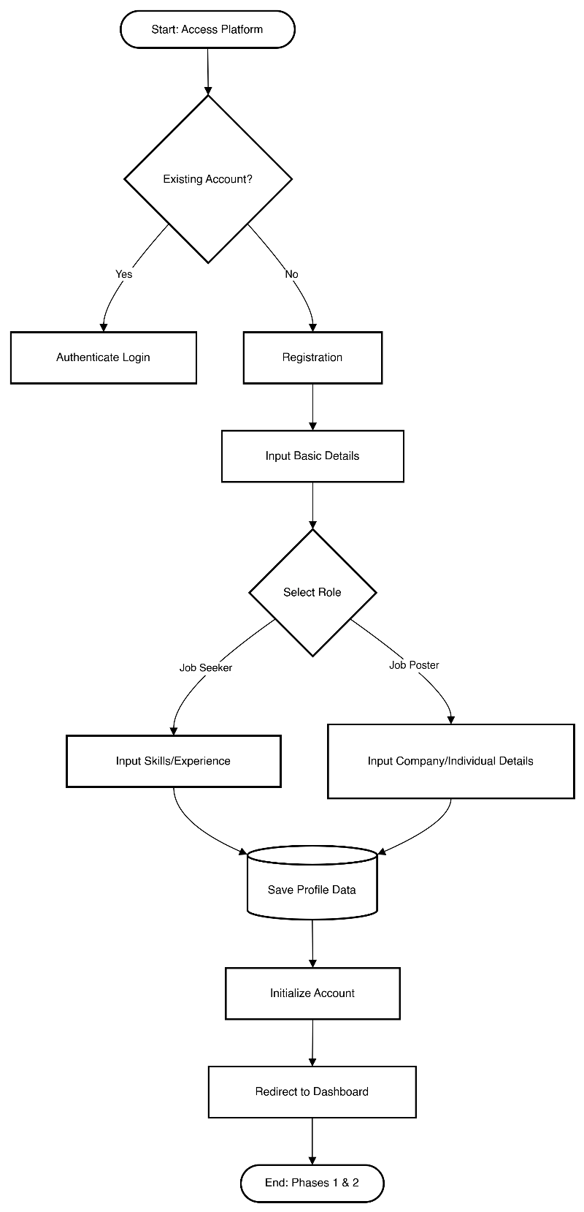
Figure 1 This is a flowchart

Dashboard & Job Creation
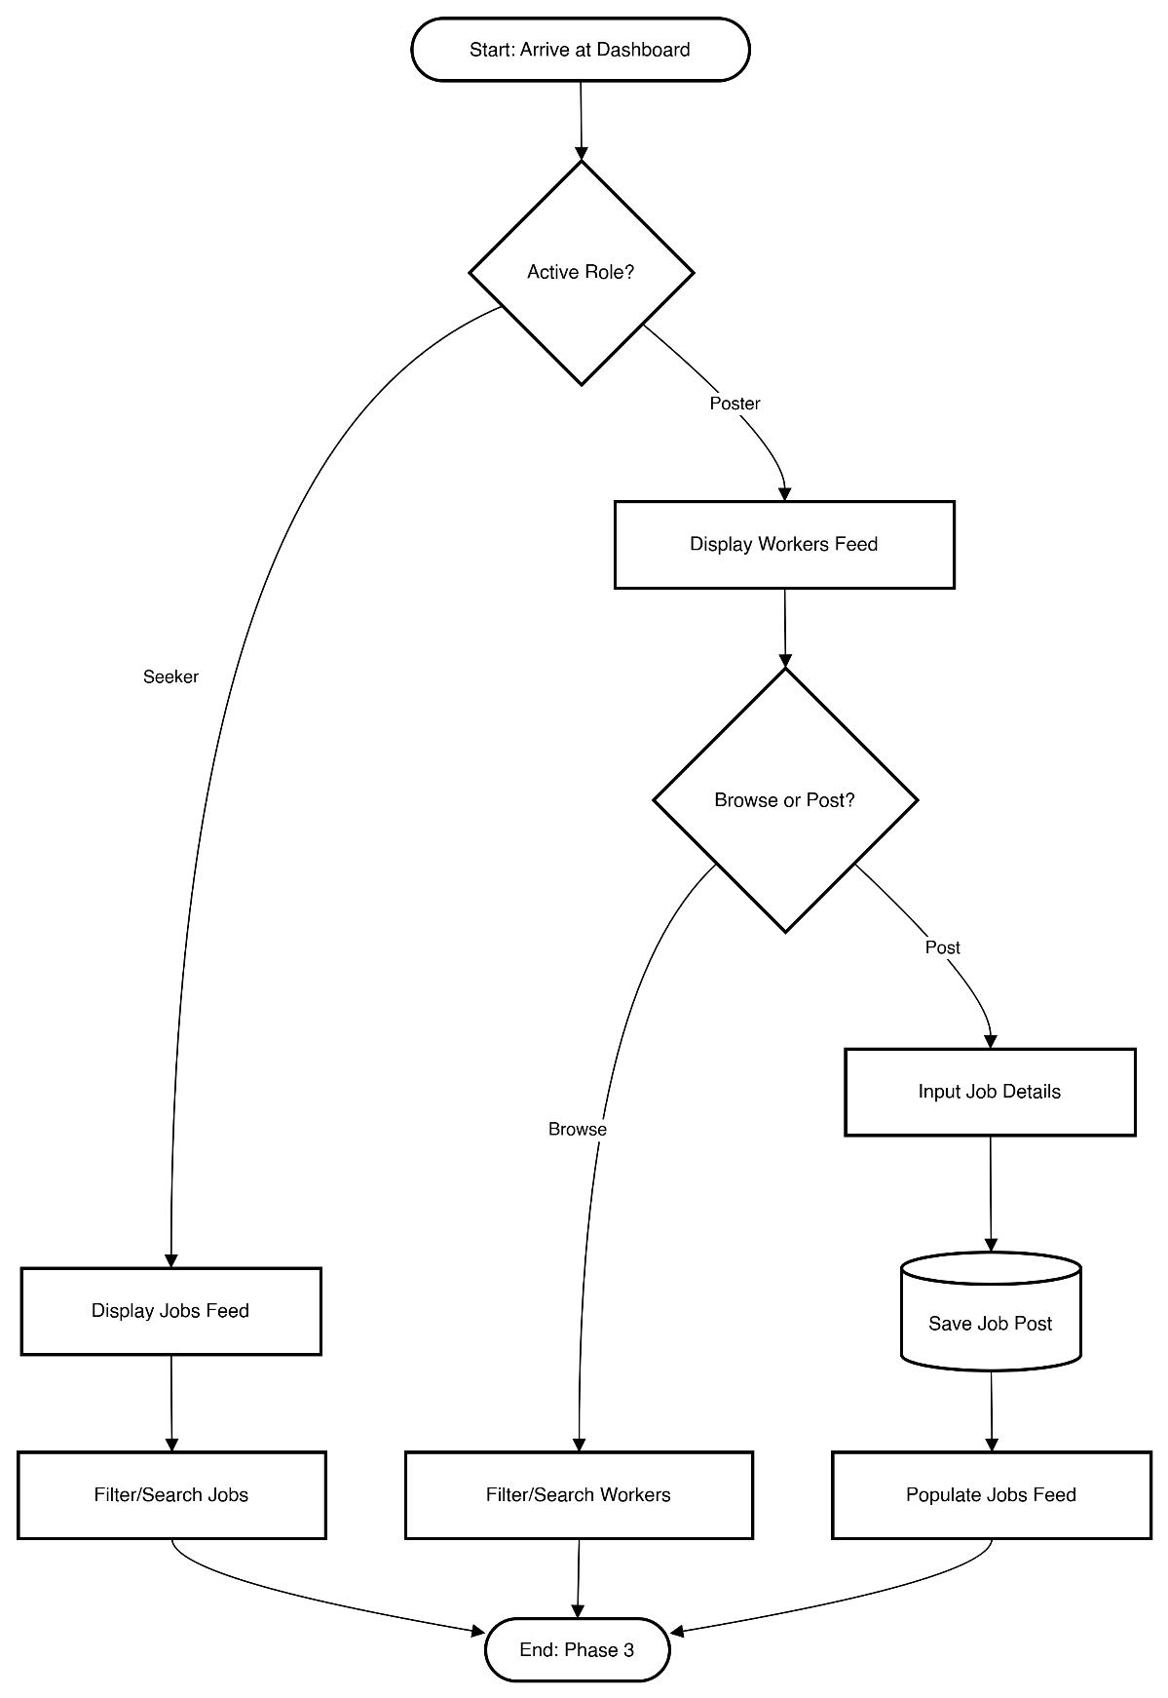

Matching & Approval
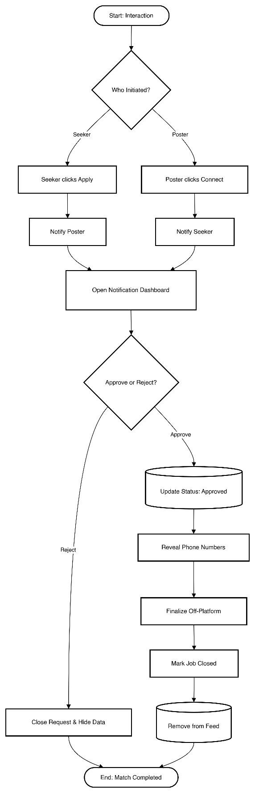

3.5 User Interface Design
Before implementing the application, the layouts for few pages were designed. Having these designs provided a guideline for developing the user interface of the application and helped in actual implementation. The initial layouts of the pages are shown in Figures 2 to 8.
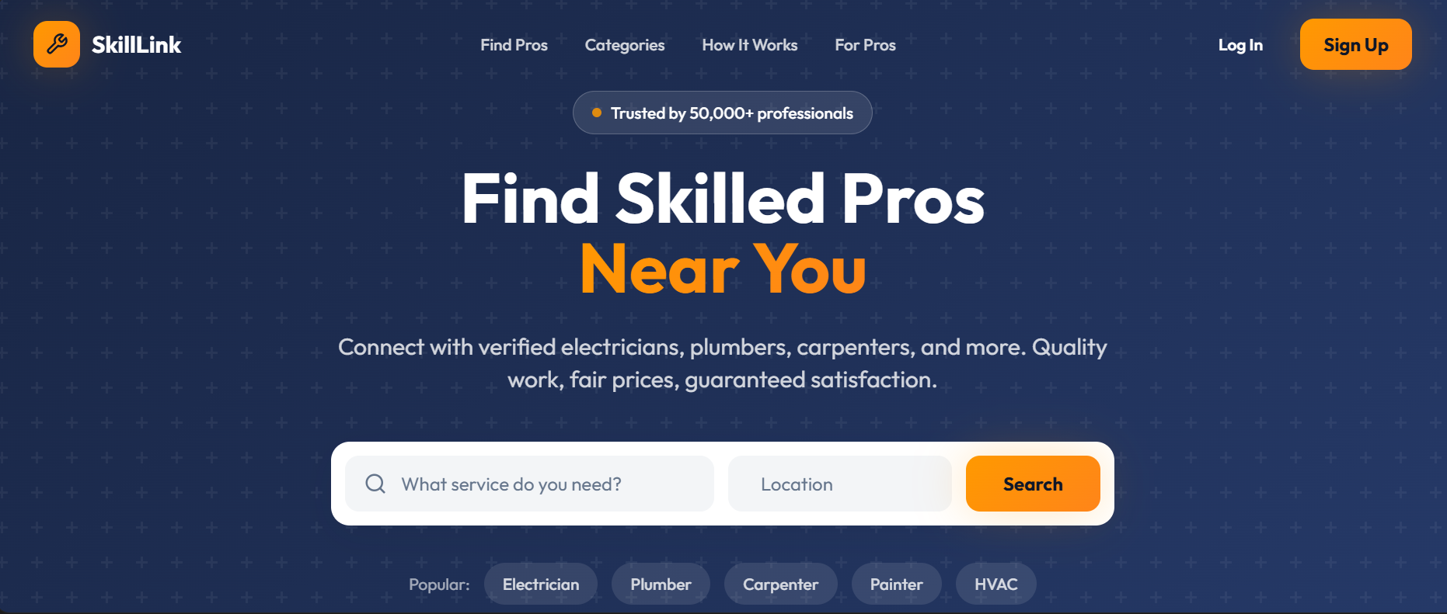
Figure 2 Home Page

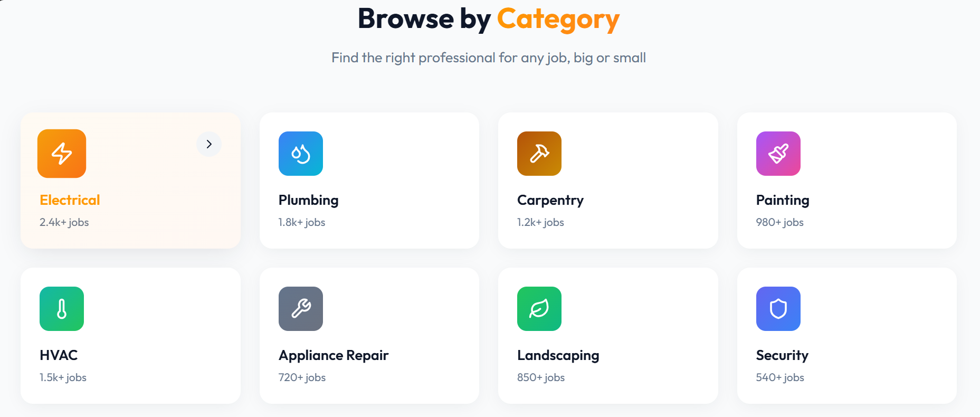
Figure 3 Service Category


Figure 4 Skilled Professionals


Figure 5 Platform landing interface and service search functionality.
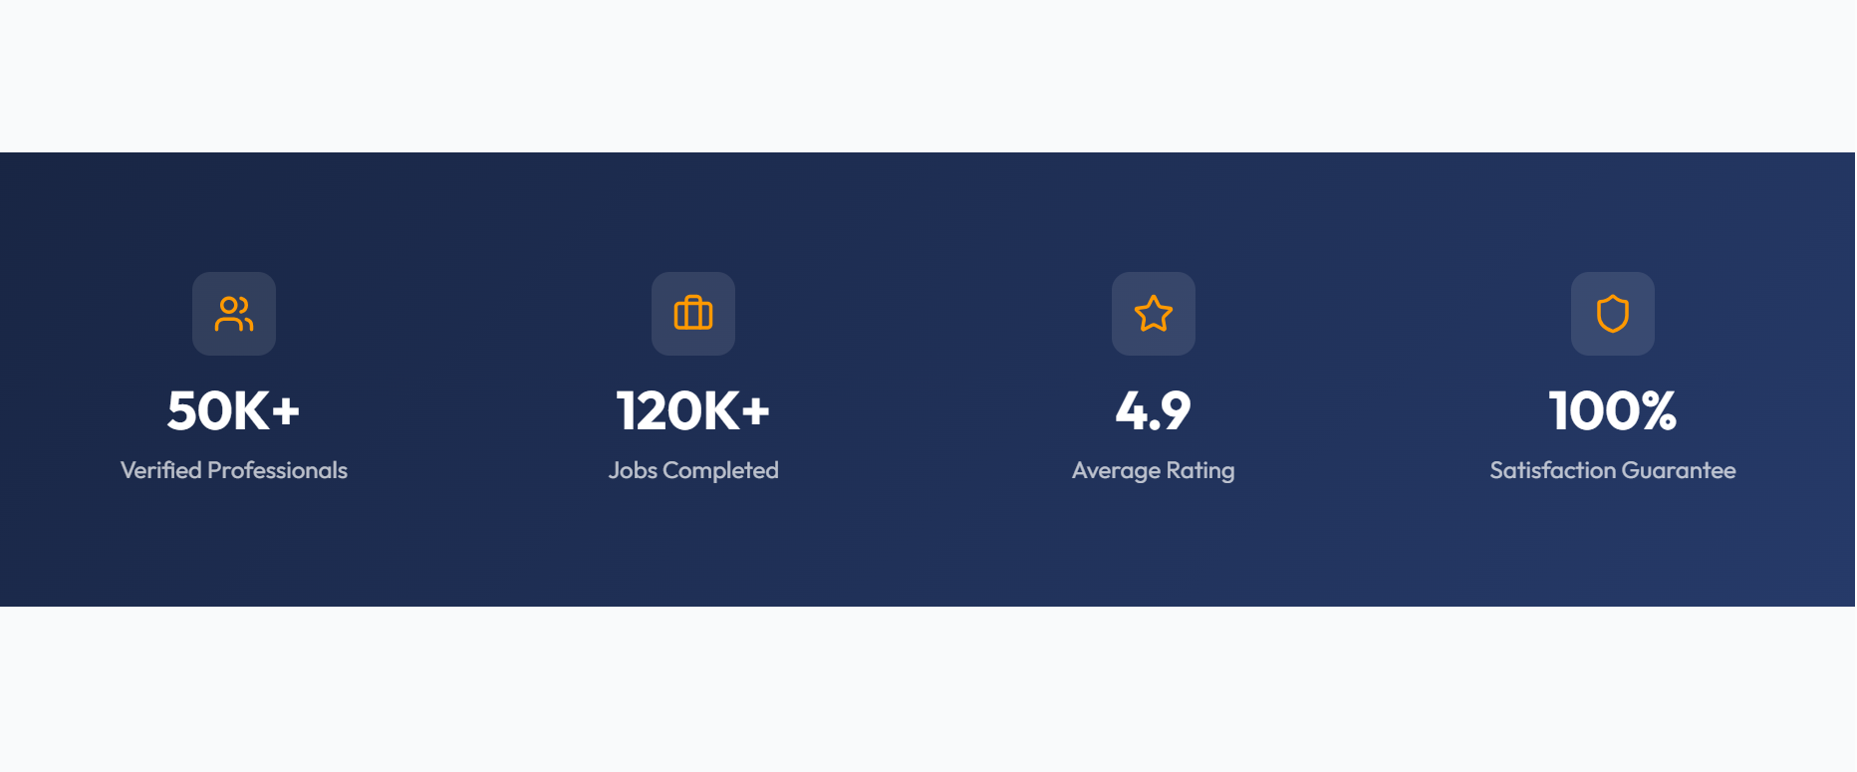
Figure 6 Classification of skilled labor categories and professional services.


Figure 7 Operational workflow for user engagement and service acquisition.

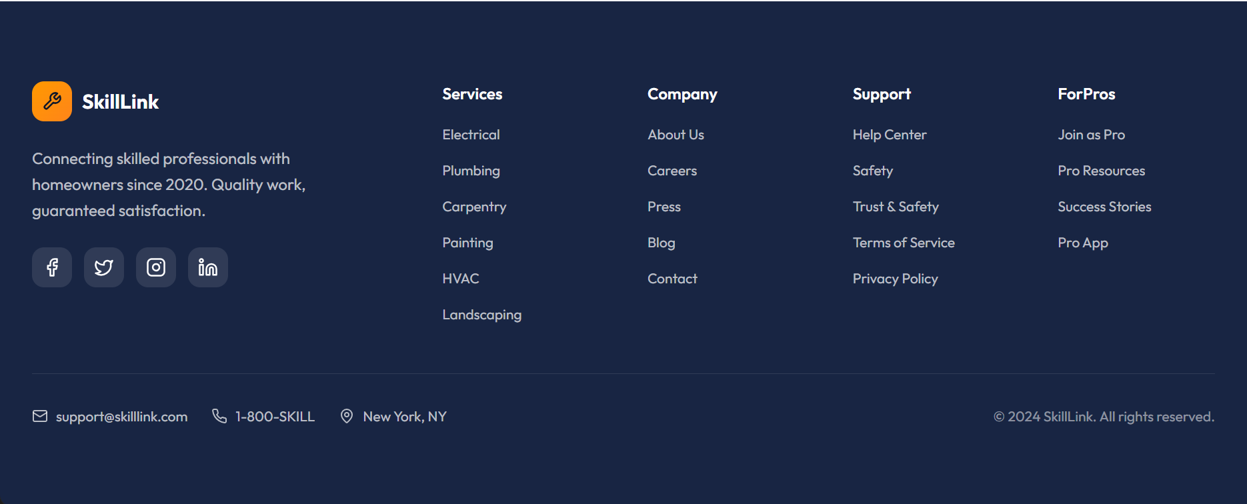
Figure 8 Organizational structure, service taxonomy, and support infrastructure.

3.6 UX Research

3.6.1 UX Research Design
This study adopts a Quantitative Research Design to objectively measure and evaluate the User Experience (UX) and User Interface (UI) of the developed system. The decision to use a quantitative approach ensures the generation of statistical data suitable for rigorous analysis and objective comparison against established industry benchmarks.
The core evaluation was conducted through a structured, 12-question survey administered to a targeted user group.
- Objective Measurement: The survey utilizes standardized, reliable, and valid instruments, including the 10-item System Usability Scale (SUS) and two bespoke Likert-scale questions, to generate measurable data points on system usability and aesthetic appeal.
- Statistical Analysis: The resulting numerical data allows for the calculation of key metrics, such as the overall SUS score and mean appearance ratings. These metrics form the basis of the analysis, which seeks to prove or disprove the hypotheses regarding the system's effectiveness.
Score Calculation (per user): The scoring is adjusted to account for the alternating positive and negative phrasing of the questions:
- Odd-numbered items: Subtract 1 from the user's rating (score ranges from 0 to 4).
- Even-numbered items: Subtract the user's rating from 5 (score ranges from 0 to 4).

Final SUS Score = (Sum of all 10 component scores) × 2.5
Interpretation of the SUS Score:
Score Range | Interpretation for your Thesis
Above 80.3 | Excellent Usability (Top 10% of scores)
68 to 80.3 | Good Usability (Above average)
Exactly 68 | Acceptable (Industry average/benchmark)
Below 68 | Poor Usability (Below average, indicating areas for major improvement)

$$Visual Design Likert Mean Score= \frac{Sum of all user ratings}{Total number of users}$$
Interpretation of the Mean Score
Since the scale is 1 to 5, the mean score directly reflects the level of agreement:
- Mean Score near 5: Very strong agreement that the visual design/clarity is excellent.
- Mean Score near 3: Neutral or mixed feelings—no strong positive or negative opinion.
- Mean Score near 1: Strong disagreement, suggesting the appearance is poor or distracting.

3.6.2 Sample Size
The sample size for this study will consist of 5 participants per cohort/group of users. This number was selected as it satisfies the saturation requirement, where additional data collection no longer yields new themes or insights ( (Nielsen, 1994). Furthermore, this sample size aligns with research standards for achieving statistical significance in qualitative studies, ensuring that the findings are both robust and representative of the target user group.

3.6.3 Sampling Procedures
Sampling is a procedure or system of picking a sub-assemble from a populace to partake in the investigation; it is the way toward choosing various people for a study such that the people chose speak to the vast gathering from which they were chosen (Ogula, 2005). The study will adopt stratified random sampling. It respects the categories of staff and offers accurate results. In this respect participants were categorized to different strata that are desktop users and mobile users. Purposive sampling was employed in the case of key informants because they were knowledgeable about testing systems.

3.6.4 Research Validity
Research validity ensures that the study measures what it is intended to measure and accurately reflects the phenomena under investigation. In this study, validity was primarily addressed by focusing on construct validity and content validity related to the system's User Interface (UI) and User Experience (UX).
- Content Validity: This was achieved by using a well-established and academically validated instrument. The core of the user experience assessment was the System Usability Scale (SUS), which is widely recognized as a valid measure for assessing the usability construct. Furthermore, the two bespoke appearance questions were designed to directly align with the visual design hypotheses of the thesis.
- Construct Validity: This refers to the degree to which a test measures the theoretical construct it is supposed to be measuring. By employing the SUS, we measured the established construct of "Usability." The inclusion of appearance questions ensured the full scope of the thesis's independent variables (usability and visual design) was accurately captured.
- Expert Review (Face Validity): Prior to deployment, the complete survey instrument, including the SUS and the appearance questions, was subjected to a panel review by two subject matter experts in UI/UX design. This ensured that the questions were clear, unambiguous, and appropriate for gathering meaningful insights related to the system's design and functionality.

3.6.5 Research Reliability
Research reliability refers to the consistency and dependability of the methods and findings. Ensuring reliability is critical, especially when relying on quantitative scores like the SUS.
- Internal Consistency Reliability (Quantitative): The reliability of the measurement instrument itself was ensured by using the System Usability Scale (SUS). The SUS exhibits strong internal consistency, typically yielding a Cronbach’s Alpha value above 0.70. This statistical measure confirms that all ten items within the scale consistently measure the same single construct (usability).
- Standardized Procedure: The research procedures were meticulously standardized to enable replication. All participants underwent the exact same process:
  - Introduction and task briefing.
  - Completion of the predefined tasks on the system.
  - Completion of the identical 12-question survey (SUS + Appearance).
This uniformity reduced variability in data collection and ensured that differences in scores were due to the system, not the testing process.
- Consistent Data Analysis: Reliability in analysis was maintained by applying the standardized scoring formula for the SUS to every response, which involved the specific mathematical calculation (alternating subtraction and multiplication by 2.5) and Likert Scale for the appearance responses. This ensured that the final reported SUS score was objective, repeatable, and trustworthy.

3.6.6 Data Collection/ Research Instrument
This study will develop a questionnaire then employ Google Forms to collect data.

3.6.7 Data Analysis
This study will use quantitative data analysis tools like: SPSS and Excel.

3.6.8 Ethical Considerations
• Permission to Conduct the Research In order to conduct research at an institution, approval for conducting the research should be obtained before data is collected (Mc Millan& Schumacher, 1993). In this study, the researcher first sought permission from EAU University before collecting data in that title
• Informed consent Participants were given enough information pertaining to the study before data collection” (Schulze 2002) in this study, the participants were given adequate information on the aims of the study, the procedures that would be followed the possible advantages for the participants, the credibility of the research and the way in which the results would be used. This enabled participants to make an informed decision on whether they wanted to participate in the research or not. No form of deception was used to ensure the participation of the participants
• Confidentiality and Anonymity a researcher has to be responsible at all times and be vigilant, mindful and sensitive to human dignity (Gay, 1996). This is supported by McMillan and Schumacher (1993) who stress that information on participants should be regarded as confidential unless otherwise agreed on through informed consent.” In this study participants’ confidentialities was not compromised, as their names would not be used in the collection of data. No private or secrete information would be divulged as the right to confidentiality of the participants would be respected. For this reason, no concealed company would be used. Only the researcher would have access to names and data to ensure that the confidentiality of the participants. Research findings would therefore be presented anonymously.

