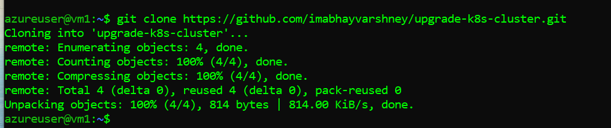

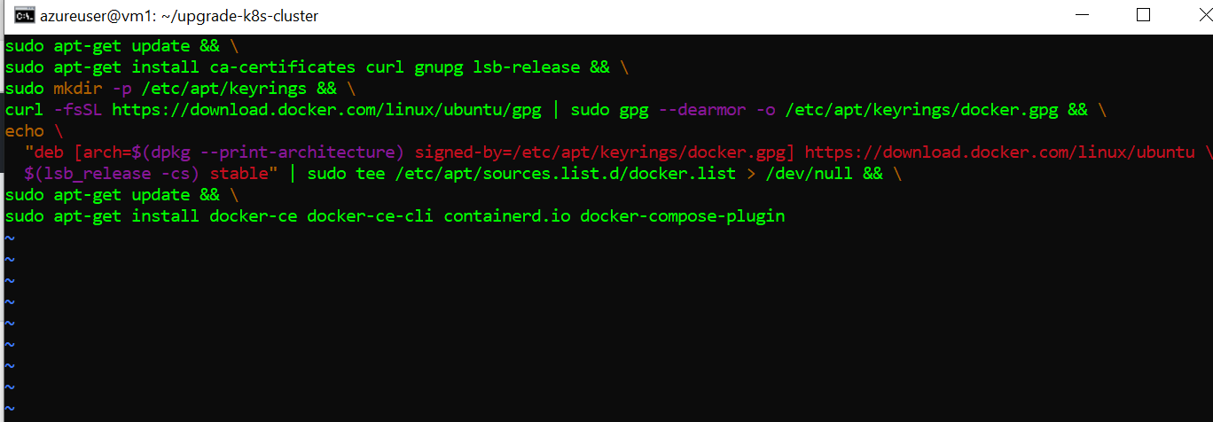



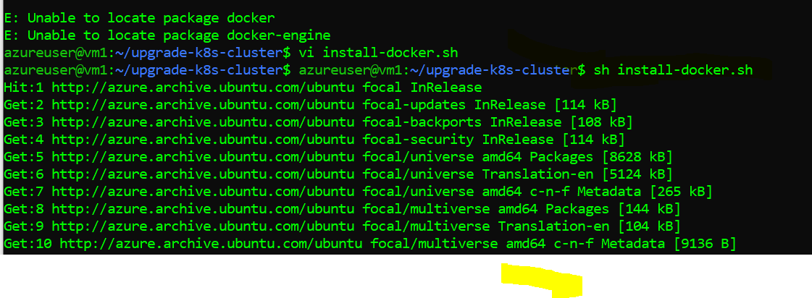



sudo usermod -aG docker azureuser





sudo docker run -p 8080:8080 -p 50000:50000 -d jenkins/jenkins:lts-jdk11



sudo docker run -p 8082:8082 -d releases-docker.jfrog.io/jfrog/artifactory-oss:latest --name jfrog



**Tunnelling for Jenkins:**

ssh -i vm1_key.pem -L 8080:0.0.0.0:8080 [azureuser@20.15.201.39](mailto:azureuser@20.15.201.39)

**Tunnelling for Jfrogs:**

ssh -i vm1_key.pem -L 8082:0.0.0.0:8082 azureuser@20.15.201.39

docker container logs <containernameofjenkins>

**Go inside the Jenkins container to see the logs:**

Sudo docker exec -it 5e3 /bin/bash

**Install artifactory plugin: Manage Jenkin🡪plugin manager**

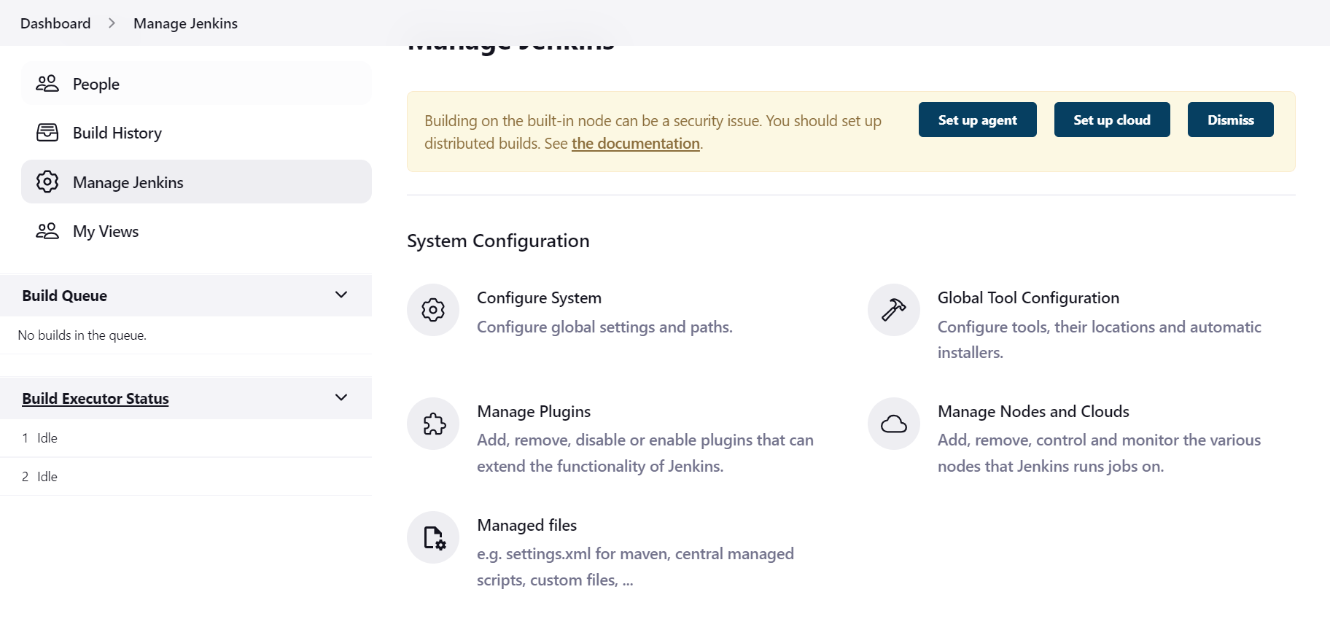

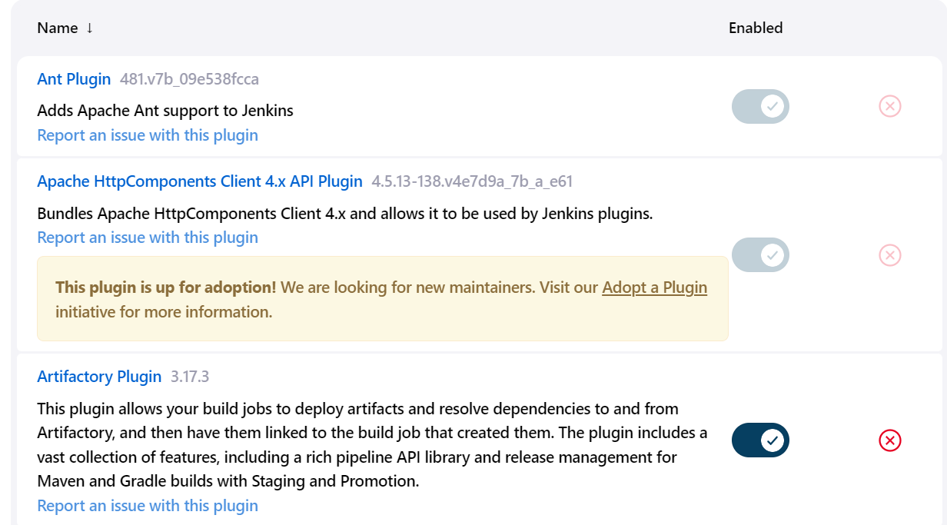

**In Global tool configuration:**

Jenkins configuration..

