**Student ID: 77275565**

**Full Name: Sokil Thapa**

**Module Name: Advance Web Engineering**

1. **Laravel Version**

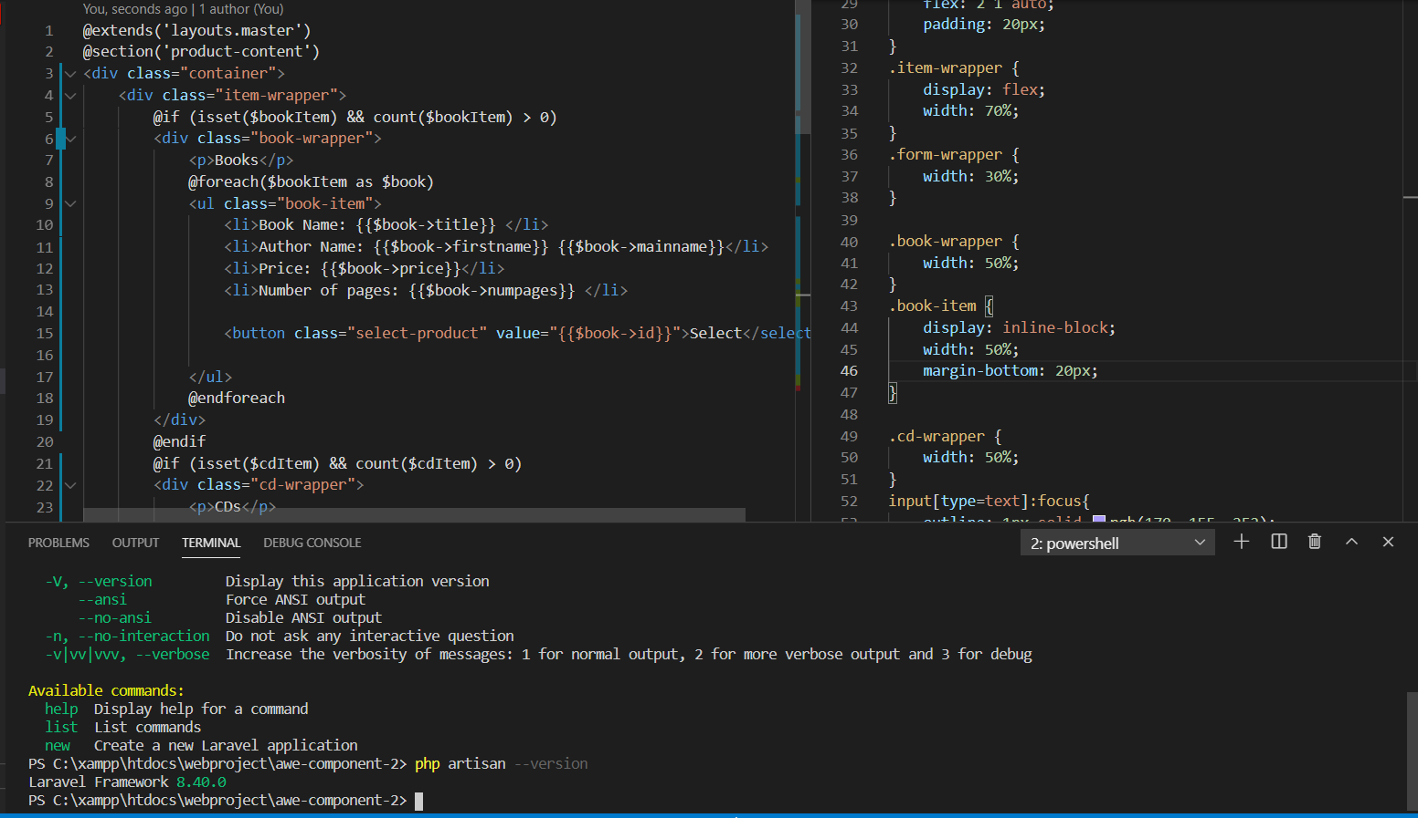

Fig: Laravel Version 8.4.0

1. **Integrated Development Environment**

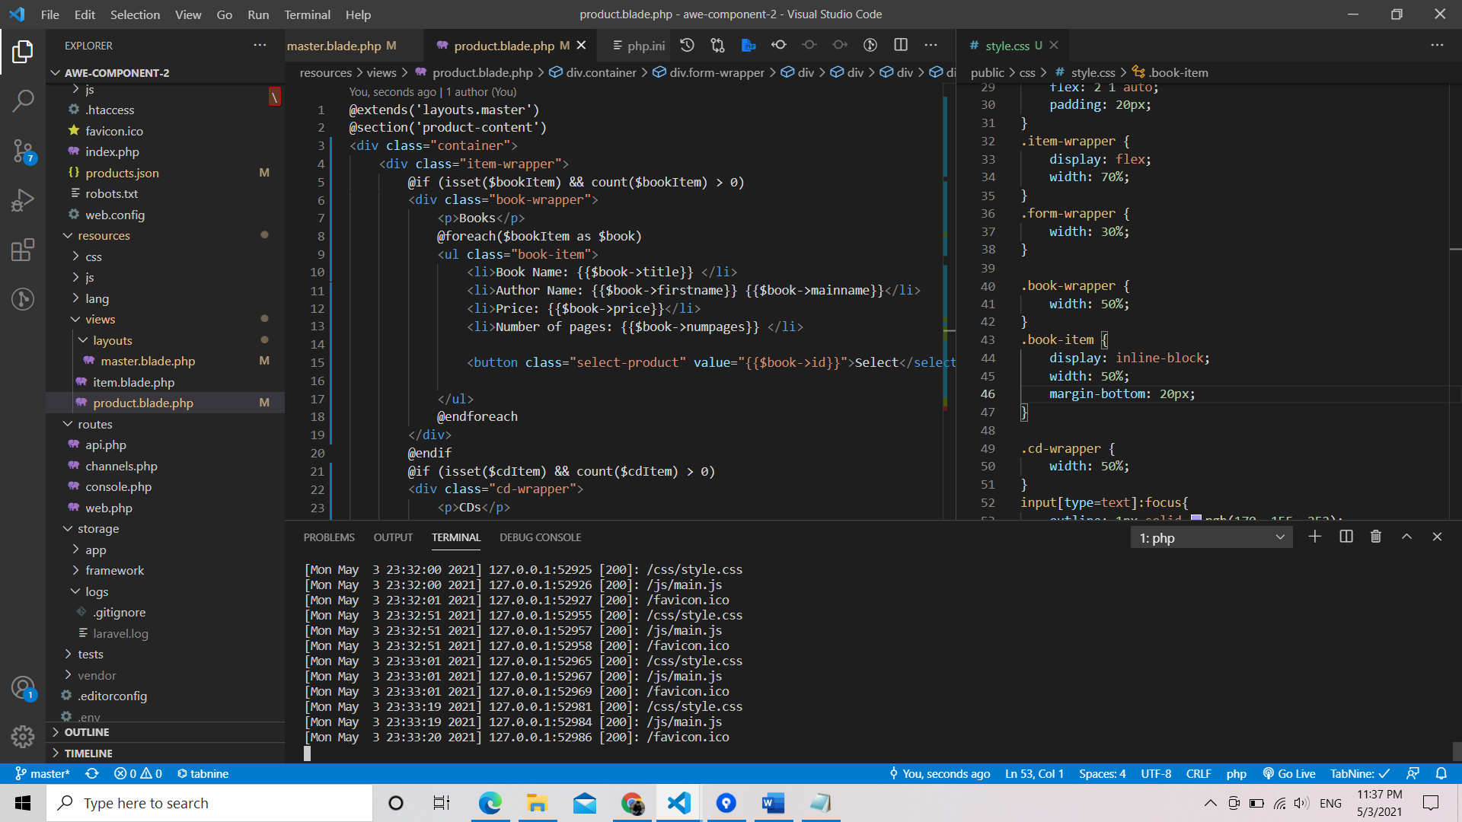

Fig: IDE - Visual Studio Code