# Coursera IBM Data Science Capstone Project — Car accident severity (Week 2)

I did my data science course capstone on the severity of car accidents in Seattle. More specifically, I did my research on what types of traffic collisions are most likely to result in injury. This explanation will walk you through my process.

First, I imported the libraries from the Course 8 final project. I figured that those libraries would have everything I needed for this project. The libraries that I ended up using were pandas , matplotlib, seaborn

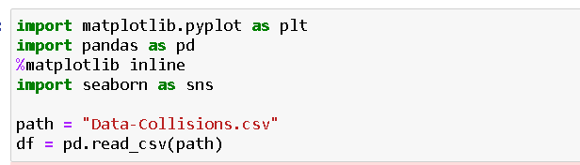

Then, I used the provided .csv with the course and listed the datatypes

.

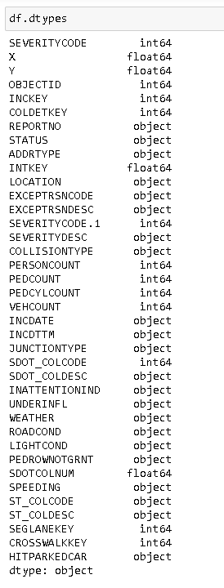

Then I also found out the number of missing values in the dataset.

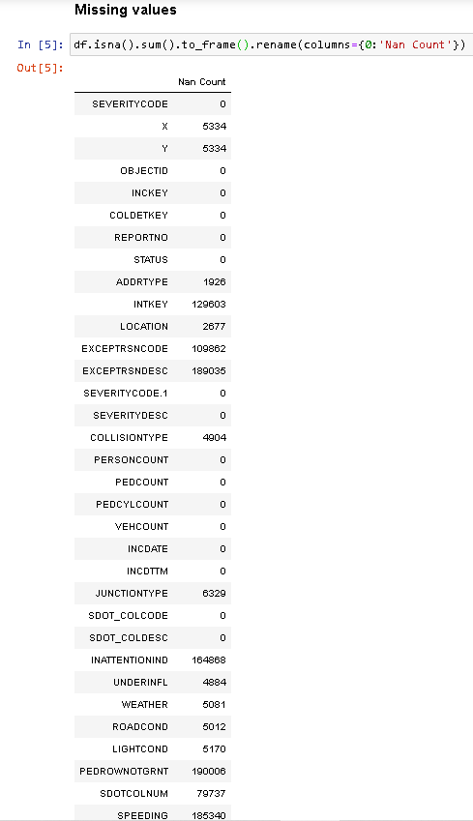

Then, I began choosing columns to use from the dataframe that I created. The columns that I chose were SEVERITYCODE, which were Property damage only collision and Injury collision

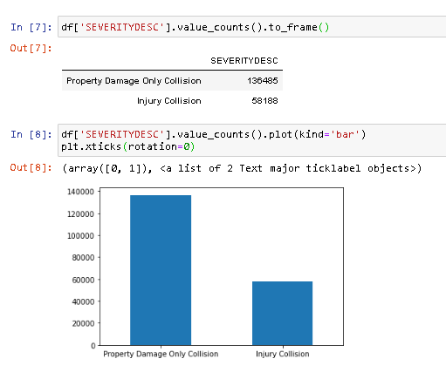

Then, considering the factors which caused these collisions were:

COLLISIONTYPE, which describes the type of collision.

WEATHER, which describes the weather at the time of collision.

ROADCOND, which describes the condition of the road at the time of collision.

LIGHTCOND, which describes the light conditions at the time of collision.

WEATHER, which describes weather condition at the time of collision.

UNDERINFL, which describes whether the driver was under the influence.

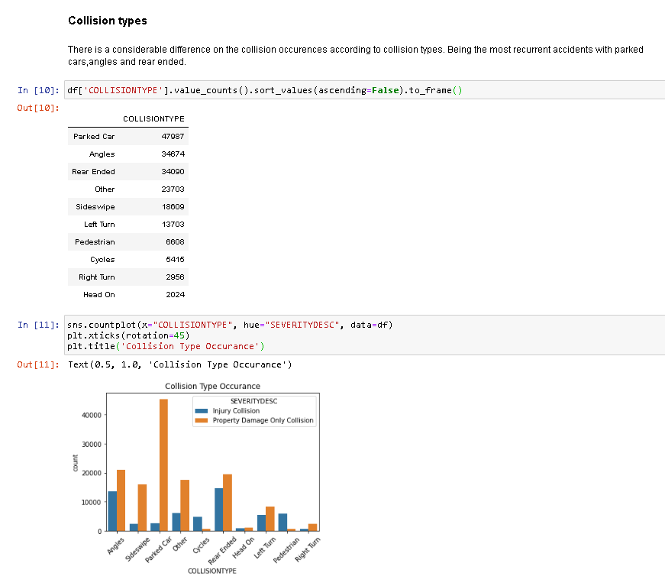

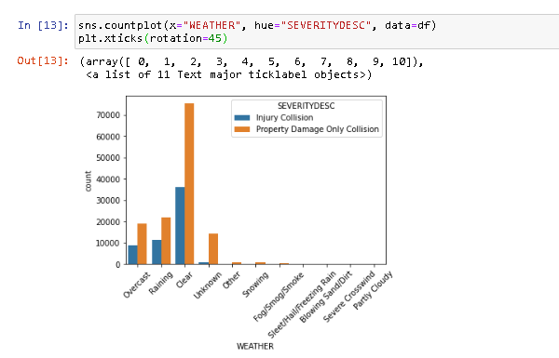

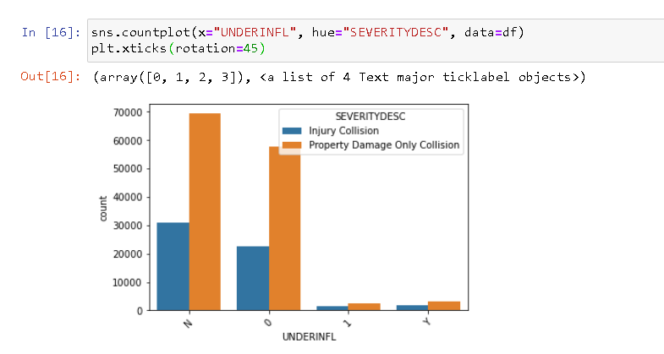

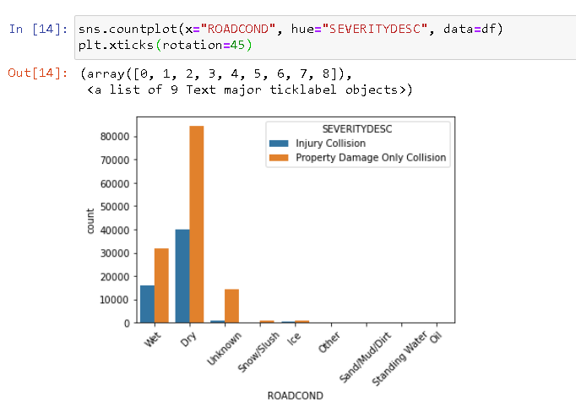

Lastly, I visualized the data in the form of bar graphs. I filtered out the columns I wanted from the provided .csv and then called value_counts to graph the mostly categorical data.

Most crashes happened in clear, dry, and bright conditions. Most days are clear, dry, and bright, so it’s no surprise that most car crashes occur under these conditions. I also found out that crashes common in the case of driver under influence . The results of the data indicate to city officials that they should ask drivers to be more alert in ideal conditions.