**Users / Role:**

1. Admin
2. Student

**Activities :**

|  |  |  |  |
| --- | --- | --- | --- |
| Sl No | Activity | User | Remarks |
| Ex-1 | My Grades | Admin, Student |  |
| Ex-2 | View PDF Report | Admin, Student |  |

**My Grades :**

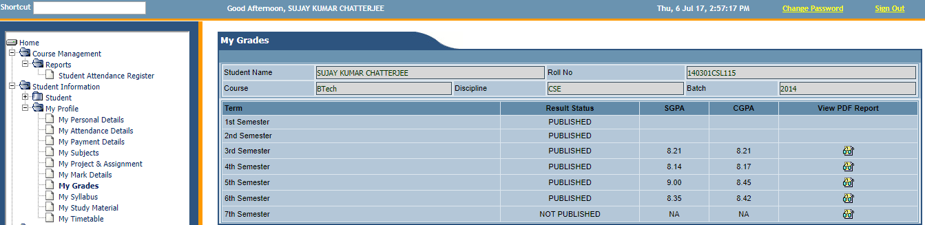

* Users: Admin, Student .
* This page is used to view the Grades of a student of each semester.
* By default, it will show the student’s name, Rollno, Course, Discipline and Batch.
* The page will contain 5 columns (Term, Result Status, SGPA, CGPA & View PDF Report).
* Term will contain semesters list according to the student’s Discipline.
* Result Status will show whether the Result is published or not.
* SGPA will show the Semester Grades and CGPA will Show Average Grades of previous and current semester.
* If the Result Status is published then the student will be able to view the PDF Report by clicking on View PDF Report.

**View PDF Report :**

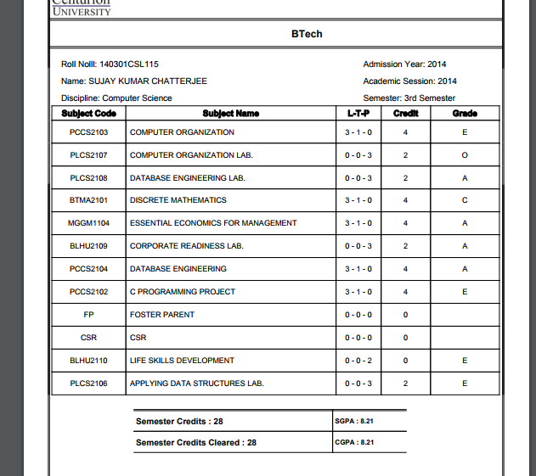

* User: Student, Admin.
* About : This page will contain the detailed Result of the semester.
* Student’s Roll no, Name, Discipline, Course, Admission Year, Academic Session & Semester will be shown at the top.
* Below in tabular format there will be List of Subjects taken, subject name, total credit in subject (L-T-P) and Grade obtained in each subject.
* Below the tabular format it will show the Semester Credits , Semester Credits Cleared and SGPA along with CGPA will be shown.
* This PDF format can be download by the students.