**Users / Role:**

1. Admin
2. Student

**Activities :**

|  |  |  |  |
| --- | --- | --- | --- |
| Sl No | Activity | User | Remarks |
| Ex-1 | Student Mark Details | Admin, Student |  |
| Ex-2 | Examinations along with Class Test | Admin, Student |  |
| Ex-3 | View Marks | Admin, Student |  |

**Student Mark Details:**

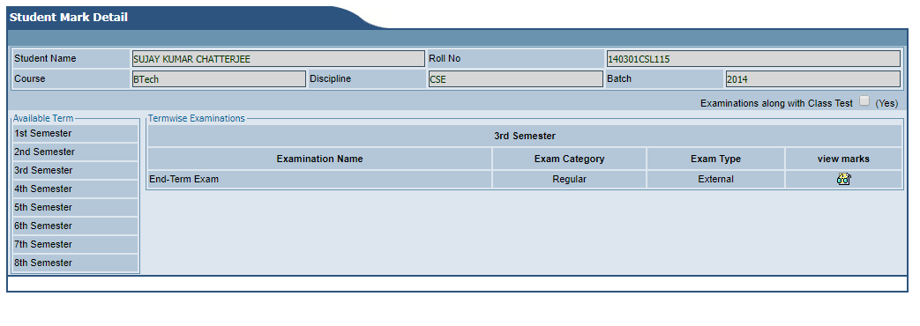

* Users: Admin, Student .
* This page is used to view the Mark Details of all the subjects registered by a student semester wise.
* By default, it will show the student’s name, Rollno, Course, Discipline and Batch in the top section of the page.
* It will also show a option (Examinations along with Class Test) which will be by default unchecked. Which means by default the page will only show the end-term marks.
* The page will contain 2 columns (Available Term & Termwise Examinations).
* Available Term will contain semesters list according to the student’s Discipline.
* Termwise Examinations will show the semester selected at the top and following it there will be 4 columns (Examination Name, Exam Category, Exam Type, View marks).
* Examination Name will contain the name of the examination.
* Exam Category will contain the category of the exam.
* Exam Type will contain the type of exam it was held (External/Internal).
* View Marks will view the marks.

**Examinations along with Class Test:**

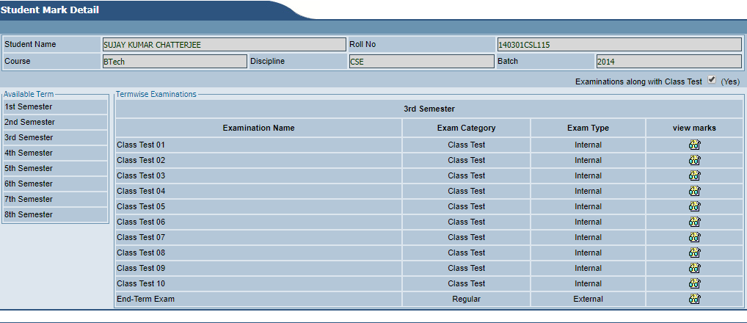

* User: Student, Admin.
* About : This page will contain the detailed result of the all the class tests in each semester.
* Student’s Roll no, Name, Discipline, Course, Admission Year, Academic Session & Semester will be shown at the top.
* Below it the option (Examinations along with Class Test) which will be shown checked/ticked.
* The page will show list of all the class tests in that particular semester along with the end-term exam.
* The page will contain 2 columns (Available Term & Termwise Examinations).
* Available Term will contain semesters list according to the student’s Discipline.
* Termwise Examinations will show the semester selected at the top and following it there will be 4 columns (Examination Name, Exam Category, Exam Type, View marks).
* Examination Name will contain the name of the examination.
* Exam Category will contain the category of the exam.
* Exam Type will contain the type of exam it was held (External/Internal).
* View Marks will view the marks.

**View Marks:**

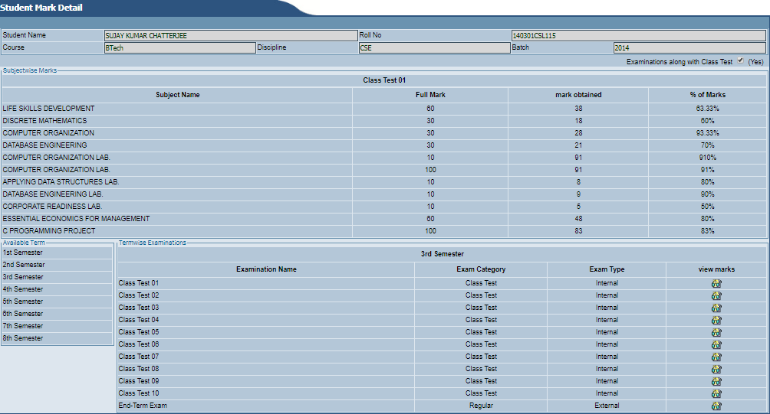

* User: Student, Admin.
* About : This page will view the marks of all the subjects a particular examination name.
* Student’s Roll no, Name, Discipline, Course, Admission Year, Academic Session & Semester will be shown at the top.
* Below it the option (Examinations along with Class Test) which will be shown checked/ticked.
* Below it examination name that is selected will be displayed at the top.
* Below it there are 4 columns named as (Subject Name, Full Mark, Mark Obtained, % of marks)
* Subject Name will show the names of the subjects.
* Full Mark will show the total available marks.
* Mark Obtained will show the total mark obtained in that subject.
* % of marks will show the % obtained in that subject by calculating the total and obtained marks.
* Below it the page will show list of all the class tests in that particular semester along with the end-term exam.
* The page will contain 2 columns (Available Term & Termwise Examinations).
* Available Term will contain semesters list according to the student’s Discipline.
* Termwise Examinations will show the semester selected at the top and following it there will be 4 columns (Examination Name, Exam Category, Exam Type, View marks).
* Examination Name will contain the name of the examination.
* Exam Category will contain the category of the exam.
* Exam Type will contain the type of exam it was held (External/Internal).
* View Marks will view the marks.

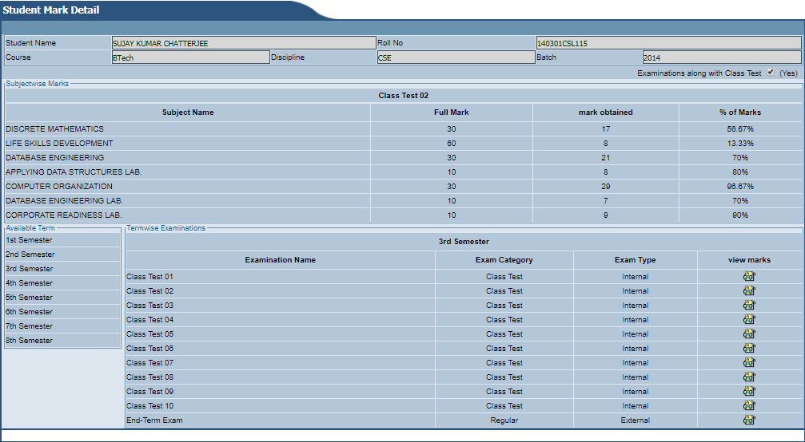

* If you click on view marks of another examination name it will show the marks details of all the subjects of that examination in same window.