
 | Course Code: INTM591 | Course Title: Predictive Analytics
 | Academics Task No. 3 | Academics Task Type: Project
 | Date of Allotment: 18-04-2026 | Date of submission: 24-04-2026
 | Name- Abhinav Adarsh | Student Reg. No.: 12500393
 | Max. Marks: _ | Section: Q5E08
 | Evaluation Parameters: _ | Submitted to: Mr. Robin Tyagi
DECLARATION:
I declare that this Assignment is my individual work. I have not copied it from any other students’ work or from any other source except where due acknowledgement is made explicitly in the text, nor has any part been written for me by any other person.

ACKNOWLEDGEMENT
I would like to express my sincere gratitude to my faculty mentor, Mr. Robin Tyagi, for his invaluable guidance and constant encouragement throughout the duration of this project. His insights into modelling and data analytics helped me navigate the complexities of both Python and SPSS Modeler with greater clarity.
I am also thankful to Lovely Professional University (LPU) for providing a curriculum that bridges the gap between theoretical knowledge and practical industry tools. This project has been a significant learning milestone in my MBA journey, particularly in understanding how global markets correlate. Finally, I want to thank my family and peers for their constant support and feedback, which kept me motivated to complete this work with precision.

CERTIFICATE
This is to certify that Adarsh Srivastava, a student of MBA (Business Analytics) at Lovely Professional University, has successfully completed the project titled "Exploratory Data Analysis of Titanic: Machine Learning from Disaster" as part of the academic coursework for the subject PREDICTIVE ANALYTICS.
During the project, Lovish demonstrated exceptional analytical skills by performing detailed Exploratory Data Analysis (EDA) using Python and IBM SPSS Modeler. He successfully identified historical market patterns, handled complex time-series data cleaning, and derived meaningful insights regarding asset correlations.
His approach to the project was structured, diligent, and met all the requirements set by the department. I wish him the very best in his future academic and professional endeavors.

Signature of Supervising Teacher
(Mr. Robin Tyagi)

Project Definition:
This project performs Exploratory Data Analysis (EDA) on the Titanic dataset sourced from Kaggle (https://www.kaggle.com/c/titanic/data). The dataset contains information about 891 passengers who were aboard the Titanic, including their demographic details, ticket class, fare, cabin, and survival status. The objective is to uncover patterns and relationships in the data that influenced passenger survival, using Python (Pandas, Matplotlib, Seaborn) and IBM SPSS Modeler.

Outcomes / Learning:
After completing this project, the following skills and insights were developed:
- Hands-on experience with data cleaning, missing value treatment, and feature encoding.
- Ability to generate descriptive statistics and interpret distributions using Python and SPSS Modeler.
- Visualization of survival patterns across gender, passenger class, age, and fare using charts and graphs.
- Understanding of how to use SPSS Modeler nodes (Data Audit, Distribution, Histogram) for visual EDA.

Required Tools:
- Python 3.x — with libraries: Pandas, NumPy, Matplotlib, Seaborn, Missingno
- IBM SPSS Modeler 18.x — for stream-based EDA using Data Audit, Distribution, and Plot nodes
- Kaggle — dataset source (Titanic: Machine Learning from Disaster)
- Jupyter Notebook — for Python-based analysis and visualization

Working:
The project involves loading the Titanic CSV dataset, performing initial exploration (shape, data types, null counts), cleaning missing values in 'Age', 'Cabin', and 'Embarked', and then conducting visual analysis. In Python, charts such as survival count plots, age histograms, and correlation heatmaps are generated. In SPSS Modeler, a stream is built using Source → Data Audit → Distribution/Plot nodes to replicate the same analysis visually.

Step 1: Importing Libraries and Loading the Dataset (Python)
The first step is to import all necessary Python libraries and load the Titanic CSV dataset using Pandas. The dataset is read from the local file system after downloading from Kaggle. An initial preview of the first five rows is displayed using df.head() to understand the structure.
import pandas as pd import numpy as np
import matplotlib.pyplot as plt import seaborn as sns

# Load the dataset
df = pd.read_csv('train.csv') print(df.head()) print(df.shape)
Output-
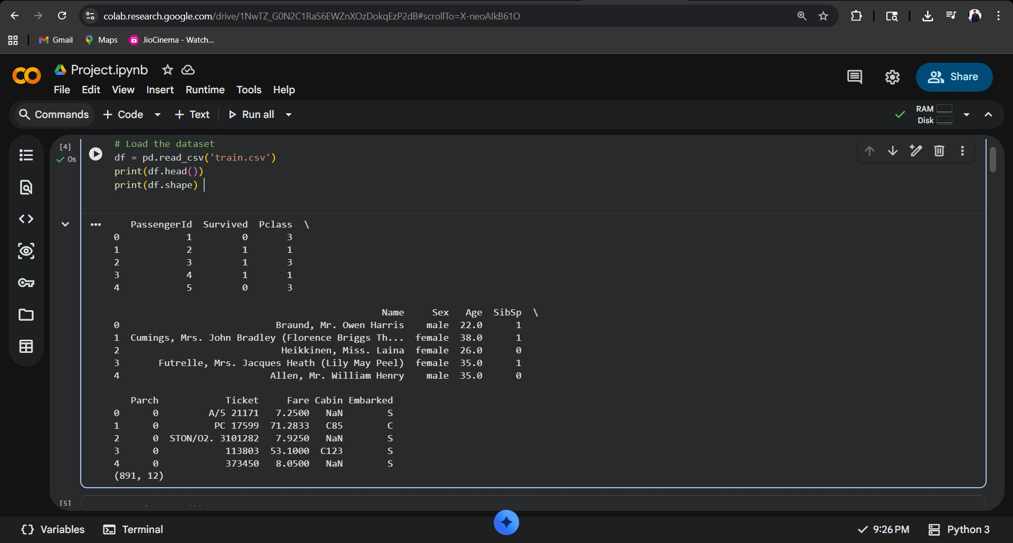

Step 2: Understanding the Data — Shape, Data Types, and Basic Statistics
In this step, the dataset dimensions, column data types, and descriptive statistics are examined. The dataset has 891 rows and 12 columns. Numerical statistics such as mean, median, and standard deviation are computed to understand distributions, particularly for Age (mean ≈ 29.7) and Fare.
print(df.info()) # Column types & non-null counts print(df.describe()) # Descriptive statistics print(df.isnull().sum()) # Missing value count per column

Column | Data Type | Non-Null Count | Missing Values
PassengerId | int64 | 891 | 0
Survived | int64 | 891 | 0
Pclass | int64 | 891 | 0
Name | object | 891 | 0
Sex | object | 891 | 0
Age | float64 | 714 | 177
SibSp | int64 | 891 | 0
Parch | int64 | 891 | 0
Ticket | object | 891 | 0
Fare | float64 | 891 | 0
Cabin | object | 204 | 687
Embarked | object | 889 | 2

Output-
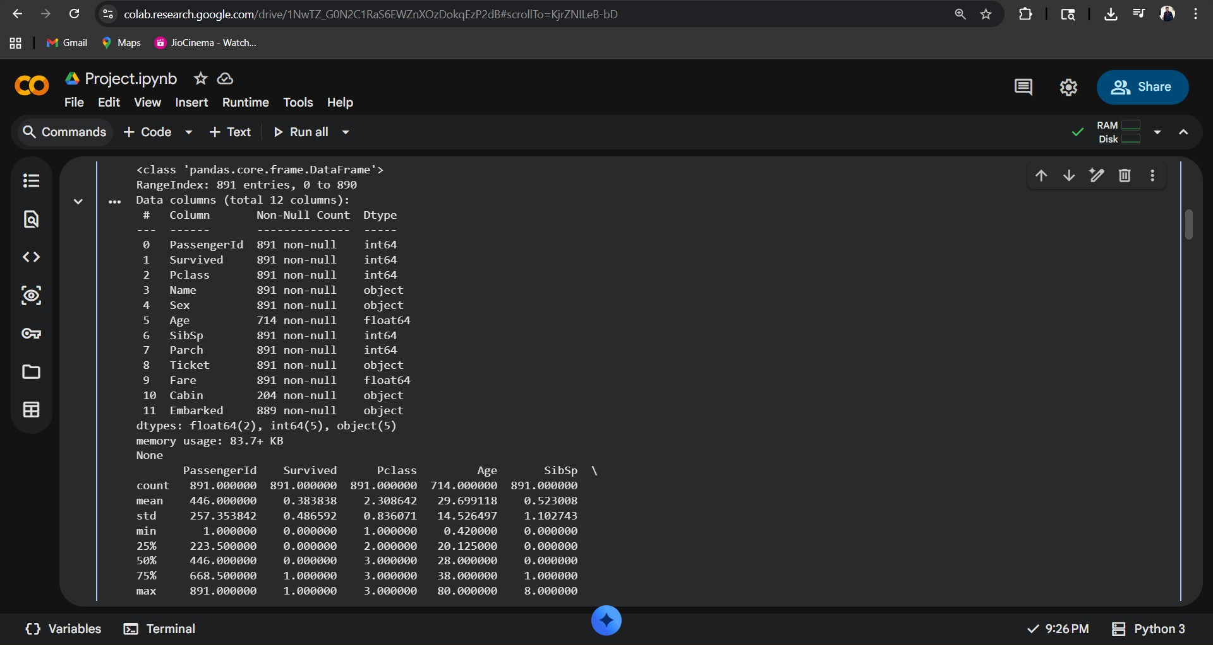

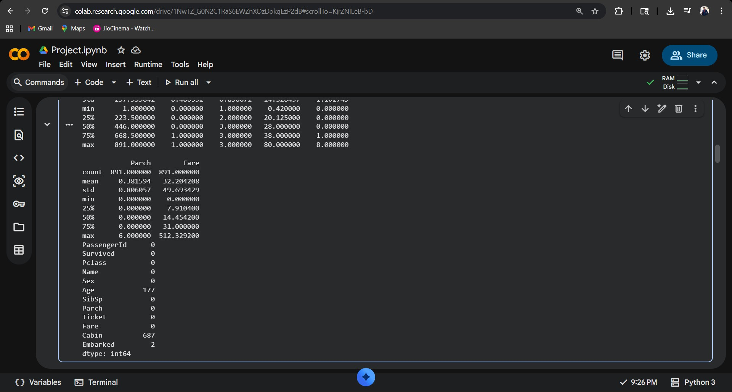

Step 3: Handling Missing Values
Three columns contain missing values: Age (177), Cabin (687), and Embarked (2). Age is imputed with the median value to reduce the effect of outliers. Cabin is dropped due to excessive missingness (77%). The two missing Embarked rows are filled with the mode value ('S').

# Fill Age with median df['Age'].fillna(df['Age'].median(), inplace=True)

# Drop Cabin column (too many nulls) df.drop(columns=['Cabin'], inplace=True)

# Fill Embarked with mode df['Embarked'].fillna(df['Embarked'].mode()[0], inplace=True)
print(df.isnull().sum())

Output-
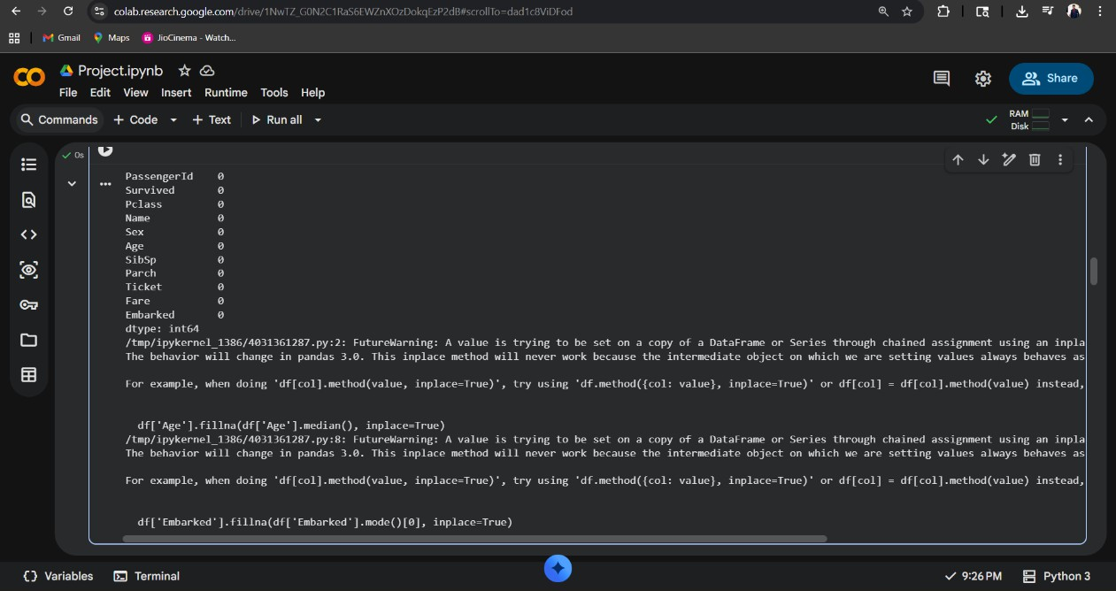
Step 4: Survival Count Visualization
A count plot is created to show the distribution of survivors vs. non-survivors. Out of 891 passengers, 342 survived (38.4%) and 549 did not survive (61.6%). This imbalance is important context for subsequent analysis.
sns.countplot(x='Survived', data=df, palette='Set2') plt.title('Survival Count (0 = Did Not Survive, 1 = Survived)') plt.xlabel('Survived')
plt.ylabel('Count') plt.show() Output-
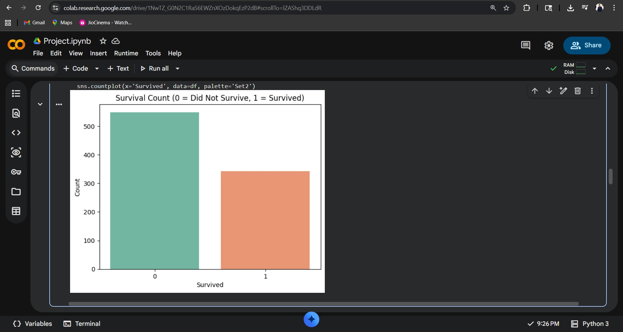

Step 5: Survival by Gender
The survival rate is broken down by gender using a grouped count plot. Female passengers had a significantly higher survival rate (~74%) compared to males (~19%), consistent with the 'women and children first' evacuation policy.
sns.countplot(x='Sex', hue='Survived', data=df, palette='pastel') plt.title('Survival by Gender')
plt.xlabel('Gender') plt.ylabel('Count')
plt.legend(title='Survived', labels=['No', 'Yes']) plt.show()
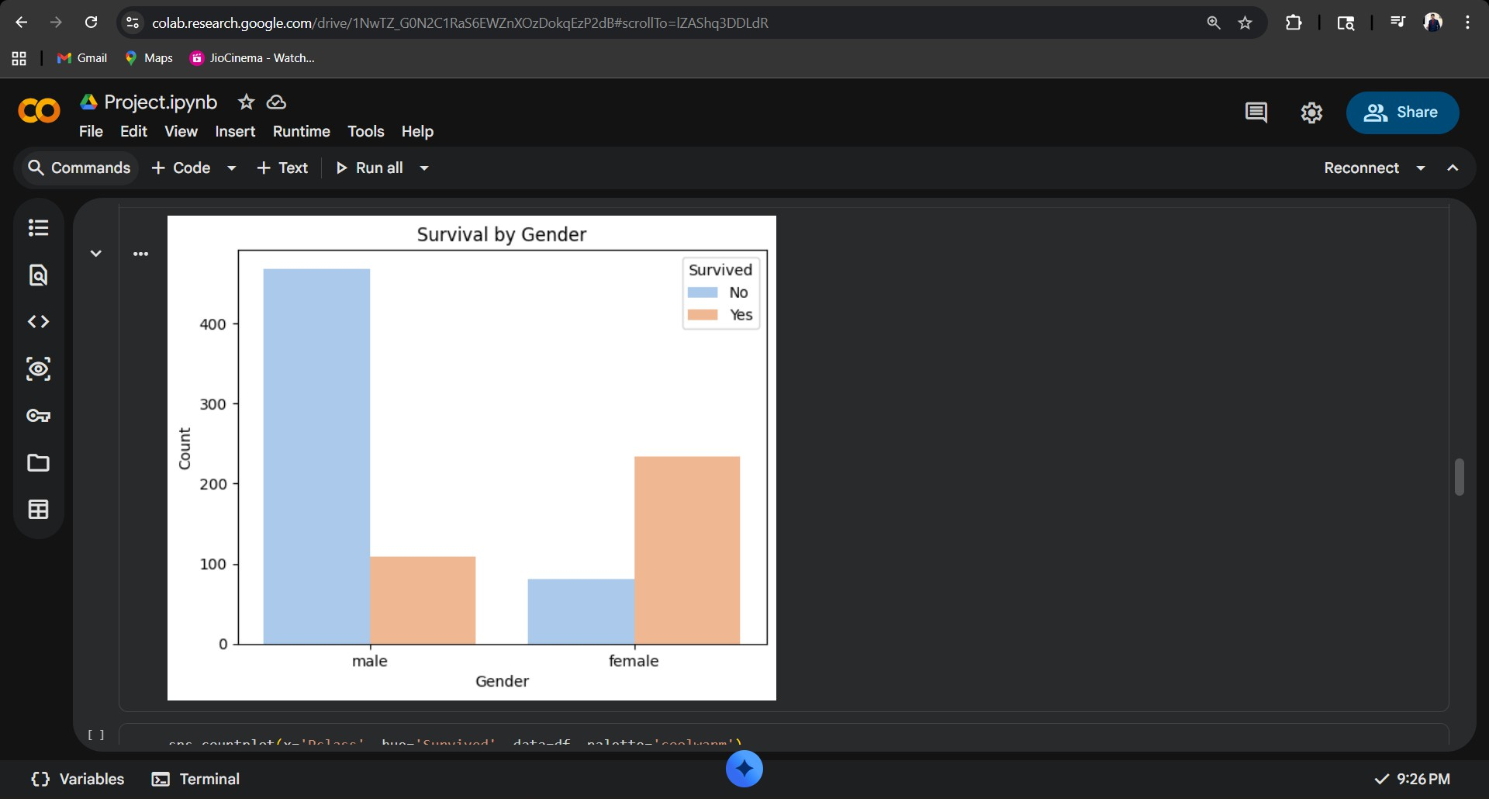
Output-
Step 6: Survival by Passenger Class (Pclass)
This step analyses how ticket class (1st, 2nd, 3rd) influenced survival. First-class passengers had a survival rate of approximately 63%, second class ~47%, and third class only ~24%. Wealthier passengers with higher-class tickets had better access to lifeboats.
sns.countplot(x='Pclass', hue='Survived', data=df, palette='coolwarm') plt.title('Survival by Passenger Class')
plt.xlabel('Passenger Class') plt.ylabel('Count') plt.show()

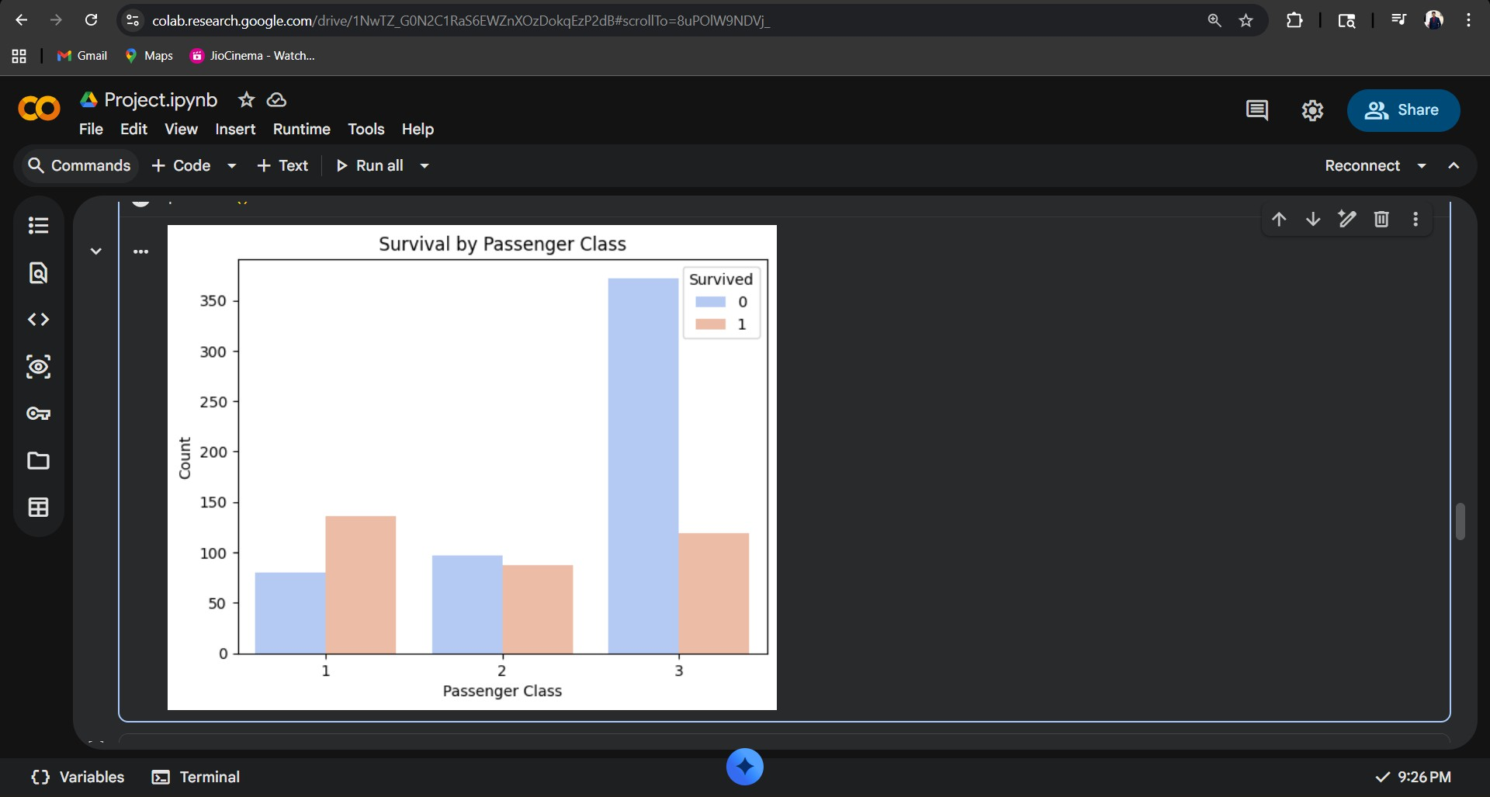
Output-

Step 7: Age Distribution Histogram
A histogram of the Age column reveals a roughly right-skewed distribution with most passengers between 20–40 years old. A KDE (Kernel Density Estimation) curve is overlaid to show the age density. Children under 10 had relatively higher survival rates.
plt.figure(figsize=(8, 5))
sns.histplot(df['Age'], bins=30, kde=True, color='steelblue') plt.title('Age Distribution of Passengers')
plt.xlabel('Age') plt.ylabel('Frequency') plt.show()

Output-
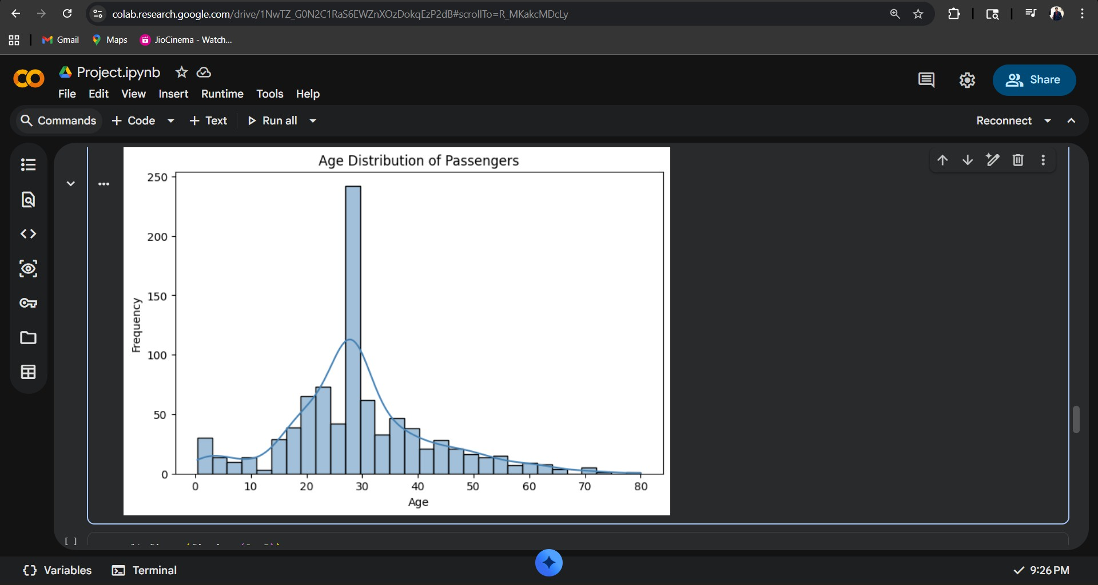
Step 8: Fare Distribution and Boxplot by Class
A boxplot of Fare grouped by passenger class shows that 1st class passengers paid significantly higher fares with more outliers. The median fare for 3rd class was around
£8, while for 1st class it was approximately £60. Fare is positively correlated with survival.
plt.figure(figsize=(8, 5))
sns.boxplot(x='Pclass', y='Fare', data=df, palette='Set3') plt.title('Fare Distribution by Passenger Class') plt.xlabel('Passenger Class')
plt.ylabel('Fare (£)') plt.show()

Output-
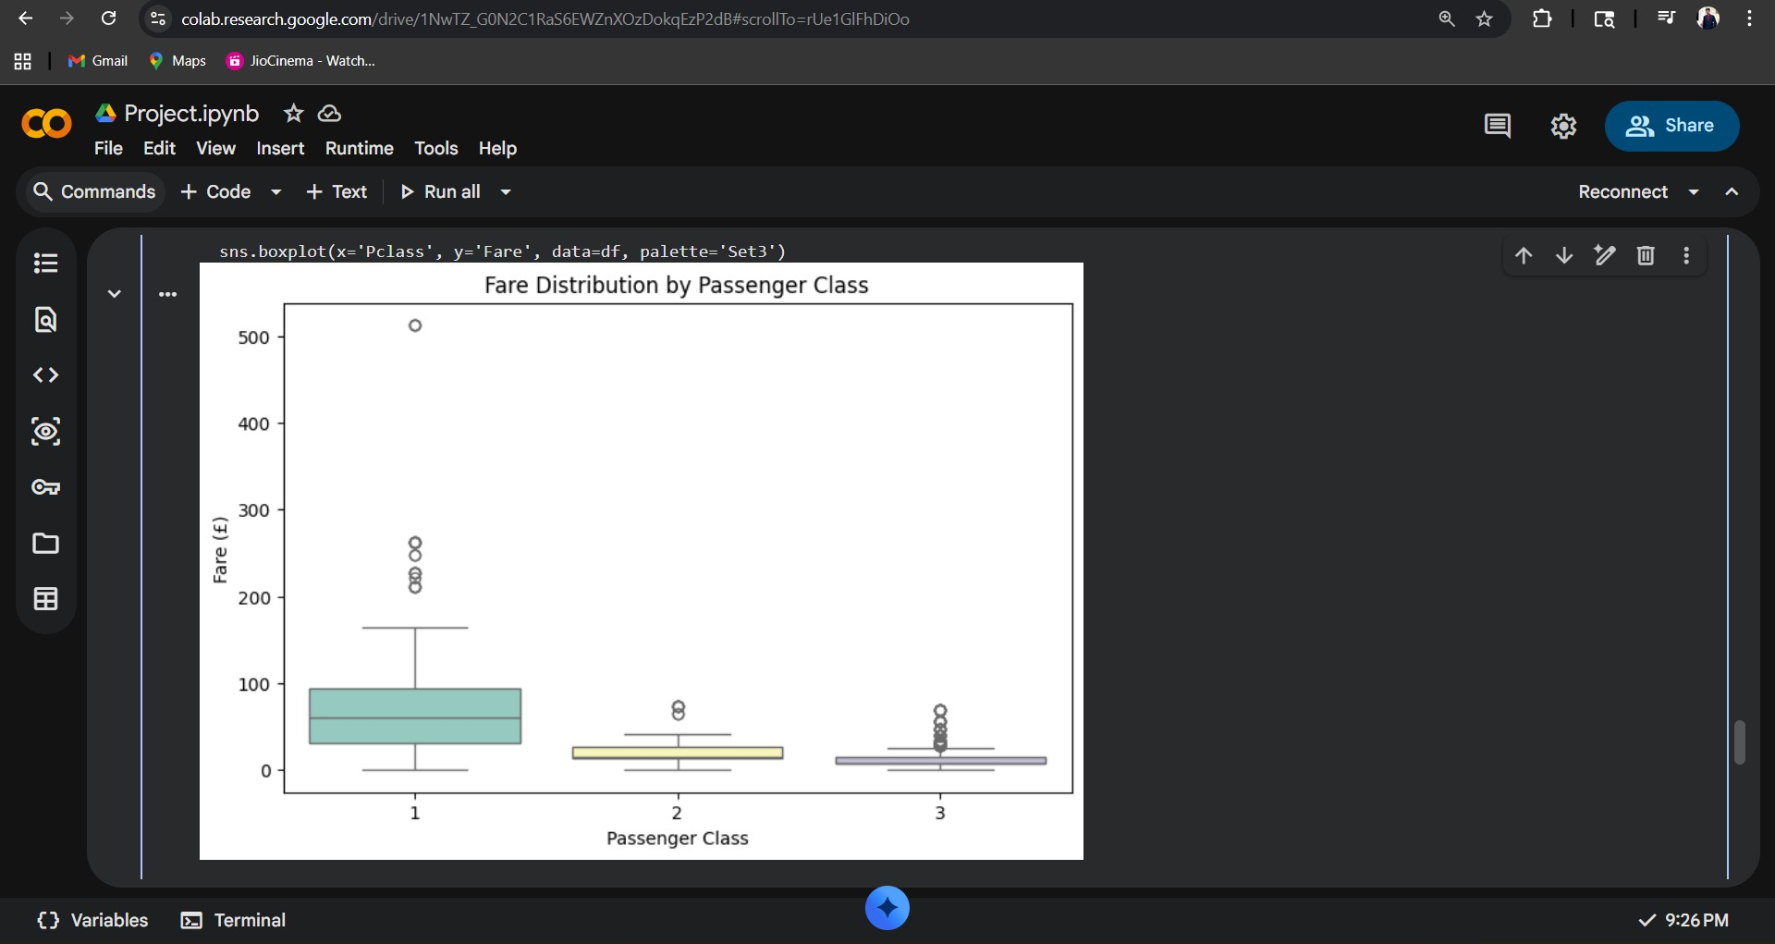

Step 9: Correlation Heatmap
A heatmap of the correlation matrix reveals relationships between numerical variables. 'Survived' shows a positive correlation with Fare (0.26) and a negative correlation with Pclass (-0.34), confirming that higher class and higher fare improved survival odds.
plt.figure(figsize=(8, 6))
corr = df[['Survived','Pclass','Age','SibSp','Parch','Fare']].corr() sns.heatmap(corr, annot=True, fmt='.2f', cmap='coolwarm', linewidths=0.5) plt.title('Correlation Heatmap')
plt.show()

Output-
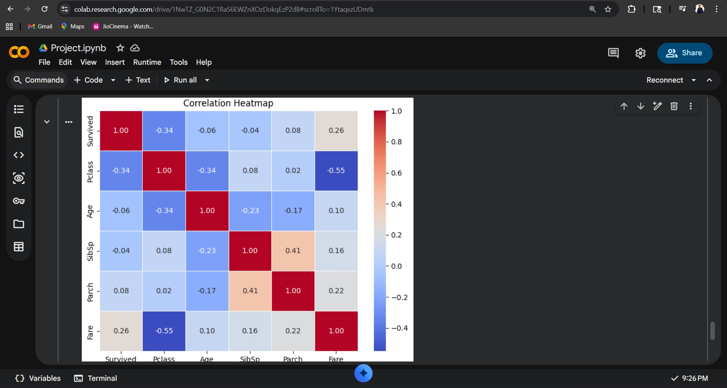
Step 10: Setting Up SPSS Modeler — Importing the Dataset

In IBM SPSS Modeler, a new stream is created. A 'Variable File' source node is added and configured to point to the train.csv file downloaded from Kaggle. The node is run to load 891 records into the stream for further analysis.

Step 11: Data Audit Node in SPSS Modeler
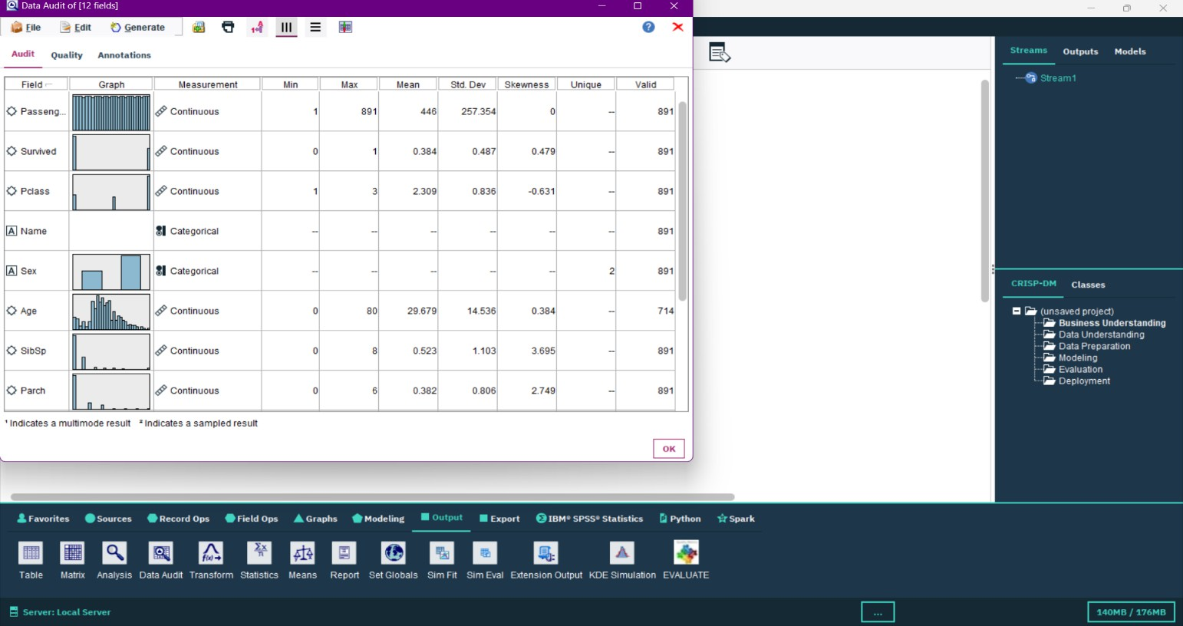
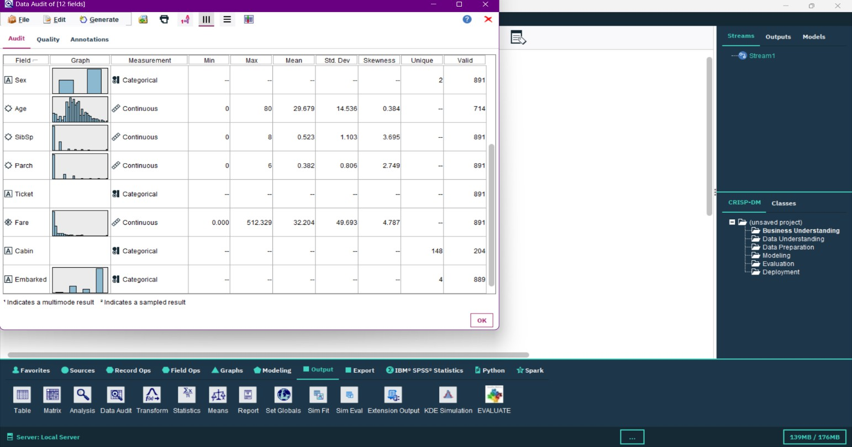
A 'Data Audit' node is connected to the source node and executed. This node provides a comprehensive summary of each column including count, percentage of missing values, minimum, maximum, mean, and standard deviation — mirroring df.describe() in Python.

Step 12: Histogram Node — Survival Count in SPSS Modeler
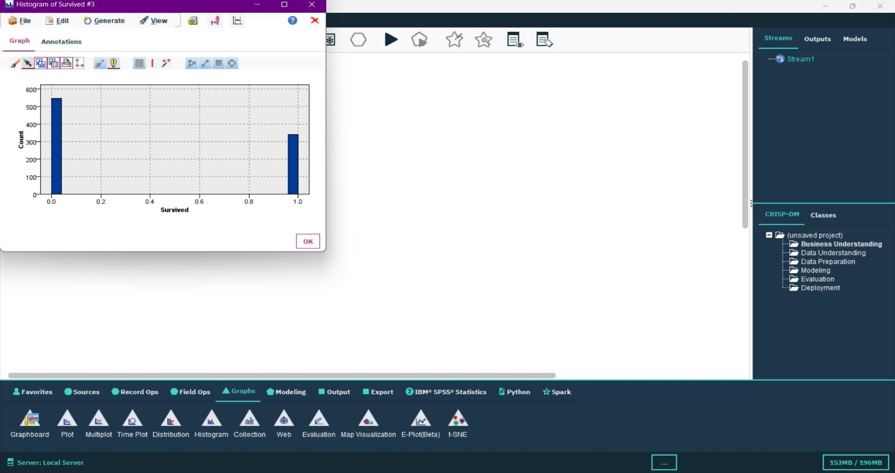
A 'Histogram' node is connected and configured with 'Survived' as the field. When executed, it produces a bar chart showing the count of survivors (1) and non-survivors (0), visually replicating the Step 4 Python chart within the SPSS environment.
Step 13: Histogram Node — Age Distribution in SPSS Modeler
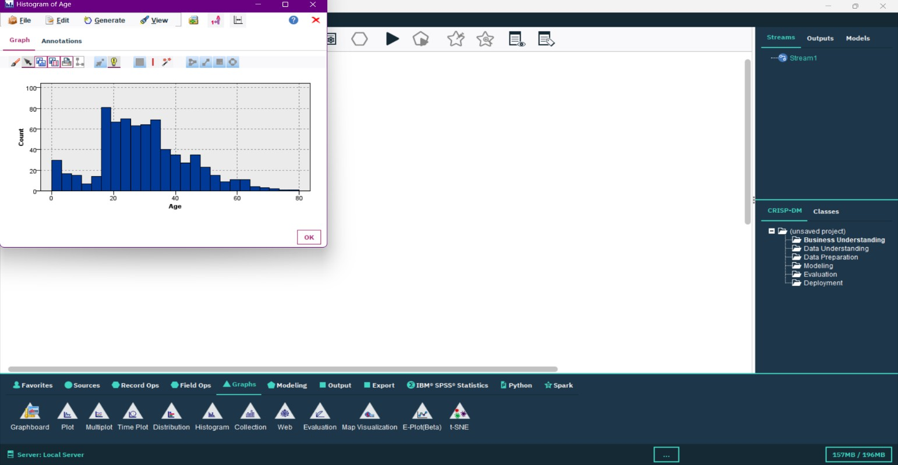
A 'Histogram' plot node is added and set to visualize the Age column distribution. The resulting histogram matches the Python-generated plot, confirming consistency between the two tools. The most frequent age group is 20–35 years.

Step 14: Web Graph Node — Survival by Gender & Class in SPSS Modeler
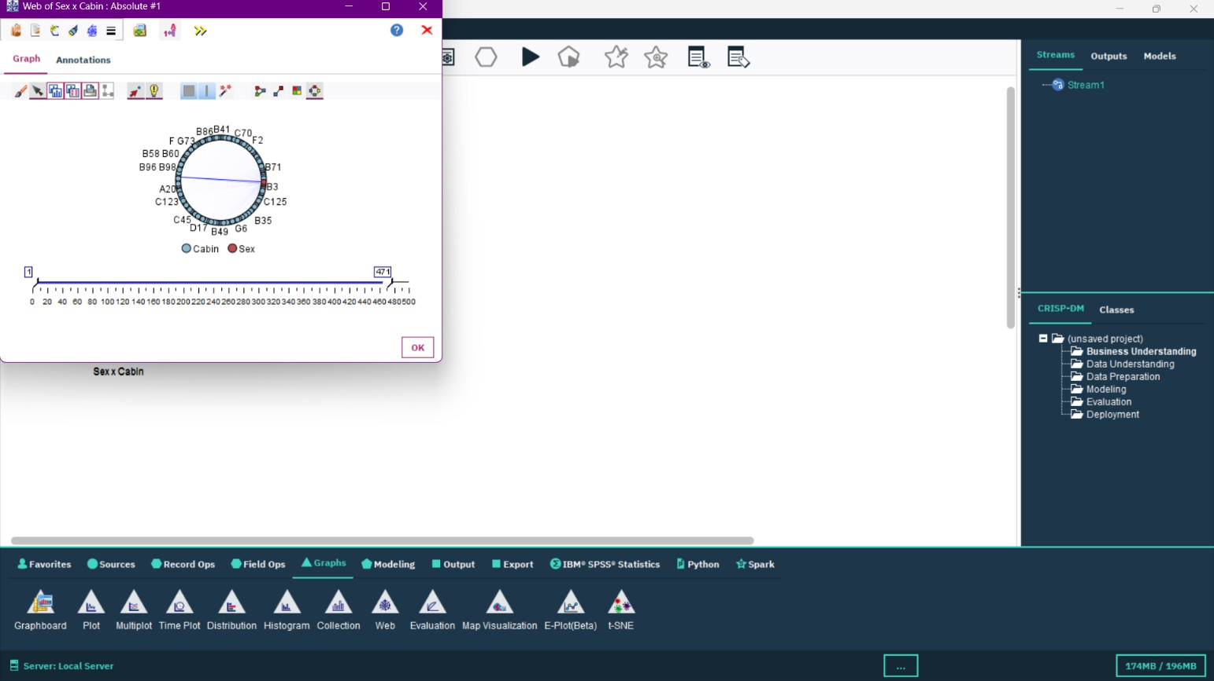
A 'Multiplot' or 'Web' graph node is configured to cross-tabulate Survived with Sex and Pclass. The output confirms the Python findings: females and first-class passengers had higher survival rates. The SPSS Modeler stream is saved as 'Titanic_EDA.str'.

Key Insights & Findings:
- Gender was the strongest survival predictor: 74% of females survived vs. only 19% of males.
- Passenger class strongly correlated with survival — 1st class passengers had the highest survival rate (63%).
- Age: Children (under 10) had a higher survival rate; elderly passengers were less likely to survive.
- Fare was positively correlated with survival (r = 0.26), as higher fares indicate higher class.
- Cabin data was too sparse (77% missing) to yield reliable insights and was removed from analysis.
- Both Python and SPSS Modeler produced consistent findings, validating the analysis across platforms.

