

PROJECT PLAN FOR
ENVIRONMENTAL ACTIVITIES MONITORING PLATFORM

TEAM MEMBERS:
QASIM ALI
MUHAMMAD ABUZAR JAVED

SUPERVISED BY:
DR. ONAIZA MAQBOOL
DEPARTMENT OF COMPUTER SCIENCE
QUAID-I-AZAM UNIVERSITY, ISLAMABAD

Project Plan Approval:
The undersigned have reviewed this project plan and agree with the approach it describes. Any changes to this plan will be discussed and approved by the persons listed below.
Name | Role | Signature
Muhammad Abuzar Javed | Team Member
Qasim Ali | Team Member

Change History:
Version | Date | Changed By | Description
1.0 | Sep 16, 2026 | Group | Initial Draft
1.0.1 | Sep 16, 2026 | Qasim Ali | Added Project Overview
1.0.2 | Sep 17, 2026 | Muhammad Abuzar Javed | Refined Project Overview
1.0.3 | Sep 17, 2026 | Muhammad Abuzar Javed | Added Gantt Chart
1.0.4 | Sep 17, 2026 | Qasim Ali | Added References, Project Plans, etc
2.0 | Sep 18, 2026 | Group | FInal Report

Remarks:

(Signature)
Dr. Onaiza Maqbool
Professor
Preface:
This document is the project plan for the Environmental Activities Monitoring Platform, prepared for the case study given in CS 322 – Software Construction. The plan follows the ISO/IEC/IEEE 16326 project management guideline and covers the overview, planning, and risk management of the project.

Table of Contents:
1. Project Overview 6
1.1 Project Summary 6
1.2 Purpose, Scope and Objectives 6
1.3 Assumptions and Constraints 7
1.4 Project Deliverables 7
1.5 Schedule Summary 7
2. References 9
3. Definitions 10
4. Project Context 11
4.1 Process Model 11
4.2 Methods, Tools and Techniques 11
4.3 Product Acceptance Plan 11
5. Project Planning 12
5.1 Project Work Plan 12
5.2 Work Activities 12
5.3 Schedule Allocation 12
5.4 Resource Allocation 13
6. Supporting Process Plans 14

1. Project Overview

1.1 Project Summary
This project is about building a platform that helps people organize environmental activities such as tree plantations and cleanups in their neighborhood. Neighborhoods can be added to the system as areas. People can join an area and as they join any area, they become part of that area's group. A group can then plan activities such as a cleanup or a tree plantation. All the members of that group get an alert as long as an activity is scheduled. After the activity is completed, members can upload photos and videos. Threre is also an ranking system where areas and groups can be ranked based on number of activities completed.

1.2 Purpose, Scope and Objectives
Purpose
To build a system that makes it easier for people to plan environmental activities, keep everyone informed, and keep a record of what has been done.
Scope
- Add and manage areas (neighborhoods).
- Allow users to join an area and become part of that area's group.
- Allow a group to create an activity (e.g. cleanup, tree plantation) and fill the required details.
- Add alerting system that sends an alert to group members when an activity is scheduled or changed.
- Allow photos and videos to be uploaded once an activity is completed.
- Show a ranking of areas and groups based on the number and type of activities completed.
- Keep a simple profile for each user, showing their name and the area/groups they have joined.
- Show a list/calendar of upcoming and past activities for each area, alongwith search and filtering options.
- Allow group members to leave a short comment on an activity, for example to ask about timing or what to bring.
Objectives
- Make it easier for a group to plan an activity and inform all its members and automate the management.
- Keep a record of all activities done by each area along with photos and videos as proof.
- Encourage more people to take part by showing area/group rankings.
- Keep the system simple enough that a non-technical person can use it without training.

1.3 Assumptions and Constraints
Assumptions
- Users have access to a phone or computer with internet.
- A user joining an area actually lives in or nearby that area.
- At least one member of a group is available to create and manage each activity.
- Users are willing to upload photos/videos after an activity.
Constraints
- The project has to be completed within the current semester.
- The team has two members, so the number of features that can be built in parallel is limited.
- Only free or open-source tools will be used, as there is no budget for the project.
- The prototype won’t support complete ready project as it requires a little but more experties to build exactly what is intended to be built.

1.4 Project Deliverables
- Project Plan
- Software Requirements Specification (SRS)
- Design Document
- Working Prototype
- User Manual
- Project Presentation

1.5 Schedule Summary
The table below follows the semester schedule shared in the first lecture.
Week | Phase | Main Activity
1–2 | Planning | Stakeholder discussion and development of the project plan
3–5 | Analysis | Defining use cases, analysis modelling, SRS development and review
6–9 | Design | Data design, interface design, detailed design and review
9–13 | Development | Database connectivity, front-end development, class development and refinement
14 | Testing | Testing of the software system
15–16 | Presentation | Project presentations

2. References
- ISO/IEC/IEEE 16326:2019 — Systems and Software Engineering — Life Cycle Processes — Project Management.
- Case study/problem statement provided by the course instructor.
- CS 322 lecture slides on project planning and scheduling.

3. Definitions
Area
A neighborhood which is added to the system, inside which groups are formed and activities take place.
Group
All the users who have joined a particular area.
Activity
An event such as a cleanup or a tree plantation, created by a group and scheduled for a specific date.
Activity Attribute
An extra field attached to an activity depending on its type, e.g. tree species for a plantation.
Alert
A notification sent to group members when an activity is scheduled or updated.
Ranking
A score given to an area or group based on the number and type of activities it has completed.

4. Project Context

4.1 Process Model
The Incremental Model will be used for this project. The system can be broken down into a few clear parts that are area/group management, activity management, alerts, and media upload with ranking. Each part can be built and shown separately instead of waiting for the whole system to be finished. This also makes the testing part easier as we can test each individual component before putting everything together.
- Increment 1: Area and group management, create an area, join an area, view group members.
- Increment 2: Activity management, create an activity, add type-specific details, view the activity list/calendar.
- Increment 3: Alerts and comments, notify group members when an activity is scheduled, allow comments on an activity.
- Increment 4: Media upload and ranking, upload photos/videos after an activity, calculate and display area/group ranking.

4.2 Methods, Tools and Techniques
Methods
- Use case diagrams to describe the required functionality.
- ER diagrams for designing the database.
Tools
- Programming language: Java
- Code editor: VSCode
- Database: MySQL
- Front end: HTML, CSS, JavaScript
- Project scheduling: ProjectLibre
- Version control: Git

4.3 Product Acceptance Plan
The finished system will be checked against the SRS to see if all requirements have been met. A few volunteers can be asked to try the prototype to see if it works as expected. The project will be considered complete once all the increments are working togethe.

5. Project Planning

5.1 Project Work Plan
- Phase 1: Requirements gathering and analysis.
- Phase 2: System design.
- Phase 3: Development of increments.
- Phase 4: Testing and presentation.

5.2 Work Activities
Activity | Responsibility | Duration
Requirements gathering & use cases | Qasim Ali | Week 1–5
System & database design | Muhammad Abuzar Javed | Week 6–9
Area/Group & Activity modules | Qasim Ali | Week 9–11
Alerts, media & ranking modules | Muhammad Abuzar Javed | Week 11–13
Testing and debugging | Muhammd Abuzar Javed | Week 14
Presentation & documentation | All | Week 15–16

5.3 Schedule Allocation
The figure given below shows the project schedule as a Gantt chart, prepared in ProjectLibre. The ProjectLibre file is submitted along with this document.

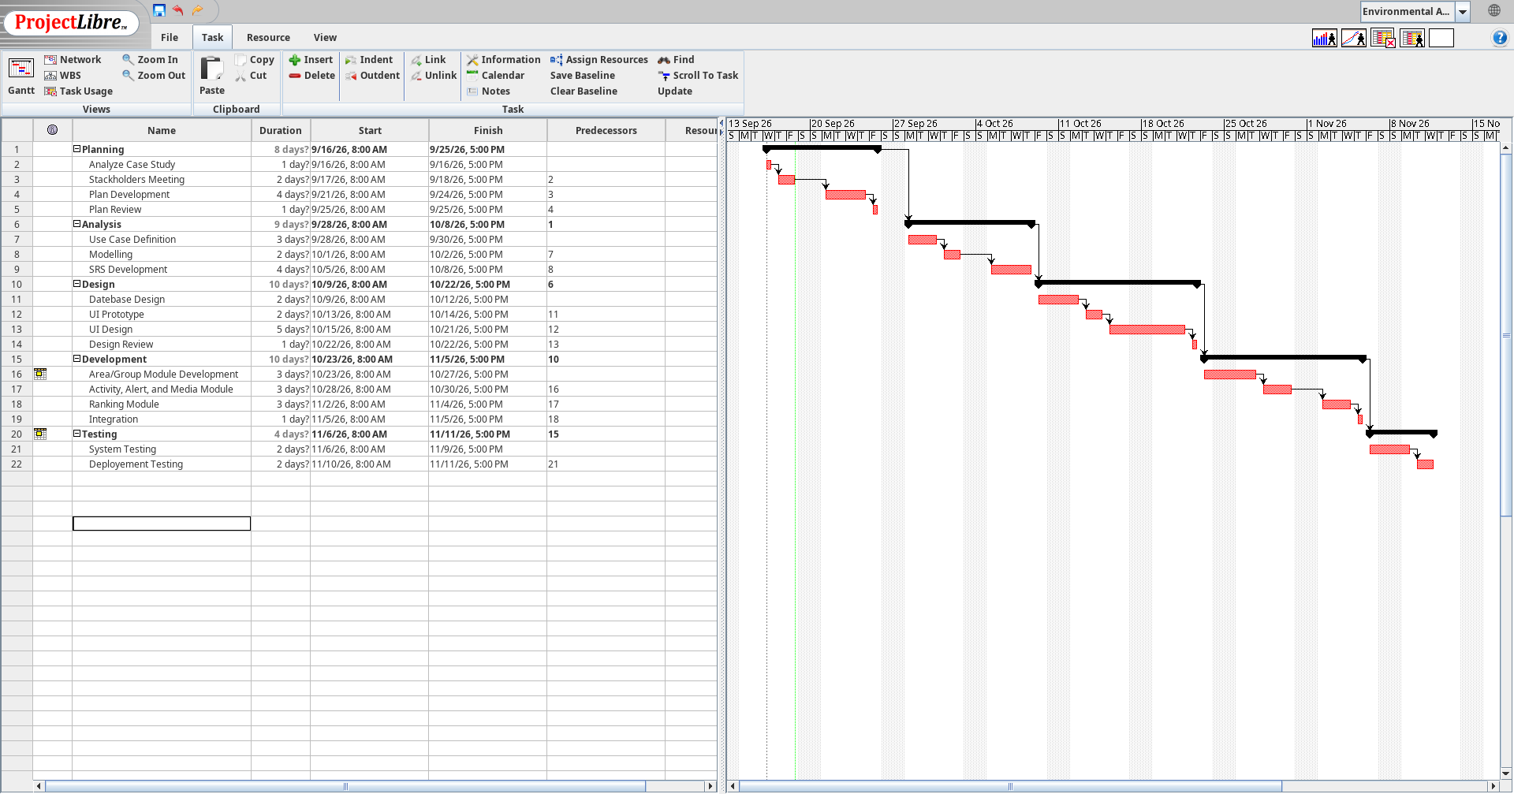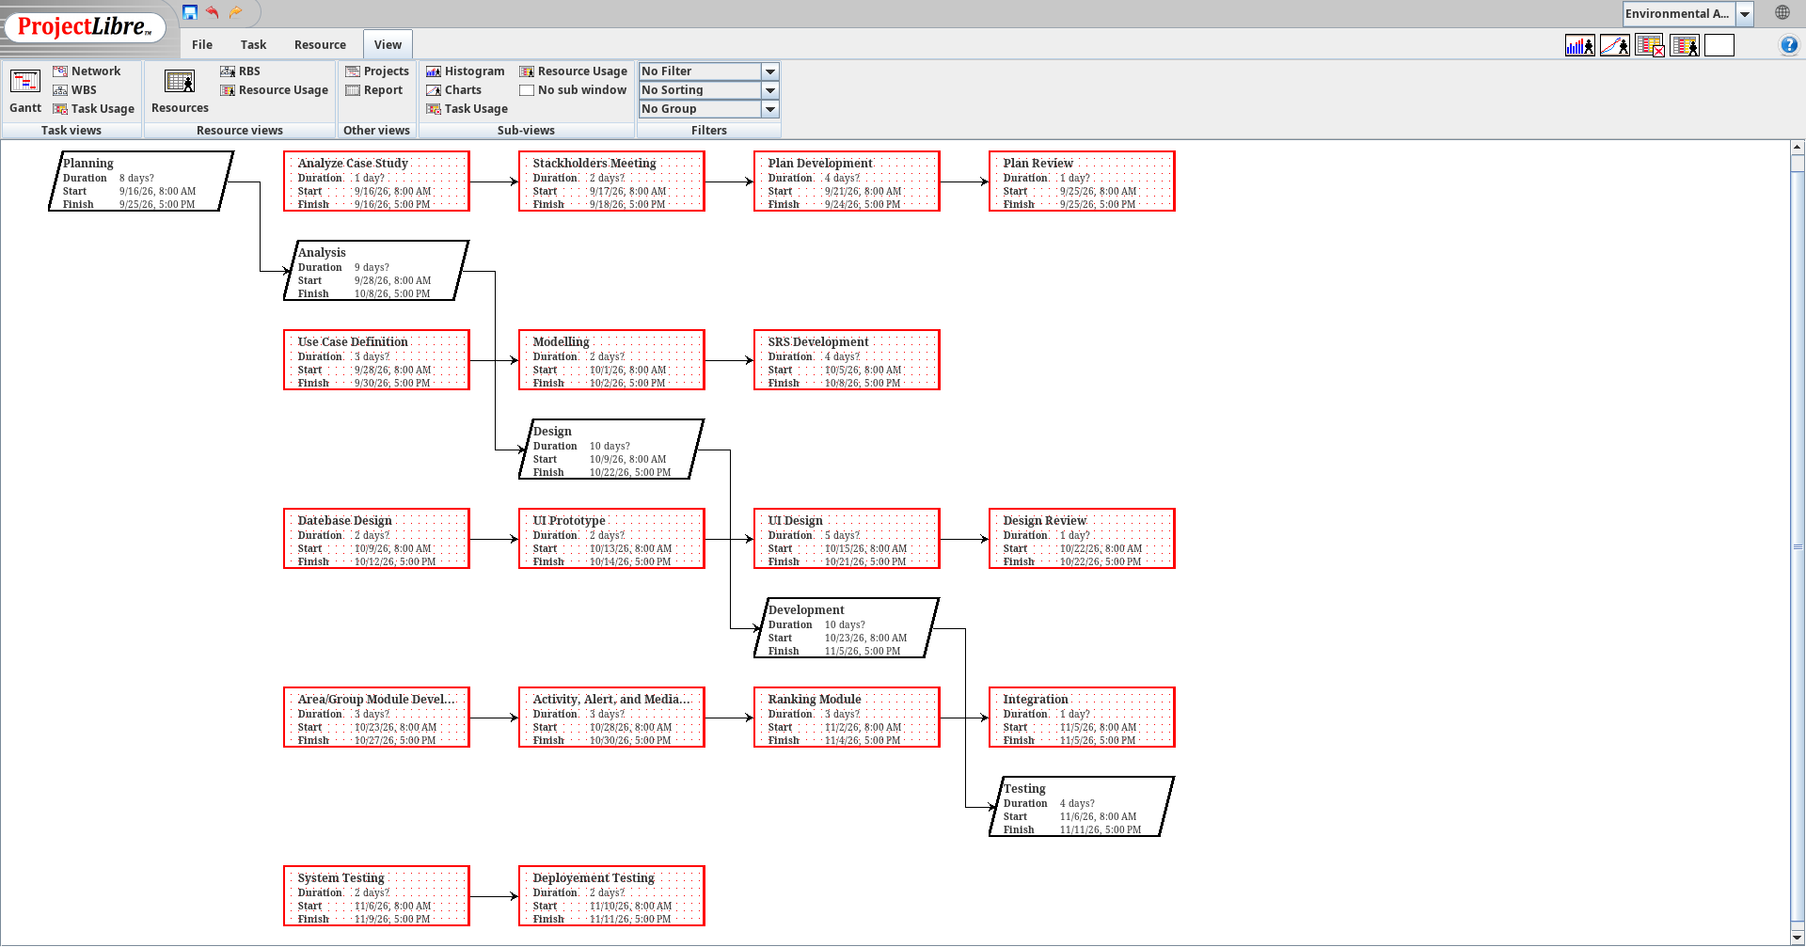

5.4 Resource Allocation

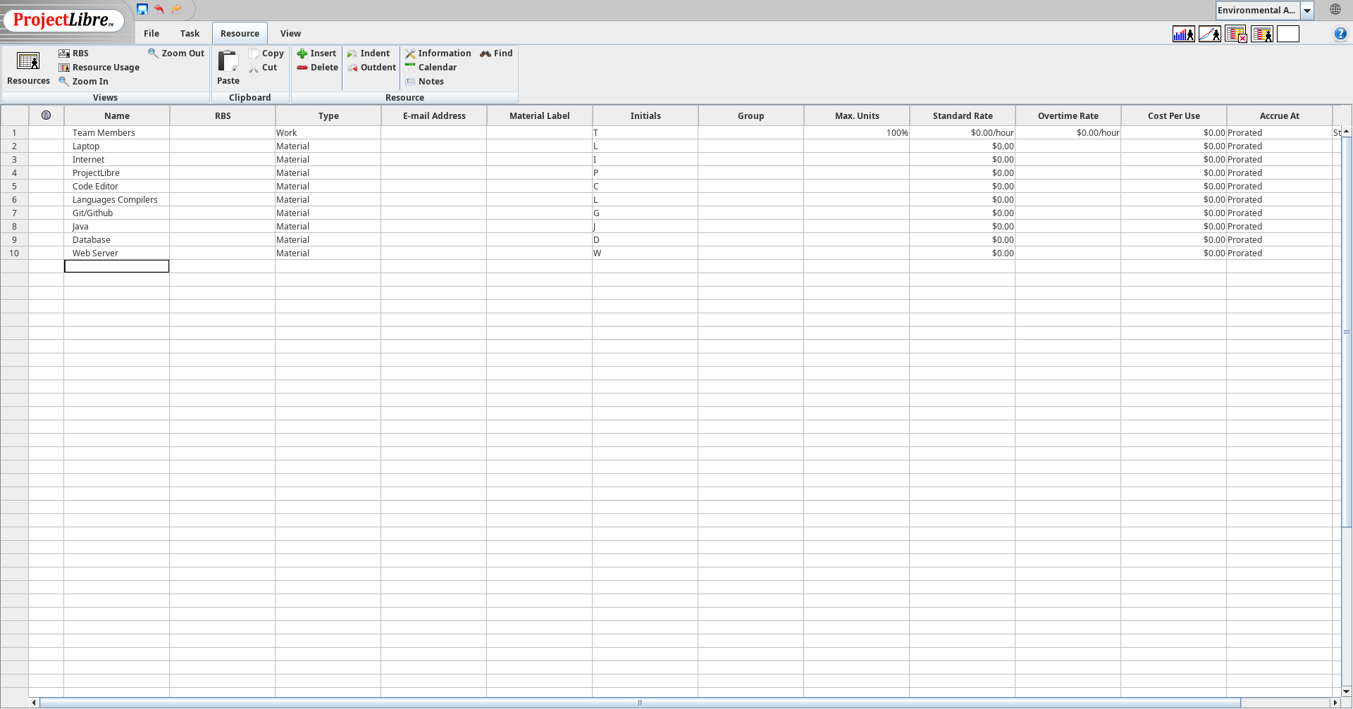

6. Supporting Process Plans
The table below lists the main risks identified for this project, along with their impact, likelihood, and how they will be handled.
Risk | Impact | Likelihood | Mitigation Strategy
Difficulty on deciding how to define an area | Medium | Medium | Keep area definition simple such as just a name and short description instead of using precise map boundaries.
Storing photos/videos | Medium | Low | Limit file size, and only allow uploads from group members or main organizer.
Too many custom fields requested for activities | High | Medium | Fix the list of supported activity types and fields after the SRS is finalized.
Delay due to overlapping coursework/exams | Medium | High | Keep some extra/free time in the schedule and divide tasks early.
A team member can become unavailable | High | Low | Share progress regularly so another member can contribute to the work if needed.

