Group Project Proposal – CSC 4370/6370
Project 1: CSS & HTML | Sevenfold – Card Gaming Hub (Track D)
Georgia State University | Submitted October 2026 | Project due October 18, 2026

1. Group Members
- Ibrahim Mackey – Project Leader and sole team member (design, HTML, CSS, QA, documentation, presentation)
Working solo, the Project Leader role covers daily standups (a short written daily check-in recorded in the development journal), the Kanban board, time tracking, and final submission.

2. Project Summary
- Selected topic track: Track D – Card Gaming Hub
- Extension pack: Strategy Table Pack (best fit for Track D): play-area zones, deck stacks, turn indicators, and card-state styling with clear hierarchy.
- Bonus feature (undergraduate, 1 of 6): #6 Model comparison cards for speed, quality, and cost – side-by-side opponent model cards in the Lobby that flip to show details.

Project Overview
Sevenfold is a static, HTML/CSS-only card gaming hub built around a simple dice-based card battler. A player chooses one of three champions, and the champion decides which cards are available: each champion owns a unique pool of 14 cards, for 42 cards in the whole game. The player builds a deck of 7 cards from their champion’s pool, then enters a battle lobby to face another player online. Every card has dice (for example 2d6 or 1d4). Each turn both players play a card and roll its dice, the higher total wins the clash, and the loser loses one life. Each player starts with 5 lives, and a player who runs out of lives loses (rare cards can win lives back). Played cards go to the graveyard, where they gain a post-mortem effect that triggers on every later turn, before the main dice are rolled.
The site is organized as a complete game hub: a Home page that introduces the game and shows how many players are online, a Game Lobby for choosing a champion and joining a match, a Deck Table for building the 7-card deck and playing a sample match on the Strategy Table, a Rules & Strategy page, and the required Team Introduction page. The intended experience is readable and tactile: cards flip and lift on hover or focus, pages move with smooth transitions, and every control stays usable on a phone.

Important scope notes: online play, the player counter, and dice
Course rules require HTML and CSS only (no JavaScript, PHP, APIs, or databases), so real networked matchmaking, a real live user count, and truly random dice rolls cannot be built. The online experience is therefore a designed, simulated interface: a lobby with a match queue, player cards, and a Strategy Table that replays a sample match. The Home page “Players online now” section is a simulated display (a fixed demo number with a pulsing live indicator and a CSS count-up animation). In the sample match, the dice results are preset, and the dice tumble animation (an animated @property number) lands on those preset values. The Rules page documents the full dice rules, and everything simulated is labelled as demo data in the interface, the README, and the presentation.

Game Design Summary
- Champions decide the cards: Phoenix, Gambler, and Tide Warden each have a unique pool of 14 cards (42 total, none shared). Choosing a champion locks the Deck Table to that champion’s pool, so each champion offers a different set of choices and a different playstyle.
- Deck: 7 cards chosen from the champion’s 14. Each card has a unique name, a suit (Ember, Gambit, or Tide, shown by colour and a shape glyph), a main dice value in dice notation that works as its rank (from 1d4 up to 1d20, or several dice such as 2d6), and a post-mortem effect.
- Turns and clashes: Each turn, both players play one card from their 7. Before your dice are rolled, every card already in your graveyard triggers its post-mortem effect, oldest first. Then both players roll the dice on their cards; the higher total wins the clash and the loser loses 1 life. A tie means nobody loses a life. The played card then moves to your graveyard.
- Lives: Each player starts with 5 lives (a number that can be tuned in playtests) and loses the game at 0. Life gain is rare: 3 of the 42 cards (one per pool) can restore 1 life, up to a maximum of 6.
- Graveyard and post-mortems: A post-mortem is a second, different effect on each card, and it often does no damage at all. Examples are adding a die to your roll, re-rolling a die, lowering the opponent’s roll, shielding a lost clash, or gaining a life. Post-mortems trigger every later turn while the card is in the graveyard, except effects marked “once,” which dim after they fire. On screen, each triggering graveyard card shakes and glows with a text label, one at a time, before your main dice are rolled.
- End of the game: If both players use all 7 cards and nobody has run out of lives, the player with more lives wins. A tie is decided by a final 1d20 roll-off.
Champion | Suit / pool | Pool identity (all 42 cards finalized during Days 1–3)
Phoenix | Ember, 14 cards | Aggressive pool. High dice, and post-mortems that add dice to your roll or lower the opponent’s roll.
Gambler | Gambit, 14 cards | Risk pool. Post-mortems that re-roll, swap, or gamble on a die, for big swings in either direction.
Tide Warden | Tide, 14 cards | Defensive pool. Post-mortems that shield lost clashes, weaken the opponent’s roll, and include the most life gain.
Sample cards (names, dice, and effects are placeholders to be balanced in playtests):
Card | Pool | Dice | Post-mortem effect (sample)
Cinder Strike | Phoenix | 2d6 | Add +1d4 to your roll.
Ashen Wing | Phoenix | 1d4 | Opponent’s roll is lowered by 2.
Rising Ash (rare) | Phoenix | 1d6 | Once: gain 1 life (maximum 6).
Loaded Dice | Gambler | 1d8 | Re-roll your lowest die.
Wager | Gambler | 2d10 | Roll 1d6; on a 5 or 6, add +1d6 to your roll.
Lucky Coin (rare) | Gambler | 1d4 | Roll 1d6; on a 6, gain 1 life.
Tidal Wall | Tide Warden | 1d6 | Once: ignore your next lost clash.
Undertow | Tide Warden | 2d4 | Opponent’s roll is lowered by 1.
Mend (rare) | Tide Warden | 1d4 | Once: gain 1 life.
The three champions are the initial roster; the page structure allows a fourth champion pool to be added later without redesigning the layout.

Statement of Scope (14 core days + 3 buffer days)
- In scope: 5 pages (Home, Lobby, Deck Table, Rules & Strategy, Team Introduction), a shared stylesheet system, a reusable card component, 3 champions with 14 cards each (42 cards maximum), the Strategy Table Pack (play-area zones, deck stacks, turn indicators, card states), the lives hearts, dice display, graveyard post-mortem effects, the simulated players-online section on the Home page, the model comparison cards (bonus), responsive layouts for three breakpoints, and the transitions, transforms, and animations in Section 4.
- Scoped to stay realistic: Card art is generated with CSS (gradients, shapes, glyphs) rather than 42 custom images. Dice results in the sample match are preset rather than random. Deck selection uses CSS-only checkbox state with a live counter (n / 7). CSS cannot hard-block an 8th selection, so the counter changes to a warning style at 8 or more and the instructions state the 7-card rule.
- Out of scope: Real multiplayer networking, a real live user count, truly random dice rolls, accounts, saved decks across sessions, JavaScript logic, and sound.

3. Proposed Wireframe

Homepage Details (intro and navigation flow)
The Home page opens with a hero section: the Sevenfold title, a one-line tagline, and a floating fan of cards animated with CSS keyframes. A single primary call-to-action button, “Enter Lobby,” leads into the game flow. Directly below the hero is the “Players online now” section, shown only on this page: a large number with a pulsing live dot, labelled as a simulated demo value. Next come four “How it works” tiles (Choose a Champion, Build 7 of 14, Roll the dice, Learn the rules) and a strip of three flip cards previewing the champions and their pools. A persistent top navigation (Home, Lobby, Deck Table, Rules, Team) appears on every page and collapses into a CSS-only menu on mobile.

Layout List: 5 Unique Pages
# | Page (file) | Content and purpose
1 | Home (index.html) | Introduces the game, shows the simulated players-online section, previews the champions, and routes to the Lobby. Purpose: first impression and navigation.
2 | Game Lobby (lobby.html) | Step 1: choose a champion (3 selectable cards). Step 2: shows the current 7-card deck slots and links to the Deck Table. Includes the lives tracker (hearts), a simulated match queue, and the bonus model comparison cards for choosing a simulated opponent. Purpose: the main game flow hub.
3 | Deck Table (deck.html) | The 14-card pool of the chosen champion (tabs switch between the 3 pools), a card detail area, 7 deck slots with a live counter, and a dice-spread summary. A second section, the Strategy Table (Extension Pack), shows the match play area with a replayable sample match. Purpose: deck building and match view.
4 | Rules & Strategy (rules.html) | Sticky side navigation, turn-flow diagram (post-mortems, dice roll, clash), lives and graveyard explanation, suit/dice legend, one strategy card per champion pool, and a glossary accordion. Purpose: readable game flow and learning.
5 | Team Introduction (team.html) | Project Leader card, title, one-sentence description, responsibilities, time-tracking table, and links to Kanban evidence. Purpose: required course page.

Page-by-Page Wireframes
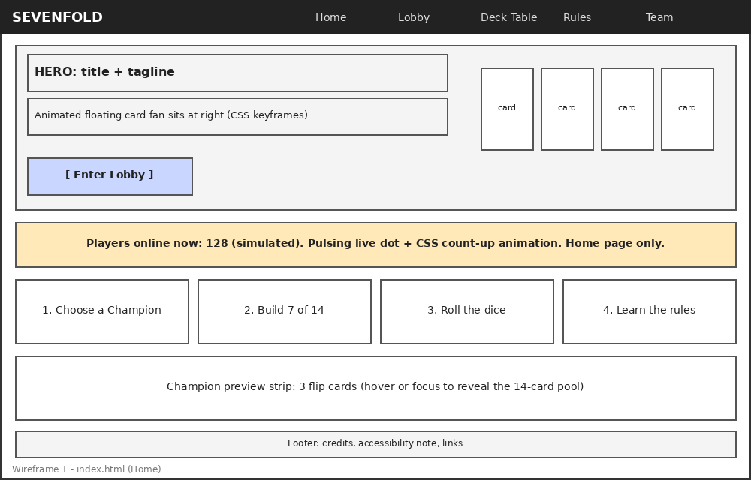
Wireframe 1 – Home (index.html)
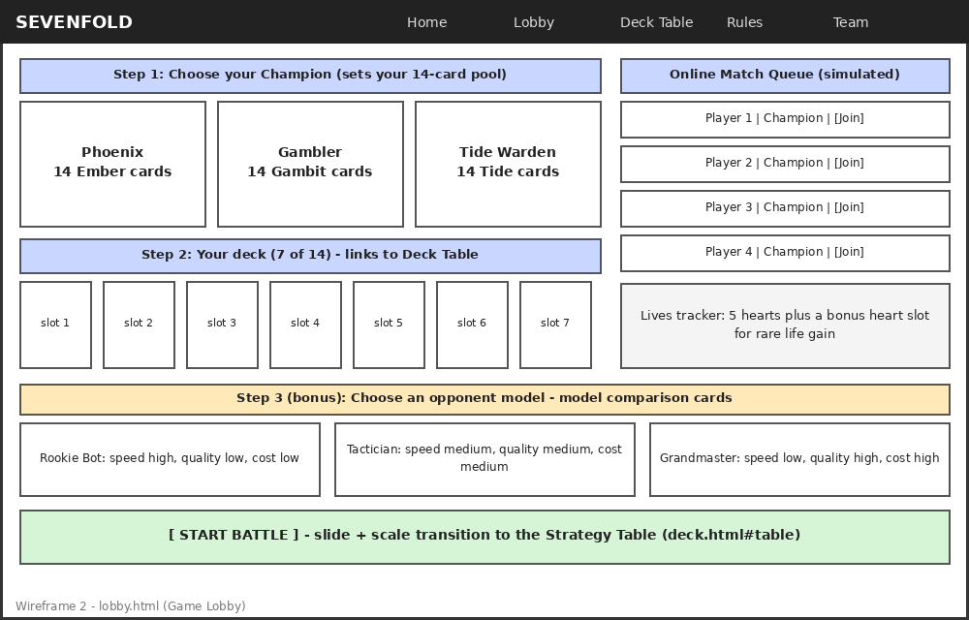
Wireframe 2 – Game Lobby (lobby.html)
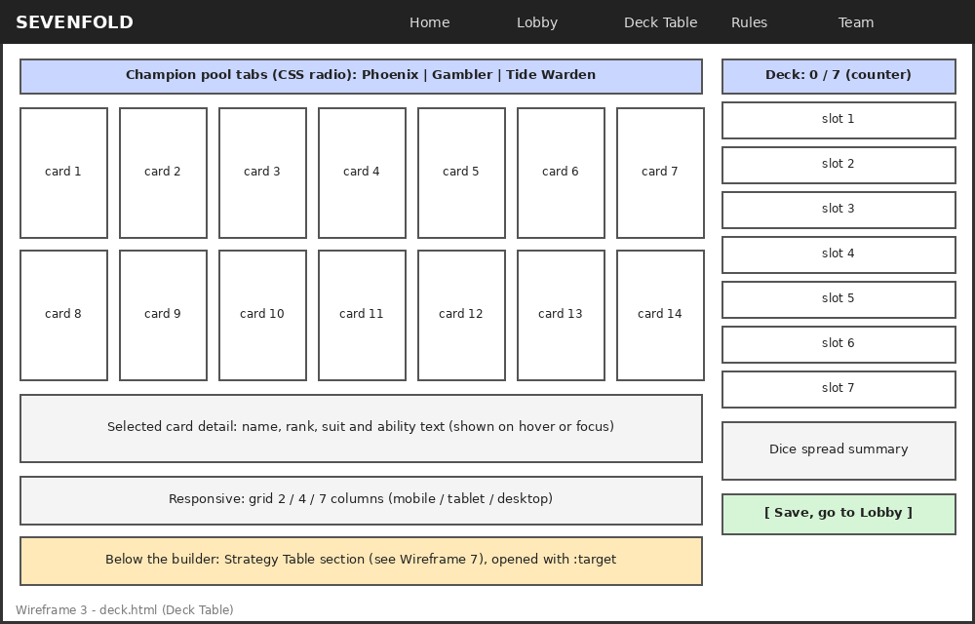
Wireframe 3 – Deck Table (deck.html)
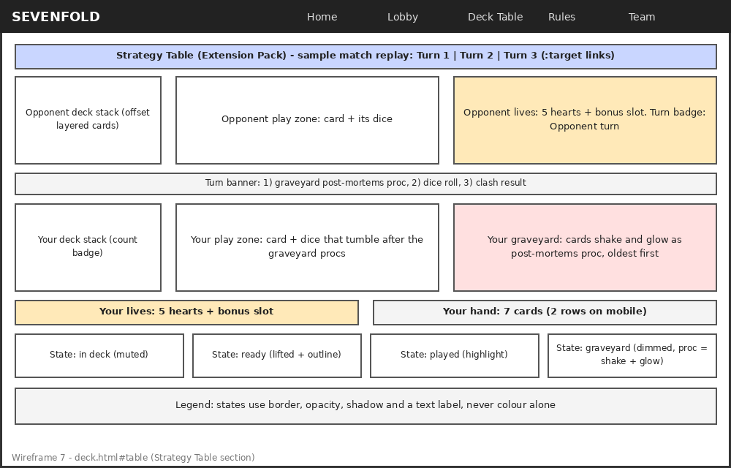
Wireframe 7 – Strategy Table section (deck.html#table)
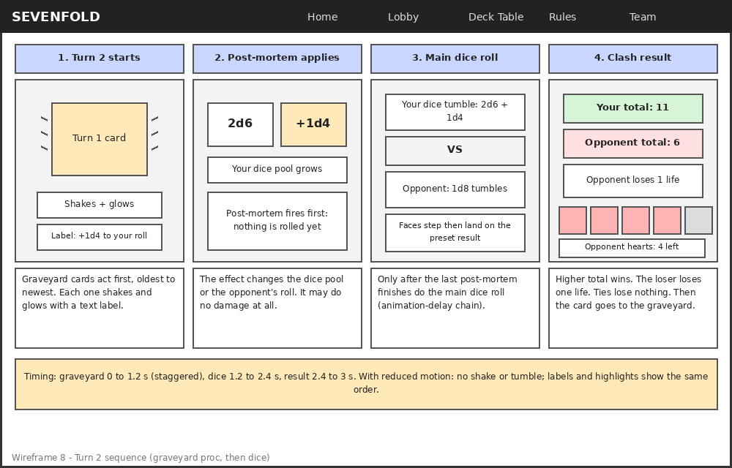
Wireframe 8 – Sample turn sequence (graveyard proc, then dice roll)
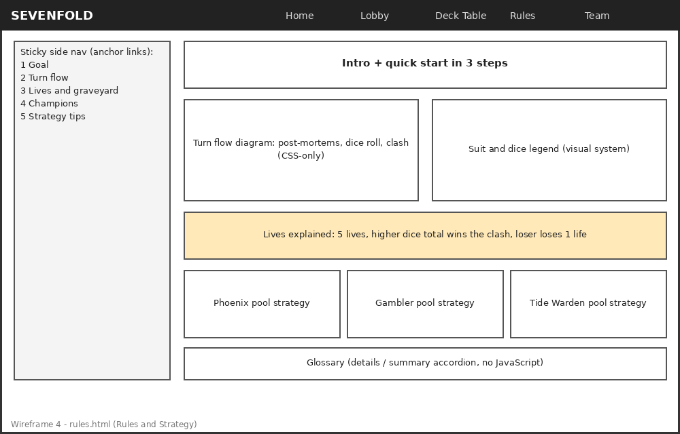
Wireframe 4 – Rules & Strategy (rules.html)
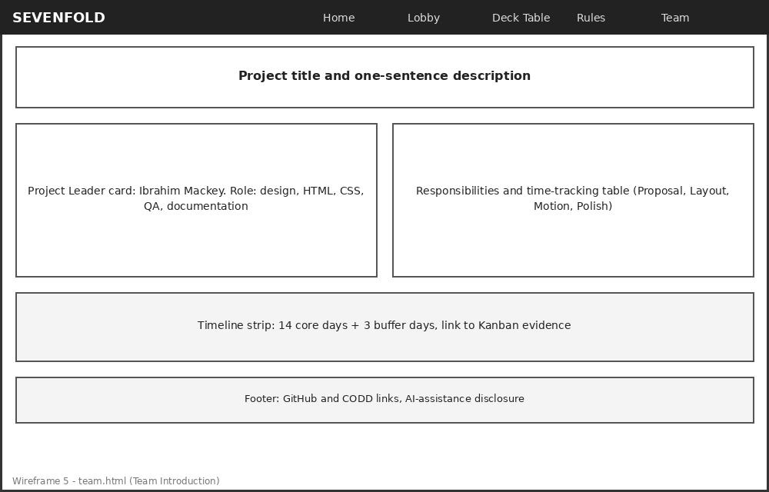
Wireframe 5 – Team Introduction (team.html)
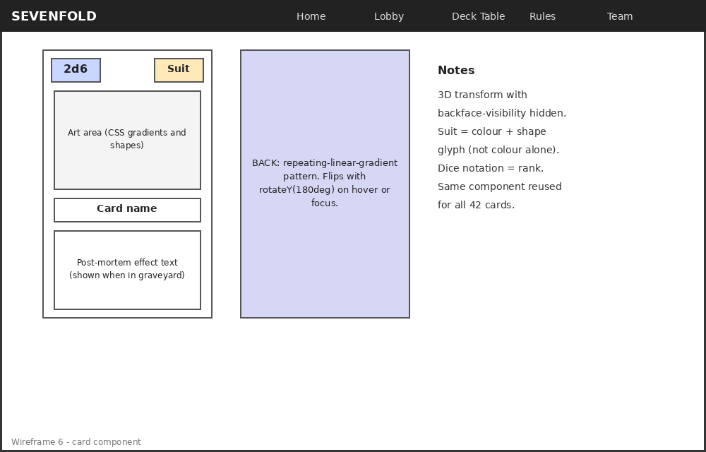
Wireframe 6 – Card component (front, back, suit, and dice notation)
Wireframes are low-fidelity outlines of desktop layouts. Tablet and mobile versions follow the breakpoint plan in Section 6. Final colours, typography, and spacing will be defined as CSS custom properties (design tokens) during Days 1–4.

4. Functionality

Screen-to-Screen Transition Use Cases
- Home → Lobby: click “Enter Lobby” to begin a match setup.
- Lobby → Deck Table: click a deck slot or “Edit Deck” to build or change the 7-card deck from the chosen champion’s pool.
- Deck Table → Lobby: click “Save, go to Lobby” after filling 7 slots.
- Lobby → Strategy Table: click “Start Battle” to jump to the Strategy Table section of the Deck Table page (deck.html#table), which is revealed with the :target selector.
- Any page → Rules: open the strategy for a specific champion pool via an anchor link (for example, from a Lobby champion card).
- Any page → Team: footer and top navigation link.

Transition Implementation Details
- Buttons and links: transition on background-color, transform, and box-shadow (0.2–0.3s ease) for hover, focus-visible, and active states.
- Navigation links: animated underline using a transition on a pseudo-element’s transform: scaleX().
- Deck slots: a selected card’s slot fades and slides in using opacity and transform transitions triggered by the :checked state.
- Champion pool tabs: switching pools uses a radio input and a fade/slide transition between the three 14-card grids.
- Strategy Table: the :target section slides and scales into view; cards move between the hand, play zone, and graveyard states with transform and opacity transitions.
- Sample match replay: Turn 1, Turn 2, and Turn 3 links use :target to show each turn’s sequence, so a viewer steps through the match without JavaScript.
- Page-to-page motion: each page’s main content uses a short CSS entrance animation on load so navigation feels continuous without JavaScript.

Transformation Implementation Details
- Card flip: transform-style: preserve-3d with rotateY(180deg) and backface-visibility: hidden on hover and keyboard focus (and on tap for touch via :focus-within).
- Card lift: translateY(-8px) rotate(-2deg) scale(1.04) on hover, with perspective set on the card grid.
- Hero card fan: cards rotated at increasing angles with transform-origin set to the bottom center.
- Champion select: the chosen champion card scales up while others scale down slightly, driven by a radio input and the :checked sibling selector.

Animation Implementation Details
- @keyframes float: gentle up/down drift on the hero fan cards, staggered with animation-delay.
- Players online (Home only): a pulsing live-dot @keyframes, plus a count-up animation using an @property-registered number so the demo value counts up on page load.
- Graveyard post-mortem proc: each triggering graveyard card shakes (@keyframes with small translate and rotate steps) and glows (@keyframes on box-shadow), staggered with animation-delay so cards trigger one at a time, oldest first, before the dice roll.
- Dice roll: dice tumble (rotate and scale keyframes) while an @property integer steps through faces and lands on the preset result; the roll starts only after the last graveyard card finishes, using an animation-delay chain.
- Turn indicator: a pulsing badge shows whose turn it is (Your turn / Opponent turn) on the Strategy Table.
- Model comparison bars (bonus): Speed, Quality, and Cost bars grow from zero to their level when a card is shown.
- Lives: a heart cracks and fades when a life is lost, and pops and glows into the bonus heart slot when a life is gained.
- @keyframes slide-in: staggered entrance for deck slots, lobby queue rows, and Rules sections.
- @keyframes glow: pulsing box-shadow on the primary call-to-action and on the active champion.
- A prefers-reduced-motion media query disables or shortens all non-essential animation.

5. User Experience

Proposed Use Cases for Each Page
Page | Use case
Home | A new visitor understands what the game is in under 10 seconds, sees that others are playing (simulated count), and finds the Lobby button.
Lobby | A player picks a champion, sees which deck is ready, sees their lives (hearts), and compares the opponent model cards (speed, quality, cost), and chooses an opponent from the match queue.
Deck Table | A player browses their champion’s 14 cards, selects 7, checks the dice spread, and previews a sample match on the Strategy Table.
Rules & Strategy | A first-time player learns the turn flow (post-mortems, then dice, then clash) in under two minutes and reads the strategy for their champion’s pool.
Team | An instructor or reviewer finds the leader, responsibilities, and project links quickly.

Accessibility Notes
- Semantic HTML5 landmarks (header, nav, main, section, article, aside, footer), one h1 per page, and logical heading order.
- Visible :focus-visible outlines on every interactive element; all card interactions work with keyboard Tab and focus, not only hover.
- Colour contrast target of WCAG AA (4.5:1 for text); suits are distinguished by shape glyph and label as well as colour.
- ARIA labels on navigation and card controls, aria-hidden for decorative CSS art, a skip-to-content link, and an aria-label on the players-online section that says the number is demo data.
- Post-mortem effects are shown as text labels (for example, “Post-mortem: +1d4 to your roll”) and not only by motion and glow.
- Reduced motion: @media (prefers-reduced-motion: reduce) removes flips, floats, glows, shakes, dice tumbles, and the count-up in favour of simple fades, static numbers, and highlighted labels.

Extension Pack Detail: Strategy Table Pack
The Strategy Table Pack is the best fit for Track D. On the Deck Table page, a Strategy Table section shows a sample match as a game board, and it is entered from the Lobby with “Start Battle.” It covers each element of the pack:
- Play-area zones: an opponent play zone, your play zone, your graveyard, and your hand row, laid out with CSS Grid.
- Deck stacks: your 7-card deck and the opponent’s deck shown as offset, layered cards with a count badge, built with transforms.
- Turn indicators: lives hearts for both players (with a bonus heart slot for rare life gain), a pulsing “Your turn / Opponent turn” badge, and a turn banner that shows the order: post-mortems, dice, clash.
- Card-state styling with clear hierarchy: four states (in deck, ready, played, graveyard) that differ by border, opacity, shadow, and a text label, plus a shake-and-glow state for graveyard cards that are triggering, so state is never shown by colour alone.

Bonus Feature Detail: Model Comparison Cards
- Concept and simulation: the AI concept is comparing models by speed, quality, and cost. In the Lobby, three simulated opponent models (Rookie Bot, Tactician, Grandmaster) appear as side-by-side cards with Speed, Quality, and Cost bars. The values are fixed demo data, labelled as simulated, and no real AI is used.
- Integration in the main flow: choosing an opponent model is Step 3 in the Lobby, between building the deck and pressing Start Battle, so it is part of the main user flow and not a separate page.
- Transitions: cards flip (rotateY) to reveal a short description and stack vertically on mobile, reusing the same card component as the game cards.
- Original design decision: the three dimensions are tied to game meaning (Speed = how fast the opponent plays, Quality = how strong its card choices are, Cost = the stake for facing it), and bar fill uses CSS custom properties so values can be edited in one place.
- Checks (3 or more): (1) layout: cards align in 3 columns on desktop and stack on mobile with no clipping, (2) accessibility: bars have text labels and values and meet AA contrast, and the flip works with keyboard focus, (3) responsive: tested at 360 px, 768 px, and 1280 px widths, and (4) reduced motion: the flip becomes a fade.
- Documentation: the README will have a short section on the feature’s purpose, implementation, and trade-offs.

6. Test Cases

Usability Test Approach with Peer Feedback
Two rounds of peer testing with classmates or friends (3–5 people each), using task-based prompts: “Find the Lobby,” “Select a champion,” “Pick 7 cards,” “Explain what happens to a card after you play it.” Observers record time to complete, wrong clicks, and comments. Round 1 happens around Day 11 (styled pages); Round 2 around Day 15 (during buffer days).

Responsive Test on Multiple Screen Sizes
Breakpoint | Width | Expected behaviour
Mobile (mobile-first base) | 360–480 px | Single column, CSS-only menu, deck grid 2 columns, deck slots below the grid.
Tablet | 768–1024 px | Two-column lobby, deck grid 4 columns, side navigation collapses.
Desktop | 1280 px and wider | Full layouts as wireframed, deck grid 7 columns, sticky side panels.
Browsers: latest Chrome, Firefox, Safari (if available), and Edge, plus Chrome DevTools device emulation and at least one real phone.

Validation Plan for Quality and Consistency
- W3C HTML validator and W3C CSS validator on every page before each milestone.
- Sequence check in each browser: graveyard animations finish before the dice start, the @property dice animation works or falls back to a static number, and reduced-motion shows the same order with labels.
- Contrast checker for colour tokens; keyboard-only walkthrough of every page.
- Bonus feature: at least 3 documented checks (layout, accessibility, responsive) for the model comparison cards, plus a Strategy Table check that all four card states are distinguishable without colour.
- Checklist of consistent components (navigation, buttons, cards, footer) across all 5 pages.
- Reduced-motion test by enabling the OS setting; broken-link and file-path check on the CODD server URL before submission.

7. Codebase and Technical Plan

Technologies and Tools
- Languages: HTML5 and CSS3 only. No JavaScript, PHP, APIs, databases, or frameworks.
- CSS features: Grid and Flexbox layouts, custom properties (design tokens), transforms (including 3D), transitions, @keyframes, @property for the count-up and dice faces, :checked, :has(), :focus-visible, :focus-within, CSS counters, media queries, and prefers-reduced-motion.
- Editor and workflow: Visual Studio Code, Git with a GitHub repository (same name as the project folder, full commit history), and the CODD server for hosting.
- Quality tools: Chrome DevTools (device emulation, accessibility tab), W3C HTML and CSS validators, and a colour-contrast checker.
- Project management: Kanban board (Trello or sticky notes) with Backlog, To Do, In Progress, Review, and Done columns, plus a development journal.

Folder Structure
Project folder name follows the course convention [LeaderName]_[ProjectTitle]:
Mackey_Sevenfold/
├── index.html (Home + players-online section)
├── lobby.html (champion select, deck slots, queue, model cards)
├── deck.html (42-card library in 3 pools, deck slots)
├── rules.html (rules and strategy)
├── team.html (team introduction)
├── css/
│ ├── base.css (reset, design tokens, typography)
│ ├── utilities.css (shared utility classes: spacing, text, visibility)
│ ├── layout.css (header, nav, grids, page shells)
│ ├── components.css (card, buttons, pips, badges, accordion, table zones)
│ ├── animations.css (@keyframes, transitions, reduced motion)
│ └── deck.css (page-specific: pool tabs, counter, strategy table)
├── assets/ (favicon, fonts if self-hosted, credits)
├── docs/ (proposal, wireframes, Kanban, journal, QA notes)
├── README.md (setup, design decisions, AI disclosure)
└── links.txt (CODD, GitHub, and YouTube URLs)

Code Architecture
- Stylesheet order: each page links base.css, utilities.css, layout.css, components.css, and animations.css (in that order, using link tags, not @import), plus a page-specific file only where needed. Order is documented so the cascade is predictable.
- Design system: colours, spacing, radii, shadows, font sizes, and durations are CSS custom properties on :root, paired with shared utility classes, so the whole theme can be changed in one place. This is the reusable design system (variables plus utility classes) the track requires.
- Naming: block-element-modifier style class names in kebab-case (for example, card, card__rank, card--ember), with no IDs used for styling.
- Reusable card component: one markup pattern and one set of classes for all 42 cards; suit classes set colour and glyph, and dice notation and post-mortem text are set per card, and suit classes set colour and glyph.
- CSS-only state: hidden radio and checkbox inputs drive champion select, pool tabs, and deck slots. The deck counter uses CSS counters, so the counter output is placed after the checkboxes in the HTML source and moved visually with Grid.
- Shared page chrome: with no JavaScript or PHP includes, the header, nav, and footer markup is repeated on each of the 5 pages. A consistency checklist covers this trade-off, which will be explained in the presentation.
- Responsive strategy: mobile-first base styles with min-width breakpoints at about 768 px and 1280 px, fluid type with clamp(), and images/art that scale with the container.
- Accessibility in code: landmarks, skip link, focus styles, aria-labels, and reduced-motion rules live in the shared files so every page inherits them.

8. Delivery and Evidence Plan
- Folder and repository: Mackey_Sevenfold on the CODD server and in a GitHub repository with the same name and a meaningful commit history.
- README: project story, setup instructions, structure, design decisions and trade-offs, screenshots or a GIF, the bonus feature section, and disclosure of any significant AI assistance.
- Evidence: this approved proposal and wireframes, Kanban board screenshots, a development journal, and responsive QA notes for mobile, tablet, and desktop.
- Process: Kanban board (Backlog, To Do, In Progress, Review, Done), a short daily check-in, and hours logged by phase (Proposal, Layout, Motion, Polish).
- Presentation: a 15–20 minute PowerPoint and recorded walkthrough (1080p) with a code walkthrough from VS Code, a live demo, the Kanban benefits slide, and answers to the required Q&A prompts, uploaded to YouTube.
- Links: one .txt file with the CODD, GitHub, and YouTube URLs, submitted through iCollege.

9. Approach to Refine Improvements

How Feedback Will Be Incorporated
Peer feedback is logged on the Kanban board as new cards, labelled by severity (blocker, usability, polish), and prioritized each day. Each change and its reason is recorded in the development journal.

Iteration Plan Across the 14-Day Development Window
Days | Phase | Deliverables
Before Day 1 | Proposal | This proposal, Kanban board set up (Backlog, To Do, In Progress, Review, Done), GitHub repository created.
1–3 | Plan + structure | Track, extension pack, and bonus choice locked; wireframes, colour system, typography; semantic page skeletons; 42-card list with dice and post-mortem effects.
4–7 | Layout + components | Grid and Flexbox layouts, shared card, button, and navigation components, Strategy Table zones, confirmed responsive breakpoints.
8–11 | Styling + motion | Visual design system, transitions and animations, players-online section, model comparison cards, Strategy Table card states, graveyard proc and dice-roll sequence. Peer test round 1.
12–14 | QA + portfolio packaging | Accessibility and content review, flow and readability refinements, README, screenshots, and QA notes.
15–17 | Buffer: QA + presentation | Bug fixes, validation, peer test round 2, PowerPoint, video recording, CODD upload, submission. No major new features.
Days 1–17 are a Kanban work sequence, not calendar dates, and the published project deadline of October 18, 2026 stays unchanged.

10. External Assets
Asset | Source and credit/license | Fallback if unavailable
Fonts | Google Fonts (SIL Open Font License); two families, credited in the footer and README. | System font stack (Georgia, Segoe UI, sans-serif).
Card art and icons | Created with CSS gradients, shapes, and Unicode glyphs; no external images required. | Not needed; art is generated by the project’s own CSS.
Reference code | Course-provided CSS_Ex_Samples and CSS Animations Notes, adapted and credited. | Own implementation from course notes.
Any significant AI assistance will be disclosed in the README, per course rules, and all submitted code will be understood and explainable during the walkthrough.

11. Alignment with Learning Objectives
- Semantic HTML structure: landmarks, clear heading hierarchy, ARIA labels, validated markup.
- CSS fundamentals: transforms (card flip/lift), transitions (all interactive states), keyframe animations, Grid and Flexbox, mobile-first responsive design.
- User experience: one clear flow (Home → Lobby → Deck → Battle) with consistent components and readable layouts.
- Critical thinking: CSS-only constraints are handled deliberately (checkbox-based deck selection, simulated online play and player count) and each trade-off is documented for the defense.
- Team professionalism: Kanban workflow, daily journal, time tracking by phase, test strategy, and a realistic 17-day timeline.

12. Signed Proposal Statement
We acknowledge the conditions in this proposal, commit to active participation, and understand that individual grades may vary based on contribution and performance.

Name + Signature: Ibrahim Mackey ____________________________
Date: ____________________

