Report on feasibility of housing developments in the Lagoon Area

Extending Flamingoville town

Prepared for:

Mr. Jacob de Wet

Town Council, Flamingoville

Prepared by:

Ms Imaculate Mosha

Environmentalist

Key Words: housing, flora, fauna, construction,

Lagoon, Flamingoville

September 2015

## Terms of reference

In August 2015 , Jacob de Wet, --- of the Town Council requested for this research to be done. The need for it came as a result of need of the Flamingoville Town Council to extend the town along the banks of its lagoon to accommodate the large influx of annual visitors to Flamingoville and the growing labour force which has been attracted to Flamingoville because of the mining in the area. The Council is forced to develop in the lagoon area as there is no other suitable land available. The plan is to build about 1500 housing units in an area bordering the nature reserve. Any housing development has to be considered carefully for its impact on the lagoon as the lagoon is the summer feeding ground for large numbers of migratory birds. There are plans for three different housing developments from which the Town Council has to choose.

Mr De Wet’s specific instructions were the following:

1. Examine the proposed development plans given to the Town Council.
2. Gather information about the existence and location of birds, flora and fauna in the area.
3. For each plan:
   1. Describe the effect of the development as a whole on the marine life of the lagoon itself and its tributary streams and beaches, and describe the countermeasures suggested.
   2. Describe the economic and visual impact (aesthetics) of the development on the town and the nature reserve, incorporating the point of view of Flamingoville town residents.
4. Draw conclusions on the basis of all your findings and recommend the plan that will do the least damage, and that will have the most positive long term impact on the area.

## Executive summary

This report concerns the development plans proposed for housing development in the lagoon area, as well as their impact on the ecosystem and community.

### Background and motivation

Mr. Jacob de Wet of the Town Council requested a report to examine proposed development plans and determine the development plan with the least impact on the lagoon. These development plans came out of the need to extend Flamingoville town to the lagoon to accommodate the large influx of annual visitors as well as growing labor force attracted by the mining in the area.

### Objectives of investigation and methodology

The report is intended to assess the proposed development plans and recommend the plan with the least impact on the environment and most benefit to the residents. Facts were gathered by means of interviews with two experts and some residents.

### Results of the study

The study highlighted the crucial parties that will be greatly affected by the development which is the flora, fauna and general aesthetics of the area. The interviewees revealed that the development would have negative impact on the area, but also proposed solutions that would counter these effects.

### Conclusions

It was concluded that it is crucial to preserve the ecosystem of the lagoon area. The aesthetics of the area is what drives visitors to the area therefore any development plan should put that into account. It was concluded plan A would be a good compromise. It was also concluded that building the houses would be a good investment for development of the town.

### Recommendations

Based on the facts that were gathered and the conclusions drawn, it was recommended that the Council proceed with Plan A of development. In addition to that, precautionary measures suggested by interviewed people be incorporated to reduce environmental damage.

Table of Contents

Terms of reference ii

Executive summary iii

Background and motivation iii

Objectives of investigation and methodology iii

Results of the study iii

Conclusions iii

Recommendations iv

List of illustrations vii

Figures vii

Glossary viii

1. Introduction 1

1.1. Subject and motivation for report 1

1.2. Background to investigation 1

1.3. Objectives of report 1

1.4. Limitations and scope of investigation 1

1.5. Plan of development 2

1.6. Method of investigation 2

2. Plans of housing development 3

2.1 The lagoon area 3

2.2 Plan A. 4

2.3 Plan B 4

2.4 Plan C 5

3. Impact of development on flora and fauna 6

4. Effect on aesthetics. 6

5. Effects on economy 7

6. Proposed solutions. 7

6.1 Build water retention dams just before streams enter the lagoon. 7

6.2 Use the historical farm house for preservation. 7

6.3 No further development should be allowed along the lagoon’s edge. 8

6.4 A road should be constructed to join the existing road into the nature reserve. 8

8. Recommendations 8

8.1 Proceed with development plan A 8

8.2 Use the farmhouse as the conservation center. 8

8.3 Build a water retention dam across the nearby stream. 8

8.4 Construct a road from Flamingoville to join the road to the nature reserve 9

8.5 Raise pedestrian pathways 9

8.6 Do not allow further development along the lagoon’s edge. 9

6.5 Buildings should blend with the vegetation. 9

6.7 Raise pedestrian pathways. 10

6.8 Limited number of access points to the beach. 10

7. Conclusions 11

7.1 Paramount importance of conserving the ecosystem and aesthetics at the lagoon. 11

7.2 Satisfactory adherence of Plan A to conservation efforts. 11

7.3 Indirect benefits of development on the local economy 11

Bibliography 12

## List of illustrations

### Figures

Figure 1: Map of the whole lagoon area 3

Figure 2: Map of Plan A 4

Figure 3: Map of Plan B 5

Figure 4: Map of Plan C 5

## Glossary

|  |  |
| --- | --- |
| Aesthetics | Visual attractiveness |
| Bird hide | Covered shelter built to view fauna and birds without detection |
| Cluster housing | Small groups of houses attached to one another (semidetached) |
| Conventional housing | Homes that are separate from one another and in straight lines (grid pattern) |
| Fauna | Wild animals |
| Flora | Flowers and Grasses that make up the fynbos |
| Fynbos | Natural vegetation (grass, bush, trees) indigenous to the Western Cape |
| Lagoon | Stretch of salt water, separated from the sea by sand dunes or land. |
| Wader | Birds that are commonly found on coastal shores, including beaches, rocky shores, mudflats, tidal wetlands and lagoons |

## 

## 1. Introduction

### Subject and motivation for report

This report concerns feasibility of three development plans on the lagoon area extending Flamingoville town with a focus of the impact each of them has on the environment.

### Background to investigation

Mr. Jacob de Wet of the Town Council has requested this report to determine the development plan with the least impact on the lagoon. These development plans came out of the need to extend Flamingoville town to accommodate the large influx of annual visitors as well as growing labor force attracted by the mining in the area.

### Objectives of report

The objectives of this report are therefore to:

* Examine the proposed development plans given to the Town Council
* Describe the ecosystem in the area including flora and fauna.
* Describe the effect of each development plan on the marine life of the lagoon, its tributary streams and beaches and describe the countermeasures suggested.
* Describe the economic and visual impact of each development plan on the town and nature reserve including the point of view of Flamingoville residents.
* Draw conclusions on the basis of the findings.
* Recommend the plan that will do the least damage and have the most positive impact on the area.

### Limitations and scope of investigation

Although other issues emerged during this study, this report covers only the feasibility of proposed development plans around Flamingoville. It does not examine the need for construction nor does it provide alternatives to construction. Although residents expressed their opinions about a number of things concerning preservation of the lagoon, this report reports only how the development plans can achieve this and not all the other measures

### Plan of development

This report begins with describing the proposed plans of development, it then examines the impact of these plans on the ecosystem, aesthetics, geological structure as well as economic development. It proceeds to assess the solutions proposed by the people consulted. Finally it draws conclusions and make recommendations on the plan with the greatest benefit.

### Method of investigation

Three development plans were collected from the Town Council. Local residents and business owners were interviewed about their feelings on the planned developments. Two experts were consulted: Prof Thabo Ntuli, an environmental scientist and Mr. Duncan Greenspan, an urban and regional town planning specialist.

## 

## 2. Plans of housing development

Three plans of development have been set forth by the Town Council. This section elaborates them in detail.

### 2.1 The lagoon area

Figure 1 below shows the map of the whole lagoon area.

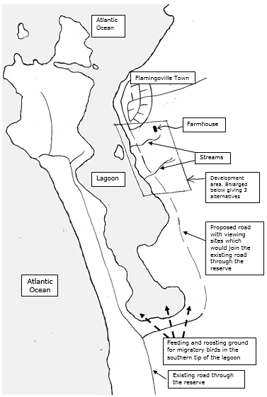

Figure 1: Map of the whole lagoon area

It can be noted that Flamingoville is at the edge of the lagoon and a huge portion of the lagoon is undisturbed.

### 2.2 Plan A.

This plan entails a conventional housing scheme of single and double storied houses running south along the lagoon edge. The plan is depicted in Figure 1 below .

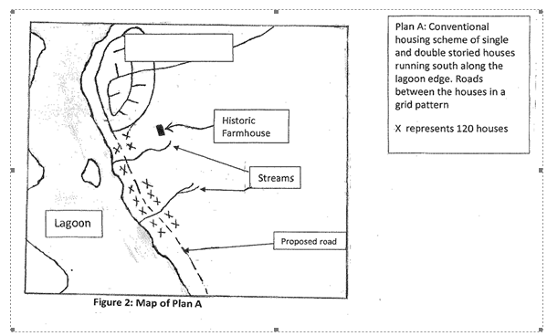

Figure 2: Map of Plan A

As observed from the figure above the houses won’t extend far south to the feeding grounds of the migratory birds. On the other hand, the scheme contains a few double storied houses. Moreover, with this plan 14 * 20 houses = 1680 single-storied houses can be constructed which means there is no need for double-stories.

### 2.3 Plan B

The plan entails a conventional housing scheme as in Plan A but houses run from West to East rather than North to South.

The plan is depicted in Figure 2 below.

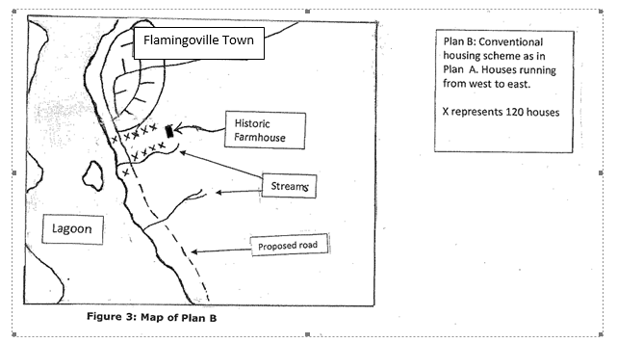

Figure 3: Map of Plan B

As can be seen above, the houses won’t occupy a huge portion of the lagoon, only one stream will be affected. On the other hand for the plan to be compact, many double storied houses will be built which will negatively impact the aesthetics. If they are single-storied a total 120* 10 = 1200 houses will be obtained. This means at least (1500-1200) houses = 300 houses have to be built.

### 2.4 Plan C

The development consists of clusters of single storied houses. Open areas between the clusters of houses preserve the growth of the natural vegetation. The plan is depicted in Figure 3 below.

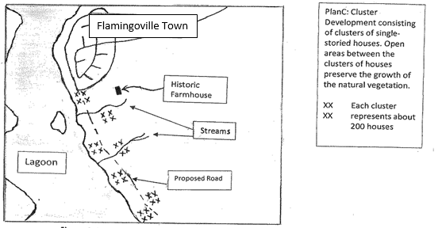

Figure 4: Map of Plan C

As it can be observed above, all the houses will be single storied separated out by natural vegetation hence will be good for aesthetics. On the other hand, the plan extends far south to the feeding grounds of the migratory birds.

## 3. Impact of development on flora and fauna

#### 3.1 Impact on flora.

There has been concerns that the construction and habitation of more people will jeopardize the growth of the vegetation, trample the dunes and disturb the ecology. Prof Ntuli. He is concerned about pedestrian pathways. Mr. Greenspan also anticipates it will have a negative impact on the lagoon as it will disturb the aquatic plants on the edge of the sand flats. Trampling these plants will reduce the effectiveness of the ecosystems between the lagoon and the shore line.

#### 3.2 Impact on fauna

One resident was concerned for the migratory birds than all the other animals. Prof Ntuli also explained that the mudflats (in the restricted section) are a major breeding ground for whelks, clams , worms and prawns all of which are food items for fish and birds. He elaborates that due to construction activities and increased population, polluted storm water will run off the lagoon if the houses are built around the streams. Polluted water could reduce the prawn population which in turn could affect the number of burrowing organisms in the lagoon. Ultimately the feeding grounds.

## 4. Effect on aesthetics.

The development if doesn’t blend with natural vegetation, it will not look pleasant.

Resident opinion “I am so worried about the vegetation or flora in the area. It might not look very spectacular.” Prof Ntuli is also worried about the visual impact.

## 5. Effects on economy

The houses are anticipated to have a positive impact on the local economy. Business people such as one supermarket the writer interviewed was excited about the extra customers that 1500 houses would bring. On the other hand a lot of money will be lost from tourism since it will not be as beautiful.

## 6. Proposed solutions.

Some of the people interviewed by the writer made suggestions that help reduce environmental impact. These include the following:

### 6.1 Build water retention dams just before streams enter the lagoon.

Mr. Duncan Greenspan suggested this to prevent polluted stream water entering the lagoon. The dams will help to filter any pollution from the water and also help to prevent erosion of the beach area at the stream exits, as the flow of water will decrease. Dams will also help maintain the ecology between the water’s edge and the lagoon. There will certainly be a reduction in the prawn population if polluted water from the development is allowed to flow into the lagoon. This in turn will disturb the feeding of the wading bird population and put pressure on the existing fish stocks in the lagoon.

### 6.2 Use the historical farm house for preservation.

Mr. Greenspan suggests that since the historical farmhouse is situated outside the boundaries of the proposed developments, it will have no impact on the site. He suggests ways to ensure it is preserved. These include making it a museum or conference center or a restaurant or be turned to a working farm. Another resident suggested that the land around the farmhouse be set aside as a small nature reserve to preserve the existing fauna in the area.

### 6.3 No further development should be allowed along the lagoon’s edge.

Mr. Greenspan suggests that the town council declare the remaining land a nature reserve to join the existing reserve. It will enhance the value of the properties, secure the future for migratory birds and attract visitors who will increase the council’s revenue. Prof Ntuli also suggests that development must not spread too far south along the lagoon’s edge for the same reason.

### 6.4 A road should be constructed to join the existing road into the nature reserve.

Mr. Greenspan suggests this to be an extra addition. If the road has viewing bird hides and the number of cars allowed on the road was controlled, the area would be preserved for posterity.

## 8. Recommendations

On the basis of the above conclusions, the following recommendations are made:

### 8.1 Proceed with development plan A

Of all the development plans, plan A is a good compromise because it minimizes effect on the lagoon. Moreover only one water retention dam will need to build across one stream that will be affected, minimizing costs. In conjunction with this the following the following additional measures should be taken to ensure conservation.

### 8.2 Use the farmhouse as the conservation center.

As suggested by experts as well as residents, the farmhouse should be enhanced by making it a conservation center. This will help retain fauna in the area as well as add value to tourists.

### 8.3 Build a water retention dam across the nearby stream.

The writer strongly agrees with Mr. Greenspan’s suggestion to prevent polluted stream water from entering the lagoon. As pointed out in section 6.1, the dam will filter out any pollution from the water and also help prevent erosion of the beach area. Only one dam is needed with plan A since only one stream will be affected by the construction

### 8.4 Construct a road from Flamingoville to join the road to the nature reserve

As suggested by Mr. Greenspan in section 6.4 with appropriate measures the road will add value to the visitors.

### 8.5 Raise pedestrian pathways

The writer agrees with Prof Ntuli’s suggestion in section 6.7, this will help conservation of the flora in the area.

### 8.6 Do not allow further development along the lagoon’s edge.

It has been suggested by the interviewees of this study (refer to section 6. 3) and it is the writer’s opinion that no future development should be made along the lagoon. This development was only allowed out of necessity but the lagoon is a beautiful place and primarily a touristic attraction.

### 6.5 Buildings should blend with the vegetation.

Several residents expressed the hope that there would not be any double-storey houses built. They thought that if the houses were single-storey, they would be less prominent on the edge of the lagoon. Prof Ntuli suggests that the development is designed to blend with the natural vegetation but not a solid block of houses. This suggestion has been implemented in plan C where all the houses are single-storey spaced out to allow growth of the vegetation.

### 6.7 Raise pedestrian pathways.

Prof Ntuli suggests this in order to allow natural vegetation to continue growing underneath them

### 6.8 Limited number of access points to the beach.

Prof Ntuli suggests that developers have limited number of access points to the beach as he fears that people will trample the dunes and jeopardize growth of the beach. Of all the plans, plan A adheres to suggestion.

## 7. Conclusions

In the light of the above findings, the following conclusions were drawn:

### 7.1 Paramount importance of conserving the ecosystem and aesthetics at the lagoon.

It has been observed that a good number Flamingoville residents care about the lagoon. They admire its beauty as well the number of tourists it attracts. Anything that will jeopardize the flora and fauna could potentially reduce the number of visitors, rendering the new houses useless hence decrease revenue for the Town Council.

### 7.2 Satisfactory adherence of Plan A to conservation efforts.

Although plan A has its cons, it is a good compromise. As mentioned in section 1.1, houses won’t extend far south to the feeding grounds of the migratory birds, the houses will be close to the farmhouse hence convenient for tourists and only one stream will be affected by pollution. It is unfavorable in that it involves double-storey buildings which is not good aesthetics but this will not be as prominent due to the small size the houses will occupy. Due to the close proximity to Flamingoville town it appears as a natural extension of the town.

### 7.3 Indirect benefits of development on the local economy

Since the houses will be rented out to the residents, the real estate will be a good asset for the Town Council. Moreover, as pointed out by one of the residents, having 1500 more residents will increase revenue for the local businesses. In addition to that, since tourists will feel more comfortable at the lagoon, the number of visitors as well as the duration of stay is expected to increase. It should be note that this can only happen if the ecosystem and aesthetics are preserved.

## 

# Bibliography

UCT PCS Department, EEE3073S 2015 Course Handout.

Prof. Jane English, Professional Communication, Juta and Company.