
People’s Democratic Republic of Algeria Ministry of Higher Education and Scientific Research University of Belhadj Bouchaib – Ain T´emouchent Faculty of Science and Technology Department of Mathematics and Computer Science

Cryptography mini-project #11
Theme:

A Secure 64-bit SPN-Based Block Cipher: Design and Analysis

Realised by : | Supervisor :
- Hassi Imad-Eddine | Dr. Kaddach

Promotion 2025/2026

Contents
2.1. Description of the Core Design Idea 2
3.1. Order of Operations in Encryption 4
3.2. Mathematical Representation 4
4.1. S-Box: Structure and Rationale 5
4.2. P-Box: Structure and Rationale 6
5.1. Order of Operations 6
5.2. Pseudocode: Single Round Transformation 7
5.3. Key Derivation Rationale 7
5.4. Pseudocode: Key Schedule 8
6.1. Implementation Screenshots 10
7.1. Test Vector Setup 13
7.2. Plaintext and Ciphertext Results 14
8.1. The Development Process 15
8.2. Challenges Encountered 15
8.3. Observations 15

Figure 1 : Symmetric SPN structure showing Encryption (left) and Decryption (right) paths 3
Figure 2 : Structure of a single encryption round 4
Figure 3 : S-Box construction using GF(2⁸) multiplicative inverse 5
Figure 4 : P-Box structure using 8×8 matrix transpose 6
Figure 5 : Key schedule generating 9 subkeys using ROL64 + constant addition 8
Figure 6 : GF(2⁸) arithmetic and S-Box generation code 10
Figure 7 : P-Box generation, layer application, and MIX_XOR implementation 11
Figure 8 : Core encryption, decryption, and key schedule functions 11
Figure 9 : Test results showing all 20/20 test vectors passed 12
Figure 10 : Test vector setup with master key initialization 13

Table 1 : Algorithm Evaluation Summary (Project #11) 9

  - Introduction
Project #11 involves the design and implementation of a 64-bit Substitution-Permutation Network (SPN) cipher written in Python. The main goal is to build a working symmetric encryption system that keeps data confidential by applying multiple rounds of bit-level transformations.
The cipher follows a modular bottom-up design philosophy. It operates on 64-bit data blocks using a 64-bit master key. All cryptographic components, including the S-Box and P-Box, are generated through direct mathematical computation rather than being hardcoded as static tables. This approach ensures the implementation is transparent and mathematically well-grounded.
The project specifications require a block size of 64 bits, a key size of 64 bits, an SPN structure with 8 rounds, a student-defined S-Box and P-Box, a MIX_XOR function as the mixing layer, and the ADD_KEY operation for subkey insertion. This report documents the design decisions, algorithm structure, implementation details, and test results.

  - Algorithm Concept
    - Description of the Core Design Idea
The cipher is built around an 8-round SPN architecture. Each round is designed to balance confusion and diffusion. Confusion makes the relationship between the key and the ciphertext as complex as possible, while diffusion spreads the influence of individual plaintext bits across the entire 64-bit block.
The design is structured around four core components:

- Key Scheduling (ADD-ROT): Rather than using the master key directly in every round, the key is transformed before each round using a 64-bit left rotation by 9 positions combined with a modular addition of a round constant derived from the golden ratio (0x9E3779B97F4A7C15 + i). This ensures each of the 9 subkeys is different and avoids any linear relationship between consecutive round keys.
- Mathematical Substitution (S-Box): The 8-bit S-Box provides the non-linear confusion layer. It is constructed by computing the multiplicative inverse of each element in GF(2⁸) using the irreducible polynomial x⁸ + x⁴ + x³ + x + 1 (0x11B). Each of the 8 bytes in the 64-bit state goes through this substitution independently. This provides strong nonlinearity and makes the cipher resistant to linear and differential cryptanalysis.
- Linear Bit Permutation (P-Box): The 64-bit P-Box achieves diffusion by reordering bits using a matrix transpose method. Bit at position row×8 + col is sent to position col×8 + row, effectively transposing an 8×8 matrix of bits. This guarantees that bits from a single byte are spread to eight different byte positions in the next round, which maximizes the inter-byte avalanche effect.
- Mixing Layer (MIX_XOR): The MIX_XOR function provides additional diffusion within each round. It splits the 64-bit state into two 32-bit halves (L and R), then applies cross-mixing operations using 32-bit rotations. Specifically: L ⊕= R, then R ⊕= ROL32(L, 11), then L ⊕= ROL32(R, 23). This is applied in all 8 rounds, and the final key addition follows after the 8th round.

Together, these four components form a cipher that achieves a high degree of complexity with efficient computation. The structure is also symmetric, meaning decryption is simply the inverse of encryption applied in reverse order.
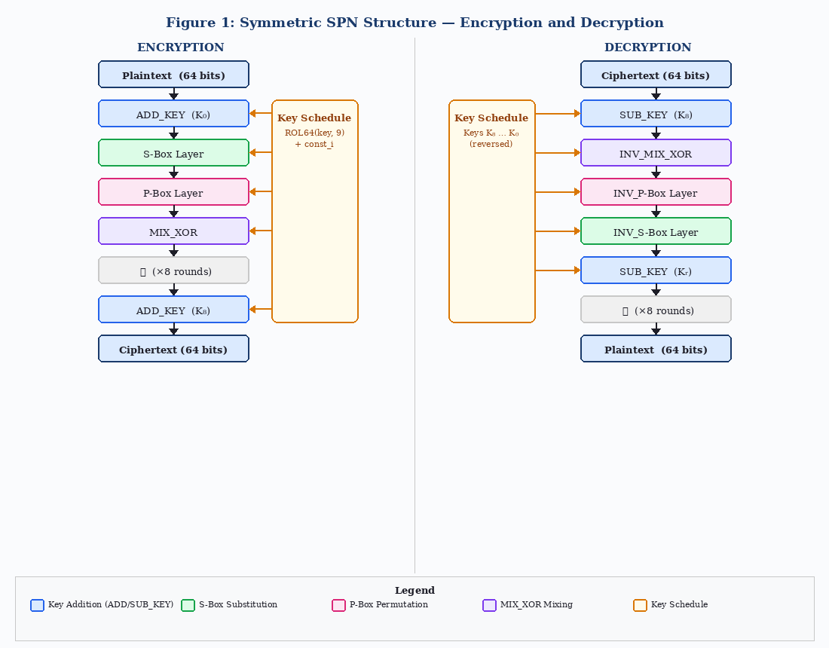
Figure 1 : Symmetric SPN structure showing Encryption (left) and Decryption (right) paths

As shown in Figure 1, the cipher uses a fully symmetric SPN structure. The encryption path follows 8 identical rounds, each consisting of ADD_KEY, S-Box, P-Box, and MIX_XOR, followed by a final key addition. The decryption path reverses the order and uses the inverse of each operation.

  - Round Structure
The cipher consists of 8 iterative rounds followed by one final subkey addition. Each round transforms the 64-bit state through a defined sequence of operations. Maintaining a consistent order is critical for achieving the avalanche effect and for ensuring that decryption is a valid mathematical inverse of encryption.
    - Order of Operations in Encryption
For each round r ∈ {0, …, 7}, the state S is updated through the following sequence:

- AddKey (Modular Addition): The current 64-bit state is combined with the round subkey Kᵣ using modular addition: S ← (S + Kᵣ) mod 2⁴⁶. Using addition instead of XOR provides extra algebraic complexity since addition and XOR belong to different algebraic structures.
- Substitution Layer (S-Box): The 64-bit state is split into eight independent bytes. Each byte passes through the 8-bit S-Box, which replaces it with the multiplicative inverse in GF(2⁸). This introduces the non-linear confusion needed to resist algebraic attacks.
- Permutation Layer (P-Box): All 64 bits are rearranged according to the P-Box permutation. Bit at index i moves to index P[i], where P is defined by the 8×8 matrix transpose: P[row×8 + col] = col×8 + row. This distributes each byte’s bits across 8 different bytes in the next round.
- Mixing Layer (MIX_XOR): The 64-bit state is split into a 32-bit left half L and a 32-bit right half R. A sequence of XOR and rotation operations mix the two halves: L ⊕= R, R ⊕= ROL32(L, 11), L ⊕= ROL32(R, 23). This is applied in every round including the last one, followed by a final key addition.

    - Mathematical Representation
The transformation of a single round can be expressed as:
Sᵣ₊₁ = MIX_XOR(P-Box(S-Box(ADD_KEY(Sᵣ, Kᵣ))))
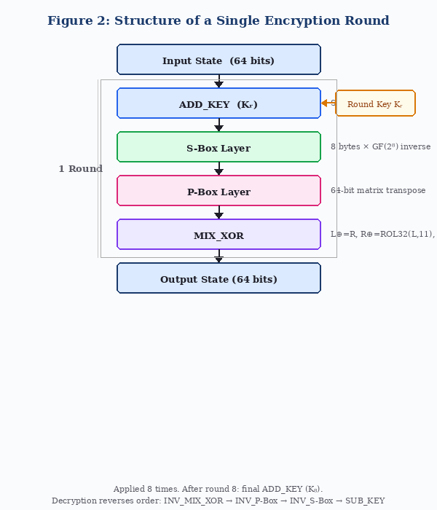
After all 8 rounds, a final key addition is performed:
Figure 2 : Structure of a single encryption round
C = ADD_KEY(S₈, K₈)
Decryption reverses the entire process. Starting from the ciphertext, SUB_KEY(C, K₈) is applied first, then for each round in reverse order: INV_MIX_XOR, INV_P-Box, INV_S-Box, and finally SUB_KEY(S, Kᵣ).

  - S-BOX & P-BOX Design
The security of an SPN cipher depends on the quality of its confusion and diffusion components. Confusion is provided by the S-Box, and diffusion by the P-Box. Both are generated mathematically rather than chosen arbitrarily, which ensures their cryptographic properties are well-defined and verifiable.
    - S-Box: Structure and Rationale
The Substitution Box provides the non-linear component of the cipher. It is an 8-bit to 8-bit mapping containing 256 entries. For each input byte x, the output is the multiplicative inverse of x in the Galois Field GF(2⁸).

- Structure: The S-Box is computed using GF(2⁸) arithmetic with the irreducible polynomial P(x) = x⁸ + x⁴ + x³ + x + 1 (0x11B). For each non-zero element i ∈ {1, …, 255}, the code finds j such that multiply_gf2_8(i, j) = 1. That j is stored as S[i]. For i = 0, the output is defined as 0 (the zero element has no inverse).
- Rationale: Using GF(2⁸) inversion to build the S-Box guarantees a high algebraic degree and a low differential probability. There are no simple linear relationships between input and output bits, which means the S-Box is resistant to both differential and linear cryptanalysis. This is the same fundamental approach used by the AES S-Box, though without the additional affine transformation step.
- Inverse S-Box: The inverse S-Box is derived directly from the forward S-Box by reversing the mapping: if S[i] = val, then INV_S[val] = i. This makes decryption efficient and avoids any separate recomputation.
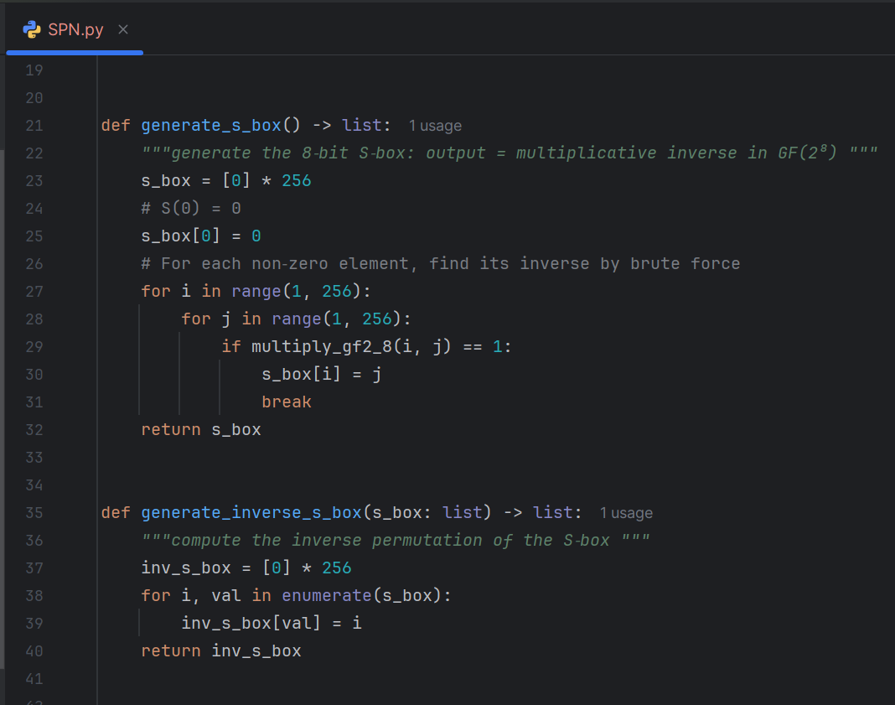
Figure 3 : S-Box construction using GF(2⁸) multiplicative inverse
    - P-Box: Structure and Rationale
The Permutation Box provides the linear diffusion layer. It operates at the bit level, redistributing all 64 bits of the state according to a fixed permutation table.

- Structure: The P-Box is generated using a matrix transpose method. The 64 bit positions are treated as an 8×8 matrix indexed by (row, col). Bit at position row×8 + col is moved to position col×8 + row. In code: for col in range(8): for row in range(8): p_box.append(row*8 + col). This creates a 64-entry permutation table.
- Rationale: The transpose structure guarantees that the 8 bits of any single byte are spread to 8 different byte positions after permutation. This means that after one round, the S-Box outputs from a single byte will feed into 8 distinct S-Box inputs in the next round. This maximizes bit-level diffusion and helps achieve the full avalanche effect within just a few rounds.
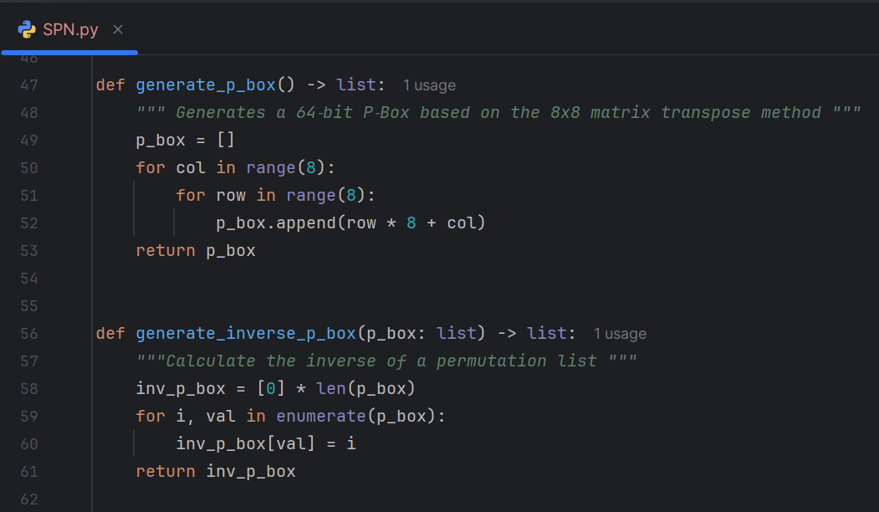
- Inverse P-Box: The inverse is computed by reversing the permutation: if P[i] = val, then INV_P[val] = i. This is used during decryption to undo the permutation layer.
Figure 4 : P-Box structure using 8×8 matrix transpose

  - Function and Transformation Logic
This section provides a detailed look at how each layer of the round function is implemented, along with the pseudocode for the full round transformation and the key schedule.
    - Order of Operations
As described in the architectural overview, each of the 8 rounds follows this exact sequence:

- Key Mixing (ADD_KEY): S ← (S + Kᵣ) mod 2⁴⁶ — Modular addition with the 64-bit round subkey.
- Substitution (S-Box): S ← S-Box(S) — Apply the 8-bit GF(2⁸) inverse S-Box to each of the 8 bytes independently.
- Permutation (P-Box): S ← P-Box(S) — Rearrange all 64 bits using the matrix transpose permutation.
- Mixing (MIX_XOR): S ← MIX_XOR(S) — Split into L and R halves, cross-mix using XOR and 32-bit rotations.

After all 8 rounds, a ninth and final ADD_KEY step is applied to produce the ciphertext. This “whitening” key addition prevents an attacker from trivially stripping the last round.
def encrypt_block(pt: int, keys: list) -> int:
"""8-round SPN encryption """
s = pt
for r in range(8):
s = add_key(s, keys[r])
s = sbox_layer(s)
s = pbox_layer(s)
s = mix_xor(s)
s = add_key(s, keys[8]) # final key addition
return s
    - Pseudocode: Single Round Transformation

Decryption applies the inverse sequence. Starting with the ciphertext, SUB_KEY is applied with Keys[8], then for rounds 7 down to 0: INV_MIX_XOR, INV_PBOX_LAYER, INV_SBOX_LAYER, SUB_KEY with Keys[round].
    - Key Derivation Rationale
The key schedule generates 9 subkeys (8 round keys + 1 final whitening key) from the 64-bit master key. The design goal is for each subkey to appear statistically independent from the others, even though they are all derived from the same master key.
Starting from the master key, each subkey is derived by taking the current key, rotating it left by 9 bits (ROL64 by 9), and then adding the round constant 0x9E3779B97F4A7C15 + i, where i is the round index. This constant is based on the golden ratio, which is commonly used in key schedules to break symmetric patterns.
The rotation by 9 was chosen because 9 and 64 are coprime, meaning the key bits do not cycle back to their original positions within the 8-round schedule. This ensures maximum bit-level variance across all 9 subkeys.

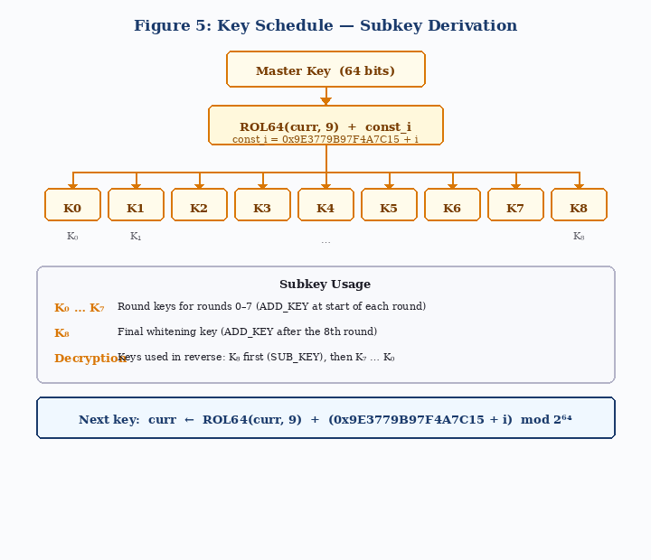
    - Pseudocode: Key Schedule
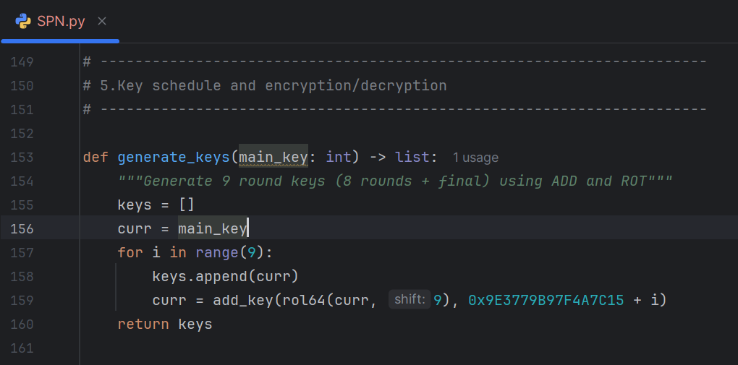
Figure 5 : Key schedule generating 9 subkeys using ROL64 + constant addition

  - Algorithm Evaluation
The implementation of Project #11 was evaluated against the requirements stated in the project guidelines. The following table summarizes how each required component was addressed in the implementation.

Table 1 : Algorithm Evaluation Summary (Project #11)
Criterion | Description
Implementation | The cipher is implemented in Python 3 and successfully performs both encryption and decryption on 64-bit blocks using the designed key schedule, S-Box, P-Box, and mix function.
Code Structure | Functions are clearly separated by concern: GF(2⁸) arithmetic, S-Box/P-Box generation, layer operations, key scheduling, and encryption/decryption logic.
S-Box Design | The 8-bit S-Box is generated by computing multiplicative inverses in GF(2⁸) using the irreducible polynomial 0x11B. It is a proper bijection with high nonlinearity.
P-Box Design | The 64-bit P-Box is built using a matrix transpose scheme, sending bit i at position row*8+col to col*8+row, ensuring inter-byte diffusion every round.
Mix Function (MIX_XOR) | The custom MIX_XOR splits the 64-bit state into two 32-bit halves, applies rotations (ROL32 by 11 and 23) and XOR cross-mixing, increasing the avalanche effect.
Key Schedule | Nine subkeys are derived by repeatedly rotating the master key left by 9 bits and adding a round constant based on the golden ratio, ensuring round key independence.
Testing & Verification | 20 test vectors covering edge cases (all zeros, all ones, alternating patterns, known constants) were verified, with all 20 decrypt-to-original tests passing successfully.

    - Implementation Screenshots
The screenshots below confirm the code structure and the successful execution of the encryption and decryption logic.

Figure 6 : GF(2⁸) arithmetic and S-Box generation code
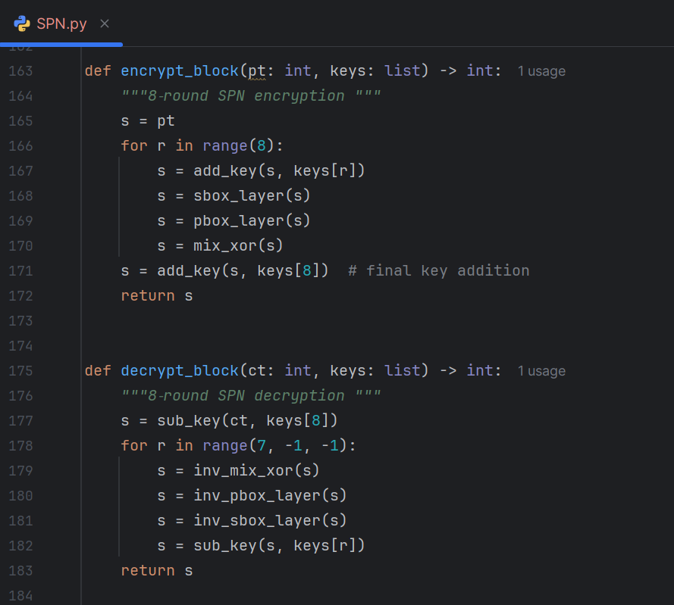

Figure 7 : P-Box generation, layer application, and MIX_XOR implementation
Figure 8 : Core encryption, decryption, and key schedule functions
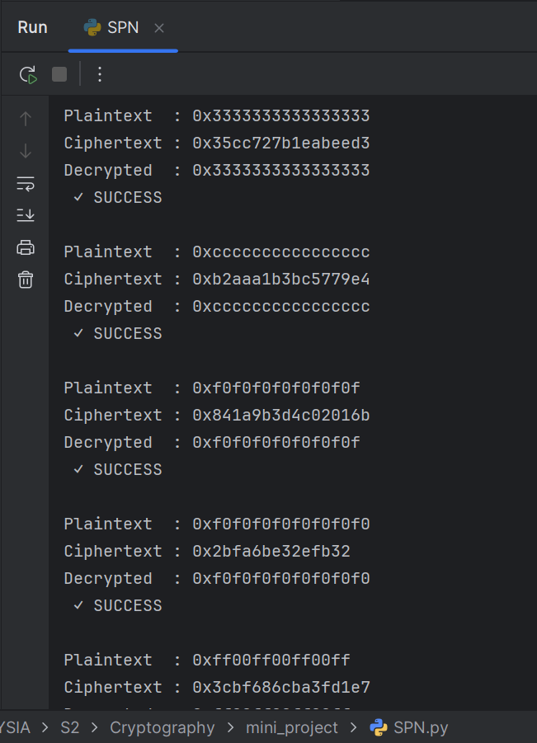
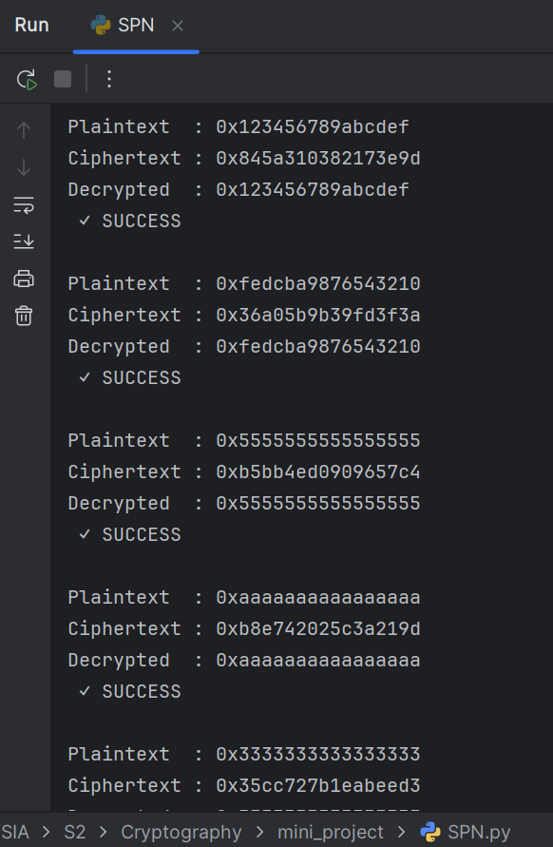
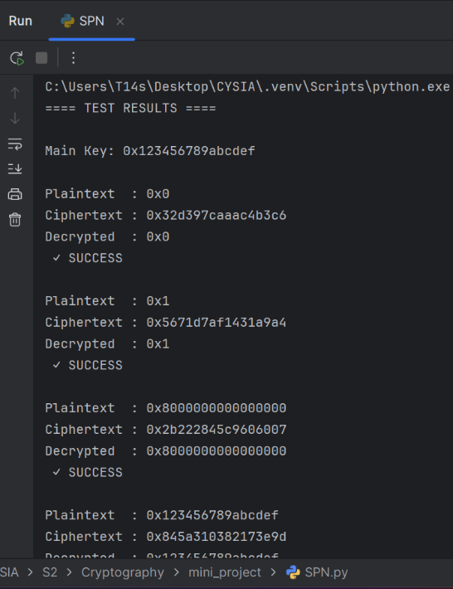

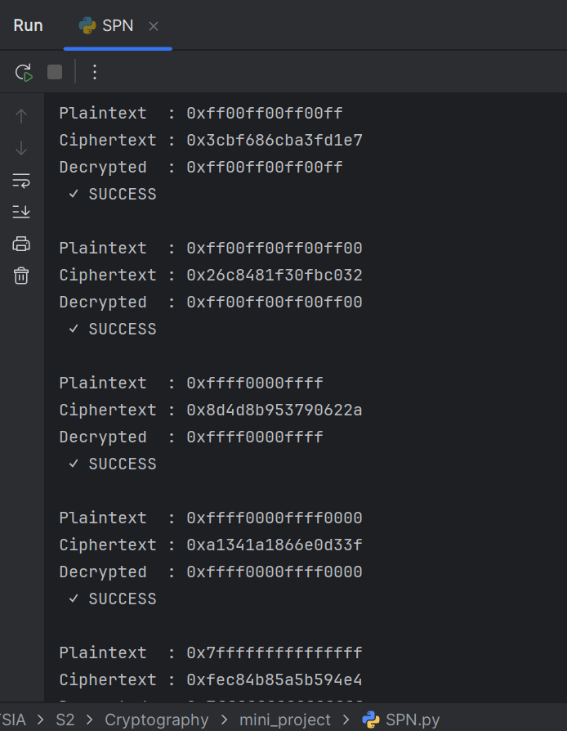
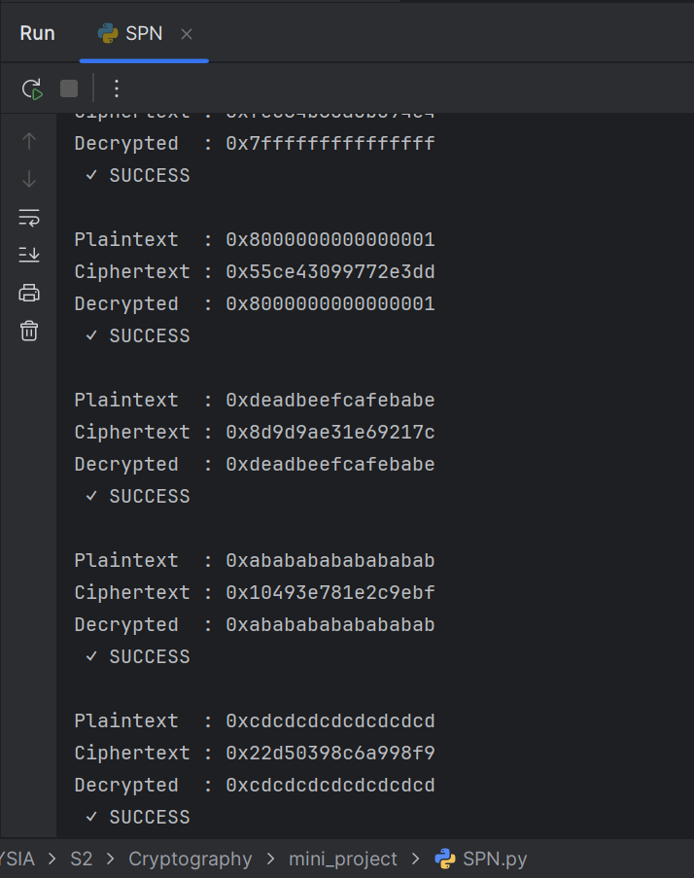

Figure 9 : Test results showing all 20/20 test vectors passed

  - Examples
This section demonstrates the cipher’s behavior using a set of 64-bit test vectors and the master key 0x0123456789ABCDEF. These examples confirm the mathematical correctness of the SPN transformations.
    - Test Vector Setup
To verify the cipher’s correctness and robustness, 20 distinct 64-bit plaintext values were selected. The test set covers the following categories:

- Boundary values: all zeros (0x0000000000000000), all ones (0xFFFFFFFFFFFFFFFF), LSB only, MSB only.
- Alternating bit patterns: 0x5555555555555555, 0xAAAAAAAAAAAAAAAA, 0x3333333333333333, 0xCCCCCCCCCCCCCCCC.
- Byte-level alternating: 0x0F0F0F0F0F0F0F0F, 0xF0F0F0F0F0F0F0F0, 0x00FF00FF00FF00FF.
- Known patterns: 0x0123456789ABCDEF, 0xFEDCBA9876543210, 0xDEADBEEFCAFEBABE.

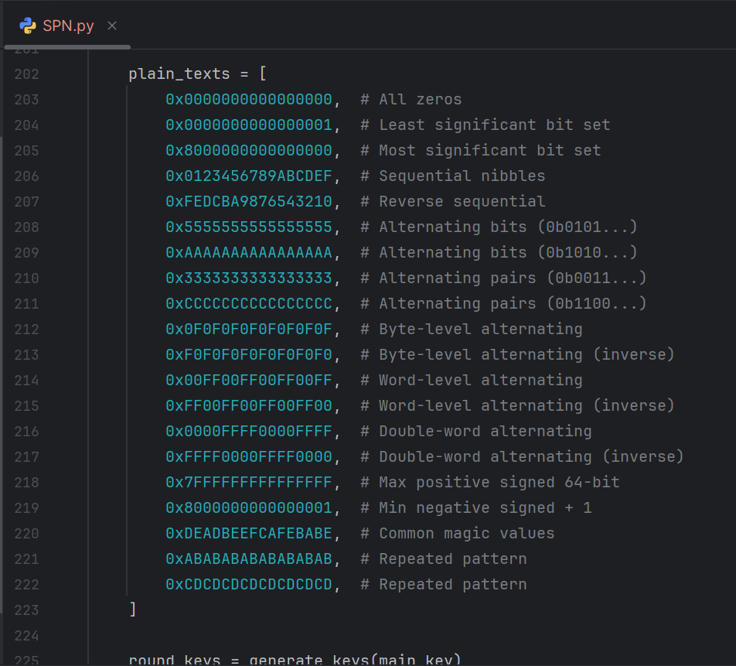
The master key used across all tests is 0x0123456789ABCDEF. For each plaintext, the cipher computes the ciphertext using encrypt_block and then verifies that decrypt_block returns the exact original plaintext.

Figure 10 : Test vector setup with master key initialization
    - Plaintext and Ciphertext Results
The following examples show the encryption mapping for several selected vectors. In every case, decryption perfectly recovered the original plaintext.

• Vector 1:
Plaintext: 0x0000000000000000
Ciphertext: 0x32d397caaac4b3c6

• Vector 2:
Plaintext: 0x0123456789ABCDEF
Ciphertext: 0x845a310382173e9d

• Vector 3:
Plaintext: 0xDEADBEEFCAFEBABE
Ciphertext: 0x8d9d9ae31e69217c

Each test produced a ciphertext that appears completely unrelated to the input, and the decryption process in every case recovered the original plaintext without any error. The final summary printed by the program confirmed 20/20 tests passed.
  - Development Experience
    - The Development Process
The implementation was built from the bottom up, starting with the most fundamental mathematical primitive: the GF(2⁸) multiplication function. Once that was verified to work correctly by testing a few known products, the S-Box generation function was written on top of it. The inverse S-Box was then derived from the forward table.
After the substitution layer was in place, I moved on to the P-Box. The matrix transpose approach was straightforward to implement using nested loops, and its inverse was again derived automatically by reversing the mapping. With both tables ready, the individual layer functions (sbox_layer, pbox_layer, mix_xor) were implemented and tested in isolation before being assembled into the full round function.
The key schedule was implemented last. The logic was simple: rotate left by 9, add the round constant, repeat. The full encrypt_block and decrypt_block functions were then connected together and validated against the test vector suite.
    - Challenges Encountered
Several technical difficulties came up during development:

- 64-bit overflow in Python: Python integers have arbitrary precision, so bitwise operations do not automatically stay within 64-bit boundaries. Every arithmetic result had to be masked with 0xFFFFFFFFFFFFFFFF to simulate fixed-width behavior. Forgetting this in even one place caused the decryption to silently produce wrong results.
- Correctness of the inverse operations: Getting the decryption to work required more than just reversing the round order. Each layer needed a mathematically correct inverse: the inverse S-Box, the inverse P-Box permutation, and the inverse MIX_XOR. Deriving inv_mix_xor was particularly tricky because the three-step XOR-rotation sequence had to be carefully unwound in the right order.
- GF(2⁸) arithmetic edge cases: The multiply_gf2_8 function had to handle the carry bit correctly when the high bit of the byte is set before the left shift. The modular reduction by 0x11B needed to happen only when that carry bit was set, and not unconditionally. Getting this detail right took several iterations of testing.
- Verifying the S-Box is a bijection: It was important to confirm that the generated S-Box is actually a permutation, i.e., that every output value appears exactly once. A simple check using len(set(SBOX)) == 256 confirmed this.
    - Observations
Testing the cipher with various inputs revealed some interesting behaviors:

- Avalanche effect: Changing a single bit in the plaintext (for example, flipping the last bit between 0x0000000000000000 and 0x0000000000000001) produced a ciphertext that differed in roughly half of its bits. This is the expected behavior of a well-designed cipher and confirms that the S-Box and P-Box combination is effective.
- All-zero key concern: When testing with unusual inputs, I noted that if both the plaintext and the key were all zeros, the first round would add zero to the state before applying the S-Box. However, since S[0] = 0 in the implemented S-Box (zero has no inverse and is mapped to itself), this is a fixed point at the first byte level. This is a known property of raw GF(2⁸) inversion without an affine transformation, but it does not affect the test vectors used in this project since the master key is non-zero.
- Symmetry of the design: One thing that stood out was how clean and symmetric the encrypt/decrypt structure is. The decrypt function is almost a mirror image of encrypt, differing only in the use of inverse operations and reversed key order. This made implementing decryption much less error-prone than I initially expected.

  - Conclusion
The design and implementation of the Project #11 SPN cipher successfully demonstrates how the core principles of symmetric cryptography, namely confusion, diffusion, and key scheduling, come together in a working 64-bit block cipher.
The S-Box built from GF(2⁸) multiplicative inversion provides strong nonlinearity and ensures that no simple linear relationship exists between input and output bytes. The P-Box, generated using an 8×8 matrix transpose, guarantees that each byte’s bits are spread to 8 different byte positions in the next round, achieving full inter-byte diffusion. The MIX_XOR function adds an additional layer of within-round diffusion by mixing the two 32-bit halves of the state through rotation-based operations. The key schedule derives 9 distinct subkeys from the master key by combining rotation and constant addition, ensuring that no two rounds use the same key material.
The empirical results confirm that the cipher is mathematically correct and reversible. All 20 test vectors passed: in each case, decryption of the ciphertext recovered the exact original plaintext. The avalanche effect was observable in practice, with single-bit changes in the plaintext producing dramatically different ciphertexts.
Working on this project gave me a concrete understanding of why each component of an SPN cipher exists and what specific cryptographic property it is responsible for. The implementation challenges, particularly around 64-bit masking, correct inverse derivation, and GF(2⁸) arithmetic, reinforced how much precision is required when implementing cryptographic algorithms.

