Université belhadj bouchaib d'ain témouchent Faculté des sciences et technologie

Mathématiques et Informatique

Theme:

Homework: Extracting Algerian Phone Numbers & University Emails
Using Regex

Realised by : | Supervisor :
- Hassi Imad-Eddine | Dr. Bendiabdullah Mohamed Hakim

Introduction
In this homework assignment, we work with a text file that contains a mix of Algerian phone numbers and email addresses. The goal is to use Python and regular expressions to extract only specific information: phone numbers from two mobile operators (Mobilis and Ooredoo) and email addresses from the University of Ain Temouchent.
Regular expressions are a powerful tool for finding patterns in text. They allow us to search for strings that follow a specific format, like phone numbers that start with certain digits or emails that end with a particular domain name.
We start by creating a file called algerian.txt that includes various records. Then we write a Python program that reads this file, applies regular expression patterns to filter the content, and displays only the Mobilis and Ooredoo phone numbers along with the university emails. This exercise helps us practice pattern matching and text processing in Python.

Objectives
- Create a sample file containing Algerian phone numbers and various email addresses.
- Identify and extract only Mobilis (starting with +213 6) and Ooredoo (starting with +213 5) phone numbers.
- Identify and extract only email addresses belonging to the University of Ain Temouchent (domain @univ-temouchent.edu.dz).

Methodology

Data File Preparation
To begin, we create a new text file named algerian.txt. We write several records into this file, each record containing either a phone number or an email address, separated by commas. The phone numbers are written in the international format with the +213 country code, followed by the operator code (6 for Mobilis, 5 for Ooredoo, and 7 for jezze) and groups of two digits. The email addresses include common domains like gmail.com, yahoo.fr, outlook.com, and also the specific university domain univ-temouchent.edu.dz. We ensure that at least one email uses this university domain.
The file content is designed to simulate a realistic mix of data, allowing us to test our regular expressions.

Regular Expression Patterns
We use the re module in Python to define patterns for the data we want to extract.
- Mobilis Phone Number Pattern
Mobilis numbers start with the country code +213, followed by a space, then the digit 6, and then groups of two digits separated by spaces. The pattern is:
\+213\s6\s\d{2}\s\d{2}\s\d{2}\s\d{2}
This pattern matches the literal plus sign, the country code, a space, the digit 6, a space, and then four pairs of two digits each separated by spaces.
- Ooredoo Phone Number Pattern
Ooredoo numbers follow the same structure but use the digit 5 instead of 6. The pattern is:
\+213\s5\s\d{2}\s\d{2}\s\d{2}\s\d{2}
- University Email Pattern
Emails from the University of Ain Temouchent must end with @univ-temouchent.edu.dz. The local part (before the @) can contain any characters except whitespace. The pattern is:
\S+@univ-temouchent\.edu\.dz
The \S+ matches one or more non-whitespace characters, and the domain part is written with escaped dots to match literal periods.
These patterns are applied using re.findall() to return all matching substrings in the text.

Implementation

Reading the Input File
First, we open the file algerian.txt in read mode and store its entire content in a string variable. This allows us to apply regular expressions on the whole text at once.
with open("Algerian.txt", "w") as file:
file.write("+213 6 55 23 41 98, ahmed.benali@gmail.com, +213 5 91 78 90 12, y.khelifi@yahoo.fr, +213 6 66 34 56 01, m.amrani@outlook.com, +213 5 83 11 88 73, lina.bouzid@protonmail.com, +213 6 70 45 22 19, sofiane.rahmani@gmail.com, +213 5 54 60 14 55, nour.elhouda@icloud.com, +213 6 91 02 67 44, k.zerrouki@company.dz, +213 5 88 73 09 26, samira.toumi@univ-temouchent.edu.dz, +213 6 64 98 31 07, bilal.messaoudi@student.univ-temouchent.edu.dz, +213 5 66 40 12 89, amel.boudjemaa@univ-temouchent.edu.dz")

Extraction of Mobilis/Ooredoo Phone Numbers
We define the Mobilis and ooredoo pattern and use re.findall() to get all occurrences. Then we check if any matches were found and print them with a descriptive message.
import re
#extract ooredoo numbers
mobilis_pattern = r"(\+213\s6\s\d{2}\s\d{2}\s\d{2}\s\d{2})"
mobilis_result = re.findall(mobilis_pattern, text)
if mobilis_result:
print(f"Ther is {len(mobilis_result)} Mobilis Phones : ")
for i in mobilis_result:
print("mobilis phone : ", i)
else: print("Mobilise phones Not Found!")
#extract ooredoo numbers
ooredoo_pattern = r"(\+213\s5\s\d{2}\s\d{2}\s\d{2}\s\d{2})"
ooredoo_result = re.findall(ooredoo_pattern, text)
if ooredoo_result:
print(f"Ther is {len(ooredoo_result)} ooredoo Phones : ")
for i in ooredoo_result:
print("ooredoo phone : ", i)
else: print("ooredoo phones Not Found!")

Extraction of University of Ain Temouchent Emails
We define the university email pattern, extract all matching email addresses, and display them.
tmouch_pattern = r"(\S+@univ-temouchent.edu.dz)"
tmouch_result = re.findall(tmouch_pattern, text)
if tmouch_result:
print(f"Ther is {len(tmouch_result)} tmouchent mails : ")
for i in tmouch_result:
print("tmouchent mails : ", i)
else: print("tmouchent mails Not Found!")

The program is structured to handle cases where no matches are found by printing an appropriate message.

Results
After running the Python program on the created algerian.txt file, the following results were obtained:
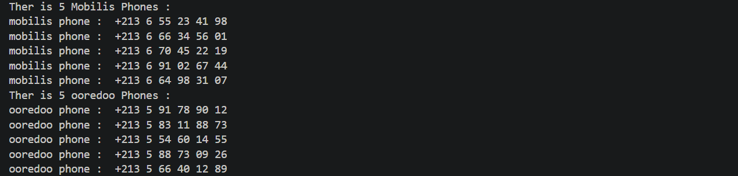
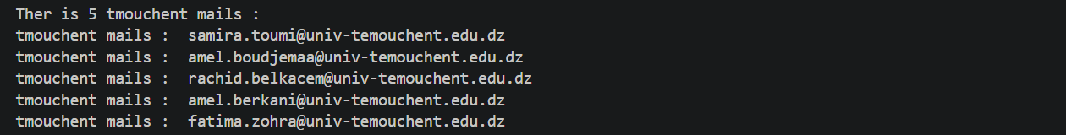
These results match exactly the records we inserted into the file, confirming that the regular expressions worked correctly.

Conclusion
This homework successfully met its objectives. We created a sample file containing mixed Algerian phone numbers and emails. Using Python and regular expressions, we extracted only the Mobilis and Ooredoo phone numbers and the emails from the University of Ain Temouchent. The program correctly identified all target items and displayed them clearly.
Regular expressions proved to be a concise and powerful method for pattern-based extraction. This skill is valuable for many real-world tasks such as data cleaning, log analysis, and information retrieval.

