

MINI-PROJECT REPORT

Android & iOS Architectures:
Attack Surface Analysis
Field | Details
Course | Security Systeme M1 CYSIA
Topic | Mobile Security & Distributed Architectures
Student 1 | Hassi Imad-Eddine
Student 2 | SETTAH Omar Abderrahmane
Group | G1
Supervisor | Dr. Mededjel
Academic Year | 2025 – 2026

Table of Contents
1. Introduction
1.1 Context
1.2 Security Problem Statement
2. Theoretical Background
2.1 Android Architecture & Attack Surface
2.2 iOS Architecture & Attack Surface
2.3 Comparative Overview
3. Lab / TP Sheet
3.1 Learning Objectives
3.2 Environment Setup
3.3 Lab Walkthrough — Step by Step
3.4 Expected Results Summary
3.5 Reflection Questions
4. Conclusion
5. References

1. Introduction

1.1 Context
Mobile devices have become the cornerstone of modern digital life. Smartphones store our most sensitive assets — personal communications, banking credentials, private data, and corporate information. As of 2025, Android and iOS collectively power over 99% of the global smartphone market, making mobile platforms the single most attractive target for cybercriminals, hackers, and nation-state actors alike.
This mini-project explores the security architectures of both Android and iOS, maps their respective attack surfaces, and provides a fully reproducible hands-on laboratory scenario demonstrating two of the most common and impactful attack vectors: Reverse Engineering (Static Analysis) and Insecure Data Storage (Dynamic Analysis).

1.2 Security Problem Statement
Despite significant security investments by Google and Apple, mobile platforms remain vulnerable due to a combination of platform design choices and developer mistakes.

1.2.1 Android Attack Surface
Android is an open-source platform used by many different manufacturers (Samsung, Pixel, Xiaomi, etc.), which creates a broad and diverse attack surface.
- App Distribution: Users can "sideload" apps from third-party websites or unofficial stores. This is a major entry point for malware.
- Manufacturer Bloatware: Every phone maker adds their own software skins and pre-installed apps. Each addition can have its own vulnerabilities.
- Fragmentation: Because there are thousands of different Android devices, many do not receive the latest security patches at the same time, leaving older vulnerabilities open for longer.
- Hardware Diversity: Various chipsets and drivers (Wi-Fi, Bluetooth) from different vendors increase the number of potential hardware-level exploits.

1.2.2 iOS Attack Surface
Apple uses a "walled garden" approach. Because they control both the hardware and the software, the attack surface is more uniform but highly targeted.
- The App Store: Apple's strict review process makes it harder for malware to enter via apps, though "zero-day" exploits in popular apps (like iMessage) are high-value targets.
- System Services: Features like AirDrop, iMessage, and Find My are always running. Because they process data automatically, they are primary targets for "zero-click" attacks.
- WebKit: Almost every browser on iOS is forced to use Apple's WebKit engine. A single vulnerability in WebKit can potentially affect every iPhone user.
- Physical Ports: The Lightning or USB-C port remains a surface for "juice jacking" or hardware-based forensic tools.

The central question driving this project is: How do the architectural choices of Android and iOS shape their attack surface, and what concrete developer practices introduce the most critical vulnerabilities?

2. Theoretical Background

2.1 Android Architecture & Attack Surface

2.1.1 Android Security Architecture
Android is built on a modified Linux kernel and structured in layered components:
- Linux Kernel : hardware abstraction, SELinux Mandatory Access Control (MAC), device drivers
- Hardware Abstraction Layer (HAL) : standardised interfaces for camera, sensors, and GPS
- Android Runtime (ART) : DEX bytecode execution with AOT/JIT compilation
- Native Libraries : libc, OpenSSL, SQLite, WebKit
- Application Framework : Activity Manager, Package Manager, Content Providers
- Applications : user-facing apps isolated from one another by UID-based sandboxing

Key Android security mechanisms are summarised in the table below:

Mechanism | Description | Attack Relevance
App Sandbox | Each app runs as a unique Linux UID | UID spoofing, privilege escalation
SELinux (MAC) | Enforced policies on processes and files | Policy misconfigs, kernel exploits
Permission Model | Dangerous permissions require user approval | Over-privileged apps, abused permissions
Verified Boot (AVB) | Chain of trust from bootloader to OS | Bootloader unlocking, boot image tampering
Google Play Protect | On-device malware scanning | Obfuscated malware, APK sideloading
Keystore / StrongBox | Hardware-backed cryptographic key storage | Key extraction via cold-boot / Rowhammer

2.1.2 Android Attack Surface
The Android attack surface spans four distinct layers:

A) Application Layer
- Exported Activities, Services, and Broadcast Receivers without permission checks accessible to any installed app
- Intent injection: malicious apps sending crafted Intents to exported components
- WebView misconfigurations: addJavascriptInterface() exposing native code to JavaScript
- Insecure data storage: plaintext credentials in SharedPreferences, SQLite, or external storage
- Insecure logging: sensitive data written to Logcat

B) IPC & Component Layer
- Content Provider path traversal: exposing arbitrary files via file:// URIs
- Deep link hijacking: malicious apps registering duplicate URI schemes
- Pending Intent abuse: writable Intents forwarded to privileged components

C) Network Layer
- Cleartext HTTP traffic due to NetworkSecurityConfig misconfiguration
- TLS certificate validation bypass: trusting all certificates in SSLSocketFactory
- Man-in-the-Middle attacks via rogue Wi-Fi access points

D) Kernel / Hardware Layer
- Kernel exploits (CVE-2021-0920, Dirty Pipe CVE-2022-0847)
- Rooting via bootloader unlock and custom recovery (TWRP)
- Physical extraction via ADB, JTAG, or chip-off forensics

2.2 iOS Architecture & Attack Surface

2.2.1 iOS Security Architecture
iOS uses a microkernel-based design (XNU combining Mach and BSD) with a strict layered security model:
- Secure Enclave Processor (SEP): isolated co-processor handling Touch ID, Face ID, and cryptographic keys; keys never leave the enclave
- Secure Boot Chain: each boot stage is cryptographically verified by Apple's signature before execution
- App Sandbox: strict entitlement-based per-app permissions with no direct inter-app file access
- Data Protection API: per-file encryption tied to the device passcode and lock state
- System Integrity Protection (SIP): prevents modification of protected OS files even by root
- Pointer Authentication Codes (PAC): ARMv8.3 hardware mitigation against ROP/JOP exploit chains

Mechanism | Description | Attack Relevance
Secure Enclave | Dedicated crypto processor; keys never exposed | Side-channel, fault injection
App Store Review | Mandatory code review and signing | Bypassed via TestFlight, MDM profiles
Code Signing | All binaries signed by Apple | Jailbreak, FairPlay DRM research
TCC (Transparency, Consent) | Per-app access to camera/mic/location | TCC database tampering post-root
ASLR + PAC | Memory randomisation + pointer authentication | Return-oriented exploits (limited)
Lockdown Mode (iOS 16+) | Hardened mode for high-risk users | Reduces attack surface drastically

2.2.2 iOS Attack Surface

A) Application Layer
- URL scheme hijacking: multiple apps registering the same custom scheme
- Universal Link misconfiguration: weak apple-app-site-association validation
- Keychain misconfigurations: storing secrets with kSecAttrAccessibleAlways
- UIWebView / WKWebView JavaScript bridges exposing native functionality

B) Data Layer
- Unprotected NSUserDefaults or plist files containing credentials
- Core Data / SQLite databases stored without Data Protection encryption
- Clipboard leakage: sensitive data remaining in UIPasteboard

C) Network Layer
- ATS (App Transport Security) exceptions via NSAllowsArbitraryLoads
- Certificate pinning bypass via SSL Kill Switch or Frida hooks
- Proxied traffic analysis with Burp Suite via manual proxy configuration

D) Jailbreak / System Layer
- Jailbreak detection bypass using Shadow, Liberty Lite, or Frida scripts
- iCloud backup extraction: sensitive files included without encryption
- MDM profile abuse: enterprise certificates signing malicious apps

2.3 Comparative Overview

Dimension | Android | iOS
Kernel | Linux (monolithic + SELinux) | XNU (Mach + BSD microkernel)
App Distribution | Play Store + sideloading | App Store only (exc. jailbreak)
Sandbox Model | UID-based Linux isolation | Entitlement-based sandbox
Key Storage | Android Keystore / StrongBox | Secure Enclave
Updates | Fragmented (OEM-dependent) | Centralized (Apple controls)
Jailbreak / Root | Easier — wide community tools | Difficult — rare/expensive exploits
Main Threat Vector | Malicious APKs, IPC abuse, insecure storage | Jailbreak exploits, MDM abuse

3. Lab / TP Sheet
LAB TITLE: Static & Dynamic Analysis of an Android Application — Exploring the Attack Surface

3.1 Learning Objectives
By completing this lab, fellow students will be able to:
- Understand how Android APKs are structured and why they are vulnerable to decompilation.
- Use Jadx-GUI to perform static analysis and extract hardcoded secrets from compiled Android source code.
- Use ADB (Android Debug Bridge) to gain shell access to a rooted Android emulator.
- Navigate the Android file system and locate application private data directories with Kali Linux.
- Query an unencrypted SQLite database to extract plaintext user credentials.
- Articulate the developer mistakes that create these vulnerabilities and describe the correct mitigations.

3.2 Environment Setup

3.2.1 Required Tools

Tool | Purpose | Where to Obtain
Kali Linux (VM) | Attacker/analyst machine with all security tools pre-installed | kali.org pre-built VirtualBox/VMware image
VirtualBox or VMware | Hypervisor to run Kali Linux VM | virtualbox.org / vmware.com
Genymotion (Personal) | Android emulator rooted by default, ideal for pentesting | genymotion.com free Personal Use tier
DIVA APK | Damn Insecure and Vulnerable App intentionally vulnerable target | github.com/payatu/diva-android
Jadx / Jadx-GUI | Decompile DEX bytecode back to readable Java source code | github.com/skylot/jadx or: sudo apt install jadx
ADB (Android Debug Bridge) | Connect Kali to Genymotion emulator; shell and file access | Included in Android SDK: sudo apt install adb
SQLite3 | Query and read SQLite database files extracted from the device | Pre-installed on Kali Linux

3.2.2 Network Topology
The lab uses a simple two-node topology connected over the VirtualBox host-only network:

Target Machine | Attacker Machine
Genymotion Android Emulator (or actual phone)• DIVA app installed and running • Rooted by default (ADB daemon active) • IP visible in title bar (e.g. 192.168.56.101) • ADB port: 5555 | Kali Linux VM• Jadx-GUI for static analysis • ADB client for shell access • SQLite3 for database queries • Connected over VirtualBox host-only adapter

Connection path: Kali terminal → ADB over TCP (port 5555) → Genymotion emulator → DIVA app data

3.2.3 Pre-Lab Checklist

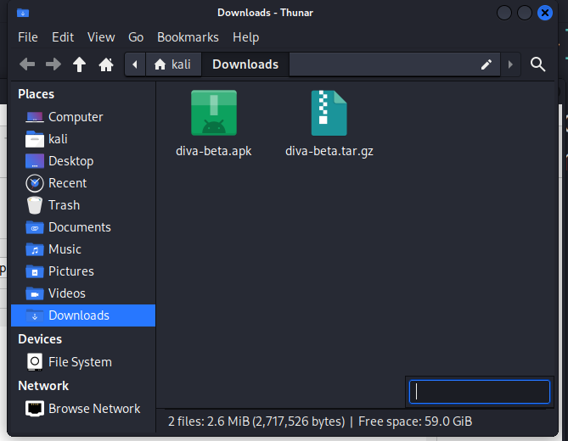
Image 1: VirtualBox running with the Kali Linux VM booted with access to Diva.apk source code

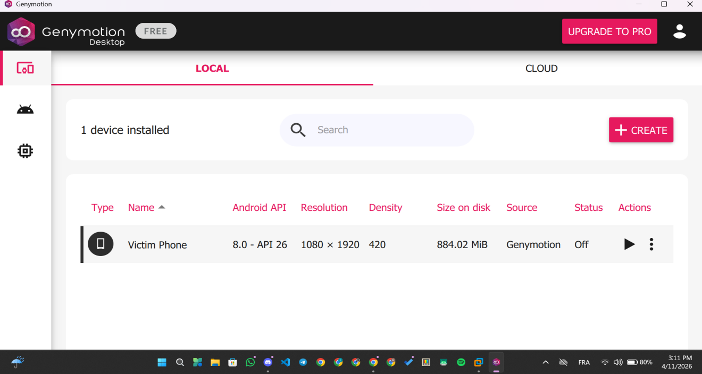
Image 2: Genymotion emulator started with a device running Android 7.0–11.0

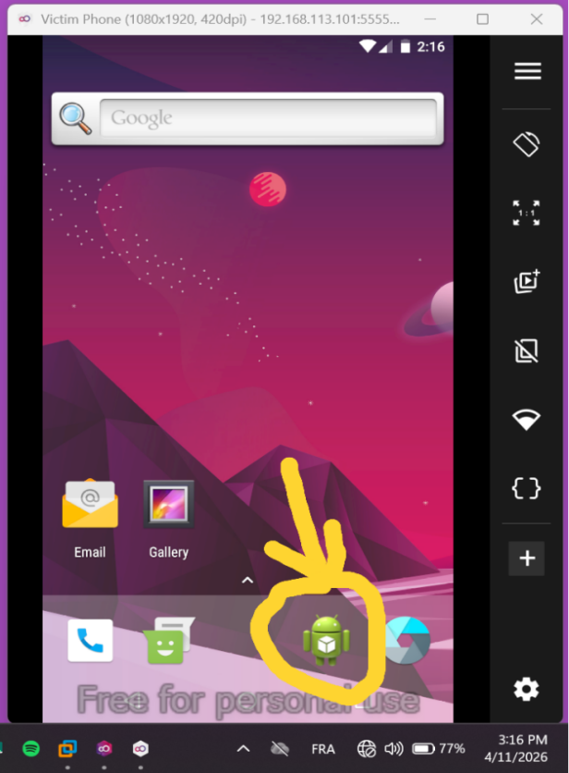
Image 3: DIVA APK installed on the emulator (drag-and-drop into the Genymotion window)

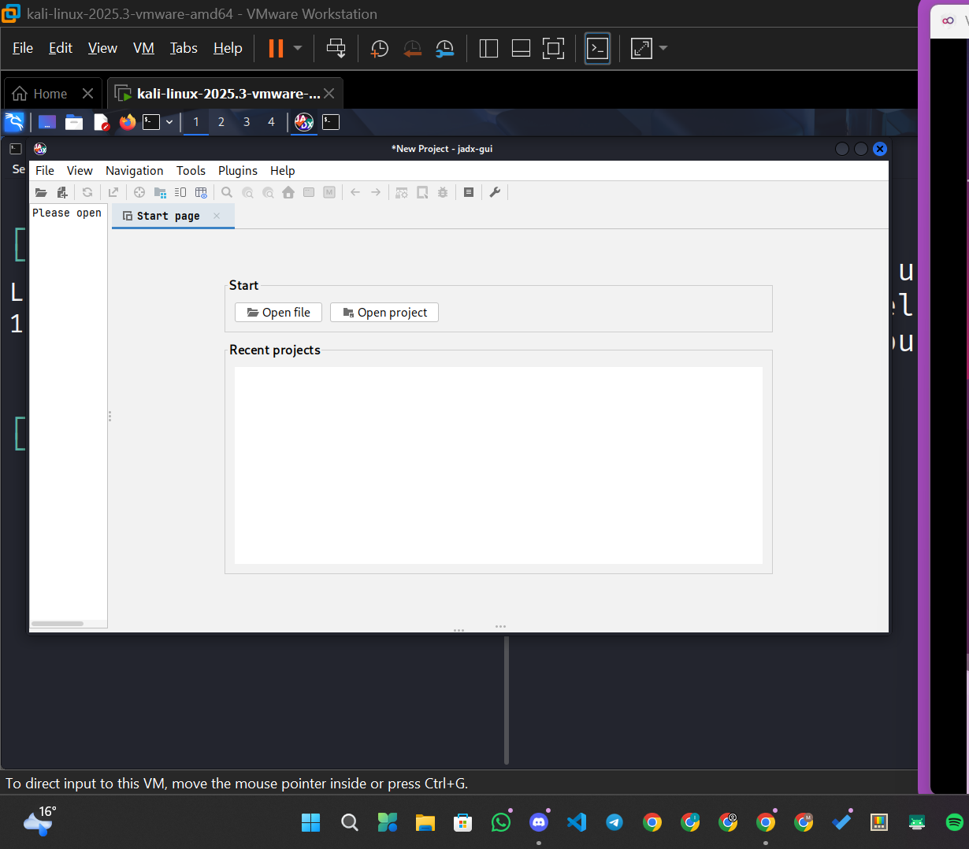
Image 4: Jadx-GUI already open in Kali (type jadx-gui in a terminal to launch)

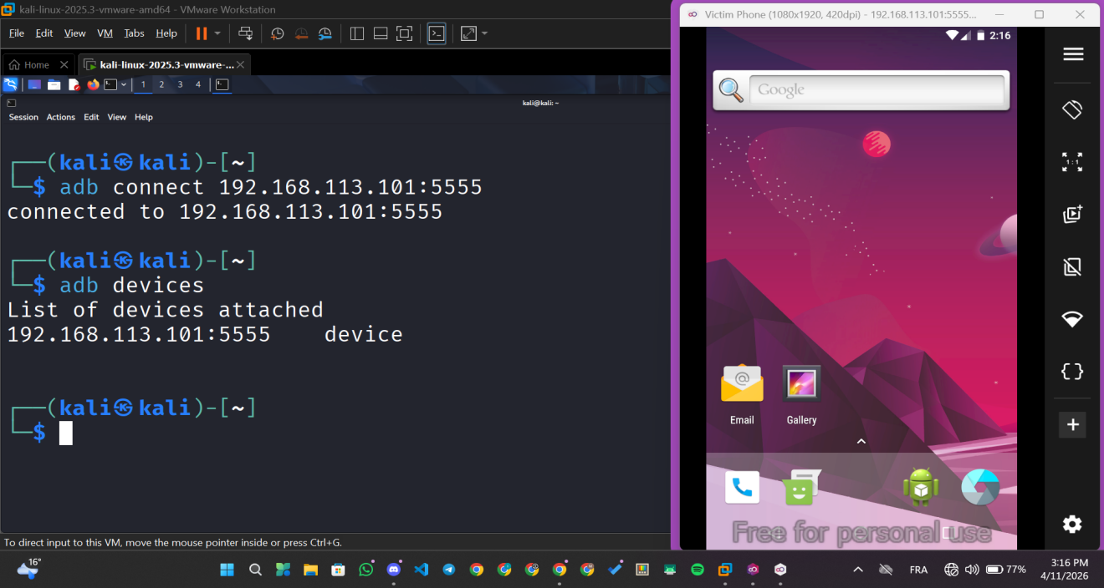
Image 5: Two clean terminal windows open in Kali with the Genymotion IP noted

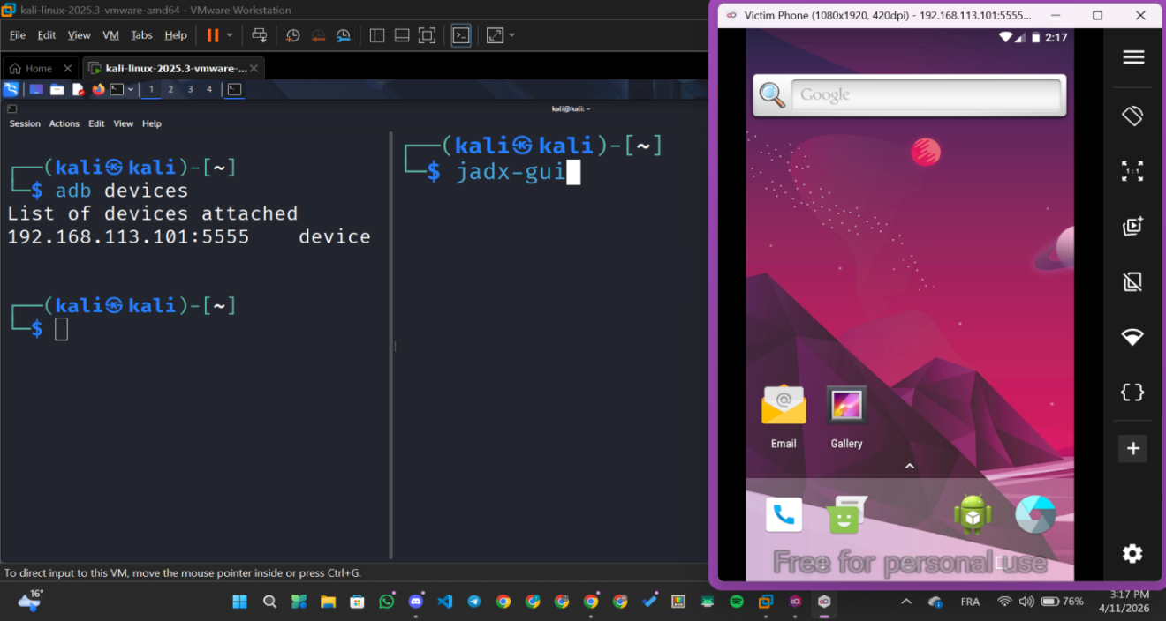
Image 6: Command to open jadx-gui

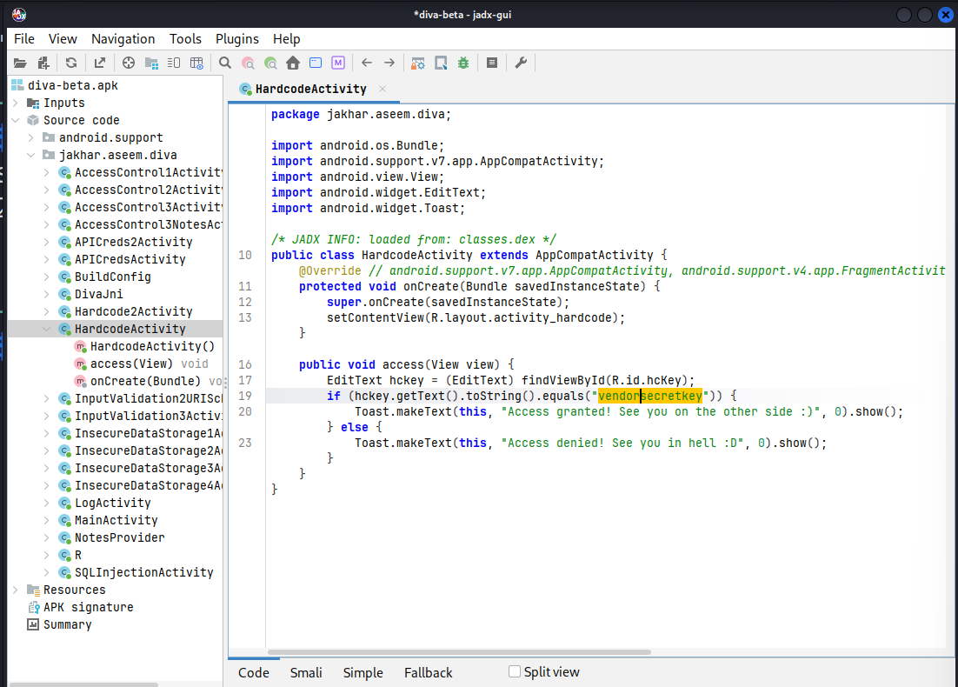
Image 8: Getting the access key via Jadx — Reverse Engineering the APK

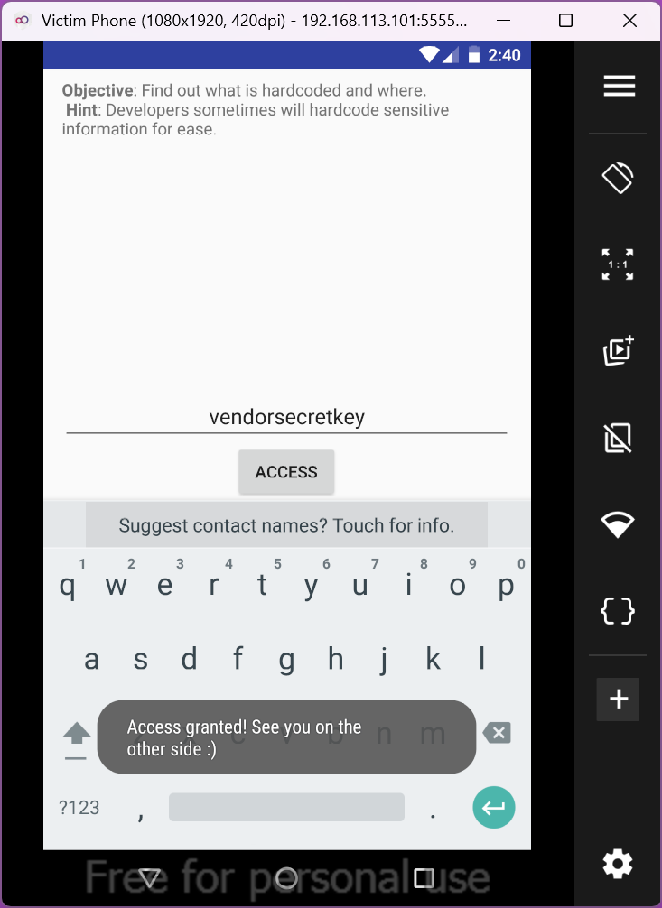
Image 9: Access to the victim phone (Successful attack)
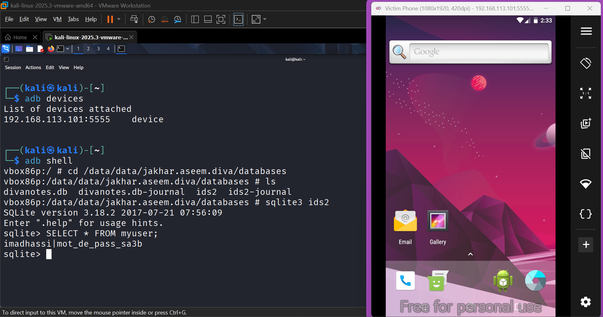
Image 10 ( ADB Shell Access): SELECT * FROM myuser; returns admin|password in plaintext
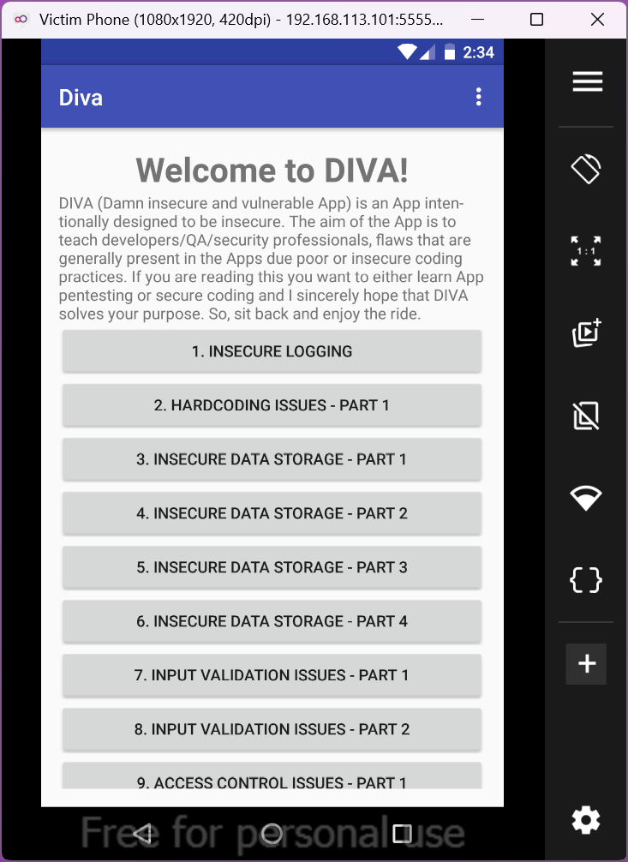
Image 11: DIVA interface on Android

3.3 Lab Walkthrough — Step by Step

Phase 0: Connecting Kali Linux to Genymotion
Before attacking the app, your Kali Linux VM must be able to communicate with the Genymotion emulator over the local virtual network using ADB (Android Debug Bridge).

Step | Action | Command / Instruction
0.1 | Find the Android IP Address | Look at the title bar of your Genymotion window. Note the IP (e.g. 192.168.56.101).
0.2 | Install ADB on Kali (if not present) | $ sudo apt update && sudo apt install adb
0.3 | Connect Kali to the Genymotion device | $ adb connect [GENYMOTION_IP]:5555
0.4 | Verify the connection | $ adb devices → Expected output: [IP]:5555 device

Phase 1: Static Analysis — Reverse Engineering the APK
Android applications are distributed as APK files, which are ZIP archives containing compiled DEX bytecode. Using Jadx, we can decompile this bytecode back into readable Java source code. Developers who hardcode sensitive information (passwords, API keys, tokens) directly in their code expose them to anyone who downloads the APK.

Step | Action | Command / Instruction
1.1 | Launch Jadx-GUI | Open a Kali terminal and type: $ jadx-gui
1.2 | Open the DIVA APK | In Jadx-GUI: File → Open file → select diva-beta.apk Jadx will decompile the entire app into Java source code.
1.3 | Navigate to the vulnerable class | In the left panel, expand: Source code → jakhar.aseem.diva Click on HardcodeActivity
1.4 | Locate the hardcoded secret | In the Java code, find: if (editText.getText().toString().equals("vendorsecretkey")) — The vendor password is compiled in plaintext.

Expected finding: The string "vendorsecretkey" is hardcoded directly in the source code. Any attacker who downloads the APK can read this without touching the device.

Phase 2: Dynamic Analysis — Extracting the SQLite Database
In the Dynamic Analysis phase, we interact with the running application on the emulator, supply test credentials, and then use ADB root access to bypass the Android application sandbox and read the private SQLite database that the app uses to store those credentials in plaintext.
The Android Sandbox assigns each app its own private directory at /data/data/[package_name]/. Normal apps cannot access each other's directories. However, on a rooted device (or when an attacker has ADB access to a rooted device), this sandbox can be bypassed entirely.

Step | Action | Command / Instruction
2.1 | Generate target data in the app | On Genymotion, open DIVA app. Tap: "2. Insecure Data Storage - Part 2" Enter Username: admin Enter Password: SuperSecret123 Tap Save.
2.2 | Enter the Android shell via ADB | In Kali terminal: $ adb shell Your prompt changes to # confirming you are now executing commands inside the Android OS.
2.3 | Navigate to the app's private database directory | cd /data/data/jakhar.aseem.diva/databases/ ls — You will see a file named ids2 (the app's SQLite database).
2.4 | Open the SQLite database | sqlite3 ids2 Your prompt changes to sqlite> confirming the database is open.
2.5 | Query the credentials table | SELECT * FROM myuser; The username and password you typed in Step 2.1 appear in plaintext.

Expected output from Step 2.5: imadhassi|mot_de_pass_sa3b

3.4 Expected Results Summary

Lab Phase | Expected Result / Evidence
Phase 0: ADB Connection | adb devices shows the Genymotion IP with status: device
Phase 1: Static Analysis | Jadx-GUI displays HardcodeActivity.java containing the string vendorsecretkey in plaintext
Phase 2: ADB Shell Access | Terminal prompt changes to # after adb shell, confirming root access
Phase 2: Directory Navigation | ls command shows the ids2 SQLite database file inside /data/data/jakhar.aseem.diva/databases/
Phase 2: Credential Extraction | SELECT * FROM myuser; returns admin|SuperSecret123 in plaintext

3.5 Reflection Questions

3.5.1 Questions
- The Android Sandbox is supposed to protect application data. Why did it NOT prevent us from reading DIVA's database in this lab?
- What is the difference between static analysis and dynamic analysis? Which one is more dangerous from a developer's perspective, and why?
- A developer stores an API key directly in strings.xml inside the APK. Explain two ways an attacker could extract this key and two correct alternatives.
- What library could the DIVA developer have used to encrypt the SQLite database? How does it integrate with the Android Keystore system?
- In this lab we targeted Android. Explain why performing the same dynamic analysis on iOS is significantly more difficult, referencing at least two iOS security mechanisms.

3.5.2 Answers
1. Why didn't the Sandbox protect DIVA's database?
The Genymotion emulator is rooted by default. Root (UID 0) bypasses all sandbox restrictions it can read any app's private files. The sandbox protects apps from each other, not from the superuser.
2. Static vs Dynamic Analysis — which is more dangerous?
Static = analyzing the APK without running it (Jadx decompilation). Dynamic = analyzing the app while it runs (ADB + SQLite extraction). Static is more dangerous for developers because the attacker only needs the APK file publicly downloadable from any app store and can extract secrets instantly with zero device access.
3. Two ways to extract a key from strings.xml + two correct alternatives:
Extract it: (1) Decompile with Jadx/apktool → read the file directly. (2) Rename .apk to .zip → open like an archive, no tools needed. Correct alternatives: (1) Fetch the key at runtime from a secure backend server (never bundle it in the APK). (2) Store it in the Android Keystore (hardware-backed, key never exposed to the app).
4. What library encrypts SQLite + how does it integrate with Keystore?
Use SQLCipher (256-bit AES encryption on every database page). The passphrase that unlocks the database is stored inside the Android Keystore a hardware-backed container where the raw key is never exposed. Even if an attacker steals the database file, they cannot open it without the Keystore key, which cannot be extracted.
5. Why is the same attack much harder on iOS?
Secure Boot Chain + Code Signing: All iOS software must be signed by Apple → no legal iOS emulator exists → you need a real physical device. No accessible root: Getting root on iOS requires jailbreaking via unpublished kernel exploits rare, expensive, and patched rapidly by Apple's centralized updates. Without root, /var/mobile/Containers/ (iOS equivalent of /data/data/) is completely inaccessible.

Why iOS Was Excluded from the Practical Lab
While iOS is covered in the theoretical section of this report, the practical lab focuses exclusively on Android for both legal and technical reasons. Apple's iOS ecosystem is entirely closed-source, and all software running on an iOS device must be cryptographically signed by Apple making it impossible to run a legal iOS emulator on standard PC hardware. Unlike Genymotion, which provides a rooted Android environment out of the box, gaining equivalent access on iOS requires jailbreaking a physical Apple device, which involves exploiting unpublished kernel vulnerabilities. These exploits are rare, device-specific, rapidly patched by Apple's centralized update system, and potentially illegal depending on jurisdiction. For these reasons, replicating the ADB shell and SQLite extraction attack in an isolated, reproducible, and legally compliant lab environment is not feasible on iOS.

4. Conclusion

4.1 Key Takeaways
This mini-project provided a structured and hands-on exploration of the attack surface of Android and iOS mobile platforms. Through the theoretical analysis and the practical lab, we observed that both platforms implement strong foundational security mechanisms at the OS level, yet application developers consistently introduce critical vulnerabilities by misusing or ignoring those mechanisms.
The two exploits demonstrated in the lab static reverse engineering of hardcoded credentials and dynamic extraction of an unencrypted SQLite database required no advanced exploit research. Both attacks exploited developer mistakes rather than OS-level flaws. This reinforces a fundamental principle of mobile security: the OS can only protect what the developer does not give away.

4.2 Answers to the Five Mandatory Questions
1. What security problem is addressed?
This project addresses the vulnerabilities within the attack surface of mobile architectures. Specifically, it highlights the severe risks of insecure local data storage and the ease of reverse engineering when developers fail to implement proper architectural security measures on Android.
2. What mechanisms / architectures are used?
The lab exploits several core Android mechanisms: the APK packaging structure (which acts as a simple ZIP archive), the Android Sandbox / File System (/data/data/ directories assigned to specific App UIDs), and the Android Debug Bridge (ADB) daemon which allows root-level interaction with the OS architecture.
3. What concrete scenario was implemented?
A two-phase penetration test on a vulnerable application (DIVA). Phase 1 (Static Analysis): Decompiling the application's source code using Jadx to extract hardcoded vendor secrets. Phase 2 (Dynamic Analysis): Leveraging root ADB access to bypass the application sandbox and extract unencrypted user credentials directly from a live SQLite database.
4. What limits or difficulties were observed?
The primary limitation is that dynamic analysis and emulation of the iOS architecture are highly restricted due to Apple's closed ecosystem, strict code signing, and hardware dependencies. Therefore, the practical lab is limited to Android. Additionally, the dynamic database attack requires the device to be rooted or the attacker to have physical ADB access.
5. What best practices do you recommend?
Based on the vulnerabilities observed: (1) Code Obfuscation use tools like ProGuard to make decompiled source code unreadable. (2) Secret Management never hardcode API keys or passwords; fetch them securely from a backend. (3) Data Encryption always encrypt local SQLite databases using libraries like SQLCipher and securely store the cryptographic keys inside the hardware-backed Android Keystore.

4.3 Project Contribution Summary

Question | Summary Answer
Security problem addressed | Insecure mobile app design exposing credentials via reverse engineering and plaintext storage
Mechanisms used | APK structure, Android Sandbox (UID/SELinux), ADB, SQLite, Jadx decompilation
Concrete scenario | Static APK decompilation (Jadx) + Dynamic SQLite extraction (ADB root shell) on DIVA via Genymotion
Observed limitations | Rooted device required; iOS legally non-emulable; real apps use obfuscation and root detection
Best practices | No hardcoded secrets; SQLCipher encryption; ProGuard obfuscation; EncryptedSharedPreferences; OWASP MASVS

5. References

Official Documentation & Standards
- Android Security Documentation (2024) — https://source.android.com/docs/security
- Apple Platform Security Guide (2024) — https://support.apple.com/guide/security/
- OWASP Mobile Security Testing Guide (MSTG) v2.0, 2024 — https://mas.owasp.org/MASTG/
- OWASP Mobile Application Security Verification Standard (MASVS) v2.0, 2024 — https://mas.owasp.org/MASVS/
- OWASP Mobile Top 10 (2024 Edition) — https://owasp.org/www-project-mobile-top-10/
- Android Keystore System — https://developer.android.com/training/articles/keystore
- Jetpack Security (EncryptedSharedPreferences) — https://developer.android.com/topic/security/data
- Android Debug Bridge (ADB) Reference — https://developer.android.com/tools/adb

Security Tools & Projects
- DIVA Android Project (Payatu, 2024) — https://github.com/payatu/diva-android
- JADX — Dex to Java Decompiler (v1.5.0, 2024) — https://github.com/skylot/jadx
- SQLCipher — Open Source SQLite Encryption (2024) — https://www.zetetic.net/sqlcipher/
- Genymotion Android Emulator — https://www.genymotion.com/
- ProGuard / R8 Android Code Shrinking — https://developer.android.com/build/shrink-code

Research Papers & Technical Articles
- Felt A. P. et al., "Android Permissions: User Attention, Comprehension, and Behavior", ACM SOUPS 2012
- Google Project Zero — iOS & Android Vulnerability Research Blog (2023–2024) — https://googleprojectzero.blogspot.com/
- CVE-2022-0847 Dirty Pipe Linux Kernel Exploit — https://dirtypipe.cm4all.com/
- NVD — National Vulnerability Database — https://nvd.nist.gov/

