IMad Ahmed

15401688

Assignment 1: Web Development

Submission Date: 15/01/17

# Introduction

Table of Contents

Introduction 2

Design 3

Index Design 4

CV Design 5

Bio Design 6

Contact Design 7

Coding 8

Evidence of Good practise 10

Images 10

Page Load Speed 11

Visual Appeal 11

Navigation 11

The Website 12

Aspects of the Work Have Been Correctly Implemented 14

This website is created for education purposes and not to be used for anything else. This portfolio will describe how this website was created, describing each page and any difficulties faced. I will also be showing the codes I used to create the website.

# Design

Logo

Footer

Body

Navigation Bar

The design you see above is used throughout the four pages. The logo navigation bar and footer stays consistent the information stayed the same throughout only the body changes depending on the content displayed.

## Index Design

Body

Profile Picture

Rows of Information (Introduction)

Footer

Logo

Navigation Bar

## CV Design

Contact Information

Body

Rows of Information

Footer

Logo

Navigation Bar

## Bio Design

Rows of Information

Body

Footer

Logo

Navigation Bar

## Contact Design

Message

Email

Submit

Name

Contact

Body

Footer

Logo

Navigation Bar

# Coding

This is website was created using html5 and CSS style sheets only. I first created the index.html file to create a foundation for the other pages.

Naturally I started with the basic code as a foundation.

<html>

<head>

</head>

<link Href (css)>

<body>

</body>

</html>

I then went section by section started with the head. Every page as a meta charset and a title. After the head, there link to the CSS file. In the body, it consists three main div classes and within them consists of sub div classes to accompany the styles.

The first div class will be explain is the header. The header consists of two sub div class content (style and logo) and nav (navigation bar)

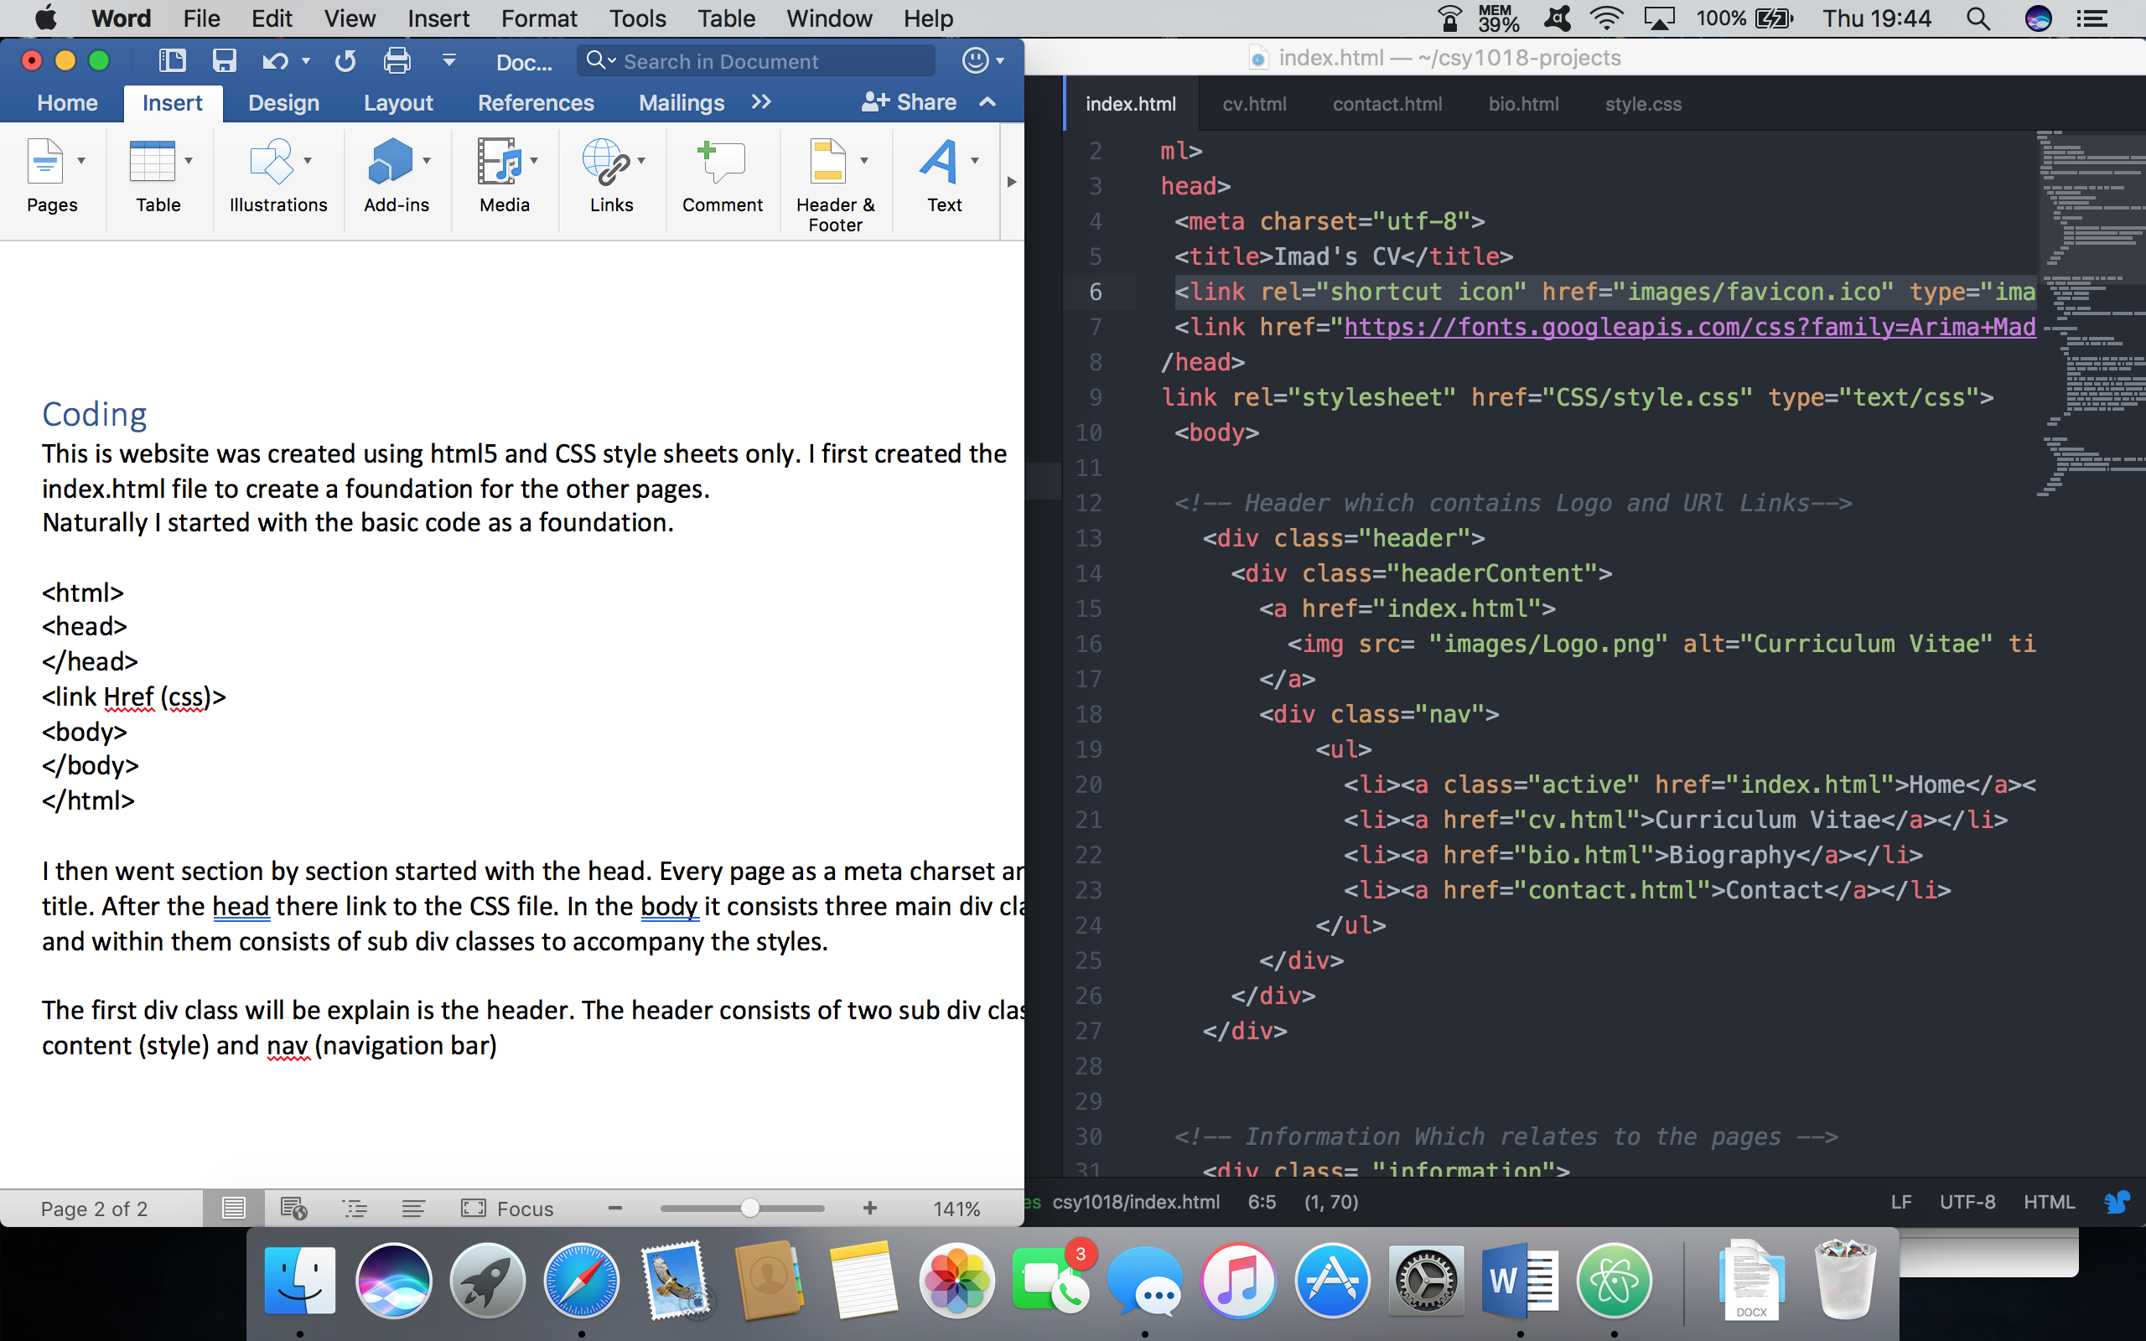

the header has the background colour and has information to adjust to screen size. The headContent has the logo inside and has be given a margin and image size and properties, next is the nav.

The nav div has a lot of properties inside first I created a list which has names of the all links needed. I then removed the bullet points and gave it a font style and size, I then changed the style to display the bar from left to right and gave it a background colour, button colour, active link colour, and hover colour to make it more appealing to the user.

The next set if main div was the information div. just like the header div it also has properties to suit all screen size and given margin and padding to make the website more appealing. Within the information div it has a sub div called information Content which has properties for the headings and the paragraph, which has the font style and font size. For the font style google fonts was used for the headings and the paragraph.

Lastly was the footer div again just like header and information div the same properties was used.

The three main div I have mentioned above stayed consistent throughout the four other pages

# Evidence of Good practise

## Images

Throughout the website I only used three images; My profile picture, the favicon and the

logo.

**The logo**



I used a logo generator using the world wide web the website is called <https://logomakr.com/5YqEqI>. Once you have access to the site it allows you to pick an image from the catalogue and allows the user to add text

**My profile Picture**

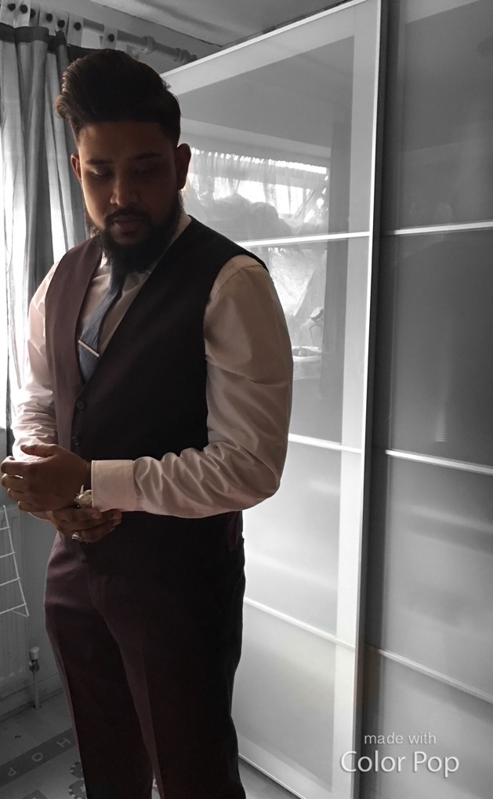

The profile was created using my IOS device (iPhone). Using the app called colour pop to make the background black and white and myself still in colour including the outfit. This image was used in the CV.html page

**Favicon**



The website I used to create the favicon was <http://www.favicon-generator.org>. which allows the user to create a favicon just by importing an image.

## Page Load Speed

When it comes to creating a website, it is also important to understand page loading speed, we all hate waiting for a page to load. So, test the loading speed on this website I used a website called PIngdom. As you can see the result below the website loaded in (…..)

## Visual Appeal

Visual appeal is one the most important factor as to attracts users to your website. It important to use colours that is appealing to the eyes for example not using bright colours, does it affect the user reading the content and not to use improper graphics. I tried to use colour that appealing yet modern. I also seek advice from friends and family to see if they agree with my choice

## Navigation

It is important to choose a location for the navigation where users can access the navigation bar that will allow the user to navigate the website more efficiently. It is important to make the bar easy to use and not having to many links or else the website will look cluttered. I chose to keep the bar at the top under the logo. This way user can easily can scroll up and find the bar without the need to trace back their steps to a certain page.

## The Website

Here is the finish product of the website

Index.html

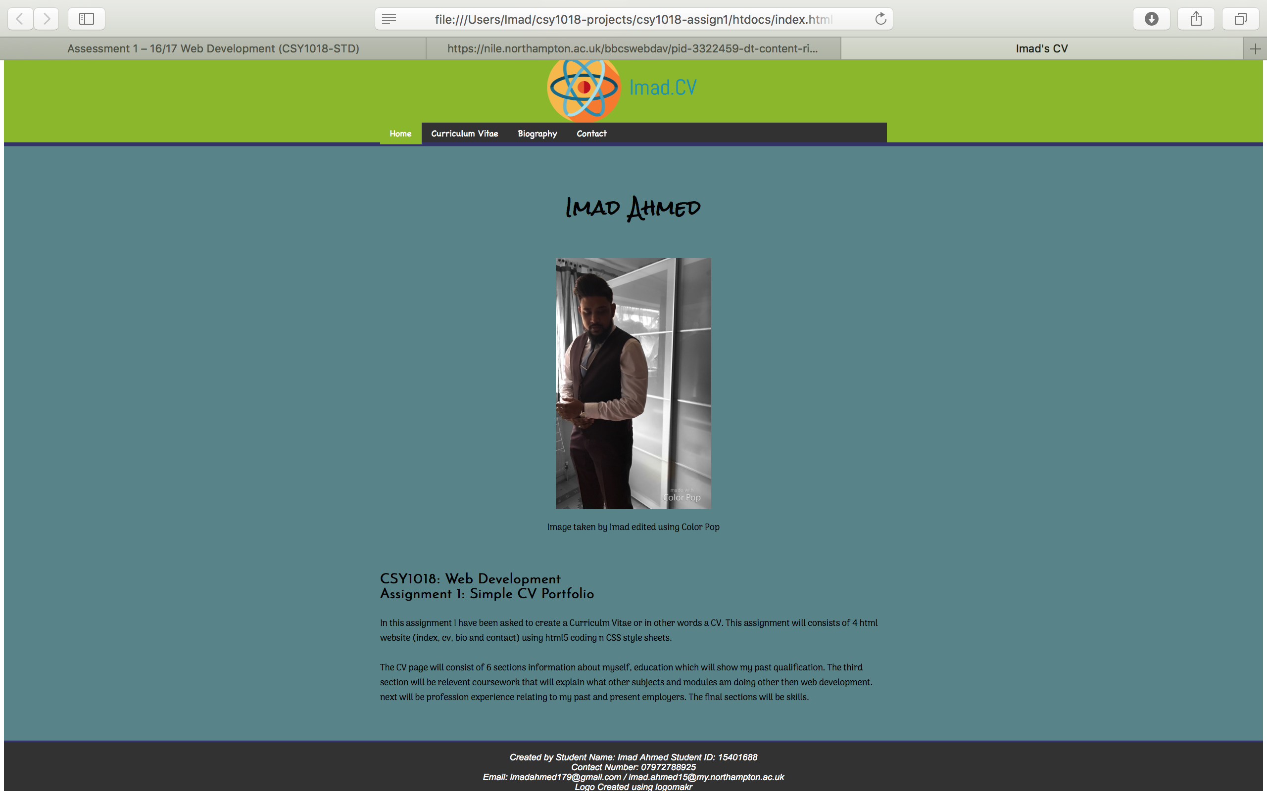

CV.html

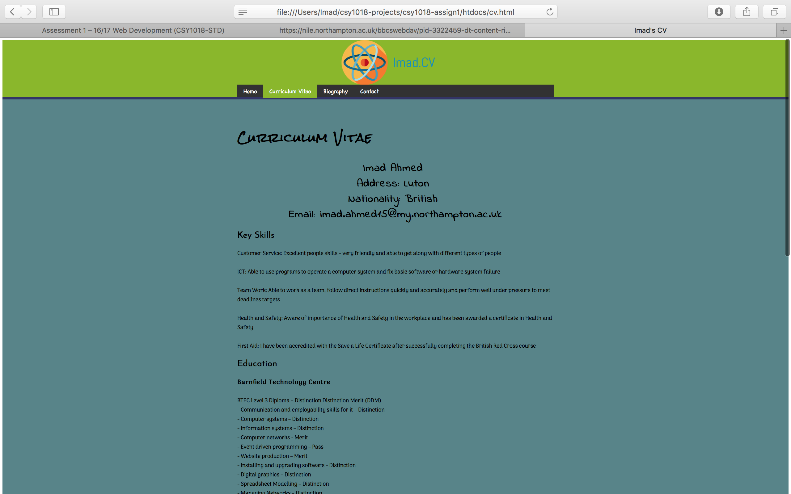

Contact.html

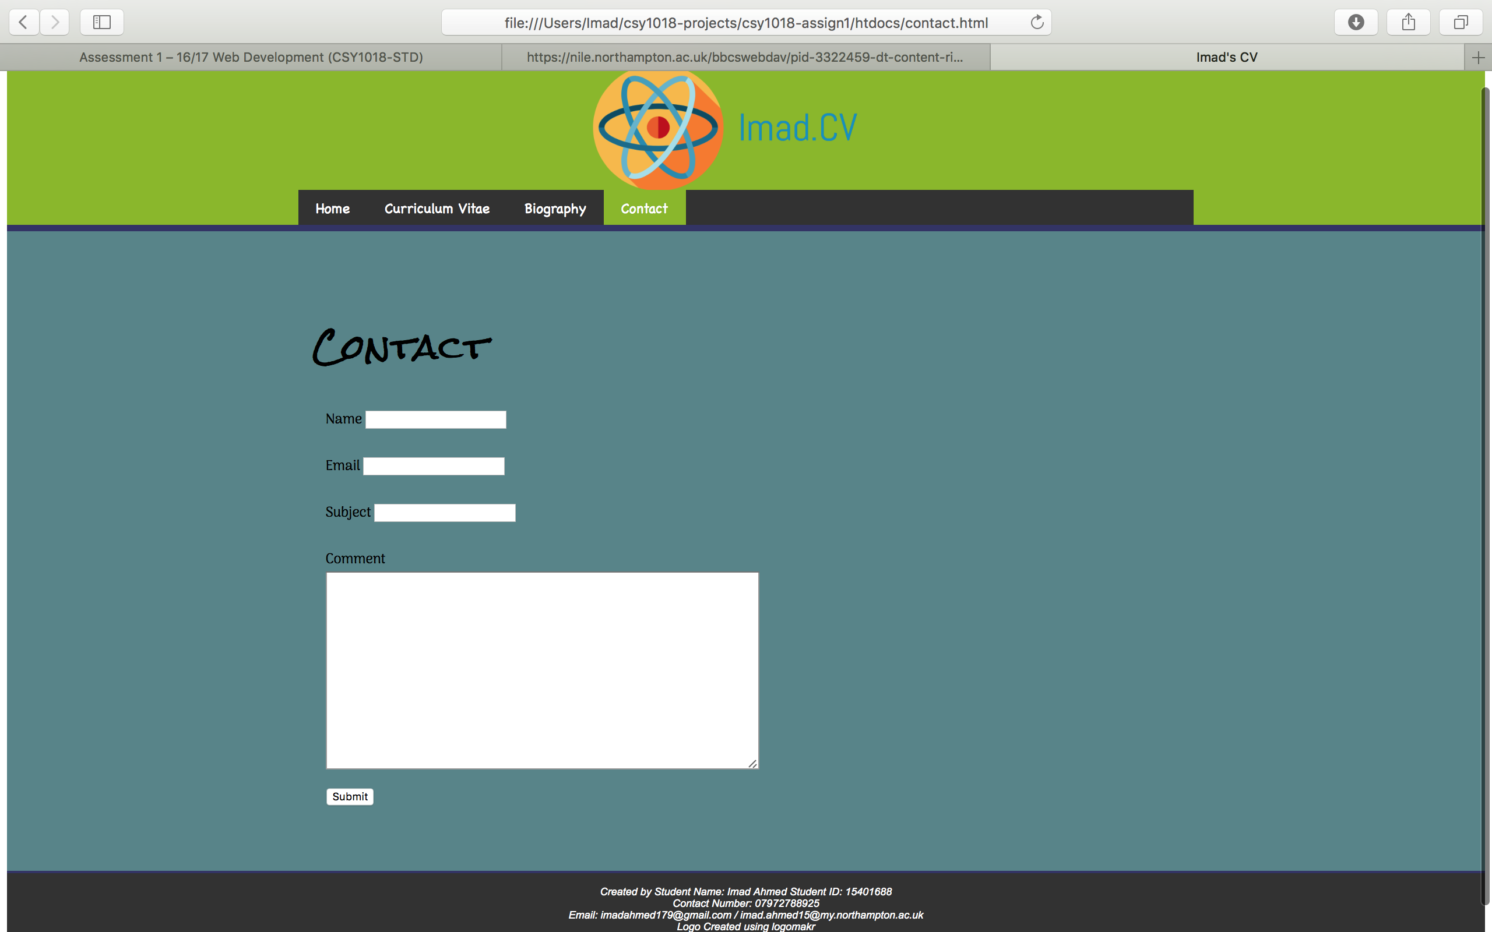

Bio.html

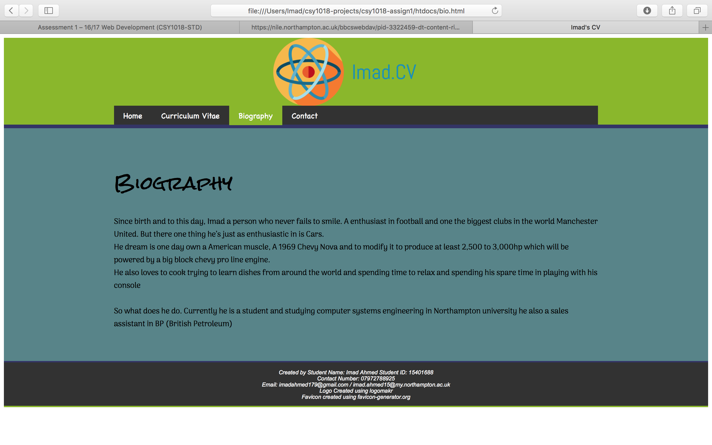

# Aspects of the Work Have Been Correctly Implemented

This part of the documentation will explain what areas and targets that where implemented within the website, I’ll also explain targets that wasn’t met.

**Targets that where met**

* The Website is available on GitHub
* Commenting is available on the html files
* The Site structure is correct
* The Doctype is HTML5 and HTML5 elements have been used
* Google Webfonts API have been used
* No filler text or lorem ipsum was used
* Wireframes have been included in the readme file
* Favicon is available

**Targets that wasn’t met**

* CSS flexbox was not used
* The logo image or icon wasn’t place in the upper left corner
* Commenting is not available on the CSS files