RE-11: Add Active Ingredient

Activity Diagram
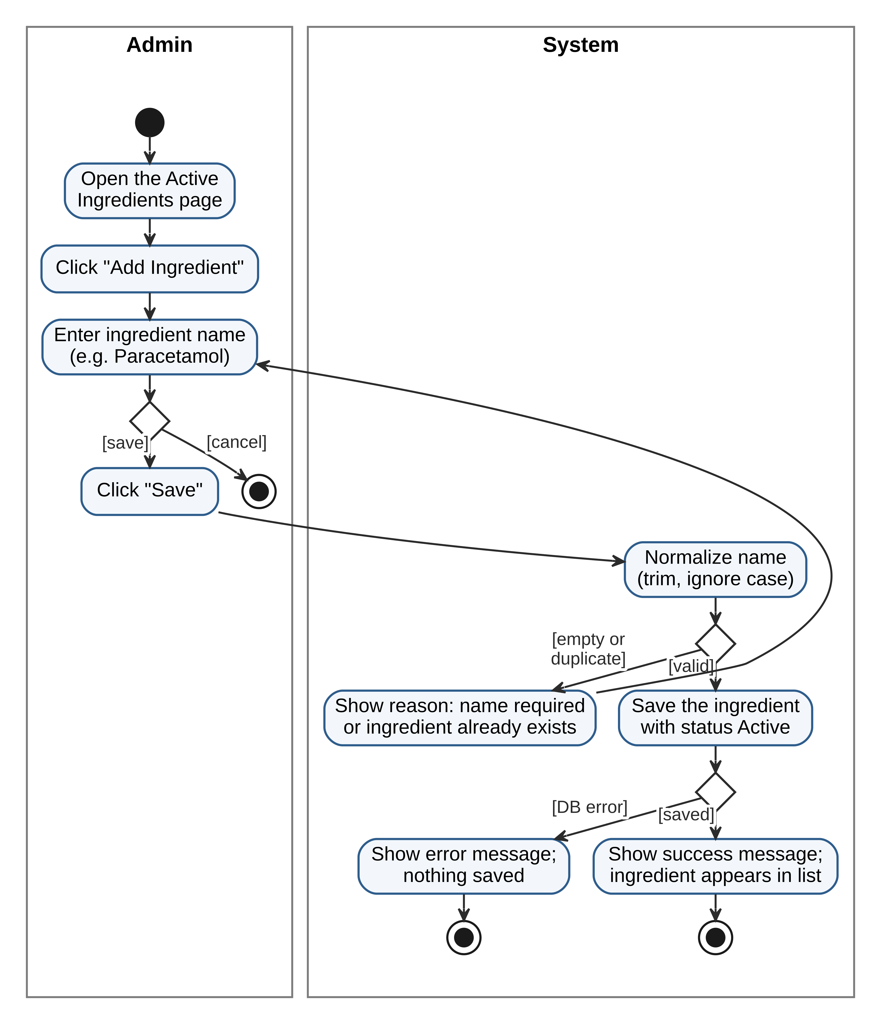

Sequence Diagram
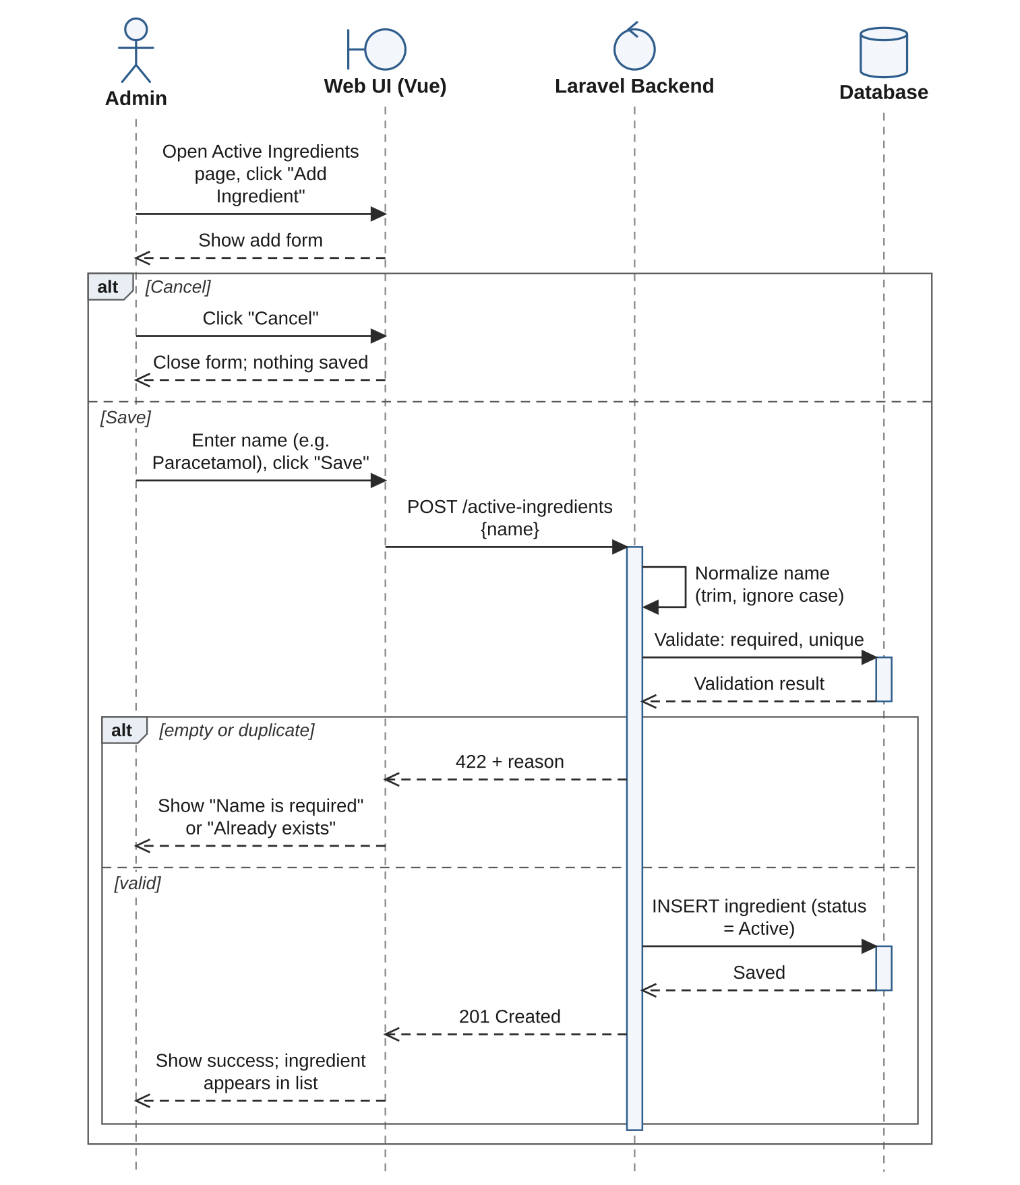

RE-12: Edit Active Ingredient

Activity Diagram
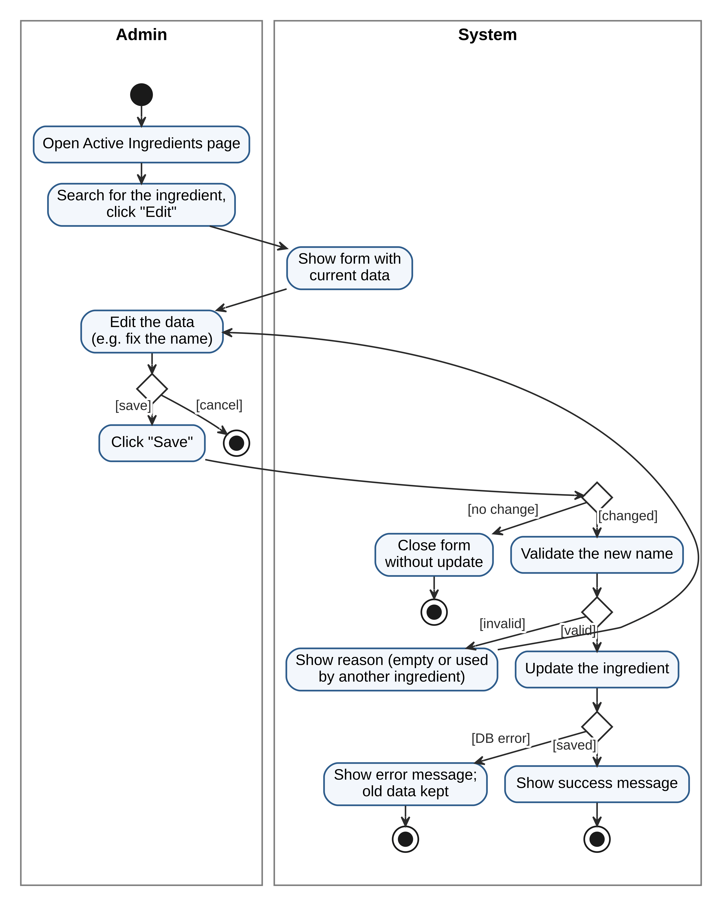

Sequence Diagram
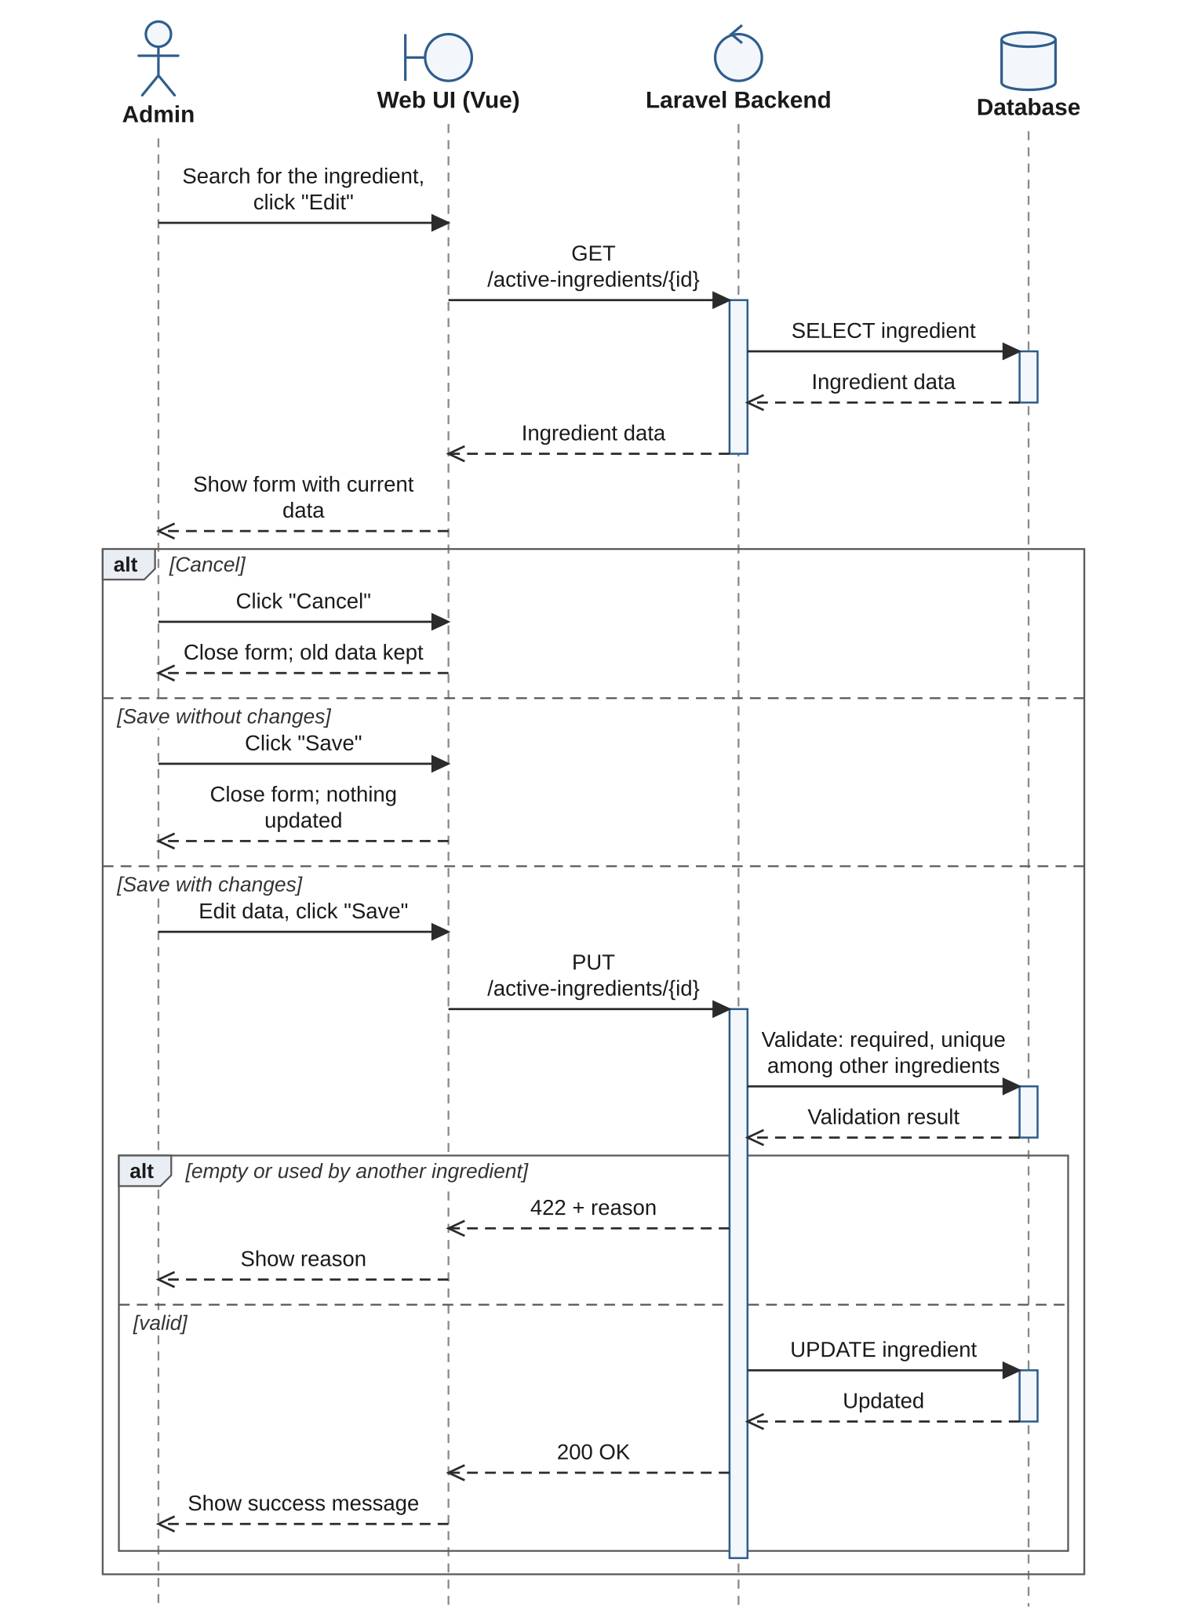

RE-13: Deactivate Active Ingredient

Activity Diagram
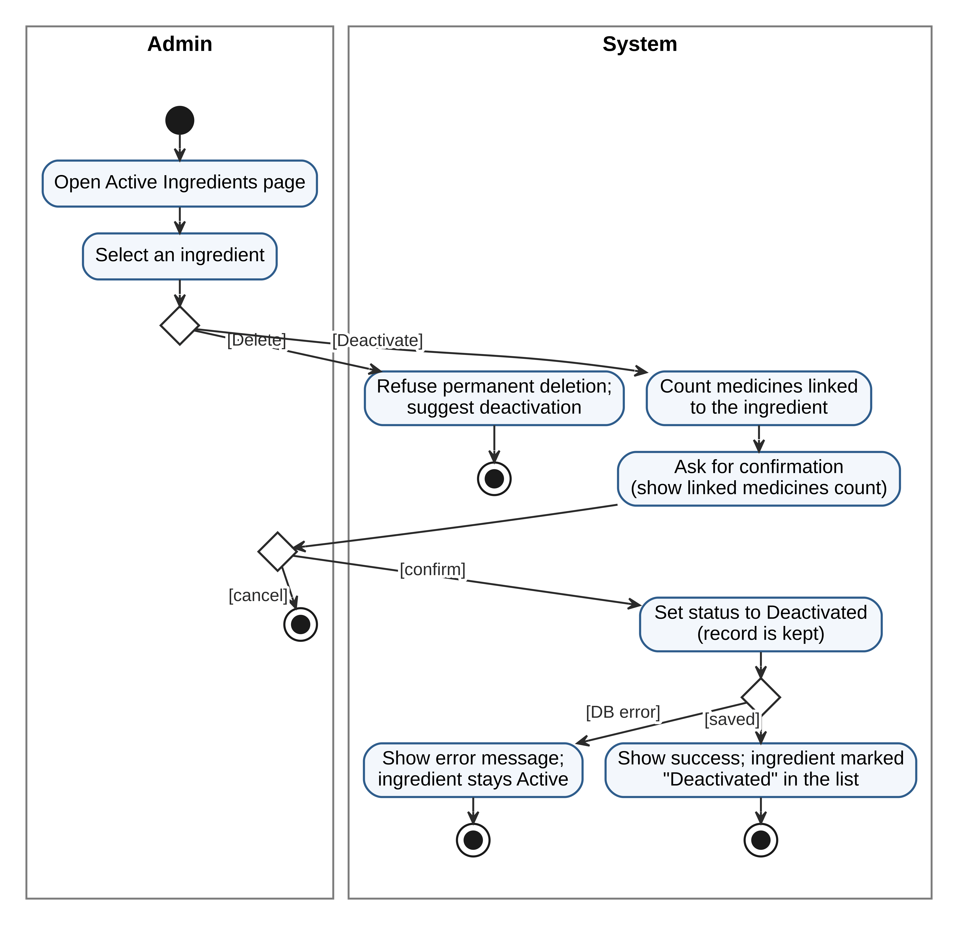

Sequence Diagram
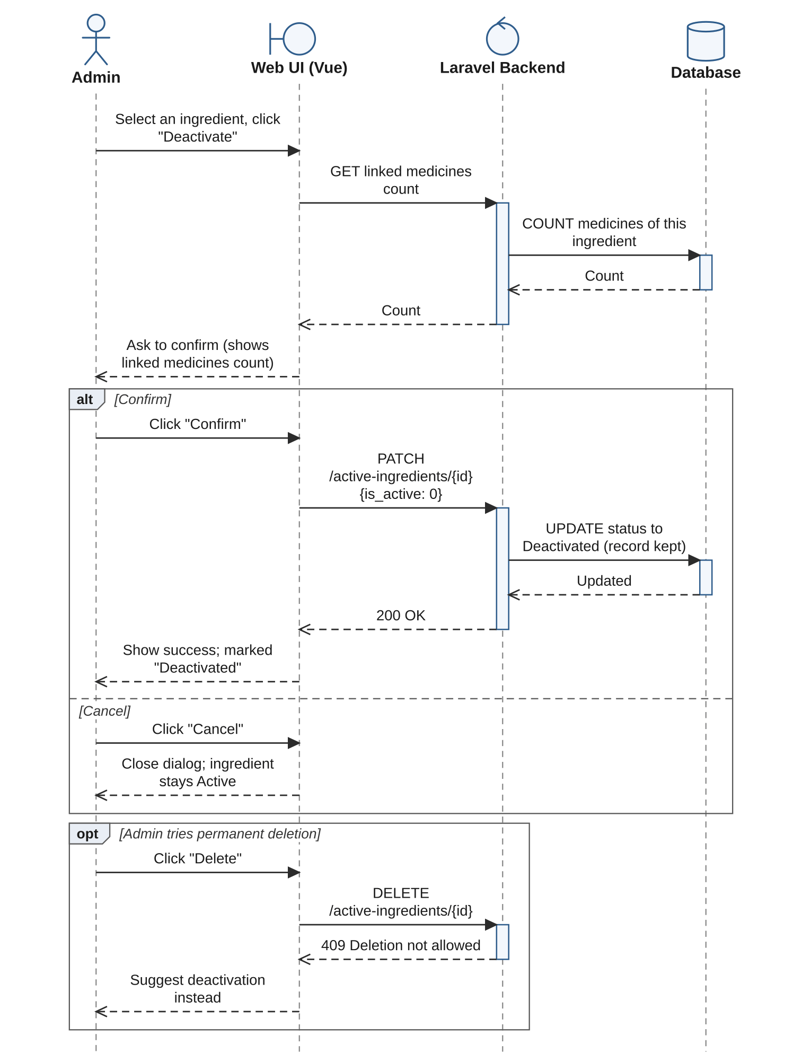

RE-14: Add Therapeutic Class

Activity Diagram
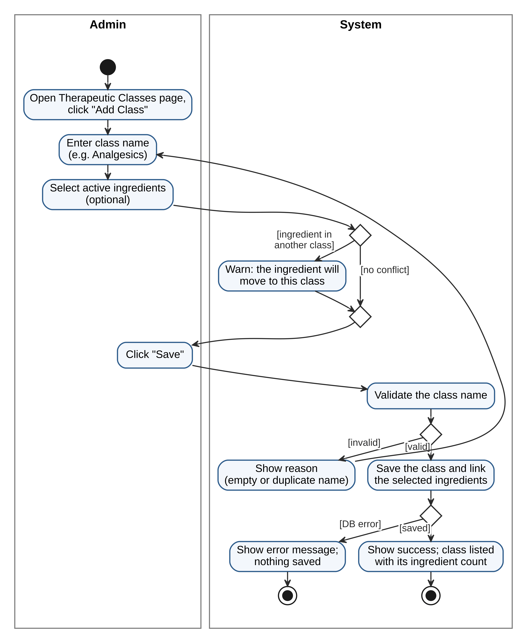

Sequence Diagram
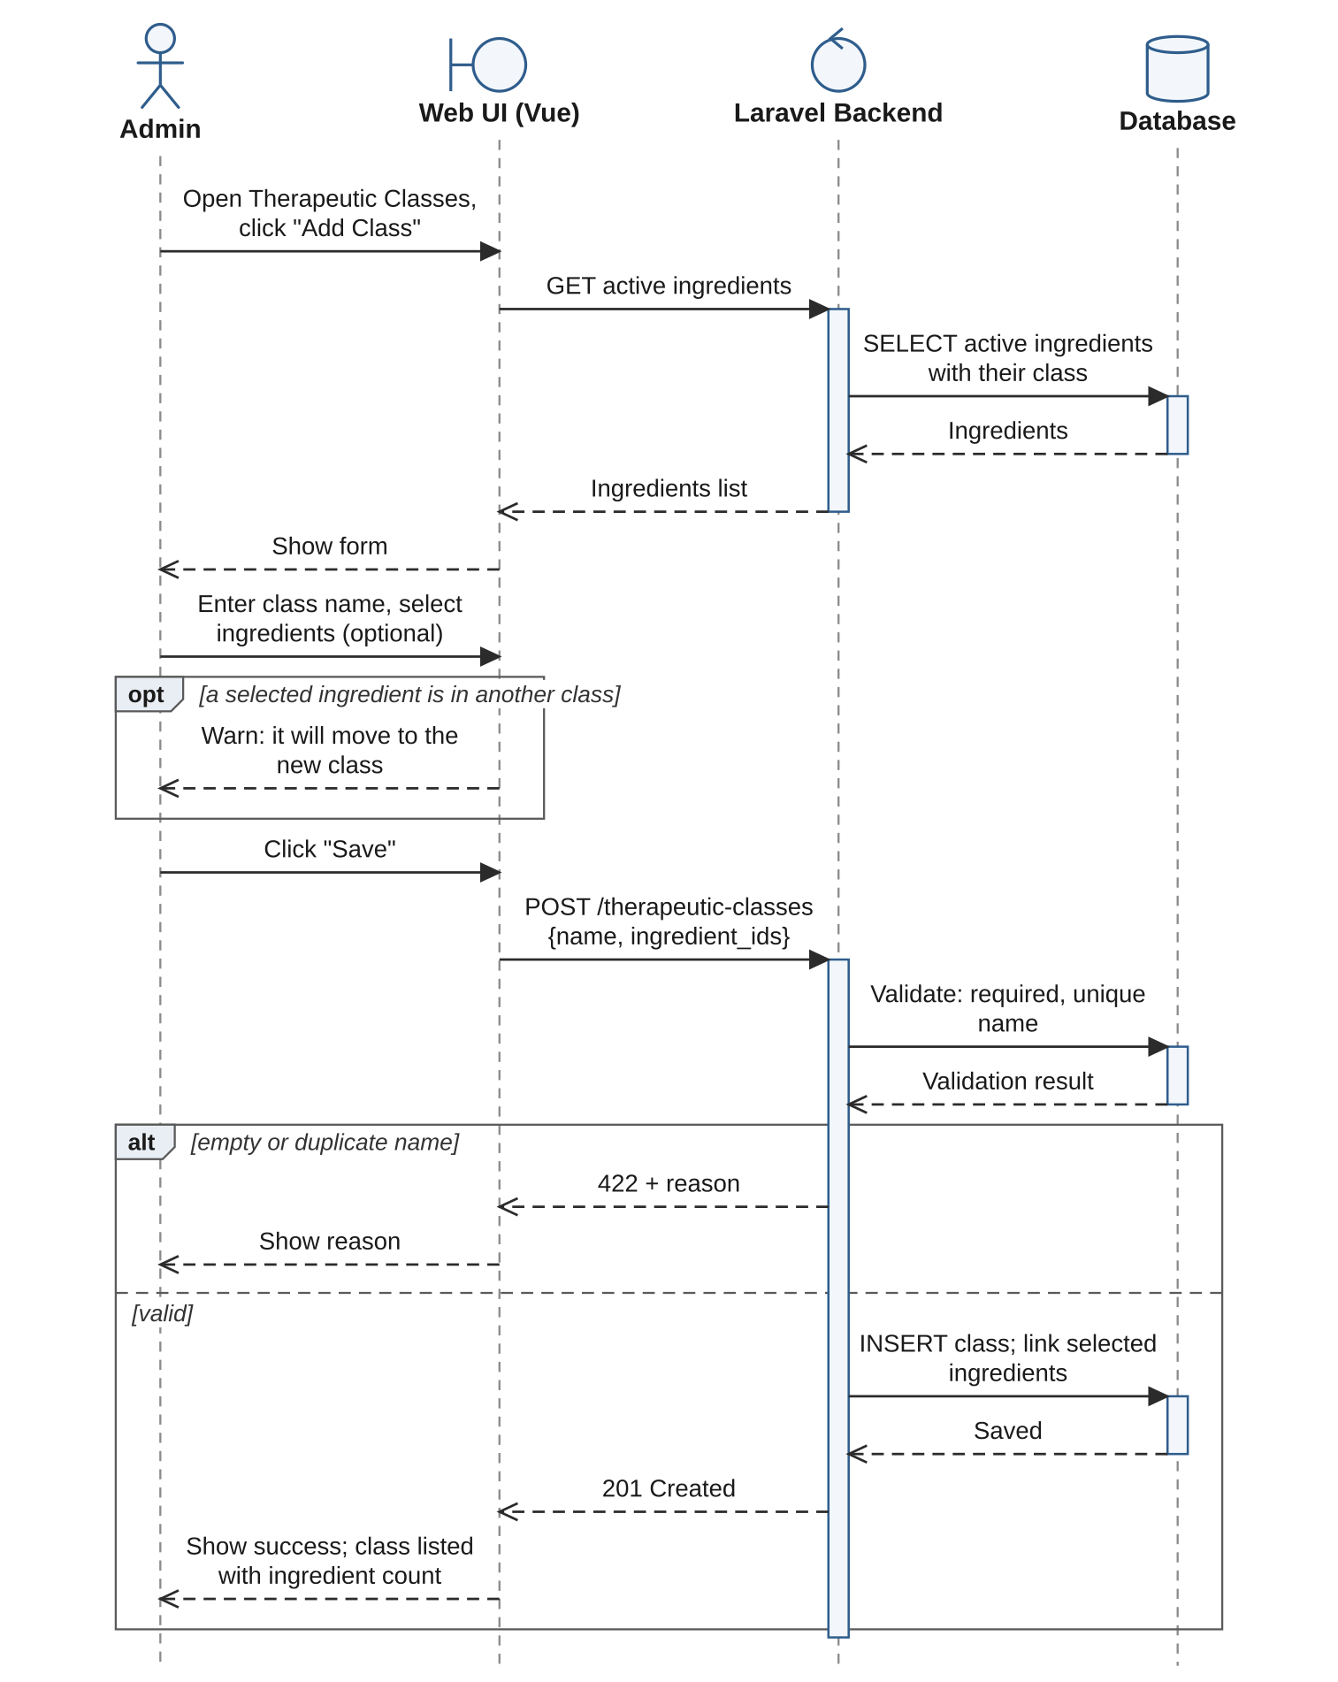

RE-15: Edit Therapeutic Class

Activity Diagram
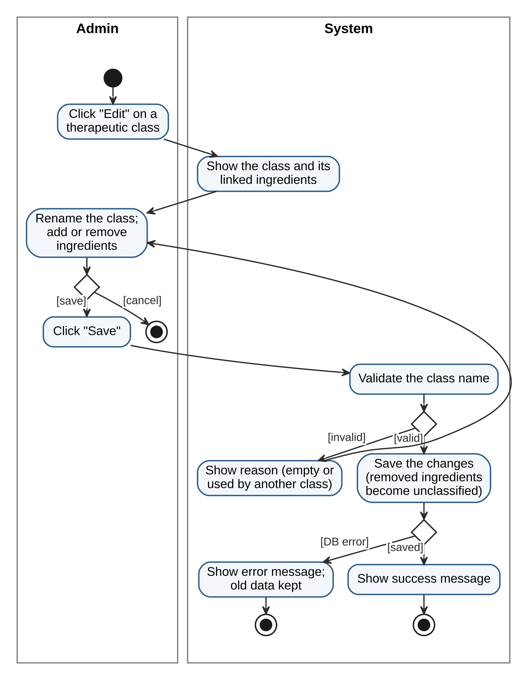

Sequence Diagram
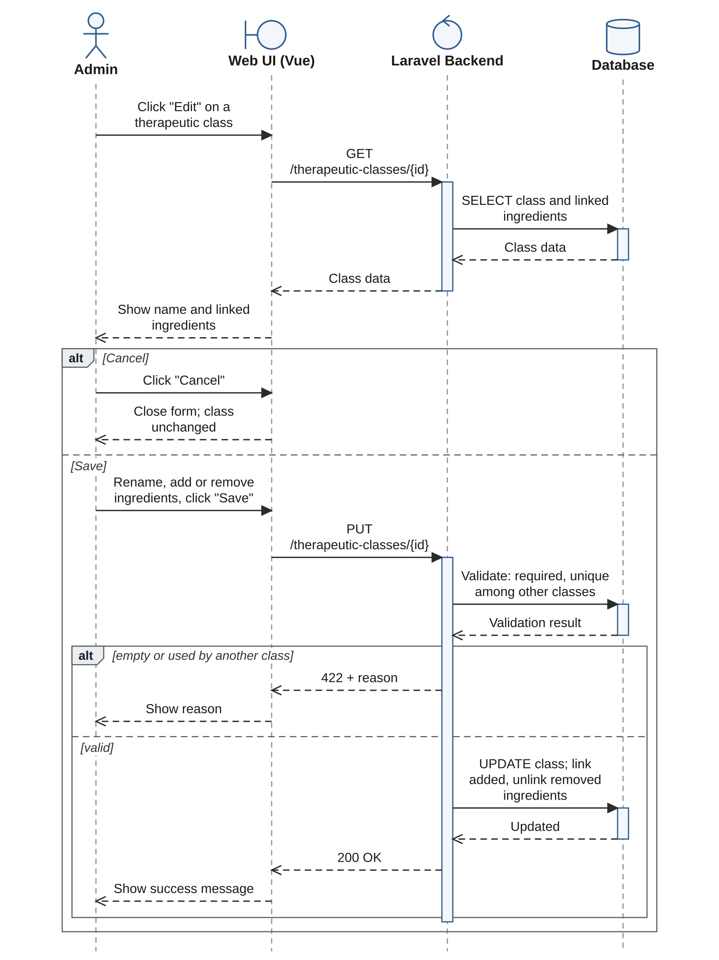

RE-16: Add Medicine to Inventory

Activity Diagram
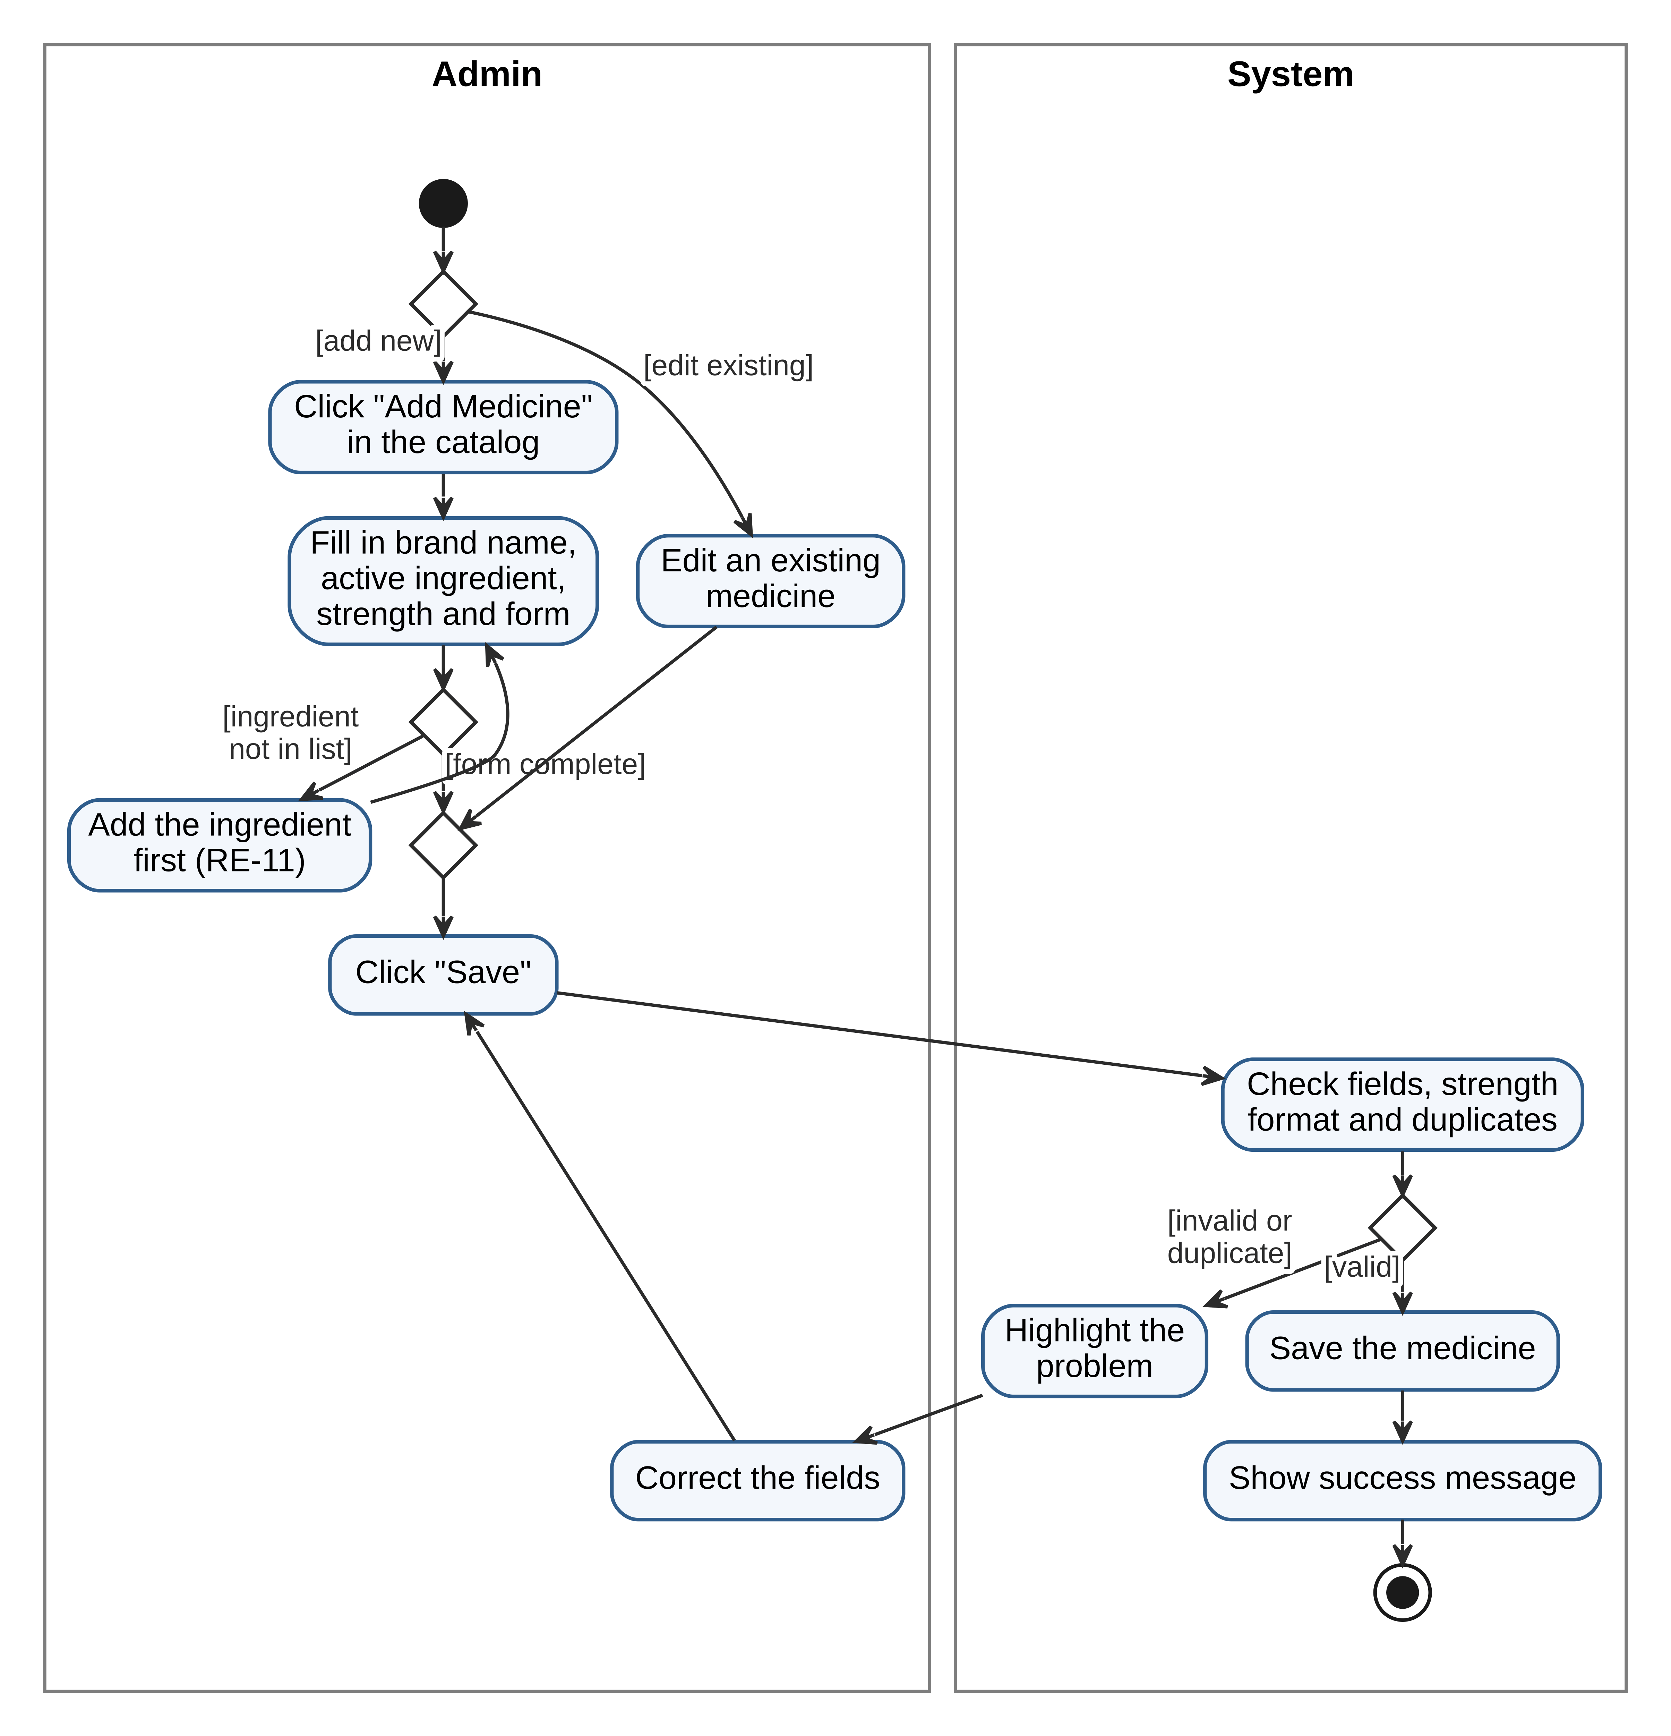

Sequence Diagram
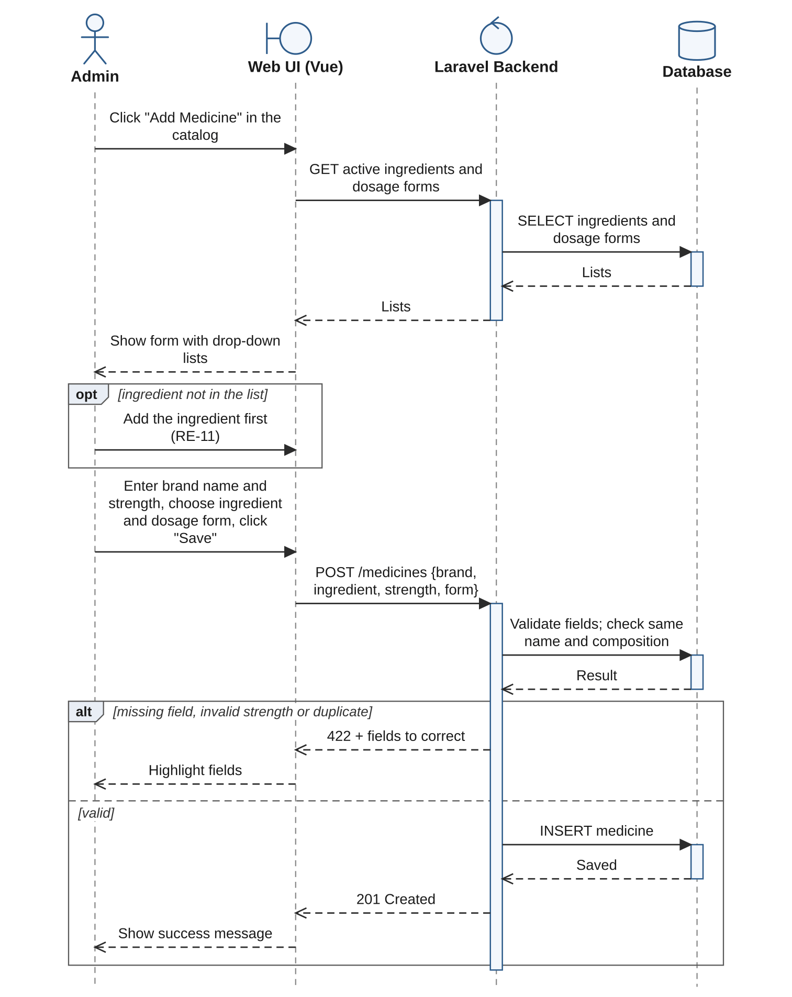

RE-17: Select Medicine from the Catalog When Adding It to Stock, Then Set the Quantity

Activity Diagram
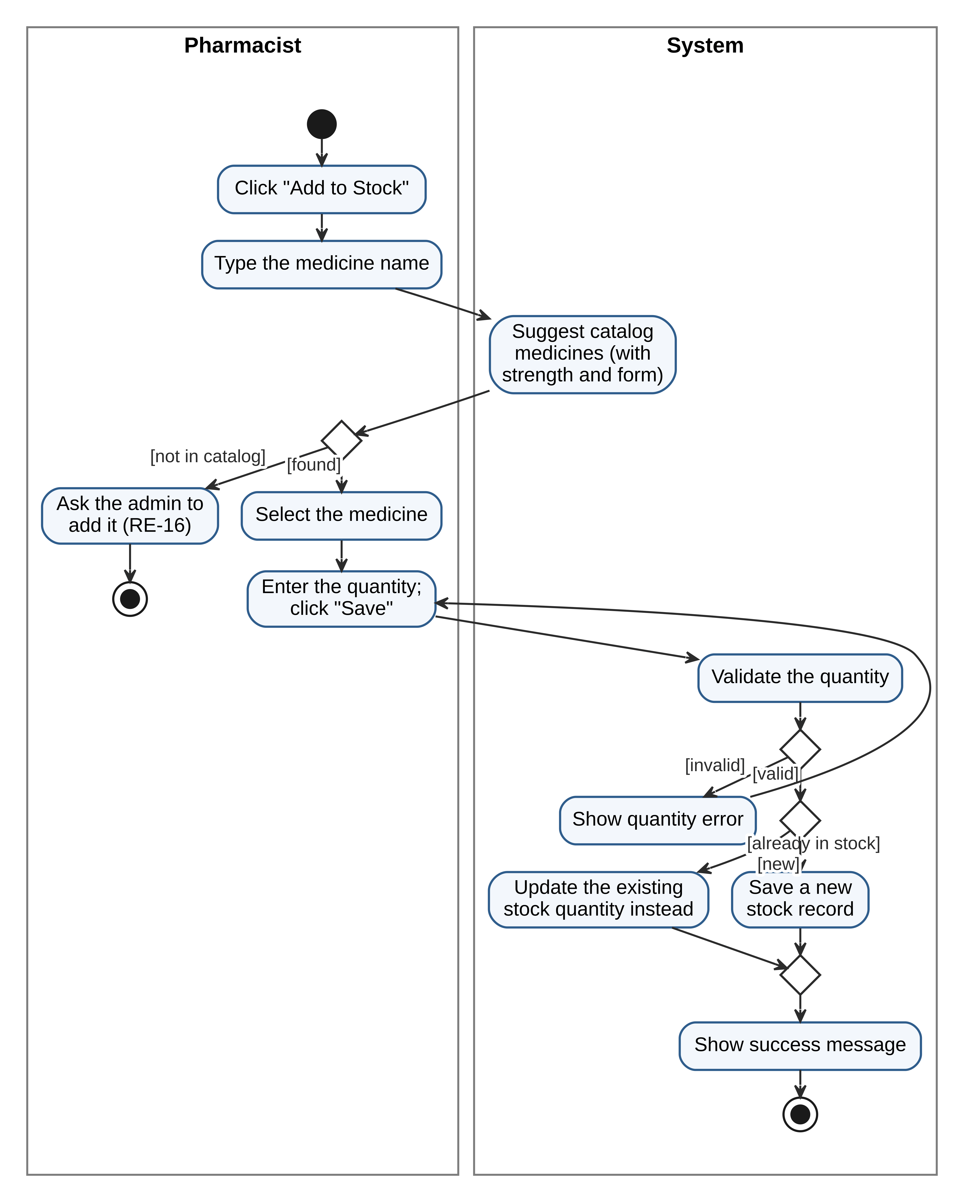

Sequence Diagram
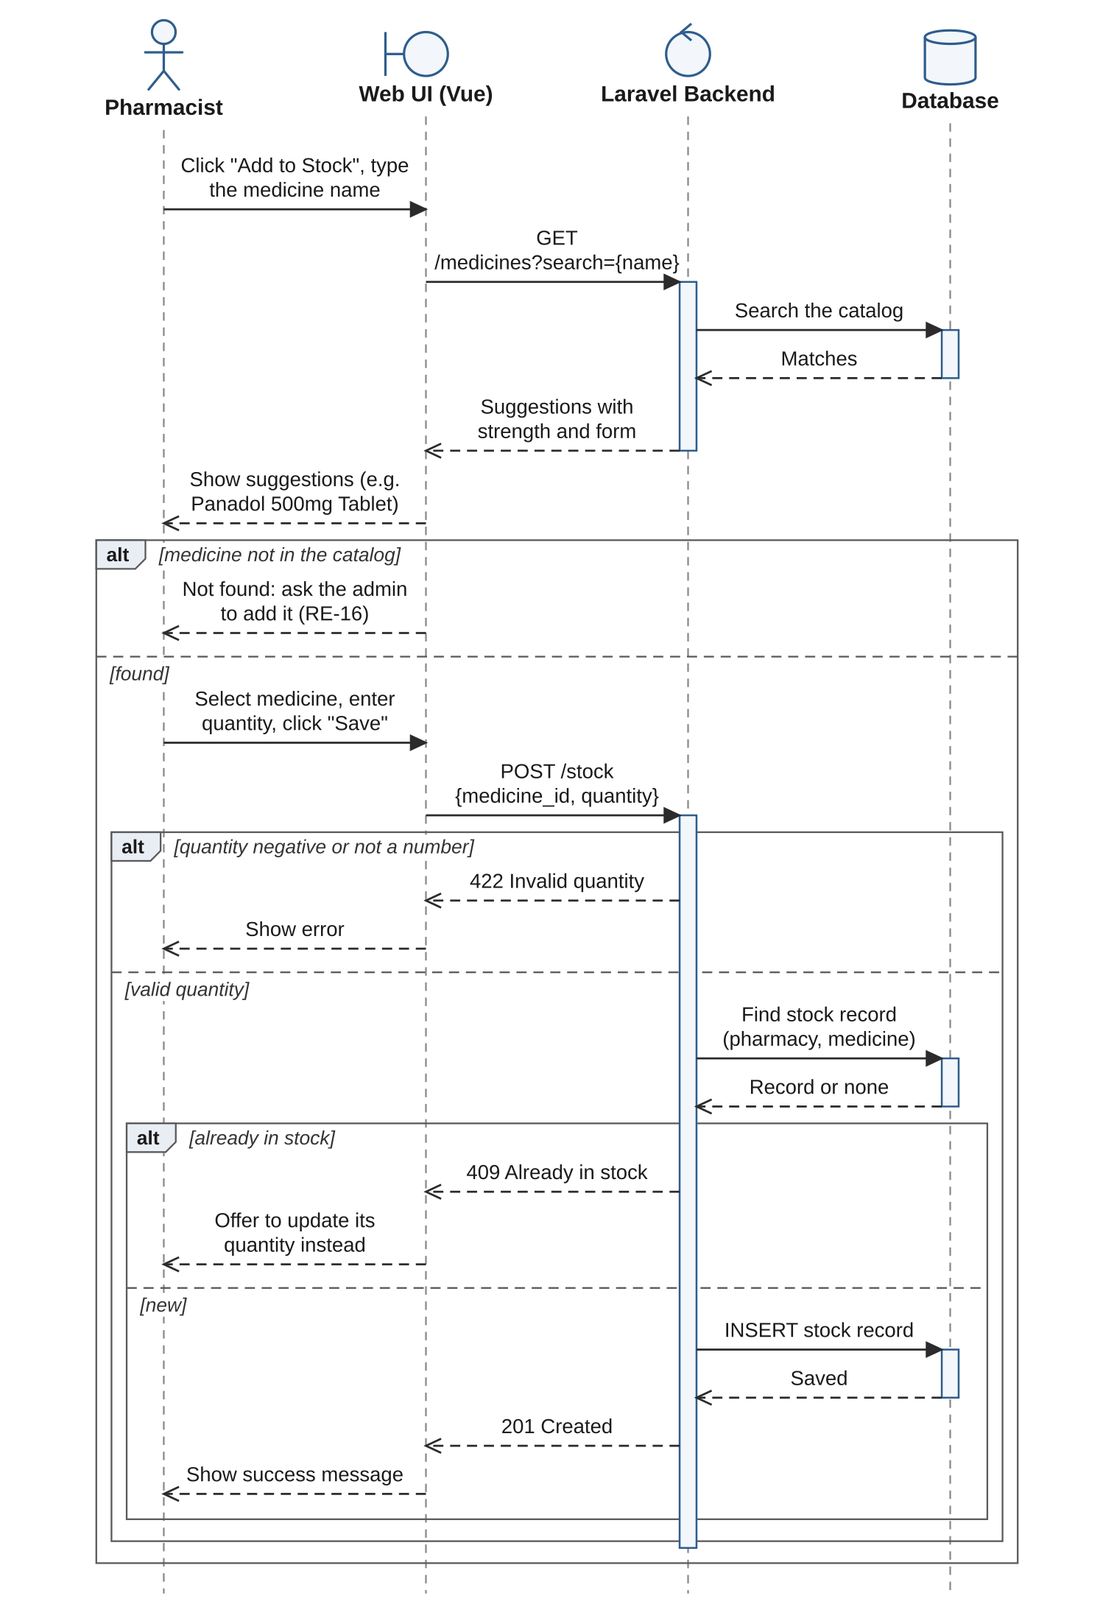

RE-18: View a Medicine's Active Ingredient, Strength, Dosage Form and Therapeutic Class

Activity Diagram
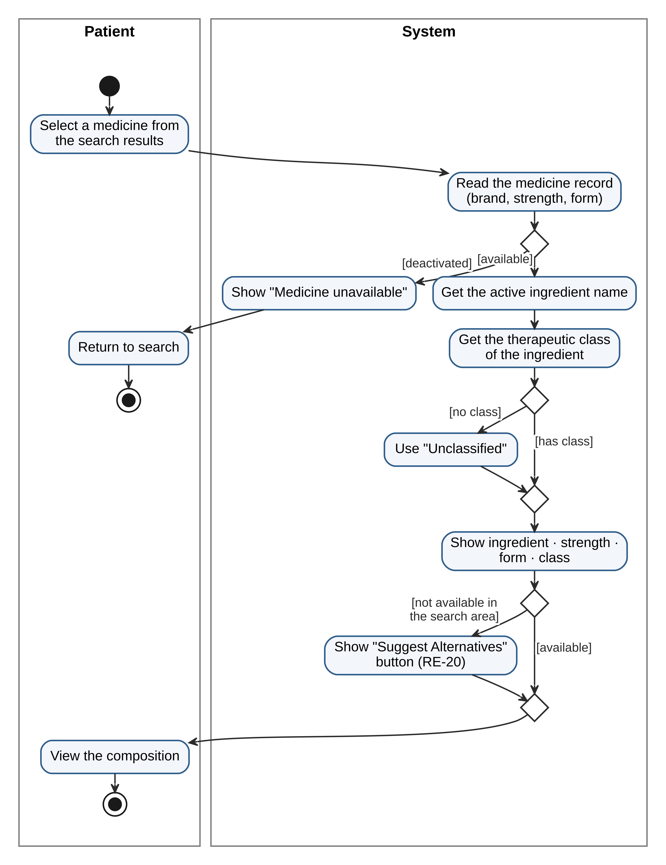

Sequence Diagram
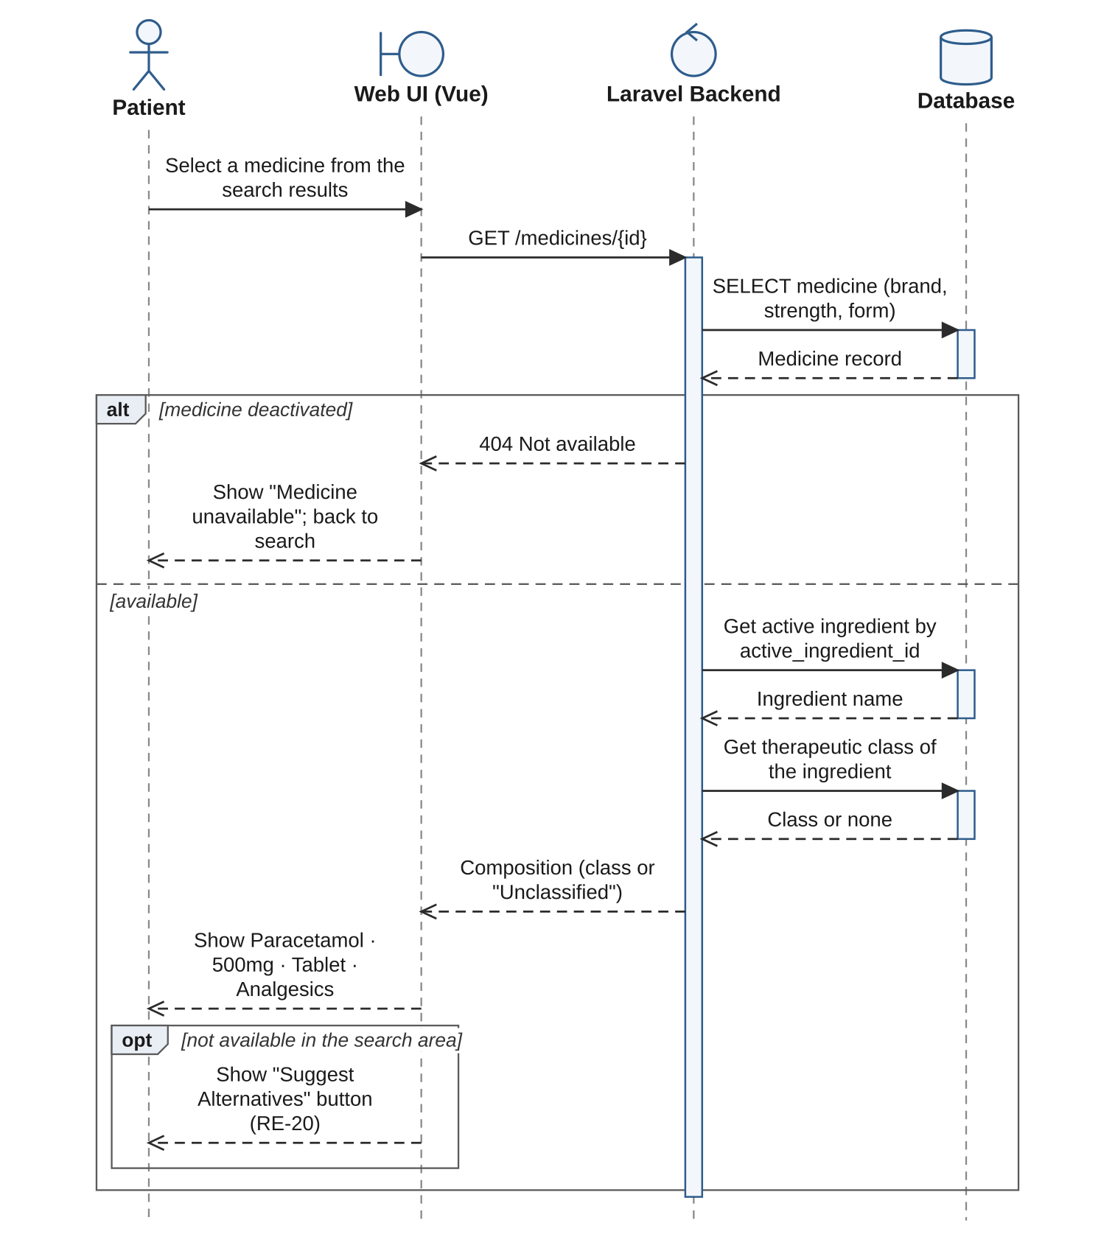

RE-19: Search Medicines by Active Ingredient Name

Activity Diagram

Sequence Diagram
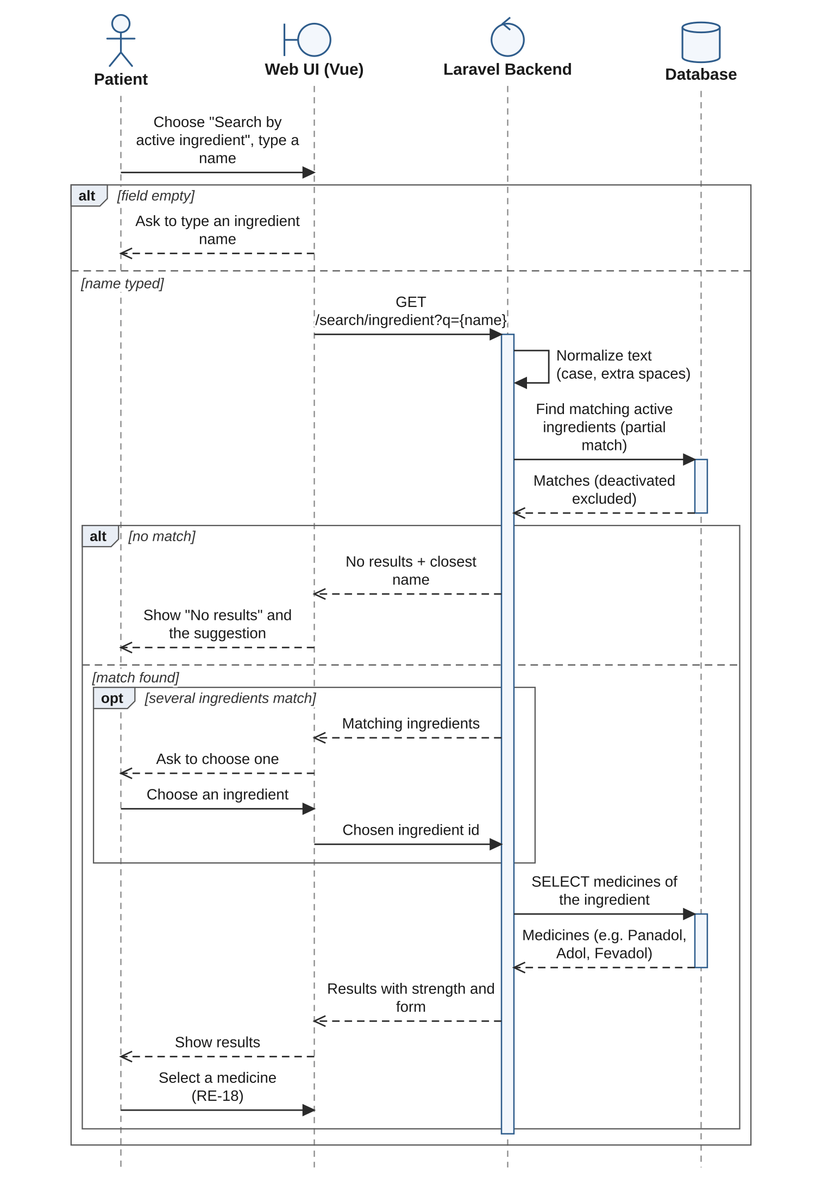

RE-20: Request Alternatives When a Medicine Is Unavailable Within the Search Area

Activity Diagram

Sequence Diagram
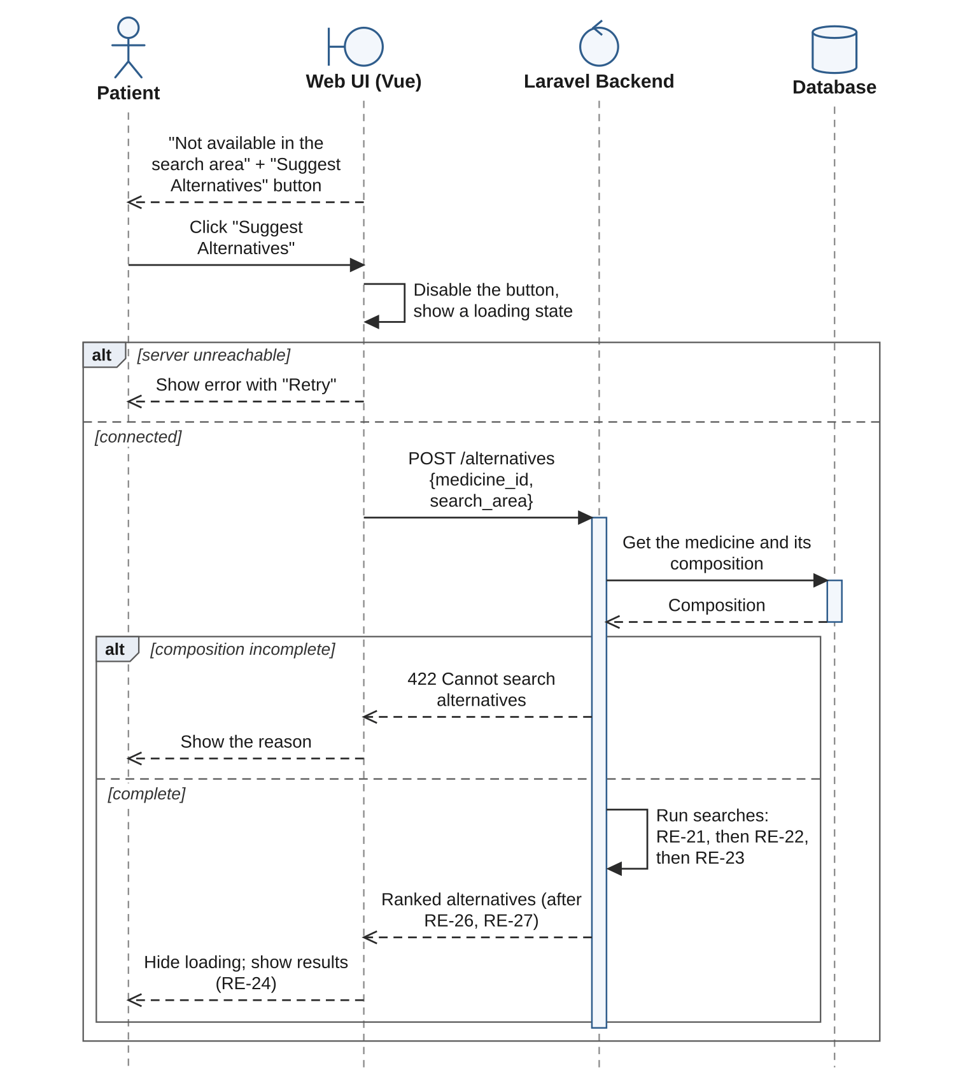

RE-21: Find Alternatives with the Same Active Ingredient, Strength and Dosage Form

Activity Diagram

Sequence Diagram
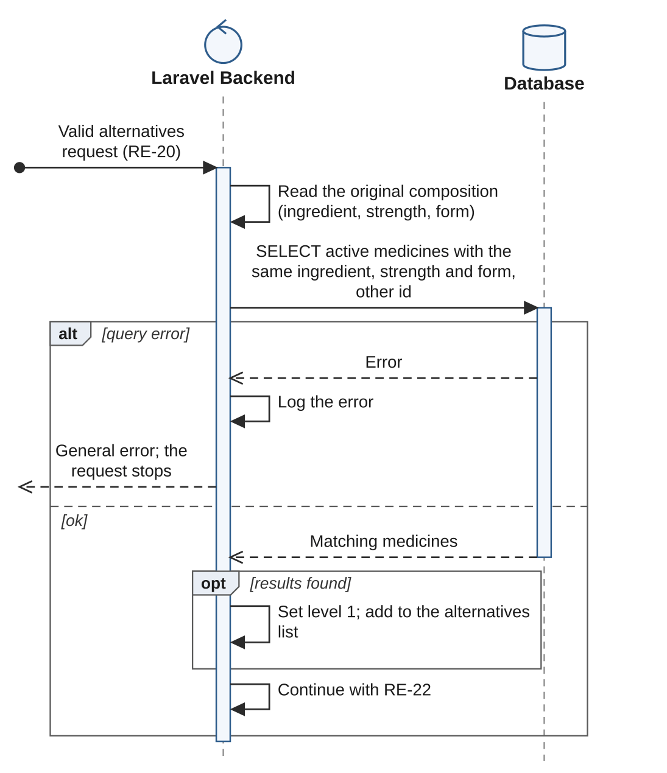

RE-22: Find Alternatives with the Same Active Ingredient but a Different Strength or Dosage Form

Activity Diagram

Sequence Diagram
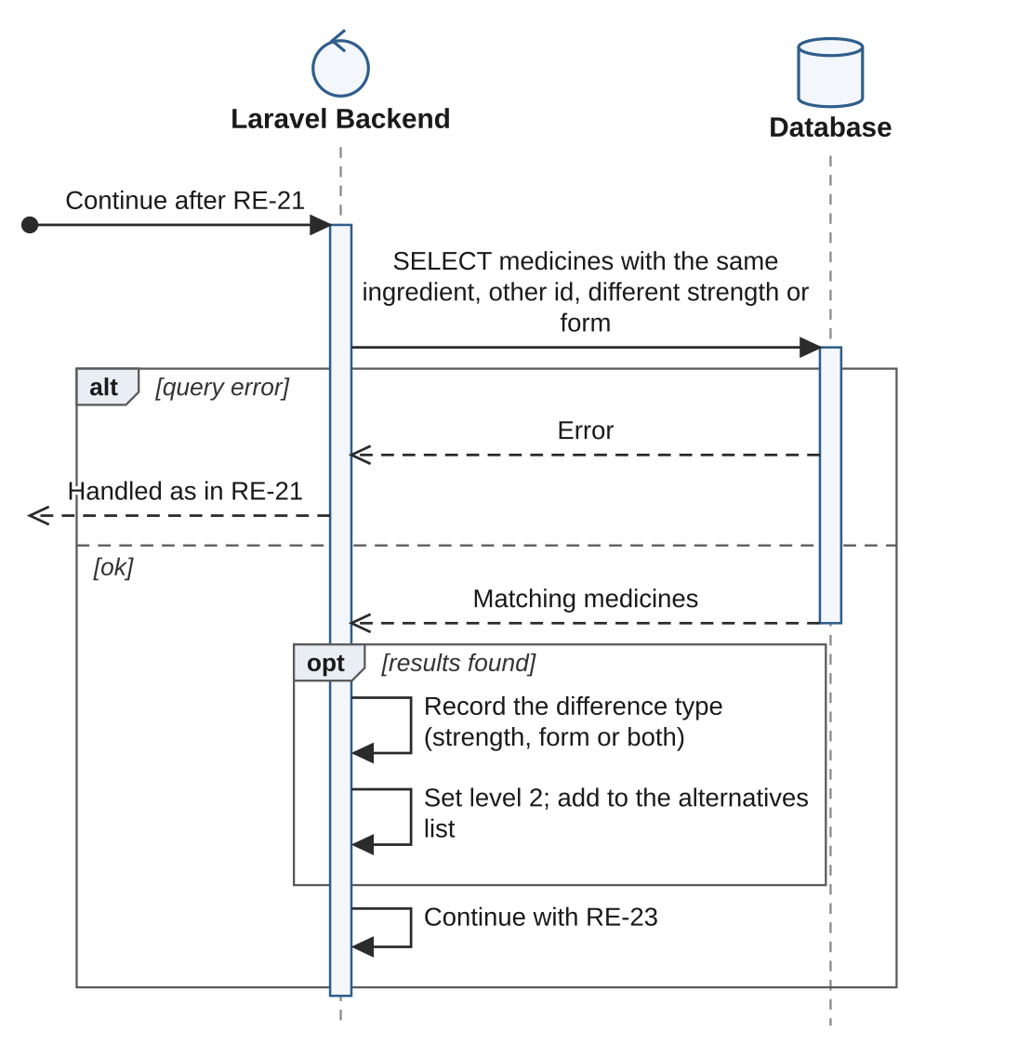

RE-23: Find Alternatives from the Same Therapeutic Class

Activity Diagram

Sequence Diagram
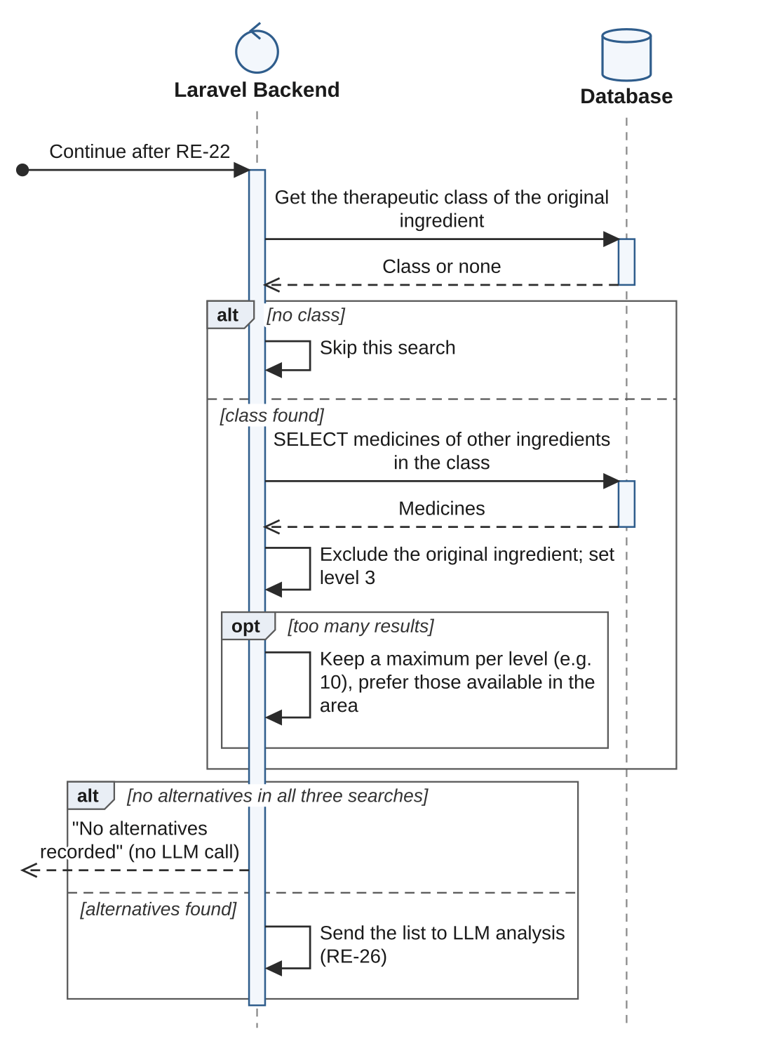

RE-24: Display Alternatives with Similarity Level, Suggestion Reason and Medical Disclaimer

Activity Diagram

Sequence Diagram

RE-25: Compare the Original Medicine with a Selected Alternative

Activity Diagram

Sequence Diagram

RE-26: Analyze the Original Medicine and Matching Alternatives Using an LLM Service

Activity Diagram

Sequence Diagram

RE-27: Rank Alternatives: Level First, Then the LLM Result Within Each Level

Activity Diagram

Sequence Diagram

RE-28: Display Pharmacies Within the Search Area That Have the Alternative, with Their Count

Activity Diagram

Sequence Diagram

RE-29: Display Pharmacies That Have the Alternative on a Map

Activity Diagram

Sequence Diagram

RE-30: Manage Patient Profile

Activity Diagram

Sequence Diagram

RE-31: Manage Pharmacist Profile

Activity Diagram

Sequence Diagram

