THESIS ARCHITECTURE PROPOSAL
Predictive Cloud-Native Mobile Edge
Optimized Task Offloading Architecture for Vehicular IoT Networks

A proactive 3-tier IoT–Fog–Cloud continuum orchestrating DAG microservice chains
using Deep Reinforcement Learning, MMDE-NSGA-II offline optimisation, SDN-managed networking,
and GPS-driven proactive mobility handoff.

1. Executive Summary
This document presents the complete proposed architecture for a thesis on optimized task offloading in IoT–Fog–Cloud systems. The architecture addresses five interconnected research problems that no single published system has solved together:

- The Boulder Problem: compute-heavy tasks crashing fog nodes (solved by TOF-Broker, from Paper 2).
- The Cold-Start Problem: RL agents making poor decisions before they have learned anything (solved by pre-training on NSGA-II Pareto solutions).
- The Static Optimisation Problem: NSGA-II is too slow for real-time decisions (solved by DQN Agent 1 as the live decision-maker).
- The Network Congestion Problem: task data competing with background traffic and causing delays (solved by RL Agent 2 managing SDN flow rules proactively).
- The Mobility Problem: tasks failing when vehicles move between fog zones mid-computation (solved by GPS-based trajectory prediction + NTB/HTB fallback buffers).

NOVELTY CLAIM | No published system combines all five solutions: TOF-MMDE-NSGA-II offline optimizer + DQN Agent 1 (compute placement) + DQN Agent 2 (SDN routing) + proactive GPS-based handoff + NTB/HTB fallback. This pipeline is the original contribution of this thesis.

2. System Architecture — Three-Tier Overview
The system is organised into three strictly defined tiers connected by a software-defined physical network. The fog layer acts as the intelligent brain — it houses all decision-making logic and AI agents. The IoT layer generates tasks. The cloud layer handles overflow.

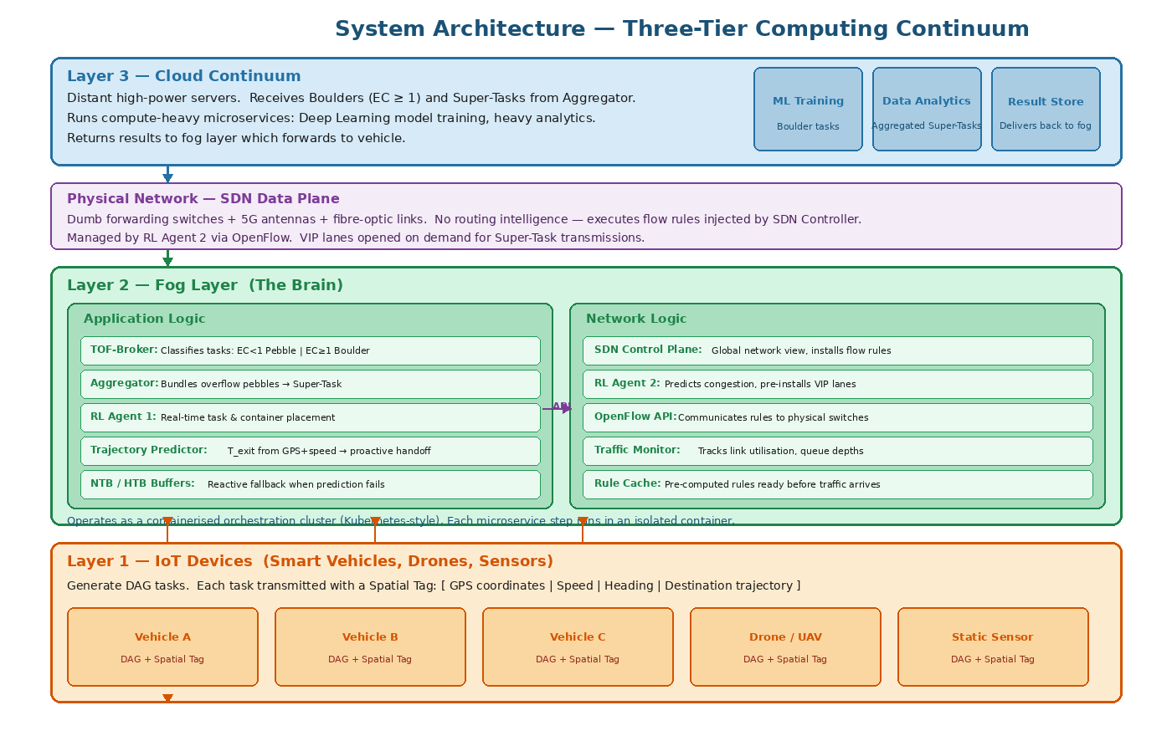
Figure 1: Three-tier system architecture. Layer 1 (IoT vehicles) generates DAG tasks with Spatial Tags. Layer 2 (Fog) contains all intelligence: TOF-Broker, Aggregator, RL Agent 1, trajectory predictor, NTB/HTB buffers, SDN Controller, and RL Agent 2. The SDN Data Plane is the physical network. Layer 3 (Cloud) receives boulders and Super-Tasks.

2.1 Layer 1 — IoT Devices (Smart Vehicles, Drones, Sensors)
IoT devices are the task generators. In the vehicular scenario, each smart car acts as a mobile IoT node. Every 100ms, the on-board camera captures a frame. The device cannot run a full object detection model locally — it is computationally infeasible. The device must offload.

Every task transmitted by an IoT device includes two components:

- DAG task: a Directed Acyclic Graph of dependent microservice steps. Each step has a computational demand (MI), data size (MB), and deadline contribution. Example: Capture → Compress → Extract Features → Classify Objects → Generate Alert.
- Spatial Tag: a telemetry header appended to every task. Contains: current GPS coordinates (latitude, longitude), velocity (km/h), heading direction (degrees from north), and projected trajectory (next 30 seconds of predicted path).

The Spatial Tag is the core innovation at Layer 1. Without it, the fog layer cannot predict where the vehicle will be when the task finishes executing — it can only react to disconnections after they occur. The Spatial Tag enables proactive placement and eliminates most handoff failures.

2.2 Physical Network — SDN Data Plane
The physical network between all three layers consists of 5G antennas, fibre-optic links, and forwarding switches. These switches are deliberately dumb — they hold no routing intelligence. They do exactly one thing: look up incoming packets against a flow table of rules and forward packets out the correct port.

All routing intelligence is separated into the SDN Control Plane (housed in the Fog Layer). This decoupling means the entire network can be reprogrammed in milliseconds from a single location — without touching physical hardware. When RL Agent 2 decides that a VIP lane is needed for a large Super-Task transmission, the Controller installs the corresponding flow rules on all switches simultaneously.

2.3 Layer 2 — Fog Layer (The Brain)
The fog layer is the most complex component of the system. It operates as a containerised orchestration platform — analogous to a localised Kubernetes cluster. Every microservice step runs in an isolated container that can be created, migrated, paused, or terminated in milliseconds.

The fog layer is divided into two logical subsystems: Application Logic and Network Logic.

Component | Role and function
TOF-Broker | First point of contact for every incoming task. Computes Execution Cost (EC = task_MI / fog_MIPS) for each DAG step. Routes boulders (EC ≥ 1.0) directly to the cloud. Queues pebbles (EC < 1.0) for RL Agent 1.
Aggregator | Monitors the pebble queue. When queue depth exceeds threshold (pebble avalanche risk), bundles hundreds of small pebble tasks into a single compressed Super-Task and forwards to cloud via SDN VIP lane.
RL Agent 1 | The live task placement brain. Pre-trained on NSGA-II Pareto solutions. Observes current fog loads, task properties, and vehicle spatial data. Makes millisecond placement decisions for each pebble step.
Trajectory Predictor | Parses Spatial Tags. Computes T_exit (time until vehicle leaves current fog zone). Compares T_exit with T_exec (estimated task execution time). Triggers proactive migration if T_exec > T_exit.
NTB / HTB Buffers | Two-tier fallback system. New Task Buffer (NTB) is the normal queue. Handoff Task Buffer (HTB) is the high-priority queue for in-flight tasks when vehicle disconnects unexpectedly.
SDN Control Plane | Maintains global view of the physical network. Receives routing commands from RL Agent 2. Translates them into OpenFlow flow rules installed on physical switches.
RL Agent 2 | The live network routing brain. Pre-trained on historical city traffic patterns. Predicts upcoming congestion and pre-installs SDN flow rules before traffic arrives.

2.4 Layer 3 — Cloud Continuum
The cloud layer is the ultimate computational backstop. It receives two types of workloads: (1) boulders — individual DAG steps with EC ≥ 1.0 that are too heavy for fog processing; and (2) Super-Tasks — aggregated bundles of pebbles that overflow the fog's queue capacity.

The cloud runs GPU-accelerated compute for tasks like deep learning model inference and large-scale data analytics. It returns results to the fog layer, which forwards them to the vehicle via 5G. Cloud latency (20–50ms round-trip) is acceptable for boulders because these are batch tasks, not safety-critical real-time operations.

3. End-to-End Task Processing Pipeline
The pipeline describes the complete journey of one vehicular object detection task — from camera capture to result delivery. This is the operational core of the system.

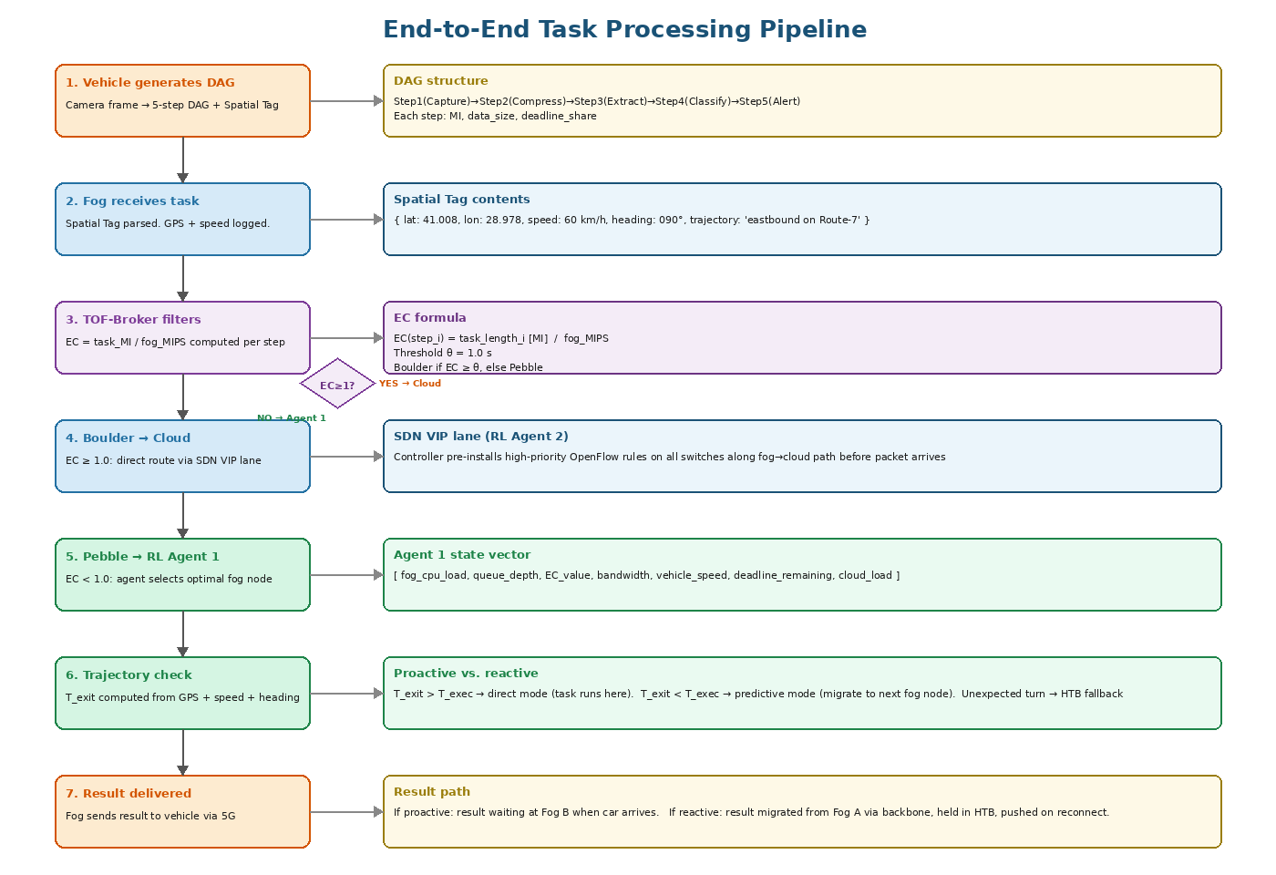
Figure 2: Full task processing pipeline. Left column shows the 7 processing phases. Right column shows the detailed logic, formulas, and data at each phase. Decision diamond at Phase 3 routes boulders to cloud and pebbles to RL Agent 1.
• T_exit — how many seconds until the vehicle leaves Fog A's coverage
• T_exec — how many seconds the task still needs to finish

3.1 Phase 1 — Task Creation at the IoT Device
The vehicle's camera captures a frame at time t=0. Step 1 of the DAG (capture and JPEG compression) runs locally on the device — it is lightweight enough to process on-device and reduces data size from ~8MB raw to ~200KB compressed. The device generates the full 5-step DAG:

- Step 1 (Compress): 20 MI, 200KB output. Runs on device.
- Step 2 (Pre-process): 200 MI, 50KB output. Fog candidate.
- Step 3 (Feature extraction): 2,000 MI, 30KB output. Fog candidate.
- Step 4 (Object classification): 8,000 MI, 5KB output. Boulder → Cloud.
- Step 5 (Alert generation): 50 MI, 1KB output. Returns to device.

The Spatial Tag is appended: { GPS: (41.008°N, 28.978°E), speed: 60 km/h, heading: 090° (east), trajectory: 'Route-7 eastbound' }. The full task packet is transmitted to the nearest fog node via 5G in approximately 1.5ms.

3.2 Phase 2 — Fog Reception and TOF-Broker Classification
The fog node receives the task. The TOF-Broker immediately processes each DAG step through the EC formula:

EC Formula | EC(step_i) = task_length_i [MI] ÷ fog_MIPS | Threshold θ = 1.0 second | Boulder if EC ≥ θ, Pebble if EC < θ

Applying this with fog_MIPS = 2,000: Step 2 EC = 0.10 (Pebble), Step 3 EC = 1.00 (exactly at threshold — treated as Pebble with high monitoring priority), Step 4 EC = 4.00 (Boulder — immediately forwarded to cloud). Steps 2 and 3 are queued for RL Agent 1.

3.3 Phase 3 — RL Agent 1: Placement Decision
RL Agent 1 receives the pebble steps and constructs its state vector from live observations. It then outputs a placement decision for each step:

State variable | Value in this example
State variable | Value in this example
fog_cpu_load (Fog A) | 0.42 (42% utilised)
queue_depth (Fog A) | 7 tasks pending
EC value (Step 3) | 1.00 (borderline heavy)
available_bandwidth | 0.80 (80% link capacity free)
vehicle_speed | 60 km/h (16.7 m/s)
T_exit from Fog A zone | 4.2 seconds
T_exec estimate (Step 3) | 5.1 seconds at current fog load
deadline_remaining | 0.085 seconds (85ms total deadline - elapsed)

Agent 1 calculates T_exit = 4.2s < T_exec = 5.1s. Proactive mode is triggered. Instead of placing Step 3 on Fog A (which the vehicle is about to leave), the agent instructs Fog B (the vehicle's destination) to spin up the Step 3 container immediately. When the vehicle arrives at Fog B in 4.2 seconds, the container is already running and has been executing for those 4.2 seconds.

3.4 Phase 4 — SDN Routing for Boulder (Step 4)
Simultaneously, RL Agent 2 handles Step 4's cloud routing. It has already predicted (from historical patterns) that a burst of boulder tasks will arrive at approximately this time. It has pre-installed high-priority OpenFlow rules on all switches along the fog-to-cloud path. Step 4's data packet arrives at the first switch, matches the pre-installed VIP rule, and is forwarded to the cloud at the highest priority — bypassing all background telemetry traffic with zero queuing delay.

3.5 Phase 5 — Execution and Result Delivery
Step 4 executes on the cloud (GPU-accelerated, ~0.8s). Steps 2 and 3 execute on fog nodes. Results flow back through the pipeline: Step 4 result (bounding boxes) returns to the fog, which feeds it as input to Step 5 (alert generation). Step 5 executes on the fog (50 MI, ~0.025s) and the final alert signal is pushed back to the vehicle via 5G in ~1.5ms.

4. Hybrid AI Pipeline — Offline Training and Online Deployment
The intelligence in this system comes from a two-phase hybrid AI approach. The offline phase uses MMDE-NSGA-II to generate optimal solutions from historical data. The online phase uses two DQN agents that were pre-trained on those solutions and continue learning from live simulation rewards.

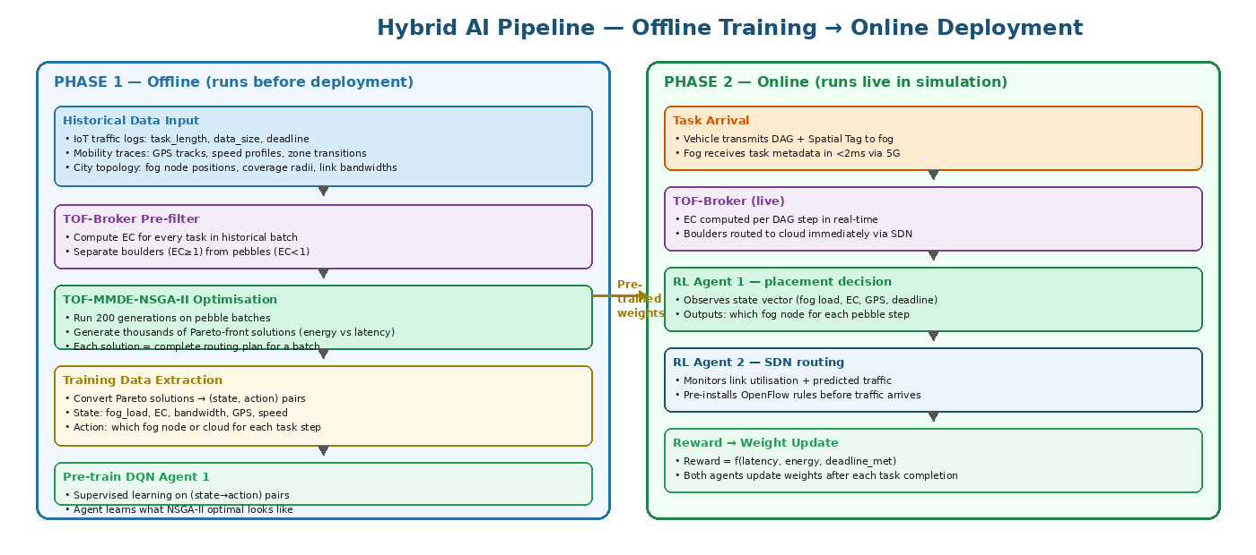
Figure 3: Hybrid AI pipeline. Left (blue): offline phase using TOF-MMDE-NSGA-II on historical data to generate Pareto solutions, converted to (state, action) training pairs for DQN pre-training. Right (green): online phase where pre-trained agents make real-time decisions and update weights from live rewards. Arrow shows pre-trained weights transferred from offline to online.

4.1 Phase A — Offline Optimisation with TOF-MMDE-NSGA-II
Before the system is deployed in simulation, the offline optimizer runs on a dataset of historical task batches. The optimizer is the combined TOF-MMDE-NSGA-II algorithm — the key improvement over Papers 1 and 2 individually:

- Paper 1 contribution: MMDE replaces standard NSGA-II mutation with directional differential evolution, improving convergence speed and solution robustness.
- Paper 2 contribution: TOF-Broker pre-filters the task set, removing boulders before NSGA-II runs, dramatically reducing the search space.
- This thesis: both are combined for the first time. The Broker reduces the problem size; MMDE finds better solutions in less time on the reduced problem.

The output of this phase is thousands of Pareto-front solutions — each solution is a complete, mathematically verified routing plan for a batch of pebble tasks. Each solution encodes: for every task step, which fog node to assign it to, given the fog loads and vehicle positions at the time.

4.2 Training Data Extraction
Each Pareto-front solution is decomposed into individual (state, action) training pairs. A single solution covering 100 tasks produces up to 300 training pairs (one per task step, excluding boulders). With thousands of Pareto solutions generated offline, the training dataset contains hundreds of thousands of labelled examples of 'what optimal looks like.'

State vector | [ fog_cpu_A, fog_cpu_B, fog_cpu_C, queue_depth_A, queue_depth_B, queue_depth_C, task_EC, bandwidth, vehicle_speed, vehicle_heading, T_exit, deadline_remaining, cloud_queue_depth ]

Action (label) | One of: { FOG_NODE_A, FOG_NODE_B, FOG_NODE_C, CLOUD } — the routing decision NSGA-II made for this task step in this Pareto-optimal solution.

The DQN agent is pre-trained on this dataset using supervised learning (behavioural cloning). The agent learns to approximate the NSGA-II decision boundary — mapping state vectors to actions. This eliminates the cold-start problem: when the agent goes live, it already knows approximately what optimal behaviour looks like.

4.3 Phase B — RL Agent 1: Live Application Brain
RL Agent 1 is a Deep Q-Network (DQN) deployed in the fog layer's Application Logic subsystem. Its architecture:

Property | Detail
Network architecture | 3-layer fully-connected neural network. Input: state vector (13 dimensions). Hidden layers: 256 → 128 neurons with ReLU activation. Output: Q-value for each action (4 values: 3 fog nodes + cloud).
Action selection | Epsilon-greedy: with probability ε (starts at 0.3, decays to 0.05) take a random action (exploration). Otherwise take argmax of Q-values (exploitation). ε decays over the first 10,000 steps.
Experience replay | Transitions (state, action, reward, next_state) stored in a replay buffer of 50,000 entries. Mini-batches of 64 sampled randomly for gradient updates. Prevents correlation between consecutive training samples.
Target network | A separate copy of the Q-network with frozen weights, updated every 1,000 steps. Used to compute stable target Q-values during training. Prevents divergence.
Reward function | R = -α·latency - β·energy - γ·deadline_violation. α=0.5, β=0.3, γ=0.2. deadline_violation = 1 if task misses deadline, else 0. Negative reward for missing deadlines is 10× the normal penalty.
Update frequency | Weights updated after every task completion. Learning rate = 0.001. Discount factor γ = 0.95 (values future rewards at 95% of immediate rewards).

4.4 Phase C — RL Agent 2: Live SDN Network Brain
RL Agent 2 is a second DQN deployed inside the SDN Control Plane. It operates on the network layer independently of Agent 1. Its decisions determine how data flows through the physical network, not where tasks are computed.

Property | Detail
State space | [ link_util_A_cloud, link_util_B_cloud, link_util_A_B, queue_size_switch_1..N, pending_super_task_size, predicted_traffic_next_5s, active_vehicles_zone_A, active_vehicles_zone_B ]
Action space | { PRIMARY_PATH, ALT_PATH_1, ALT_PATH_2, RESERVE_VIP_LANE, BEST_EFFORT }. Discrete selection of which physical path and priority class to assign each incoming traffic flow.
Reward function | R = +w1·delivery_ratio - w2·routing_delay - w3·controller_overhead. Large negative reward if packet loss occurs. Positive reward for zero-overhead pre-installed rule hits.
Pre-training data | Historical city traffic logs: time-of-day link utilisation patterns, peak congestion windows, historical Super-Task transmission sizes and frequencies.
Key behaviour | Agent 2 learns to pre-install VIP lane rules 2–5 seconds before a Super-Task arrives at the network edge — so the first packet of the Super-Task hits a pre-configured switch with zero rule-lookup overhead.

5. Mobility Management — GPS Prediction and Handoff
Mobility management is the most operationally challenging component. A vehicle travelling at 60 km/h traverses 250–300 metres in under 20 seconds — the typical coverage radius of an urban 5G fog zone. Any task with an execution time greater than the vehicle's remaining time in the current zone will experience a handoff mid-computation.

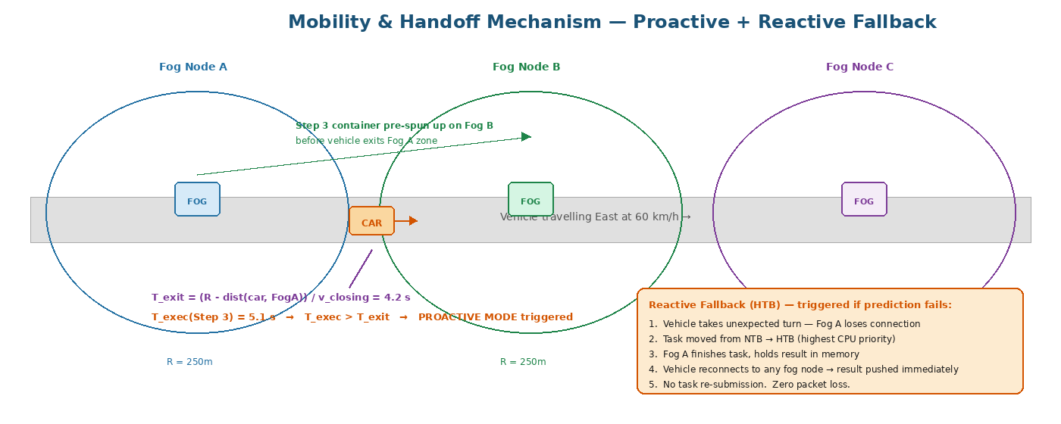
Figure 4: Mobility scenario. Vehicle moving east between Fog A (coverage R=250m) and Fog B zones. T_exit is computed from GPS position, speed, and heading. When T_exec > T_exit, the system enters proactive mode and pre-spins the task container on Fog B before the vehicle leaves Fog A. If trajectory prediction fails, the HTB buffer provides a zero-packet-loss reactive fallback.

5.1 Spatial Tag Processing and T_exit Calculation
When a task arrives from a vehicle, the Trajectory Predictor extracts the Spatial Tag and computes the time until the vehicle exits the current fog zone:

T_exit formula | x(t) = x₀ + speed·cos(heading)·t y(t) = y₀ + speed·sin(heading)·t T_exit = time t when distance(x(t),y(t), fog_node) > R_fog

This is a simple linear projection of the vehicle's current position and velocity. It does not account for turns or acceleration changes — that is handled by the fallback buffer when the prediction fails.

5.2 Proactive Mode — Pre-positioning on Destination Fog Node
When T_exit < T_exec (the task will not finish before the vehicle leaves): the system identifies the predicted next fog zone by projecting the vehicle's trajectory beyond T_exit and finding which fog node's coverage zone that projected position falls into. The Trajectory Predictor issues a container pre-spin instruction to the destination fog node.

The destination fog node (Fog B) receives the instruction: 'Prepare a container for Step 3 of task ID X. Vehicle will arrive in T_exit seconds. Allocate 2,000 MIPS and 512MB RAM.' Fog B confirms resource availability and spawns the container. If Fog B is currently overloaded, the system checks Fog C or escalates to cloud as a last resort.

When the vehicle enters Fog B's coverage zone, the container is already running. The vehicle connects and the task continues seamlessly. From the vehicle's perspective, there is no handoff delay — the result arrives at approximately the same time it would if the vehicle had never moved.

5.3 Reactive Fallback — NTB and HTB Buffer System
If the vehicle takes an unexpected turn, GPS signal is temporarily lost, or the trajectory prediction is incorrect, the proactive handoff fails. The HTB buffer system provides the deterministic fallback:

Component | Mechanism
NTB — New Task Buffer | The standard arrival queue for incoming tasks. Tasks processed in order of arrival. Normal priority access to fog CPU. Tasks move to HTB if the vehicle disconnects while the task is running.
HTB — Handoff Task Buffer | High-priority queue for in-flight tasks whose vehicle has disconnected. Tasks in HTB receive first access to all available fog CPU — they preempt NTB tasks. Goal: complete the task as fast as possible and hold the result.
Result holding | Once the task completes, the result is stored in the fog node's memory buffer, keyed by vehicle ID. The result is not dropped even though the vehicle is temporarily out of range.
Reconnection delivery | A Central Computing Tracker maintains a record of which fog node holds pending results for each vehicle. When the vehicle reconnects to any fog node in the network, that node queries the tracker, retrieves the held result, and delivers it immediately. No re-submission needed.

6. Simulation Design and Experimental Setup

6.1 Simulation Environment
The simulation will be implemented in iFogSim (the standard tool used by Papers 1 and 2) for the fog/cloud computation layer, with a Python mobility module for vehicle movement. The vehicular mobility model uses a 1,000m × 1,000m grid with roads at defined y-coordinates and three fog nodes placed at x=200m, x=500m, x=800m (each with R=250m coverage radius).

6.2 Application Scenario
The application domain is vehicular object detection. Each simulated vehicle generates one DAG task per 100ms (10 DAGs/second, simulating a 10fps camera). The DAG structure follows the 5-step pipeline described in Section 3.1 with the MI and data sizes given. This scenario is chosen because it: (1) justifies mobility (vehicles move, not static sensors), (2) contains a natural boulder (Step 4), (3) has a safety-critical latency constraint (~200ms total deadline), and (4) directly maps to the vehicular scenario of Papers 5, 6, and 9.

6.3 Parameters

Parameter | Value / Range | Notes
Number of fog nodes | 3 | Positioned along a simulated urban road corridor
Fog node MIPS | 2,000–5,000 MIPS | Varied across experiments to test EC threshold sensitivity
Fog coverage radius | 250 metres | Representing dense urban 5G deployment
Number of vehicles | 10–100 | Scaled to test system under light, medium, and heavy load
Vehicle speed | 30–100 km/h | Varied to test mobility prediction accuracy
DAG arrival rate | 10 DAGs/second/vehicle | Simulating 10fps camera capture
Total task deadline | 200 ms | End-to-end from Step 1 start to Step 5 complete
EC threshold θ | 0.5, 1.0, 2.0 | Ablation study on broker sensitivity
NSGA-II population N | 100 | Standard for this problem class
NSGA-II generations | 200 | Sufficient for convergence on this problem size
MMDE scaling factor F | 0.5 | From Paper 1 baseline
MMDE crossover rate CR | 0.9 | From Paper 1 baseline
DQN learning rate | 0.001 | Standard Adam optimiser
DQN discount factor γ | 0.95 | Values near-future rewards strongly
Replay buffer size | 50,000 | Prevents sample correlation
Fog–cloud link bandwidth | 1 Gbps | Representing urban fibre backbone
Fog–fog link bandwidth | 100 Mbps | Representing inter-node mesh
Fog–cloud propagation delay | 20–50 ms | Simulating realistic WAN latency

6.4 Baselines for Comparison
Four baselines are implemented and compared against the full proposed system:

System variant | Components and purpose
Baseline 1 — Plain NSGA-II (Paper 1) | No broker, no RL, no mobility handling. NSGA-II processes all tasks including boulders. Reactive handoff only. Worst-case reference — shows maximum improvement.
Baseline 2 — TOF-NSGA-II (Paper 2) | TOF-Broker added, plain NSGA-II (no MMDE). No RL agents. Reactive handoff. Shows contribution of MMDE specifically.
Baseline 3 — TOF-MMDE-NSGA-II, no RL | Full offline optimizer but no online RL agents. Static NSGA-II routing for all live decisions. Reactive handoff. Shows the specific contribution of the DQN agents.
Proposed System — Full pipeline | TOF-MMDE-NSGA-II + DQN Agent 1 + DQN Agent 2 + proactive trajectory-based handoff + NTB/HTB fallback. Should outperform all baselines.

6.5 Evaluation Metrics

Metric | What it measures and why
Average task latency (ms) | End-to-end time from DAG creation to result delivery. Primary metric.
Total energy consumption (J) | Sum of transmission energy + device computation energy across all tasks. Primary metric.
Pareto front quality (HV) | Hypervolume indicator measuring the quality and diversity of the offline NSGA-II Pareto front. Compares MMDE vs. plain mutation.
Task feasibility rate (%) | Percentage of tasks completing within their deadline. Must exceed 95% for the system to be considered viable.
Handoff success rate (%) | Percentage of mobility-affected tasks delivered without re-submission. Proactive vs. reactive comparison.
Fog node utilisation (%) | Average CPU utilisation across fog nodes. Should be balanced — no single node overloaded while others are idle.
Boulder rejection rate (%) | Percentage of incoming task steps identified as boulders by the broker. Validates the EC threshold choice.
SDN rule pre-installation rate (%) | Percentage of traffic flows hitting pre-installed rules vs. requiring new controller decisions. Higher = less bottleneck.

7. Literature Anchoring — How Each Component is Justified
Every component of this architecture is directly grounded in a peer-reviewed paper. This table maps each architectural component to its primary literature source and the specific justification for its inclusion.

Component | Primary source | Justification detail
TOF-Broker + EC classification | Paper 2 (Springer 2024) | Directly adopted. EC formula, θ=1.0 threshold, and pebble/boulder terminology come directly from this paper.
MMDE mutation in NSGA-II | Paper 1 (Springer 2021) | Directly adopted. MMDE operator, F=0.5, CR=0.9 parameters, and convergence results come from this paper.
TOF-Broker + MMDE combined | Novel contribution | Paper 1 has MMDE (no broker). Paper 2 has broker (no MMDE). This thesis combines both — the first such combination.
SDN architecture (control/data separation) | Paper 3 (IJCNIS 2023) | Architecture and motivation. Flow table structure, OpenFlow mechanism, and controller bottleneck problem all cited from this survey.
DAG microservice task model | Paper 4 (arXiv 2024-25) + Paper 8 (Elsevier 2025) | P4 establishes the 5-pillar taxonomy. P8 provides the specific DAG formulation G=(V,E) with per-node MI/data properties used in this system.
NTB/HTB mobility buffers | Paper 5 (PDF 2023) | Directly adopted. Buffer names, the reactive handoff mechanism, and the 50%+ latency improvement cited from this paper.
DRL for vehicular task placement | Paper 6 (arXiv 2024) | Justifies DQN Agent 1 design. State space structure and reward function design patterns adopted from this paper.
SDN + DRL combined routing | Paper 7 (Springer 2025) | Justifies DQN Agent 2 design. CSFD architecture is the closest published prior work. This thesis extends it with compute placement integration.
NSGA-II offline → DRL online pre-training | Paper 8 (Elsevier 2025) | Directly justifies the offline-to-online pipeline. Paper 8 demonstrates NSGA-II as DRL pre-training data source for DAG tasks.
GPS T_exit trajectory prediction | Paper 9 (MDPI 2024) | Directly justifies the proactive handoff mechanism. MAVTO's T_exit formula and direct/predictive/hybrid mode framework adopted from this paper.
Spatiotemporal traffic prediction (future) | Paper 10 (Elsevier 2025) | Justifies STGNN-based trajectory prediction as a future extension beyond this thesis's linear prediction model.

8. Plain-English Explanation — The Highway Food Delivery Analogy
The following analogy is provided to build an intuitive understanding of the full system before engaging with the technical detail. Every element in the analogy maps directly to an architectural component.

Analogy element | Architecture component
Analogy element | Architecture component
Customer driving at 60 mph | IoT vehicle generating DAG tasks
3-part meal order (Soda, Burger, 5-Tier Cake) | DAG with pebble steps (Soda, Burger) and a boulder step (Cake)
Local food trucks along the highway | Fog nodes — close, fast, limited capacity
Industrial factory kitchen 100 miles away | Cloud — powerful, but high latency
The order-processing system | TOF-Broker — splits order into what the trucks can make vs. what the factory must make
'That cake will break the food truck oven' | EC ≥ 1.0 — boulder classification, route to cloud immediately
Brilliant Manager (RL Agent 1) | Task placement agent — reads customer GPS, decides which truck makes each item
'Don't cook at Truck A — cook at Truck B 5 miles ahead' | Proactive container placement based on T_exit < T_exec calculation
Traffic Cop (RL Agent 2 + SDN) | Network routing agent — pre-opens highway lane before the cake leaves the factory
VIP highway lane with all green lights | SDN flow rules pre-installed by RL Agent 2 before Super-Task transmission
Burger ready exactly as car passes Truck B | Result waiting at Fog B when vehicle arrives after proactive migration
Cake and Burger arriving simultaneously | Both cloud result and fog result delivered to vehicle at optimal time
If customer takes wrong exit | Vehicle takes unexpected turn — trajectory prediction fails — HTB fallback activates

End of Architecture Proposal — submitted for supervisor review.

