***INDEX***

|  |  |
| --- | --- |
| **Sr no** | **TOPIC Title** |
| **1** | PROJECT DETAILS |
| **2** | ACKNOWLEDGEMENT |
| **3** | INTRODUCTION |
| **4** | TECHNOLIGIES AND TOOLS |
| **5** | SYSTEM DESIGN DETAILS |
| **6** | CODE IMPLEMENTATION |
| **7** | RESULTS : DIAGRAMS |
| **8** | OUTPUTS |
| **9** | CONCLUSION |
| **10** | REFERENCES |

**PROJECT DETAILS**

Project Title: Hospital Management System in Python Django

Submitted By: Imad Chougle, Roll - 21

GUIDE: Miss Sampada Margaj

**ACKNOWLEDGEMENT**

I express my sincere gratitude and thanks to Miss SAMPADA MARGAJ (Data Science Faculty) for providing me the excellent opportunity to do a project on *Hospital Management System in Python Django* and providing me with all Essential elements required for the completion and enhancement of this project.

**INTRODUCTION**

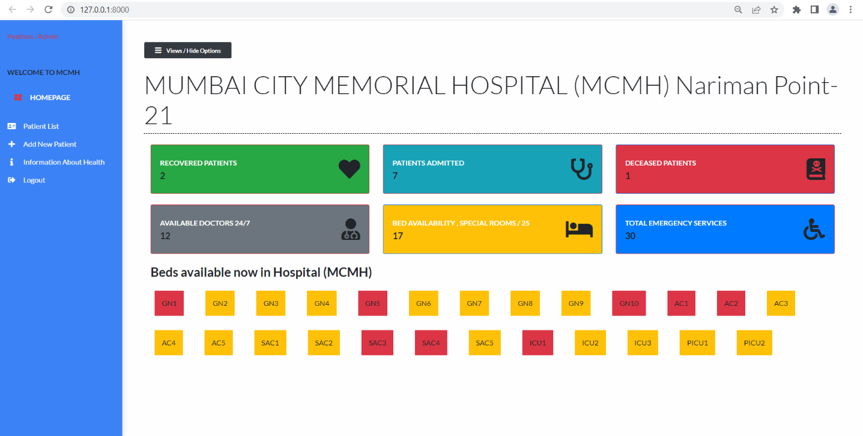

**Hospital Management System is a web application for the hospital which manages Patients and live Hospital Status . In this project, we use Python Django  and SQLite database. A responsive web-app with aesthetic and accessible UI for managing patients of a certain hospital built using Django**

**Also, the system displays all the available Medical activity with their respective details. In addition, the system allows managing Patients, Beds ,Doctors , in the Beds grid section we can easily know the current status of each room** This is a easy GUI based web-application that’s very easy to understand and use.

* ***User-friendly Interface***
  + The project was designed to have a user-friendly interface in order for the user to be familiarize the operation of the system.
* ***Automated Design***
  + It is designed to develop real conceivable benefits to hospitals

**TECHNOLIGIES AND TOOLS**

Software Used:

*FRONT END, LANGUAGE USED* = *HTML5,CSS3,Bootstrap*

*BACKEND END, LANGUAGE USED = PYTHON DJANGO-FRAMEWORK,SQLITE*

PYTHON is a widely used general-purpose, high level programming language. It was created by Guido van Rossum in 1991 and further developed by the Python Software Foundation. It was designed with an emphasis on code readability, and its syntax allows programmers to express their concepts in fewer lines of code. Python is a programming language that lets you work quickly and integrate systems more efficiently.

***IDE***: Pycharm 3.5, **PyCharm** is a dedicated Python Integrated Development Environment (IDE) providing a wide range of essential tools for Python developers, tightly integrated to create a convenient environment for productive Python, web, and data science development.

One aim of the IDE is to reduce the configuration necessary to piece together multiple development utilities, instead, it provides the same set of capabilities as one cohesive unit. Reducing setup time can increase developer productivity, especially in cases where learning to use the IDE is faster than manually integrating and learning all of the individual tools. Tighter integration of all development tasks has the potential to improve overall productivity beyond just helping with setup tasks.

| **Requirement** | **Minimum** | **Recommended** |
| --- | --- | --- |
| RAM | 4 GB of free RAM | 8 GB of total system RAM |
| CPU | Any modern CPU | Multi-core CPU. |
| Disk space | 2.5 GB and another 1 GB for caches | SSD drive with at least 5 GB of free space |
| Monitor resolution | 1024x768 | 1920×1080 |
| Operating system | Officially released 64-bit versions of the following:   * Microsoft Windows 8 or later * macOS 10.13 or later * Any Linux distribution that supports Gnome, KDE, or Unity DE. PyCharm is not available for some Linux . | Latest 64-bit version of Windows, macOS,  Or Linux (for example Ubuntu, or RHEL) |

**SYSTEM DESIGN DETAILS**

1. **Clean aesthetic User Interface, which changes dynamically as per the status of patient changes**
2. **In bed availability grid the red color indicates that bed is occupied else available**
3. **It is one of the two pages available for public to view**
4. **Here you can add patient for storing it to the db.**
5. **Beds number , Room types which are available are shown only**
6. **Information in admin panel , will make changes in dashboard dynamically**
7. **Here you can search patients write to name, bed no. doctor assigned and status**
8. **You can also find update button to update the patient details**.
9. **Hospital capacity, including information on ICU capacity and other available Rooms.**

**SYSTEM IMPLEMENTATION CODE**

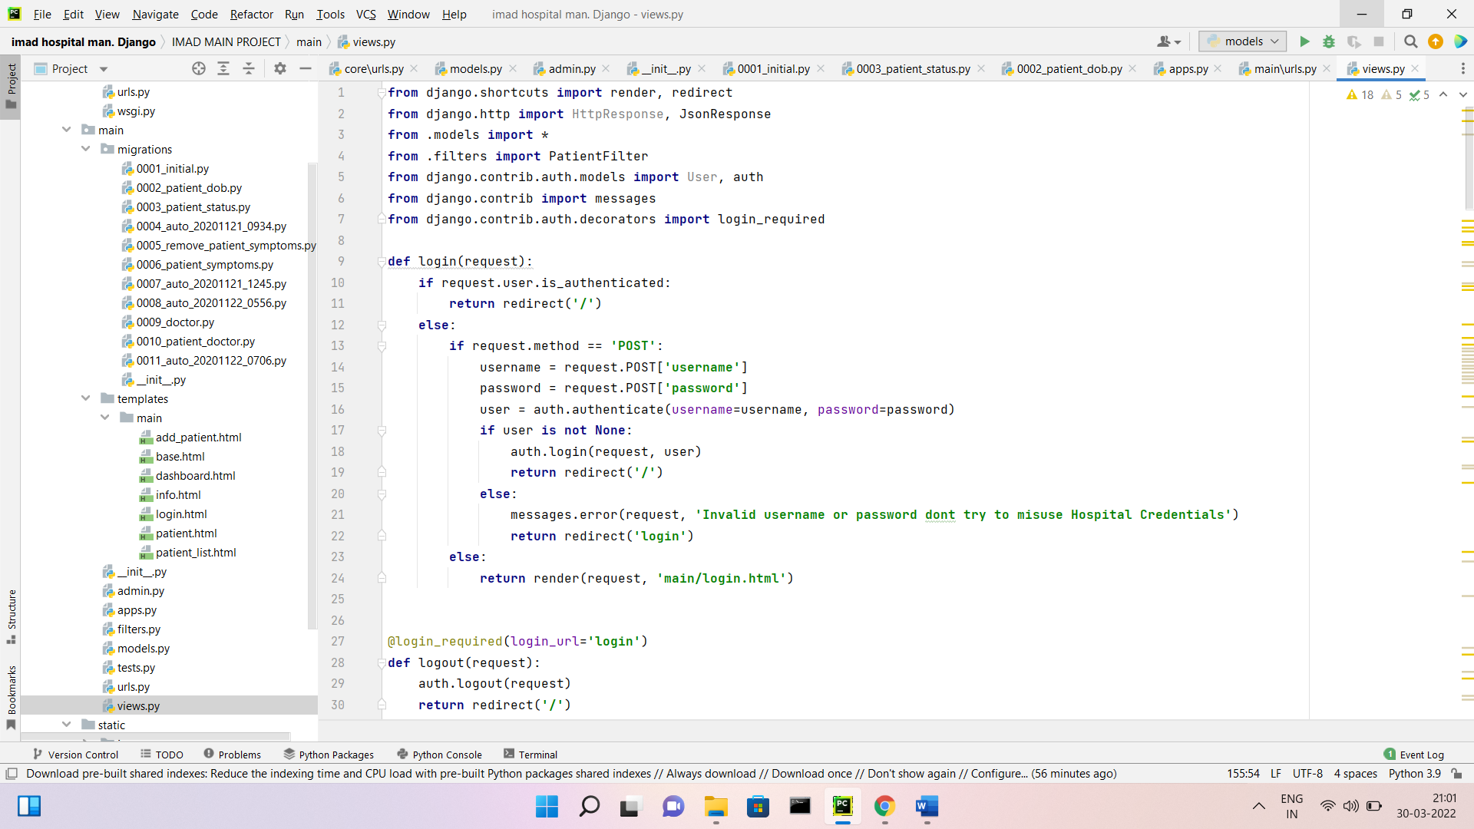

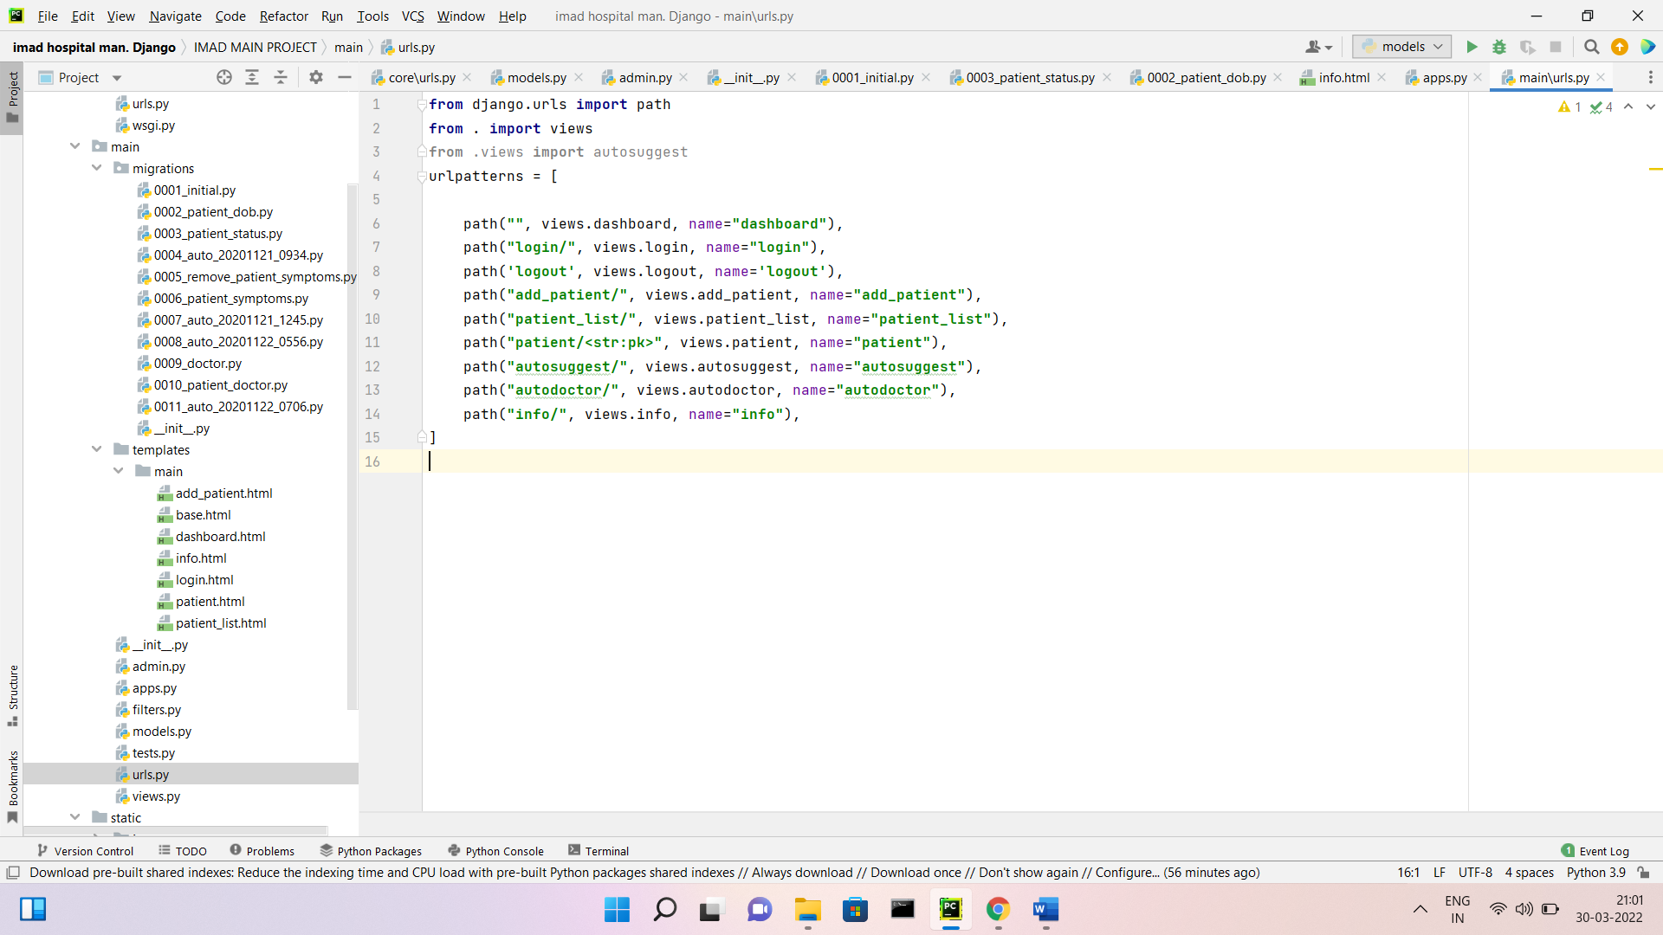

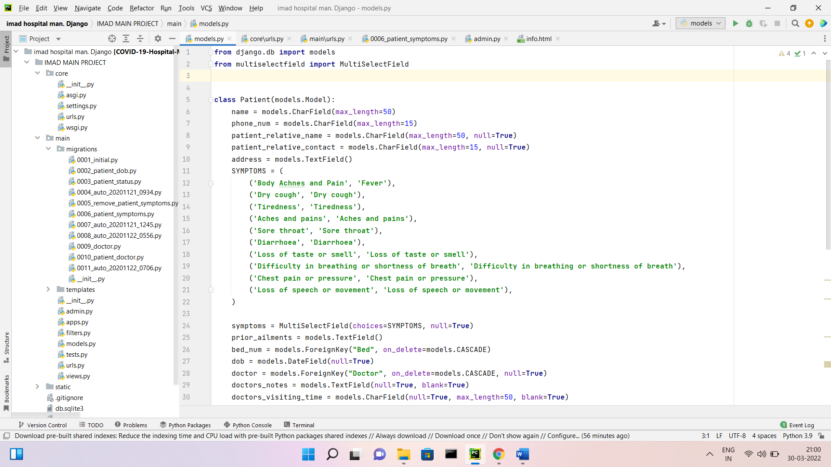

***Results : Diagrams***

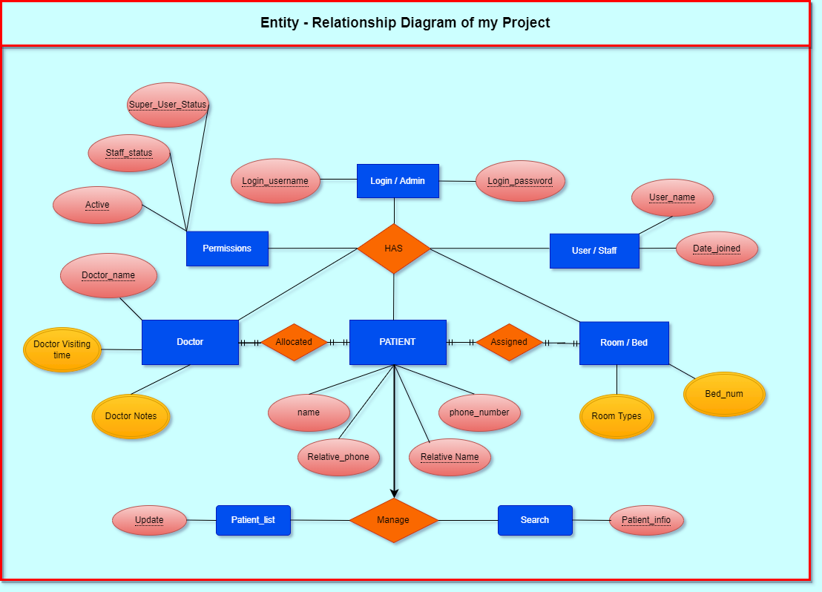

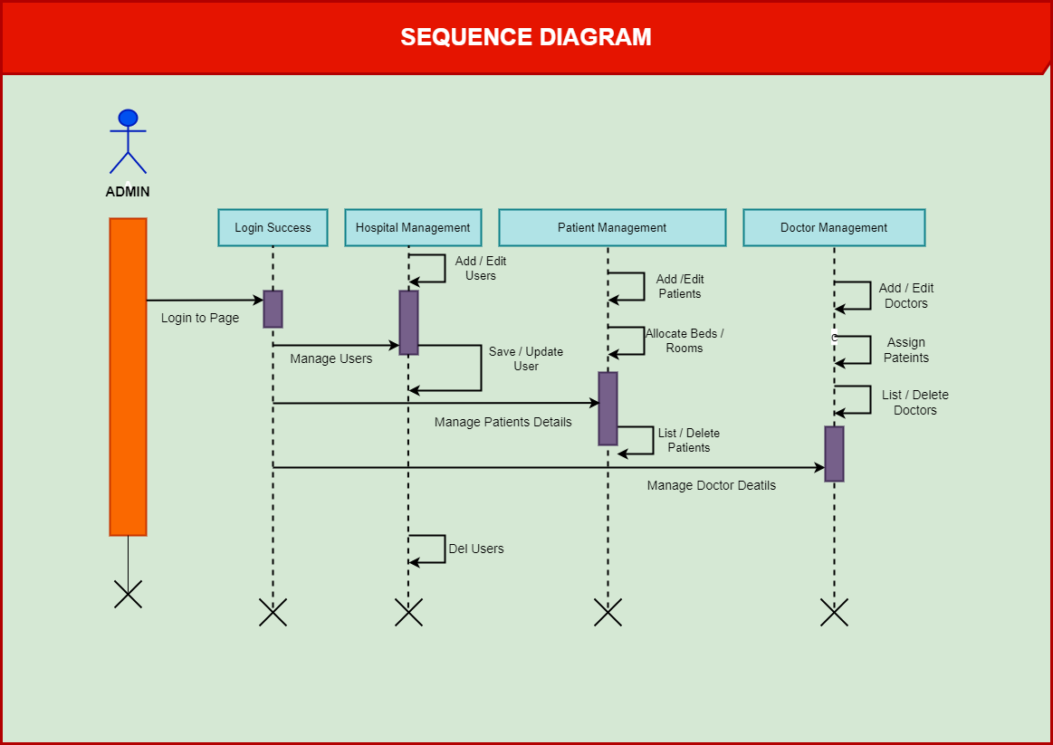

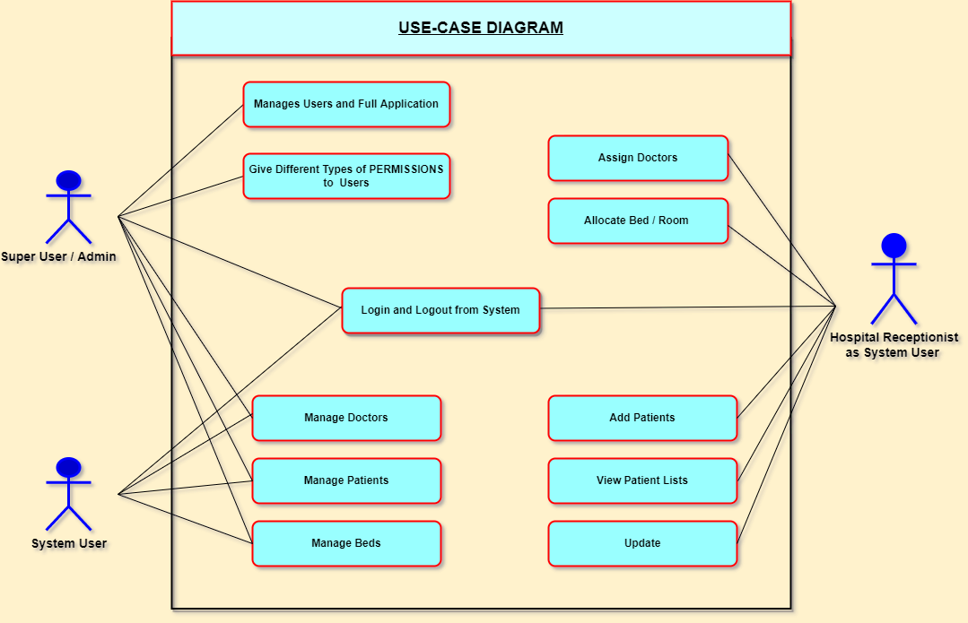

***OUTPUTS***

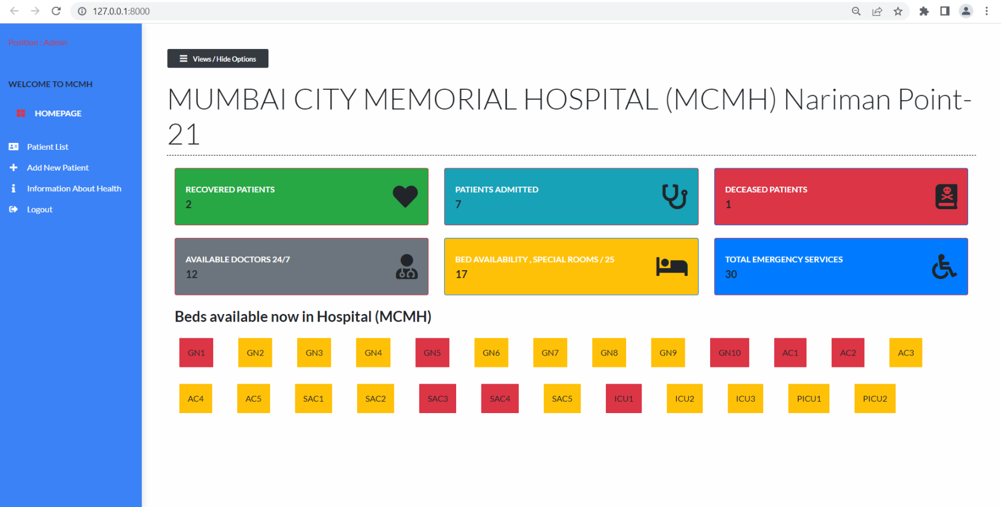***Dasboard***

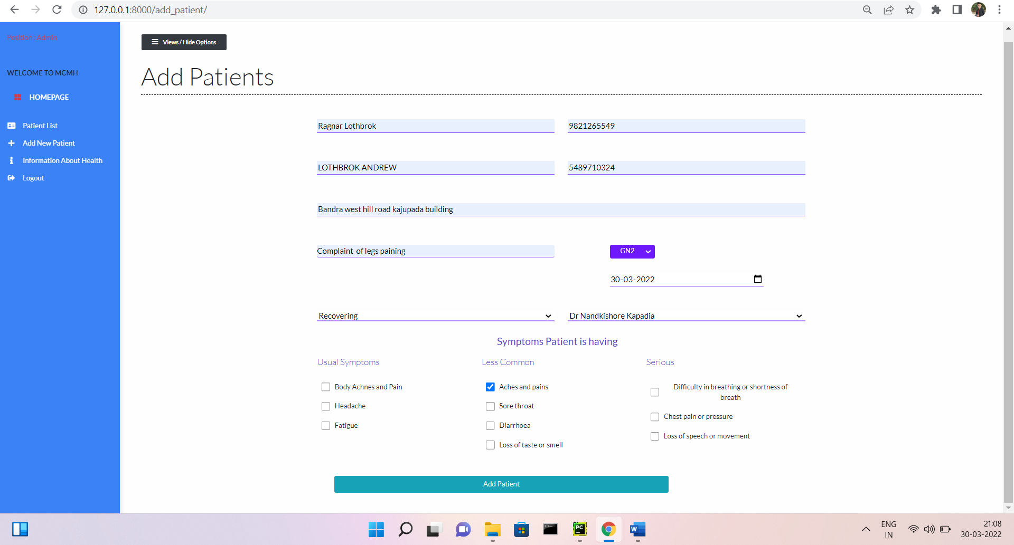***ADD PATIENT***

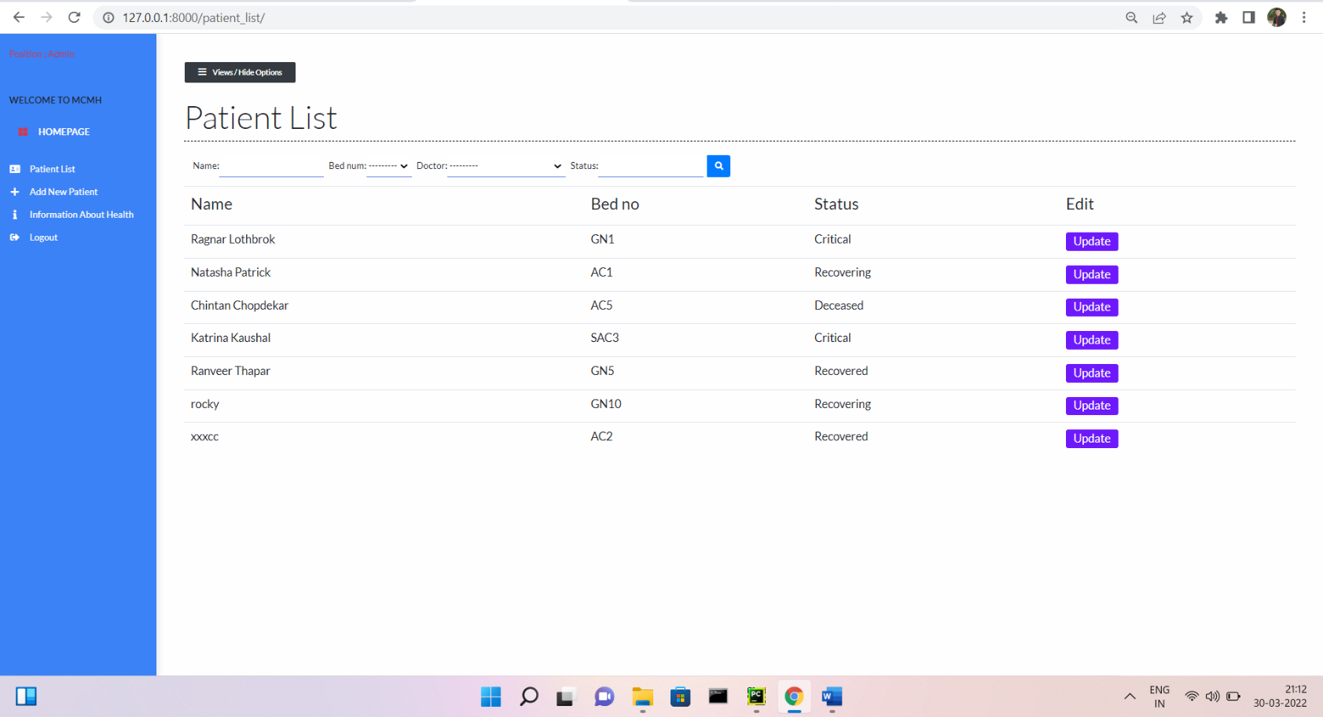***PATIENT LIST***

***CONCLUSION***

**In this system,**

**we are entering details of the patients electronically in the” Hospital Management System”, data will be secured. Using this application we can retrieve patient’s Current status in the Hospital. Thus processing information will be faster. It guarantees accurate maintenance of Patient details. It easily reduces the book keeping task and thus reduces the human effort and increases accuracy speed.**

***Future Scope***

**The Hospital Management System is designed for any hospital to replace their existing manual paper based system**

**The new system is to control the information of patients**

***Reference***

Books: **Python Programming: An Introduction to Computer Science (3rd Edition) / Author : *John M. Zelle***

Links: <https://freecomputerbooks.com/langPythonBooks.html>

<https://www.py4e.com/book.php>