ASSIGNMENT NO. 2
Create a One-Page Course Registration Website Using HTML
DESIGN GUIDE: Follow the same section order and content arrangement. Visual styling is not required in this assignment.
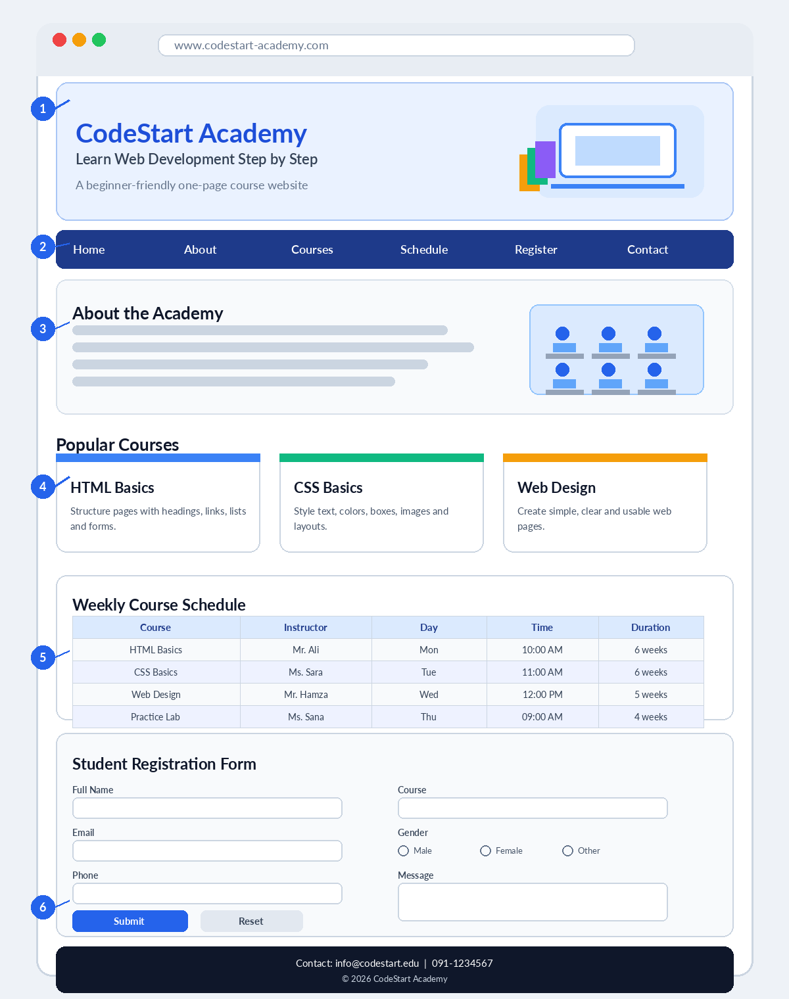
1. Header with website title and image | 2. Navigation links to page sections | 3. About section and course cards
4. Course schedule table | 5. Student registration form | 6. Contact details and footer

ASSIGNMENT QUESTIONS
Task: Create a one-page website named “CodeStart Academy” by following the design guide on Page 1. Use HTML only.
Question 1: Basic Page Structure
Create index.html with the HTML document structure, page title, meta charset and viewport meta tag.
Question 2: Header and Navigation
Add a header containing the academy name, a short tagline and one image. Create navigation links for Home, About, Courses, Schedule, Register and Contact. The links should move to the matching sections on the same page.
Question 3: About and Courses
Create an About section with a heading, two paragraphs and an image. Add at least three course blocks using section, article or div elements. Each course should show its name, short description and duration.
Question 4: Lists
Add an unordered list of academy facilities and an ordered list showing the steps for course registration.
Question 5: Course Schedule Table
Create a table with a caption and at least four course records. Include Course, Instructor, Day, Time and Duration columns. Use thead and tbody.
Question 6: Student Registration Form
Create a form containing full name, email, phone, date of birth, gender, course selection, skills checkboxes, message textarea, file upload, submit button and reset button. Use proper labels, id, name, placeholder and required attributes.
Question 7: Resources and Links
Add one external website link that opens in a new tab, one email link, one downloadable file link and one embedded YouTube video using iframe.
Question 8: Contact and Footer
Create a Contact section with address, phone, email and office timing. Finish the page with a footer containing the academy name and copyright text.
Submit: One project folder containing index.html and the image, video and document files used in the webpage.

