2024
COMPUTER NETWORKS

COMPUTER NETWORK
Contributors
Muhammad Haroon Azhar
Adnan Ahmed
Muhammad Imtisaal
Muhammad Obaid

Table of Contents
INTRODUCTION: 2
PURPOSE: 2
TOOLS USED: 2
DEVICES: 2
CONTROL DEVICE: 2
LOUNGE: 3
ROOMS: 4
KITCHEN: 4
GARDEN: 5
GARAGE: 5
CONCLUSION: 6

INTRODUCTION:
In our Cisco Packet Tracer smart home project, we've simulated a network comprising routers and IoT devices such as smart lights and security cameras. Our focus includes designing automation scenarios for efficient device control, implementing security measures, and emphasizing troubleshooting and simulation for a complete smart home system within the Packet Tracer environment.

PURPOSE:
The purpose of the smart home project in Cisco Packet Tracer is to provide a hands-on simulation environment for learning and experimenting with networking and Internet of Things (IoT) concepts. This project allows users to explore the mixing of various devices, routers, within a home network, design automation scenarios, implement security measures, and gain practical experience in troubleshooting and network documentation. It serves as a valuable educational tool for understanding the difficulties and functionalities of smart home systems in a controlled, virtual environment.

TOOLS USED:
- Cisco Packet Tracer
- COMPUTER
- Laptop

DEVICES:
We created a smart home system which is connected wirelessly with HOME GATEWAY router and smartphone. You can control everything with your smartphone all of the things in the smart home have wi-fi adapters and are connected wirelessly with router and smartphone.
- All the things in the smart home are connected wirelessly.
- They have the same single network.

CONTROL DEVICE:
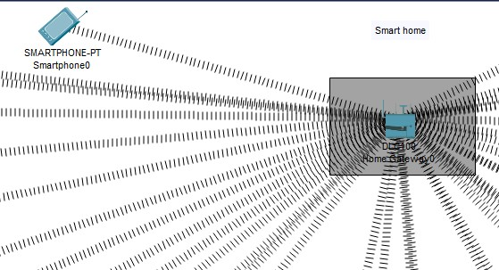
- Smartphone.
- Home Gateway Router.

LOUNGE:
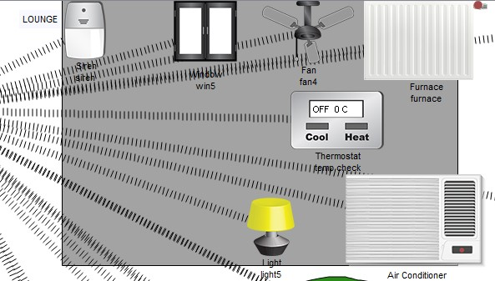
In this lounge we have several devices like:
- Window.
- Fan.
- Lights.
- Air Conditioner.
- Furnace.
- Siren (which reacts to smoke detection).
- Temperature check system.
- Doors.

ROOMS:
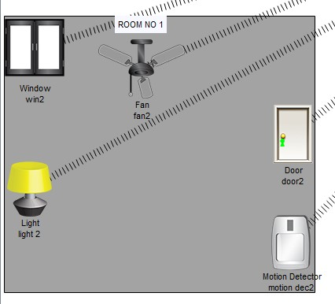
In the rooms of the smart home, we have several devices:
- Window.
- Lights.
- Fan.
- Door.
- Montion Detection.

KITCHEN:
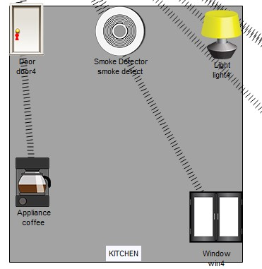
In this kitchen we have: • Lights.
- Kitchen Appliances.
- Coffee Maker And Others Things.
- Window.
- Smoke Detection.

GARDEN:
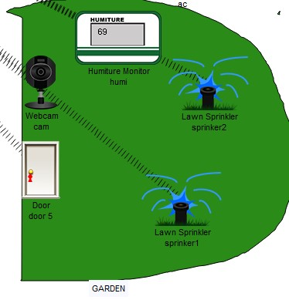
In the garden we have:
- A Camera (for security reason).
- Door.
- Lawn Sprinklers.
- Humiture Monitor (for the sprinklers).

GARAGE:
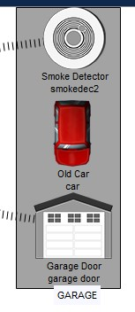
In the garage we have:
- Smoker Detection.
- A Car.
Serial # | Product | Quantity | price | subtotal
1 | USR iot gateway | 1 | 36500pkr/- | 36500pkr/-
2 | Smart Bulb | 5 | 1250pkr/- | 6250pkr/-
3 | Smart fan | 4 | 17000pkr/- | 68,000pkr/-
4 | Motion sensor | 4 | 3850pkr/- | 15400pkr/-
5 | Smoke sensor | 2 | 3000pkr/- | 6000pkr/-
6 |  |  |  |  | Total:132,000pkr/-
- Garage Door.

CONCLUSION:
In this semester project, we have gained knowledge and better understanding of cisco packet tracer software. Where we simulate networks. We learned that we cannot just simulate a network but we can create an entire network like how we created an entire smart home in cisco packet tracer we can make others companies networks. By making smart home we learned how smart homes works and how to create a network and connect all the things in the house with your router and control them with your smartphone. This helped us gained better knowledge and understanding of networking and cisco packet tracer. This concludes this semester project.

