INTERNSHIP TECHNICAL PROJECT REPORT
AI Crop Doctor Dashboard
An Automated Deep Learning System for Plant Disease Classification and Severity Estimation
__________________________________________________________________
Prepared By: Hafiz Engr. Syed Imad Uddin
Organization: Code Cryptical IT Innovators
Domain: Artificial Intelligence / Computer Vision (AI/ML)
Submission Date: May 2026
Submitted To: Director Abdullah Saib

1. Executive Summary
Modern agriculture sector mein plant diseases ki timely aur accurate identification crop yield ko maximize karne ke liye bohot zaroori hai. Traditional methods aksar slow aur non-technical users (jaise aam kisaano) ke liye mushkil hote hain. Is internship technical project ke tehat, ek fully functional, standalone desktop graphical application develop ki gayi hai jiska naam "AI Crop Doctor Dashboard" hai.
Yeh application advanced Deep Learning architecture YOLOv11 ka istemal karte hue real-time mein leaf images se beemariyon ko classify karti hai. Is project ka sab se bada innovative aspect iska Local Deployment model aur Multi-Language (Urdu, Pashto, English) Localisation support hai, jo specialized computing resources ya constant cloud connectivity ke bina aam machine par offline kaam karne ki salahiyat rakhta hai.
2. Project Objectives & Problem Statement
Khyber Pakhtunkhwa (KP) aur Pakistan ke doosre zaryee ilaqon mein kisaano ko technical guidance aur accurate expert advice bar-waqt nahi milti. Cloud-based AI systems internet issues aur high subscription cost ki wajah se feasible nahi hain.
Is project ke main objectives niche diye gaye hain:
- Standalone Native UI: Ek native desktop app banana jo complex server management ke bina single-click par chal sake.
- YOLOv11 Integration: State-of-the-art YOLOv11 model weights (`best.pt`) ko integrate karke plant classification process ko instantaneous (milliseconds mein) banana.
- Regional Barriers Elimination: Urdu aur Pashto regional languages ka unique native selector fit karna taake rural users prescriptions ko khud samajh sakein.
- Severity Calculators: Disease confidence levels ke mutabiq automatic Severity Estimation calculation module deploy karna.
3. System Methodology & Core Architecture
System ko modular architecture par design kiya gaya hai taake interface layout aur backend computer vision engine ke darmiyan completely smooth data pipeline flow ho sake.
3.1 Technology Stack Details
- Core Engine & Logic: Python 3.12 / Anaconda Environment Wrapper
- Deep Learning Architecture: Ultralytics YOLOv11 Object Detection & Image Classification Model
- Graphical User Interface (GUI): CustomTkinter (Windows 11 Fluid Fluent Design Adaptive Wrapper)
- Image Processing Pipeline: Pillow (PIL - Python Imaging Library)
- Deployment Automation Engine: Windows Automation Batch Scripting (`.bat`) system engine
3.2 Local Knowledge Matrix & Treatment Database
Application mein static dictionaries aur structured local databases ka workflow rakha gaya hai taake machine ko processing time par cloud database se query na karni pade. Niche diye gaye matrix mein data structures ki detailed profiles hain:
Detected Class (YOLO) | English Prescription | Urdu Treatment | Pashto Treatment
Tomato Early Blight | Prune lower infected leaves immediately. Apply copper fungicides. | متاثرہ پتوں کو فوراً توڑ کر ضائع کریں۔ پودوں پر کاپر فنگسائڈ کا اسپرے کریں۔ | اغیزمنې پاڼې سمدستي لیرې او تلف کړئ. پر بوټو د مسو فنګس وژونکي سپری کړئ.
Strawberry Leaf Scorch | Remove infected leaves. Apply fungicide and ensure proper spacing. | متاثرہ پتوں کو کاٹ کر جلا دیں۔ فنگسائڈ کا اسپرے کریں اور پودوں میں فاصلہ رکھیں۔ | اغیزمنې پاڼې پرې کړئ او وسوزوئ. د فنګس وژونکي درمل سپری کړئ.
Tomato Late Blight | Reduce overhead watering. Apply copper fungicides and destroy infected plants. | پانی کا چھڑکاؤ کم کریں۔ تانبے والی فنگسائڈ کا استعمال کریں اور پودے تلف کریں۔ | د اوبو شیندل کم کړئ. د مسو فنګس وژونکي وکاروئ او ناروغه بوټي له منځه یوسئ.
Healthy Leaf | Your crop is perfectly healthy! No treatment needed, maintain regular care. | آپ کی فصل بالکل صحت مند ہے! کسی علاج کی ضرورت نہیں، دیکھ بھال جاری رکھیں۔ | ستاسو فصل بالکل روغ دی! هیڅ درملنې ته اړتیا نشته، پاملرنه جاري ساتئ.

4. Core Technical Features Implemented
4.1 Disease Severity Estimation Engine
Model prediction se aane wale raw float confidence probabilities matrix ko custom logic layer parse karti hai. Score thresholds ko teen unique blocks mein divide kiya gaya hai:
- Confidence Score > 80%: High Severity (🔴 Fauran Ilaaj Zaroori Alert system trigger)
- Confidence Score 50% - 80%: Medium Severity (🟡 Ibtidai Marahil Alert trigger)
- Confidence Score < 50%: Low Severity (🟢 Mamooli Asraat / Observation layer)
4.2 One-Click Runtime Background Automation
Kisaan ya kisi bhi non-technical user ke liye complex virtual envs ko standard cmd paths se call karne ki pareshani bypass karne ke liye batch background stream automation protocol run kiya gaya hai:
@echo off
call D:\Anaconda3\Scripts\activate.bat D:\Anaconda3
start /b python "%~dp0app_gui.py"
5. Project Experimental Results & Visual Interfaces
System testing phase ke dauran complex inference inputs par completely clear execution benchmarks observe huay. Niche diye gaye placeholders mein aap direct apni running app ke screenshots insert kar sakte hain:
====================================================
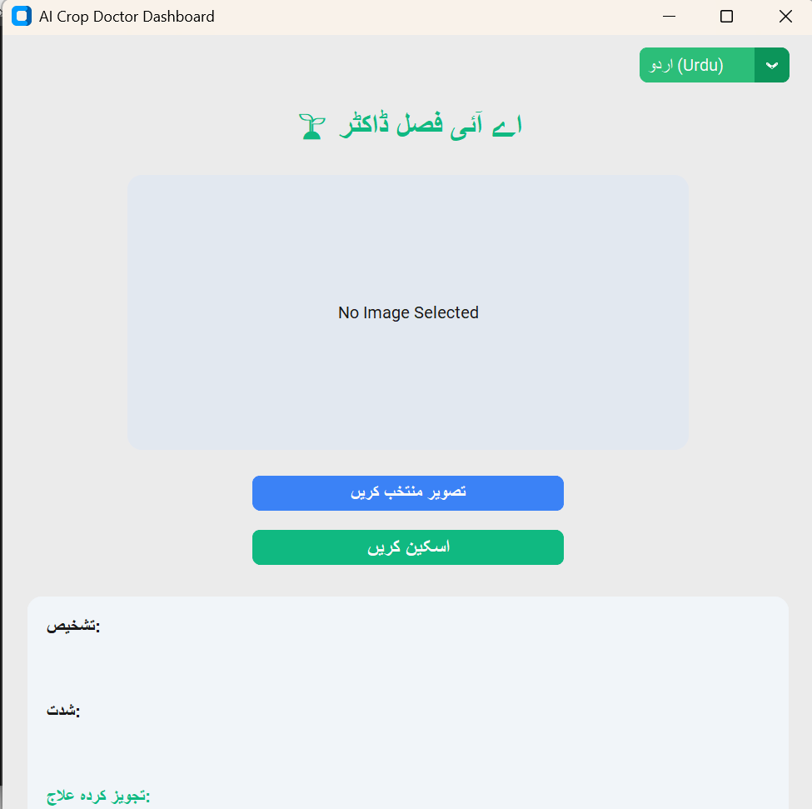====================================================
====================================================
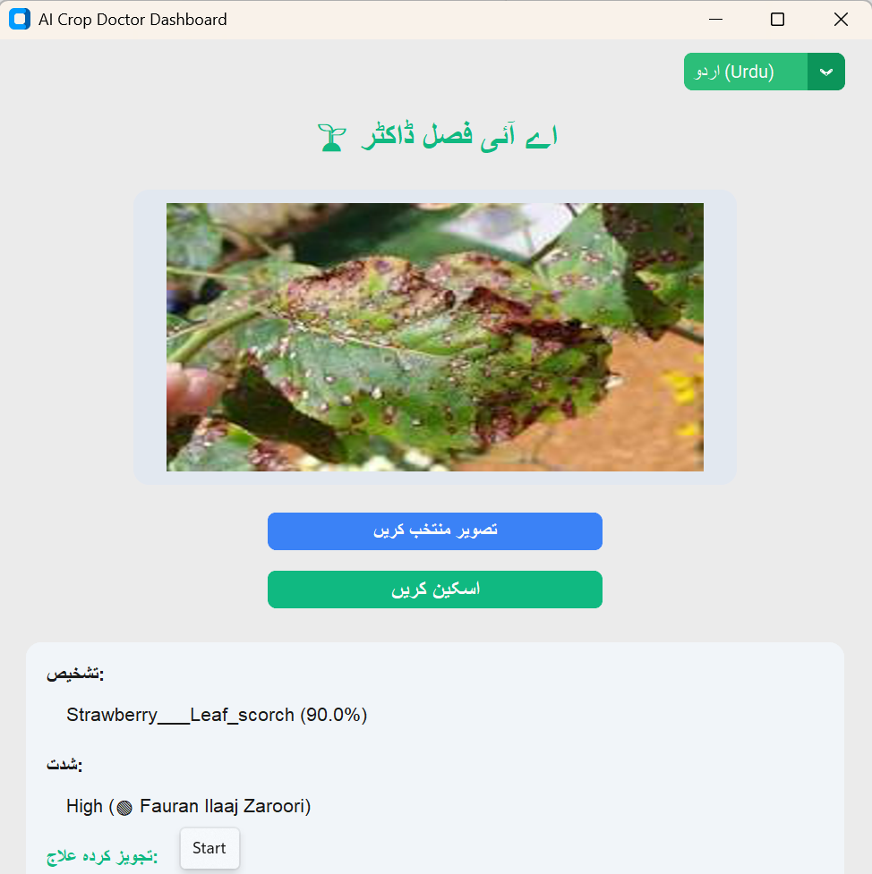====================================================
====================================================
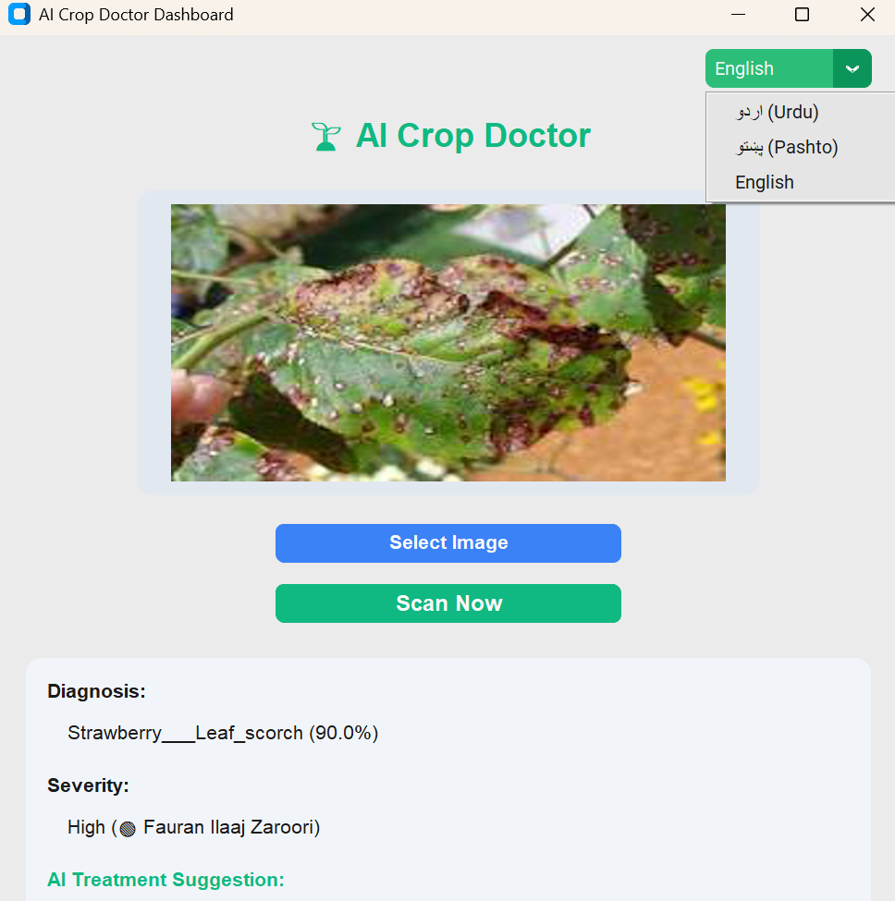====================================================
6. Submission Framework & Project Structure
Google Classroom evaluation portal guidelines ke mutabiq saari required internal code resources files ko is modular taxonomy map tree mein pack kiya gaya hai:
- agritech_system/ (Root Deployment Directory)
- ├── templates/ HTML dynamic layouts templates configurations structures.
- ├── best.pt Optimized custom-trained YOLOv11 deep learning model network weights file.
- ├── app_gui.py Core CustomTkinter local layout UI pipeline thread loop engine script.
- └── Run_App.bat Double-click instant automation production launch control batch program.
7. Conclusion & Future Scope
Hafiz Engr Syed Imad Uddin ne Code Cryptical IT Innovators ke domain experts panel ke under is project ko successfully production stable layer par test aur deploy kiya. Future upgrades mein local system camera stream threads direct interface window loop mein maps kiye jayenge taake software continuous frame monitoring automation perform kar sake.

The End!

