Green capital investment
18th September, 2023
Kind Attention of: MR. JAE-HOON JANG
DATAGENE, INC.
11, WONHYO-RO 90GIL THE PRIME BLD,16F #1607,
YONGSAN-GU, SEOUL, 04315 REPUBLIC OF KOREA
Dear Sir,

Offer Letter for Loan of $46,063,000 (Forty-Five Million Sixty Three Thousand United States Dollars)
Based on the authorization and approval from our Board of Directors, Green Capital Investment of 12a White Friars, Chester, Cheshire, CHI IN, United Kingdom, we are pleased to inform you that the above amount has been approved as loan amount for period of Ten (10) years.
Please be advised that the loan amount will only be transferred to you after we have signed the Loan Agreement, and you are able to fulfil all the terms and conditions as stated on this offer letter. You will manage the funds for the agreed period of Ten (10) renewable years. You are therefore expected to provide bank accounts where the funds will be transferred from its present location for your immediate usage after we must have signed the necessary agreements.

Terms and Conditions
- Messer's; Jae-Hoon Jang will receive the sum of $46,063,000 (Forty-Five Million Sixty Three Thousand United States Dollars) as Loan for period of Ten (10) years with interest rate of Three (3%) PERCENT yearly and Two (2) years grace period.
- Receipt of filled Know Your Customer (KYC) Form.
- Receipt of 2.575% Credit Life Insurance noting Green Capital Investment as first loss payee and it will be deducted from the loan amount.

- Payment of 0.1% management fee and it will be deducted from the loan amount.
- Receipt of duly executed letter of Lien and Set-off.
12a White Friars, Chester, Cheshire, CHI IN, United Kingdom
-2-
Finally, should the above terms and conditions meet your working conditions, kindly indicate by accepting our offer in your company's letter headed paper. Upon the receipt of your acceptance letter, we shall send a set of draft agreements for your review, input, and perusal.
For further discussion, you can call the undersign on telephone number: +447700304603
Looking forward to working with you.
Yours faithfully,

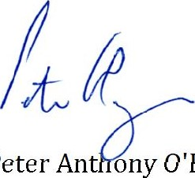
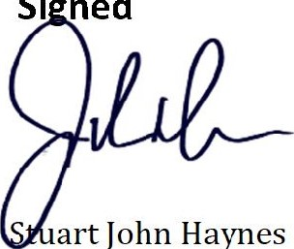
For: Green Capital Investment

Peter Anthony O’Brien
Managing Partner Investment Advisor/Asset Manager Green Capital Investment Green Capital Investment

12a White Friars, Chester, Cheshire, CHI IN, United Kingdom

