The main code file for the Banff Automation System algorithm is “app.R”. This is the Shiny application derivation code file. For the transparency of the code, here, we will describe the code of the system line by line. The app.R file is divided into two big sections.

Section 1 (line 1 to 1273)

From the line 1 to 120, the code brings necessary libraries and defines global variables for the calculations and descriptions of the Banff Automation System.

other_diagnoses_ls is to define the list of other diagnoses.
full_color is to define the list of colors to assign by rejection categories for the tree diagram visualization in the application.

toMatch is the list of “Possible TCMR cases”. When the final TCMR diagnosis is one of them, then the tree visualization stays “white” since they are not true TCMR.

other_diagnoses_pattern is to define cases when the rejection diagnosis should be interpreted regarding associated other diagnoses. When other diagnoses were selected but not among those from other_diagnoses_pattern, the rejection diagnosis should be interpreted regarding associated other diagnoses.

Code from the line 82 to 105 is to assign numbers to unique diagnoses.

Line 108: tmpls loads all possible coloring cases (“colorLOCAL_updated.rds”).
Line 113: org loads a dataframe to shape the tree shaped diagram.
Line 115 to 120: minor naming edits of the org dataframe.

Line 130 to 282: Defining the user interface (UI) of the Banff Automation System shiny application.

Line 287 to 378: Functions to fix variables. This was done to avoid refreshing the application when a user selects different inputs but not yet clicking the submit button.

Line 382 to 423: the same as above. This is to prevent re-rendering to reduce the computation burden.

Line 426 to 463: Defining make_original_DF function. As the name suggests, this function creates the original data frame without making additional computation. We used this function to bring the original data input before the Banff Automation computation.

Line 467 to 504: Defining makeDF function. Similar to the make_original_DF but the makeDF function introduces a slight change for the easy calculation of the Banff Automation System. For example, when cv scores from 0-3 but not new onset, then they are considered as 0 since the Banff classification only considers new onset cv scores. This function was the main function to generate the base data frame, which brings all user inputs of Banff lesions.

Line 507 to 641
makeGraph: the main code block to calculate the Banff Automation System. Each line of the code defines the possible Banff rejection diagnoses; they are assigned as a number (a unique identification for the computation). The numbers go from 1 to 63. Each number represents a branch of the tree diagram.

Unique number assigned to give identifications of cases of the tree-diagram visualization | Banff rejection diagnosis
1 to 2 | C4d Staining Without Evidence of Rejection
3 to 26 | Active AMR
27 to 44 | Chronic active AMR
45 to 52 | Chronic inactive AMR
53 to 54 | Suspicious (Borderline) for Acute TCMR
55 | Acute TCMR IA
56 | Acute TCMR IB
57 | Acute TCMR IIA
58 | Acute TCMR IIB
59 | Acute TCMR III
60 | Chronic Active TCMR IA
61 | Chronic Active TCMR IB
62 | Chronic Active TCMR II
63 | No evidence of rejection

The block is separated by diagnosis_AMR to calculate the AMR, diagnosis_TCMR to calculate the chronic TCMR, diagnosis_TCMR_nonCh to calculate the acute TCMR and borderline, diagnosis_IFTA to calculate IFTA grade, and diagnosis_BK to calculate polyomavirus nephropathy class. The function returns the data frame of results of diagnosis_AMR, diagnosis_TCMR, diagnosis_TCMR_nonCh, diagnosis_IFTA, and diagnosis_BK.

Line 644 to 738
chooseColor: the code block to assign the tree diagram the correct colors to visualize. It loads the makeGraph function to bring the diagnosis. Then, by the diagnosis, it assigns certain colors (line 663 to 677). If TCMR diagnoses are matching to “toMatch” (possible TCMR but not TCMR), then the TCMR colors are “which” suggesting that non-TCMR. Then, colored AMR, TCMR, TCMR_nonCh as the diagnoses. final_color is made for the final coloring choice.

Line 741 to 755
Graph drawing function for the tree diagram. This diagram is using the package collapsibleTree html widget as mentioned in the manuscript (available here: https://github.com/AdeelK93/collapsibleTree/). The function brings full_color to draw the initial tree visualization. When, a user input is submitted, the function calls chooseColor and brings the color information corresponding to the user input to draw the tree diagram.

Line 757 to 866
textBasic: the code block to assign appropriate diagnoses names from the makeGraph. makeGraph function diagnoses and assigns the user input (Banff lesion inputs) to the unique identifiers for computation. textBasic function is to translate these identifications into the user-friendly texts. Since there are many complexities in the Banff classification, the assignment is not as straightforward as the Table above. This function introduces “Equivocal Active AMR” and “Possible TCMR” cases.

Line 868 to 981
textResult1: the code block to finalize the diagnosis text outputs. This function calls make_original_DF and textBasic functions as well as other_diagnoses and free functions to bring all information received from users and computed results.
Additional considerations regarding TMA, ATI, and other diagnoses occur here before the final text output.

Line 983 to 1150
Recommendation text: the code block to generate recommendation text outputs. When there is an essential missing information such as C4d type and DSA, the system warns and suggests the user. When ABO is incompatible, the positive C4d is not interpretable. Several other warnings and suggestions exist such as for TMA, ATI, C4d, i-IFTA, DSA, isolated v lesion, Borderline, equivocal AMR, etc.

Line 1153 to 1176: commented out. This code block was used to debug during the development process.

Line 1178 to 1192: a code block to generate a title “Banff Diagnosis” above the decision box.

Line 1194 to 1206: a code block to generate a title “Notes and Suggestions” above the recommendation box.

Line 1209 to 1226: references integrated in the 3rd panel of the application.
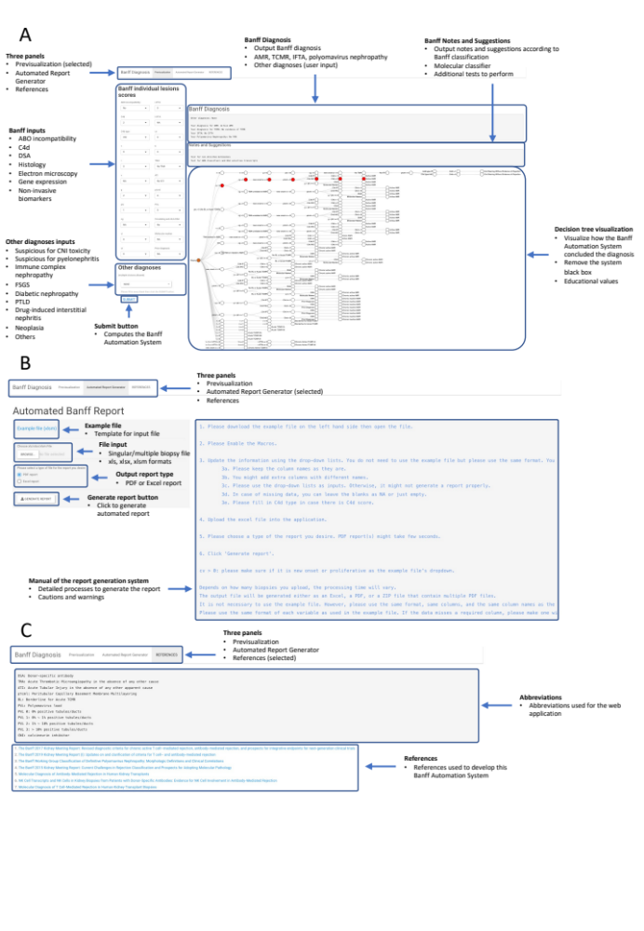

Line 1228 to 1246: abbreviations integrated in the 3rd panel of the application as above.

Line 1250 to 1273: integrating the references (line 1209 to 1226) in the application.

Section 2 (line 1276 to 2236)

Section 2 duplicates the section 1 but this is to generate an automatic report (2nd panel of the application).

Line 1276 to 1660
generateReport: this code block reads an imported excel file and computes the Banff Automation System. This code block functions as makeDF, makeGraph, textBasic, textResult1, altogether. It also computes to result in the Recommendation text.

Line 1662 to 1763: chooseColor function for the PDF report in the previous version of the application. It is now deprecated.

Line 1767 to 1781: a manual for the utility of the application. The text is displayed in the 2nd panel of the application.

Line 1785 to 1827
report_tab: a code block to enable exporting the generated report as an Excel file after the computation of the Banff Automation System. This function is enabled when a user selects “Excel report” and clicks the “GENERATE REPORT” button on the 2nd panel. This function handles both single and multiple biopsy results as imports.

Line 1831 to 1925
report.single: a code block to enable exporting the generated report as a PDF file after the computation of the Banff Automation System. This section integrates the “test1.Rmd” file to generate the PDF report file. This function is enabled when an imported Excel file includes a single biopsy result, a user selects “PDF report” and clicks the “GENERATE REPORT” button on the 2nd panel.

Line 1928 to 2029
report: a code block to enable exporting the generated report as multiple PDF files after the computation of the Banff Automation System. This section integrates the “test1.Rmd” file to generate the PDF report file. The function finally zips the multiple PDF files. This function is enabled when an imported Excel file includes multiple biopsy results, a user selects “PDF report” and clicks the “GENERATE REPORT” button on the 2nd panel.

Line 2032 to 2035
file1_ui: a code block to generate an alarm when an imported Excel file is in the wrong format.

Line 2037 to 2166
This code block generates warnings according to the imported Excel file format. The code block reads the imported file as well as the file1_ui function. When a missing variable exists, a wrong variable name exists, a wrong data format exists, the function creates an appropriate warning message, such as, “Please correctly fill in ‘g’ lesion.” This is to improve the usability of the system by accurately letting a user know where the present problem lies.

Line 2168 to 2235: deprecated functions.

Line 2239: Run the application.

