watIAM: sh2yap

student ID: 21111395

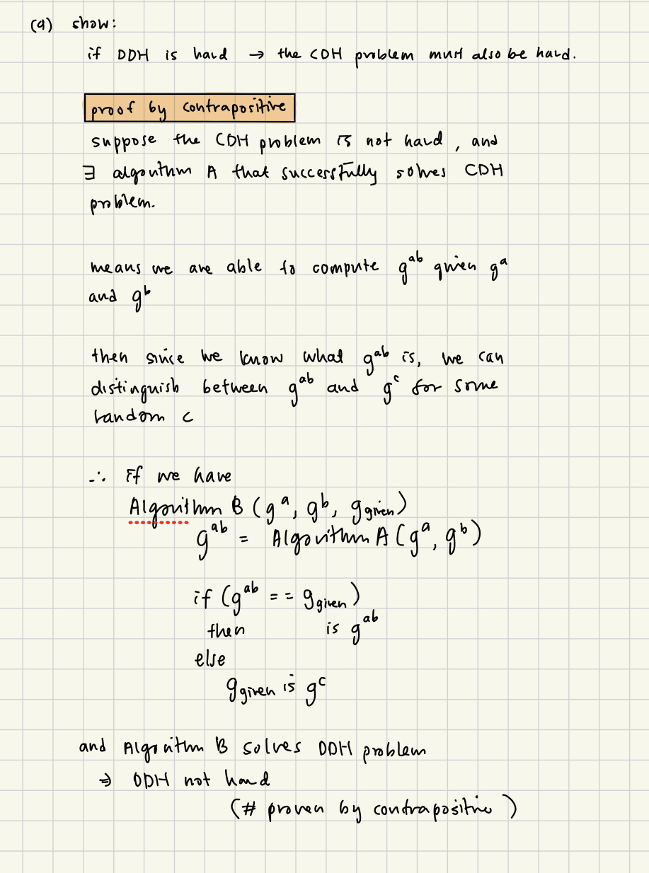

c)