This research paper serves as an attachment for:
- ☒ Outline defense/ Final Outline
- ☐ Manuscript defense /Final Manuscript

This research paper used AI for (Check all that apply):
☒ Improving word choice and sentence structure | ☒ Improving paragraph organization and overall tone
☐ Computer code generation or correction | ☒ Improvement of graphics
☐ Assistance in interpretation of data | ☒ Summarization
☐ Transcription and/or Translation | ☒ Brainstorming
☐ I did not use AI in this paper | ☒ Idea framing

The use of AI for this paper is reflected herein
AI Tool Used: ChatGPT
Prompts used
"assist me in fixing the table of contents and list of figures, make sure the page and figure number is correct." (Table of Contents, List of Dummy Tables, List of Figures, List of Appendices)
"can you check if our introduction clearly explain the current problem of SK and LYDO? dont change our scope." (Introduction, pp. 1-3)
"is the expected outputs match with each objective? check it one by one." (Expected Outputs of the Project, pp. 9-11)
"check our operational terms if the meaning is based on youthlink only." (Operational Definition of Terms, pp. 14-16)
"is this conceptual framework proper for our system? does it connect to our modules and agile?" (Conceptual Framework, pp. 17-18)
"is this statement in rrl has connection to our youthlink? explain to me why." (Review of Related Literature, pp. 19-30)
"can you fix the flow of our rrl paragraphs but dont add sources or findings." (Review of Related Literature, pp. 19-30)
"what is the gap of these studies compared to our youthlink? base only on our rrl." (Research Gap and Synthesis, pp. 31-32)
"is quantitative research design okay for our system evaluation? explain it simple." (Research Design, p. 33)
"check if our respondents and data collection are clear. dont change the 36 respondents." (Project Respondents and Instruments / Data Collection, pp. 33-35)
"can you improve the ethical consideration wording but keep the same meaning." (Ethical Consideration, pp. 35-36)
"is this considered agile? our modules will be done by sprint and some modules can overlap." (Project Development / Agile Methodology, pp. 36-37)
"check if our software and hardware requirements are okay for laravel web and youth mobile app." (Software and Hardware Requirements, pp. 46-47)
"can you help me describe this screenshot, be specific what user can input and what KPI is there. dont use the word screen." (User Interface descriptions, Figures 3-52, pp. 48-97)
"check if our ERD, use case and class diagram explanation match the diagram." (Figures 53-55, pp. 99, 101, and 103)
"can you check if our 20 references are searchable online or legit, arrange alphabetically APA and find the url." (Literature Cited, pp. 158-160)
Disclosure of AI Use in Non-Text Media, Including Images, Videos, etc.
Figure number or Location | Prompt Used | Caption
Figure 95  p. 157 | "can you revise our gantt chart, make it like from may-november, the development should finish mid october" | 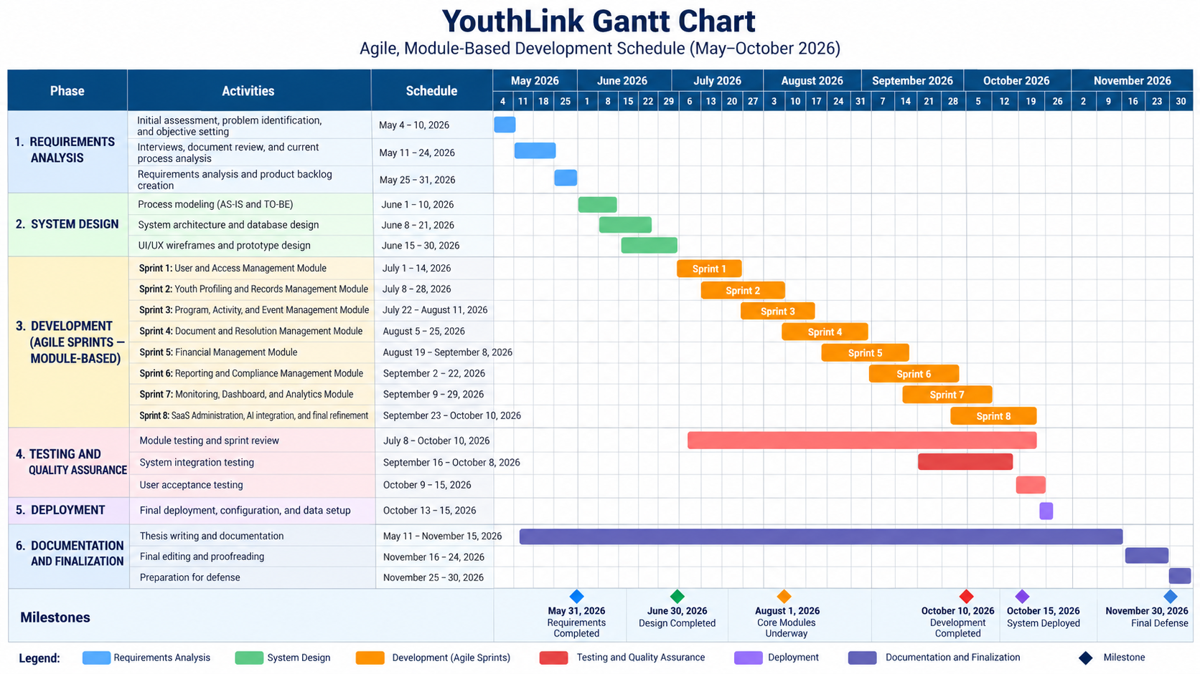  Figure 95. Gantt Chart of Youthlink Web System. Generated using ChatGPT, October 4, 2026.

All AI-assisted outputs were critically reviewed, edited, and validated by the authors, adviser, and department research coordinator to ensure accuracy, originality, academic integrity, and compliance with ethical research practices. The authors assume full responsibility for the content and integrity of this paper.

FITZ GERALD ALAGANO | JOHN ALLAN MARK P. GOTERA | DONALD M. MIRANDA
Printed name and signature of student | Printed name and signature of student | Printed name and signature of student
APPROVED:
JOSH LORILLA  Adviser  .  Date | CATHERINE C. DAFFON  Department Research Coordinator  .  Date

DEVELOPMENT OF YOUTHLINK: A SAAS-BASED WEB SYSTEM FOR YOUTH MANAGEMENT AND SERVICES PLATFORM

Thesis title:
Fitz Gerald Alagano, John Allan Mark P. Gotera, Donald Miranda
Name of students:
Date:

For Outline/Manuscript Defense
- Defense ☐ 1st re-defense ☐ 2nd re-defense

 | Yes | No
The student can explain complex passages from the thesis in simpler terms when asked by the panel. For example, the student can answer questions such as:
- How can you explain this paragraph of the thesis?
The student can justify the sources, citations, or theoretical concepts used in the literature review. For example, the student can answer questions such as:
- What is the main argument of this cited study?
- How or what part of this cited study is relevant in your research?
(For manuscript defense only)
The student can clearly explain how the data were analyzed.
Sample question: For example, the student can answer questions such as:
- How did you analyze your data?
All cited references are existing (i.e., There are no fake references).
All information presented in the thesis is accurate, and assertions supported by references are true to the cited sources.
- (At least one "no”) The student has to re-defend.
- The student has demonstrated knowledge of all claims and may proceed to be evaluated on other aspects of the paper.
Approved:

JOSEPH C. LORILLA
Adviser
CATHERINE C. DAFFON
Department Research Coordinator

For Approval of Outline/Manuscript
  - 1st checking ☐ 2nd checking ☐ 3rd checking ☐ 4th checking

INDICATORS OF IRRESPONSIBLE USE OF AI | Yes | No
A. Sanctionable AI use
A1. The thesis contains fake citations or references.
A2. The thesis contains hallucinations, fake data, unsupported claims, and/or claims that are not true to the cited sources.
B. According to Prompts
B1. Portions of the thesis were generated by AI, without substantial human input.
B2. AI was used as the sole tool for analyzing the results
B3. Personal information was fed into the system.
B4. References were summarized using AI, with little indication that the student actually read the original source.
B5. The thesis contains fake citations or references.

- (At least one "Yes" in section A) Thesis contains sanctionable use of AI, and must be revised.
(Note: If instances of A1 and/or A2 persist after the first revision, students will be subject to approved sanctions.)
- (At least one "Yes" in section B) Thesis contains irresponsible use of AI, and must be revised.
- Thesis is found to be compliant with responsible use of AI.

Approved:

JOSEPH C. LORILLA
Adviser

CATHERINE C. DAFFON
Department Research Coordinator

___________- -_______________
Date Date

