PRINTIFY: INTEGRATED DYNAMIC ORDER, JOB SCHEDULING, AND INVENTORY MANAGEMENT SYSTEM FOR PRINTING SERVICES WITH AUTOMATED REPLENISHMENT

CHRISTIAN JAMES J. PEREZ
KAYE P. COMISSION

BACHELOR OF SCIENCE IN INFORMATION SYSTEMS



OCTOBER 2026
PRINTIFY: INTEGRATED DYNAMIC ORDER, JOB SCHEDULING, AND INVENTORY MANAGEMENT SYSTEM FOR PRINTING SERVICES WITH AUTOMATED REPLENISHMENT

CHRISTIAN JAMES J. PEREZ
KAYE P. COMISSION

Thesis Outline Submitted to the Department of Computing and Library Information Science, College of Engineering and Information Technology,
University of Southern Mindanao, Kabacan, Cotabato in Partial Fulfilment of the
Requirements for the Degree of
BACHELOR OF SCIENCE IN INFORMATION SYSTEMS

OCTOBER 2026

ACADEMIC INTEGRITY STATEMENT

I hereby declare and confirm with my signature that the Outline is exclusively the result of my own autonomous work based on my research and literature published, which is referenced immediately after the information is presented and listed in the reference section. I also declare that no part of the work submitted has been made in an inappropriate way, whether by plagiarizing, infringing on any third person's copyright, or falsifying data. Finally, I declare that no part of the Manuscript submitted has been used for any other paper in another higher education or research institution.

CHRISTIAN JAMES J. PEREZ
Printed Name and Signature

KAYE P. COMISSION
Printed Name and Signature

_____________
Date




UNIVERSITY OF SOUTHERN MINDANAO
Kabacan, Cotabato
Philippines
APPROVAL OF THESIS OUTLINE

Name | CHRISTIAN JAMES J. PEREZ, KAYE P. COMISSION
Major | N/A
Degree Sought | BACHELOR OF SCIENCE IN INFORMATION SYSTEMS
Specialization | N/A
Thesis Title | INTEGRATED DYNAMIC ORDER, JOB SCHEDULING, AND INVENTORY MANAGEMENT SYSTEM FOR PRINTING SERVICES WITH AUTOMATED REPLENISHMENT
APPROVED BY THE GUIDANCE COMMITTEE
____________________________ ______________________________
Adviser Co-Adviser
(Optional)

______________ _____________
Date Date

____________________________ ______________________________
Statistician Department Research Coordinator (Optional)

______________ _____________
Date Date
____________________________
Department Chairperson

______________
Date

_________________________ ______________________
College Research Coordinator Dean

______________________ ______________________
Date Date

Study No: Study No: Dept-YYYY-### (Sample: Chem-2022-001)
Index No: ________________
Recorded by: _____________
RECORDED:

_________________________________
Head, Academic Research and Monitoring Unit

_________________
Date
Recorded by: __________

TABLE OF CONTENTS

PRELIMINARIES Page
Title Page i
Approval of Thesis Outline ii
Table of Contents iii
List of Dummy Tables v
List of Figures vi
List of Appendices vii
INTRODUCTION 1
Significance of the Project 3
Statement of the Problem 4
Objectives of the Project 6
Expected Output of the Project 7
Limitations of the Project 8
Operational Definition of Terms 11
Conceptual Framework 13
REVIEW OF RELATED LITERATURE 16
Dynamic Order 16
Job Scheduling 19
Inventory Management System With Automated Replenishment 21
METHODOLOGY 26
Project Design 26
Project Participants and Materials 27
Data Collection 28
Data Analysis Procedure 29
Validity 35
Ethical Considerations 35
Project Development Approach 36
Project Timeline & Budget 39
System Requirement Specifications 41
Functional Requirements 42
Software Requirements Specification 54
Hardware Requirements Specification 55
Use Case Diagram 56
Class Diagram 59
Project Design 61
Entity Relationship Diagram 61
Activity Diagram 65
User Interface 86
LITERATURE CITED 100
APPENDICES 103
Appendix A. Application for Research Adviser 104

Appendix B. Application for Research Title 105

Appendix C. Estimated Budget for the Research 106

Appendix D. Application for Thesis Outline Defense 107

Appendix E. Application for Group Research 108

Appendix F. Master Functional Test Cases 109

Appendix G. Test Case Specification 112

Appendix H. Task Allocation Matrix (TAM) 138

Appendix I. Curriculum Vitae 146

LIST OF DUMMY TABLES

Table Title Page

- Functional Test Plan and Requirements Traceability Matrix 32
- Estimated Project Development Budget 40
- Software Requirements Specification 54
- Hardware Requirements Specification 55

LIST OF FIGURES

Figure Title Page

- Conceptual Frame Work 15
- Agile Model 37
- Gantt Chart 39
- Use Case Diagram 58
- Class Diagram 60
- Entity Relationship Diagram 64
- User Account Registration 65
- User Authentication 66
- User Profile Management 67
- Session Termination and Logout 68
- Service Catalog Browsing and Quotation 69
- Print Order Placement and Document Upload 70
- Print Attribute and Finishing Specification 71
- Customer-Supplied Substrate Declaration 72
- Proof of Payment Submission 73
- Live Order Progress and Status Tracking 74
- Payment Transaction Auditing and Verification 75
- Production Floor 5-Stage Kanban Queue 76
- Automated Bill of Materials (BOM) Inventory Deduction 77
- Customer-Supplied Substrate Intake and counter verification 79
- Material Spoilage Logging and Stock Adjustments 80
- Dynamic Service and Rate Configuration Workflow 82
- Bill of Materials (BOM) Recipe Definition 83
- Inventory Oversight and Dynamic Reorder Point Alerting 84
- Sales, Cashflow, and Operational Analytics Generation 85
- Landing Page of Printify 86
- Registration Interface 87
- Login Interface 88
- Business Owner Setup Wizard 89
- Business Owner Setup Wizard 89
- Business Owner Master Dashboard 90
- Application and Service Management Interface 91
- Dynamic Service Configuration Hub 92
- Dynamic Service Configuration Hub 93
- Customer Ordering Wizard and Live
Five-Stage Progress Stepper 94
- Customer Ordering Wizard and Live
Five-Stage Progress Stepper 94
- Customer Ordering Wizard and Live
Five-Stage Progress Stepper 95
- Staff Production Kanban Console 96
- Report Spoilage Interface 97
- Inventory Hun with Automated Restock Alerts 98
- Sales and Financial Analytics Hub 99

LIST OF APPENDICES

Appendix Title Page

A Application for Research Adviser 104

B Application for Research Title 105

C Estimated Budget for the Research 106

D Application for Thesis Outline Defense 107

E Application for Group Research 108

F Master Functional Test Cases 109

G Test Case Specification 112

H Task Allocation Matrix (TAM) 138

I Curriculum Vitae 146

INTRODUCTION

The commercial printing and binding sector operates within a fast-paced environment catering to diverse customer demands, ranging from routine document printing and seasonal thesis binding to commercial marketing collaterals. As academic institutions and local commercial enterprises continuously generate demand, printing service providers face persistent hurdles in sustaining operational efficiency and consistent turnaround times (Saragih et al., 2026; Susila et al., 2025). Despite handling complex custom job specifications, many local printing establishments continue to rely on manual, paper-based workflows or fragmented spreadsheet tracking systems (Apriadi & Dewi, 2026; Tanaman et al., 2023). These unintegrated setups create severe operational bottlenecks, especially during peak academic semester deadlines when order volumes surge rapidly (Jebbor et al., 2021; Kurniawan et al., 2025). Without a synchronized management framework, delegating tasks across workshop machinery and production personnel becomes disorganized (Smagowicz et al., 2024), while the absence of real-time material monitoring frequently results in unexpected stockouts of essential supplies like paper stocks, toner, and binding covers, leading to costly delays and compromised customer satisfaction (Abu Zwaida et al., 2021; Albayrak Ünal et al., 2023).
To resolve these operational limitations, conventional software approaches prove inadequate because they are often rigidly hardcoded, preventing shop owners from introducing new service variations or modifying dynamic pricing rules without modifying underlying application source code (Joshi et al., 2026; Saragih et al., 2026). In response, this capstone project develops the Integrated Dynamic Order, Job Scheduling, and Inventory Management System for Printing Services with Automated Replenishment (Printify). The platform introduces a modular web architecture enabling administrators to configure service catalogs, page rates, and linked Bill of Materials (BOM) recipes dynamically through an intuitive interface. To streamline shop floor productivity, an integrated job scheduling console organizes active orders into a visual production queue, systematically allocating machinery and labor to maintain delivery schedules (Smagowicz et al., 2024; Zonta et al., 2022). Furthermore, instead of relying on long-term predictive models requiring extensive historical datasets, the system calculates the real-time consumption burn rate of raw materials directly from active sales volume, automatically triggering restocking alerts when inventory levels reach critical reorder thresholds (Jebbor et al., 2021; Ugbebor et al., 2024). Uniting dynamic order intake, visual floor tracking, and automated material replenishment within a centralized web platform modernizes print shop operations, ensuring punctual fulfillment, balanced labor allocation, and data-driven inventory control (Apriadi & Dewi, 2026; Bhaktha et al., 2023).

Significance of the Project

The realization of this project will profoundly benefit various stakeholders within the printing and binding industry by transforming disjointed manual processes into a streamlined, automated workflow. Primarily, Business Owners and Management will gain a dynamic and highly adaptable platform that allows them to effortlessly configure, add, or modify printing services and pricing structures without needing complex source code alterations. Furthermore, the automated inventory replenishment module will eliminate the guesswork in restocking, calculating real-time material burn rates to prevent costly stockouts and maximize potential revenue, especially during peak seasons.
For Employees and Production Staff, the system will significantly reduce the chaos associated with sudden influxes of orders. The dedicated job scheduling module will provide a clear, visual queue of assigned tasks and deadlines, preventing overlapping duties and allowing staff to focus efficiently on production rather than manual coordination. Consequently, Customers and Clients will experience highly reliable service. With optimized order tracking, systematic job delegation, and guaranteed raw material availability, clients will benefit from faster turnaround times, strict adherence to deadlines, and an overall enhanced customer experience.
Finally, this study will serve as a substantial foundation for Future Researchers and Developers. The integration of a dynamic, configurable service architecture combined with a short-term, data-driven material replenishment logic provides a modern software framework. Future IT and Information Systems scholars can utilize this project as a baseline reference for designing scalable, industry-specific management systems that do not rely on long-term, data-heavy predictive machine learning models.

Statement of the Problem

This study addresses the overarching problem of how to design and develop an Integrated Dynamic Order, Job Scheduling, and Inventory Management System for Printing Services with Automated Replenishment to effectively resolve the manual operational bottlenecks experienced by printing establishments. Currently, the reliance on disjointed, traditional processes creates significant frustrations for all primary stakeholders. For customers, the absence of real-time order tracking leads to the inconvenience of repeatedly visiting or contacting the establishment just to check the status of their print jobs, often resulting in dissatisfaction when orders are unexpectedly delayed. For production staff and employees, depending on manual, paper-based queuing systems creates a chaotic workflow where physical job tickets are easily misplaced, miscommunicated, or improperly prioritized, leading to overlapping duties and unfulfilled deadlines. Meanwhile, business owners and administrators are hindered by rigid software that cannot adapt to new services, and they are forced to rely on pure guesswork and intuition to manage inventory, which inevitably leads to unexpected material stockouts and lost revenue during peak seasons.
To resolve these interconnected operational challenges, the project must explicitly address how to formulate a dynamic order management architecture that allows administrators to configure services, pricing tariffs, and consumable requirements on the fly without modifying application source code. Furthermore, it must establish how to engineer an interactive production floor scheduling module that digitizes workshop queues, visually tracks order progression across five defined stages, and systematically delegates machinery and labor. Concurrently, it must determine how to implement an automated inventory replenishment module that computes daily material burn rates and triggers timely replenishment alerts at dynamic reorder points. Finally, the project must answer how to integrate these targeted modules into a single, cohesive web-based platform, and how to conduct rigorous software functional testing and system verification using a structured Test Plan to empirically validate that all functional requirements execute accurately on a pass-or-fail basis.

Objectives of the Project

The general objective of the project is to design and develop an Integrated Dynamic Order, Job Scheduling, and Inventory Management System for Printing Services with Automated Replenishment to modernize and automate the operational workflows of printing establishments, from customizable order intake and production tracking to data-driven inventory maintenance.
Specifically, this study aims to:
- create a dynamic order management architecture that enables administrators to configure, add, or modify printing services, pricing variables, and material requirements without altering the source code;
- develop a job scheduling module that digitizes the production queue, visually tracks order progress, and systematically allocates labor and machinery to ensure timely fulfillment;
- implement an automated inventory replenishment module that calculates the real-time burn rate of materials based on active sales volume and triggers alerts at critical reorder points;
- integrate the dynamic ordering, job scheduling, and inventory replenishment modules into a single, cohesive web-based platform; and
- conduct comprehensive functional testing and system verification of the developed platform using a structured Test Plan and discrete Test Cases to validate that all 19 functional requirements satisfy their specified operational parameters, boundary conditions, and database transactions on a pass-or-fail basis and execute operational user acceptance walkthroughs with printing shop stakeholders.

Expected Outputs of the Project

The expected output of the project will include the following to:
- A fully functional web-based platform that integrates dynamic order configuration, job scheduling, and inventory replenishment tailored specifically for printing and binding service operations.
- A dynamic order management module that grants business administrators the flexibility to seamlessly create, customize, and modify various printing services and pricing structures without needing backend code alterations.
- A customer-facing portal that provides an intuitive interface for clients to easily submit their specific printing requirements and track the real-time progress of their orders, eliminating the need for frequent physical follow-ups
- A digital job scheduling module that equips production staff with a visual, organized queue of pending and ongoing tasks, allowing for the efficient allocation of labor and machinery to meet strict fulfillment deadlines.
- An automated inventory replenishment module that continuously tracks material consumption and calculates real-time burn rates based on active sales, providing management with data-driven alerts before essential printing supplies reach critical depletion levels.
- A comprehensive software quality assurance report comprising the Functional Test Plan, Requirements Traceability Matrix, and executed Test Case execution ledgers demonstrating 100% verification across all 19 functional modules on a pass-or-fail basis.

Limitations of the Project

The scope of this project is strictly bounded to the order configuration, job scheduling, and inventory replenishment of printing services. The system is not designed to function as a full-scale Enterprise Resource Planning (ERP) software; thus, it completely excludes comprehensive financial accounting, third-party logistics or courier integration, and Human Resource modules such as payroll and biometric employee attendance. Furthermore, the system relies on manual payment verification (e.g., uploading of GCash receipts) and does not integrate with automated bank APIs or live payment gateways. Lastly, the software is purely web-based and does not feature Internet of Things (IoT) capabilities; it will not directly interface with physical printing or binding machines to automatically read hardware statuses or ink levels.

People
The system is designed to facilitate seamless interaction among three primary users:
- Administrators / Business Owners: They have full access to the dynamic configuration of the system. They are responsible for setting up the types of printing services offered, managing pricing structures, monitoring the real-time inventory burn rate, and verifying customer payments.
- Production Staff / Employees: They utilize the job scheduling module to view their assigned tasks, update the production progress of each order, and systematically deduct raw materials from the digital inventory as jobs are completed.
- Customers / Clients: They access the customer-facing web portal to easily browse offered printing services, submit specific order requirements, upload necessary files, and track the real-time status of their print jobs without needing physical follow-ups.

Data

The system will process, store, and manage essential operational data to ensure smooth transactions. This includes customer profiles and contact details, transaction histories, and uploaded print files. On the administrative side, the database will handle the dynamic service configurations (custom pricing and variations), real-time job order statuses, and automated inventory records, specifically the current stock levels, material burn rates, and reorder point thresholds.

Process

The system automates the core operational workflow of the printing establishment. The process begins with dynamic order intake, where customers select services configured by the admin. It proceeds to manual payment verification, followed by the automated routing of the confirmed order into the digital job scheduling queue. During production, the system systematically allocates tasks to specific staff members. As production progresses, the system processes inventory deductions based on material consumption, ultimately triggering automated restocking alerts when supplies reach critical levels.

Hardware

To effectively run and access the web-based system, users only require standard web-capable devices such as desktop computers, laptops, tablets, or smartphones. A stable internet connection is required for all actors (administrators, staff, and customers) to access the cloud-hosted platform and synchronize data in real-time.

Operational Definition of Terms

To ensure clarity and establish a shared understanding of the concepts discussed throughout this study, the following terms are operationally defined. These definitions reflect how each technical and business-specific term is explicitly utilized within the context of the developed system's dynamic architecture, modules, and workflows, rather than their general dictionary meanings:

Administrator - Refers to the business owner or authorized management personnel who has full access to the system. They are responsible for dynamically configuring printing services, managing pricing variables, monitoring the inventory burn rate, and verifying customer payments.
Automated Replenishment - Refers to the specific system module that eliminates manual stock guesswork by calculating real-time material consumption and automatically triggering alerts when supplies reach a critical level.
Burn Rate - In this study, it refers to the calculated velocity or speed at which specific raw printing materials (e.g., paper, ink, binding covers) are consumed based on active, short-term sales volume.
Customer - Refers to the clients or end-users who utilize the customer-facing web portal to browse offered printing services, submit specific order requirements, upload files, and visually track the real-time status of their print jobs.
Dynamic Configuration - Refers to the core architectural feature of the system that allows administrators to seamlessly create, add, or modify printing services and pricing structures through the user interface without requiring continuous modifications to the backend source code.
Inventory Management - Refers to the digital tracking system used to monitor the availability, quantity, and depletion of raw materials required for production, which automatically updates as production staff complete their assigned tasks.
Job Scheduling - Refers to the digital production queue that replaces physical job tickets. It visually tracks the progress of each order and systematically allocates labor and machinery to ensure fulfillment deadlines are met.
Printing Services - Refers to the customizable products and services offered by the establishment (e.g., hardbound binding, document printing, customized merchandise) which are dynamically defined and categorized by the administrator within the system.
Production Staff - Refers to the shop employees who utilize the job scheduling module to view their assigned tasks, update the production progress of specific orders, and initiate the digital deduction of consumed raw materials.
Reorder Point - Refers to the specific, data-driven stock level threshold calculated by the system which, when reached, immediately notifies the administrator that new raw materials must be purchased from suppliers.
Conceptual Framework
The Figure illustrates the conceptual framework of the capstone project, detailing the operational flow of the platform across the Input, Process, Output, Outcome, and Impact stages. The Input encompasses stakeholder profiles (business owners, production staff, and customers), modular service parameters (dynamic pricing formulas, media dimensions, substrate types, and finishing rules), customer digital assets (PDF manuscripts, vector artwork, and remittance proofs), and raw consumables inventory baselines. The central Process executes real-time multi-attribute cost computation, manual payment auditing, 5-stage workshop Kanban queue scheduling, customer-supplied paper tracking, automated stage-based Bill of Materials (BOM) inventory deductions, and rolling consumption velocity calculations to evaluate dynamic Reorder Points (ROP).
The primary Outputs include the integrated role-segregated web-to-print platform, interactive customer self-service ordering wizards with live five-stage visual progress tracking, workshop floor Kanban digital job tickets, automated replenishment alert banners, and multi-service business intelligence summaries. Consequently, the immediate Outcomes eliminate manual calculation errors, eradicate lost paper job tickets, provide 24/7 transparent order tracking for clients, prevent unexpected stockouts during peak academic rushes, and establish data-driven procurement based on true sales burn rates. In the long term, the framework achieves significant organizational Impact by maximizing enterprise productivity and profitability, strengthening market trust, providing code-free business adaptability for shop proprietors, and establishing a validated information systems benchmark for lightweight job-shop printing automation.
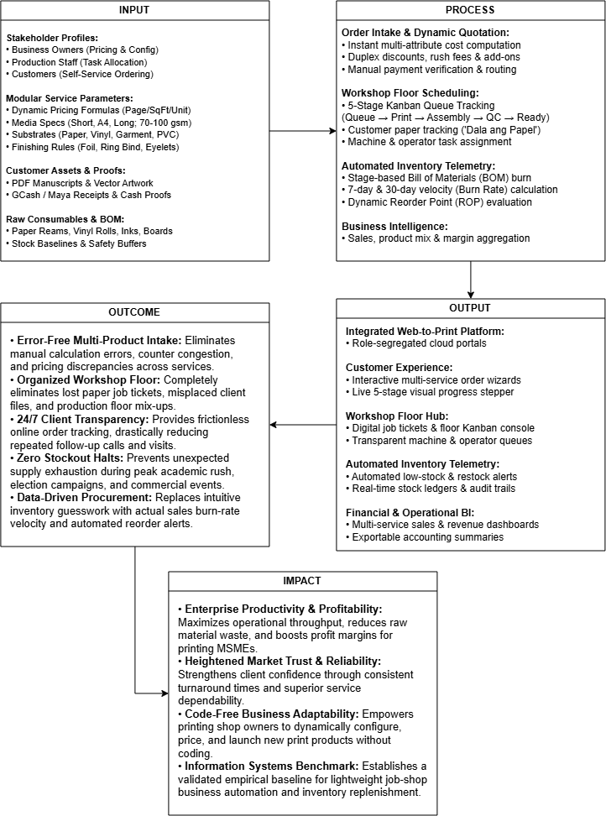
Figure 1. Conceptual Framework of Printify
REVIEW RELATED LITERATURE

Dynamic Order
Apriadi and Dewi (2026) highlighted that many small and medium-sized printing businesses still rely on manual or semi-digital processes, resulting in miscommunication, data inconsistencies, and inefficient workflow management. To address these challenges, the researchers developed a web-based printing service system that integrates order management, inventory control, and production workflow into a unified platform. The findings demonstrated that an integrated information system can reduce operational errors, improve communication between departments, and enhance overall operational efficiency. Similarly, Susila et al. (2025) identified limitations in order recording, cost estimation, and production monitoring, where manual processes can cause delays and errors. Their study developed a web-based system with online ordering, automated cost estimation, job tracking, and real-time updates, which improved production efficiency and customer satisfaction. Saragih et al. (2026) likewise emphasized the increasing demand for efficiency and accuracy in service industries and noted that many organizations, particularly small and medium-sized enterprises such as printing services, still rely on manual or semi-digital processes. Their study addressed operational inefficiencies, data inconsistencies, and communication gaps through the design and implementation of a web-based information system for digital printing services. These studies support the use of an integrated web-based platform for printing-service operations, particularly in managing orders and connecting different operational processes.

Kurniawan et al. (2025) found that the use of unintegrated spreadsheets across divisions in a Production Planning and Inventory Control (PPIC) system at an Indonesian packaging manufacturer resulted in production inaccuracies, scheduling errors, and additional time spent on repetitive manual processes. To address these problems, the researchers developed a web-based data integration system that enabled real-time data synchronization and reduced manual data entry. The findings demonstrate the importance of connecting information across production-related activities to improve coordination and data availability. Joshi et al. (2026) similarly demonstrated how web-based services have contributed to the modernization of document handling and printing processes. Traditional printing was described as being limited by manual coordination, physical presence, and tightly coupled backend infrastructure. The study introduced Zaprint, a remote printing management system that allows users to submit print jobs through a web application while local print shops manage and process the jobs through a desktop application. The system uses Supabase for authentication, database management, file storage, and communication, with a cloud-based data layer enabling real-time connectivity between users and print shops. The findings showed that the system was more efficient and easier to use than traditional print management systems. These findings support the present study's use of an integrated web-based system for coordinating printing-service activities.

Bhaktha et al. (2023) developed an online order management system that provides sellers with an overview of their orders and inventory, allowing them to manage products through a centralized system. The platform includes order tracking, stock management, and customer management features accessible through a single dashboard. These features support the present study's development of an integrated web-based system for printing services, particularly its Dynamic Order Management and Inventory Management components, which aim to centralize order information, monitor inventory, and improve the efficiency of printing-service operations. Dhiman (2021) demonstrated how the Online Food Ordering Management System can simplify order management by allowing customers to submit their requirements through an online interface. The system records orders in a centralized database, places them in a queue, and provides real-time updates through the administrative panel. This enables staff to monitor incoming orders and process them systematically, reducing errors and improving workflow efficiency. These features are relevant to the present study because the proposed printing service system similarly integrates digital order intake with a centralized job queue and real-time order tracking. Hernada et al. (2024) developed a web-based design and print ordering system to improve customer service efficiency and effectiveness. The system demonstrated how web-based technology can streamline ordering processes in digital printing businesses. Together, these studies present web-based ordering as a means of organizing customer orders, centralizing order information, and improving the efficiency of printing-related services.

Job Scheduling
Smagowicz et al. (2024) presented a method for developing production schedules based on a printing company's operational processes and production technologies. The approach considered production resources and business requirements to support resource-balanced production decisions. The study is relevant to the present research because it demonstrates the importance of systematic production scheduling in printing operations. Zonta et al. (2022) likewise highlighted the importance of connectivity and data availability in supporting decision-making within production processes. The study proposed an integrated approach to production scheduling that considers available resources and uses data to improve scheduling decisions. These findings support the present study's Job Scheduling module, which organizes printing orders into a digital production queue, tracks job progress, and allocates labor and machinery to support timely order fulfillment.
Jiang et al. (2022) discussed how changes in production systems and technological development have influenced the methods used for production scheduling. The study highlighted the evolution of scheduling approaches in response to changing production environments and emerging technologies. This supports the present study's development of a digital job scheduling module for printing services, which aims to organize production queues, track order progress, and allocate labor and machinery systematically to improve production efficiency. Destouet et al. (2023) examined various approaches for supporting scheduling decisions in evolving production environments. The study emphasized the challenges of coordinating machines and operators in flexible production scheduling. These findings support the present study's Job Scheduling module, which organizes printing jobs and systematically allocates production staff and machinery to improve workflow and ensure timely order fulfillment. Hernada et al. (2024) developed a web-based design and print ordering system that demonstrated how web-based technology can streamline ordering processes in digital printing businesses. This supports the present study's use of a web-based platform for printing services, particularly its dynamic order management and customer-facing ordering functions. However, the present study extends beyond online ordering by integrating job scheduling, inventory management, and automated replenishment into a single system.

Inventory Management System with Automated Replenishment
Tanaman et al. (2023) developed a web-based inventory management system for a small business enterprise in Pagadian City, Zamboanga del Sur, Philippines. The study identified challenges associated with the manual use of paper-based inventory records, including data inaccuracy and process inefficiency in recording and distributing inventory and sales reports. To address these issues, the researchers developed an automated web-based solution that electronically recorded and processed inventory data and generated reports. The study demonstrated how web-based automation can improve inventory management efficiency and convenience. Jebbor et al. (2023) demonstrated that automated and integrated inventory management can help organizations address inventory and replenishment problems, particularly during periods of high demand. Their study on hospital logistics proposed an automated and integrated inventory and replenishment management system that uses a proactive, real-time replenishment policy. This approach demonstrates the potential of automated replenishment in maintaining the availability of essential resources and reducing inventory-related problems. Asim and Arbaiy (2026) similarly demonstrated that a computerized inventory management system can help businesses address problems associated with manual inventory operations, particularly inaccurate stock levels and delays in replenishment. Their study on Alfudullallah Co. developed an inventory management system that provides real-time inventory tracking and supports inventory, warehouse, ordering, reporting, and analysis management.

Ugbebor et al. (2024) examined the role of automated inventory management systems integrated with Internet of Things (IoT) technology in improving inventory management among small and medium-sized enterprises (SMEs). The development of automated solutions, such as IoT sensors, real-time data analytics, and cloud-based applications that enhance inventory control, was also identified in their review of the literature. According to the study, the use of IoT in automation has improved inventory accuracy, decreased stockouts, and decreased carrying costs for SMEs. The research also identified reverse logistics systems with intuitive demand forecasting for optimal stock replenishment, automation of reordering systems while efficiently managing working capital, and decreased downtime from real-time tracking as operational improvements. Rolf et al. (2023) identified inventory management as a common application of data-driven decision-making in supply chain management. Their literature review on reinforcement learning in supply chain management emphasized the importance of inventory management in coordinating supply chain operations. The study also highlighted the potential of real-time, data-driven decision-making in managing complex and dynamic operations. These findings support the present study's approach of using real-time inventory data, particularly material consumption and burn rate, to support automated replenishment decisions in printing services.

Munyaka and Yadavalli (2022) explained that inventory is one of the main management tasks and a fundamental component of material management, logistics, and supply chain management. Warehouse inventory may be required to meet customer or humanitarian demands, depending on the organization's goals. Inventory control is essential to both organizational performance and operational success. In light of the growing demands of human needs, the study examined inventory management concepts and applications and noted that inventory treatment is influenced by demand, which is a crucial variable in the inventory control system. Albayrak Ünal et al. (2023) reported that organizations seeking to keep pace with technological advancements and globalization must efficiently manage their supply chains to achieve superior quality, enhanced efficiency, and reduced costs. The diverse needs of customers, along with competition from global players and market rivalry, have prompted companies to focus more on inventory management. Their article presented a systematic literature review of the use of Artificial Intelligence (AI) in inventory management, concentrating on research papers from two academic databases published between 2012 and 2022, with a total of 59 articles identified for detailed examination. The current state of inventory management and potential future directions were also outlined, with the findings indicating a rising interest in AI techniques in recent years.

Abu Zwaida et al. (2021) highlighted that drug shortages pose a significant challenge for inventory management within healthcare systems, as they can lead to various adverse effects. In the realm of supply chain management, achieving optimization is closely linked to controlling inventory in order to address problems associated with the supply, management, and utilization of medications. The study noted that identifying a shortage scenario in a hospital can be challenging due to numerous unpredictable factors, such as manufacturing issues, fluctuations in supply and demand, and problems with raw materials. To mitigate the risk of shortages in hospitals, effective inventory management is essential to maintain sustainable operations and maximize organizational performance within the Hospital Supply Chain (HSC).

The reviewed literature addresses several operational needs related to the development of the Printify system. The studies discuss digital order management, production scheduling, inventory control, automated replenishment, and customer service in printing and other operational settings. Apriadi and Dewi (2026) and Susila et al. (2025) demonstrate the use of web-based systems for improving order management and production-related processes, while Smagowicz et al. (2024) and Zonta et al. (2022) emphasize systematic scheduling and the use of production information for scheduling decisions. Tanaman et al. (2023) and Jebbor et al. (2023) demonstrate the role of automated inventory management and replenishment, while Rolf et al. (2023) highlights the use of real-time inventory data for data-driven decision-making. These studies provide the literature-based support for the operational features of Printify, including order management, job scheduling, inventory monitoring, stock replenishment, and reporting.

METHODOLOGY

This chapter outlines the research procedures and engineering techniques employed in designing, constructing, and evaluating the Integrated Dynamic Order, Job Scheduling, and Inventory Management System for Printing Services with Automated Replenishment. It details the research design, operational characterization of participants, project materials, empirical data collection techniques, statistical analysis procedures, system validity measures, and ethical safeguards. Furthermore, it presents the architectural requirements and software modeling diagrams that guided the systematic implementation and quality assessment of the platform.

Project Design

This study employs a Developmental Research Design, a methodology centered on the systematic analysis, design, development, implementation, and evaluation of an instructional or technological solution to address operational problems. This research design is suited for this study because the primary objective is to engineer a functional, integrated web-based information system that unites dynamic order management, floor job scheduling, inventory management, and automated replenishment.
Through the developmental framework, the project developers systematically establish operational requirements from real-world printing workflows, translate these requirements into modular software components, conduct rigorous verification, and evaluate the final system through a comprehensive Software Quality Assurance (SQA) and Functional Testing protocol. This ensures that the resulting software artifact is practically grounded, technically sound, and empirically validated against all specified functional requirements on a pass-or-fail basis.

Project Participants and Materials

The project participants include the business owners, production staff or workshop employees, and customers or retail clients of the printing-service establishment. The business owners and administrators provide authoritative operational requirements concerning dynamic service definitions, pricing formulas, material attributes, baseline stock levels, and commercial policies, while evaluating administrative controls, inventory telemetry, and reporting modules during system assessment. The production staff and workshop employees supply operational insights regarding job queueing, prepress inspection, task bottlenecks, machinery capacity, and raw material waste, while testing the practical usability of the five-stage production Kanban console and digital job tickets. Furthermore, customers and clients—comprising university students, faculty members, institutional organizations, and walk-in patrons—provide essential qualitative feedback regarding counter ordering hurdles, file submission issues, and tracking difficulties, while evaluating the customer self-service portal, the dynamic ordering wizard, and the live visual progress stepper.
The materials required for the research and development of the system encompass both physical and digital resources. Hardware materials include development workstations, laptops, and mobile smartphones equipped with internet connectivity to evaluate responsive layouts across various screen viewports. Software tools include integrated development environments, local web servers, database management systems, and web application frameworks (PHP, Laravel, Livewire, and Tailwind CSS) necessary for designing, building, and deploying the platform. In addition, the researchers utilize operational documents from the partner printing establishment—such as manual paper job tickets, physical order receipts, pricing tariffs, and inventory ledgers—as empirical reference materials to ensure that the system accurately models real-world business workflows.

Data Collection

The researchers will gather data using interviews, direct workplace observations, document reviews, and survey questionnaires to understand the operational requirements of the printing business.
First, semi-structured interviews will be conducted with the business owners and production staff to identify current operational challenges, service pricing rules, job scheduling workflows, and inventory restocking habits. Second, direct observations of daily shop activities will be carried out to observe counter order intake, task delegation across workstations, and material handling on the workshop floor. Third, the researchers will examine existing business documents, including sample receipts, manual job order slips, supplier invoices, and price lists, to accurately model pricing formulas and material consumption in the system. Finally, a formal Software Quality Assurance and Functional Testing protocol will be conducted during the evaluation phase. The project developers will execute a structured Test Plan consisting of discrete test cases mapped directly to the 19 functional requirements, recording binary evaluation outcomes (Pass or Fail) across boundary inputs, database persistence, and operational workflows. Additionally, operational user acceptance testing (UAT) will be conducted with the shop owner and production personnel to verify real-world task execution without reliance on subjective numerical Likert rating scales.

Data Analysis Procedure

- System Testing and Functional Verification Plan
To rigorously evaluate the software without introducing subjective evaluation bias, the project developers implemented a formal Software Quality Assurance (SQA) and Functional Verification protocol. Rather than relying on perceptual survey ratings, system verification is governed by empirical, binary evaluation criteria (Pass or Fail) modeled after IEEE 829 software test documentation standards.
- Multi-tier testing Strategy
The system evaluation follows a two-tier verification architecture:
Tier 1: Developer Functional and Automated System Testing (Primary Verification): The project developers execute discrete functional test cases covering normal, boundary, and exceptional input conditions across all 19 Functional Requirements (FR-01 to FR-19). In addition, core computational routines—including dynamic pricing algorithms, duplex paper calculations, automated Bill of Materials (BOM) inventory deductions, and rolling Reorder Point (ROP) alerts—are continuously verified using automated unit and feature test suites built on the Pest/PHPUnit testing framework.
Tier 2: Stakeholder Operational Walkthrough (User Acceptance Testing): Printing shop owners and production personnel execute end-to-end operational scenarios simulating daily commercial activities, including customer counter intake, job ticket delegation across Kanban columns, material spoilage adjustments, and financial report exports. The walkthrough validates task completion success, business workflow alignment, and operational ergonomics.

- Technical Testing Environment
Functional testing is conducted across the project’s standardized runtime environment:
Backend Runtime: PHP 8.5 executing on the Laravel 13 framework.
Reactive Frontend Engine: Livewire 4 with Alpine.js client-side state synchronization.
Database & Persistence: Relational database management system with ACID transaction guarantees and foreign key referential integrity constraints.
Client Workstations: Modern web browsers (Google Chrome, Microsoft Edge, Brave, Mobile Safari) simulating desktop administration and mobile customer order submission
- Pass/Fail Evaluation Criteria
Each functional test case is evaluated against deterministic binary criteria:
PASS: The actual system execution, state mutation, database transaction, and user interface response exactly conform to the defined expected output with zero unhandled exceptions.
FAIL: The system produces an execution halt, unhandled runtime exception, database integrity violation, incorrect mathematical computation, unauthorized state transition, or fails to render expected user telemetry.
To achieve production readiness, the platform mandates a 100% Pass rate across all 19 core functional modules, ensuring zero critical defects prior to deployment.
Table 1. Functional Test Plan and Requirements Traceability Matrix
Test Suite ID | Linked Functional Requirement | Module Scope | Verification Method | Evaluation Metric
TS-01 | FR-01: User Account Registration | Customer Onboarding | Automated Feature Test & Form Boundary Validation | Pass / Fail
TS-02 | FR-02: User Authentication (Login) | Security & Access Control | Credential Validation & Role-Based Route Gate | Pass / Fail
TS-03 | FR-03: User Profile Management | User Profile & Settings | Field Validation, Bcrypt Hash Check & Profile Mutation | Pass / Fail
TS-04 | FR-03: Session Termination & Logout | Session Management | Token Invalidation & Browser Storage Eviction Test | Pass / Fail
TS-05 | FR-04: Service Catalog & Quotation | Pricing Engine | Reactive Livewire Formula Interrogation & Price Recalculation | Pass / Fail
TS-06 | FR-05: Print Order Placement & Upload | Ordering & Storage | Document MIME Validation, Disk Tokenization, & Order Creation | Pass / Fail
TS-07 | FR-06: Print Attribute Specification | Job Modeling | Attribute Constraint Checking & Duplex Sheet Math ($\left\lceil P/2\right\rceil ×C$) | Pass / Fail
TS-08 | FR-07: Substrate Declaration | Order Extension | Cover-Only Pricing Flagging & Intake Delivery Tagging | Pass / Fail
TS-09 | FR-08: Proof of Payment Submission | Billing Intake | Payment Proof Image Upload & Pending Status Transition | Pass / Fail
TS-10 | FR-09: Live Order Progress Tracking | Customer Telemetry | Real-Time Production Milestone Telemetry Stepper Query | Pass / Fail
TS-11 | FR-10: Payment Auditing & Verification | Billing Audit | Staff Ledger Cross-Reference & Order Queue Release | Pass / Fail
TS-12 | FR-11: 5-Stage Kanban Floor Queue | Workshop Scheduling | Interactive 5-Stage Transition & QC Rework Step-Back Loops | Pass / Fail
TS-13 | FR-12: Automated BOM Stock Deduction | Inventory Automation | Automated Consumption Decrement & Customer-Paper Bypass Rule | Pass / Fail
TS-14 | FR-13: Substrate Counter Inspection | Production Intake | Sheet Count/Condition Physical Audit & Intake Hold Release | Pass / Fail
TS-15 | FR-14: Material Spoilage Logging | Stock Adjustment | Scrap Inventory Decrement & Waste Audit Ledger Entry | Pass / Fail
TS-16 | FR-15: Dynamic Service Configuration | Admin Management | No-Code Parameter Injection & Relational Rate Persistence | Pass / Fail
TS-17 | FR-16: BOM Recipe Definition | Inventory Mapping | Service-to-Item Consumable Mapping & Recipe Coefficient Setup | Pass / Fail
TS-18 | FR-17: Inventory Oversight & ROP Alert | Inventory Analytics | Rolling Burn Rate Calculation & Dynamic ROP Threshold Warning | Pass / Fail
TS-19 | FR-18: Analytics & Financial Reporting | Business Intelligence | Transaction Aggregation, Profit Metrics, & CSV Ledger Export | Pass / Fail

Validity

The validity of the project is established through structured software verification and stakeholder operational validation to determine whether the developed platform satisfies its intended objectives and functional requirements. System validity is verified through a two-tiered protocol: first, technical functional verification conducted by the project developers using formal test cases mapped to the 19 functional requirements to verify algorithmic accuracy, data integrity, and error handling on a pass-or-fail basis; and second, operational user acceptance validation conducted by the printing-service business owner and workshop staff. Stakeholders evaluate the system during practical operational walkthroughs, validating digital job ticketing, counter paper intake, dynamic rate updates, and inventory tracking. The qualitative feedback and defect logs gathered during testing serve as the basis for refining and optimizing the platform prior to production deployment.

Ethical Considerations

The researchers will maintain strict adherence to ethical protocols and statutory mandates throughout the undertaking, specifically complying with Republic Act No. 10173, otherwise known as the Data Privacy Act of 2012. Prior to field inquiries, formal administrative clearance and a certificate to conduct the project will be secured from the University Ethics Review Committee alongside written endorsements from proprietor management. Participation across all interviews, workflow observations, and usability trials will remain entirely voluntary, substantiated by executed informed consent agreements outlining participant rights and withdrawal procedures without institutional penalty.
Data confidentiality and digital intellectual property safeguards are rigorously enforced within the system architecture. Customer-uploaded documents notably academic theses, capstone manuscripts, and proprietary creative artwork are stored in access-restricted server directories utilizing secure tokenized hashes to prevent unauthorized access. Furthermore, transaction proofs and payment reference screenshots submitted through mobile wallet gateways are encrypted at rest and accessible exclusively to authenticated business owners and assigned billing personnel. All collected project telemetry will be anonymized, reported strictly in aggregated academic formats, and retained securely on encrypted media before scheduled disposal upon formal manuscript acceptance.

Project Developmental Approach

This capstone project adopts the Agile Software Development Methodology as its developmental framework. Agile is an iterative and incremental approach that emphasizes modular engineering, continuous stakeholder collaboration, and rapid adaptability. This methodology is suited for engineering the Printify platform, which integrates dynamic service configuration, production job scheduling, automated Bill of Materials (BOM) inventory deductions, and business analytics.

Figure 2. Development Methodology

Plan. Requirements elicitation was conducted through structured interviews and observational studies at partner printing shops to establish operational workflows, pricing algorithms, job scheduling bottlenecks, and inventory tracking constraints.
Design. Software modeling diagrams, specifically the Entity Relationship Diagram (ERD), Class Diagram, Use Case Diagram, and operational Activity Diagrams were constructed alongside responsive user interface wireframes to define structural constraints and interaction flows.
Develop. The platform was built iteratively across four targeted development sprints:
- Sprint 1: User authentication, role-based access controls (RBAC), and the Business Owner Onboarding Setup Wizard.
- Sprint 2: The Dynamic Service Configuration Hub, universal ordering engine, artwork file upload handling, and manual payment verification.
- Sprint 3: The 5-stage workshop production Kanban console, digital job ticketing, and the automated Bill of Materials (BOM) inventory deduction engine.
- Sprint 4: The Material Spoilage Logging console, dynamic Reorder Point (ROP) burn-rate alerting, and the Sales and Financial Analytics Hub.
Test. Functional unit and integration testing were conducted continuously during each sprint, verifying database transactional integrity, reactive Livewire component states, file upload validation, and inventory deduction formulas.
Release. The stabilized web application was deployed to a cloud staging environment, allowing authenticated business owners, production personnel, and retail customers to interact with the platform during usability testing.
Feedback. Qualitative observations and structured evaluator assessments gathered during user acceptance testing were analyzed to guide final code refinements and optimize user interface responsiveness.
Project Timeline & Budget
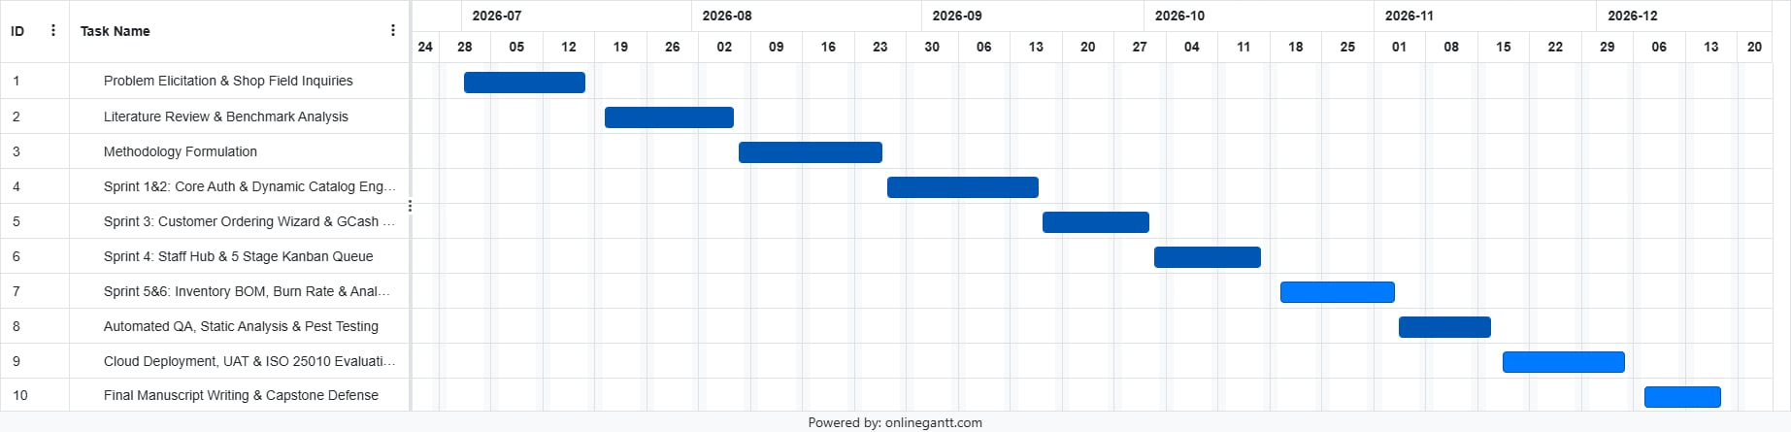
Figure 3. Gantt Chart
The Gantt chart presents the overall timeline of the project from July to December 2026, showing how each phase of the study connects and builds on the one before it. The process begins with problem elicitation and field inquiries, followed by literature review, methodology formulation, and system architecture design. Once the groundwork is set, development proceeds through a series of Agile sprints covering core system functions, customer ordering, staff production tools, and inventory management features. After development, the system undergoes quality assurance and automated testing before moving into deployment, user acceptance testing, and final evaluation. The timeline concludes with the completion of the manuscript and the capstone oral defense.

Table 2. Estimated Project Development Budget
Budget Category / Item | Detailed Description | Estimated Total Cost
1. Requirements Analysis
a. Transportation & Site Visits | Field travel to partner print shops. | 500
2. Design
a. Figma Professional Subscription | Design software subscription for system mockups. | 1,160
3. Development
a. AI Coding Assistance & Tooling | Google Gemini and developer code models are utilized as pair−programming assistants for backend query optimization. | 1,150.00
b. JetBrains PhpStorm Pro License | Provides professional-grade PHP static analysis, database introspection, and automated refactoring tools. | 1,000.00
c. SMS Gateway API Prepaid Credit | An initial credit bundle for SMS gateways budgeted early to prepare automated SMS dispatching when customer orders transition stages. | 500
4. Integration
a. Payment Gateway Sandbox Integration | GCash and PayMongo developer sandbox environments do not charge setup fees or require live deposit balances. Test API keys are issued free of charge for staging and academic research. | 0
5. Testing
a. Multi-Tier Automated SQA Testing | Testing is executed using open-source tools. Functional verification is automated programmatically rather than distributed via physical survey questionnaires, no consumable survey expenses are incurred. | 0
6. Connectivity
a. Internet Broadband  Connectivity | Reflects the standard monthly billing plan for a home fiber internet connection for system development and testing. | 1,499.00
7. Paper Supplies
a. Documentation Printing  Materials | 2 reams of bond paper and printer ink for reports, draft and revision iterations. | 800
8. Administrative Costs
a. Evaluator Honoraria | Token of appreciation allocated for the expert panelists | 1,000.00
b. Manuscript Defense  Copies | Draft printing and binding for multiple copies distributed to panel members and the project adviser. | 1,900.00
Total |  | 9,509.00

System Requirement Specifications

This section defines the functional and technical requirements of the Integrated Dynamic Order, Job Scheduling, and Inventory Management System. It outlines the specific behavioral functions of the platform alongside the minimum and recommended software and hardware environments required for development, hosting, and end-user access.

Functional Requirements

      - User Account Registration
Description: Provides self-service client account registration for customers wishing to transact through the platform.
Input: Customer full name, valid email address, mobile phone number, and a secure password with confirmation.
Process: Validates form syntax and email uniqueness, hashes the password securely using bcrypt, initializes a user record assigned with the default customer role, and persists the entity in the database.
Output: Account creation confirmation alert and automatic redirection to the authentication interface.
2. User Authentication (Login)
- Description: Authenticates registered credentials, establishes secure stateful sessions, enforces role-based access control (RBAC), and directs actors to their designated portal interfaces.
- Input: Registered email address, password, optional "remember me" flag, and optional two-factor authentication (2FA) one-time token.
- Process: Cross-references submitted credentials against bcrypt-hashed database records, evaluates account active status, resolves the user role (Customer, Production Staff, or Business Owner), issues session tokens, and executes route redirection to authorized dashboard hubs.
- Output: Authenticated user session, role-gated interface routing, or invalid credential error prompts.
Session Termination and Logout
3. User Profile Management
- Description: Allows authenticated users across all roles to inspect, modify, and maintain personal account information, security credentials, and communication preferences.
- Input: Updated full name, mobile contact number, profile avatar file, current password, and new password with confirmation.
- Process: Validates form syntax, enforces uniqueness on contact identifiers, verifies current password authenticity prior to credential modification, re-hashes new passwords using bcrypt, updates user entity records in the database, and dispatches status feedback.
- Output: Updated database profile entity, success flash alerts, and updated session profile display.
4. Session Termination and Logout
- Description: Securely invalidates active authentication tokens and terminates user sessions to prevent unauthorized device access.
- Input: Logout command trigger from the user navigation interface.
- Process: Flushes authenticated session storage, invalidates security tokens, regenerates the CSRF token, and destroys cookie references.
- Output: Redirection to the public landing page accompanied by a session termination confirmation.
- 5. Service Catalog Browsing and Quotation Calculation
- Description: Enables customers to explore active printing services and calculate real-time itemized price quotations based on selected operational parameters.
- Input: Selected print service category, document dimensions, page counts, color mode (monochrome/color), paper stock, binding finishing, and copy volume.
- Process: Interrogates database pricing formulas in real time, applies dynamic rate multipliers via reactive Livewire component state, and computes cost subtotals without reloading the page.
- Output: Dynamic, itemized quotation breakdown reflecting base costs, per-page rates, finishing surcharges, and estimated totals.
- 6. Print Order Placement and Document Upload
- Description: Captures finalized customer print requests and facilitates digital document or artwork file submission for prepress inspection.
- Input: Customer order details, fulfillment mode preference (pickup/counter handoff), optional production notes, and digital document files (PDF, DOCX, or high-resolution images).
- Process: Validates file MIME types and size constraints, transfers uploaded files to an encrypted private storage disk with tokenized filenames, writes the parent order record to the database, and generates a unique tracking code (e.g., ORD-2026-001).
- Output: Instantiated pending order record, generated tracking code, and visual order submission confirmation.
- 7. Print Attribute and Finishing Specification
- Description: Mandates the capture and technical validation of detailed print configuration attributes required to fulfill an active order.
- Input: Paper dimensions (Short, A4, Long), paper thickness (70 gsm, 80 gsm, 100 gsm), print orientation (simplex single-sided or duplex back-to-back), and binding finishes (spiral coil, sliding cover, softbound, or hardbound foil stamping).
- Process: Encapsulates submitted attributes into a structured line-item specification record, verifies technical feasibility (e.g., maximum page limits for specific binding styles), and calculates exact physical sheet requirements (ceil (pages / 2) * copies for duplex).
- Output: Validated line-item specification entity inextricably linked to the parent order.
- 8. Customer-Supplied Substrate Declaration
- Description: Conditionally extends the order placement workflow when a client elects to supply their own physical paper, adjusting financial calculations and tagging production requirements.
- Input: Customer-supplied substrate toggle activation, provided paper description, and declared sheet count.
- Process: Subtracts shop raw paper material charges from the running price quotation, designates line-item fulfillment as cover-only, and appends an "Awaiting Paper Delivery" intake flag to the digital job ticket.
- Output: Discounted order total and an intake-tagged digital job ticket for workshop counter tracking.
- 9. Proof of Payment Submission
- Description: Enables customers to submit manual payment verification references for counter cash transactions or mobile wallet remittances (GCash / Maya).
- Input: Selected payment channel, alphanumeric transaction reference number, and a graphic screenshot of the remittance receipt.
- Process: Validates image file structure, attaches the proof payload to the pending order record, flags order payment status as pending verification, and alerts shop staff of pending billing audits.
- Output: Payment submission acknowledgment and updated pending verification status badge on the client portal.
10. Live Order Progress and Status Tracking
- Description: Provides transparent, real-time telemetry displaying the operational progression of customer orders across workshop milestones.
- Input: Customer Order ID, tracking code, or authenticated client dashboard session.
- Process: Queries active production status flags in the database and renders an illuminated, color-coded 5-stage visual stepper reflecting milestone progression and stage completion timestamps.
- Output: Real-time visual progress stepper indicating current order stage (Queue, Printing, Finishing, QC, Ready for Pickup) and estimated fulfillment date.
- 11. Payment Transaction Auditing and Verification
- Description: Empowers production staff and business administrators to audit customer-submitted payment proofs against billing ledgers and update order financial states.
- Input: Staff audit decision (Approve or Reject), cross-referenced reference numbers, and optional rejection remarks.
- Process: Verifies transaction validity against shop financial ledgers, transitions payment status to verified paid (or rejected), records the verifying staff ID and verification timestamp, and transitions the order into the active production queue.
- Output: Updated order financial status and automated payment confirmation notification broadcast to the customer dashboard.
- 12. Production Floor 5-Stage Kanban Queue Management
- Description: Organizes workshop production orders into an interactive visual 5-stage Kanban board to direct job scheduling, operator delegation, and machine allocation.
- Input: Assigned staff operator ID, assigned printing machine designation, stage progression triggers, and optional quality control (QC) rework remarks.
- Process: Moves active orders across five sequential workshop stages (1. In Queue -> 2. Printing Pages -> 3. Finishing & Assembly -> 4. Quality Inspection -> 5. Ready for Pickup), logs transition timestamps, synchronizes customer tracking steppers, or executes step-back transitions upon QC failure.
- Output: Interactive visual Kanban board, updated digital job ticket states, and synchronized customer progress updates.
- 13. Automated Bill of Materials (BOM) Inventory Deduction
- Description: Automatically decrements raw material inventories based on linked service BOM recipes as print jobs advance into production or pickup stages.
- Input: Active order line-item parameters (page count, paper dimensions, duplex flags, binding consumables, copy quantity) and stage advance trigger.
- Process: Evaluates item fulfillment status; if designated as customer-supplied paper, raw paper sheet deduction is completely bypassed. For standard orders, computes exact consumption based on duplex math (ceil(pages / 2) * copies) and finishing multipliers, decrements physical inventory stock balances, and records immutable audit entries in the stock movement ledger.
- Output: Decremented physical stock balances and recorded inventory transaction audit trails.
- 14. Customer-Supplied Substrate Counter Inspection
- Description: Conditionally extends the production queue workflow when an order contains customer-supplied paper, requiring staff to inspect physical stock before machine processing begins.
- Input: Physical paper bundle presented at the counter, physical sheet count verification, grammage/condition inspection, and staff verification confirmation.
- Process: Cross-references physical stock against digital job ticket parameters; upon staff confirmation, updates order state to paper received, logs the receiving staff ID, and releases the job ticket from intake hold into the active printing queue.
- Output: Verified substrate receipt status on the job ticket and release into active machine production.
- 15. Material Spoilage Logging and Stock Adjustments
- Description: Allows production operators to record physical material waste and accidental damage resulting from printer jams, paper misfeeds, or binding errors.
- Input: Damaged inventory item selection, wasted quantity, and specific operational failure explanation.
- Process: Validates numeric quantity limits, decrements the item's on-hand stock balance, appends an audit entry to the stock movement ledger tagged as spoilage, records the reporting operator's ID, and checks remaining stock against reorder thresholds.
- Output: Adjusted on-hand inventory levels, recorded waste audit logs, and dynamic replenishment threshold evaluation.
- 16. Dynamic Service and Rate Configuration
- Description: Allows business owners to dynamically define, modify, or retire service offerings, pricing structures, and rate tariffs without altering application source code.
- Input: Service key, descriptive name, active status toggle, base setup fee, monochrome/color per-page rates, paper profile limits, rush fee multipliers, and finishing add-on prices.
- Process: Validates input parameters against numeric boundaries, writes updated configuration records to service entities and JSON attribute schemas, clears cached application pricing models, and exposes new configurations to the client ordering interface.
- Output: Updated service catalog, active pricing formulas, and instant administrative configuration confirmation.
- 17. Bill of Materials (BOM) Recipe Definition
- Description: Mandates the relational mapping between dynamic shop services and physical inventory stock items to govern automated material depletion formulas.
- Input: Configured service identifier, linked inventory item IDs, applicable variant bindings (hardbound, softbound, spiral comb, sliding folder), and unit consumption coefficients.
- Process: Enforces relational integrity across services and inventory items, stores recipe mappings in configuration tables, and validates formula mathematical logic.
- Output: Relational Bill of Materials recipe linking dynamic services to automated inventory consumption.
- 18. Inventory Oversight and Dynamic Reorder Point (ROP) Alerting
- Description: Monitors physical stock balances, computes rolling consumption velocity, and triggers visual replenishment warnings when supplies reach critical levels.
- Input: Historical stock movement logs, rolling daily consumption data, supplier lead times, and baseline safety stock levels.
- Process: Computes the daily material burn rate (Burn Rate = Total Material Consumed / Time Period in Days), derives the dynamic Reorder Point threshold (ROP = (Daily Burn Rate * Lead Time) + Safety Stock), evaluates current stock against the threshold, and flags items requiring replenishment.
- Output: Real-time stock health summaries, visual low-stock badges on the Inventory Hub, and automated restocking banners on the Owner Master Dashboard.
- 19. Sales, Cashflow, and Operational Analytics Generation
- Description: Aggregates transaction data, service volume, material expenses, and revenues to generate interactive business intelligence and exportable reports.
- Input: Date range selection parameters, service category filters, and report export commands.
- Process: Aggregates database transactions across orders, computes gross revenues, net margins, material consumption expenses, spoilage costs, and rush revenue, rendering visual trend charts and formatted tabular ledgers.
- Output: Interactive visual charts, service product mix reports, and exportable financial audit ledgers.

Software Requirements Specification

Table 3 outlines the software environment and developer toolchains utilized in designing, developing, and operating the web-based system.
Table 3. Software Requirements Specification
Component | Minimum Requirement | Recommended Requirement
Operating System | Windows 10 / Ubuntu 20.04 LTS / macOS 12 | Windows 11 / Ubuntu 22.04 LTS / macOS 14
Web Server | Apache 2.4 / Nginx 1.18+ / PHP Built-in Server | Nginx 1.24+ / Apache 2.4+
Database Server | MySQL 8.0 / SQLite 3 | MySQL 8.0+ / MariaDB 10.6+
Programming Language / Runtime | PHP 8.2 | PHP 8.3 or higher
Backend Framework | Laravel 11.x | Laravel 11.x / 13.x
Frontend Reactive Stack | Livewire 3.x / Alpine.js | Livewire 4.x / Flux UI
CSS Framework & Bundler | Tailwind CSS v3 / Vite | Tailwind CSS v4 via Vite
Web Browser | Modern Browser (Chrome, Firefox, Edge, Safari) | Latest Google Chrome / Brave / Microsoft Edge

Hardware Requirements Specification
Table 4 details the minimum and recommended hardware specifications for the development workstations, hosting servers, and client access devices.
Table 4. Hardware Requirements Specification
Category | Specification |  | Minimum Requirement | Recommended Requirement
Development Workstation |  | Processor  Memory (RAM)  Storage  Display | Dual-Core 2.0 GHz Processor  8 GB RAM  256 GB SSD  1366 × 768 Resolution | Quad-Core 3.0 GHz or higher  16 GB RAM or higher  512 GB NVMe SSD  1920 × 1080 Full HD Display
Web Server (Hosting) |  | Processor  Memory (RAM)  Storage  Bandwidth | 1 vCPU (Cloud VM or Dedicated)  1 GB RAM  20 GB Storage  10 Mbps Internet Connection | 2 vCPUs or higher  2 GB – 4 GB RAM  50 GB SSD Storage  50 Mbps+ High-Speed Internet
Client Devices (Users) |  | Device Type  Memory (RAM)  Connectivity | Any Web-Capable Device (PC, Smartphone)  2 GB RAM  Standard 3G/4G/Wi-Fi Connection | Smartphone / Laptop / Desktop PC  4 GB RAM or higher  Stable 4G/5G/Broadband Internet

Use Case Diagram

This figure illustrates the Use Case Diagram of the Integrated Dynamic Order, Job Scheduling, and Inventory Management System. The diagram defines the system boundary and visualizes how external actors interact with core system functions across administrative, production, and customer domains. Three primary actors govern platform activity: the Business Owner, the Production Staff, and the Customer. Access privileges are strictly segregated through role-based authentication, directing each actor to dedicated operational interfaces upon system entry.
The Customer initiates transaction lifecycles through the client-facing ordering interface. Customers browse the active service catalog, configure print specifications, and generate instant price quotations before placing orders and uploading digital artwork. The ordering workflow inherently requires configuring technical print parameters—such as paper dimensions, GSM weight, color mode, and binding options—represented through an <<include>> relationship. In contrast, the option to declare customer-supplied substrates "Dala ang Papel” extends the ordering workflow conditionally via an <<extend>> dependency, dynamically discounting service totals and bypassing raw material allocations. Following order placement, customers submit transaction reference numbers and payment proof, subsequently tracking the real-time stage progression of their print jobs through to pickup readiness.
The Production Staff and Business Owner govern floor execution and enterprise management from internal authenticated interfaces. Production operators supervise jobs across a visual five-stage Kanban board (Queue, Printing, Finishing/Assembly, Quality Check, and Ready for Pickup). Advancing a job across these production stages automatically triggers an <<include>> dependency for automated Bill of Materials (BOM) inventory deductions, decrementing physical stock levels in real time. When an order involves customer-supplied materials, staff verify the delivered paper at the shop counter through an <<extend>> verification procedure before machine processing begins. At the managerial level, the Business Owner oversees system configuration. Owners dynamically configure print services and their underlying BOM recipes <<include>>, adjust inventory safety thresholds, track material burn rates against dynamic reorder point thresholds, and generate business analytics to evaluate financial and operational performance.
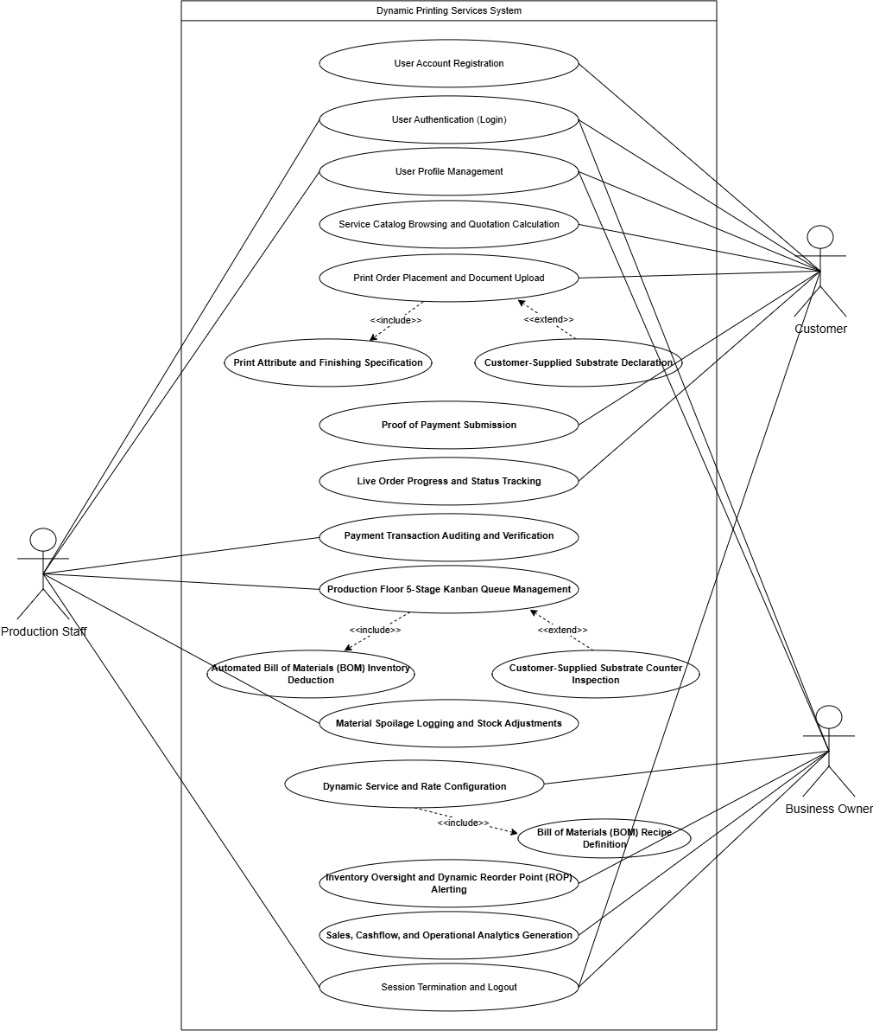z
Figure 4: Use Case Diagram of Printify
Class Diagram

This figure illustrates the Class Diagram of the Integrated Dynamic Order, Job Scheduling, and Inventory Management System. The diagram models the static structure of the platform, defining system entities, internal state attributes, operational methods, and structural relationships. System actors are formalized through an object-oriented inheritance hierarchy rooted in the generalized User superclass. This superclass encapsulates shared authentication states and profile management operations, which are subsequently specialized into three distinct subclasses: BusinessOwner, ProductionStaff, and Customer. Each specialized subclass defines role-specific behaviors, ensuring that administrative configuration, workshop floor job handling, and client order placement remain modular and structurally isolated.
The domain model operationalizes print shop transactions and inventory replenishment through interconnected entity classes. A BusinessOwner manages a single PrintShop aggregate root (1:1), which anchors the establishment's catalog of ShopService offerings and physical InventoryItem supplies. Customers initiate transactions by placing an Order (1:M), which establishes a composite aggregation with one or more OrderItem instances to encapsulate itemized production parameters and document attachments. As production operators in the ProductionStaff role advance active orders across workshop stages, the system queries linked ServiceBom consumption recipes to calculate exact raw material usage. These material deductions directly decrement stock balances in InventoryItem and write immutable audit records to StockMovement, preserving strict inventory traceability and providing reliable telemetry for automated reorder alerts.
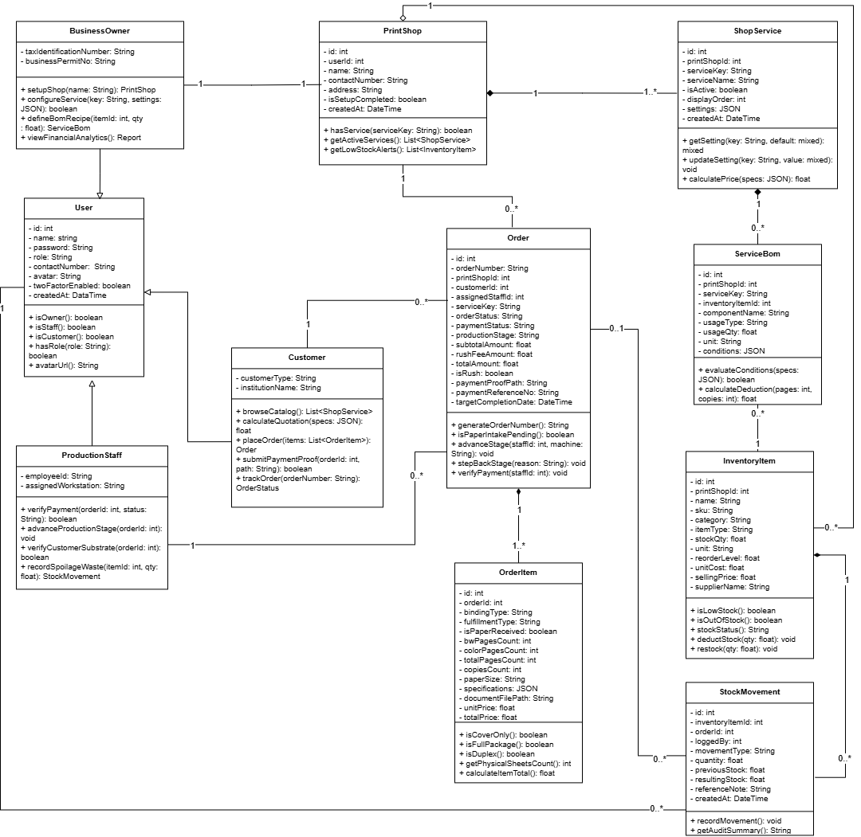
Figure 5. Class Diagram of Printify

Project Design

The project design translates the operational requirements and technical constraints into actionable architectural blueprints. This stage bridges business rules with software implementation. Structurally, it defines the normalized data models and relational constraints that synchronize incoming print orders with automated Bill of Materials (BOM) inventory deductions. Behaviorally, it outlines how business owners, production operators, and customers interact across core functional modules, tracking jobs as they advance through workshop queues from intake to final handoff. The succeeding discussions present the logical database schema through an Entity Relationship Diagram (ERD), followed by behavioral use case models and operational workflow diagrams that direct daily print shop operations.

Entity Relationship Diagram
This Figure illustrates the Entity Relationship Diagram (ERD) of the system, detailing the logical entities, primary keys, and foreign key constraints across the normalized database tables. At the architectural center is the Users table (user_id), governing authentication and role-based access control (RBAC) across business owners, workshop staff, and customers. A single registered business owner manages an enterprise instance in the PrintShops table (print_shop_id) through a strict one-to-one relationship (owner_user_id), anchoring all tenant-level operations. Each print shop maintains its dynamic service catalog through the ShopServices table (service_id, referenced via print_shop_id 1:N). Rather than relying on separate tables for each print offering, this unified entity encapsulates production lead times, daily shop floor capacity quotas, and custom pricing rules within a structured settings JSON attribute, allowing owners to update service parameters without altering the underlying database schema.
Customer transactions and workshop scheduling converge in the Orders table (order_id, referenced from print_shop_id 1:N). This entity links to Users through two distinct foreign keys: customer_user_id for order placement and assigned_staff_user_id for production delegation. It tracks human-readable tracking codes, verified payment receipts, and the active workstation state across a five-stage Kanban pipeline (Queue, Printing, Finishing/Assembly, Quality Check, and Ready for Pickup). Each order contains individual line items captured in the OrderItems table (order_item_id, referenced via order_id 1:N). To avoid hardcoding product variations, OrderItems employs a universal line-item design with a specifications JSON attribute. This structure flexibly accommodates varying parameters—such as page counts, paper dimensions, binding finishes, or garment sizes—while preserving strict relational integrity with the parent transaction.
Material resources and consumables are tracked in the InventoryItems table (inventory_item_id, referenced via print_shop_id 1:N), which maintains verified stock levels, unit acquisition costs, and dynamic Reorder Point (ROP) thresholds. Automated material deduction is governed by the ServiceBoms table (bom_id), establishing a unified Bill of Materials repository. ServiceBoms decouples services from physical stock by mapping service_id to inventory_item_id (1:N) alongside conditional usage formulas. Whenever an order progresses into production, required materials are automatically deducted and recorded in the StockMovements table (movement_id). This entity maintains an append-only audit ledger linked to inventory_item_id, logged_by_user_id, and order_id (1:N). By preserving prior and resulting balances alongside order references, the ledger guarantees complete accountability and provides real-time data for rolling burn rate and stockout risk calculations.

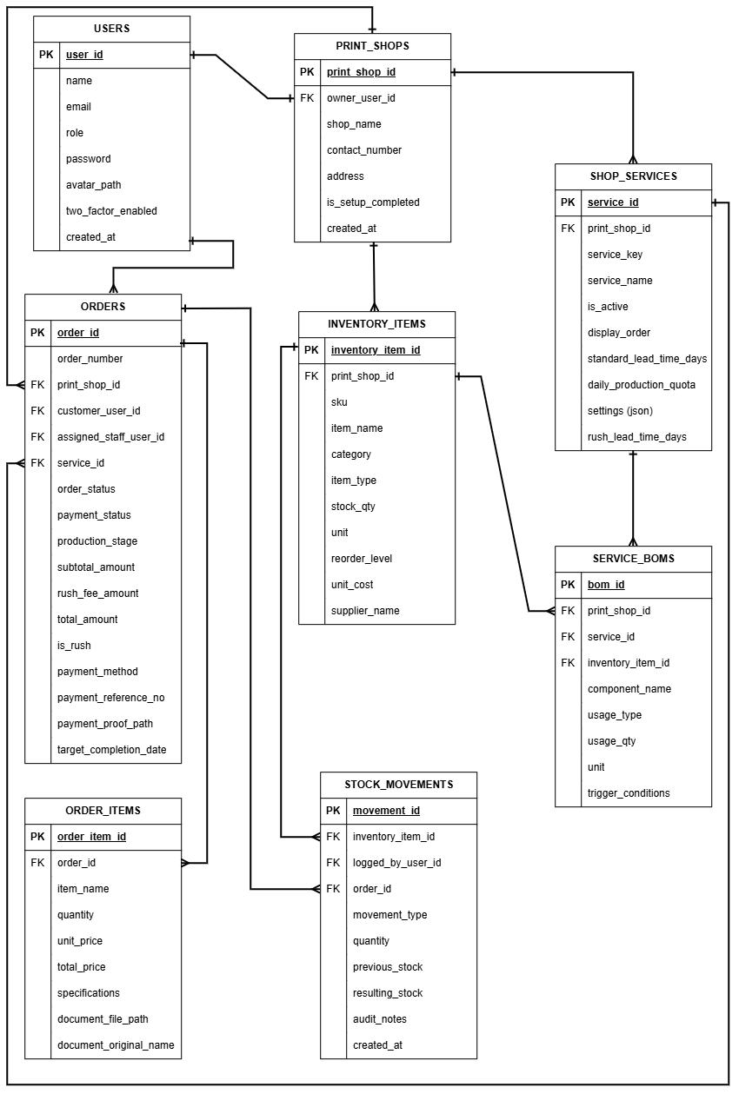Figure 6. Entity Relationship Diagram of Printify

Activity Diagram
Figure 7 illustrates the User Account Registration process, where prospective customers provide their name, email, mobile number, and password. The system validates the submitted information and checks if the email is already registered. If errors are found, the user is prompted to correct the information. Once validated, the password is securely hashed, a customer account is created with the default customer role, and the data is saved. The process ends with a confirmation message and redirection to the login page.
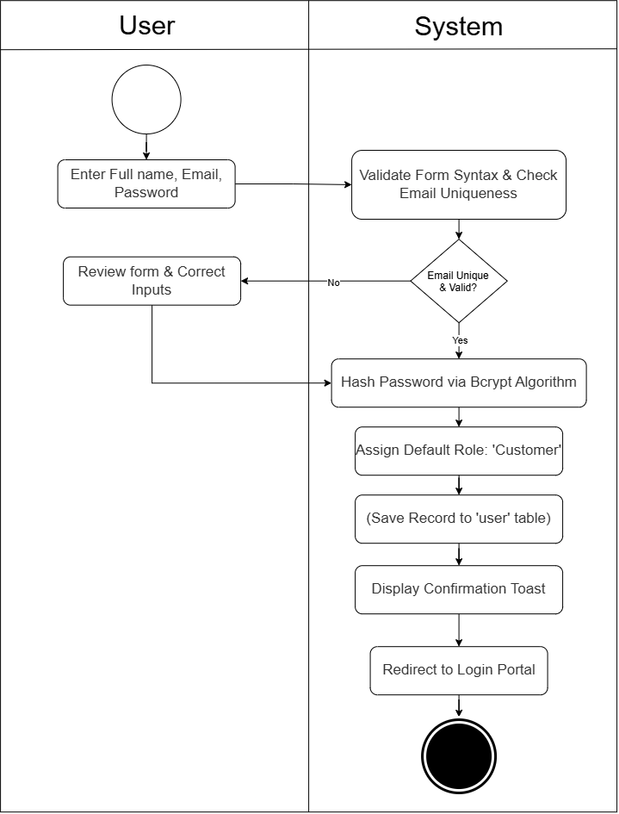
Figure 7. User Account Registration
Figure 8 illustrates the operational activity diagram for User Authentication (Login). The process begins when an actor (Customer, Production Staff, or Business Owner) submits their registered email address and password into the authentication portal. The authentication guard cross-references the submitted credentials against bcrypt password hashes stored in the database. If the credentials fail validation or the account is inactive, the system increments the failed login counter and displays an authentication error alert. Upon successful verification, the system initializes an authenticated session token, determines the actor's role-based access level, and redirects the user to their designated portal: the Customer Dashboard, Staff Production Console, or Owner Master Hub."
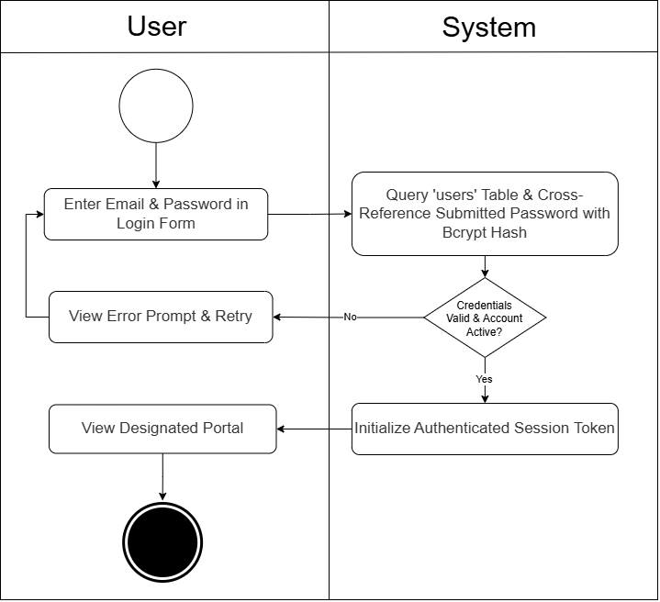
Figure 8. User Authentication (Login)
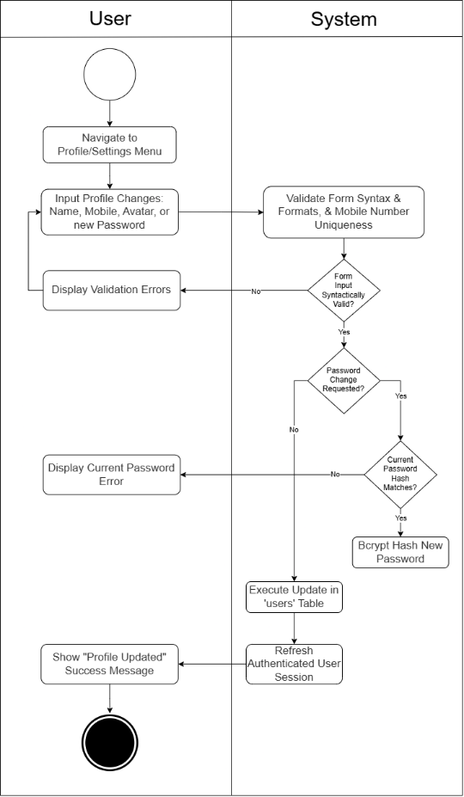
Figure 9 illustrates the operational activity diagram for User Profile Management. The workflow begins when an authenticated user accesses the account settings interface to modify personal details, contact information, or security credentials. The user inputs their updated attributes, providing current password verification if a password change is requested. The system validates syntactic constraints and checks mobile number uniqueness. If password alteration is submitted, the backend verifies the current password hash before encrypting the new password via bcrypt. Upon successful validation, the system executes an atomic database transaction updating the user entity, flushes the cached session state, and renders an update confirmation notification.

Figure 9. User Profile Management
Figure 10 illustrates the activity diagram for Session Termination and Logout process, where users log out through the navigation bar. The system clears session data, invalidates security tokens, and removes authentication cookies. This prevents further access to protected pages and redirects the user to the public landing page, helping protect the account from unauthorized access.
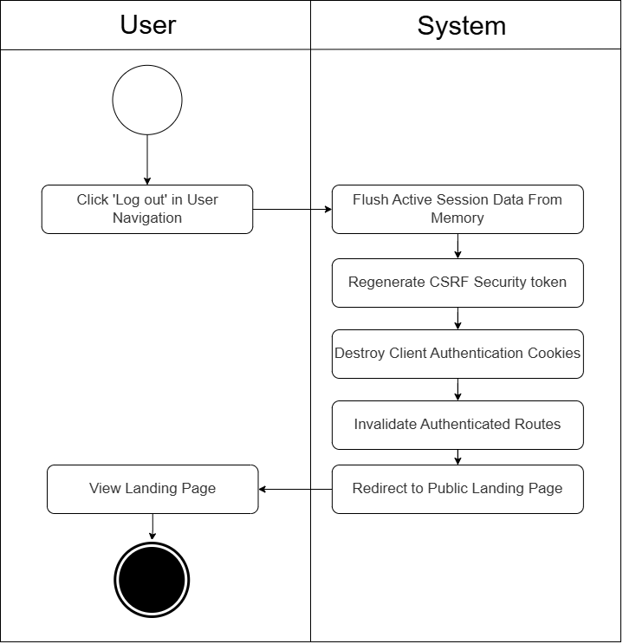
Figure 10. Session Termination and Logout

The figure 11 shows the activity diagram for Service Catalog Browsing and Quotation Calculation depicts the interactive estimation process on the customer storefront. The customer navigates through available service offerings (e.g., document printing, thesis binding, merchandise) and adjusts operational parameters, including page quantities, color profiles (monochrome or full color), paper grammage, and copy volume. The reactive Livewire component intercepts each parameter change without triggering a manual browser reload. The engine interrogates database pricing formulas, computes unit sheet rates, incorporates finishing surcharges, and renders an illuminated, itemized cost subtotal in real time, providing transparent pricing before order commitment.
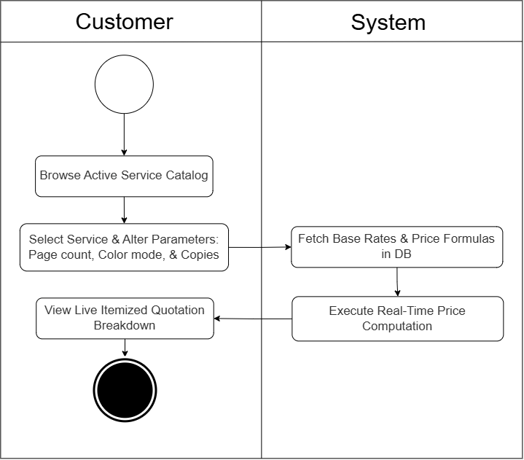
Figure 11. Service Catalog Browsing and Quotation Calculation
As shown in Figure 12 the activity diagram presents the process of placing an order and uploading files through the system. The customer begins by selecting the required printing service specifications and submitting the necessary files. The order system then calculates the quotation and validates the uploaded document and checkout information. Once the information is successfully validated, the file storage component saves the uploaded document and payment proof when applicable. At the same time, the orders database records the order and its corresponding order item. The process is completed when the system displays the order confirmation to the customer.
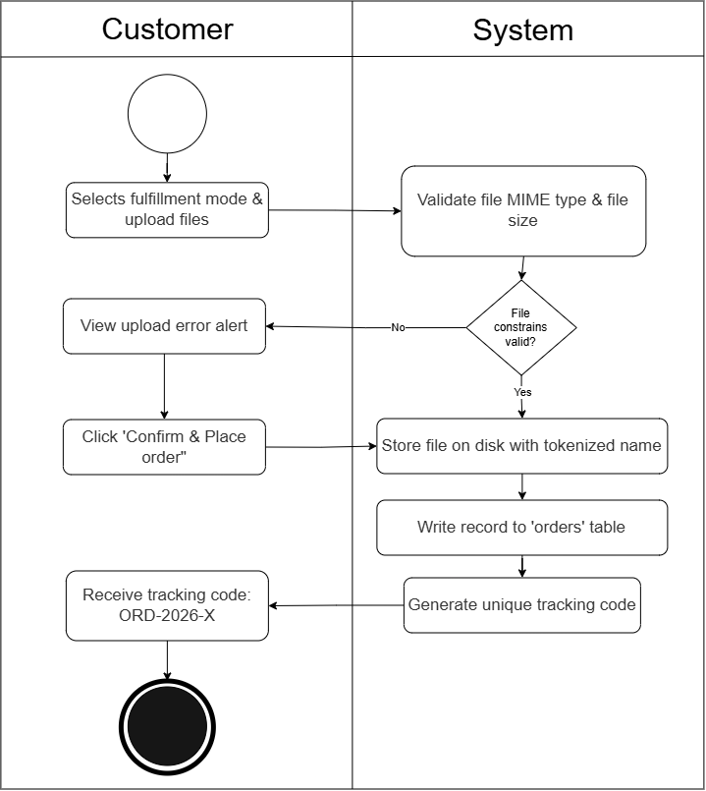
Figure 12. Print Order Placement and Document Upload
Figure 13 shows the activity diagram for Print Attribute and Finishing Specification models the structural parameterization of custom print jobs. The customer configures exact technical attributes: paper dimensions (Short, A4, Long), paper thickness (70, 80, 100 gsm), print orientation (simplex single-sided or duplex double-sided), and binding finishes (plastic comb, sliding folder, softbound, or hardbound foil stamping). The specification engine inspects page counts against physical binding thresholds (e.g., maximum page limits for sliding folders) and executes duplex mathematical calculations where physical sheet requirements equal $\left\lceil \text{Pages}/2\right\rceil ×\text{Copies}$. The system encapsulates these attributes into structured JSON specifications within the order_items entity.
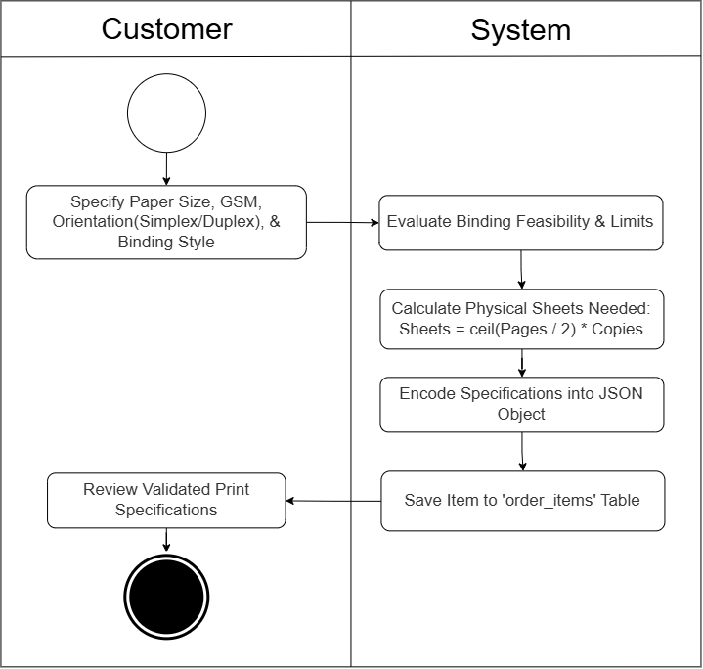
Figure 13. Print Attribute and Finishing Specification
Figure 14 shows activity diagram for Customer-Supplied Substrate Declaration illustrates the client checkout extension for "Dala ang Papel" orders. When placing an order, the customer activates the substrate declaration toggle, specifying their paper brand, type, and sheet volume. The pricing engine detects the flag, zeroes out shop raw paper material fees from the running subtotal, and designates the line item as cover-only fulfillment. Upon order submission, the system attaches an "Awaiting Paper Delivery" intake flag to the digital job ticket, ensuring that shop paper is not billed while alerting the client to deliver their paper bundle to the counter.
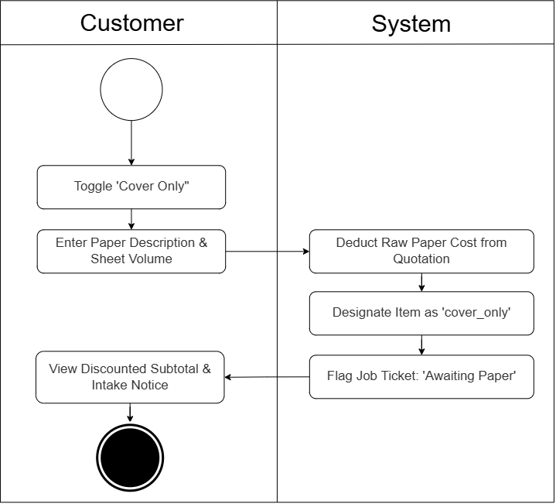
Figure 14. Customer-Supplied Substrate Declaration
Figure 15 shows the activity diagram for Proof of Payment Submission models client remittance submission. Following order placement, the customer navigates to the payment step, selecting either counter cash settlement or mobile wallet options (GCash or Maya). For digital transactions, the customer scans the shop payment QR code, inputs the transaction reference number, and uploads a screenshot of the remittance receipt. The server validates image dimensions and file formats, stores the receipt file on a private disk, updates the order payment status to "pending_verification", and alerts workshop staff for audit.
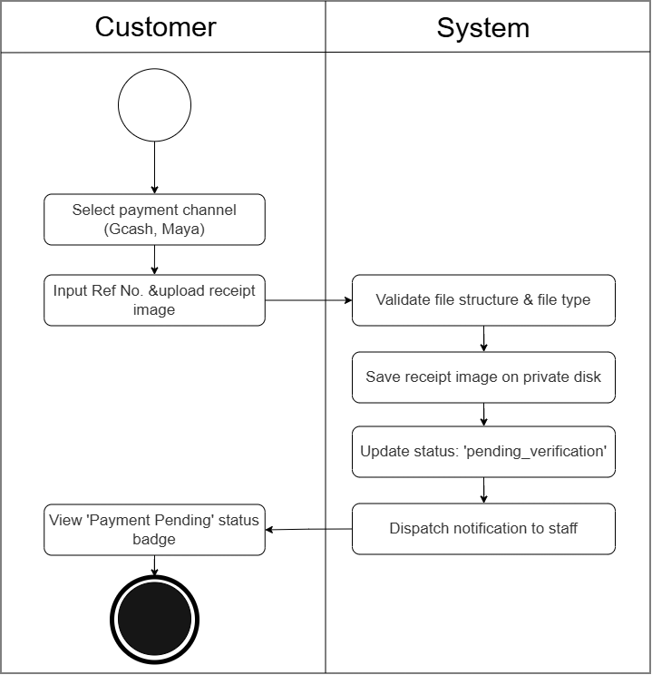
Figure 15. Proof of Payment Submission
Figure 16 shows the Live Order Progress and Status Tracking depicts real-time operational telemetry available to clients. The customer accesses their dashboard or inputs their unique tracking code. The tracking subsystem queries active order records from the database, extracts current production flags, and checks stage transition timestamps. The system renders an illuminated, color-coded five-stage stepper component (Queue, Printing, Finishing/Assembly, Quality Inspection, Ready for Pickup). Completed milestones display checkmarks and recorded timestamps, the active milestone displays an illuminated pulse badge, and estimated fulfillment times are updated dynamically.
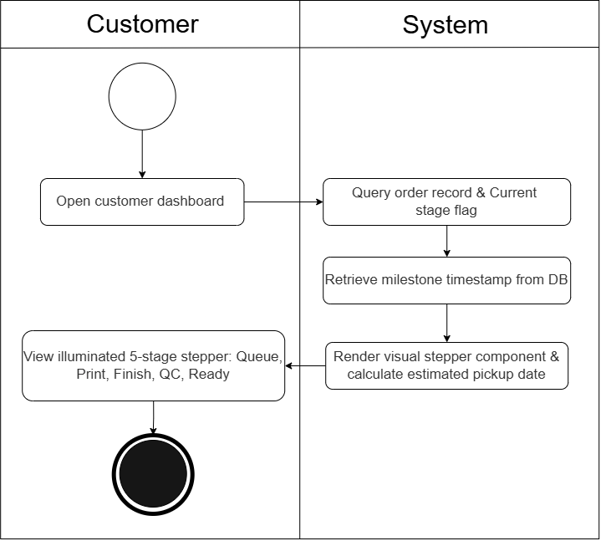
Figure 16. Live Order Progress and Status Tracking
Figure 17 illustrates the process of recording and verifying customer payment information. The customer provides a payment reference and payment proof when applicable, after which the system stores the submitted payment details and current payment status in the order record. A production staff member or business owner then reviews the payment information through the job ticket or analytics order list. If the payment is verified, the system records the verified status, verification time, and verifying user. Otherwise, the existing payment status remains unchanged.
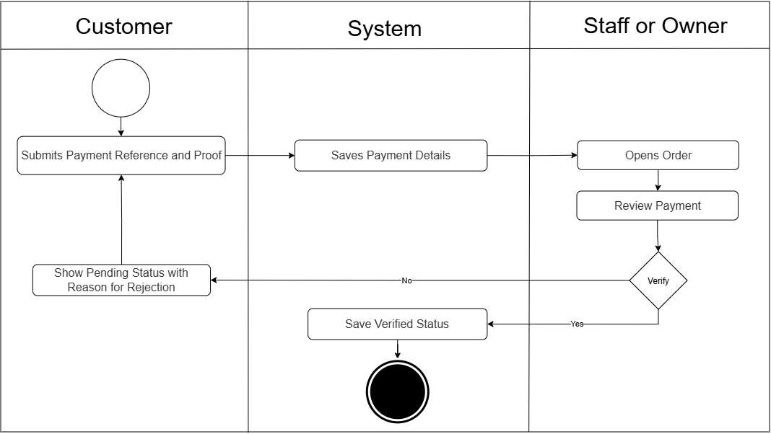Figure 17. Payment Transaction Auditing and Verification

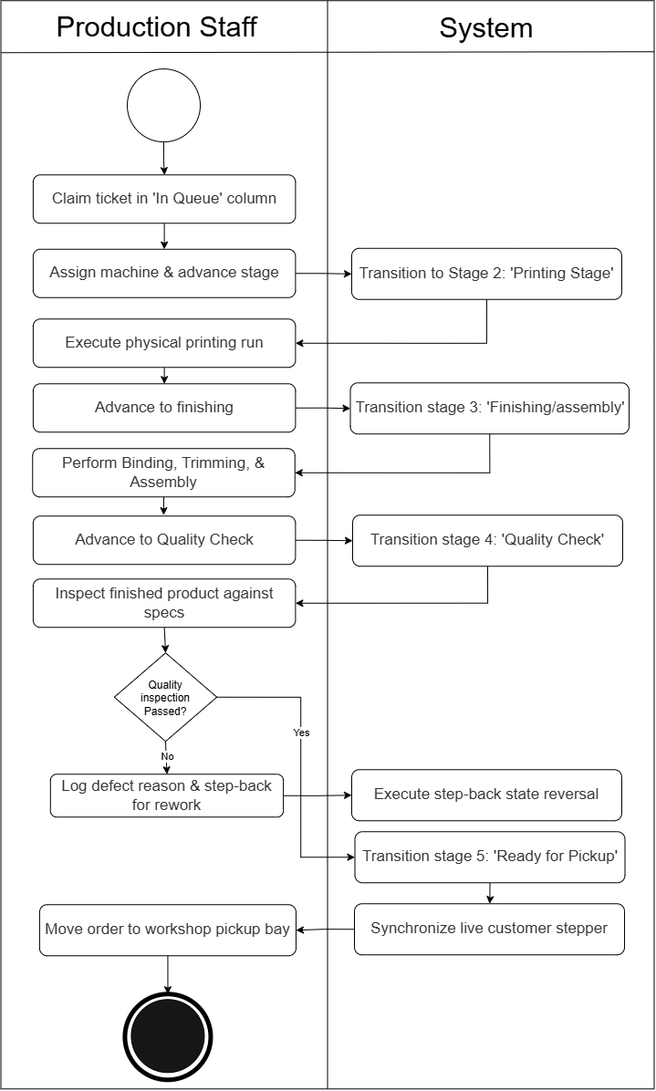
The activity diagram in Figure 18 is for Production Floor 5-Stage Kanban Queue Management process organizes workshop orders through five stages: In Queue, Printing Pages, Finishing and Assembly, Quality Inspection, and Ready for Pickup. Staff claim orders, assign machinery, record production details, and move each ticket through the stages. During quality inspection, defects may send the order back for rework in Printing or Finishing. Once approved, the order is marked Ready for Pickup, while each stage transition updates the customer’s tracking information in real time.

Figure 18. Production Floor 5-Stage Kanban Queue Management
Figure 19 illustrates the Automated Bill of Materials (BOM) Inventory Deduction process, where the system automatically calculates and deducts materials as an order enters production. For customer-supplied paper, paper deduction is skipped, while standard orders calculate paper usage based on pages and copies. Finishing materials such as ring spines, PVC covers, and backings are deducted based on their defined quantities. The system then updates inventory levels and records each deduction for tracking and auditing.
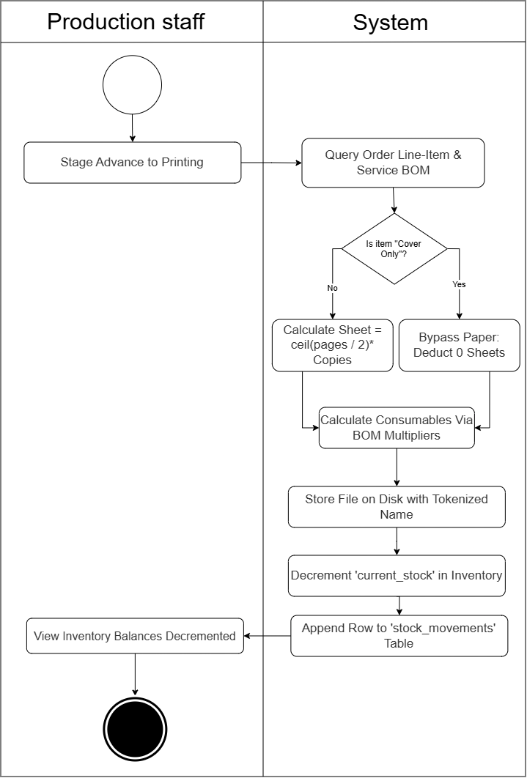
Figure 19. Automated Bill of Materials (BOM) Inventory Deduction
The activity diagram in Figure 20 illustrates the operational workflow governing customer-supplied paper handling ("Cover only"). When a customer elects to supply their own pre-printed or blank paper stock during online order submission, the system flags the resulting digital job ticket with an "Awaiting Paper Delivery" alert and zeroes out the raw paper material cost from the transaction subtotal. The customer subsequently brings the physical paper bundle to the shop service counter. Upon arrival, production personnel inspect the physical stock to verify sheet quantity, standard paper grammage (GSM), and sheet physical condition against the specifications stated on the digital ticket. If the delivered stock is damaged, crumpled, or insufficient in quantity, staff reject the submission and prompt the client to supply supplemental sheets or switch to in-house shop paper. Once the paper is verified, the staff member marks the job ticket as "Paper Received" within the production console. This administrative verification unlocks the order in the Kanban queue, automatically transitioning its operational state from intake hold to the active printing and finishing queue.

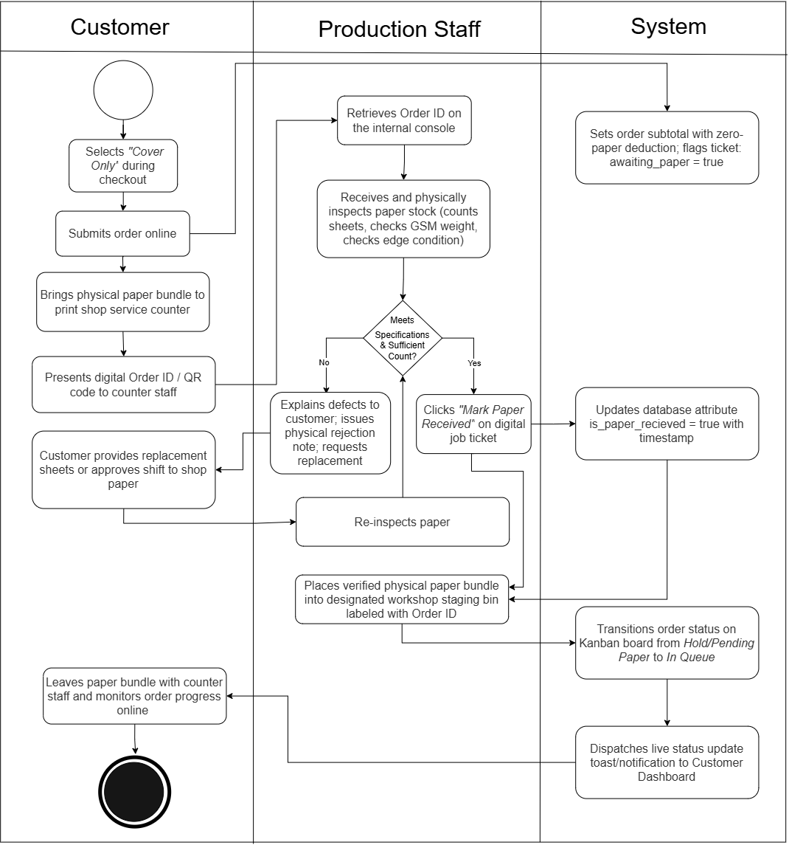Figure 20. Customer-Supplied Substrate Counter Inspection

Figure 21 shows the process of recording material waste and checking inventory levels. Staff record damaged materials by selecting the item, entering the wasted quantity, and providing the reason. The system then deducts the wasted amount from inventory and records the transaction for tracking. After updating the stock, the system checks the remaining quantity against the Reorder Point (ROP). If the stock reaches or falls below the threshold, the system automatically displays a low-stock warning and recommends replenishment to the business owner.
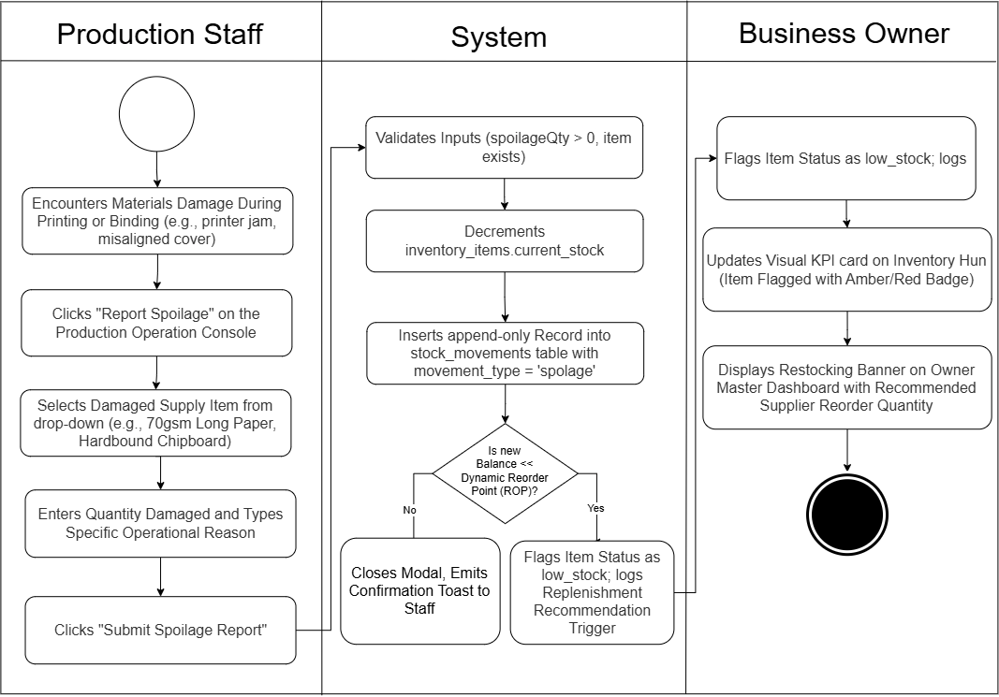Figure 21. Material Spoilage logging and Stock Adjustments
The activity diagram in Figure 22 depicts the administrative procedure for dynamically configuring service offerings and their underlying Bill of Materials (BOM) recipes without modifying application source code. The business owner accesses the authenticated Dynamic Service Configuration Hub from the administrative console. The owner initiates the workflow by selecting an existing service category or establishing a new print service catalog entry.
The configuration workflow requires defining baseline commercial parameters, including service titles, base preparation fees, incremental per-page rates for monochrome and full-color print passes, paper dimension profiles (Short, A4, Long), paper thickness options (70, 80, 100 gsm), and binding style surcharges. Crucially, the owner links operational service parameters to physical inventory stock items through the ServiceBoms mapping interface. The owner assigns unit consumption coefficients—such as one plastic ring spine per bound volume, two PVC clear cover sheets per booklet, or duplex paper consumption formulas. Upon submission, the platform performs data validation against numeric boundaries and relational foreign key constraints before persisting the configuration parameters into the database. These updated rates and material recipes are instantaneously ingested by the client-facing ordering engine, dynamically recalibrating real-time price calculations and inventory deduction rules across the entire platform.
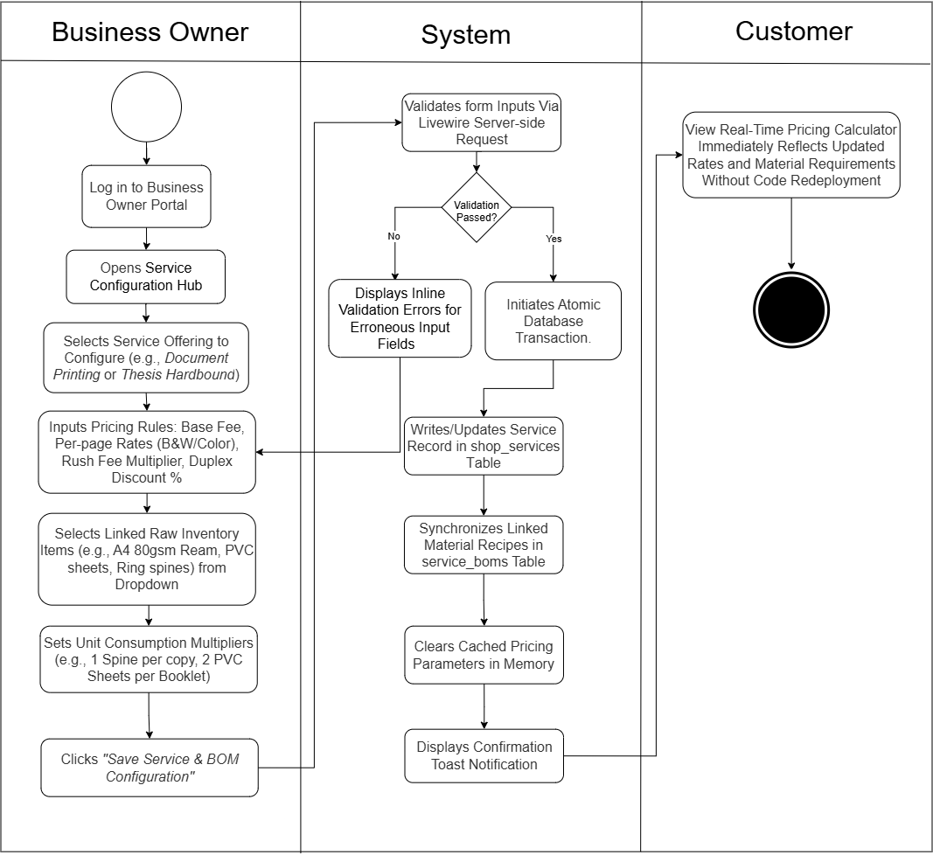Figure 22. Dynamic Service and Rate Configuration

Figure 23 shows the activity diagram for Bill of Materials (BOM) Recipe Definition depicts the administrative linking between commercial services and inventory consumables. The business owner accesses the BOM Recipe Manager, selects a target service (e.g., Thesis Hardbound), and maps required raw stock items (e.g., chipboard, book cloth, foil ribbon, end-sheets) from the inventory catalog. The owner defines consumption coefficients (such as 2 sheets per book or 1 coil per booklet). The system validates foreign key relationships, writes recipe mappings to the service_boms configuration table, and binds the operational consumption rules to automated floor deduction routines.
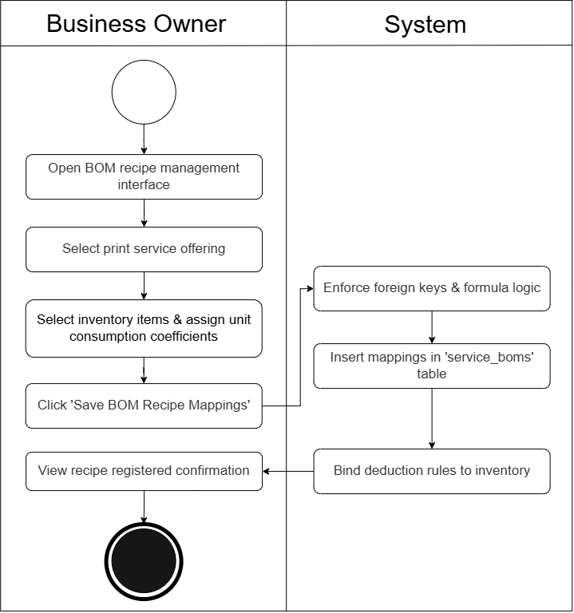
Figure 23. Bill of Materials (BOM) Recipe Definition
Figure 24 The activity diagram for Inventory Oversight and Dynamic Reorder Point (ROP) Alerting models continuous stock monitoring and proactive replenishment alerting. The automated inventory monitor computes material daily burn rates based on rolling consumption velocity: Burn Rate=Total Consumed/Days. The system derives the dynamic Reorder Point threshold using ROP=(Daily Burn Rate×Lead Time)+Safety Stock, and evaluates current on-hand stock balances against this threshold. If on-hand stock falls to or below the dynamic ROP, the platform flags the inventory item with a visual low-stock badge on the Inventory Hub and renders a high-priority restocking recommendation banner on the Owner Master Dashboard.
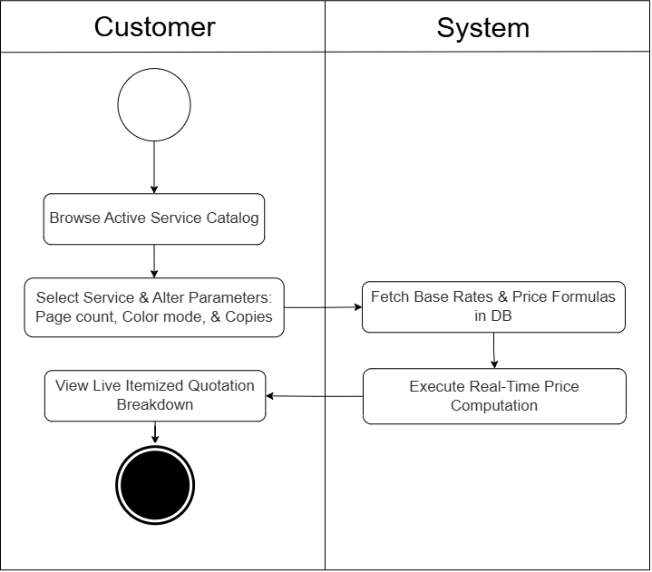
Figure 24. Inventory Oversight and Dynamic Reorder Point (ROP) Alerting
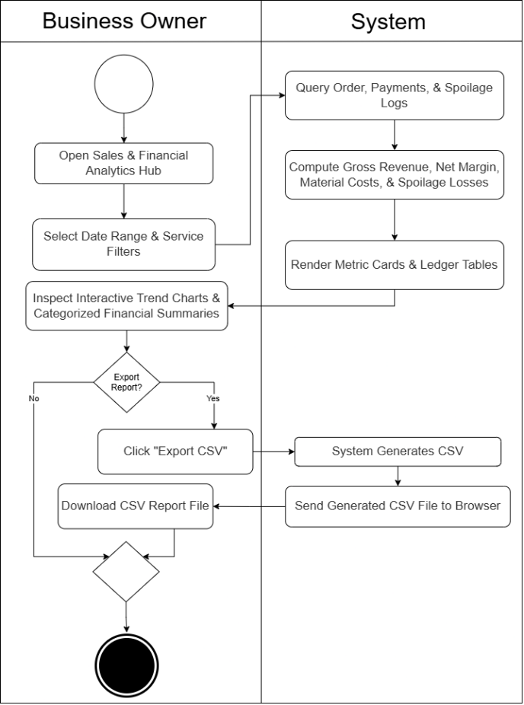
As seen in Figure 25 the activity diagram outlines how the business owner generates and reviews operational and financial reports. The owner first selects the reporting period and available filters. The analytics system then processes order, payment, inventory, and spoilage information to calculate sales, order counts, costs, profit, margins, and other related metrics. These results are presented through the report interface for review. If the owner chooses to export the report, the system generates a CSV ledger and sends it to the browser for download. Otherwise, the process ends after the report has been reviewed.

Figure 25. Sales, Cashflow, and Operational Analytics Generation
User Interface

Figure 26 and 27 illustrates the user interface of the landing page and registration page of Printify. The registration interface collects the required account information, including the user's name, email address, password, and password confirmation. Validation messages are presented when information is incomplete or incorrect, allowing the user to correct the form before submitting the registration. After successful registration, the system creates the user account and applies the default customer role, after which the user may log in to access the appropriate portal. This arrangement supports accurate account creation and controlled access to the Printify system.

Figure 26. Landing page of Printify
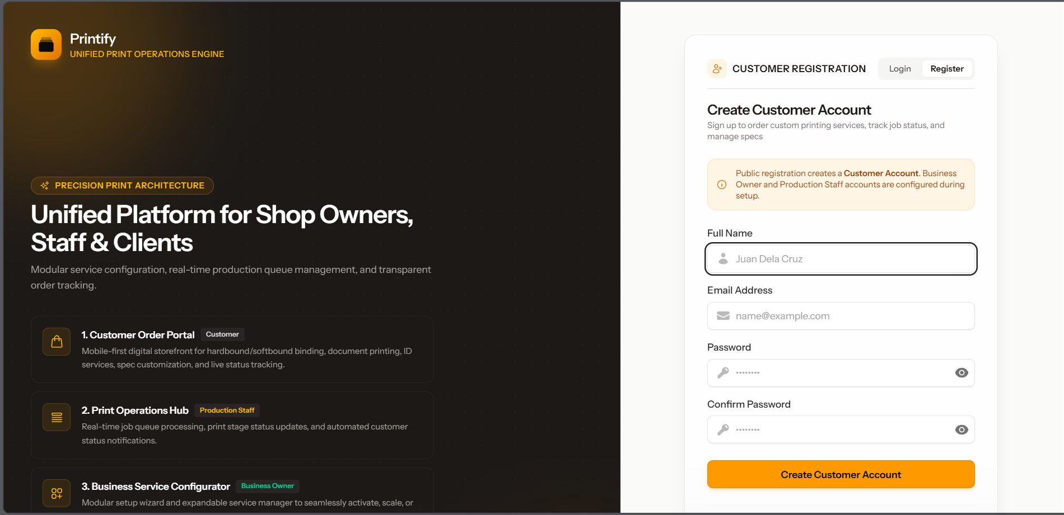
Figure 27. Registration Interface

Figure 28 illustrates the user interface of the Login page. The interface authenticates registered users through their email address and password. Validation messages are presented when credentials are missing or incorrect, allowing the user to correct the form before proceeding. After successful authentication, the system establishes the user session and applies role-based routing, directing business owners, production staff, and customers to their respective portals. This arrangement provides a controlled and straightforward entry point to the Printify system.

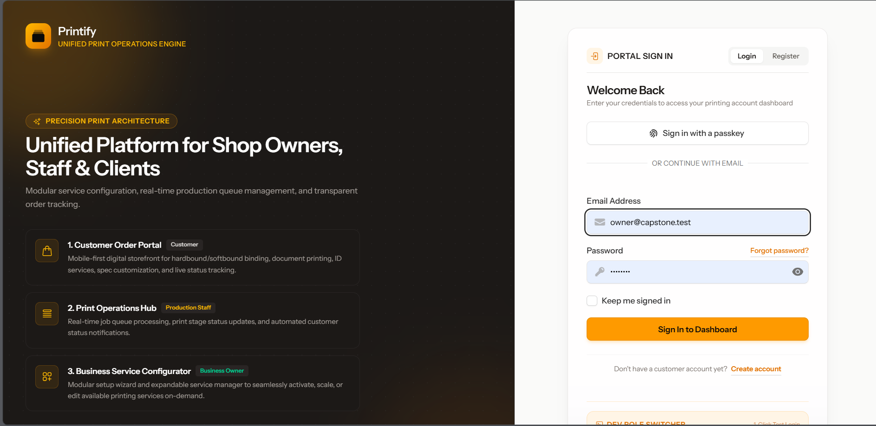
Figure 28. Login Interface

Figure 29 & 30 illustrates the user interface of the Business Owner Setup Wizard. This screen represents the initial configuration and onboarding stage for a newly registered business owner. The wizard first collects the shop identity and then presents the available printing services for selection. The owner can choose the services relevant to the shop's business requirements before completing setup, while validation prevents an incomplete shop name or an empty service selection from being saved. The selected services are synchronized with the shop profile and determine the applications and customer-orderable services that become available in the system. Therefore, the setup wizard establishes the initial modular configuration instead of assuming that every shop operates with the same fixed service set.



Figure 29. Business Owner Setup Wizard

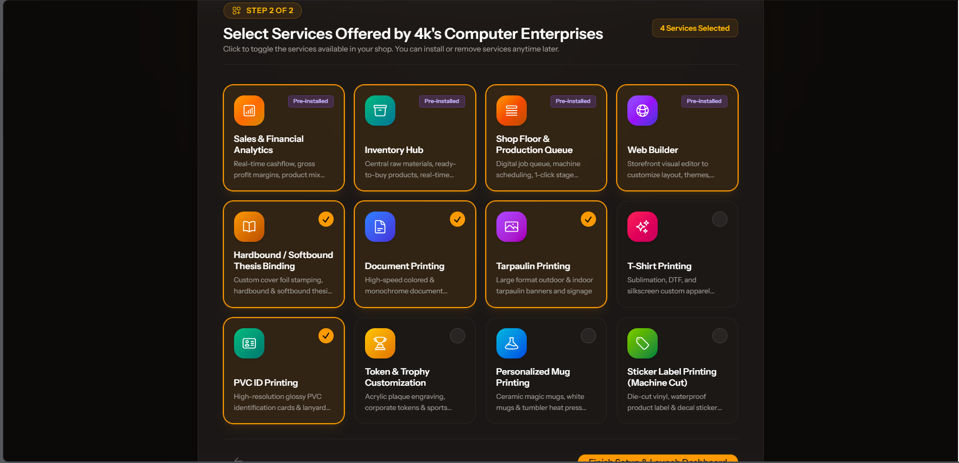
Figure 30. Business Owner Setup Wizard


Figure 31 illustrates the user interface of the Business Owner Master Dashboard. The dashboard serves as the central administrative workspace for managing the printing business. It consolidates access to shop setup, service management, order monitoring, inventory oversight, and sales analytics within a role-restricted interface. Summary information and operational shortcuts enable the owner to review current business activity and move directly to the area requiring attention. The dashboard also supports the owner setup state by directing an incompletely configured shop to the setup workflow before normal operations are displayed. As the primary management screen, it provides a consolidated view of the system's operational modules without exposing staff-only or customer-only controls.
Figure 31. Business Owner Master Dashboard

Figure 32 illustrates the user interface for managing the shop's applications and services. Through the More Services or service-management panel, the business owner can browse the service catalog, install or activate optional applications, and deactivate optional services that are no longer needed. Deactivation removes an optional service from the active workspace and customer-facing service choices without removing its catalog definition. The interface distinguishes these configurable services from core applications that are required by the platform and cannot be removed. After an optional service is activated or deactivated, the launcher refreshes its installed-application list so that the owner's workspace reflects the updated configuration. This interface provides the clearest visual evidence of the platform's modular installation, management, and deactivation capabilities.
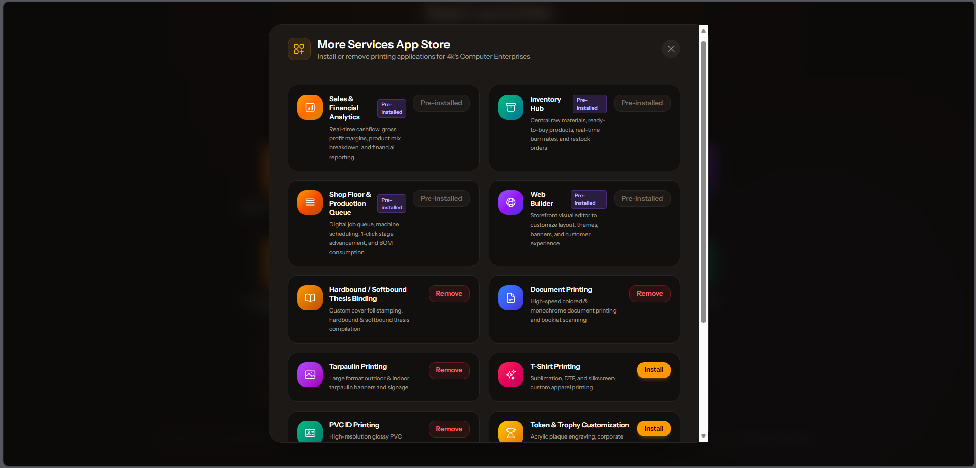
Figure 32. Application and Service Management Interface

Figure 33 & 34 shows the user interface of the Dynamic Service Configuration Hub. The hub enables the business owner to define and maintain the services offered by the printing shop without changing the application's source code. Through the configuration interface, the owner can manage service availability, pricing parameters, options, limits, document-printing rules, thesis-binding settings, and bill-of-material relationships where applicable. The hub validates submitted values before saving them and provides feedback when a configuration requires correction. These settings are subsequently used by the ordering wizard to present current service choices and calculate quotations. Consequently, the interface establishes a direct connection between administrative configuration and the customer-facing ordering experience.
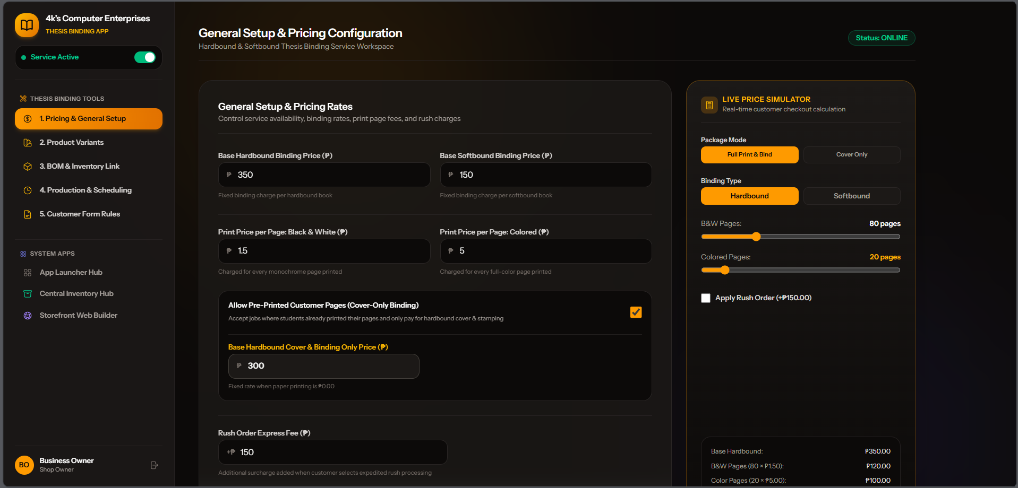
Figure 33. Dynamic Service Configuration Hub

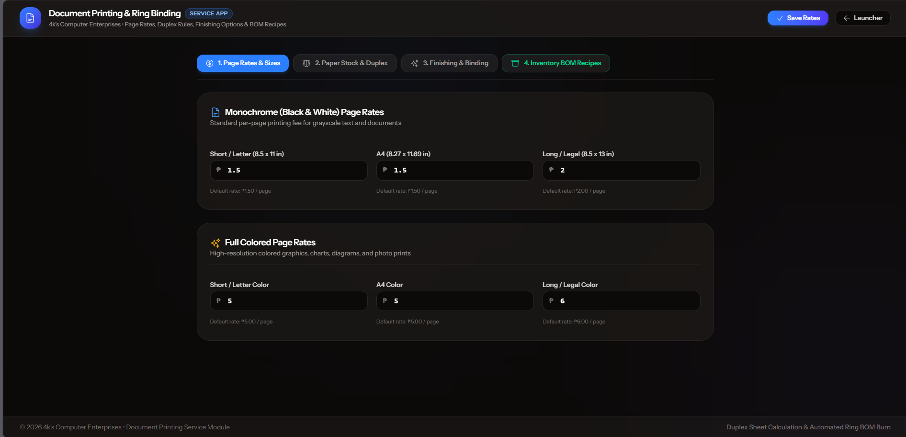
Figure 34. Dynamic Service Configuration Hub

Figure 35, 36, 37 illustrates the user interface of the Customer Ordering Wizard and Live Five-Stage Progress Stepper. The ordering wizard guides customers through the preparation and submission of a printing or thesis-binding order. The interface presents service-specific selections such as document specifications, binding options, paper, finishing, copies, uploaded files, and payment information in a structured sequence. As the customer changes applicable options, the system recalculates the quotation and displays validation feedback for incomplete or invalid entries. After submission, the progress stepper communicates the order's production status through the stages of Queue, Printing, Binding or Assembly, Quality Check, and Ready for Pickup. This combination reduces information overload during order entry and gives customers a clear view of progress after the order has entered production.
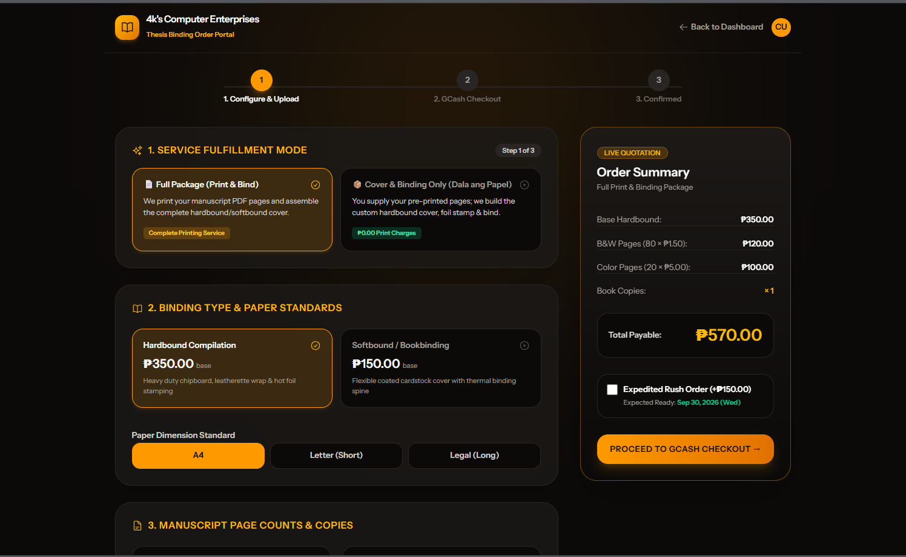
Figure 35. Customer Ordering Wizard and Live Five-Stage Progress Stepper

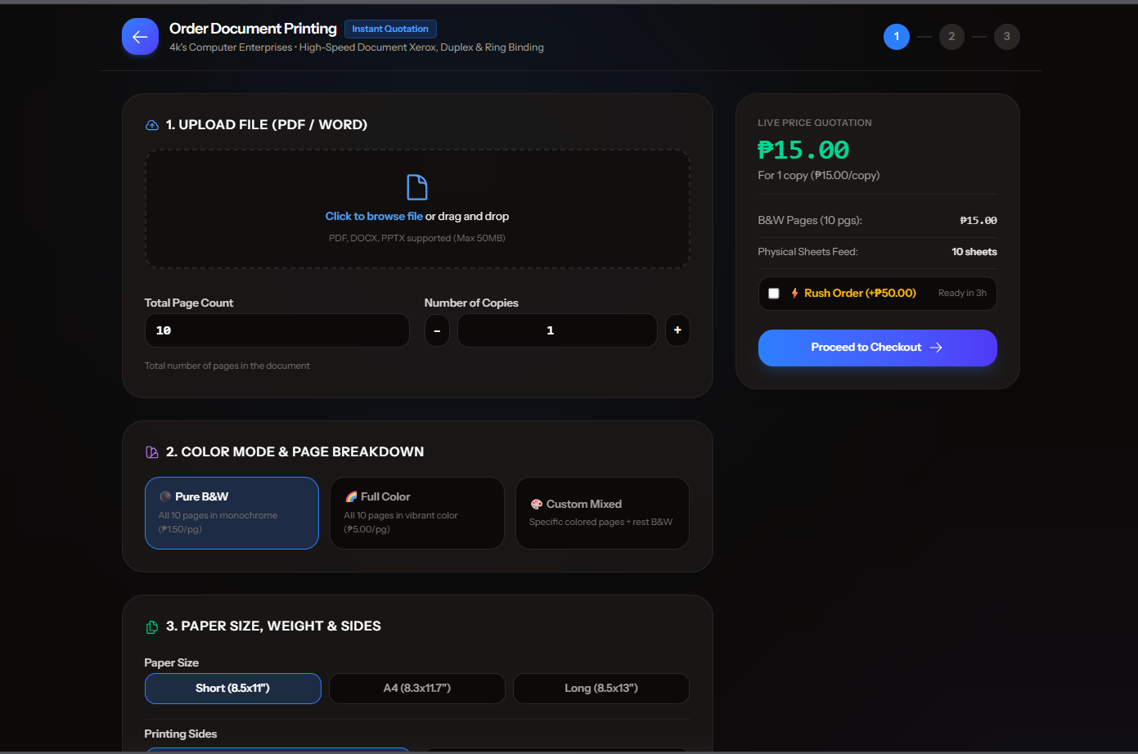
Figure 36. Customer Ordering Wizard and Live Five-Stage Progress Stepper

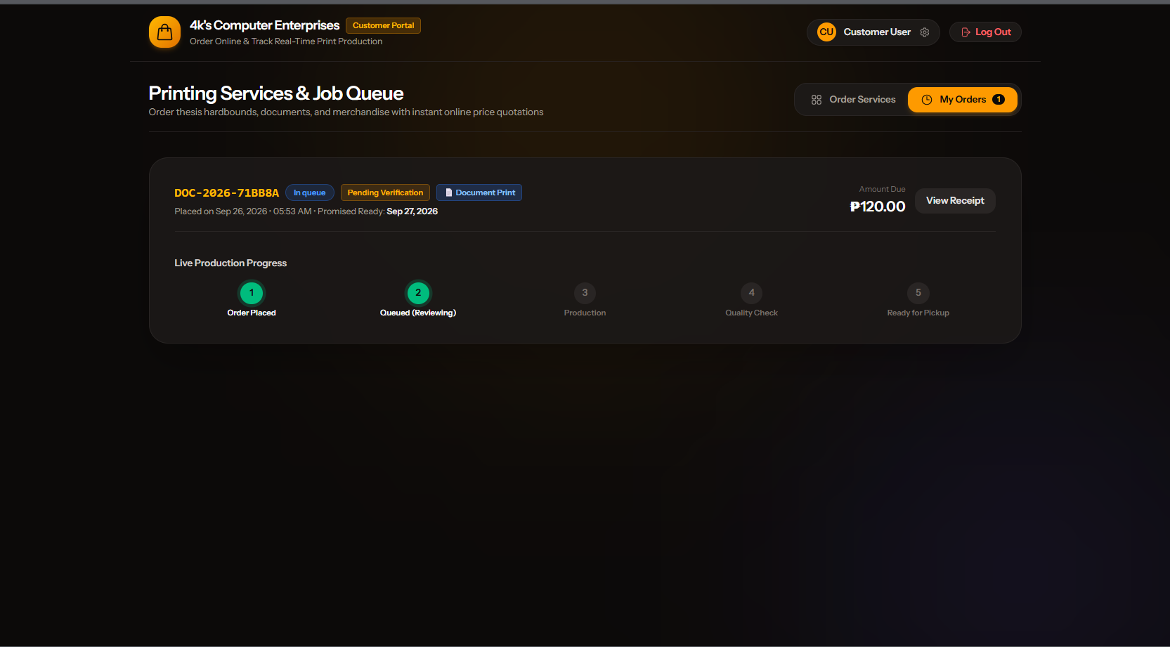
Figure 37 . Customer Ordering Wizard and Live Five-Stage Progress Stepper

Figure 38 shows the user interface of the Staff Production Kanban Console. The console is the operational interface used by production personnel to organize and advance active customer orders. It displays digital job cards according to their current production stage and provides search and filtering controls for locating work by service, rush status, fulfillment method, binding, or other relevant attributes. Staff members can open a job ticket to review order details, record customer-supplied paper intake, assign a machine, add production notes, and update the order stage. The five-stage Kanban arrangement makes workflow status visible at a glance and supports orderly movement from Queue through Printing, Binding or Assembly, Quality Check, and Ready for Pickup. When quality control is unsuccessful, the interface allows the staff member to record the reason and return the order to an earlier stage for corrective action.
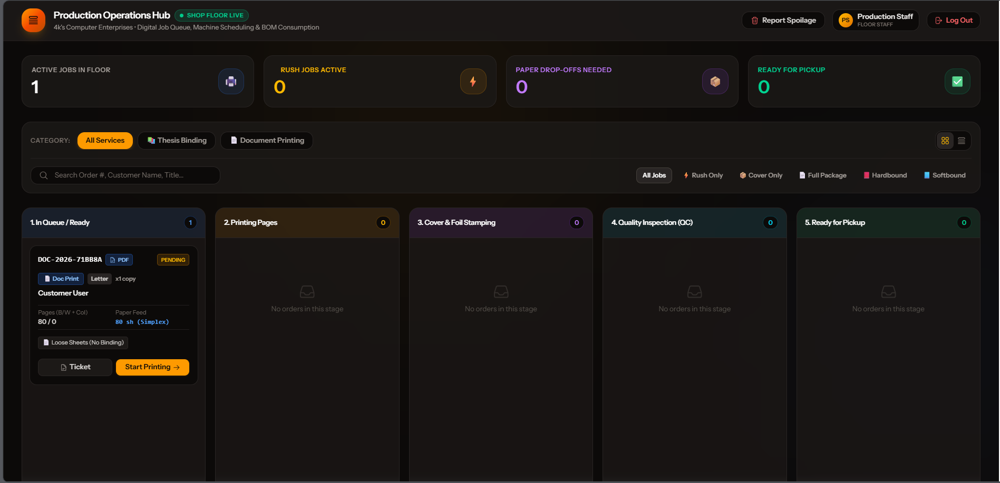
Figure 38. Staff Production Kanban Console

Figure 39 illustrates the user interface of the Report Spoilage function available to production staff. The interface allows staff to immediately record damaged or wasted material while the incident is still known on the production floor. The staff member selects the affected inventory item, enters the quantity wasted, and provides a reason or note before confirming the deduction. After submission, the system reduces the item's stock quantity, creates a spoilage or waste movement containing the previous and resulting stock values, and records the reporting user. The spoilage record remains available in the Inventory Hub and contributes to the spoilage-loss information used by the Analytics Hub. This separate interface supports timely and traceable inventory reporting without interrupting the order's Kanban stage progression.
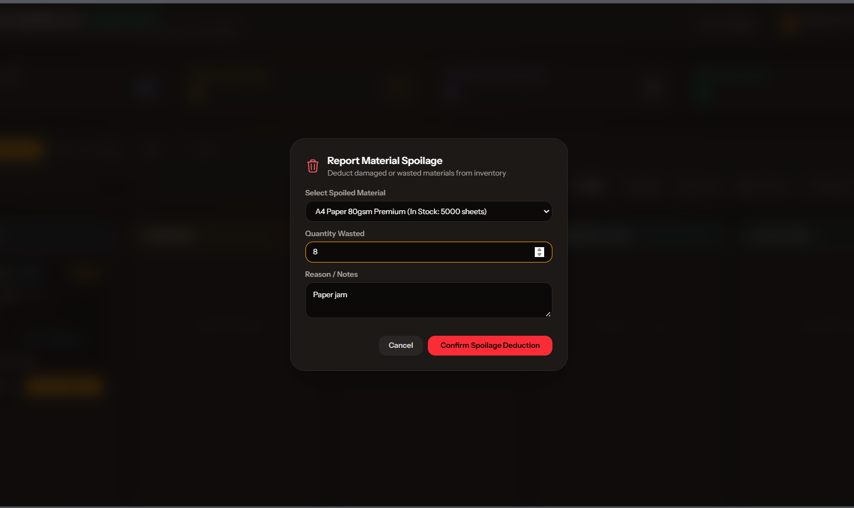
Figure 39. Report Spoilage Interface

Figure 40 illustrates the user interface of the Inventory Hub with Automated Restock Alerts. The hub provides the business owner with a consolidated view of materials, quantities on hand, reorder levels, stock movements, and restocking priorities. Inventory quantities may be adjusted through authorized management actions, while production-related consumption is recorded through the system's BOM-based deduction process when applicable. The interface evaluates current stock against the configured reorder level and marks materials requiring attention with a low-stock or restock alert. It also presents movement information to support traceability of additions, deductions, and adjustments. The restock alert is therefore an operational decision-support feature: it identifies supplies that require review and replenishment planning based on recorded inventory conditions, while the actual purchase or supplier transaction remains a business-owner action.
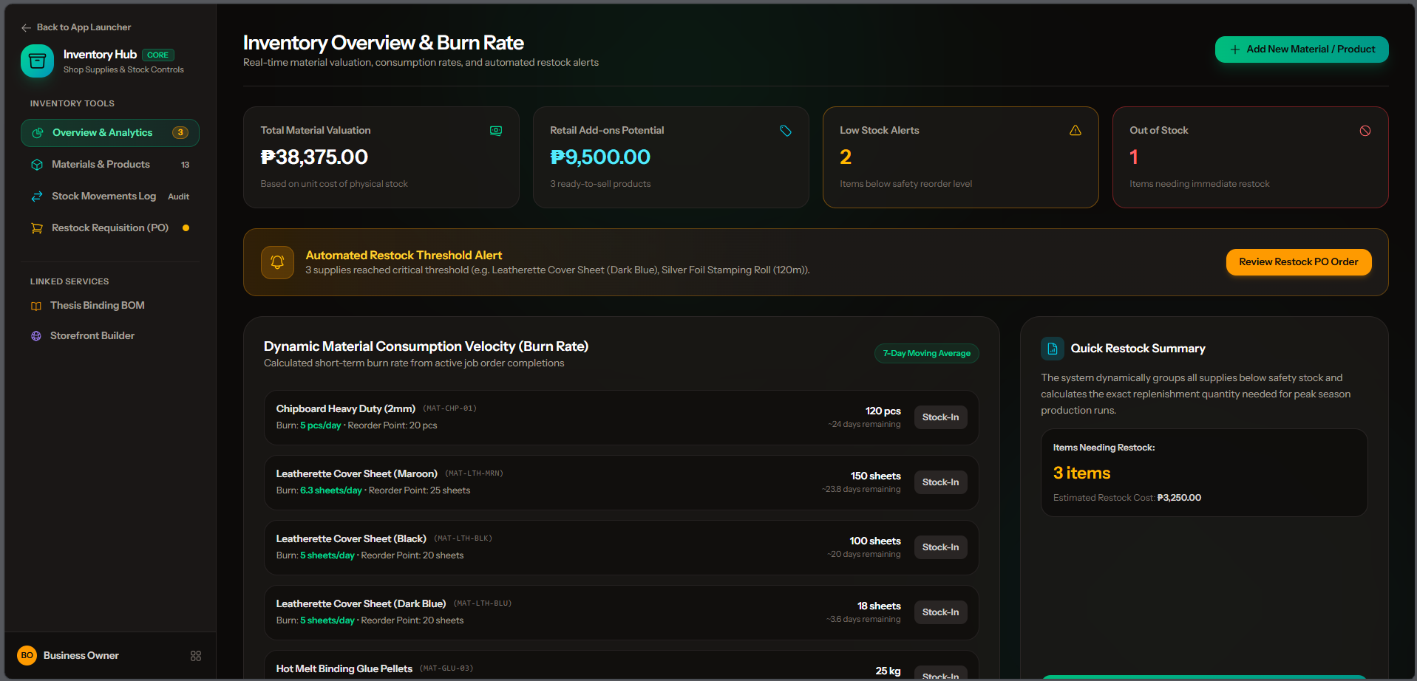
Figure 40. Inventory Hub with Automated Restock Alerts

Figure 41 shows the user interface of the Sales and Financial Analytics Hub. The hub transforms recorded order, payment, inventory, and production information into an organized management report. The business owner can select a reporting period and apply available service or fulfillment filters before reviewing key performance indicators, order summaries, sales trends, product mix, costs, profit, margins, rush revenue, and payment status information. The interface also supports payment verification for displayed orders and provides a CSV export for transaction-level reporting. By combining operational and financial measures in one screen, the hub helps the owner evaluate service performance, monitor revenue and cost behavior, and support procurement or pricing decisions using recorded business data rather than informal estimates.

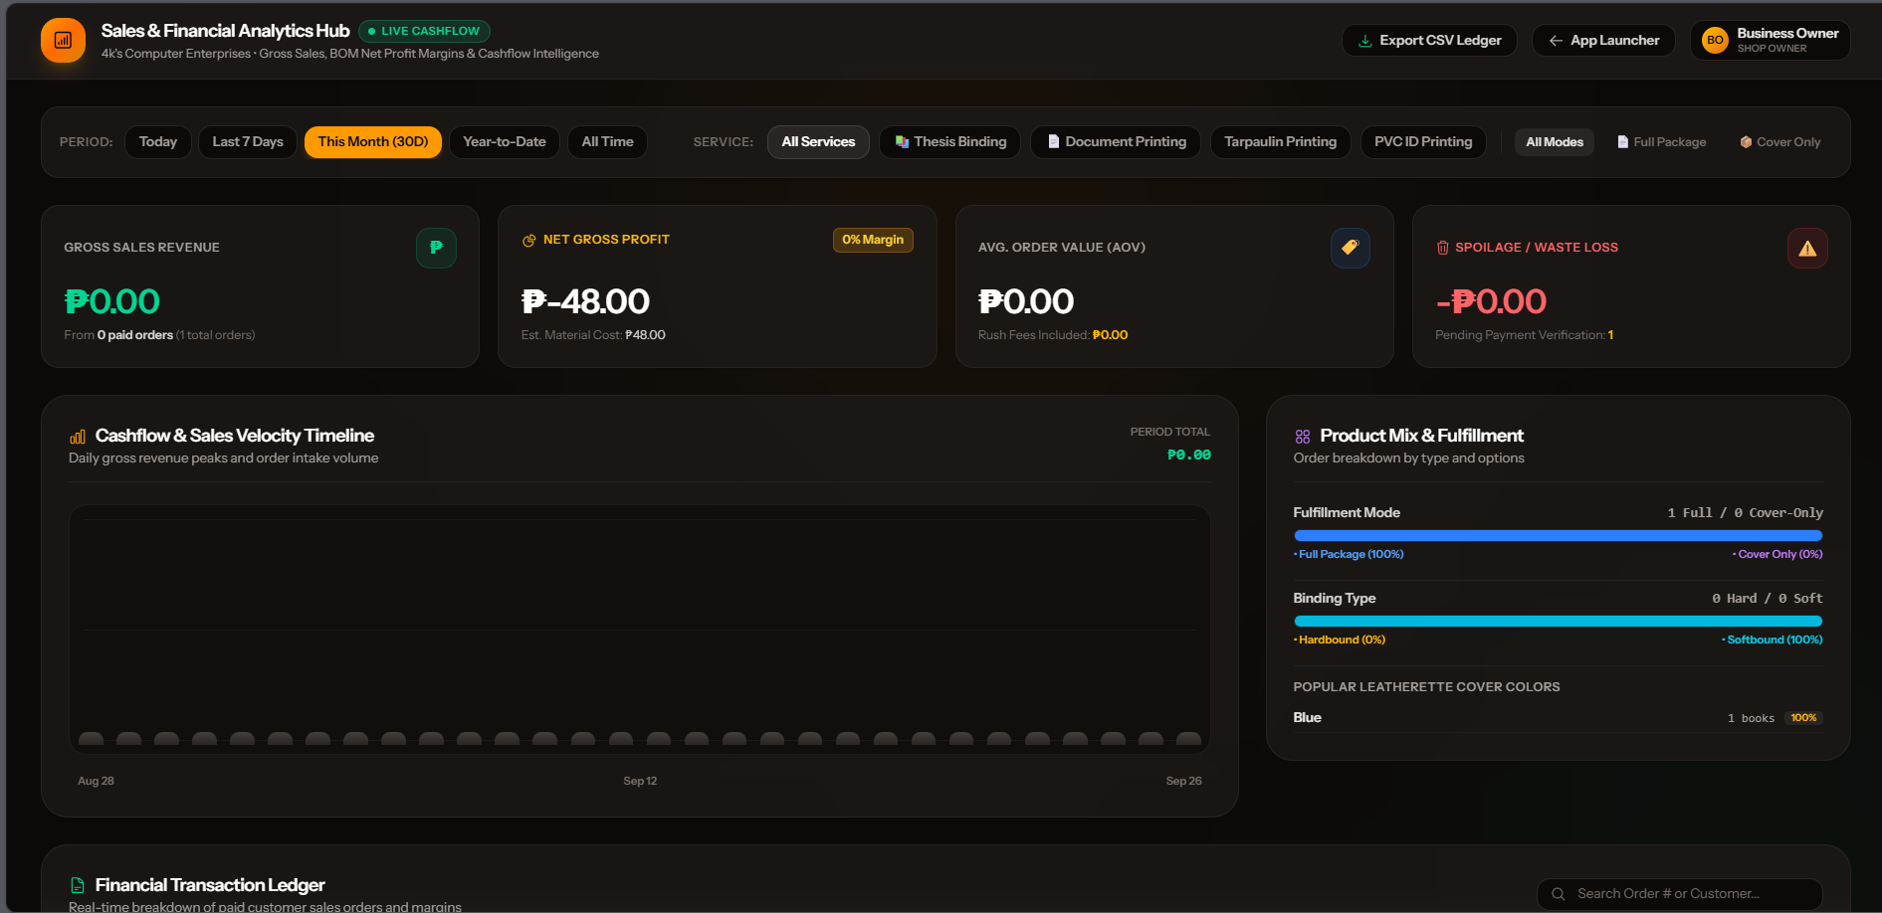
Figure 41. Sales and Financial Analytics Hub

LITERATURE CITED

Albayrak Ünal, Ö., Erkayman, B., & Usanmaz, B. (2023). Applications of Artificial Intelligence in Inventory Management: A Systematic Review of the Literature. Archives of Computational Methods in Engineering.

Apriadi, D., & Dewi, A. R. (2026). Design and Implementation of a Web-Based Printing Service System Using UML and Waterfall: A Case Study of Business Process Optimization. Journal of Information Technology and Systems Engineering, 1(1), 1–7.

Asim, I., & ARBAIY, N. . (2026). Business Inventory Management System for Alfudullallah Co. Applied Information Technology And Computer Science, 7(1), 1324-1338.

Bhaktha, Ankith & Raj, Akshay & N, Devika & Paul, Gripsy. (2023). Online Order Management System. International Journal for Research in Applied Science and Engineering Technology. 11. 1-10. 10.22214/ijraset.2023.54265.

Destouet, C., Tlahig, H., Bettayeb, B., & Mazari, B. (2023). Flexible job shop scheduling problem under Industry 5.0: A survey on human reintegration, environmental consideration and resilience improvement. Journal of Manufacturing Systems, 67, 155–173.

Dhiman, K., & Phansikar, M. (2021). Online food ordering management system. International Journal for Research in Applied Science and Engineering Technology, 9(7), 2096-2107.

Jebbor, S., Chiheb, R., El Afia, A., & Gallab, M. (2023). Designing a fully automated and integrated inventory and replenishment system for hospitals. International Journal of Systems Science: Operations & Logistics, 10(1), 1962429.

Jiang, Z., Yuan, S., Ma, J., & Wang, Q. (2022). The evolution of production scheduling from Industry 3.0 through Industry 4.0. International Journal of Production Research, 60(11), 3534–3554.

Joshi, S., Ekhande, R., Kazi, I., Naik, T., & Chintawar, S. (2026). Zaprint – A Remote Printing Management System. International Journal For Multidisciplinary Research.

Kurniawan, I., Saraswati, T., & Ongkopratama, P. D. P. (2025). Enhancing production planning and inventory control with a web-based system: A case study in an Indonesian packaging manufacturer company. Jurnal Teknik Industri, 26(1), 105-126.

Munyaka, J. B., & Yadavalli, V. S. S. (2022). Inventory management concepts and implementations: A systematic review. South African Journal of Industrial Engineering, 33(2), 15–36.

Oktavian, E. H., Sumarno, S., Jamaaluddin, J., & Sumartik, S. (2024). Enhancing design and print services: A web-based ordering system for InDesign digital printing store. AIP Conference Proceedings, 3167(1), 040025.

Rolf, B., Jackson, I., Müller, M., Lang, S., Reggelin, T., & Ivanov, D. (2023). A review on reinforcement learning algorithms and applications in supply chain management. International Journal of Production Research, 61(20), 7151–7179.

Saragih, R., Cynthia, E. P., & Cynthia, M. M. (2026). Improving Operational Efficiency in Digital Printing Services Through a Web-Based Information System: An Empirical Case Study. Journal of Information Technology and Systems Engineering, 1(1), 8–14.

Smagowicz, J., Szwed, C., & Berlec, T. (2024). An Assortment–Quantity Optimization Problem in Printing Industry Using Simulation Modelling. Sustainability, 16(4), 1693.

Susila, M. N., Haryanto, H., Fridayanthie, E. W., & Budiyono, P. (2025). Development of a Web-Based Printing Service Application Using the Waterfall Model. Jurnal Multidisiplin Sahombu, 5(08), 2832–2839. Retrieved from

Tanaman, M.T., Lloyd, J., Baylosis, A., Abiles, B.J., Lester, M., Catungal, P., & Encarnacion, D.P. (2023). Web-based Inventory Management System. International Journal of Science and Applied Information Technology.

Ugbebor, F. ., Adeteye, M., & Ugbebor, J. (2024). Automated Inventory Management Systems with IoT Integration to Optimize Stock Levels and Reduce Carrying Costs for SMEs: A Comprehensive Review. Journal of Artificial Intelligence General Science (JAIGS) ISSN:3006-4023, 6(1), 306–340.

Zonta, T., Da Costa, C. A., Zeiser, F. A., Ramos, G. de O., Kunst, R., & Righi, R. da R. (2022). A predictive maintenance model for optimizing production schedule using deep neural networks. Journal of Manufacturing Systems, 62, 450–462.
Zwaida, T.A.; Pham, C.; Beauregard, Y. Optimization of Inventory Management to Prevent Drug Shortages in the Hospital Supply Chain. Appl. Sci. 2021, 11, 2726.

APPENDICES



UNIVERSITY OF SOUTHERN MINDANAO
Kabacan, Cotabato
Philippines

APPLICATION FOR RESEARCH ADVISER
Appendix A. Application for Research Adviser
Application for Research Adviser
February 06,2026

DANILYN A. FLORES
Department of Computing and Library Information Science
College of Engineering and Information Technology
USM, Kabacan, Cotabato

Sir / Madam:

We would like to request that you will be our Research adviser effective 2nd semester,
SY 2025-2026. I intend to work on “PRINTIFY: INTEGRATED DYNAMIC ORDER, JOB SCHEDULING, AND INVENTORY MANAGEMENT SYSTEM FOR PRINTING SERVICES WITH AUTOMATED REPLENISHMENT”

We are hoping for your most favorable approval on this request. Thank you very much.

Very truly yours,

CHRISTIAN JAMES J. PEREZ
Printed Name and Signature of Student
KAYE P. COMISSION
Printed Name and Signature of Student

APPROVED
DANILYN A. FLORES
Adviser

____________________
Date
USM-EDR-F01-Rev.4.2022.10.18

Appendix B. Application for Research Title
Appendix B. Application for Research Title

UNIVERSITY OF SOUTHERN MINDANAO
Kabacan, Cotabato
Philippines
APPLICATION FOR RESEARCH TITLE
March 18, 2026

RYAN Z. GONZAGA
Chairperson, Department of Computing and Library Information Science

SIR:
We would like to request your office to allow us to research on the study entitled “PRINTIFY: INTEGRATED DYNAMIC ORDER, JOB SCHEDULING, AND INVENTORY MANAGEMENT SYSTEM FOR PRINTING SERVICES WITH AUTOMATED REPLENISHMENT”
The study has the following objectives:
1. create a dynamic order management architecture that enables administrators to configure, add, or modify printing services, pricing variables, and material requirements without altering the source code;
2. develop a job scheduling module that digitizes the production queue, visually tracks order progress, and systematically allocates labor and machinery to ensure timely fulfillment;
3. Implement an automated inventory replenishment module that calculates the real-time burn rate of materials based on active sales volume and triggers alerts at critical reorder points;
4. integrate the dynamic ordering, job scheduling, and inventory replenishment modules into a single, cohesive web-based platform; and
5. conduct comprehensive functional testing and system verification of the developed platform using a structured Test Plan and discrete Test Cases to validate that all 19 functional requirements satisfy their specified operational parameters, boundary conditions, and database transactions on a pass-or-fail basis and execute operational user acceptance walkthroughs with printing shop stakeholders.
Very truly yours,

CHRISTIAN JAMES J. PEREZ KAYE P. COMISSION
Printed Name and Signature of Student Printed Name and Signature of Student
NOTED
DANILYN A. FLORES  Adviser | Date
CATHERINE C. DAFFON  Department Research Coordinator | Date
ANITA C. SORNITO  College Research Coordinator | Date
APPROVED
RYAN Z. GONZAGA  Department Chairperson | Date
USM-EDR-F02-Rev.4.2021.11.04
Appendix C. Estimated Budget of the Research
Appendix C. Estimated Budget of the Research
UNIVERSITY OF SOUTHERN MINDANAO
Kabacan, Cotabato
Philippines
ESTIMATED BUDGET OF THE RESEARCH

Title of Study
PRINTIFY: INTEGRATED DYNAMIC ORDER, JOB SCHEDULING, AND INVENTORY MANAGEMENT SYSTEM FOR PRINTING SERVICES WITH AUTOMATED REPLENISHMENT

ITEMS/DESCRIPTION ESTIMATED COST
Transportation 600.00
Bond Papers (3 Reams) 570.00
Ink 1,200.00
Clips(6 pcs) 50.00
Wifi 1,499.00
Adviser 500.00
Examining Committee 900.00
Department Research Coordinator 250.00
Grand Total 5,569.00

Prepared and submitted by:

CHRISTIAN JAMES J. PEREZ KAYE P. COMISSION
Printed Name and Signature of Student Printed Name and Signature of Student
NOTED
DANILYN A. FLORES  Adviser | __________________________  Date
CATHERINE C. DAFFON  Department Research Coordinator | __________________________  Date
RYAN Z. GONZAGA  Department Chairperson | __________________________  Date
USM-EDR-F06-Rev.3.2020.02.24

Appendix D. Application for Thesis Outline Defense
Appendix D. Application for Thesis Outline Defense

UNIVERSITY OF SOUTHERN MINDANAO
Kabacan, Cotabato
Philippines
APPLICATION FOR THESIS OUTLINE DEFENSE

Name | CHRISTIAN JAMES J. PEREZ, KAYE P. COMISSION
Degree/Major | BACHELOR OF SCIENCE IN INFORMATION SYSTEMS
Thesis Title | INTEGRATED DYNAMIC ORDER, JOB SCHEDULING, AND INVENTORY MANAGEMENT SYSTEM FOR PRINTING SERVICES WITH AUTOMATED REPL ENISHMENT
Date of Examination
Time
Place

MEMBERS OF THE EXAMINING COMMITTEE
Name Signature Date

ELIZABETH R. Genotiva __________________ _____________
RYAN Z. GONZAGA __________________ _____________
NELSON G. BALNEG JR. __________________ _____________

RECOMMENDING APPROVAL:

DANILYN A. FLORES _______________________________
Adviser Co-Adviser (Optional)
APPROVED:
_______________________________ RYAN Z. GONZAGA
College Statistician Department Chairperson
(Optional)
CATHERINE C. DAFFON
Department Research Coordinator

REPORT ON THE RESULT OF EXAMINATION

Name Signature Remarks
ELIZABETH R. Genotiva __________________ _____________
RYAN Z. GONZAGA __________________ _____________
NELSON G. BALNEG JR. __________________ _____________

APPROVED:

CATHERINE C. DAFFON
Department Research Coordinator

____________________
Date
USM-EDR-F07-Rev.3.2020.02.24

USM-EDR-F07-Rev.3.2020.02.24

USM-EDR-F07-Rev.3.2020.02.24

USM-EDR-F08-Rev.3.2020.02.24

Appendix E. Application for Group Research
UNIVERSITY OF SOUTHERN MINDANAO
Kabacan, Cotabato
Philippines
APPLICATION FOR GROUP RESEARCH

October 15, 2026
DANILYN FLORES
Department of Computing and Library Information Science
College of Engineering and Information Technology
USM, Kabacan, Cotabato

Sir / Madam:

We would like to request that you allow us to work on our research by group. It is within our understanding that working as a group is of our own choice and each bears equal responsibility in completing the output, as indicated in the task allocation matrix.

We, the undersigned, do hereby certify and declare that Christian James J. Perez and Kaye P. Comission is duly authorized to process, on behalf of the group, all outline- and manuscript-related forms, including but not limited to the Application for Research Adviser, Application for Research Title, Acceptance of Thesis, and Budgetary Requirements (Estimated Budget and Actual Budget). The aforementioned member’s name and signature shall serve as the official representation of the group for such purposes.

Should some group member/s decide not to continue with the thesis due to unforeseeable circumstances, e.g. transfer to another university, file a leave of absence, and etc., the remaining members shall proceed with the study without the inclusion of additional members.

We are hoping for your most favorable approval on this request. Thank you very much.

Very truly yours,

CHRISTIAN JAMES J. PEREZ KAYE P. COMISSION
Printed Name and Signature of Student Printed Name and Signature of Student
APPROVED
DANILYN FLORES
Adviser

____________________
Date

USM-EDR-F19-Rev.0.2025.09.08

USM-EDR-F07-Rev.3.2020.02.24

USM-EDR-F07-Rev.3.2020.02.24

USM-EDR-F08-Rev.3.2020.02.24

Appendix F. Master Functional Test Cases
Appendix D. Application for Thesis Outline Defense

MASTER FUNCTIONAL TEST CASES

Below is the complete, expanded set of 25 discrete Test Cases covering both positive scenarios (happy path) and negative/boundary scenarios (validation, constraints, and error handling) across all 5 Core Modules.

Master Test Case Traceability Table

Test Case ID | Core System Module | Linked Requirement | Test Scenario Type | Verification Method | Status
TC-MOD1-01 | Module 1: Auth & RBAC | FR-01: User Account Registration | Positive: Valid Customer Registration | Form Submission & DB Insertion | PASS
TC-MOD1-02 | Module 1: Auth & RBAC | FR-01: User Account Registration | Negative: Duplicate Email Rejection | Validation Rule Enforcement | PASS
TC-MOD1-03 | Module 1: Auth & RBAC | FR-02: User Authentication & RBAC | Positive: Role-Based Dashboard Routing | Middleware Role Gate Routing | PASS
TC-MOD1-04 | Module 1: Auth & RBAC | FR-02: User Authentication & RBAC | Negative: Invalid Password Rejection | Authentication Error Handling | PASS
TC-MOD1-05 | Module 1: Auth & RBAC | FR-03: Session Termination & Logout | Security: Token Invalidation & Cookie Flush | Session Storage Destruction | PASS
TC-MOD2-01 | Module 2: Pricing Engine | FR-04: Service Catalog & Quotation | Positive: Dynamic Livewire Recalculation | Reactive Component State Audit | PASS
TC-MOD2-02 | Module 2: Pricing Engine | FR-15: Dynamic Service Configuration | Positive: No-Code Service & Rate Injection | Admin Rate Persistence | PASS
TC-MOD2-03 | Module 2: Pricing Engine | FR-16: BOM Recipe Definition | Relational: Item Consumable Mapping | Relational Integrity Verification | PASS
TC-MOD2-04 | Module 2: Pricing Engine | FR-06: Print Attribute Specification | Boundary: Page Limit Exceedance Handling | Business Rule Constraint Validation | PASS
TC-MOD3-01 | Module 3: Customer Ordering | FR-05: Print Order Placement & Upload | Positive: Valid PDF Upload & Tokenization | File Tokenization & Order Record | PASS
TC-MOD3-02 | Module 3: Customer Ordering | FR-05: Print Order Placement & Upload | Negative: Disallowed File Extension Rejection | MIME & Extension Validation | PASS
TC-MOD3-03 | Module 3: Customer Ordering | FR-06: Print Attribute Specification | Computation: Duplex Sheet Math ($\left\lceil P/2\right\rceil ×C$) | Formula Verification & JSON Storage | PASS
TC-MOD3-04 | Module 3: Customer Ordering | FR-07: Substrate Declaration | Business Logic: "Dala ang Papel" Fee Deduction | Cover-Only Flag & Intake Tag | PASS
TC-MOD3-05 | Module 3: Customer Ordering | FR-08: Proof of Payment Submission | Intake: Digital Remittance Proof Upload | Payment Pending State Transition | PASS
TC-MOD3-06 | Module 3: Customer Ordering | FR-09: Live Order Progress Tracking | Telemetry: 5-Stage Stepper Synchronization | Real-Time Production Query | PASS
TC-MOD4-01 | Module 4: Floor Scheduling | FR-10: Payment Auditing & Verification | Positive: Staff Payment Approval | Status Transition to Paid | PASS
TC-MOD4-02 | Module 4: Floor Scheduling | FR-10: Payment Auditing & Verification | Negative: Staff Payment Rejection | Payment Rejection & Customer Alert | PASS
TC-MOD4-03 | Module 4: Floor Scheduling | FR-11: 5-Stage Kanban Floor Queue | Workflow: Sequential Stage Progression | Kanban Board State Transition | PASS
TC-MOD4-04 | Module 4: Floor Scheduling | FR-11: 5-Stage Kanban Floor Queue | Exception: QC Failure Step-Back Rework Loop | Quality Rejection & Stage Step-Back | PASS
TC-MOD4-05 | Module 4: Floor Scheduling | FR-13: Substrate Counter Inspection | Intake: Physical Paper Audit & Release | Intake Hold Unlocking | PASS
TC-MOD5-01 | Module 5: Inventory Telemetry | FR-12: Automated BOM Stock Deduction | Positive: Stage-Triggered Material Decrement | Inventory Balance Decrement | PASS
TC-MOD5-02 | Module 5: Inventory Telemetry | FR-12: Automated BOM Stock Deduction | Exception: Customer Paper Stock Bypass | Paper Deduction Bypass Rule | PASS
TC-MOD5-03 | Module 5: Inventory Telemetry | FR-14: Material Spoilage Logging | Adjustment: Scrap Recording & Ledger Audit | Waste Movement Ledger Entry | PASS
TC-MOD5-04 | Module 5: Inventory Telemetry | FR-17: Inventory Oversight & ROP Alert | Analytics: Rolling Burn Rate & Low-Stock Banner | Dynamic ROP Threshold Trigger | PASS
TC-MOD5-05 | Module 5: Inventory Telemetry | FR-18: Analytics & Financial Reporting | Intelligence: Multi-Factor BI & CSV Export | Financial Ledger Compilation | PASS

Appendix G. Test Case Specification
Appendix D. Application for Thesis Outline Defense

DETAILED TEST CASE SPECIFICATION

Module 1: User Onboarding, Authentication & Role-based Access Control (RBAC)
Test Case ID: TC-MOD1-01
Requirement Reference: FR-01: User Account Registration
Test Description: Verify self-service customer registration with valid credentials and database persistence.
Preconditions: Public registration portal accessible; database connection online.
Test Input Data: Full Name: "Juan Dela Cruz", Email: "juandelacruz@example.com", Mobile: "09123456789", Password: "Password123!"
Execution Steps:
- Access the /register route.
- Input valid registration details into corresponding form fields.
- Submit the registration request.
Expected Output: User record inserted into users table with password hashed via bcrypt; default role set to customer; system redirects to login interface with account creation confirmation.
Actual Result: Account created successfully with hashed credentials; user redirected to login page.
Status: PASS
Test Case ID: TC-MOD1-02
Requirement Reference: FR-01: User Account Registration
Test Description: Validate duplicate email constraint handling and form validation error rendering.
Preconditions: User account with email juandelacruz@example.com already exists in the database.
Test Input Data: Full Name: "Juan Duplicate", Email: "juandelacruz@example.com", Mobile: "09998887777", Password: "Password123!"
Execution Steps:
- Access the /register route.
- Enter the duplicate email address and valid supplemental fields.
- Submit the registration form.
Expected Output: Submission intercepted by validation layer; database write prevented; inline error message rendered: "The email has already been taken."
Actual Result: Duplicate entry blocked; error message displayed without database mutation.
Status: PASS

Test Case ID: TC-MOD1-03
Requirement Reference: FR-02: User Authentication
Test Description: Verify credential verification and role-based access control (RBAC) portal routing.
Preconditions: Three active accounts configured with distinct roles: Business Owner, Production Staff, and Customer.
Test Input Data:
Case A: owner@printify.com / OwnerSecret123!
Case B: staff@printify.com / StaffSecret123!
Case C: customer@printify.com / CustomerSecret123!
Execution Steps:
- Navigate to /login.
- Authenticate sequentially using Case A, Case B, and Case C credentials.
Expected Output:
Case A routes strictly to /owner/dashboard.
Case B routes strictly to /staff/dashboard.
Case C routes strictly to /customer/dashboard.
Actual Result: Authenticated sessions isolated; role middleware redirected each user to their designated portal.
Status: PASS

Test Case ID: TC-MOD1-04
Requirement Reference: FR-02: User Authentication (Login)
Test Description: Validate rejection of invalid credentials and unauthorized protected route access.
Preconditions: Unauthenticated browser session.
Test Input Data: Email: owner@printify.com, Password: WrongPassword999!
Execution Steps:
- Attempt authentication with incorrect password.
- Attempt direct HTTP URL access to protected route /owner/inventory.
Expected Output: Authentication fails with message "These credentials do not match our records"; unauthenticated URL request redirected to /login with HTTP 302.
Actual Result: Login rejected; direct access to protected administrative route successfully intercepted.
Status: PASS
Test Case ID: TC-MOD1-05
Requirement Reference: FR-03: Session Termination and Logout
Test Description: Verify server-side session invalidation, CSRF token regeneration, and browser cookie eviction.
Preconditions: Active authenticated session on Customer Dashboard.
Test Input Data: User triggers "Log Out" action in navigation profile menu.
Execution Steps:
- Click "Log Out".
- Attempt to return to dashboard using browser "Back" navigation.
- Attempt direct HTTP request to /customer/dashboard.
Expected Output: Session flushed from memory; session cookie destroyed; CSRF token regenerated; subsequent requests redirected to public landing page.
Actual Result: Session destroyed; browser back navigation redirected to login.
Status: PASS

Test Case ID: TC-MOD1-06
Requirement Reference: FR-03: User Profile Management
Test Description: Verify user profile attribute modification, mobile number uniqueness enforcement, and current password verification during password update.
Preconditions: Authenticated user session active (Customer, Staff, or Owner).
Test Input Data:
- Updated Name = "Christian J. Perez (Updated)"
- Updated Mobile = "09123456789"
- Current Password = "CorrectOldPassword123"
- New Password = "NewSecurePassword456"
- New Password Confirmation = "NewSecurePassword456"
Execution Steps:
- Access user settings interface via /user/profile.
- Modify full name and contact number fields.
- Enter current password and matching new password in credential update section.
- Submit profile update form.
Expected Output: Form passes validation; database entity updated in 'users' table with re-hashed bcrypt password; session state refreshed; visual success notification "Profile Updated Successfully" rendered.
Actual Result: User record mutated cleanly; password re-hashed via bcrypt; success toast displayed.
Status: PASS
Module 2: Dynamic Service Configuration & Catalog Pricing Engine

Test Case ID: TC-MOD2-01
Requirement Reference: FR-04: Service Catalog Browsing and Quotation Calculation
Test Description: Validate reactive Livewire quotation computation without full browser reloads.
Preconditions: Document Printing service configured with Base Fee = ₱10.00, Color Rate = ₱3.50/page, Comb Binding = ₱25.00.
Test Input Data: Page Count = 40, Copies = 2, Color Profile = Full Color, Binding = Spiral Comb.
Execution Steps:
- Navigate to customer ordering wizard.
- Input 40 pages, 2 copies, Full Color, and Comb Binding.
- Observe computed subtotal display.
Expected Output: Dynamic formula evaluates: $\left(\left(\text{Pages}×\text{Rate}\right)+\text{BaseFee}+\text{Finishing}\right)×\text{Copies}=\left(\left(40×3.50\right)+10.00+25.00\right)×2=\text{₱}350.00$ rendered instantaneously.
Actual Result: Livewire component updated quotation subtotal to ₱350.00 without page refresh.
Status: PASS

Test Case ID: TC-MOD2-02
Requirement Reference: FR-15: Dynamic Service and Rate Configuration
Test Description: Verify administrative dynamic rate updates without source code modification.
Preconditions: Business owner authenticated session.
Test Input Data: Modify Booklet Printing base preparation fee from ₱20.00 to ₱35.00 and color per-page rate from ₱4.00 to ₱5.00.
Execution Steps:
- Access administrative Service Hub at /owner/services.
- Update rate input fields and save changes.
- Open customer storefront ordering wizard in separate private window.
Expected Output: Updated rates persisted in shop_services table; customer storefront immediately recalculates quotations using updated ₱35.00 base fee and ₱5.00 page rate.
Actual Result: Database updated; customer quotation engine ingested new rates instantly.
Status: PASS

Test Case ID: TC-MOD2-03
Requirement Reference: FR-16: Bill of Materials (BOM) Recipe Definition
Test Description: Validate relational mapping between dynamic service offerings and raw inventory consumables.
Preconditions: Active service "Hardbound Thesis" and inventory items: Chipboard, Book Cloth, Foil Ribbon.
Test Input Data: Link Chipboard (2 sheets/unit), Book Cloth (1 sheet/unit), Foil Ribbon (1 meter/unit).
Execution Steps:
- Open BOM Recipe Manager.
- Select Hardbound Thesis service.
- Map consumable items and assign consumption coefficients.
- Submit recipe mapping.
Expected Output: Foreign key relationships validated; recipe entries written to service_boms configuration table; floor deduction routines bound to recipe.
Actual Result: Relational recipe mappings saved; automated deduction bindings verified.
Status: PASS

Test Case ID: TC-MOD2-04
Requirement Reference: FR-06: Print Attribute and Finishing Specification
Test Description: Validate structural constraints preventing incompatible binding styles for excessive page counts.
Preconditions: Sliding Folder binding configured with physical threshold of maximum 50 sheets.
Test Input Data: Page Count = 120 pages, Orientation = Simplex (single-sided, requiring 120 sheets), Finishing = Sliding Folder.
Execution Steps:
- Configure 120 single-sided pages.
- Select Sliding Folder binding finish.
Expected Output: System displays validation warning: "Sliding folder binding capacity exceeded (maximum 50 sheets). Please select Spiral Coil or Softbound." Checkout disabled.
Actual Result: Incompatible binding option blocked; user prompted to choose viable finishing method.
Status: PASS

Module 3: Customer Self-Service Ordering & Prepress Intake

Test Case ID: TC-MOD3-01
Requirement Reference: FR-05: Print Order Placement and Document Upload
Test Description: Verify secure PDF manuscript upload, disk tokenization, and order instantiation.
Preconditions: Authenticated customer session; valid order attributes configured.
Test Input Data: Upload File: manuscript_final.pdf (6.2 MB).
Execution Steps:
- Upload PDF file through ordering wizard.
- Finalize checkout and click "Submit Order".
Expected Output: File stored on private disk with tokenized hash filename; parent order inserted into orders table with unique code (ORD-2026-XXXX); order status initialized to awaiting payment.
Actual Result: PDF stored securely; unique tracking code generated; order persisted in database.
Status: PASS

Test Case ID: TC-MOD3-02
Requirement Reference: FR-05: Print Order Placement and Document Upload
Test Description: Validate rejection of disallowed executable extensions and oversized file payloads.
Preconditions: Customer ordering wizard file upload step.
Test Input Data: File A: malicious_script.exe (1.5 MB); File B: oversized_document.pdf (65 MB, exceeding 50 MB threshold).
Execution Steps:
- Attempt upload of malicious_script.exe.
- Attempt upload of oversized_document.pdf.
Expected Output: File A rejected: "The file must be a file of type: pdf, docx, png, jpg"; File B rejected: "The file size may not exceed 50 megabytes."
Actual Result: Both unauthorized files intercepted and rejected by server validation.
Status: PASS

Test Case ID: TC-MOD3-03
Requirement Reference: FR-06: Print Attribute and Finishing Specification
Test Description: Validate duplex physical sheet requirements calculation and JSON specification storage.
Preconditions: Customer order with duplex printing enabled.
Test Input Data: Pages = 55, Copies = 2, Orientation = Duplex (two-sided).
Execution Steps:
- Select 55 pages and enable duplex printing for 2 copies.
- Submit order item.
- Inspect database order_items record.
Expected Output: System computes physical sheets: $\left\lceil 55/2\right\rceil ×2=28×2=56$ sheets; saves structured JSON: {"duplex": true, "paper_size": "A4", "gsm": 80, "sheets_required": 56}.
Actual Result: Mathematical calculation verified; JSON parameters persisted accurately.
Status: PASS

Test Case ID: TC-MOD3-04
Requirement Reference: FR-07: Customer-Supplied Substrate Declaration ("Dala ang Papel")
Test Description: Verify price deduction and intake alert attachment for customer-supplied paper orders.
Preconditions: Standard in-house paper charge = ₱1.00/sheet.
Test Input Data: Enable "Dala ang Papel" toggle; declare paper brand = "PaperOne A4 80gsm", count = 100 sheets.
Execution Steps:
- Toggle customer-supplied paper switch on.
- Enter paper brand and declared count.
- Submit order.
Expected Output: Raw paper material cost zeroed out from transaction subtotal; job ticket tagged with awaiting_paper_delivery alert; counter delivery instructions displayed to client.
Actual Result: Paper fees subtracted; job ticket flagged for physical counter intake.
Status: PASS

Test Case ID: TC-MOD3-05
Requirement Reference: FR-08: Proof of Payment Submission
Test Description: Verify digital payment receipt upload and order payment status transition.
Preconditions: Placed order with payment status awaiting_payment.
Test Input Data: Payment Channel = GCash, Reference = "GCASH-987654321", Receipt = gcash_screenshot.jpg.
Execution Steps:
- Access payment submission screen.
- Enter transaction reference number and upload receipt screenshot.
- Click "Submit Payment Proof".
Expected Output: Receipt image saved to private disk; order payment status transitioned to pending_verification; billing audit task generated for production staff.
Actual Result: Image stored; payment status updated to pending_verification.
Status: PASS

Test Case ID: TC-MOD3-06
Requirement Reference: FR-09: Live Order Progress and Status Tracking
Test Description: Verify real-time 5-stage progress stepper synchronization on client interface.
Preconditions: Active order ORD-2026-0042 advancing through workshop queues.
Test Input Data: Staff advances order status: in_queue $→$ printing $→$ finishing.
Execution Steps:
- Open client tracking interface /track/ORD-2026-0042.
- Advance order stage from staff console.
- Observe client tracking interface.
Expected Output: Five-stage stepper dynamically reflects milestones: completed stages show checkmarks and timestamps; current stage displays illuminated active indicator.
Actual Result: Stepper displayed real-time milestone transitions and timestamps.
Status: PASS

Module 4: Production Floor 5-Stage Kanban Scheduling & Counter Intake

Test Case ID: TC-MOD4-01
Requirement Reference: FR-10: Payment Transaction Auditing and Verification
Test Description: Verify staff auditing, approval, and order release into active production queue.
Preconditions: Order with pending_verification payment status.
Test Input Data: Staff auditor matches GCash reference number against merchant ledger and clicks "Approve".
Execution Steps:
- Open Staff Billing Audit modal.
- Verify reference number and click "Approve Payment".
Expected Output: Order payment status updated to paid; verifying staff user ID and timestamp logged; job ticket released to active Kanban "In Queue" column.
Actual Result: Payment verified; order successfully released into production queue.
Status: PASS

Test Case ID: TC-MOD4-02
Requirement Reference: FR-10: Payment Transaction Auditing and Verification
Test Description: Verify staff payment rejection handling and customer notification generation.
Preconditions: Order with illegitimate payment reference.
Test Input Data: Staff auditor clicks "Reject" with remark: "Reference number not found in merchant ledger."
Execution Steps:
- Open Staff Billing Audit modal.
- Enter rejection remark and click "Reject Payment".
Expected Output: Payment status updated to rejected; rejection reason recorded; alert rendered on customer dashboard prompting payment resubmission.
Actual Result: Rejection logged; customer alerted with resubmission form.
Status: PASS

Test Case ID: TC-MOD4-03
Requirement Reference: FR-11: Production Floor 5-Stage Kanban Queue Management
Test Description: Verify job ticket progression across the five active Kanban columns.
Preconditions: Order ticket in "In Queue" stage.
Test Input Data: Operator claims ticket, assigns Printer #2, and transitions ticket across stages.
Execution Steps:
- Move ticket: In Queue $→$ Printing Pages.
- Move ticket: Printing Pages $→$ Finishing & Assembly.
- Move ticket: Finishing & Assembly $→$ Quality Inspection.
- Move ticket: Quality Inspection $→$ Ready for Pickup.
Expected Output: Ticket transitions sequentially across columns; machine and operator assignments logged; customer tracking stepper updates in lockstep.
Actual Result: 5-stage progression executed reliably with full audit trails.
Status: PASS

Test Case ID: TC-MOD4-04
Requirement Reference: FR-11: Production Floor 5-Stage Kanban Queue Management
Test Description: Verify Quality Inspection defect flagging and step-back rework loop.
Preconditions: Order ticket in "Quality Inspection" column.
Test Input Data: QC inspector detects misaligned binding; triggers "Flag Rework" with note: "Re-bind front cover".
Execution Steps:
- Open QC inspection modal on Kanban board.
- Input rework note and click "Send Back for Rework".
Expected Output: Ticket automatically steps back to "Finishing & Assembly" column; defect note attached to ticket header; "Ready for Pickup" status prevented.
Actual Result: Ticket returned to previous production column with defect notice logged.
Status: PASS

Test Case ID: TC-MOD4-05
Requirement Reference: FR-13: Customer-Supplied Substrate Counter Inspection
Test Description: Validate staff counter paper inspection and release from intake hold.
Preconditions: Job ticket on intake hold with status awaiting_paper_delivery.
Test Input Data: Customer presents 100 sheets of A4 paper at shop counter; staff verifies count and paper condition.
Execution Steps:
- Staff locates ticket in Counter Intake console.
- Enters verified sheet count (100) and clicks "Confirm Paper Received".
Expected Output: Ticket status updated to paper_received; intake hold unlocked; ticket automatically routed into active Kanban "In Queue" column.
Actual Result: Intake hold released; order advanced to active workshop queue.
Status: PASS

Module 5: Automated Inventory Telemetry, Spoilage & Financial Analytics

Test Case ID: TC-MOD5-01
Requirement Reference: FR-12: Automated Bill of Materials (BOM) Inventory Deduction
Test Description: Validate automated inventory decrement upon advancing a standard print job to production.
Preconditions: Standard Order: 50 pages duplex, 2 copies (requires 50 A4 sheets, 1 coil). Initial Stock: A4 Paper = 500 sheets, Coils = 50 units.
Test Input Data: Operator advances order ticket to "Printing Pages".
Execution Steps:
- Advance order status to active production.
- Inspect database inventory_items and stock_movements tables.
Expected Output: A4 Paper decremented by 50 (New Balance: 450); Coils decremented by 1 (New Balance: 49); immutable stock_movements record created for each deduction.
Actual Result: Inventory balances decremented accurately; stock movement ledger logged.
Status: PASS

Test Case ID: TC-MOD5-02
Requirement Reference: FR-12: Automated Bill of Materials (BOM) Inventory Deduction
Test Description: Validate automated raw paper deduction bypass rule for customer-supplied paper orders.
Preconditions: Order flagged as customer_supplied_substrate = true. Consumables: 50 pages duplex, 2 copies, 1 coil. Initial Stock: A4 Paper = 450 sheets, Coils = 49 units.
Test Input Data: Operator advances customer-supplied order to "Printing Pages".
Execution Steps:
- Advance order to production stage.
- Inspect inventory stock balances.
Expected Output: Raw paper deduction completely bypassed (A4 Paper remains 450); non-paper finishing items deducted (Coils decremented to 48).
Actual Result: Paper bypass rule executed successfully; raw paper stock preserved.
Status: PASS

Test Case ID: TC-MOD5-03
Requirement Reference: FR-14: Material Spoilage Logging and Stock Adjustments
Test Description: Verify damaged material recording, stock deduction, and audit log generation.
Preconditions: Inventory item: Long 80gsm Paper with balance = 300 sheets.
Test Input Data: Spoilage Quantity = 15 sheets, Failure Reason = "Printer head jam during full-color pass".
Execution Steps:
- Staff accesses Spoilage Report interface.
- Selects item, inputs quantity (15), and provides failure explanation.
- Submits spoilage report.
Expected Output: On-hand balance updated to 285 sheets; stock_movements records audit entry tagged as spoilage with user ID, timestamp, and incident reason.
Actual Result: Inventory balance updated to 285; immutable waste record created.
Status: PASS

Test Case ID: TC-MOD5-04
Requirement Reference: FR-17: Inventory Oversight and Dynamic Reorder Point (ROP) Alerting
Test Description: Validate rolling daily burn rate calculation and automated low-stock banner trigger.
Preconditions: Short 70gsm Paper; Total consumption over 30 days = 900 sheets (Burn Rate = 30 sheets/day); Lead Time = 3 days; Safety Stock = 50 sheets.
Test Input Data:
Dynamic ROP Threshold: $\text{ROP}=\left(\text{Daily Burn Rate}×\text{Lead Time}\right)+\text{Safety Stock}=\left(30×3\right)+50=140\text{ sheets}$.
Stock decremented to 130 sheets (below ROP).
Execution Steps:
- Record consumption reducing stock to 130 sheets.
- Access Owner Master Dashboard.
Expected Output: System derives dynamic ROP = 140; evaluates $130≤140$; item flagged with visual "Low Stock" badge; automated replenishment recommendation banner rendered on Owner Dashboard.
Actual Result: Dynamic ROP evaluated accurately; restock alert banner rendered on dashboard.
Status: PASS

Test Case ID: TC-MOD5-05
Requirement Reference: FR-18: Sales, Cashflow, and Operational Analytics Generation
Test Description: Validate multi-factor financial aggregation, profit calculations, and CSV ledger export.
Preconditions: Completed and paid orders recorded across date range.
Test Input Data: Filter period: "Current Month", Export Format = CSV.
Execution Steps:
- Access /owner/analytics hub.
- Apply date range filter.
- Inspect calculated Gross Revenue, Material COGS, Spoilage Loss, and Net Margin.
- Click "Export CSV Ledger".
Expected Output: Summary cards display aggregate financial metrics; browser downloads formatted CSV ledger detailing all transactions.
Actual Result: Financial metrics computed accurately; CSV exported cleanly.
Status: PASS

UNIVERSITY OF SOUTHERN MINDANAO
Kabacan, Cotabato
Philippines
Task Allocation Matrix (TAM)
Appendix H. Task Allocation Matrix (TAM)

Thesis Title | Printify: Integrated Dynamic Order, Job Scheduling, and Inventory Management System for Printing Services with Automated Replenishment
Adviser | DANILYN P. FLORES | Date Submitted:
Group Members | CHRISTIAN JAMES J. PEREZ, KAYE P. COMISSION

Thesis components  (these can be revised, as appropriate) | Member/s Assigned  (For shared tasks, indicate % contribution) | Description
Problem statement and objective | Perez – 60%  Comission – 40 % | Member A (Christian James J. Perez):  • Identified and formulated the core technical challenges: manual order calculation overhead, unmonitored shop floor queue delays, and decoupled inventory stockouts.  • Authored the General Objective and the five (5) Specific Objectives aligning system engineering with empirical printing shop constraints.  • Defined the architectural boundaries and operational scope of the automated replenishment and scheduling engines.  Member B (Kaye P. Comission):  • Conducted initial field inquiries and stakeholder interviews at commercial print shops in Kabacan, Cotabato to document baseline operational bottlenecks.  • Synthesized end-user pain points into cohesive narrative paragraphs conforming to USM BSIS non-itemized Statement of the Problem conventions.  • Drafted the Significance of the Project section for shop owners, production employees, customers, and future developers.
Related literature – Topic A | Perez: 30%  Comission: 70% | Member B (Kaye P. Comission):  • Conducted comprehensive academic literature searches across Google Scholar, IEEE, and DOAJ for modern Web-to-Print paradigms and self-service ordering portals.  • Authored in-depth critical evaluations and summaries for cited authors: Apriadi & Dewi (2026), Susila et al. (2025), Saragih et al. (2026), Kurniawan et al. (2025), Joshi et al. (2026), Bhaktha et al. (2023), and Dhiman (2021).  • Synthesized how digital quoting and structured prepress intake reduce counter customer wait times and prevent intake specification errors.  Member A (Christian James J. Perez):  • Evaluated the technical architectures in reviewed literature against multi-variable pricing constraints (dimensional sizing, substrate weight, duplex print logic).  • Identified the technical research gap regarding dynamic quotation engines capable of instant mathematical recalculation upon asset configuration.
Related literature – Topic B | Perez: 60%  Comission: 40% | Member A (Christian James J. Perez):  • Investigated operational scheduling algorithms, state-machine queue transitions, and production queue visibility frameworks in industrial environments.  • Analyzed foundational studies: Smagowicz et al. (2024) on operational scheduling, Zonta et al. (2022) on data availability in operational decisions, and Destouet et al. (2023) on scheduling decision support.  • Formulated the theoretical rationale for establishing a 5-stage sequential Kanban state machine (Pending, Prepress, Printing, Finishing, Ready for Pickup) to replace static paper job tickets.  Member B (Kaye P. Comission):  • Gathered and synthesized empirical studies on shop-floor tracking and worker communication: Hernada et al. (2024) and Jiang et al. (2022).  • Documented the operational delays caused by verbal job handoffs and uncoordinated prepress revisions in physical print shops.  • Encoded citations, standardized paragraph formatting, and verified publication metrics.
Related literature – Topic C | Perez: 60%  Comission: 40% | Member A (Christian James J. Perez):  • Researched quantitative inventory control models, automated replenishment triggers, and rolling burn rate formulations: Rolf et al. (2023) on data-driven supply chain decision-making and Munyaka & Yadavalli (2022) on inventory optimization.  • Derived the mathematical framework for the Dynamic Reorder Point ($ROP=d×L+SS$) and evaluated real-time Bill of Materials (BOM) stock deduction mechanics.  • Analyzed algorithmic supply chain automation literature: Ugbebor et al. (2024), Jebbor et al. (2023), and Albayrak Ünal et al. (2023).  Member B (Kaye P. Comission):  • Surveyed empirical SME inventory studies: Tanaman et al. (2023) on retail inventory challenges and Asim & Arbaiy (2026) on computerized stock control.  • Researched literature on material spoilage overhead, carrying costs, and the operational risks of paper substrate stockouts.  • Encoded literature citations, compiled publication metadata, and cross-referenced author years.
Synthesis of literature | Perez: 40%  Comission: 60% | Member B (Kaye P. Comission):  • Authored the comprehensive literature synthesis integrating findings from all twenty (20) empirical and theoretical studies.  • Articulated the operational evolution of the printing industry from disparate, manual bookkeeping to unified, cloud-based workflow platforms.  • Structured the narrative bridging user interaction, floor scheduling, and material availability.  Member A (Christian James J. Perez):  • Articulated the primary research and engineering gap: the persistent technical decoupling between customer ordering interfaces, shop floor Kanban queues, and automated inventory replenishment.  • Grounded the design of Printify as an integrated architectural solution resolving this identified industry gap.
Theoretical/Conceptual Framework | Perez: 50%  Comission: 50% | Collaborative Effort:  • Jointly structured the 5-Stage Input-Process-Output-Outcome-Impact (IPO) model conforming to the USM institutional standard.  Member A (Christian James J. Perez):  • Defined the technical parameters for the Input Stage (system architecture, Laravel/Livewire stack, relational database schema, dynamic formulas) and Process Stage (multi-tier verification, Kanban state transitions, dynamic burn rate calculation, automated Pest testing).  • Specified the verifiable technical deliverables under the Output Stage (Printify platform, Functional Test Summary Report, Requirements Traceability Matrix).  Member B (Kaye P. Comission):  • Formulated the Outcome Stage (streamlined order processing, reduction in prepress misprints, elimination of paper stockouts) and Impact Stage (long-term operational resilience, maximized profit margins, scalable micro-enterprise capacity).  • Designed and illustrated the formal conceptual framework diagram (Figure 1: Conceptual Framework of Printify).
Technology Design – Module 1 | Perez: 40%  Comission: 60% (Lead) | Member B (Kaye P. Comission — UI/UX & Frontend Lead):  • Prototyped and built the user onboarding views, registration forms, login layouts, and password recovery interfaces.  • Designed the responsive customer profile management interface, navigation bars, and role-differentiated menu sidebars.  • Structured user experience flows and visual access indicators for Customers, Production Staff, and Business Owners.  Member A (Christian James J. Perez — Backend & Security Support):  • Integrated Fortify authentication backend services, session security, and bcrypt credential hashing.  • Implemented role authorization middleware guards and route policies enforcing strict boundary separation across user tiers.  • Structured database migrations for users, role enumerations, and authentication audit logs.
Technology Design – Module 2 | Perez: 70% (Lead)  Comission: 30% | Member A (Christian James J. Perez — Lead Backend Architect):  • Engineered the multi-variable dynamic pricing calculation engine handling dimensional matrices, substrate weights, and duplex multipliers.  • Designed the relational database architecture linking configurable service options to physical inventory Bill of Materials (BOM) items.  • Implemented administrative controllers and Eloquent models for dynamic service provisioning, price updates, and option toggling.  Member B (Kaye P. Comission — UI/UX Layout Support):  • Designed the service catalog management dashboard views, pricing tier modals, and substrate specification cards.  • Structured the visual hierarchy for service categories, add-on finishes, and turnaround time options.  • Documented dynamic pricing matrices and captured administrative catalog interface screenshots.
Technology Design – Module 3 | Perez: 40%  Comission: 60% (Lead) | Member B (Kaye P. Comission — UI/UX & Interaction Lead):  • Prototyped and developed the multi-step customer ordering wizard, digital asset upload dropzone, and custom specification selectors.  • Built the real-time quote preview component displaying price updates synchronously upon user option selections.  • Designed the customer job tracking portal featuring a visual 5-stage progress stepper and digital downpayment receipt upload modal.  Member A (Christian James J. Perez — Backend Pipeline Support):  • Engineered the secure file upload pipeline with MIME-type verification, storage disk isolation, and prepress asset validation.  • Implemented transactional order persistence, reference tracking code generation, and payment proof handling.  • Coded duplex calculation logic and page-count verification routines.
Technology Design – Module 4 | Perez: 70% (Lead)  Comission: 30% | Member A (Christian James J. Perez — Lead Production Systems Engineer):  • Engineered the 5-stage Kanban state machine governing order progression: Pending, Prepress, Printing, Finishing, and Ready for Pickup/Claimed.  • Programmed database transaction locks, concurrency controls, and automated timestamp logging across stage transitions.  • Implemented the quality control rework loop, rejection reason tracking, payment verification workflows, and staff task assignment logic.  Member B (Kaye P. Comission — UI/UX & Flow Prototyping):  • Prototyped the visual drag-and-drop Kanban board layout with responsive swimlanes, job detail cards, and urgency color tags.  • Designed the walk-in counter order intake interface allowing staff to rapidly log on-site customer orders.  • Captured production floor UI screenshots and documented operator interaction flows.
Technology Design – Module 5 | Perez: 70% (Lead)  Comission: 30% | Member A (Christian James J. Perez — Lead Telemetry & Algorithms Engineer):  • Engineered the real-time Bill of Materials (BOM) inventory consumption deduction triggered synchronously as jobs advance through Kanban stages.  • Implemented the Dynamic Reorder Point algorithm ($ROP=d×L+SS$) using rolling 30-day historical material burn rates.  • Programmed automated low-stock banner trigger logic, material spoilage audit log tracking, and financial metric aggregation routines (Gross Revenue, COGS, Net Margin, Spoilage Loss) with CSV ledger exports.  Member B (Kaye P. Comission — UI/UX Dashboard Support):  • Designed the owner executive analytics dashboard layout featuring key performance indicator (KPI) metric cards and restock alerts.  • Built the inventory ledger data tables, material movement history views, and staff spoilage submission modal.  • Formatted analytical reporting views and verified filter controls.
Methodology – Phase 1 | Perez: 40%  Comission: 60% | Member B (Kaye P. Comission):  • Prepared qualitative interview guides and conducted shop floor observations at local commercial print shops.  • Transcribed operational workflow procedures, recorded machine operating bottlenecks, and documented material waste patterns.  • Synthesized qualitative field data into formal operational requirements and user persona profiles.  Member A (Christian James J. Perez):  • Analyzed gathered operational data to establish technical software specifications, performance criteria, and hardware/software design constraints.  • Structured the developmental research design and mapped operational problems directly to system architectural features.
Methodology – Phase 2 | Perez: 30%  Comission: 70% | Member B (Kaye P. Comission — Lead System Modeler):  • Drafted, illustrated, and finalized all eighteen (19) UML Activity Diagrams corresponding to all 19 functional requirements (FR-01 to FR-19).  • Structured multi-lane swimlanes clearly delineating responsibilities among Customer, Counter/Production Staff, Business Owner, and System.  • Ensured visual clarity, standard UML syntax compliance, and cohesive layout across all diagrams.  Member A (Christian James J. Perez — Technical Logic Verification):  • Audited all decision nodes, guard conditions, and alternate branch paths in the activity diagrams against backend database transactions and route controllers.  • Validated error handling paths (e.g., payment rejection, material stockout, rework loops) against server-side logic.
Methodology – Phase 3 | Perez: 70%  Comission: 30% | Member A (Christian James J. Perez — Lead SQA Engineer):  • Authored and executed the automated test suite comprising 28 Pest feature test cases with 90 programmatic assertions across all five modules.  • Formulated the Black-Box Functional Test Plan detailing 25 exhaustive scenario test cases (TC-MOD1-01 to TC-MOD5-05) with rigorous preconditions, test inputs, step-by-step procedures, and expected outputs.  • Programmed automated edge case simulations (zero inventory, corrupt file uploads, invalid discount rules, concurrent Kanban status updates).  Member B (Kaye P. Comission — Functional Verification Support):  • Participated in manual functional scenario walkthroughs across all 25 test cases, recording actual outputs and UI behavioral responses.  • Audited and compiled the Requirements Traceability Matrix linking all 19 functional requirements to specific test cases and outcomes.  • Authored the Functional Test Summary Report and test execution documentation in Chapter 4 and Appendix.
Formatting & Referencing | Perez: 30%  Comission: 70% | Member B (Kaye P. Comission — Lead Formatting Specialist):  • Standardized manuscript margins (1.5 in left, 1.0 in top/bottom/right), font hierarchies (Times New Roman 12 pt), line spacing (2.0), and paragraph indentation per USM guidelines.  • Verified all in-text citations and compiled the complete Literature Cited section in strict compliance with APA 7th edition formatting.  • Formatted all formal tables, captions, and appendices according to institutional standards.  Member A (Christian James J. Perez — Technical Formatting Support):  • Verified mathematical equation formatting ($ROP=d×L+SS$), source code snippets, and database entity naming conventions.  • Formatted automated test execution logs, assertion summary tables, and technical schema diagrams.
Final editing & proofreading | Perez: 40%  Comission: 60% | Member B (Kaye P. Comission — Editorial Lead):  • Conducted thorough grammatical reviews, eliminated typographical errors, and enhanced scholarly sentence flow across Chapters 1 to 5.  • Ensured strict institutional adherence to BSIS capstone guidelines (e.g., replacing "researchers" with "project developers" and "study" with "capstone project").  • Standardized table numbering, figure captions, and cross-references throughout the entire manuscript.  Member A (Christian James J. Perez — Technical Review):  • Audited the entire paper to ensure absolute consistency across functional requirements (FR-01 to FR-19), test case IDs (TC-MOD1-01 to TC-MOD5-05), and database entities.  • Verified technical accuracy and mathematical precision in all formulas and algorithmic descriptions.
Oral presentation preparation | Perez: 50%  Comission: 50% | Collaborative Preparation:  • Co-developed the oral defense presentation slide deck.  Member A (Christian James J. Perez):  • Prepared technical slides detailing system architecture, dynamic pricing formulas, Kanban state machine logic, Dynamic ROP calculations, and automated test suite results.  • Configured the live technical demonstration environment for interactive system walkthroughs during the panel examination.  Member B (Kaye P. Comission):  • Designed the visual presentation theme, structured the problem statement and literature synthesis slides, and prepared UI/UX workflow walkthroughs.  • Organized the live demonstration storyboard illustrating real-time order tracking and counter intake workflows.

Submitted by | Date Submitted:
CHRISTIAN JAMES J. PEREZ  Name & Signature of Member A | KAYE P. COMISSION  Name & Signature of Member B

UNIVERSITY OF SOUTHERN MINDANAO
Kabacan, Cotabato
Philippines

CURRICULUM VITAE


KAYE P. COMISSION
Purok Miracle Extension Poblacion Kabacan
09069181280
s.kapecomission@usam.edu.ph

PERSONAL INFORMATION
Last Name | Comission
First Name | Kaye
Middle Name | Perez
Nickname | Kayie
Age | 22
Nationality | Filipino
Religion | Born Again
Civil Status | Single
Father’s Name | Wendel E. Comission
Mother’s Name | Maribel P. Comission
Educational Background
Elementary | Matalam Central Elementary School
Junior High School | Matalam High School
Senior High School | Matalam High School
Tertiary | University of Southern Mindanao
RELEVANT TRAINING
- Applications Development and Emerging Technologies — Application development concepts, emerging technologies, software solutions, and modern development practices.
- IT Security and Management — Information security principles, access control, authentication, security management, and protection of information systems.
- IS Innovations & New Technology — Emerging information technologies, digital innovation, and the application of modern technologies in information systems.
- Systems Analysis and Design (SAD) — Software modeling, architectural design, UML diagramming, and functional requirements engineering.
- Database Management Systems (DBMS) — Relational database modeling, SQL scripting, database transactions, and schema normalization.
- Web Systems and Technologies — Web application development, dynamic interfaces, web architecture, and modern web technologies.
- Application Development & Software Engineering — Software development lifecycle (SDLC), Agile development practices, application development, and quality assurance.
UNIVERSITY OF SOUTHERN MINDANAO
Kabacan, Cotabato
Philippines

CURRICULUM VITAE


CHRISTIAN JAMES J. PEREZ
Molonville, Osias, Kabacan, North Cotabato
09855330897
s.cjjperez@usm.edu.ph

PERSONAL INFORMATION
Last Name | Perez
First Name | Christian James
Middle Name | Jimenez
Nickname | Cjay
Age | 22
Nationality | Filipino
Religion | Protestant
Civil Status | Single
Father’s Name | N/A
Mother’s Name | Maria Theresa J. Perez
Educational Background
Elementary | Osias Elementary School
Junior High School | Osias High School
Senior High School | Kabacan National High School
Tertiary | University of Southern Mindanao
RELEVANT TRAINING
- Systems Analysis and Design (SAD) — Software modeling, architectural design, UML diagramming, and functional requirement engineering.
- Database Management Systems (DBMS) — Relational database modeling, SQL scripting, ACID transaction handling, and schema normalization (PostgreSQL / SQLite / MySQL).
- Web Systems and Technologies / Full-Stack Web Development — Modern full-stack architecture, RESTful API design, dynamic interfaces, and reactive component frameworks (Laravel, PHP, Livewire, JavaScript, Tailwind CSS).
- Computer Programming & Object-Oriented Programming (OOP) — Algorithmic design, OOP paradigms, modular programming, and automated feature testing (PHP, Python, Java).
- Data Structures and Algorithms (DSA) — Data modeling, optimization, queue handling (FIFO production queuing), and computational problem-solving.
- Computer Networking and Systems Administration — Network topologies, client-server architectures, web server configuration, and environment deployment (Cisco, Linux/WSL).
- Application Development & Software Engineering — End-to-end software development lifecycle (SDLC), Agile development practices, and Quality Assurance (QA) verification.

