**📌 Revised Business Requirement Document (BRD) – Hospital Management System**

**📋 Document Version: 2.0 | Updated for Gold Layer Integration**

**1. Overview**

The **Hospital Management System (HMS)** aims to efficiently manage patient care, medical operations, billing, room allocation, medical tests, inventory, and staff. The system will enable optimized **data retrieval, analytics, and reporting**, supporting both operational and strategic decision-making.

**2. Scope**

**🎯 Key Features & Objectives**

* Centralized patient record management.
* Appointment scheduling and doctor allocation.
* Real-time bed and room tracking.
* Billing, surgery, and medicine stock control.
* Medical test workflow tracking.
* Staff performance monitoring and department allocation.
* Insurance claims processing.

**🔍 Target Users**

* Hospital administration
* Doctors and medical staff
* Patients and caregivers
* Billing and finance teams

**3. Data Architecture Overview**

**🛠 Multi-Layered Design: Bronze → Silver → Gold**

| **Layer** | **Purpose** |
| --- | --- |
| Bronze | **Raw, unprocessed data** from operational sources. |
| Silver | **Cleaned, historical data** (normalized, 3NF). |
| Gold | **Optimized analytical layer** (fact and dimension tables). |

**4. Database Schema – Silver Layer (Normalized Data)**

**🏥 Patient Table**

* patient_id (PK), name, gender, date_of_birth, age, weight, blood_group
* address_id (FK to Address Table)
* admission_status, admission_date, discharge_date
* email, phone, image_path

**🏥 Doctor Table**

* doctor_id (PK), name, specialization, department_id (FK)
* salary, status, availability
* qualification, experience_years, joining_date
* phone, email, image_path

**🏥 Department Table**

* department_id (PK), name, floor, head_doctor_id (FK)
* total_staff, phone_extension

**🏥 Appointment Table**

* appointment_id (PK), patient_id (FK), doctor_id (FK)
* appointment_date, appointment_time
* reason, diagnosis, doctor_notes, suggestions
* payment_method, discount, fees

**🏥 Surgery Table**

* surgery_id (PK), appointment_id (FK), patient_id (FK), doctor_id (FK)
* status, surgery_notes, fees, payment_method, discount

**🏥 Room & Bed Management**

* room_id (PK), department_id (FK)
* room_type, floor, capacity, status, daily_charges, avg_monthly_maintenance
* bed_id (PK), room_id (FK), patient_id (FK, nullable)
* occupation_start_time, occupation_end_time

**🏥 Billing & Payments**

* bill_id (PK), patient_id (FK), admission_date, discharge_date
* room_charges, surgery_charges, medicine_charges, test_charges
* doctor_fees, other_charges, total_amount, discount, amount_paid
* balance_due, payment_status, payment_method

**🏥 Medical Stock & Supplier**

* medicine_id (PK), name, category, supplier_id (FK)
* cost_price, unit_price, stock_quantity, expiry_date
* batch_number, reorder_level

**🏥 Medical Test Tracking**

* test_id (PK), test_name, category, department_id (FK)
* cost, duration, fasting_required
* patient_test_id (PK), patient_id (FK), doctor_id (FK)
* test_date, result_date, result_notes, payment_method, discount

**🏥 Satisfaction Score**

* satisfaction_id (PK), doctor_id (FK), patient_id (FK), department_id (FK)
* rating, feedback, date

**🏥 Staff & Supplier Management**

* staff_id (PK), name, department_id (FK), role, salary
* supplier_id (PK), name, contact_person, phone
* contract_start, contract_end

**5. Gold Layer – Analytical Model (Fact & Dimensions)**

**📊 Fact Tables**

**🚀 fact_appointments**

* appointment_id (PK), patient_key (FK), doctor_key (FK), date_key (FK)
* reason, diagnosis, payment_method, discount, fees

**🚀 fact_billing**

* bill_id (PK), patient_key (FK), admission_date_key (FK), discharge_date_key (FK)
* room_charges, surgery_charges, medicine_charges, test_charges
* doctor_fees, other_charges, total_amount, discount
* amount_paid, balance_due, payment_status, payment_method

**🚀 fact_patient_stay**

* stay_id (PK), patient_key (FK), room_key (FK), bed_key (FK), department_key (FK)
* days_admitted, daily_charge, total_room_cost, surgery_cost

**🚀 fact_tests**

* patient_test_id (PK), test_key (FK), patient_key (FK), doctor_key (FK)
* test_date_key, result_date_key, test_cost, discount, result_status_flag

**🚀 fact_medicine_purchases**

* purchase_id (PK), patient_key (FK), medicine_key (FK), supplier_key (FK)
* date_key, quantity_purchased, total_cost, discount_applied

**🚀 fact_satisfaction_scores**

* satisfaction_id (PK), doctor_key (FK), patient_key (FK), department_key (FK)
* date_key, rating, feedback_count, average_rating

**📊 Dimension Tables**

✅ **dim_patient** (patient demographics, age group, admission status)  
✅ **dim_doctor** (doctor details, specialization, experience)  
✅ **dim_department** (hospital department metadata)  
✅ **dim_room** (room configurations, capacity, availability)  
✅ **dim_payment_method** (payment options)  
✅ **dim_medicine** (medication inventory)  
✅ **dim_test** (medical test attributes)  
✅ **dim_date** (critical date dimension for analytics)

**6. Enhancements & Next Steps**

✔ **Insurance Claims Tracking** – Introduce dim_insurance_provider for patient claims.  
✔ **Historical Tracking for Doctor Performance** – Maintain avg_consultation_time per month.  
✔ **Hospital Operations Analytics** – Create aggregated reports for **monthly revenue, bed occupancy, doctor workload**.  
✔ **ETL Strategy** – Optimize Silver → Gold transformation for efficient query processing.

**7. Performance & Query Optimization**

✔ **Partitioning fact tables** (fact_billing, fact_tests) by **date/month** for faster retrieval.  
✔ **Indexing high-frequency query keys** (patient_id, doctor_id, department_id).  
✔ **Materialized Views** for **doctor utilization & revenue trends**.

**🧠 Silver Layer Design Philosophy**

Your intent is clear:

🧪 "Silver Layer = Cleaned, Normalized (3NF) Historical Data Storage"

That means:

* ✅ Data is atomic and normalized.
* ✅ Surrogate keys or denormalized structures **are not introduced** yet.
* ❌ No star schema or dimensional modeling.
* ❌ No Dim* or Fact* tables — that's the **Gold Layer** responsibility.

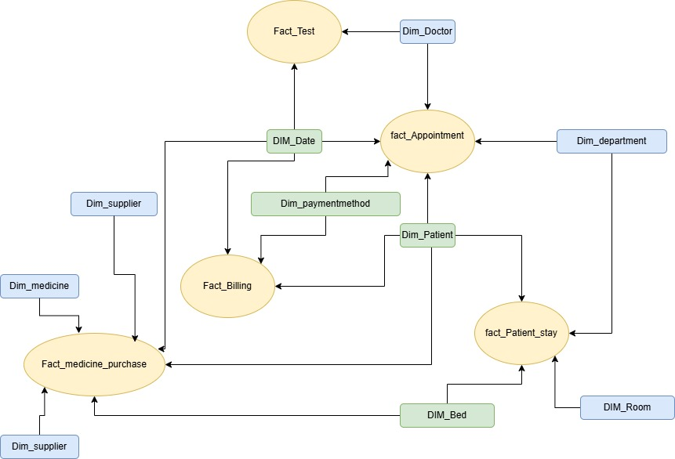

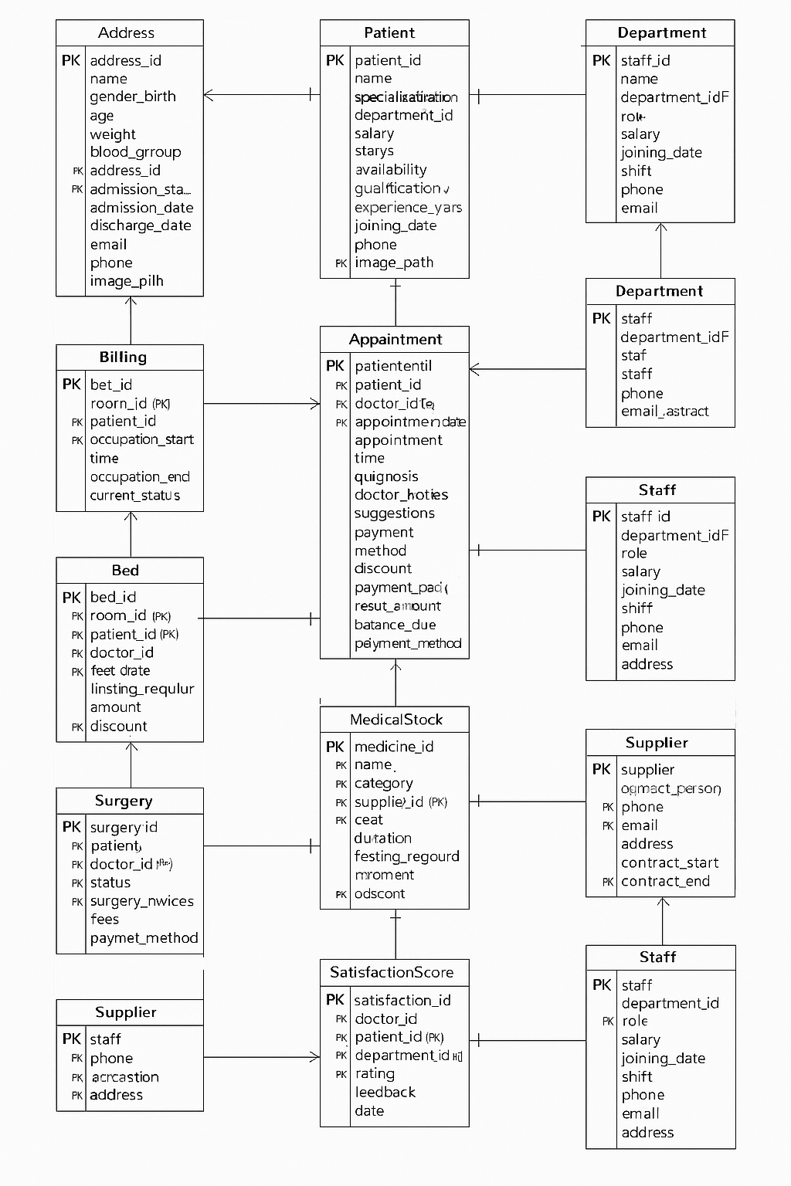

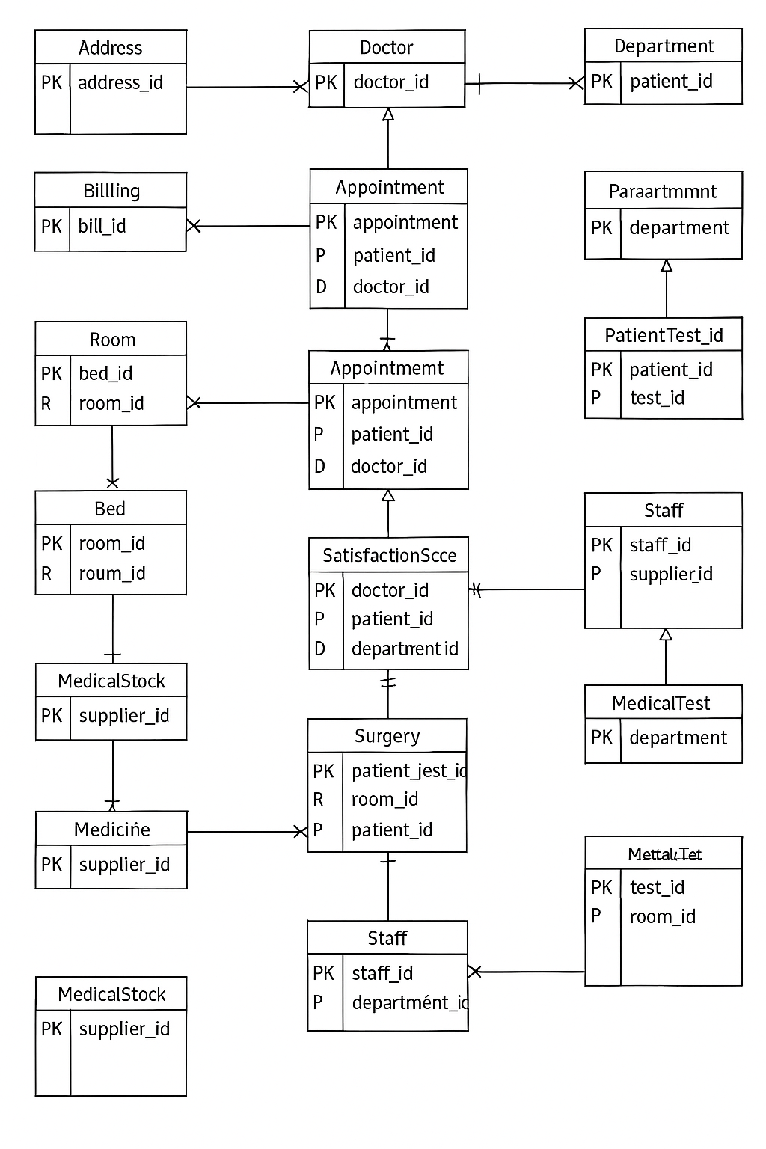

Absolutely! Below is a well-organized **“📌 Future Scope of Improvement”** section you can include in your documentation or presentation regarding your **Gold Layer schema**:

**📌 Future Scope of Improvement – Gold Layer**

As the hospital data warehouse evolves, the following enhancements are recommended to further optimize analytics, maintain flexibility, and support advanced reporting needs:

**🛠️ 1. Dimensional Enhancements**

* **Age Handling in DimPatient**
  + Replace static age with either:
    - date_of_birth for dynamic age calculation, or
    - a derived age_group field (Child, Adult, Senior) to simplify cohort analysis.
* **Normalize Doctor Availability**
  + Refactor availability in DimDoctor to link with a separate DimAvailabilityType table, making it scalable (e.g., "Morning Shift", "On Call", etc.).
* **Introduce DimDiagnosis (Optional)**
  + If common diagnosis codes (ICD-10, SNOMED) are tracked, normalize into a DimDiagnosis to enable disease-based analytics.

**🧾 2. Fact Table Improvements**

* **Remove Derived Fields Where Possible**
  + Avoid storing balance_due and total_room_cost directly in facts unless required for audit. These should ideally be calculated during ETL or reporting.
* **Clarify Discount Calculations**
  + Ensure clear distinction between:
    - gross_amount, discount_applied, and net_amount in billing- and purchase-related facts.
* **Track Completion Flags**
  + In FactTests, consider adding a field like is_completed or test_status to allow quick filtering of pending/incomplete tests.

**📊 3. Aggregated Data Improvements**

* **Composite Keys in Aggregates**
  + Replace month_key as primary key with a composite key (month_key, department_key) or add a surrogate key to allow multiple records per time period.
* **Add New Aggregated Tables**
  + AggPatientBehavior: Tracks repeat visits, average LOS, readmission rate.
  + AggTreatmentOutcomes: Measures recovery rate by doctor, department, or treatment.

**⚙️ 4. Performance & Modeling Optimization**

* **Index Optimization**
  + Add indexes on commonly joined keys in fact tables (patient_key, doctor_key, date_key, etc.) to accelerate query performance.
* **Implement Slowly Changing Dimensions (SCD)**
  + For dimension tables like DimDoctor, DimPatient, or DimRoom, consider implementing SCD Type 2 with valid_from, valid_to, and is_current columns for historical tracking.
* **Materialized Views**
  + Use materialized (indexed) views to cache heavy aggregations like revenue per department, appointment trends, etc.

**🔒 5. Auditability and Governance**

* **Add Audit Logs**
  + Maintain logs of changes to sensitive facts (e.g., billing, surgeries) for governance and compliance.
* **Extend Date Dimension**
  + Add holiday indicators, working hours, fiscal periods, etc., in DimDate to support seasonal or business calendar analytics.

**📈 6. Advanced Analytics Enablement**

* **Forecasting Fields**
  + Add fields like expected_discharge_date, expected_billing, etc., to support machine learning or forecasting use cases.
* **Predictive Model Outputs**
  + Create new fact tables or snapshot tables to store output from ML models like readmission prediction, risk scores, etc.