Emma & Nexus
Voice-First Agentic Knowledge Management System
Technical Write-Up — Patent Kickoff

Inventor: Gaurav Ahuja
JPMorgan Chase — Commercial Card
April 2026

Summary
Emma is a voice-first agentic assistant with full reasoning capabilities, designed to actively participate in team meetings. She helps with backlog grooming, refines stories, reasons through decisions alongside the team, and unblocks developers in real time. During every session she captures structured knowledge — decisions, constraints, discarded approaches, and outcomes — and writes it to persistent memory with full metadata. As a result, her memory compounds sprint over sprint, and she gets smarter with every meeting she participates in.
At scale, when every squad has its own Emma, a layer called Nexus sits above them. Nexus reads across all squad memories, detects duplication and hidden dependencies before they become problems, and alerts Product Owners. The same architecture repeats at every level of the organization — Commercial Card Nexus rolls up into Payments Nexus, into CIB Nexus, into Enterprise Nexus — producing cross-organizational intelligence no individual team can generate from its own vantage point.

The Problem This System Addresses
Engineering teams lose institutional knowledge constantly. When senior developers leave, domain expertise leaves with them. Confluence goes stale within weeks because nobody has time to keep it current. Jira tracks tasks but not the reasoning behind decisions. Chat threads bury knowledge that becomes unsearchable at scale. Developers get blocked across time zones and wait hours for Product Owners to come online. New joiners take months to ramp up because onboarding consumes senior developer time. Meanwhile, two squads frequently build the same service without knowing, and hidden cross-team dependencies surface only when integration breaks.
Existing tools are passive: Zoom transcripts capture words but not meaning; documentation requires effort nobody has; generic chatbots have no domain knowledge and no memory across sessions. Knowledge is captured by accident, retrieved by luck, and lost by design.
Emma and Nexus solve this end-to-end — active reasoning in meetings, structured decision capture, compounding per-squad memory, and cross-squad intelligence. The system is described across the four diagrams that follow.

Diagram 1 — Session Lifecycle Architecture
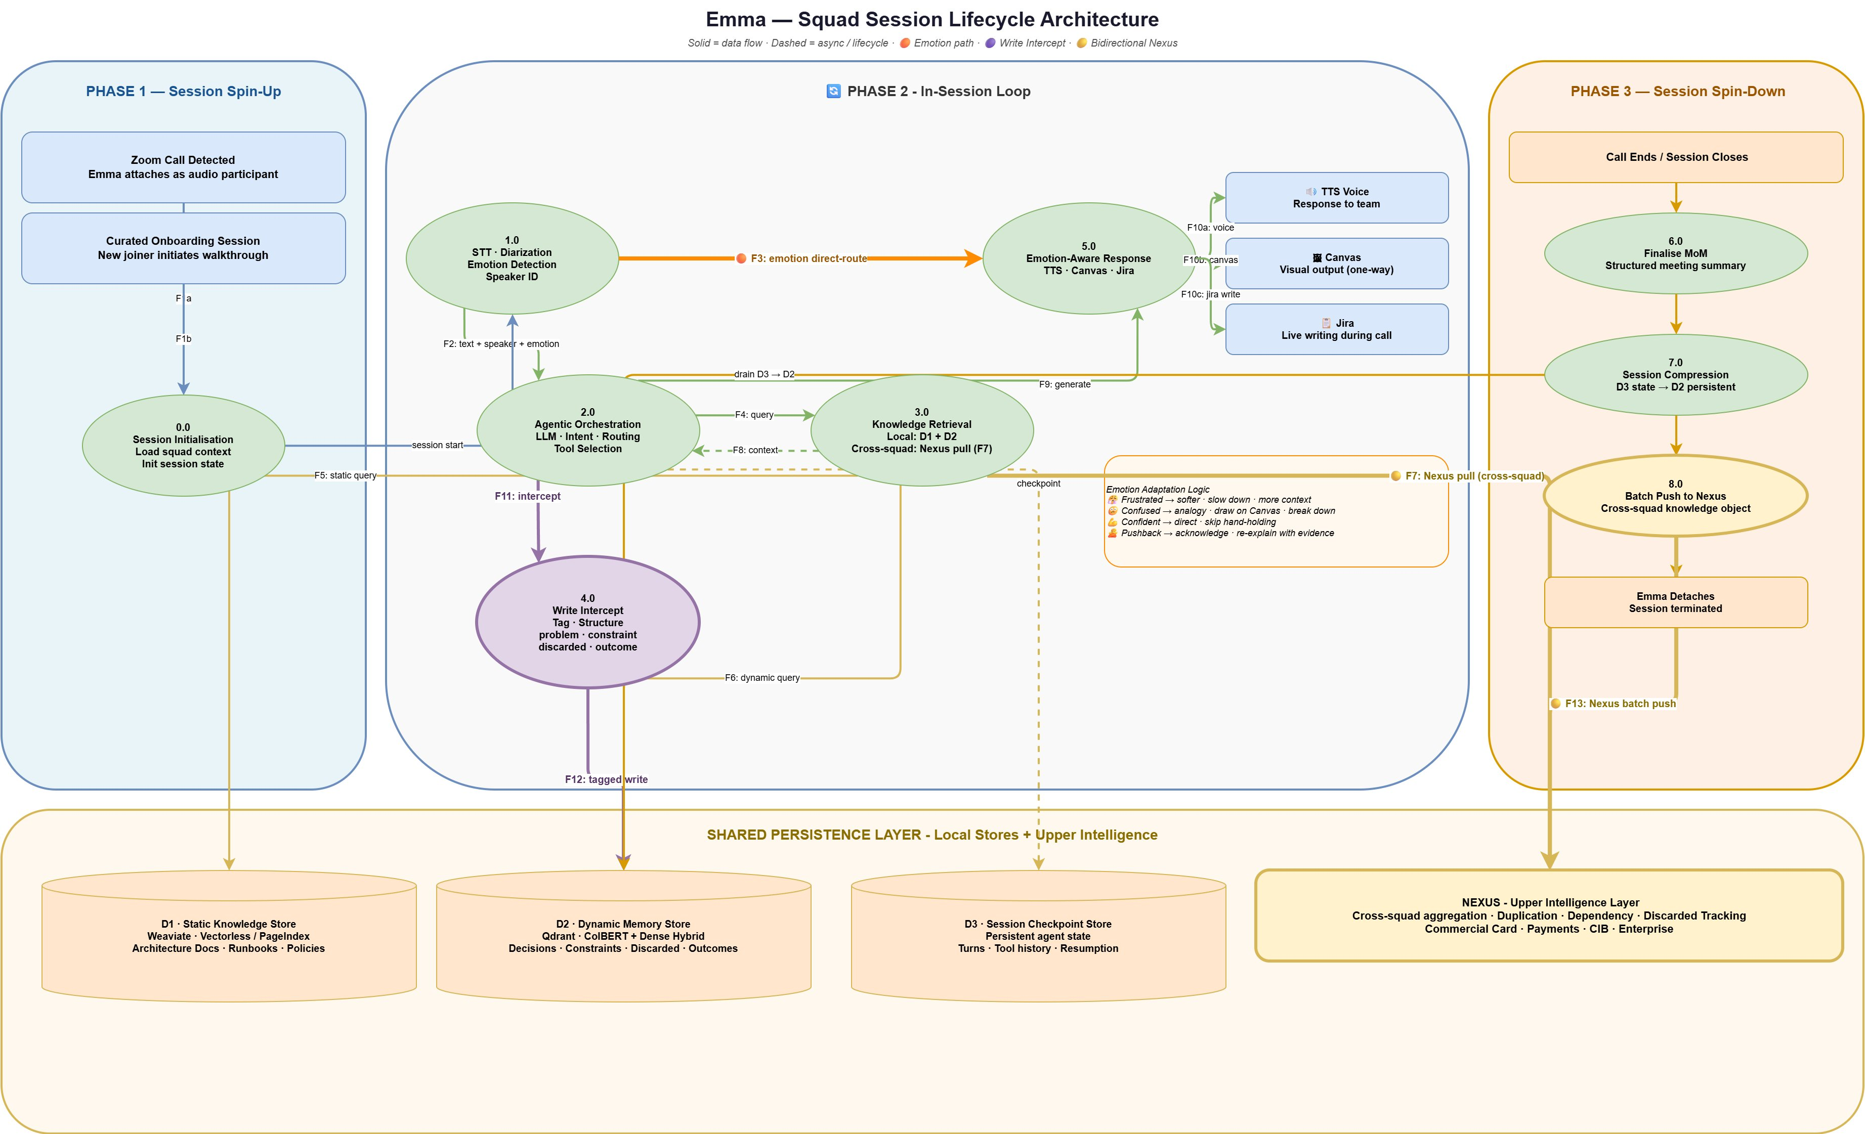

Components

Session Triggers
- Meeting Webhook — a Zoom or Teams meeting starts, a webhook fires, and Emma spins up and attaches to the call as an audio participant.
- Curated Session Trigger — a pre-scheduled onboarding or learning session initiated by a new joiner or team lead. Emma spins up without a live meeting, ready to walk the user through project history, architecture decisions, and prior sprints on demand.

Identity & Participant Awareness
- Enterprise SSO Integration — participant identity resolved via corporate single sign-on (Azure AD, Okta, or equivalent). Emma knows which humans are in the meeting by identity — their name, role, squad affiliation, and prior interaction history with her.
- Participant Engagement Tracker — monitors meeting-platform signals (chat link clicks, reactions, screen-share state) to track who is actively engaged with what Emma is presenting.

Input Layer
- SOTA Speech-to-Text (STT) Module — state-of-the-art streaming ASR converting meeting audio to text in real time. Enterprise deployment: AWS Transcribe, NVIDIA Parakeet, Azure Speech, or equivalent. Runs continuously — Emma is always listening from the moment she spins up.
- Diarization Module — identifies and labels which participant produced each utterance; paired with SSO so speakers are known by identity, not voice alone.
- SOTA Voice Emotion Module — a separate model running in parallel on the same audio stream; extracts an emotional state vector — categorical labels such as frustrated, confused, confident, neutral, and dimensional values for valence and arousal. Decoupled from STT.
- Wake Word Detection — detects "Hey Emma" invocations. Emma is already listening from spin-up; the wake word switches her from ambient capture mode into direct-response mode.
- Barge-In Handling — allows any participant to interrupt Emma's speech output; cancels in-flight TTS and returns her to listening state without disrupting the meeting.

Reasoning Layer
- Orchestrator — central decision layer (agent framework such as LangGraph); routes utterances and events to retrieval, reasoning, decision-capture, emotion-adaptive, proactive, tool-action, escalation, or cross-squad pathways based on content, signal, and playbook rules.
- Frontier LLM — reasoning engine for complex queries. Enterprise deployment: Claude Opus via AWS Bedrock or equivalent frontier-class model via enterprise gateway.
- Playbook Engine — a rule-based controller that encodes the structure of recurring team processes as patterns the Orchestrator follows. The engine defines, for each process type, (a) what roles participate, (b) what signals mark the start, progression, and completion of each phase, (c) what artifacts are typically produced, and (d) what actions Emma should proactively take at defined triggers. Initial implementation encodes agile ceremonies — daily stand-up, backlog refinement, sprint planning, review, retrospective. The mechanism is extensible: any recurring structured process with known participants, phases, and artifacts can be encoded as a Playbook, including architecture reviews, incident post-mortems, research review cycles.

Memory Layer
- D1 — Static Knowledge Store — persistent vector database for long-form structured reference material (architecture documents, runbooks, policies, coding standards). Uses structure-aware retrieval (PageIndex / vectorless) to preserve document context across long documents.
- D2 — Dynamic Memory Store — persistent vector database for compounding team decisions. Stores tagged objects with structured metadata: type (problem, constraint, discarded, outcome), feature, sprint, squad, timestamp, reason, linked entities. Hybrid retrieval (dense embeddings + ColBERT).
- D3 — Session Checkpoint Store — persistent agent state for the active session only. All STT output streams into D3 as indexed session memory — tagged with speaker, emotion, and timestamp — rather than a linear transcript fed into the LLM. The Orchestrator queries D3 via retrieval when reasoning, so only relevant session history is included in each reasoning turn. This keeps the LLM context window manageable even for long meetings. Drained to D2 via compression on session close.
- Write Intercept Module — intercepts orchestrator output and tool action results before persistence; classifies content into structured tags (problem, constraint, discarded, outcome); enriches with metadata (feature, sprint, squad, timestamp, reason, linked entities); writes the tagged object to D2.

Output Layer
- SOTA Text-to-Speech (TTS) Module — state-of-the-art voice synthesis. Enterprise deployment: AWS Polly, ElevenLabs, Azure TTS, or equivalent. Emotion-adaptive delivery.
- Canvas Renderer — a first-class explanatory capability. Emma does not just describe architecture in words — she draws it. The Canvas Renderer produces architecture diagrams, flow charts, and explanatory visuals in real time, synchronized with Emma's spoken explanation.
- Multi-Modal Link Dispatch + SSO-Authenticated Canvas Access — when Emma uses the Canvas, she dispatches a link to each participant via the meeting platform's chat (Zoom chat, Teams chat). Participants click the link, authenticate via enterprise SSO, and the canvas loads on their device. Because access is SSO-authenticated, Emma knows by identity who has opened the visual and who has not, and can adapt her explanation accordingly.
- Jira Integration — writes acceptance criteria, tickets, and MoM entries back to Jira based on in-meeting decisions.
- MCP Tools Layer — integration surface through which Emma executes actions in external systems. Built on Model Context Protocol for extensibility — new tools (test scenario reviewers, code review helpers, deployment automations, documentation writers) can be added as they become available without changing Emma's core. Critically, tool invocations and their results flow back through the Orchestrator and Write Intercept, so Emma's actions become tagged team memory just like captured decisions.
- Escalation Dispatcher — when Emma's confidence on a query is below threshold, she provides a best-attempt answer AND simultaneously drafts an escalation to the Product Owner with full context. When the PO responds, the answer writes back to D2 — so the same question never escalates twice.

Cross-Squad Interface
- F7 Pull — Emma issues a live query to Nexus during an active session; receives cross-squad prior art within 2-3 seconds.
- F13 Push — at session close, Emma pushes structured knowledge objects to Nexus in batch for cross-squad intelligence (see Diagrams 2 and 4 for the Nexus architecture).

Flow
A session starts in one of two ways. In the common case, a Zoom or Teams meeting begins and the Meeting Webhook fires — Emma spins up and attaches to the call as an audio participant. In the alternate case, a new joiner or team lead starts a Curated Session, and Emma spins up without a live meeting, ready to walk the user through project history and architecture on demand. Both paths converge at the same spin-up: Emma hydrates her session context from D1 (team architecture, policies, reference material) and D2 (the team's full decision history from prior meetings). Participant identity is resolved via Enterprise SSO, so Emma knows by name who is in the meeting, their roles, and their prior interaction history with her.
From spin-up, Emma is always listening. The STT Module, Diarization Module, and Voice Emotion Module run in parallel on the continuous audio stream, producing a unified utterance object — text + speaker + emotion, tagged to a single moment in time — for every spoken segment. Utterances stream into D3 as indexed session memory, and in parallel into the Orchestrator, which inspects each incoming signal and routes it down one of several paths. The wake word is not what activates Emma's listening; it is what switches her into direct response mode when a participant wants to address her directly.

Path 1 — Direct Query (wake-word invocation)
When a participant says "Hey Emma, what's our fraud alert SLA?", the Wake Word Detector identifies the invocation and the Orchestrator treats the follow-up as a direct query. Hybrid retrieval runs against D1 and D2; retrieved context plus the participant's question flows to the Frontier LLM; the response flows to the Output Layer. The TTS Module speaks the answer in Emma's voice. If visual explanation helps — for example, "walk me through the payment flow" — the Canvas Renderer draws the diagram alongside her speech, synchronized in real time, and a link is dispatched via chat. Participants click the link, authenticate via SSO, and the canvas loads on their device. Emma now knows by identity who is viewing the visual and can adapt her pacing accordingly. If a participant interrupts mid-response, Barge-In Handling cancels the TTS cleanly and Emma returns to listening.

Path 2 — Ambient Decision Capture
Even when no one has said "Hey Emma," she is listening and reasoning over the conversation. When a substantive decision is made — for example, "We'll use the custom phone validator, not the open-source one, too slow at scale" — the Orchestrator recognizes the decision pattern and engages the Write Intercept Module. Write Intercept classifies the content into structured tags (here: discarded approach + outcome + constraint), enriches with metadata (feature: phone validation; sprint: 14; squad: Payment Gateway; reason: latency at scale; linked entity: merchant onboarding), and writes the tagged object to D2. This is how team memory compounds silently in the background while the team keeps talking.

Path 3 — Cross-Squad Pull (F7)
When the team discusses something with potential cross-squad relevance — "has any other team built phone validation?" — the Orchestrator issues an F7 pull to Nexus. Nexus returns prior art from other squads within 2-3 seconds: who built it, where it lives, what worked, what was discarded. Emma incorporates this into her spoken response in real time — bridging naturally with "let me check across teams…" while the round trip completes.

Path 4 — Emotion-Adaptive Response (🟠 F3)
When the Voice Emotion Module detects strong emotional signal — frustration, confusion — the emotion vector routes directly to response generation, bypassing the full retrieval-plus-reasoning loop. Emma's reply adapts in structure: she slows her pace, acknowledges the difficulty, and walks through the explanation step by step with distinct, concrete framing rather than delivering a dense single-shot answer. The goal is comprehension, not just comfort.

Path 5 — Playbook-Driven Proactive Engagement
Emma does not only respond to what the team asks. The Playbook Engine encodes the structure of recurring team processes — most commonly agile ceremonies — as patterns the Orchestrator follows. When a team begins a daily stand-up, the Playbook knows the expected structure: each developer in turn, blockers surfaced, dependencies mentioned. As the conversation progresses and a blocker is raised, the Playbook triggers Emma to proactively check D2 for similar prior blockers on the same team and F7-pull Nexus for cross-squad prior work on the same issue. Emma surfaces findings in real time. Similarly, at the end of a refinement session, the Playbook triggers Emma to summarize agreed acceptance criteria and offer to write Jira tickets. The engine is extensible to any recurring structured process — architecture reviews, incident post-mortems, research review cycles — broadening Emma's applicability well beyond software engineering.

Path 6 — Action, Tools, and Escalation
When Emma's response calls for action beyond speaking — filing a Jira ticket, updating architecture documentation, pulling a code snippet — the Jira Integration and MCP Tools Layer execute the action during the meeting itself. The MCP Tools Layer is extensible; new agentic tools plug in without core changes, so Emma's capability grows over time. Critically, tool invocations and their results flow back through the Write Intercept, so Emma's actions become tagged team memory alongside captured decisions. If Emma's confidence on an answer is below threshold, the Escalation Dispatcher provides her best-attempt answer AND simultaneously drafts an escalation to the Product Owner with full context. When the PO responds, the answer writes back to D2 — so the same question never escalates twice.

Phase 3 — Session Spin-Down
When the meeting ends, spin-down begins. The contents of D3 — the full session state, including every utterance, every tool call, every in-progress reasoning trace — are compressed via the Write Intercept Module into structured, tagged knowledge objects and drained into D2. This gives the team permanent memory of what just happened: every decision, every discarded approach, every outcome, cleanly tagged and retrievable. In parallel, a batch of those same objects is pushed upward via 🟡 F13 to Nexus — the cross-squad intelligence layer that sits above every squad's Emma. Nexus receives batched knowledge from every squad in the line of business, runs pattern detection across the accumulated cross-squad memory, and produces intelligence no individual team can generate from its own vantage point. What Nexus is, how it analyzes cross-squad patterns, how it serves live queries back to Emmas, and how the same architecture repeats at every level of the enterprise is the subject of Diagrams 2, 3, and 4.
D3 is cleared. Emma detaches. The session is over — but the memory it produced lives on permanently in D2 (for the team's next meeting) and in Nexus (for any other squad in the organization that needs it).

Diagram 2 — Platform Hierarchy & Institutional Memory Architecture
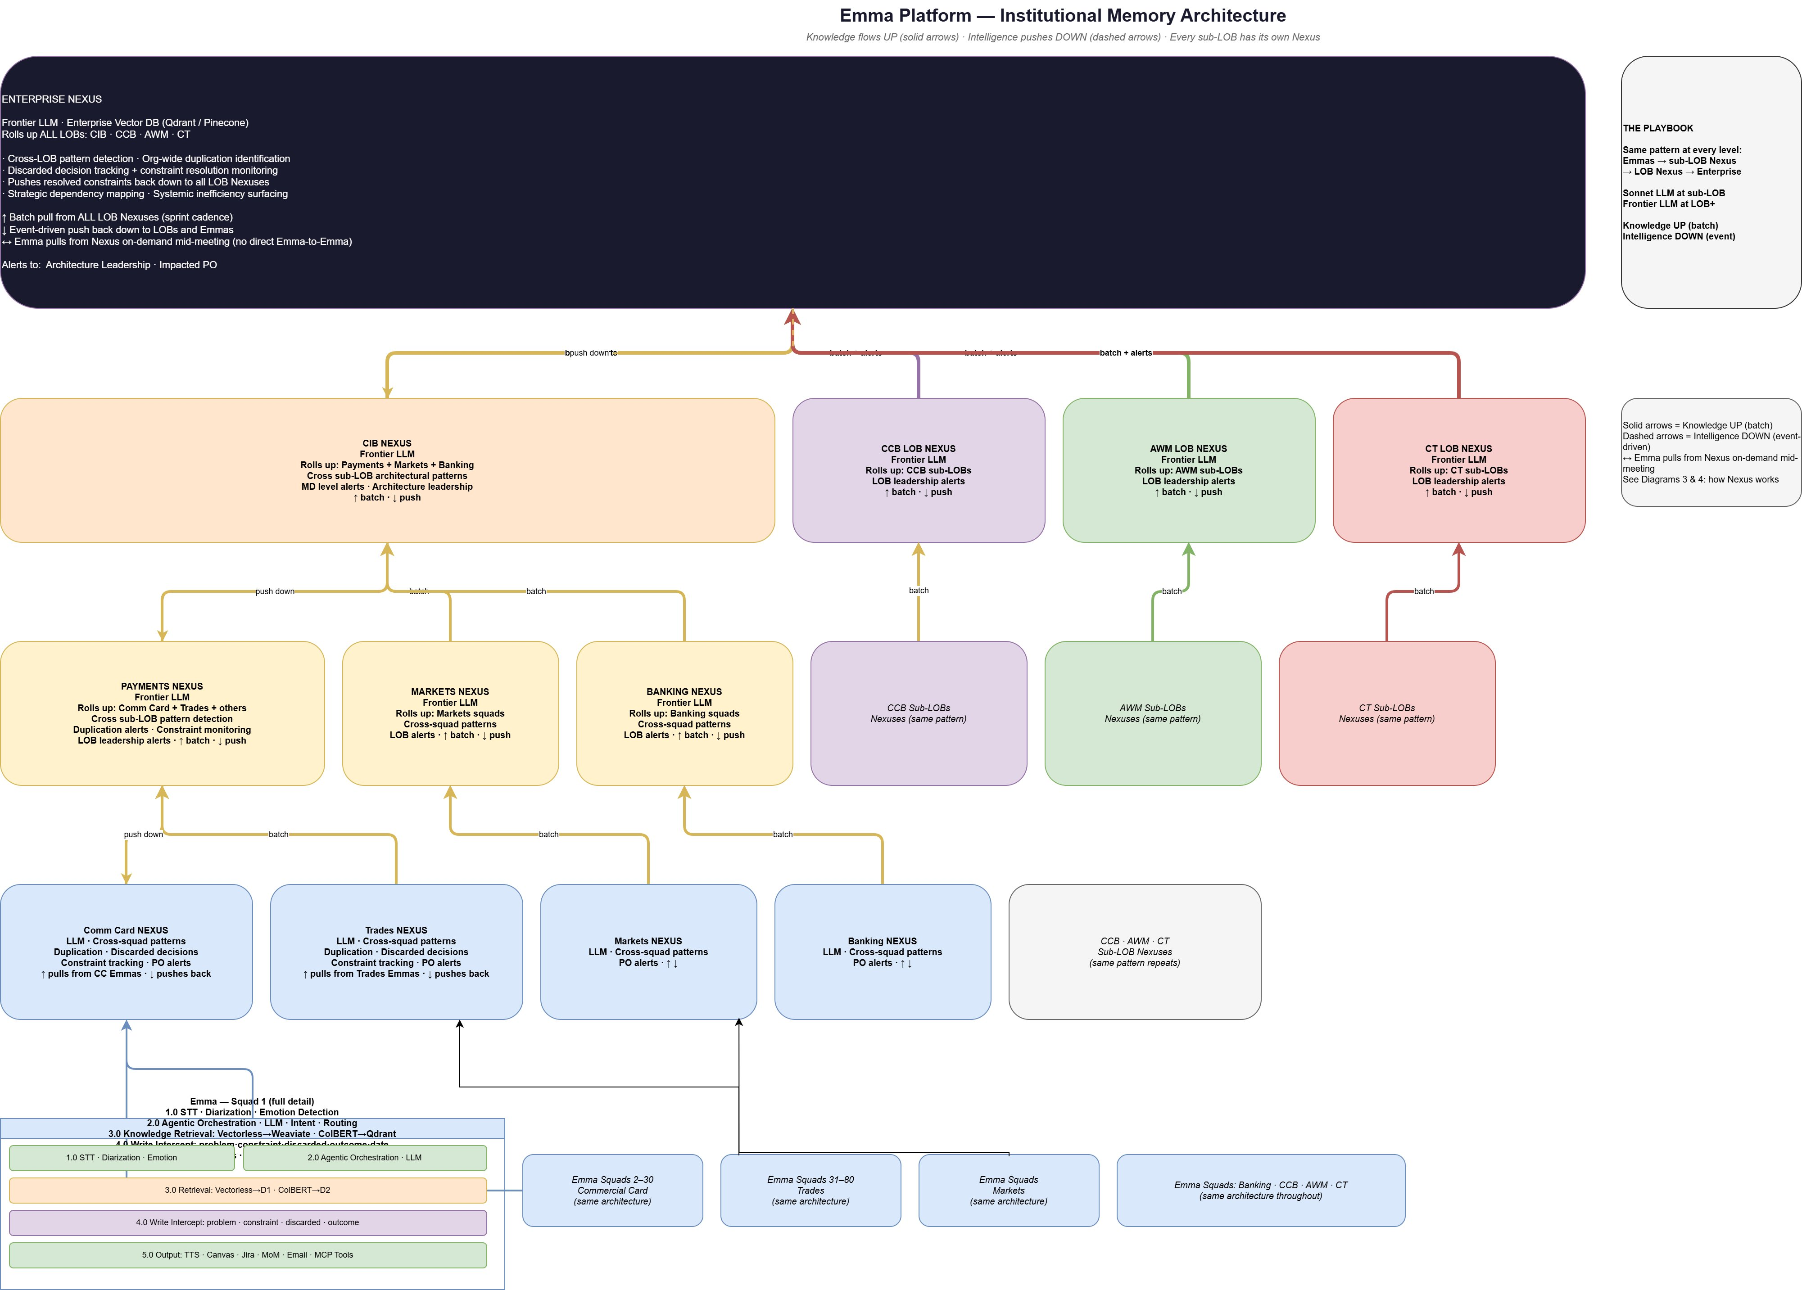

Components
- Squad Emma (per squad) — the full session-lifecycle system described in Diagram 1. Every scrum squad across the organization has its own Emma. Each squad Emma operates with isolated local memory (D1, D2, D3) and is the sole interface through which that squad's knowledge is captured and retrieved.
- Sub-LOB Nexus (e.g., Commercial Card Nexus, Trades Nexus, Markets Nexus, Banking Nexus) — aggregates structured knowledge from all Emma squads within a sub-line of business. Runs cross-squad pattern detection — duplication, discarded-decision tracking, constraint monitoring — and fires alerts to impacted Product Owners. Uses an LLM (typically Sonnet-class at this level) for pattern reasoning. Batch pull from squad Emmas on a sprint cadence; event-driven push back down.
- LOB Nexus (e.g., Payments Nexus, CCB LOB Nexus, AWM LOB Nexus, CT LOB Nexus, CIB Nexus) — aggregates structured knowledge from sub-LOB Nexuses. Runs cross-sub-LOB architectural pattern detection and surfaces MD-level and architecture-leadership alerts. Uses Frontier LLM for broader reasoning scope.
- Enterprise Nexus — the top of the hierarchy. Rolls up all LOBs (CIB, CCB, AWM, CT). Runs org-wide cross-LOB pattern detection, identifies systemic inefficiencies, maps strategic dependencies, monitors discarded-decision resolution, and pushes resolved constraints back down to all LOB Nexuses. Alerts flow to architecture leadership and impacted Product Owners.
- Knowledge Flow (UP, batch, solid arrows) — structured knowledge objects flow upward from squads → sub-LOB → LOB → Enterprise on a batch cadence (typically per sprint). Each upward push is a compressed, tagged set of decisions, constraints, discarded approaches, and outcomes.
- Intelligence Flow (DOWN, event-driven, dashed arrows) — intelligence — alerts, recommendations, resolved constraints, architectural guidance — flows downward event-driven. When Nexus at any level detects something that impacts teams below, the push is immediate, not batched.
- Cross-Squad Mid-Meeting Pull (↔) — a Squad Emma can pull from Nexus on demand mid-meeting (F7) for cross-team prior art. No direct Emma-to-Emma communication exists — all cross-squad knowledge flows through the Nexus hierarchy.
- The Playbook (organization-level meta-pattern) — the same architectural pattern repeats at every level — Emmas feed sub-LOB Nexus, sub-LOB Nexus feeds LOB Nexus, LOB Nexus feeds Enterprise. Sonnet-class LLM at sub-LOB; Frontier LLM at LOB and above. Knowledge flows UP in batch; intelligence flows DOWN event-driven. The uniformity is intentional — one pattern scales from one squad to tens of thousands of employees.

Flow
Every squad operates its own Emma instance. Each squad Emma is architecturally identical — STT, diarization, emotion detection, orchestration, memory layer, Write Intercept, output layer — as described in Diagram 1. The squad's memory (D1, D2, D3) is isolated: Squad A's Emma cannot directly read from Squad B's Emma. This isolation is enforced both technically (separate memory stores per squad) and logically (Emma only exists during a session — when Squad B is not in a meeting, there is nothing to query). Cross-squad knowledge flow happens only through the Nexus hierarchy.
At each session close, every squad Emma pushes structured knowledge to its sub-LOB Nexus via F13. For example, all 30 squads within Commercial Card push into the Commercial Card Nexus. Commercial Card Nexus, Trades Nexus, Markets Nexus, and Banking Nexus together aggregate into the Payments Nexus at the LOB level. The CIB Nexus rolls up Payments, Markets, and Banking. CCB, AWM, and CT each have their own LOB Nexuses following the same pattern. All four LOB Nexuses roll up into the Enterprise Nexus at the top of the hierarchy.
Knowledge moves upward in batch. A Sub-LOB Nexus runs pattern detection nightly or at sprint cadence across the accumulated squad knowledge it has received. An LOB Nexus runs its own pattern detection across the sub-LOBs, typically on a longer cadence. Enterprise Nexus pulls batch from all LOB Nexuses at an even longer cadence. At each level, the scope widens — more squads, more LOBs, more accumulated knowledge — but the algorithm and architecture are the same.
Intelligence moves downward event-driven. When Enterprise Nexus detects an org-wide duplication pattern or a resolved constraint, it pushes immediately to impacted LOB Nexuses, which in turn push to impacted sub-LOB Nexuses and Emmas. This is not batched — discoveries at the top of the hierarchy propagate as events so that teams can act on new information without waiting for the next sprint cycle.
A critical capability in this hierarchy is the mid-meeting cross-squad pull. When a squad Emma is in a live session and a participant raises a topic with cross-squad relevance — "has any other team built phone validation?" — the squad Emma issues an F7 pull to its sub-LOB Nexus. The Nexus returns cross-squad prior art in 2-3 seconds. Emma incorporates the finding into her spoken response during the same meeting. No direct Emma-to-Emma communication exists; all cross-squad interaction goes through the Nexus hierarchy. This is a necessary architectural property — Emmas only exist during sessions, so cross-squad memory must live in a continuously-available layer. That layer is Nexus.
The uniformity of the pattern across levels is the foundation of the system's scalability. A new squad onboarded tomorrow plugs into the same architecture as any existing squad. A new LOB integrated into the enterprise follows the same Nexus pattern. The architecture scales from one squad to the entire organization without structural change.

Diagram 3 — Nexus Cross-Squad Intelligence (Batch Mode)
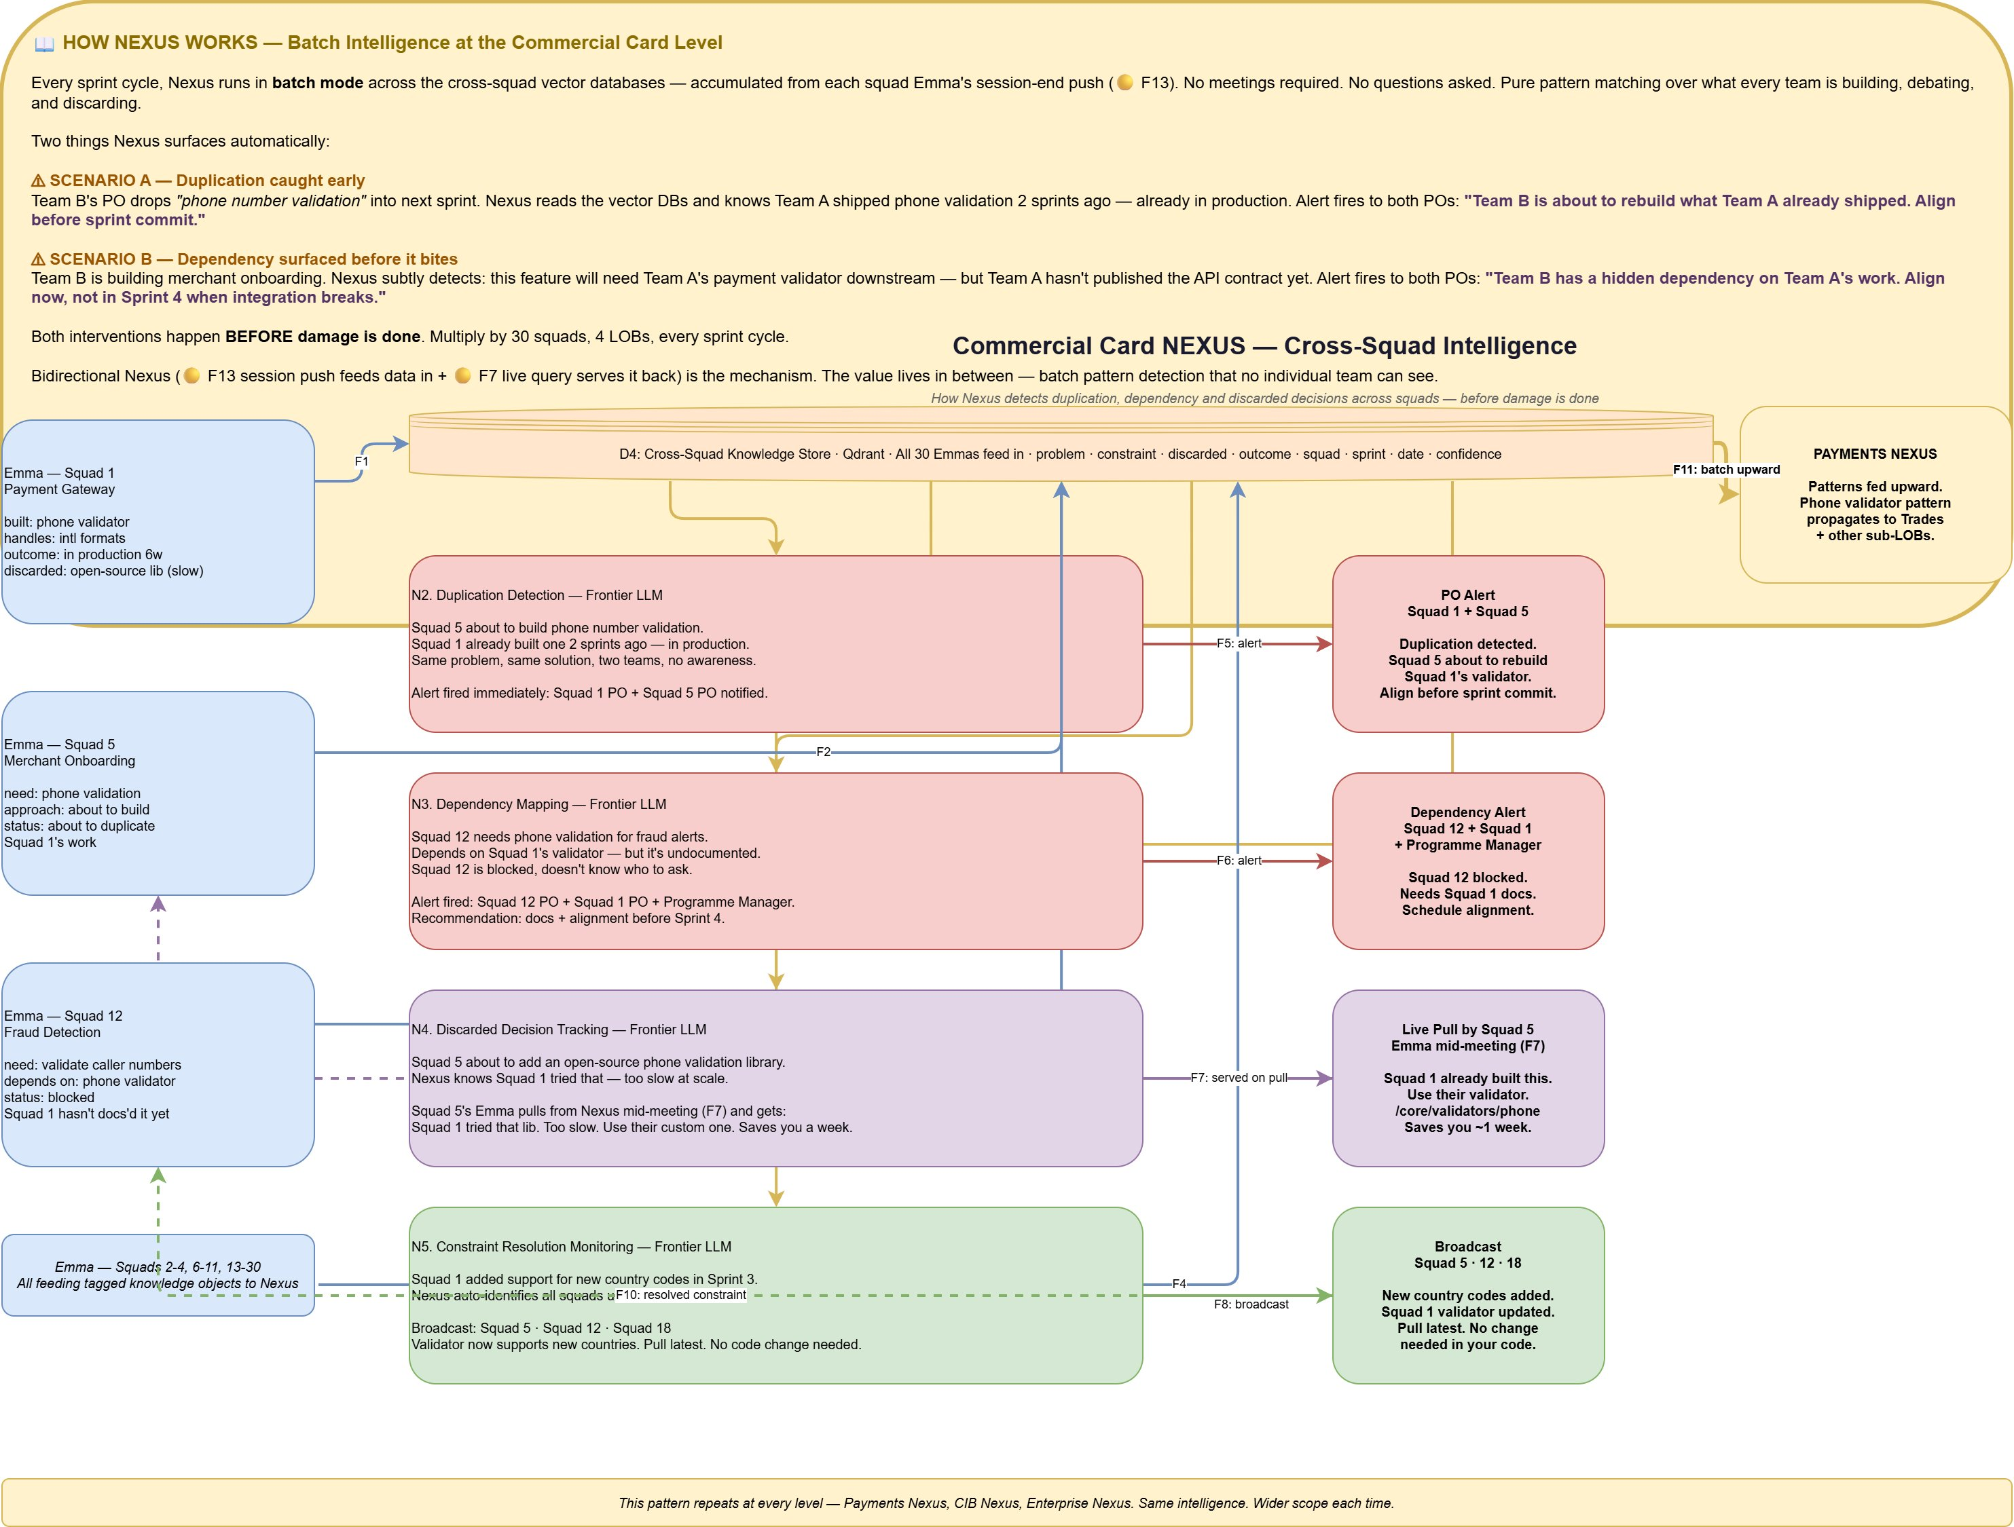

Components
- D4 — Cross-Squad Knowledge Store — a vector database (Qdrant, OpenSearch, or equivalent) that aggregates all structured knowledge objects pushed by every squad Emma at session close. Each object carries the full metadata set — type (problem, constraint, discarded, outcome), feature, squad, sprint, date, confidence. This is the substrate across which Nexus runs pattern detection.
- Duplication Detection (N2) — a Frontier-LLM-driven pattern matcher that identifies when two or more squads are building — or about to build — the same feature. Fires immediate PO Alerts to the impacted squads.
- Dependency Mapping (N3) — a Frontier-LLM-driven pattern matcher that identifies hidden cross-squad dependencies — e.g., Squad 12 is building something that depends on Squad 1's undocumented validator. Fires alerts to the impacted POs and the program manager, recommending documentation and alignment before integration breaks.
- Discarded Decision Tracking (N4) — a Frontier-LLM-driven pattern matcher that tracks approaches squads have tried and discarded. When another squad is about to try the same approach, Nexus serves the discarded decision back on an F7 pull mid-meeting: "Squad 1 tried that library — too slow at scale. Use their custom one. Saves you a week."
- Constraint Resolution Monitoring (N5) — a Frontier-LLM-driven pattern matcher that tracks constraints introduced in one squad's context and monitors when they get resolved. When a constraint is resolved in one squad — e.g., Squad 1 adds support for new country codes — Nexus auto-identifies all squads affected by the old constraint and broadcasts the resolution.
- PO Alert Dispatcher — asynchronous notification layer for duplication, dependency, and discarded-decision alerts. Delivered via email, team dashboards, or Teams/Slack channels to impacted POs.
- F7: Served on Pull — discarded-decision and cross-squad prior-art findings served on demand to Emma during a live meeting within 2-3 seconds.
- F11: Batch Upward — higher-level patterns identified at the Commercial Card Nexus feed upward into the Payments Nexus (and on to CIB, Enterprise) in batch, so that cross-sub-LOB patterns can be detected at the next level.

Flow
Nexus does not run continuously. It operates in two distinct modes — batch (described here) and on-demand query (described in Diagram 4) — and is otherwise idle.
Every sprint cycle, Nexus runs in batch mode across the Cross-Squad Knowledge Store (D4) — accumulated from each squad Emma's session-end push (F13). No meetings required, no questions asked: pure pattern matching over what every team in the sub-LOB is building, debating, and discarding.
Consider the Commercial Card Nexus in action. Squad 1 has been building a phone number validator. At session end, its Emma pushed structured objects to Nexus: built: phone validator; handles: intl formats; outcome: in production 6 weeks; discarded: open-source lib (too slow). Squad 5 is about to start merchant onboarding and has identified a need for phone number validation. At session end, its Emma pushed: need: phone validation; approach: about to build; status: about to duplicate Squad 1's work. The Duplication Detection component (N2) reads both objects, recognizes the pattern, and fires an immediate PO Alert to both squads' Product Owners: "Team B is about to rebuild what Team A already shipped. Align before sprint commit."
Meanwhile, Squad 12 is building fraud detection and has a need to validate caller phone numbers. Its dependency on Squad 1's validator is present in Squad 12's D2 objects — but Squad 1 has not yet documented the validator. The Dependency Mapping component (N3) detects that Squad 12 is blocked, doesn't know where to get the validator, and Squad 1 hasn't exposed it. Alert fires to Squad 12 PO, Squad 1 PO, and the program manager with a recommendation: "Squad 12 has a hidden dependency on Squad 1's work. Align now, not in Sprint 4 when integration breaks."
Discarded Decision Tracking (N4) adds another layer. Squad 5 is discussing in a live session whether to add an open-source phone validation library. Squad 5's Emma issues an F7 pull to Nexus. Nexus — which already knows from Squad 1's prior session push that the open-source library was tried and discarded as too slow at scale — serves the finding back to Squad 5's Emma mid-meeting: "Squad 1 tried that library. Too slow. Use their custom one at /core/validators/phone. Saves you about a week." Emma relays this in her spoken response. Squad 5 avoids the dead end.
Constraint Resolution Monitoring (N5) handles the resolution side. When Squad 1 adds support for new country codes in Sprint 3 — improving the validator — that resolution is in Squad 1's session push. Nexus auto-identifies all squads that previously had a constraint tied to the missing country codes and broadcasts the resolution to Squad 5, Squad 12, Squad 18, and any others: "New country codes added. Squad 1 validator updated. Pull latest. No change needed in your code."
All of this happens before damage is done — before the sprint commits the duplication, before the integration breaks, before another team wastes a week on a dead-end library. Multiply by 30 squads, 4 LOBs, every sprint cycle. At the same time, the patterns Nexus detects at Commercial Card level feed upward via F11 batch into the Payments Nexus, where cross-sub-LOB patterns become visible at the next scope up. The same pattern repeats at every level — Payments Nexus, CIB Nexus, Enterprise Nexus — each operating the same intelligence loop over a wider aperture of accumulated knowledge.
Bidirectional Nexus — 🟡 F13 session push feeding data in, 🟡 F7 live query serving it back out — is the mechanism. The value lives in between: batch pattern detection across cross-squad memory that no individual team can see from its own vantage point.

Diagram 4 — Nexus Architecture (How It Works Internally)
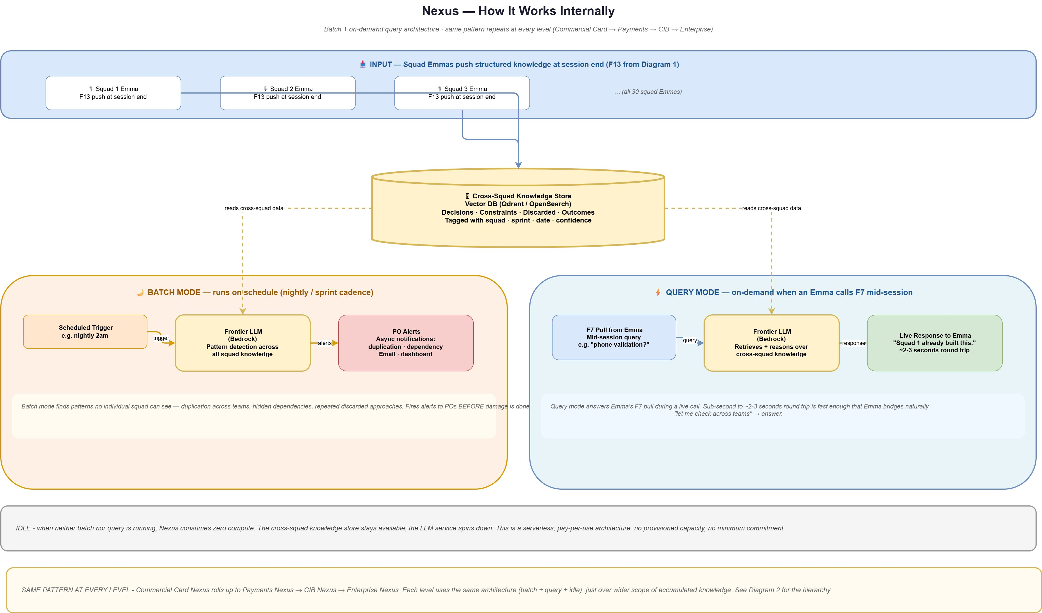

Components
- Input — Squad Emma F13 Pushes — at session end, each squad Emma pushes a batch of structured knowledge objects (decisions, constraints, discarded approaches, outcomes with full metadata) into the Cross-Squad Knowledge Store.
- Cross-Squad Knowledge Store — a vector database (Qdrant, OpenSearch, or equivalent) that holds the accumulated knowledge from all squads in the scope of this Nexus level. Always available; decoupled from compute.
- Batch Mode — Scheduled Trigger — fires on a defined cadence (e.g., nightly at 2am, or end-of-sprint). Triggers the batch analysis cycle.
- Batch Mode — Frontier LLM (Pattern Detection) — spins up on trigger; reads the Cross-Squad Knowledge Store; runs pattern detection (duplication, dependency, discarded-decision, constraint resolution) across the full accumulated data set. Hosted on AWS Bedrock or equivalent enterprise gateway.
- Batch Mode — PO Alerts — asynchronous notifications dispatched to impacted POs and program managers via email and dashboards. Delivery is not time-critical — findings arrive before the next sprint commit.
- Query Mode — F7 Pull from Emma — mid-session query from a squad Emma. Triggers on demand; e.g., "phone validation?".
- Query Mode — Frontier LLM (Retrieval + Reasoning) — retrieves relevant objects from the Cross-Squad Knowledge Store and reasons over them to produce a response. Kept warm via provisioned concurrency or low-idle-timeout warm pool so response is sub-second to 2-3 seconds.
- Query Mode — Live Response — returned to Emma in 2-3 seconds round trip. Fast enough that Emma bridges naturally with "let me check across teams..." in her spoken response.
- Idle State — when neither batch nor query is running, the Nexus LLM service spins down; the Cross-Squad Knowledge Store stays available but consumes only its own storage cost. This is a serverless, pay-per-use architecture — no provisioned capacity, no minimum commitment. Enterprise cost scales with usage, not with scale.

Flow
Nexus is an event-driven service with three states: batch, query, and idle. Input flows in continuously as squad Emmas end their sessions and F13-push structured knowledge into the Cross-Squad Knowledge Store. This store is always available; it is the only component that carries ongoing cost in the Nexus architecture, and that cost is storage, not compute.
The batch mode runs on a scheduled trigger — nightly or at sprint cadence depending on the level. When the trigger fires, the Frontier LLM service spins up, reads the Cross-Squad Knowledge Store, and runs pattern detection across the accumulated cross-squad data. The four pattern types — duplication, dependency, discarded decision, and constraint resolution — run against all squad pushes since the last cycle. When a pattern is detected, the PO Alert Dispatcher dispatches asynchronous notifications to impacted Product Owners and program managers: "Squad 5 about to duplicate Squad 1's work — align before sprint commit." These alerts are not time-critical in the millisecond sense — they need to arrive before the impacted sprint commits, not within seconds of the push that triggered detection.
The query mode runs on demand. When a squad Emma is in a live session and the Orchestrator issues an F7 pull, the Nexus query path activates. A Frontier LLM retrieves relevant objects from the Cross-Squad Knowledge Store, reasons over them in the context of Emma's specific query, and returns a response. Round-trip latency is 2-3 seconds — fast enough that Emma bridges naturally: "let me check across teams…" while the query completes, then delivers the finding in her spoken response. To achieve this latency, the query-path LLM service is kept warm — either via provisioned concurrency on AWS Bedrock or via a small always-warm pool that absorbs query spikes without cold-start penalties.
When neither batch nor query is running, Nexus is idle. The LLM service spins down. The Cross-Squad Knowledge Store continues to store data but does not consume compute. This is a serverless, pay-per-use architecture — no provisioned capacity, no minimum commitment. Enterprise cost scales with actual usage, which for a well-tuned system is batch cadence plus per-squad-meeting query volume. The economics hold at scale because every additional squad adds a small marginal query load but no fixed cost.
The same architecture repeats at every level of the Nexus hierarchy. Commercial Card Nexus uses this exact batch-plus-query-plus-idle pattern across its 30 squads. Payments Nexus uses the same pattern across all its sub-LOB Nexuses. CIB Nexus uses the same pattern across Payments, Markets, and Banking Nexuses. Enterprise Nexus uses the same pattern across CIB, CCB, AWM, and CT. The only thing that changes across levels is the scope of the data — the architecture is identical.

Worked Examples — End-to-End Scenarios
The following examples trace specific scenarios through the full system, showing how components interact to produce observable outcomes. Each example draws on the architecture described in Diagrams 1 through 4.

Example 1 — Mid-Meeting Query with Canvas Explanation
A developer in a backlog refinement session asks: "Hey Emma, walk me through our fraud alert flow."
The Wake Word Detector identifies the invocation. STT transcribes the utterance. Diarization labels the developer by name via SSO. The Orchestrator recognizes a direct query requiring architectural explanation. Hybrid retrieval runs against D1 (where the fraud alert architecture document is indexed via vectorless/PageIndex retrieval) and D2 (where prior team decisions about the fraud flow are stored). Retrieved context plus the question flow to the Frontier LLM, which generates a response that combines narrative explanation with a diagram specification. The Canvas Renderer draws the fraud alert flow in real time as Emma speaks. Simultaneously, a link is dispatched via Zoom chat. Three of five participants click the link, SSO-authenticate, and the diagram appears on their screens. The Participant Engagement Tracker notes that two participants have not opened the visual. Emma adjusts her explanation pace and, after completing the main walkthrough, asks: "Rajesh, Priya — I see you haven't opened the diagram. Want me to re-summarize or should I move on?" The developers who did not open it confirm they have enough. Emma continues. The entire exchange — question asked, decision, retrieved context, and response — is written into D3 as indexed session memory.

Example 2 — Emotion-Adaptive Response (🟠 F3)
During sprint planning, a developer raises a concern about a proposed approach: "We've been over this three times already, it's never going to work, let's just do it the old way." The tone carries audible frustration.
The STT Module transcribes the sentence. The Voice Emotion Module, running in parallel on the same audio, extracts the emotional state: frustrated (0.78), resigned (0.65), valence: -0.4. The Orchestrator sees two signals from the same utterance — text content and emotion vector. The emotion vector triggers the F3 direct route to response generation, bypassing the full retrieval-plus-reasoning loop. Rather than generating a dense single-shot answer, Emma's response adapts: she slows her delivery, acknowledges the difficulty the team has been through ("I understand this has come up several times"), and walks through the alternatives step by step with concrete, distinct framing — "Let me try to separate the two concerns. First, the data-format constraint you raised in Sprint 11 is still active. Second, the latency issue is new in this sprint. They may have different solutions." The team re-engages with the problem. Write Intercept tags the emotional signal, the constraint that was raised, and the new decision trajectory — all written to D2 for future reference.

Example 3 — Cross-Squad Prior Art Pull (🟡 F7)
In a Merchant Onboarding squad (Squad 5) refinement session, the team discusses adding phone number validation to the onboarding flow: "We'll add a phone validator — should we use the open-source library or roll our own?"
The Orchestrator recognizes a topic with potential cross-squad relevance and issues an F7 pull to the Commercial Card Nexus. Nexus — which already holds Squad 1's session push indicating that Squad 1 built a phone validator six weeks ago AND tried and discarded the open-source library as too slow at scale — serves the finding back within 2 seconds. Squad 5's Emma incorporates the response into her spoken reply: "Actually, Squad 1 on Payment Gateway shipped a phone validator six weeks ago. It's in production at /core/validators/phone. They also tried the open-source library first — decided it was too slow. I'd suggest using their validator directly. Saves about a week, and you get the battle-tested version." The squad avoids both a duplicate build and a failed library choice. The exchange, and the decision to adopt Squad 1's validator, is written into D2 via the Write Intercept — with tags: outcome (adopted cross-squad solution), constraint (latency requirement), discarded (open-source lib), linked entity (Squad 1 validator at /core/validators/phone).

Example 4 — Playbook-Driven Proactive Engagement (Stand-Up)
A daily stand-up begins. The Playbook Engine recognizes the ceremony structure: each developer reports in turn, blockers are surfaced, dependencies mentioned. A developer reports: "I'm blocked on the Kafka partition issue — still haven't figured out why consumer 3 is getting duplicate messages."
The Playbook triggers the Orchestrator to proactively check. The Orchestrator queries D2 for prior Kafka-related issues on this squad (no prior matches) and issues an F7 pull to Nexus for cross-squad Kafka partition prior art. Nexus returns: Squad 3 (Trades) hit the same Kafka partition issue in Sprint 11; their fix is documented in their runbook; the issue was related to consumer group rebalance timing. Emma — proactively, without being addressed — speaks: "Quick note: Squad 3 on Trades hit the same issue in Sprint 11. Their fix is in the Trades runbook — it was consumer group rebalance timing. Want me to pull it up on Canvas?" The developer says yes. Emma renders the relevant portion of the runbook on the Canvas and dispatches the link. The blocker resolves in the next 20 minutes. The exchange is written to D2 as outcome (Kafka rebalance fix from Squad 3 applied) with linked entity to Squad 3's runbook — so a future squad with the same issue can be served from D2 locally without needing the Nexus round-trip.

What's Distinctive About This System
The individual technical components that Emma and Nexus use are, for the most part, available in the field today. Streaming speech-to-text, voice emotion detection, frontier LLMs, vector databases, retrieval-augmented generation, meeting participation bots, and enterprise SSO integration are all established technologies. The novelty of the system lies in how these components are combined and the capabilities that combination enables. Three architectural mechanisms are highlighted below for consideration; the determination of what is patentable is left to IP counsel.

Mechanism 1 — Emotion-Adaptive Response Routing (🟠 F3)
Voice-based emotion detection is not new. Using the detected emotion vector to route response generation directly — bypassing the full retrieval-plus-reasoning loop and changing the structure of the response itself based on the emotional state of the participant — is distinctive. Most systems that detect emotion log it as metadata. In this system, emotion is a control signal that changes how the reasoning pipeline executes: the response is delivered slower, broken into distinct steps, and structured for comprehension rather than density. This is integrated with the system's memory architecture — emotional context is captured and written to D2 alongside the decisions made under that emotional state, making it possible to reason about emotional dynamics across sprints.

Mechanism 2 — Structured Decision Capture via Write Intercept (🟣 F11/F12)
Meeting transcription is a solved problem. What distinguishes this system is the Write Intercept mechanism: during the meeting itself, the Orchestrator recognizes decision patterns in conversation and intercepts the content before persistence, classifying it into structured tags (problem, constraint, discarded, outcome) and enriching it with metadata (feature, sprint, squad, timestamp, reason, linked entities). The result is that memory compounds over time in a structured, retrievable form — not as a raw transcript that loses meaning, but as tagged knowledge objects that support semantic retrieval sprint over sprint. A decision made in Sprint 4 remains directly retrievable in Sprint 40 with its full context: what problem it addressed, what constraints it was bounded by, what approaches were discarded, what the actual outcome was. This structural capture during the live meeting — not as a post-meeting summarization step — is distinctive.

Mechanism 3 — Bidirectional Cross-Squad Memory (🟡 F7/F13)
Cross-team knowledge sharing has been addressed by enterprise search, documentation platforms, and communities of practice. What distinguishes this system is the bidirectional, architecturally-integrated cross-squad memory loop. Each squad Emma pushes structured knowledge to the cross-squad layer (Nexus) at session close (F13). Each squad Emma pulls from Nexus during live sessions for cross-squad prior art (F7) with 2-3 second round-trip latency. Between those two directions, Nexus runs batch pattern detection across all accumulated squad knowledge — duplication, dependency, discarded decision, constraint resolution — and fires asynchronous alerts to impacted Product Owners before sprint commits lock in duplicated or conflicting work. The architectural uniformity of the Nexus layer at every level (squad → sub-LOB → LOB → enterprise) means the same mechanism produces cross-organizational intelligence at arbitrary scale without structural change. Critically, Emmas do not communicate directly with each other — they cannot, because Emma only exists during a session — so the continuously-available Nexus layer is the only path through which cross-squad memory flows. This necessity becomes an architectural strength: all cross-squad knowledge is routed through a consistent, tagged, queryable layer rather than through ad-hoc channels.

The Combined System
Taken together — voice-first active meeting participation, ceremony-aware proactive engagement driven by the Playbook Engine, structured decision capture via Write Intercept, emotion-adaptive response routing, compounding per-squad memory in a three-store architecture (D1 static / D2 dynamic / D3 session), bidirectional cross-squad memory through Nexus, and the uniform architectural pattern that repeats from squad to enterprise — these components form a system whose combined behavior is distinct from any individual component or combination of components available today. The specific determination of claim structure and scope is for IP counsel to assess.

