Emma & Nexus
Voice-First Agentic Knowledge Management System
Technical Write-Up

Inventor: Gaurav Ahuja
JPMorgan Chase — Commercial Card
April 2026

Summary
Emma is a voice-first agentic assistant with full reasoning capabilities, designed to actively participate in team meetings. She helps with backlog grooming, refines stories, reasons through decisions alongside the team, and unblocks developers in real time. During every session she captures structured knowledge — decisions, constraints, discarded approaches, and outcomes — and writes it to persistent memory with full metadata. As a result, her memory compounds sprint over sprint, and she gets smarter with every meeting she participates in.
At scale, when every squad has its own Emma, a layer called Nexus sits above them. Nexus reads across all squad memories, detects duplication and hidden dependencies before they become problems, and alerts Product Owners. The same architecture repeats at every level of the organization — sub-LOB Nexus rolls up into LOB Nexus, into Enterprise Nexus — producing cross-organizational intelligence no individual team can generate from its own vantage point.

The Problem This System Addresses
A senior developer leaves a Commercial Card squad after six years. Her replacement takes four months to reach similar productivity — and during those four months, three senior developers on the squad lose roughly thirty percent of their time to shadow-mentoring. Meanwhile, a developer in Singapore at 11pm is blocked on a merchant validation question; the Product Owner in London will not be online for another seven hours, and the answer exists somewhere in a Slack thread nobody can find. In an adjacent sub-LOB entirely, two squads are independently building the same phone number validation service — the duplication will surface in Sprint 4 when integration breaks, by which point both teams have committed a quarter of work. A fourth squad in the same line of business is about to adopt an open-source library that a Payments squad discarded six months ago as too slow at scale; the prior decision exists in someone's head but nowhere searchable. Across all four squads, Product Owners spend refinement sessions re-answering questions they already answered last sprint, because nobody wrote down the reasoning behind the original decisions.
Taken together, these scenes describe how knowledge actually flows in large engineering organizations today: captured by accident, retrieved by luck, lost by design. Existing tools — Confluence, Jira, chat threads, meeting transcripts, generic chatbots — each address a version of the problem, but none captures decisions as they happen, makes them retrievable with full context across sprints, or surfaces patterns across teams. Confluence depends on someone having time to write. Jira tracks tasks, not the reasoning behind them. Transcripts capture words, not meaning. Chat threads are unsearchable at scale. Generic chatbots have no domain knowledge and no memory across sessions.
The scale compounds the problem. One squad forgetting a decision is a nuisance. Thirty squads within a sub-line of business unknowingly duplicating each other's work — or failing to see dependencies between each other — is measurable cost. Multiply across an enterprise with hundreds of squads across multiple lines of business, and the aggregate cost is measured in quarters of lost delivery and strategic decisions made without access to the knowledge that should have informed them. This is not a documentation problem. It is an institutional memory problem, and no existing tool solves it at this scale.
This document illustrates the problem and the architecture that addresses it using the context of a large multi-line-of-business financial institution with distributed engineering teams, because that is the environment in which the system was developed and where its effects are most visible. The architecture itself is general: any large organization with hundreds of teams, recurring structured processes, and the cost of lost institutional knowledge at scale faces the same problem in the same shape. The system described in the following sections is designed to address it at any scope where it becomes costly.

Diagram 1 — Session Lifecycle Architecture
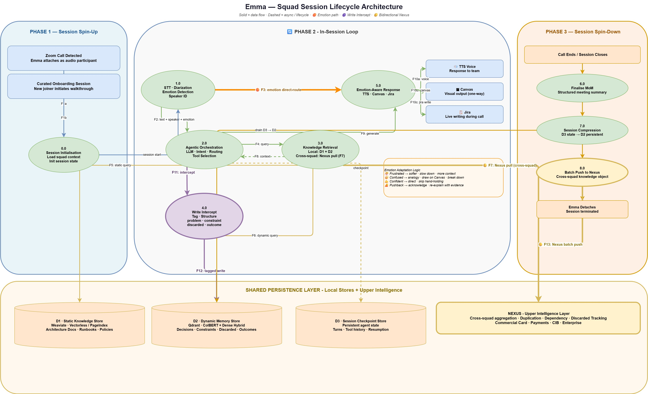

Components

Session Triggers
- Meeting Webhook — a Zoom or Teams meeting starts, a webhook fires, and Emma spins up and attaches to the call as an audio participant.
- Curated Session Trigger — a pre-scheduled session initiated without a live meeting. Use cases include new-joiner onboarding (Emma walks the user through project history, architecture decisions, and prior sprints on demand), knowledge transfer sessions when a team member is leaving (Emma sits in with the departing member and the squad, capturing their knowledge structurally into team memory), and ad-hoc learning sessions where a developer needs to understand a specific area of the codebase or domain.

Identity & Participant Awareness
- Enterprise SSO Integration — participant identity resolved via corporate single sign-on (Azure AD, Okta, or equivalent). Emma knows which humans are in the meeting by identity — their name, role, squad affiliation, and prior interaction history with her.
- Participant Engagement Tracker — monitors meeting-platform signals (chat link clicks, reactions, screen-share state) to track who is actively engaged with what Emma is presenting.

Input Layer
- SOTA Speech-to-Text (STT) Module — state-of-the-art streaming ASR converting meeting audio to text in real time. Enterprise deployment: AWS Transcribe, NVIDIA Parakeet, Azure Speech, or equivalent. Runs continuously — Emma is always listening from the moment she spins up.
- Diarization Module — identifies and labels which participant produced each utterance; paired with SSO so speakers are known by identity, not voice alone.
- SOTA Voice Emotion Module — a separate model running in parallel on the same audio stream; extracts an emotional state vector — categorical labels such as frustrated, confused, confident, neutral, and dimensional values for valence and arousal. Decoupled from STT.
- Wake Word Detection — detects "Hey Emma" invocations. Emma is already listening from spin-up; the wake word switches her from ambient capture mode into direct-response mode.
- Barge-In Handling — allows any participant to interrupt Emma's speech output; cancels in-flight TTS and returns her to listening state without disrupting the meeting.

Reasoning Layer
- Orchestrator — central decision layer (agent framework such as LangGraph); routes utterances and events to retrieval, reasoning, decision-capture, emotion-adaptive, proactive, tool-action, escalation, or cross-squad pathways based on content, signal, and playbook rules.
- Frontier LLM — reasoning engine for complex queries. Enterprise deployment: Claude Opus via AWS Bedrock or equivalent frontier-class model.
- Playbook Engine — a rule-based controller that encodes the structure of recurring team processes as patterns the Orchestrator follows. For each process type the engine defines (a) what roles participate, (b) what signals mark the start, progression, and completion of each phase, (c) what artifacts are typically produced, and (d) what actions Emma should proactively take at defined triggers. Initial implementation encodes agile ceremonies — daily stand-up, backlog refinement, sprint planning, review, retrospective. The mechanism is extensible: any recurring structured process with known participants, phases, and artifacts can be encoded, including architecture reviews, incident post-mortems, and research review cycles.

Memory Layer
- D1 — Static Knowledge Store — persistent vector database for long-form structured reference material (architecture documents, runbooks, policies, coding standards). Uses structure-aware retrieval (PageIndex / vectorless) to preserve document context across long documents.
- D2 — Dynamic Memory Store — persistent vector database for compounding team decisions. Stores tagged objects with structured metadata: type (problem, constraint, discarded, outcome), feature, sprint, squad, timestamp, reason, linked entities. Hybrid retrieval (dense embeddings + ColBERT).
- D3 — Session Checkpoint Store — persistent agent state for the active session only. All STT output streams into D3 as indexed session memory — tagged with speaker, emotion, and timestamp — rather than a linear transcript fed into the LLM. The Orchestrator queries D3 via retrieval when reasoning, so only relevant session history is included in each reasoning turn. This keeps the LLM context window manageable even for long meetings. Drained to D2 via compression on session close.
- Write Intercept Module — intercepts orchestrator output and tool action results before persistence; classifies content into structured tags (problem, constraint, discarded, outcome); enriches with metadata (feature, sprint, squad, timestamp, reason, linked entities); writes the tagged object to D2.

Output Layer
- SOTA Text-to-Speech (TTS) Module — state-of-the-art voice synthesis. Enterprise deployment: AWS Polly, ElevenLabs, Azure TTS, or equivalent. Emotion-adaptive delivery.
- Canvas Renderer — a first-class explanatory capability. Emma does not just describe architecture in words — she draws it. The Canvas Renderer produces architecture diagrams, flow charts, and explanatory visuals in real time, synchronized with Emma's spoken explanation.
- Multi-Modal Link Dispatch + SSO-Authenticated Canvas Access — when Emma uses the Canvas, she dispatches a link to each participant via the meeting platform's chat (Zoom chat, Teams chat). Participants click the link, authenticate via enterprise SSO, and the canvas loads on their device. Because access is SSO-authenticated, Emma knows by identity who has opened the visual and who has not, and can adapt her explanation accordingly.
- Jira Integration — writes acceptance criteria, tickets, and MoM entries back to Jira based on in-meeting decisions.
- MCP Tools Layer — integration surface through which Emma executes actions in external systems. Built on Model Context Protocol for extensibility — new tools (test scenario reviewers, code review helpers, deployment automations, documentation writers) can be added as they become available without changing Emma's core. Tool invocations and their results flow back through the Orchestrator and Write Intercept, so Emma's actions become tagged team memory just like captured decisions.
- Escalation Dispatcher — when Emma's confidence on a query is below threshold, she provides a best-attempt answer AND simultaneously drafts an escalation to the Product Owner with full context. When the PO responds, the answer writes back to D2 — so the same question never escalates twice.

Cross-Squad Interface
- F7 Pull — Emma issues a live query to Nexus during an active session; receives cross-squad prior art within two to three seconds.
- F13 Push — at session close, Emma pushes structured knowledge objects to Nexus in batch for cross-squad intelligence (see Diagrams 2 and 4 for the Nexus architecture).

End-to-End
A session starts in one of two ways. In the common case, a Zoom or Teams meeting begins and the Meeting Webhook fires; Emma spins up and attaches as an audio participant. In the alternate case, a Curated Session Trigger initiates onboarding, knowledge-transfer, or learning sessions without a live meeting. Both paths converge at the same spin-up: Emma hydrates her session context from D1 (architecture, policies, reference material) and D2 (the team's decision history from prior meetings). Participant identity is resolved through Enterprise SSO Integration, so Emma knows by name who is in the meeting, their roles, and their prior interaction history.
From spin-up, Emma is always listening. The STT Module, Diarization Module, and Voice Emotion Module run in parallel on the continuous audio stream, producing a unified utterance object — text, speaker, and emotion — for every spoken segment. Utterances stream into D3 as indexed session memory, and in parallel into the Orchestrator, which inspects each signal and routes it down different paths depending on content and context. Wake Word Detection switches Emma into direct-response mode when a participant addresses her directly. Barge-In Handling allows any participant to interrupt Emma's speech without disrupting the meeting.
Direct questions trigger hybrid retrieval across D1 and D2 followed by Frontier LLM reasoning, with the response flowing to the TTS Module. Where visual explanation helps, the Canvas Renderer draws alongside Emma's speech and Multi-Modal Link Dispatch sends each participant a link; participants authenticate via Enterprise SSO and the Participant Engagement Tracker surfaces who has opened the visual. Substantive decisions made in conversation trigger the Write Intercept Module, which classifies them into structured tags with full metadata and writes them to D2. Cross-squad questions trigger an F7 Pull to Nexus, returning prior art within two to three seconds. Strong emotional signal routes directly to response generation via the F3 path, changing the structure of Emma's reply to match the participant's state. The Playbook Engine watches the conversation against encoded ceremony patterns (daily stand-up, refinement, planning) and prompts Emma to proactively engage at defined triggers — summarising, capturing acceptance criteria, or offering to create Jira tickets. Action paths invoke Jira Integration and the MCP Tools Layer to execute during the meeting itself, with outcomes flowing back through Write Intercept. Where confidence on an answer is low, the Escalation Dispatcher provides a best-attempt answer and drafts an escalation to the Product Owner in parallel.
When the meeting ends, D3 is compressed via Write Intercept into structured tagged knowledge objects and drained into D2 — giving the team permanent memory of what just happened. In parallel, a batch of those objects is pushed via F13 Push to Nexus for cross-squad availability. D3 is cleared. Emma detaches. The memory persists.

Flow
The End-to-End above describes the full system in motion. The subsections that follow describe each of the six primary routing paths in greater detail.

Path 1 — Direct Query (wake-word invocation)
When a participant says "Hey Emma, what's our fraud alert SLA?", Wake Word Detection identifies the invocation and the Orchestrator treats the follow-up as a direct query. Hybrid retrieval runs against D1 and D2; retrieved context plus the participant's question flows to the Frontier LLM; the response flows to the Output Layer. The TTS Module speaks the answer in Emma's voice. If visual explanation helps — "walk me through the payment flow" — the Canvas Renderer draws the diagram alongside her speech, synchronized in real time, and Multi-Modal Link Dispatch sends the link via chat. Participants authenticate via Enterprise SSO to view. Emma knows by identity who is viewing and adapts her pacing accordingly. If a participant interrupts mid-response, Barge-In Handling cancels the TTS cleanly and Emma returns to listening.

Path 2 — Ambient Decision Capture
Even when no one has said "Hey Emma," she is listening and reasoning over the conversation. When a substantive decision is made — "We'll use the custom phone validator, not the open-source one, too slow at scale" — the Orchestrator recognises the decision pattern and engages the Write Intercept Module. Write Intercept classifies the content into structured tags (discarded approach, outcome, constraint), enriches with metadata (feature: phone validation; sprint: 14; squad: Payment Gateway; reason: latency at scale; linked entity: merchant onboarding), and writes the tagged object to D2. Memory compounds silently in the background while the team keeps talking.

Path 3 — Cross-Squad Pull (F7)
When the team discusses something with potential cross-squad relevance — "has any other team built phone validation?" — the Orchestrator issues an F7 Pull to Nexus. Nexus returns prior art from other squads within two to three seconds: who built it, where it lives, what worked, what was discarded. Emma incorporates this into her spoken response in real time, bridging naturally with "let me check across teams…" while the round trip completes.

Path 4 — Emotion-Adaptive Response (F3)
When the Voice Emotion Module detects strong emotional signal — frustration, confusion — the emotion vector routes directly to response generation via the F3 path, bypassing the full retrieval-plus-reasoning loop. Emma's reply adapts in structure: she slows her pace, acknowledges the difficulty, and walks through the explanation step by step with distinct, concrete framing rather than delivering a dense single-shot answer. The goal is comprehension, not just comfort.

Path 5 — Playbook-Driven Proactive Engagement
Emma does not only respond to what the team asks. The Playbook Engine encodes the structure of recurring team processes — most commonly agile ceremonies — as patterns the Orchestrator follows. When a team begins a daily stand-up, the Playbook knows the expected structure: each developer in turn, blockers surfaced, dependencies mentioned. As the conversation progresses and a blocker is raised, the Playbook triggers Emma to proactively check D2 for similar prior blockers on the same team and issue an F7 Pull to Nexus for cross-squad prior work on the same issue. Emma surfaces findings in real time. Similarly, at the end of a refinement session, the Playbook triggers Emma to summarize agreed acceptance criteria and offer to write Jira tickets. The engine is extensible to any recurring structured process — architecture reviews, incident post-mortems, research review cycles — broadening Emma's applicability well beyond software engineering.

Path 6 — Action, Tools, and Escalation
When Emma's response calls for action beyond speaking — filing a Jira ticket, updating architecture documentation, pulling a code snippet — the Jira Integration and MCP Tools Layer execute the action during the meeting itself. The MCP Tools Layer is extensible; new agentic tools plug in without core changes, so Emma's capability grows over time. Tool invocations and their results flow back through the Write Intercept Module, so Emma's actions become tagged team memory alongside captured decisions. If confidence on an answer is below threshold, the Escalation Dispatcher provides a best-attempt answer AND simultaneously drafts an escalation to the Product Owner with full context. When the PO responds, the answer writes back to D2 — so the same question never escalates twice.

Phase 3 — Session Spin-Down
When the meeting ends, spin-down begins. The contents of D3 — the full session state, including every utterance, every tool call, every in-progress reasoning trace — are compressed via the Write Intercept Module into structured, tagged knowledge objects and drained into D2. This gives the team permanent memory of the session: every decision, every discarded approach, every outcome, cleanly tagged and retrievable. In parallel, a batch of those same objects is pushed upward via F13 Push to Nexus — the cross-squad intelligence layer described in Diagrams 2, 3, and 4. D3 is cleared. Emma detaches. The memory persists in D2 for the team's next meeting, and in Nexus for any other squad in the organization that needs it.

Diagram 2 — Platform Hierarchy & Institutional Memory Architecture
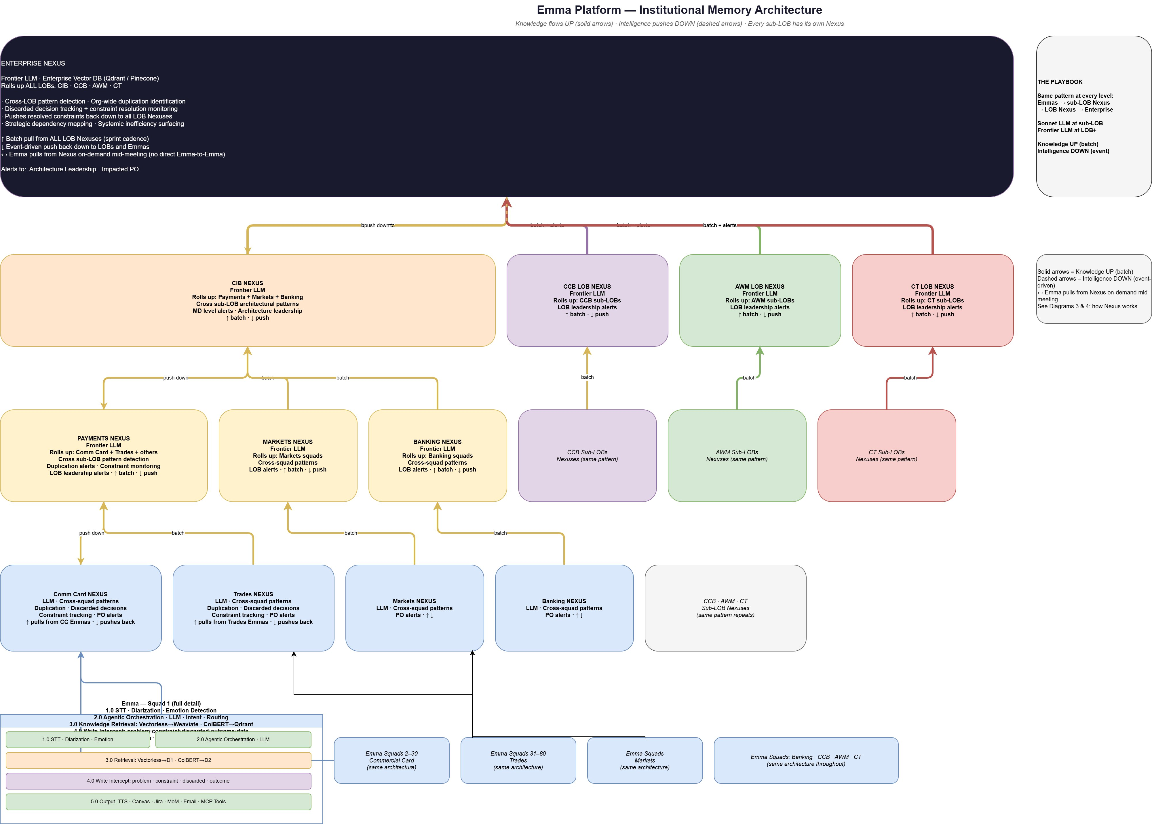

Components
- Squad Emma (per squad) — the full session-lifecycle system described in Diagram 1. Every scrum squad has its own Emma. Each squad Emma operates with isolated local memory (D1, D2, D3) and is the sole interface through which that squad's knowledge is captured and retrieved.
- Sub-LOB Nexus — aggregates structured knowledge from all Emma squads within a sub-line of business (for example, Commercial Card Nexus, Trades Nexus, Markets Nexus, Banking Nexus). Runs cross-squad pattern detection in batch mode on a scheduled cadence — duplication, discarded-decision tracking, constraint monitoring — and dispatches alerts asynchronously to impacted Product Owners. Uses an LLM at this level for pattern reasoning. Batch pull from squad Emmas on a sprint cadence; batch push of resolved patterns back down.
- LOB Nexus — aggregates structured knowledge from sub-LOB Nexuses (for example, Payments Nexus, CCB LOB Nexus, AWM LOB Nexus, CT LOB Nexus, CIB Nexus). Runs cross-sub-LOB architectural pattern detection and surfaces MD-level and architecture-leadership alerts. Uses a frontier-class LLM for broader reasoning scope.
- Enterprise Nexus — the top of the hierarchy. Rolls up all LOBs. Runs org-wide cross-LOB pattern detection, identifies systemic inefficiencies, maps strategic dependencies, monitors discarded-decision resolution, and pushes resolved constraints back down to all LOB Nexuses. Alerts flow to architecture leadership and impacted Product Owners.
- Knowledge Flow — Upward (batch, solid arrows) — structured knowledge objects flow upward from squads to sub-LOB to LOB to Enterprise on a batch cadence (typically per sprint at the lower levels, longer cadences at higher levels). Each upward push is a compressed, tagged set of decisions, constraints, discarded approaches, and outcomes.
- Intelligence Flow — Downward (batch detection, async dispatch) — intelligence — alerts, recommendations, resolved constraints, architectural guidance — is produced by batch pattern detection at each Nexus level. When a Nexus detects something that impacts teams below, the alerts are dispatched asynchronously as notifications (email, dashboard, Teams/Slack) rather than on a fixed schedule. Async dispatch ensures impacted Product Owners see the finding before the next sprint commit, without requiring live push infrastructure.
- Cross-Squad Mid-Meeting Pull — a Squad Emma can pull from Nexus on demand mid-meeting through the F7 path for cross-team prior art. No direct Emma-to-Emma communication exists — all cross-squad knowledge flows through the Nexus hierarchy.
- The Playbook (organization-level meta-pattern) — the same architectural pattern repeats at every level — Emmas feed sub-LOB Nexus, sub-LOB Nexus feeds LOB Nexus, LOB Nexus feeds Enterprise. Mid-tier LLM at sub-LOB; frontier LLM at LOB and above. Knowledge flows UP in batch; intelligence is detected in batch at each level and dispatched asynchronously. The uniformity is intentional — one pattern scales from one squad to tens of thousands of employees.

End-to-End
Every squad operates its own Emma instance. Each squad Emma is architecturally identical to the one described in Diagram 1. The squad's memory (D1, D2, D3) is isolated — Squad A's Emma cannot directly read from Squad B's Emma. This isolation is enforced both technically (separate memory stores per squad) and logically (Emma only exists during a session; when Squad B is not in a meeting, there is nothing to query). Cross-squad knowledge flow happens only through the Nexus hierarchy.
At each session close, every squad Emma pushes structured knowledge to its Sub-LOB Nexus via F13 Push. Sub-LOB Nexuses aggregate into LOB Nexus on a longer batch cadence, which in turn aggregate into Enterprise Nexus at the top. Knowledge moves upward in batch. Each Nexus runs its own batch pattern detection — the scope widens at each level but the algorithm and architecture are identical.
Intelligence moves downward as a result of batch detection cycles at each level. When Enterprise Nexus detects an org-wide duplication pattern or a resolved constraint, the Alert Dispatch delivers the finding asynchronously to impacted LOB Nexuses, sub-LOB Nexuses, and Emmas through email, dashboard, and messaging channels. Delivery is not scheduled and not real-time — it is triggered by detection and delivered as a notification, ensuring teams see the finding before the next sprint commit without requiring live push infrastructure.
A critical capability is the mid-meeting cross-squad pull. When a squad Emma is in a live session and a topic with cross-squad relevance arises, the squad Emma issues an F7 Pull to its Sub-LOB Nexus. The Nexus query path spins up the frontier LLM, retrieves relevant objects from the cross-squad knowledge store, and returns the finding within two to three seconds. Emma incorporates the result into her spoken response during the same meeting. No direct Emma-to-Emma communication exists; all cross-squad interaction goes through the Nexus hierarchy — a necessary architectural property, since Emmas only exist during sessions.
The uniformity of the pattern across levels is the foundation of the system's scalability. A new squad onboarded tomorrow plugs into the same architecture. A new LOB integrated into the enterprise follows the same Nexus pattern. The architecture scales from one squad to the entire organization without structural change.

Flow
The End-to-End above describes the hierarchy in motion. The following subsections describe each flow direction in more detail.

Knowledge Flow — Upward
Every squad Emma pushes to its Sub-LOB Nexus at session close via F13 Push. Sub-LOB Nexuses aggregate across their squads in batch; LOB Nexuses aggregate across sub-LOBs on a longer batch cadence; Enterprise Nexus aggregates across all LOBs on a longer cadence still. At each level the scope widens but the architecture is the same: structured tagged knowledge objects flow upward, batch detection runs over the accumulated data at that level, and cross-scope patterns emerge that no lower level could see.

Intelligence Flow — Async Dispatch Downward
Batch detection at each Nexus level produces findings — duplication, dependency, resolved constraint. Findings are dispatched asynchronously to impacted parties: Product Owners, program managers, architecture leadership. Delivery channels include email, dashboards, and Teams/Slack notifications. Delivery is not scheduled further after detection and is not live push — it is notification dispatch, arriving before impacted sprints lock in duplicated or conflicting work.

Cross-Squad Mid-Meeting Pull — F7
When a squad Emma is in a live session and issues an F7 Pull, the Nexus query path activates on demand. The frontier LLM at that Nexus retrieves relevant objects from the cross-squad knowledge store, reasons over them in the context of Emma's specific query, and returns a response within two to three seconds round trip. Emma bridges the round trip naturally in her spoken response. The query path is distinct from the batch path — both modes share the same underlying knowledge store but run as independent workflows. The query path and its latency characteristics are described in detail in Diagram 4.

Diagram 3 — Nexus Cross-Squad Intelligence (Batch Mode)
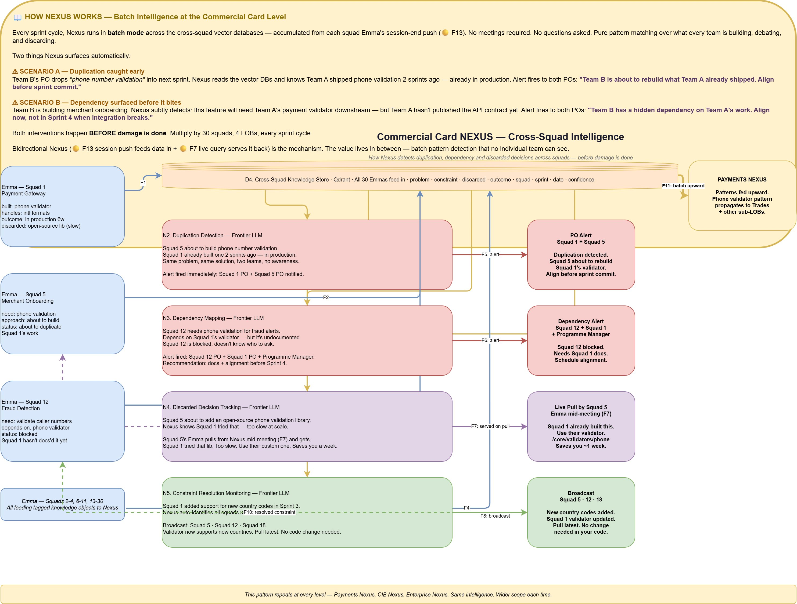

Components
- D4 — Cross-Squad Knowledge Store — a vector database (Qdrant, OpenSearch, or equivalent) that aggregates all structured knowledge objects pushed by every squad Emma at session close. Each object is atomic and self-contained — a single decision, constraint, discarded approach, or outcome with full metadata (type, feature, squad, sprint, date, confidence). Because the objects are already small and bounded, dense vector search with hybrid retrieval (ColBERT + dense) is the appropriate retrieval strategy; structure-aware retrieval is not needed at this layer.
- Duplication Detection (N2) — a frontier-LLM-driven pattern matcher that identifies when two or more squads are building — or about to build — the same feature. Produces PO Alerts dispatched asynchronously to the impacted squads.
- Dependency Mapping (N3) — a frontier-LLM-driven pattern matcher that identifies hidden cross-squad dependencies — for example, Squad 12 building something that depends on Squad 1's undocumented validator. Produces alerts to impacted POs and the program manager with recommendations for documentation and alignment.
- Discarded Decision Tracking (N4) — a frontier-LLM-driven pattern matcher that tracks approaches squads have tried and discarded. When another squad queries Nexus via F7 about the same approach, Discarded Decision Tracking serves the prior finding back on pull.
- Constraint Resolution Monitoring (N5) — a frontier-LLM-driven pattern matcher that tracks constraints introduced in one squad's context and detects when they are resolved. When a constraint is resolved — for example, Squad 1 adds support for new country codes — Nexus auto-identifies all squads previously affected by the constraint and broadcasts the resolution.
- PO Alert Dispatcher — asynchronous notification layer for duplication, dependency, and constraint-resolution alerts. Delivered via email, team dashboards, or Teams/Slack channels to impacted POs and program managers.
- F7 — Served on Pull — discarded-decision findings and cross-squad prior art served on demand to Emma during a live meeting within two to three seconds. The same knowledge store that feeds batch detection also serves live queries.
- F11 — Batch Upward — higher-level patterns identified at the Sub-LOB Nexus feed upward into the LOB Nexus (and on to Enterprise) in batch, so that cross-sub-LOB patterns become visible at the next level.

End-to-End
Nexus operates in two distinct modes: batch (described in this diagram) and on-demand query (described in Diagram 4). This diagram focuses on the batch mode — the scheduled pattern-detection cycles that produce the cross-squad intelligence alerts that protect impacted teams before damage is done.
Every sprint cycle, Nexus runs in batch mode across the Cross-Squad Knowledge Store (D4) — accumulated from each squad Emma's session-end F13 Push. No meetings required, no questions asked: pure pattern matching over what every team in the sub-LOB is building, debating, and discarding. Four pattern matchers run against the accumulated data — Duplication Detection, Dependency Mapping, Discarded Decision Tracking, and Constraint Resolution Monitoring. Each produces findings that are routed to the PO Alert Dispatcher, which delivers them asynchronously to impacted Product Owners and program managers through email, dashboards, and messaging channels. The same knowledge store is also available to the query path for F7 pulls from live sessions — when a squad Emma queries Nexus mid-meeting about an approach, Discarded Decision Tracking can serve the finding back on pull within two to three seconds. Patterns detected at this level feed upward via F11 Batch Upward to the LOB Nexus, where cross-sub-LOB patterns become visible at the next scope.

Flow
Consider the Commercial Card Nexus in action. Squad 1 has been building a phone number validator. At session end, its Emma pushed structured objects to Nexus: built: phone validator; handles: intl formats; outcome: in production 6 weeks; discarded: open-source library (too slow). Squad 5 is about to start merchant onboarding and has identified a need for phone number validation. At session end, its Emma pushed: need: phone validation; approach: about to build; status: about to duplicate Squad 1's work. The Duplication Detection component reads both objects, recognises the pattern, and produces a PO Alert routed to both squads' Product Owners through the Alert Dispatcher: "Team B is about to rebuild what Team A already shipped. Align before sprint commit."
Meanwhile, Squad 12 is building fraud detection and has a need to validate caller phone numbers. Its dependency on Squad 1's validator is present in Squad 12's D2 objects — but Squad 1 has not yet documented the validator. The Dependency Mapping component detects that Squad 12 is blocked and the dependency is undocumented. An alert is dispatched to Squad 12 PO, Squad 1 PO, and the program manager with a recommendation for documentation and alignment before Sprint 4.
Discarded Decision Tracking operates on the live path as well. Squad 5 is discussing in a live session whether to add an open-source phone validation library. Squad 5's Emma issues an F7 Pull. Discarded Decision Tracking — which already knows from Squad 1's prior session push that the open-source library was tried and discarded as too slow at scale — serves the finding back to Squad 5's Emma mid-meeting: "Squad 1 tried that library. Too slow at scale. Use their custom one at /core/validators/phone. Saves you about a week." Emma relays this in her spoken response. Squad 5 avoids the dead end.
When Squad 1 adds support for new country codes in Sprint 3 — improving the validator — that resolution is in Squad 1's session push. Constraint Resolution Monitoring auto-identifies all squads previously affected by the constraint and the Alert Dispatcher broadcasts the resolution to Squad 5, Squad 12, Squad 18, and any others: "New country codes added. Squad 1 validator updated. Pull latest. No change needed in your code."
All of this happens before damage is done — before the sprint commits the duplication, before the integration breaks, before another team wastes a week on a dead-end library. Multiply by thirty squads, four LOBs, every sprint cycle. At the same time, the patterns Nexus detects at Commercial Card level feed upward via F11 Batch Upward into the Payments Nexus, where cross-sub-LOB patterns become visible at the next scope up. The same pattern repeats at every level — Payments, CIB, Enterprise — each operating the same intelligence loop over a wider aperture of accumulated knowledge.
Bidirectional Nexus — F13 session push feeding data in, F7 live query serving it back out, with batch detection in between producing async alerts — is the mechanism. The value lives in between: batch pattern detection across cross-squad memory that no individual team can see from its own vantage point.

Diagram 4 — Nexus Architecture (How It Works Internally)
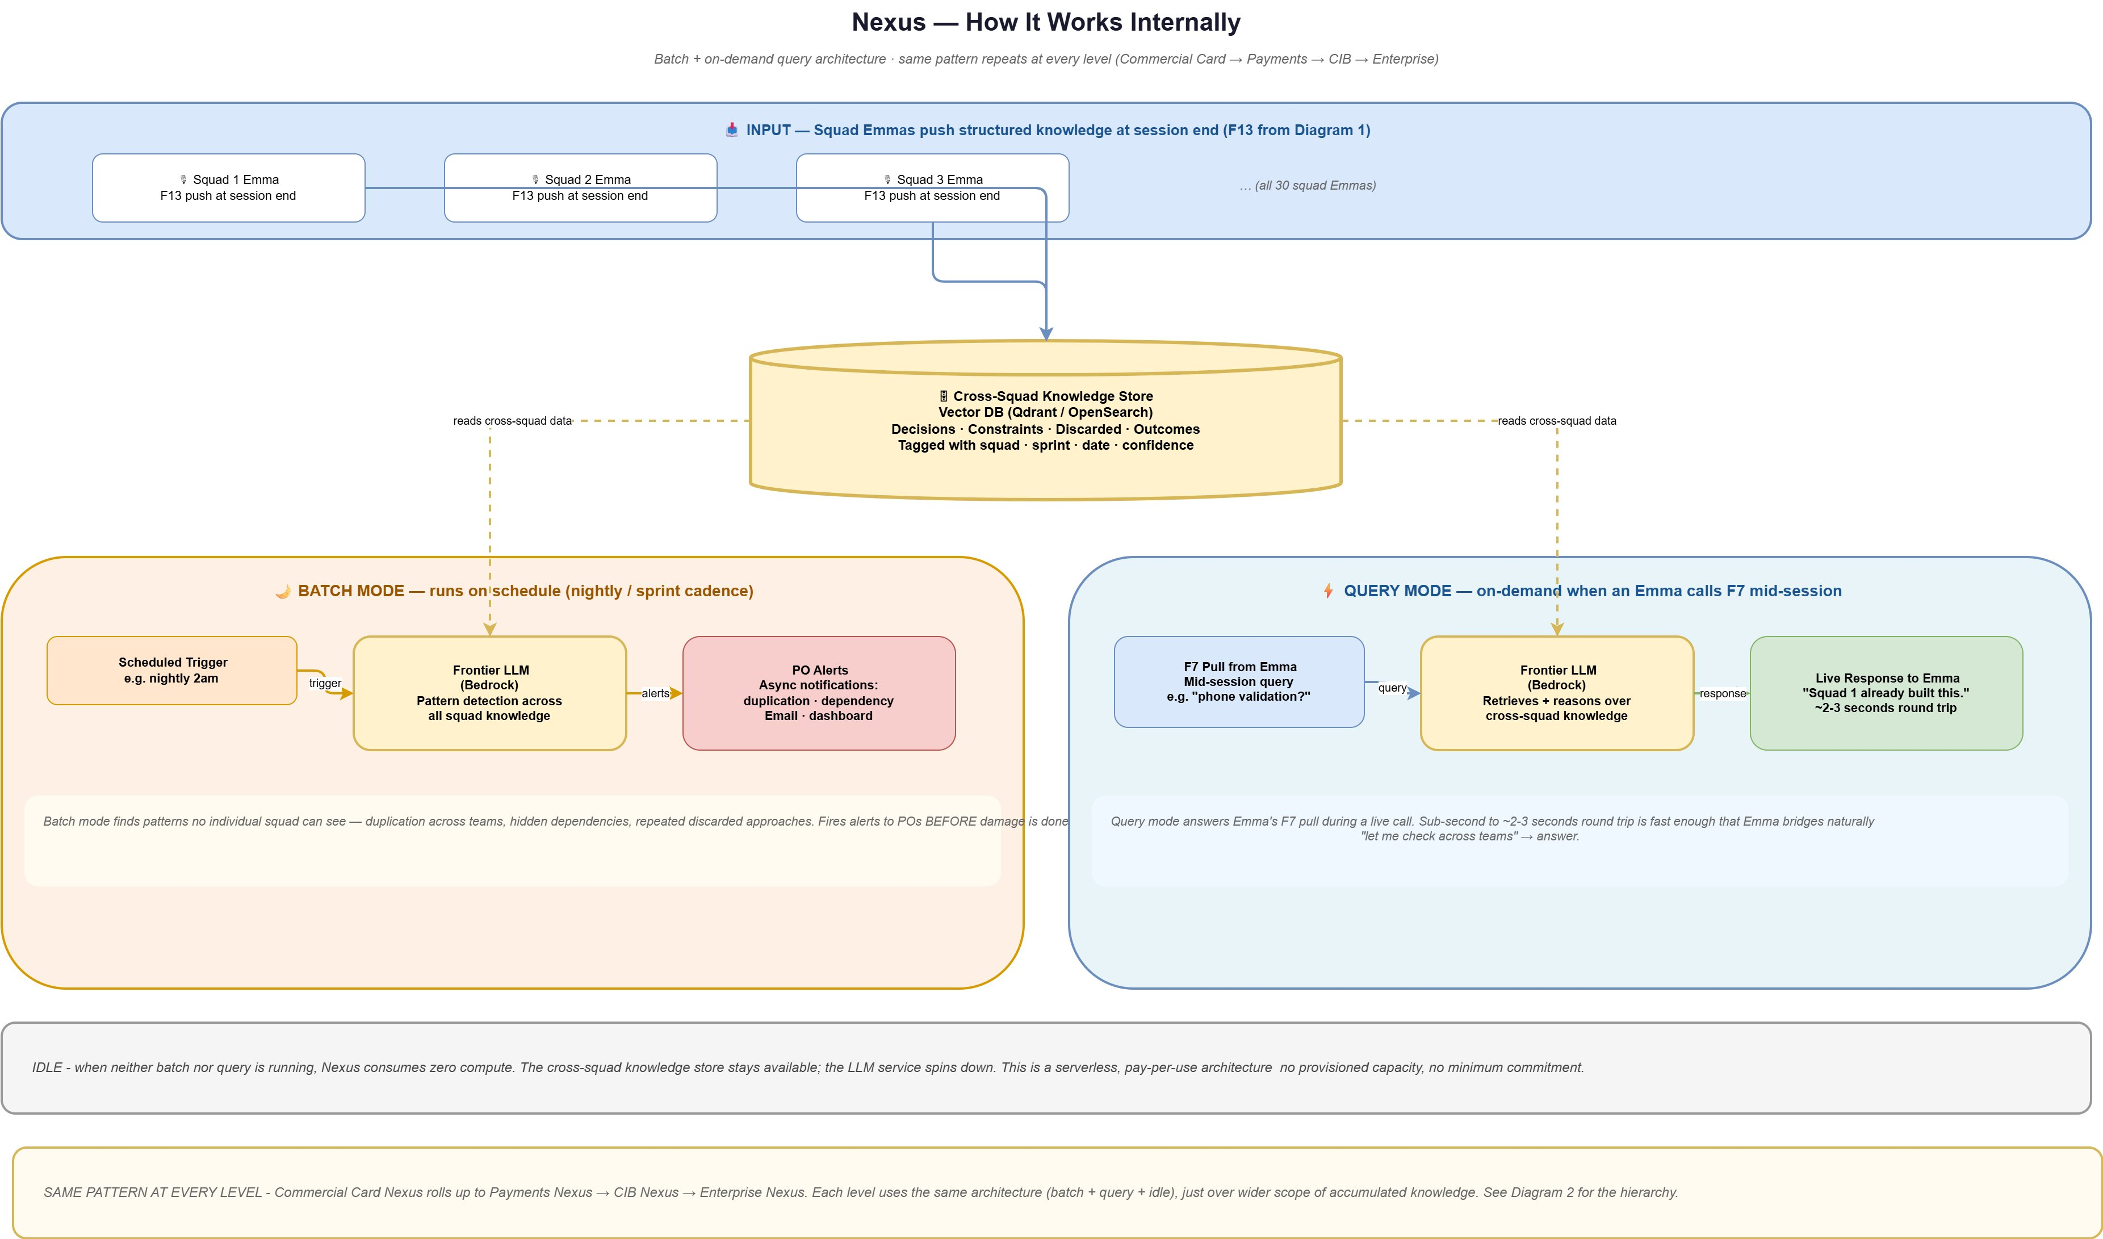

Components
- Input — Squad Emma F13 Pushes — at session end, each squad Emma pushes a batch of structured knowledge objects (decisions, constraints, discarded approaches, outcomes with full metadata) into the Cross-Squad Knowledge Store.
- Cross-Squad Knowledge Store — a vector database (Qdrant, OpenSearch, or equivalent) that holds the accumulated knowledge from all squads in the scope of this Nexus level. Always available; decoupled from compute. Because the stored objects are atomic and self-contained, dense vector search with hybrid retrieval is appropriate — structure-aware retrieval is not required at this layer.
- Batch Mode — Scheduled Trigger — fires on a defined cadence (for example, nightly or at sprint end). Triggers the batch analysis cycle.
- Batch Mode — Frontier LLM (Pattern Detection) — spins up on trigger; reads the Cross-Squad Knowledge Store; runs pattern detection (duplication, dependency, discarded-decision, constraint resolution) across the full accumulated data set. Hosted on AWS Bedrock or equivalent enterprise gateway. Spins down on completion.
- Batch Mode — PO Alerts — asynchronous notifications dispatched to impacted POs and program managers via email and dashboards. Delivery is not time-critical in the millisecond sense — findings arrive before the next sprint commit.
- Query Mode — F7 Pull from Emma — mid-session query from a squad Emma. Triggers on demand; for example, "phone validation?"
- Query Mode — Frontier LLM (Retrieval + Reasoning) — retrieves relevant objects from the Cross-Squad Knowledge Store and reasons over them to produce a response. Kept warm via provisioned concurrency or a low-idle-timeout warm pool so response is consistently within two to three seconds round trip.
- Query Mode — Live Response — returned to Emma in two to three seconds round trip. Fast enough that Emma bridges naturally with "let me check across teams…" in her spoken response.
- Idle State — when neither batch nor query is running, the Nexus LLM service spins down; the Cross-Squad Knowledge Store stays available but consumes only storage cost. This is a serverless, pay-per-use architecture — no provisioned capacity, no minimum commitment. Enterprise cost scales with usage, not with scale.

End-to-End
Nexus is an event-driven service with three states: batch, query, and idle. Input flows in continuously as squad Emmas end their sessions and F13 Push structured knowledge into the Cross-Squad Knowledge Store. This store is always available; it is the only component that carries ongoing cost, and that cost is storage, not compute.
The Batch Mode Scheduled Trigger fires on cadence (nightly or sprint-end). The Batch Frontier LLM spins up, reads the Cross-Squad Knowledge Store, runs pattern detection across the accumulated data set, and produces findings. Findings flow to the PO Alert Dispatcher, which delivers them asynchronously to impacted Product Owners and program managers. These alerts are not time-critical in the millisecond sense — they need to arrive before impacted sprints commit, not within seconds of the push that triggered detection. The LLM spins down on completion.
The query mode runs on demand. When a squad Emma issues an F7 Pull from a live session, the Query Frontier LLM activates (kept warm to avoid cold-start penalty), retrieves relevant objects from the Cross-Squad Knowledge Store, reasons over them in the context of Emma's query, and returns a response. Round-trip latency is two to three seconds — fast enough that Emma bridges naturally in her spoken response while the query completes.
When neither batch nor query is running, Nexus is idle. The LLM service spins down. The Cross-Squad Knowledge Store continues to store data but does not consume compute. This is a serverless, pay-per-use architecture — no provisioned capacity, no minimum commitment. Enterprise cost scales with actual usage, which for a well-tuned system is batch cadence plus per-squad query volume. The economics hold at scale because every additional squad adds a small marginal query load but no fixed cost.
The same architecture repeats at every level of the Nexus hierarchy. Sub-LOB Nexus uses this exact batch-plus-query-plus-idle pattern across its squads. LOB Nexus uses the same pattern across its sub-LOBs. Enterprise Nexus uses the same pattern across LOBs. Only the scope of the data changes across levels — the architecture is identical.

Flow

Batch Mode
The scheduled trigger fires. The Frontier LLM service spins up on AWS Bedrock (or equivalent) and reads the accumulated cross-squad objects from the knowledge store. Pattern detection runs across the full data set — duplication, dependency, discarded decision, constraint resolution. When a pattern is detected, findings are routed to the PO Alert Dispatcher, which dispatches asynchronous notifications to impacted POs and program managers via email, dashboards, and messaging channels. The LLM spins down on completion. Total compute time per batch cycle is measured in minutes (not sub-second) because batch completeness matters more than batch latency — alerts need to arrive before impacted sprints commit, not within seconds of the push.

Query Mode
An F7 Pull arrives from a squad Emma mid-session. The query Frontier LLM (kept warm) retrieves relevant objects from the knowledge store and reasons over them in the context of Emma's specific query. A response is returned within two to three seconds round trip. Emma bridges the round trip in her spoken response with a phrase like "let me check across teams…" Warm-pool provisioning is required because cold-start on a frontier LLM service typically exceeds the latency budget for live conversation; a small always-warm pool absorbs query spikes without cold-start penalties.

Idle State
When neither batch nor query is running, the LLM service is idle or scaled to zero. The Cross-Squad Knowledge Store remains available at storage cost only. Enterprise cost scales with actual usage, not with provisioned capacity. The serverless pay-per-use model holds across all levels of the Nexus hierarchy, making the architecture economically viable at any scope.

Worked Examples — End-to-End Scenarios
The following examples trace specific scenarios through the full system, showing how components interact to produce observable outcomes. Each example draws on the architecture described in Diagrams 1 through 4.

Example 1 — Mid-Meeting Query with Canvas Explanation
A developer in a backlog refinement session asks: "Hey Emma, walk me through our fraud alert flow."
The Wake Word Detection identifies the invocation. STT transcribes the utterance. Diarization labels the developer by name via Enterprise SSO. The Orchestrator recognises a direct query requiring architectural explanation. Hybrid retrieval runs against D1 (where the fraud alert architecture document is indexed via structure-aware retrieval) and D2 (where prior team decisions about the fraud flow are stored). Retrieved context plus the question flow to the Frontier LLM, which generates a response combining narrative explanation with a diagram specification. The Canvas Renderer draws the fraud alert flow in real time as Emma speaks. Simultaneously, Multi-Modal Link Dispatch sends a link via Zoom chat. Three of five participants click the link, SSO-authenticate, and the diagram appears on their screens. The Participant Engagement Tracker notes that two participants have not opened the visual. Emma adjusts her explanation pace and, after completing the main walkthrough, asks: "Rajesh, Priya — I see you haven't opened the diagram. Want me to re-summarise or should I move on?" The developers who did not open it confirm they have enough. Emma continues. The entire exchange — question asked, retrieved context, response — is written into D3 as indexed session memory.

Example 2 — Emotion-Adaptive Response (F3)
During sprint planning, a developer raises a concern about a proposed approach: "We've been over this three times already, it's never going to work, let's just do it the old way." The tone carries audible frustration.
The STT Module transcribes the sentence. The Voice Emotion Module, running in parallel on the same audio, extracts the emotional state: frustrated (0.78), resigned (0.65), valence: -0.4. The Orchestrator sees two signals from the same utterance — text content and emotion vector. The emotion vector triggers the F3 direct route to response generation, bypassing the full retrieval-plus-reasoning loop. Rather than generating a dense single-shot answer, Emma's response adapts: she slows her delivery, acknowledges the difficulty the team has been through ("I understand this has come up several times"), and walks through the alternatives step by step with concrete, distinct framing — "Let me try to separate the two concerns. First, the data-format constraint you raised in Sprint 11 is still active. Second, the latency issue is new in this sprint. They may have different solutions." The team re-engages with the problem. Write Intercept tags the emotional signal, the constraint that was raised, and the new decision trajectory — all written to D2 for future reference.

Example 3 — Cross-Squad Prior Art Pull (F7)
In a Merchant Onboarding squad (Squad 5) refinement session, the team discusses adding phone number validation to the onboarding flow: "We'll add a phone validator — should we use the open-source library or roll our own?"
The Orchestrator recognises a topic with potential cross-squad relevance and issues an F7 Pull to the Commercial Card Nexus. The Nexus query path activates, retrieves relevant objects from the Cross-Squad Knowledge Store, and returns within two seconds: Squad 1 on Payment Gateway built a phone validator six weeks ago and it is in production; Squad 1 also tried and discarded the open-source library as too slow at scale. Squad 5's Emma incorporates the response into her spoken reply: "Actually, Squad 1 on Payment Gateway shipped a phone validator six weeks ago. It's in production at /core/validators/phone. They also tried the open-source library first — decided it was too slow. I'd suggest using their validator directly. Saves about a week, and you get the battle-tested version." The squad avoids both a duplicate build and a failed library choice. The exchange and the decision to adopt Squad 1's validator are written into D2 via Write Intercept — with tags outcome (adopted cross-squad solution), constraint (latency requirement), discarded (open-source library), linked entity (Squad 1 validator at /core/validators/phone).

Example 4 — Playbook-Driven Proactive Engagement (Stand-Up)
A daily stand-up begins. The Playbook Engine recognises the ceremony structure: each developer reports in turn, blockers are surfaced, dependencies mentioned. A developer reports: "I'm blocked on the Kafka partition issue — still haven't figured out why consumer 3 is getting duplicate messages."
The Playbook triggers the Orchestrator to proactively check. The Orchestrator queries D2 for prior Kafka-related issues on this squad (no prior matches) and issues an F7 Pull to Nexus for cross-squad Kafka partition prior art. Nexus returns within two seconds: Squad 3 (Trades) hit the same Kafka partition issue in Sprint 11; their fix is documented in their runbook; the issue was related to consumer group rebalance timing. Emma — proactively, without being addressed — speaks: "Quick note: Squad 3 on Trades hit the same issue in Sprint 11. Their fix is in the Trades runbook — it was consumer group rebalance timing. Want me to pull it up on Canvas?" The developer says yes. Emma renders the relevant portion of the runbook on the Canvas and dispatches the link. The blocker resolves in the next twenty minutes. The exchange is written to D2 as outcome (Kafka rebalance fix from Squad 3 applied) with linked entity to Squad 3's runbook — so a future squad with the same issue can be served from D2 locally without requiring the Nexus round-trip.

What Makes This Combination Work
The individual technical components Emma and Nexus use are, for the most part, available in the field today. Streaming speech-to-text, voice emotion detection, frontier LLMs, vector databases, retrieval-augmented generation, meeting participation bots, and enterprise SSO integration are all established technologies. The following four mechanisms are highlighted as the novelty of the system — the specific combinations and capabilities that produce behaviour not available from the individual components alone. A fifth characteristic — compounding institutional memory — emerges as a system-level outcome of the mechanisms working together.

Mechanism 1 — Emotion-Adaptive Response Routing (F3)
Voice-based emotion detection is not new. What is distinctive is using the detected emotion vector to route response generation directly — bypassing the full retrieval-plus-reasoning loop and changing the structure of the response itself based on the emotional state of the participant. Most systems that detect emotion log it as metadata. In this system, emotion is a control signal that changes how the reasoning pipeline executes: the response is delivered slower, broken into distinct steps, and structured for comprehension rather than density. This is integrated with the system's memory architecture — emotional context is captured and written to D2 alongside the decisions made under that emotional state, making it possible to reason about emotional dynamics across sprints.

Mechanism 2 — Structured Decision Capture via Write Intercept (F11/F12)
Meeting transcription is a solved problem. What distinguishes this system is the Write Intercept mechanism: during the meeting itself, the Orchestrator recognises decision patterns in conversation and intercepts the content before persistence, classifying it into structured tags (problem, constraint, discarded, outcome) and enriching it with metadata (feature, sprint, squad, timestamp, reason, linked entities). The result is that memory compounds over time in a structured, retrievable form — not as a raw transcript that loses meaning, but as tagged knowledge objects that support semantic retrieval sprint over sprint. A decision made in Sprint 4 remains directly retrievable in Sprint 40 with its full context: what problem it addressed, what constraints it was bounded by, what approaches were discarded, what the actual outcome was. This structural capture during the live meeting — not as a post-meeting summarisation step — is distinctive.

Mechanism 3 — Bidirectional Cross-Squad Memory via Nexus (F7/F13)
Cross-team knowledge sharing has been addressed by enterprise search, documentation platforms, and communities of practice. What distinguishes this system is the bidirectional, architecturally-integrated cross-squad memory loop. Each squad Emma pushes structured knowledge to the cross-squad layer (Nexus) at session close (F13). Each squad Emma pulls from Nexus during live sessions for cross-squad prior art (F7) with two to three second round-trip latency. Between those two directions, Nexus runs batch pattern detection across all accumulated squad knowledge — duplication, dependency, discarded decision, constraint resolution — and dispatches asynchronous alerts to impacted Product Owners before sprint commits lock in duplicated or conflicting work. The architectural uniformity of the Nexus layer at every level (squad to sub-LOB to LOB to enterprise) means the same mechanism produces cross-organisational intelligence at arbitrary scale without structural change. Emmas do not communicate directly with each other — they cannot, because Emma only exists during a session — so the continuously-available Nexus layer is the only path through which cross-squad memory flows. This necessity becomes an architectural strength: all cross-squad knowledge is routed through a consistent, tagged, queryable layer rather than through ad-hoc channels.

Mechanism 4 — Ceremony-Aware Proactive Agent (Playbook Engine)
Rule engines are not new. Voice AI agents are not new. What is distinctive is a voice-first agent whose proactive behaviour is driven by an encoded structural model of the team's process — specifically, agile ceremonies in the initial implementation — and integrated with the same compounding memory architecture. The Playbook Engine defines, for each process type, what roles participate, what signals mark phase transitions, what artifacts are typically produced, and what actions the agent should proactively take at defined triggers. As a team works through a ceremony, the Playbook prompts the agent to engage at the right moments without waiting to be asked: summarising acceptance criteria at the end of refinement, checking cross-squad prior art when a blocker is raised in stand-up, offering to write Jira tickets when decisions are reached. The mechanism is extensible — any recurring structured process with known participants, phases, and artifacts can be encoded, including architecture reviews, incident post-mortems, and research review cycles — broadening the system's applicability beyond software engineering.

Emergent Outcome — Compounding Institutional Memory
Taken together, the four mechanisms above produce an emergent system-level outcome: compounding institutional memory. Every meeting adds structured, retrievable knowledge to a team's local memory (via Write Intercept) and to the cross-squad intelligence layer (via Nexus). Knowledge does not degrade with attrition — when a senior developer leaves, the decisions they made, the constraints they operated under, the approaches they discarded, and the outcomes they produced remain in D2 and Nexus in structured tagged form. New joiners can query that memory directly through a Curated Session. Cross-team duplication and dependency risk decreases as Nexus accumulates more squad history. The ceremony-aware proactive behaviour means the memory is captured actively during the meeting, not retrospectively after it. The uniform architecture at every level means the same compounding behaviour operates at squad scope, sub-LOB scope, LOB scope, and enterprise scope — making institutional memory a first-class property of the organisation rather than an accidental byproduct. This system-level outcome is not produced by any individual component; it is produced by the combination of mechanisms described above operating within a consistent architecture at scale.

