Emma & Nexus
Voice-First Agentic Knowledge Management System
Technical Write-Up

Inventor: Gaurav Ahuja
JPMorgan Chase - Commercial Card
April 2026

Summary
Emma is a voice-first agentic assistant with full reasoning capabilities, designed to actively participate in team meetings. She helps with backlog grooming, refines stories, reasons through decisions alongside the team, and unblocks developers in real time. During every session she captures structured knowledge - decisions, constraints, discarded approaches, and outcomes - and writes it to persistent memory with full metadata. As a result, her memory compounds sprint over sprint, and she gets smarter with every meeting she participates in.
At scale, when every squad has its own Emma, a layer called Nexus sits above them. Nexus reads across all squad memories, detects duplication and hidden dependencies before they become problems, and alerts Product Owners. The same architecture repeats at every level of the organization - sub-LOB Nexus rolls up into LOB Nexus, into Enterprise Nexus - producing cross-organizational intelligence no individual team can generate from its own vantage point.

The Problem This System Addresses
Engineering teams in large organizations lose institutional knowledge constantly. People with expertise leave and domain context leaves with them. Documentation goes stale because nobody has time to keep it current. Decisions made in meetings disappear into transcripts that capture words but not meaning. New joiners take months to ramp up because onboarding consumes senior team members' time. Product Owners re-answer the same questions sprint after sprint because the reasoning behind original decisions was never captured.
Existing categories of tools do not fulfill what this problem requires. Documentation platforms store content but do not capture decisions as they are made. Task trackers record what needs to be done but not the reasoning behind it. Transcription tools record words but do not structure them into retrievable memory. None participates in meetings, reasons alongside the team, or carries memory that compounds sprint over sprint across a team - let alone across teams.
Knowledge in large engineering organizations is captured by accident, retrieved by luck, and lost by design. This is not a documentation problem. It is an institutional memory problem, and it operates at a scale that existing categories of tools were never designed for.
This document illustrates the architecture and the solution at scale, in the context of JPMorgan Chase, though the underlying problem - and the architecture that addresses it - is not unique to any single institution.
Emma handles all of this and much more. The architecture that follows describes how.

Diagram 1 - Session Lifecycle Architecture
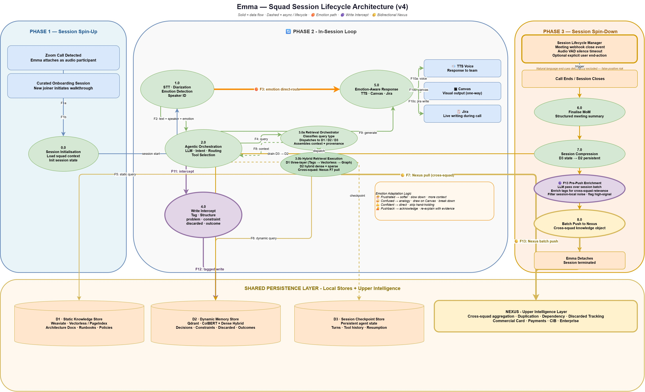

Components

Session Triggers
- Meeting Webhook - a Zoom or Teams meeting starts, a webhook fires, and Emma spins up and attaches to the call as an audio participant.
- Curated Session Trigger - a session defined by its trigger and purpose rather than by the underlying platform. Use cases include new-joiner onboarding (Emma walks the user through project history, architecture decisions, and prior sprints on demand), knowledge transfer sessions when a team member is leaving (Emma sits in with the departing member and the squad, capturing their knowledge structurally into team memory), and ad-hoc learning sessions where a developer needs to understand a specific area of the codebase or domain. A Curated Session can run over any medium - a Zoom or Teams call, an in-person room with a conference microphone, or a solo developer interacting directly with Emma through a headset - because the lifecycle is governed by the session's purpose, not by the platform. Session start and end are managed by the Session Lifecycle Manager using signals that apply uniformly across mediums.

Identity & Participant Awareness
- Enterprise SSO Integration - participant identity resolved via corporate single sign-on (Azure AD, Okta, or equivalent). Emma knows which humans are in the meeting by identity - their name, role, squad affiliation, and prior interaction history with her.
- Participant Engagement Tracker - monitors meeting-platform signals (chat link clicks, reactions, screen-share state) to track who is actively engaged with what Emma is presenting.

Input Layer
- SOTA Speech-to-Text (STT) Module - state-of-the-art streaming ASR converting meeting audio to text in real time. Enterprise deployment: AWS Transcribe, NVIDIA Parakeet, Azure Speech, or equivalent. Runs continuously - Emma is always listening from the moment she spins up.
- Diarization Module - identifies and labels which participant produced each utterance; paired with SSO so speakers are known by identity, not voice alone.
- SOTA Voice Emotion Module - a separate model running in parallel on the same audio stream as the STT module, performing audio-based emotion recognition using transformer-based encoder architectures (wav2vec2, HuBERT, or Whisper-based emotion classifiers) trained on conversational speech datasets such as IEMOCAP, RAVDESS, and MELD. Produces an emotional state vector combining categorical labels (frustrated, confused, confident, neutral, and further discrete classes with confidence scores) and continuous dimensional values along valence, arousal, and dominance axes. The vector is treated as a first-class control signal - not metadata - and feeds the F3 emotion-adaptive routing path in the Orchestrator. Enterprise deployment options include Hume AI, AWS-hosted emotion models, Azure AI Speech emotion detection, NVIDIA NeMo emotion recognition, or open-source wav2vec2/HuBERT classifiers fine-tuned for the deployment context. Decoupled from STT to preserve latency bounds on both paths.
- Wake Word Detection - detects "Hey Emma" invocations. Emma is already listening from spin-up; the wake word switches her from ambient capture mode into direct-response mode.
- Barge-In Handling - allows any participant to interrupt Emma's speech output; cancels in-flight TTS and returns her to listening state without disrupting the meeting.

Reasoning Layer
- Orchestrator - central decision layer (agent framework such as LangGraph); routes utterances and events to retrieval, reasoning, decision-capture, emotion-adaptive, proactive, tool-action, escalation, or cross-squad pathways based on content, signal, and playbook rules.
- Retrieval Orchestrator (3.0a) - coordinates retrieval across D1, D2, and D3 based on query type and urgency. Classifies incoming queries - session-context, decision-history, reference-material, or comprehensive - and dispatches to the appropriate store or stores. Assembles returned context with source-tagging and provenance metadata before handing to the Frontier LLM. Acts as the single entry point for retrieval so that the Orchestrator (2.0) does not need to reason about store topology - it issues a query and receives assembled context.
- Hybrid Retrieval Execution (3.0b) - executes the retrieval strategy selected by the Retrieval Orchestrator. For reference queries, invokes the D1 three-layer pipeline (Tags → Vectorless → Graph with confidence gating). For decision-history queries, runs D2's hybrid retrieval - dense semantic vectors (ColBERT) combined with sparse lexical search (BM25) and metadata filtering by squad, sprint, type, and topic. For session-continuity queries, performs fast indexed lookup against D3 by session ID and turn number. For cross-squad queries, issues an F7 Pull to Nexus. Multiple strategies can run in parallel when a query is comprehensive.
- Frontier LLM - reasoning engine for complex queries. Enterprise deployment: Claude Opus via AWS Bedrock or equivalent frontier-class model.
- Playbook Engine - a rule-based controller that encodes the structure of recurring team processes as patterns the Orchestrator follows. For each process type the engine defines (a) what roles participate, (b) what signals mark the start, progression, and completion of each phase, (c) what artifacts are typically produced, and (d) what actions Emma should proactively take at defined triggers. Initial implementation encodes agile ceremonies - daily stand-up, backlog refinement, sprint planning, review, retrospective. The mechanism is extensible: any recurring structured process with known participants, phases, and artifacts can be encoded, including architecture reviews, incident post-mortems, and research review cycles.

Memory Layer
- D1 - Static Knowledge Store (three coordinated layers) - the team's authoritative reference layer, architecturally composed of three coordinated sub-layers operating on shared multi-tenant infrastructure. Each squad operates as a logical tenant; isolation is enforced through access control rather than separate infrastructure per squad, which keeps infrastructure cost roughly constant as squad count grows. The three layers are described in detail in Diagram 5. In summary: Layer 1 - Metadata / Tag Index (PostgreSQL or equivalent) - filter-first search by topic, owner, sprint, squad, document type, last-updated, approval state; narrows candidate documents from thousands to tens. Layer 2 - Vectorless Structure-Aware Retrieval (PageIndex / hierarchical tree) - reasoning-based navigation within selected documents rather than chunk-based vector similarity; incremental re-indexing of affected subtree on update. Layer 3 - Knowledge Graph (confidence-gated, with graceful fallback) - typed edges (depends-on, references, owns, derives-from, was-decided-in, supersedes) with confidence scores; edges below threshold are excluded, disagreements with source-of-truth layers cause deferral, and if the graph is unavailable the pipeline returns Layers 1 and 2 results alone. Graph is treated as augmentation, never as authority. Documents are versioned with full provenance - each update creates a new version, prior versions are preserved.
- D2 - Dynamic Memory Store - persistent vector database for compounding team decisions. Stores tagged objects with structured metadata: type (problem, constraint, discarded, outcome), feature, sprint, squad, timestamp, reason, linked entities. Hybrid retrieval (dense embeddings + ColBERT).
- D3 - Session Checkpoint Store - persistent agent state for the active session only. All STT output streams into D3 as indexed session memory - tagged with speaker, emotion, and timestamp - rather than a linear transcript fed into the LLM. The Orchestrator queries D3 via retrieval when reasoning, so only relevant session history is included in each reasoning turn. This keeps the LLM context window manageable even for long meetings. Drained to D2 via compression on session close.
- Write Intercept Module - intercepts orchestrator output and tool action results before persistence; classifies content into structured tags (problem, constraint, discarded, outcome); enriches with metadata (feature, sprint, squad, timestamp, reason, linked entities); writes the tagged object to D2.

Output Layer
- SOTA Text-to-Speech (TTS) Module - state-of-the-art voice synthesis. Enterprise deployment: AWS Polly, ElevenLabs, Azure TTS, or equivalent. Emotion-adaptive delivery.
- Canvas Renderer - a first-class explanatory capability. Emma does not just describe architecture in words - she draws it. The Canvas Renderer produces architecture diagrams, flow charts, and explanatory visuals in real time, synchronized with Emma's spoken explanation.
- Multi-Modal Link Dispatch + SSO-Authenticated Canvas Access - when Emma uses the Canvas, she dispatches a link to each participant via the meeting platform's chat (Zoom chat, Teams chat). Participants click the link, authenticate via enterprise SSO, and the canvas loads on their device. Because access is SSO-authenticated, Emma knows by identity who has opened the visual and who has not, and can adapt her explanation accordingly.
- Jira Integration - writes acceptance criteria, tickets, and MoM entries back to Jira based on in-meeting decisions.
- MCP Tools Layer - integration surface through which Emma executes actions in external systems. Built on Model Context Protocol for extensibility - new tools (test scenario reviewers, code review helpers, deployment automations, documentation writers) can be added as they become available without changing Emma's core. Tool invocations and their results flow back through the Orchestrator and Write Intercept, so Emma's actions become tagged team memory just like captured decisions.
- Escalation Dispatcher - when Emma's confidence on a query is below threshold, she provides a best-attempt answer AND simultaneously drafts an escalation to the Product Owner with full context. When the PO responds, the answer writes back to D2 - so the same question never escalates twice.

Cross-Squad Interface
- F7 Pull - Emma issues a live query to Nexus during an active session; receives cross-squad prior art within a round-trip suitable for live conversation.
- F13 Pre-Push Enrichment - an LLM-driven scrutiny and enrichment pass that runs over the batch of D2 objects queued for push to Nexus at session close. Operates on three axes: (1) tag enrichment - adds cross-squad-relevant tags such as resolution-type, impact-scope, service-references, dependency-hints, and pattern-category, extending the session-local tags applied by Write Intercept with the context Nexus needs for cross-squad pattern detection; (2) noise filtering - marks session chatter and squad-local ephemera with local-only flags so they stay in D2 but do not push upward, keeping Nexus clean; (3) priority signalling - flags high-signal items (cross-squad solution adoption, discarded approaches at scale, constraint resolutions) for priority routing during batch pattern detection. Uses the local Frontier LLM batched at session end, so latency is not user-facing and cost is bounded by session-end batch size rather than per-utterance.
- F13 Push - at session close, Emma pushes the enriched batch of structured knowledge objects to Nexus for cross-squad intelligence (see Diagrams 2 and 4 for the Nexus architecture).

Session Lifecycle
- Session Lifecycle Manager - detects session end through passive signals, without relying on natural-language cues. Two primary signals plus one optional override: (1) Meeting Webhook close event - when the session is hosted on a meeting platform (Zoom, Teams, Webex, Google Meet), consumes the platform's session-end webhook; (2) Audio Voice-Activity-Detection silence timeout - when extended speech-free audio is detected (configurable threshold), the session is considered ended; this signal applies uniformly across mediums, including Curated Sessions that run in-person or through a direct audio channel with no platform; (3) Optional explicit user end-action - a structured UI action (button, command) that the user can invoke to end the session deliberately. Natural-language end-cues such as "thanks Emma" or "we're done" are deliberately excluded from the detection logic because the false-positive risk - a casual phrase uttered mid-meeting - would prematurely terminate the session and break team trust. On detection of session end through any valid signal, triggers the Phase 3 spin-down sequence: MoM compilation, Session Compression (D3 → D2), F13 Pre-Push Enrichment, Batch Push to Nexus, and Emma detach.
- MoM Compiler - at session end, generates a Minutes-of-Meeting document from the compressed D3 contents using the Frontier LLM, structured as decisions made, action items with owners, attendees, and key discussion points. Dispatched via existing Jira Integration, email through the Escalation Dispatcher, or the team dashboard depending on configuration. Runs in parallel with F13 Pre-Push Enrichment during spin-down.

End-to-End
A session starts in one of two ways. In the common case, a Zoom or Teams meeting begins and the Meeting Webhook fires; Emma spins up and attaches as an audio participant. In the alternate case, a Curated Session Trigger initiates onboarding, knowledge-transfer, or learning sessions. A Curated Session is defined by its trigger and purpose rather than by the platform - it can run over a Zoom or Teams call, in a conference room with a shared microphone, or in a direct audio interaction with a single user, because the session lifecycle is handled uniformly by the Session Lifecycle Manager regardless of medium. Both paths converge at the same spin-up: Emma hydrates her session context from D1 (architecture, policies, reference material) and D2 (the team's decision history from prior meetings). Participant identity is resolved through Enterprise SSO Integration, so Emma knows by name who is in the meeting, their roles, and their prior interaction history.
From spin-up, Emma is always listening. The STT Module, Diarization Module, and Voice Emotion Module run in parallel on the continuous audio stream, producing a unified utterance object - text, speaker, and emotion - for every spoken segment. Utterances stream into D3 as indexed session memory, and in parallel into the Orchestrator, which inspects each signal and routes it down different paths depending on content and context. Wake Word Detection switches Emma into direct-response mode when a participant addresses her directly. Barge-In Handling allows any participant to interrupt Emma's speech without disrupting the meeting.
Direct questions trigger hybrid retrieval across D1 and D2 followed by Frontier LLM reasoning, with the response flowing to the TTS Module. Where visual explanation helps, the Canvas Renderer draws alongside Emma's speech and Multi-Modal Link Dispatch sends each participant a link; participants authenticate via Enterprise SSO and the Participant Engagement Tracker surfaces who has opened the visual. Substantive decisions made in conversation trigger the Write Intercept Module, which classifies them into structured tags with full metadata and writes them to D2. Cross-squad questions trigger an F7 Pull to Nexus, returning prior art within a round-trip suitable for live conversation. Strong emotional signal routes directly to response generation via the F3 path, changing the structure of Emma's reply to match the participant's state. The Playbook Engine watches the conversation against encoded ceremony patterns (daily stand-up, refinement, planning) and prompts Emma to proactively engage at defined triggers - summarising, capturing acceptance criteria, or offering to create Jira tickets. Action paths invoke Jira Integration and the MCP Tools Layer to execute during the meeting itself, with outcomes flowing back through Write Intercept. Where confidence on an answer is low, the Escalation Dispatcher provides a best-attempt answer and drafts an escalation to the Product Owner in parallel.
The session's end is detected by the Session Lifecycle Manager through passive signals - a meeting-platform webhook close event, extended audio-activity silence, or an optional explicit user end-action. Natural-language end-cues are deliberately excluded from detection to avoid premature termination from phrases uttered mid-meeting. On detection, Phase 3 spin-down executes in a defined sequence. The MoM Compiler generates the Minutes of Meeting - decisions, action items, attendees, key discussion points - and dispatches it via Jira Integration, email, or team dashboard depending on configuration. In parallel, D3 is compressed via Write Intercept into structured tagged knowledge objects and drained into D2 - giving the team permanent memory of what just happened. The batch of compressed objects then passes through F13 Pre-Push Enrichment, an LLM scrutiny pass that enriches tags for cross-squad relevance, filters session-local noise, and flags high-signal items for priority routing at Nexus. The enriched batch is pushed via F13 Push to Nexus for cross-squad availability. D3 is cleared. Emma detaches. The memory persists.

Flow
The End-to-End above describes the full system in motion. The subsections that follow describe each of the six primary routing paths in greater detail.

Path 1 - Direct Query (wake-word invocation)
When a participant says "Hey Emma, what's our fraud alert SLA?", Wake Word Detection identifies the invocation and the Orchestrator treats the follow-up as a direct query. Hybrid retrieval runs against D1 and D2; retrieved context plus the participant's question flows to the Frontier LLM; the response flows to the Output Layer. The TTS Module speaks the answer in Emma's voice. If visual explanation helps - "walk me through the payment flow" - the Canvas Renderer draws the diagram alongside her speech, synchronized in real time, and Multi-Modal Link Dispatch sends the link via chat. Participants authenticate via Enterprise SSO to view. Emma knows by identity who is viewing and adapts her pacing accordingly. If a participant interrupts mid-response, Barge-In Handling cancels the TTS cleanly and Emma returns to listening.

Path 2 - Ambient Decision Capture
Even when no one has said "Hey Emma," she is listening and reasoning over the conversation. When a substantive decision is made - "We'll use the custom phone validator, not the open-source one, too slow at scale" - the Orchestrator recognises the decision pattern and engages the Write Intercept Module. Write Intercept classifies the content into structured tags (discarded approach, outcome, constraint), enriches with metadata (feature: phone validation; sprint: 14; squad: Payment Gateway; reason: latency at scale; linked entity: merchant onboarding), and writes the tagged object to D2. Memory compounds silently in the background while the team keeps talking.

Path 3 - Cross-Squad Pull (F7)
When the team discusses something with potential cross-squad relevance - "has any other team built phone validation?" - the Orchestrator issues an F7 Pull to Nexus. Nexus returns prior art from other squads within a round-trip suitable for live conversation: who built it, where it lives, what worked, what was discarded. Emma incorporates this into her spoken response in real time, bridging naturally with "let me check across teams…" while the round trip completes.

Path 4 - Emotion-Adaptive Response (F3)
When the Voice Emotion Module detects strong emotional signal - frustration, confusion - the emotion vector routes directly to response generation via the F3 path, bypassing the full retrieval-plus-reasoning loop. Emma's reply adapts in structure: she slows her pace, acknowledges the difficulty, and walks through the explanation step by step with distinct, concrete framing rather than delivering a dense single-shot answer. The goal is comprehension, not just comfort.

Path 5 - Playbook-Driven Proactive Engagement
Emma does not only respond to what the team asks. The Playbook Engine encodes the structure of recurring team processes - most commonly agile ceremonies - as patterns the Orchestrator follows. When a team begins a daily stand-up, the Playbook knows the expected structure: each developer in turn, blockers surfaced, dependencies mentioned. As the conversation progresses and a blocker is raised, the Playbook triggers Emma to proactively check D2 for similar prior blockers on the same team and issue an F7 Pull to Nexus for cross-squad prior work on the same issue. Emma surfaces findings in real time. Similarly, at the end of a refinement session, the Playbook triggers Emma to summarize agreed acceptance criteria and offer to write Jira tickets. The engine is extensible to any recurring structured process - architecture reviews, incident post-mortems, research review cycles - broadening Emma's applicability well beyond software engineering.

Path 6 - Action, Tools, and Escalation
When Emma's response calls for action beyond speaking - filing a Jira ticket, updating architecture documentation, pulling a code snippet - the Jira Integration and MCP Tools Layer execute the action during the meeting itself. The MCP Tools Layer is extensible; new agentic tools plug in without core changes, so Emma's capability grows over time. Tool invocations and their results flow back through the Write Intercept Module, so Emma's actions become tagged team memory alongside captured decisions. If confidence on an answer is below threshold, the Escalation Dispatcher provides a best-attempt answer AND simultaneously drafts an escalation to the Product Owner with full context. When the PO responds, the answer writes back to D2 - so the same question never escalates twice.

Phase 3 - Session Spin-Down
When the meeting ends, spin-down begins. The contents of D3 - the full session state, including every utterance, every tool call, every in-progress reasoning trace - are compressed via the Write Intercept Module into structured, tagged knowledge objects and drained into D2. This gives the team permanent memory of the session: every decision, every discarded approach, every outcome, cleanly tagged and retrievable. In parallel, a batch of those same objects is pushed upward via F13 Push to Nexus - the cross-squad intelligence layer described in Diagrams 2, 3, and 4. D3 is cleared. Emma detaches. The memory persists in D2 for the team's next meeting, and in Nexus for any other squad in the organization that needs it.

Diagram 2 - Platform Hierarchy & Institutional Memory Architecture
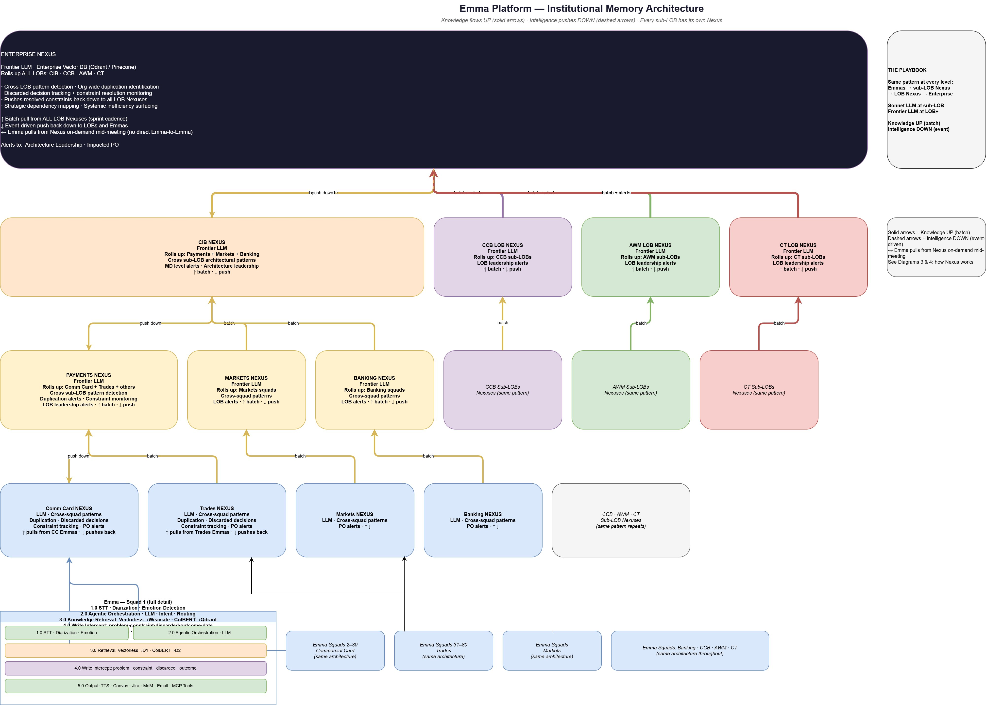

Components
- Squad Emma (per squad) - the full session-lifecycle system described in Diagram 1. Every scrum squad has its own Emma. Each squad Emma operates with isolated local memory (D1, D2, D3) and is the sole interface through which that squad's knowledge is captured and retrieved.
- Sub-LOB Nexus - aggregates structured knowledge from all Emma squads within a sub-line of business (for example, Commercial Card Nexus, Trades Nexus, Markets Nexus, Banking Nexus). Runs cross-squad pattern detection in batch mode on a scheduled cadence - duplication, discarded-decision tracking, constraint monitoring - and dispatches alerts asynchronously to impacted Product Owners. Uses an LLM at this level for pattern reasoning. Batch pull from squad Emmas on a sprint cadence; batch push of resolved patterns back down.
- LOB Nexus - aggregates structured knowledge from sub-LOB Nexuses (for example, Payments Nexus, CCB LOB Nexus, AWM LOB Nexus, CT LOB Nexus, CIB Nexus). Runs cross-sub-LOB architectural pattern detection and surfaces MD-level and architecture-leadership alerts. Uses a frontier-class LLM for broader reasoning scope.
- Enterprise Nexus - the top of the hierarchy. Rolls up all LOBs. Runs org-wide cross-LOB pattern detection, identifies systemic inefficiencies, maps strategic dependencies, monitors discarded-decision resolution, and pushes resolved constraints back down to all LOB Nexuses. Alerts flow to architecture leadership and impacted Product Owners.
- Knowledge Flow - Upward (batch, solid arrows) - structured knowledge objects flow upward from squads to sub-LOB to LOB to Enterprise on a batch cadence (typically per sprint at the lower levels, longer cadences at higher levels). Each upward push is a compressed, tagged set of decisions, constraints, discarded approaches, and outcomes.
- Intelligence Flow - Downward (batch detection, async dispatch) - intelligence - alerts, recommendations, resolved constraints, architectural guidance - is produced by batch pattern detection at each Nexus level. When a Nexus detects something that impacts teams below, the alerts are dispatched asynchronously as notifications (email, dashboard, Teams/Slack) rather than on a fixed schedule. Async dispatch ensures impacted Product Owners see the finding before the next sprint commit, without requiring live push infrastructure.
- Cross-Squad Mid-Meeting Pull - a Squad Emma can pull from Nexus on demand mid-meeting through the F7 path for cross-team prior art. No direct Emma-to-Emma communication exists - all cross-squad knowledge flows through the Nexus hierarchy.
- The Playbook (organization-level meta-pattern) - the same architectural pattern repeats at every level - Emmas feed sub-LOB Nexus, sub-LOB Nexus feeds LOB Nexus, LOB Nexus feeds Enterprise. Mid-tier LLM at sub-LOB; frontier LLM at LOB and above. Knowledge flows UP in batch; intelligence is detected in batch at each level and dispatched asynchronously. The uniformity is intentional - one pattern scales from one squad to tens of thousands of employees.

End-to-End
Every squad operates its own Emma instance. Each squad Emma is architecturally identical to the one described in Diagram 1. The squad's memory (D1, D2, D3) is isolated - Squad A's Emma cannot directly read from Squad B's Emma. This isolation is enforced both technically (separate memory stores per squad) and logically (Emma only exists during a session; when Squad B is not in a meeting, there is nothing to query). Cross-squad knowledge flow happens only through the Nexus hierarchy.
At each session close, every squad Emma pushes structured knowledge to its Sub-LOB Nexus via F13 Push. Sub-LOB Nexuses aggregate into LOB Nexus on a longer batch cadence, which in turn aggregate into Enterprise Nexus at the top. Knowledge moves upward in batch. Each Nexus runs its own batch pattern detection - the scope widens at each level but the algorithm and architecture are identical.
Intelligence moves downward as a result of batch detection cycles at each level. When Enterprise Nexus detects an org-wide duplication pattern or a resolved constraint, the Alert Dispatch delivers the finding asynchronously to impacted LOB Nexuses, sub-LOB Nexuses, and Emmas through email, dashboard, and messaging channels. Delivery is not scheduled and not real-time - it is triggered by detection and delivered as a notification, ensuring teams see the finding before the next sprint commit without requiring live push infrastructure.
A critical capability is the mid-meeting cross-squad pull. When a squad Emma is in a live session and a topic with cross-squad relevance arises, the squad Emma issues an F7 Pull to its Sub-LOB Nexus. The Nexus query path spins up the frontier LLM, retrieves relevant objects from the cross-squad knowledge store, and returns the finding fast enough for Emma to bridge naturally in spoken response. Emma incorporates the result into her spoken response during the same meeting. No direct Emma-to-Emma communication exists; all cross-squad interaction goes through the Nexus hierarchy - a necessary architectural property, since Emmas only exist during sessions.
The uniformity of the pattern across levels is the foundation of the system's scalability. A new squad onboarded tomorrow plugs into the same architecture. A new LOB integrated into the enterprise follows the same Nexus pattern. The architecture scales from one squad to the entire organization without structural change.

Flow
The End-to-End above describes the hierarchy in motion. The following subsections describe each flow direction in more detail.

Knowledge Flow - Upward
Every squad Emma pushes to its Sub-LOB Nexus at session close via F13 Push. Sub-LOB Nexuses aggregate across their squads in batch; LOB Nexuses aggregate across sub-LOBs on a longer batch cadence; Enterprise Nexus aggregates across all LOBs on a longer cadence still. At each level the scope widens but the architecture is the same: structured tagged knowledge objects flow upward, batch detection runs over the accumulated data at that level, and cross-scope patterns emerge that no lower level could see.

Intelligence Flow - Async Dispatch Downward
Batch detection at each Nexus level produces findings - duplication, dependency, resolved constraint. Findings are dispatched asynchronously to impacted parties: Product Owners, program managers, architecture leadership. Delivery channels include email, dashboards, and Teams/Slack notifications. Delivery is not scheduled further after detection and is not live push - it is notification dispatch, arriving before impacted sprints lock in duplicated or conflicting work.

Cross-Squad Mid-Meeting Pull - F7
When a squad Emma is in a live session and issues an F7 Pull, the Nexus query path activates on demand. The frontier LLM at that Nexus retrieves relevant objects from the cross-squad knowledge store, reasons over them in the context of Emma's specific query, and returns a response fast enough for Emma to bridge naturally in spoken response. Emma bridges the round trip naturally in her spoken response. The query path is distinct from the batch path - both modes share the same underlying knowledge store but run as independent workflows. The query path and its latency characteristics are described in detail in Diagram 4.

Diagram 3 - Nexus Cross-Squad Intelligence (Batch Mode)
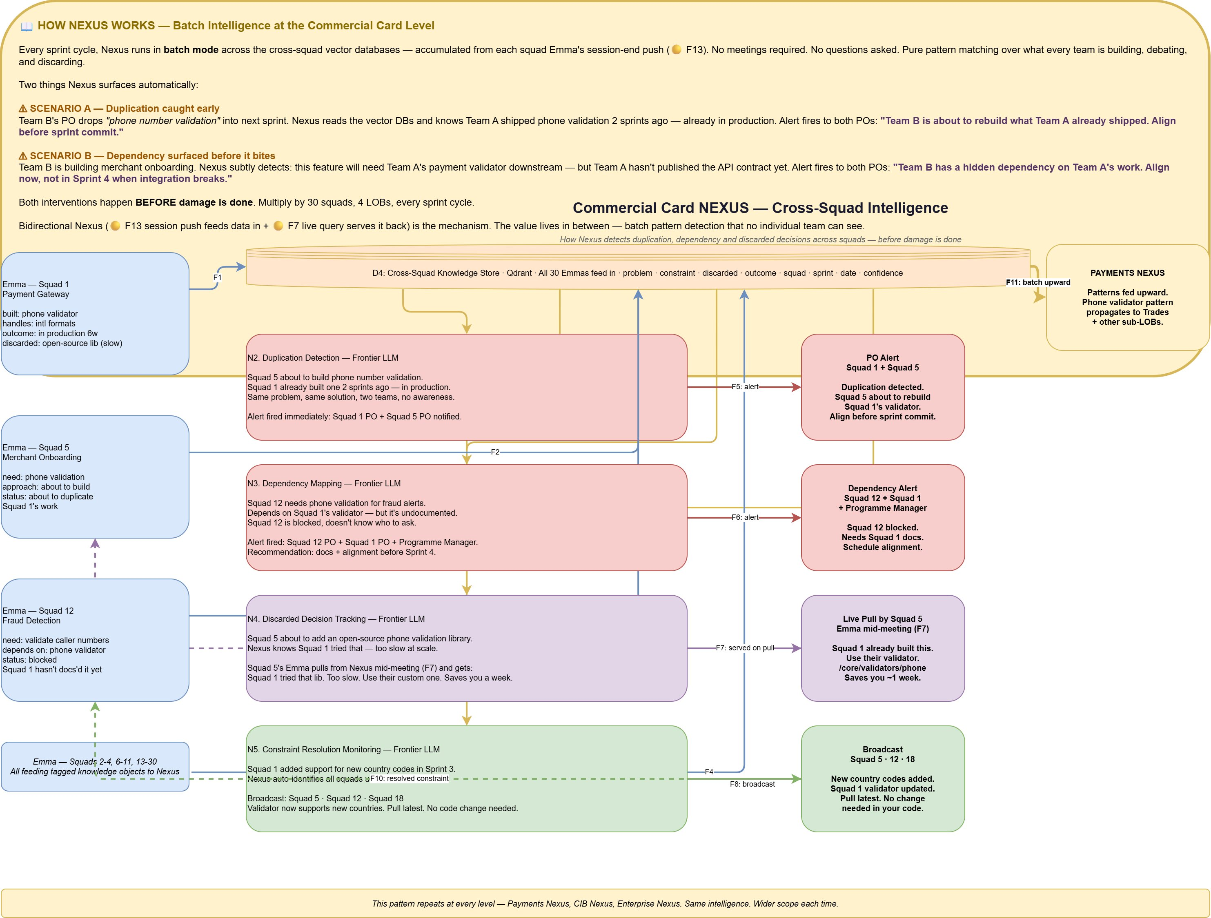

Components
- D4 - Cross-Squad Knowledge Store - a vector database (Qdrant, OpenSearch, or equivalent) that aggregates all structured knowledge objects pushed by every squad Emma at session close. Each object is atomic and self-contained - a single decision, constraint, discarded approach, or outcome with full metadata (type, feature, squad, sprint, date, confidence). Because the objects are already small and bounded, dense vector search with hybrid retrieval (ColBERT + dense) is the appropriate retrieval strategy; structure-aware retrieval is not needed at this layer.
- Duplication Detection (N2) - a frontier-LLM-driven pattern matcher that identifies when two or more squads are building - or about to build - the same feature. Produces PO Alerts dispatched asynchronously to the impacted squads.
- Dependency Mapping (N3) - a frontier-LLM-driven pattern matcher that identifies hidden cross-squad dependencies - for example, Squad 12 building something that depends on Squad 1's undocumented validator. Produces alerts to impacted POs and the program manager with recommendations for documentation and alignment.
- Discarded Decision Tracking (N4) - a frontier-LLM-driven pattern matcher that tracks approaches squads have tried and discarded. When another squad queries Nexus via F7 about the same approach, Discarded Decision Tracking serves the prior finding back on pull.
- Constraint Resolution Monitoring (N5) - a frontier-LLM-driven pattern matcher that tracks constraints introduced in one squad's context and detects when they are resolved. When a constraint is resolved - for example, Squad 1 adds support for new country codes - Nexus auto-identifies all squads previously affected by the constraint and broadcasts the resolution.
- PO Alert Dispatcher - asynchronous notification layer for duplication, dependency, and constraint-resolution alerts. Delivered via email, team dashboards, or Teams/Slack channels to impacted POs and program managers.
- F7 - Served on Pull - discarded-decision findings and cross-squad prior art served on demand to Emma during a live meeting within two to three seconds. The same knowledge store that feeds batch detection also serves live queries.
- F11 - Batch Upward - higher-level patterns identified at the Sub-LOB Nexus feed upward into the LOB Nexus (and on to Enterprise) in batch, so that cross-sub-LOB patterns become visible at the next level.

End-to-End
Nexus operates in two distinct modes: batch (described in this diagram) and on-demand query (described in Diagram 4). This diagram focuses on the batch mode - the scheduled pattern-detection cycles that produce the cross-squad intelligence alerts that protect impacted teams before damage is done.
Every sprint cycle, Nexus runs in batch mode across the Cross-Squad Knowledge Store (D4) - accumulated from each squad Emma's session-end F13 Push. No meetings required, no questions asked: pure pattern matching over what every team in the sub-LOB is building, debating, and discarding. Four pattern matchers run against the accumulated data - Duplication Detection, Dependency Mapping, Discarded Decision Tracking, and Constraint Resolution Monitoring. Each produces findings that are routed to the PO Alert Dispatcher, which delivers them asynchronously to impacted Product Owners and program managers through email, dashboards, and messaging channels. The same knowledge store is also available to the query path for F7 pulls from live sessions - when a squad Emma queries Nexus mid-meeting about an approach, Discarded Decision Tracking can serve the finding back on pull fast enough for Emma to bridge naturally in spoken response. Patterns detected at this level feed upward via F11 Batch Upward to the LOB Nexus, where cross-sub-LOB patterns become visible at the next scope.

Flow
Consider the Commercial Card Nexus in action. Squad 1 has been building a phone number validator. At session end, its Emma pushed structured objects to Nexus: built: phone validator; handles: intl formats; outcome: in production 6 weeks; discarded: open-source library (too slow). Squad 5 is about to start merchant onboarding and has identified a need for phone number validation. At session end, its Emma pushed: need: phone validation; approach: about to build; status: about to duplicate Squad 1's work. The Duplication Detection component reads both objects, recognises the pattern, and produces a PO Alert routed to both squads' Product Owners through the Alert Dispatcher: "Team B is about to rebuild what Team A already shipped. Align before sprint commit."
Meanwhile, Squad 12 is building fraud detection and has a need to validate caller phone numbers. Its dependency on Squad 1's validator is present in Squad 12's D2 objects - but Squad 1 has not yet documented the validator. The Dependency Mapping component detects that Squad 12 is blocked and the dependency is undocumented. An alert is dispatched to Squad 12 PO, Squad 1 PO, and the program manager with a recommendation for documentation and alignment before Sprint 4.
Discarded Decision Tracking operates on the live path as well. Squad 5 is discussing in a live session whether to add an open-source phone validation library. Squad 5's Emma issues an F7 Pull. Discarded Decision Tracking - which already knows from Squad 1's prior session push that the open-source library was tried and discarded as too slow at scale - serves the finding back to Squad 5's Emma mid-meeting: "Squad 1 tried that library. Too slow at scale. Use their custom one at /core/validators/phone. Saves you about a week." Emma relays this in her spoken response. Squad 5 avoids the dead end.
When Squad 1 adds support for new country codes in Sprint 3 - improving the validator - that resolution is in Squad 1's session push. Constraint Resolution Monitoring auto-identifies all squads previously affected by the constraint and the Alert Dispatcher broadcasts the resolution to Squad 5, Squad 12, Squad 18, and any others: "New country codes added. Squad 1 validator updated. Pull latest. No change needed in your code."
All of this happens before damage is done - before the sprint commits the duplication, before the integration breaks, before another team wastes a week on a dead-end library. Multiply by thirty squads, four LOBs, every sprint cycle. At the same time, the patterns Nexus detects at Commercial Card level feed upward via F11 Batch Upward into the Payments Nexus, where cross-sub-LOB patterns become visible at the next scope up. The same pattern repeats at every level - Payments, CIB, Enterprise - each operating the same intelligence loop over a wider aperture of accumulated knowledge.
Bidirectional Nexus - F13 session push feeding data in, F7 live query serving it back out, with batch detection in between producing async alerts - is the mechanism. The value lives in between: batch pattern detection across cross-squad memory that no individual team can see from its own vantage point.

Diagram 4 - Nexus Architecture (How It Works Internally)
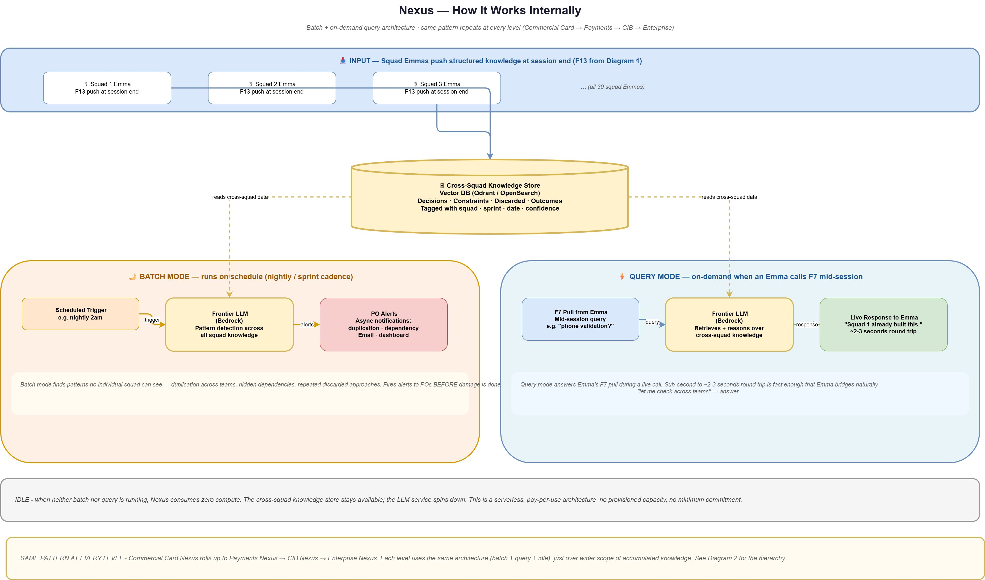

Components
- Input - Squad Emma F13 Pushes - at session end, each squad Emma pushes a batch of structured knowledge objects (decisions, constraints, discarded approaches, outcomes with full metadata) into the Cross-Squad Knowledge Store.
- Cross-Squad Knowledge Store - a vector database (Qdrant, OpenSearch, or equivalent) that holds the accumulated knowledge from all squads in the scope of this Nexus level. Always available; decoupled from compute. Because the stored objects are atomic and self-contained, dense vector search with hybrid retrieval is appropriate - structure-aware retrieval is not required at this layer.
- Batch Mode - Scheduled Trigger - fires on a defined cadence (for example, nightly or at sprint end). Triggers the batch analysis cycle.
- Batch Mode - Frontier LLM (Pattern Detection) - spins up on trigger; reads the Cross-Squad Knowledge Store; runs pattern detection (duplication, dependency, discarded-decision, constraint resolution) across the full accumulated data set. Hosted on AWS Bedrock or equivalent enterprise gateway. Spins down on completion.
- Batch Mode - PO Alerts - asynchronous notifications dispatched to impacted POs and program managers via email and dashboards. Delivery is not time-critical in the millisecond sense - findings arrive before the next sprint commit.
- Query Mode - F7 Pull from Emma - mid-session query from a squad Emma. Triggers on demand; for example, "phone validation?"
- Query Mode - Frontier LLM (Retrieval + Reasoning) - retrieves relevant objects from the Cross-Squad Knowledge Store and reasons over them to produce a response. Kept warm via provisioned concurrency or a low-idle-timeout warm pool so response is consistently within two to three seconds round trip.
- Query Mode - Live Response - returned to Emma fast enough to bridge naturally in spoken response. Fast enough that Emma bridges naturally with "let me check across teams…" in her spoken response.
- Idle State - when neither batch nor query is running, the Nexus LLM service spins down; the Cross-Squad Knowledge Store stays available but consumes only storage cost. This is a serverless, pay-per-use architecture - no provisioned capacity, no minimum commitment. Enterprise cost scales with usage, not with scale.

End-to-End
Nexus is an event-driven service with three states: batch, query, and idle. Input flows in continuously as squad Emmas end their sessions and F13 Push structured knowledge into the Cross-Squad Knowledge Store. This store is always available; it is the only component that carries ongoing cost, and that cost is storage, not compute.
The Batch Mode Scheduled Trigger fires on cadence (nightly or sprint-end). The Batch Frontier LLM spins up, reads the Cross-Squad Knowledge Store, runs pattern detection across the accumulated data set, and produces findings. Findings flow to the PO Alert Dispatcher, which delivers them asynchronously to impacted Product Owners and program managers. These alerts are not time-critical in the millisecond sense - they need to arrive before impacted sprints commit, not within seconds of the push that triggered detection. The LLM spins down on completion.
The query mode runs on demand. When a squad Emma issues an F7 Pull from a live session, the Query Frontier LLM activates (kept warm to avoid cold-start penalty), retrieves relevant objects from the Cross-Squad Knowledge Store, reasons over them in the context of Emma's query, and returns a response. Round-trip latency is two to three seconds - fast enough that Emma bridges naturally in her spoken response while the query completes.
When neither batch nor query is running, Nexus is idle. The LLM service spins down. The Cross-Squad Knowledge Store continues to store data but does not consume compute. This is a serverless, pay-per-use architecture - no provisioned capacity, no minimum commitment. Enterprise cost scales with actual usage, which for a well-tuned system is batch cadence plus per-squad query volume. The economics hold at scale because every additional squad adds a small marginal query load but no fixed cost.
The same architecture repeats at every level of the Nexus hierarchy. Sub-LOB Nexus uses this exact batch-plus-query-plus-idle pattern across its squads. LOB Nexus uses the same pattern across its sub-LOBs. Enterprise Nexus uses the same pattern across LOBs. Only the scope of the data changes across levels - the architecture is identical.

Flow

Batch Mode
The scheduled trigger fires. The Frontier LLM service spins up on AWS Bedrock (or equivalent) and reads the accumulated cross-squad objects from the knowledge store. Pattern detection runs across the full data set - duplication, dependency, discarded decision, constraint resolution. When a pattern is detected, findings are routed to the PO Alert Dispatcher, which dispatches asynchronous notifications to impacted POs and program managers via email, dashboards, and messaging channels. The LLM spins down on completion. Total compute time per batch cycle is measured in minutes (not sub-second) because batch completeness matters more than batch latency - alerts need to arrive before impacted sprints commit, not within seconds of the push.

Query Mode
An F7 Pull arrives from a squad Emma mid-session. The query Frontier LLM (kept warm) retrieves relevant objects from the knowledge store and reasons over them in the context of Emma's specific query. A response is returned within a round-trip suitable for live conversation. Emma bridges the round trip in her spoken response with a phrase like "let me check across teams…" Warm-pool provisioning is required because cold-start on a frontier LLM service typically exceeds the latency budget for live conversation; a small always-warm pool absorbs query spikes without cold-start penalties.

Idle State
When neither batch nor query is running, the LLM service is idle or scaled to zero. The Cross-Squad Knowledge Store remains available at storage cost only. Enterprise cost scales with actual usage, not with provisioned capacity. The serverless pay-per-use model holds across all levels of the Nexus hierarchy, making the architecture economically viable at any scope.

Diagram 5 - Memory Architecture, Retrieval & Promotion Loop
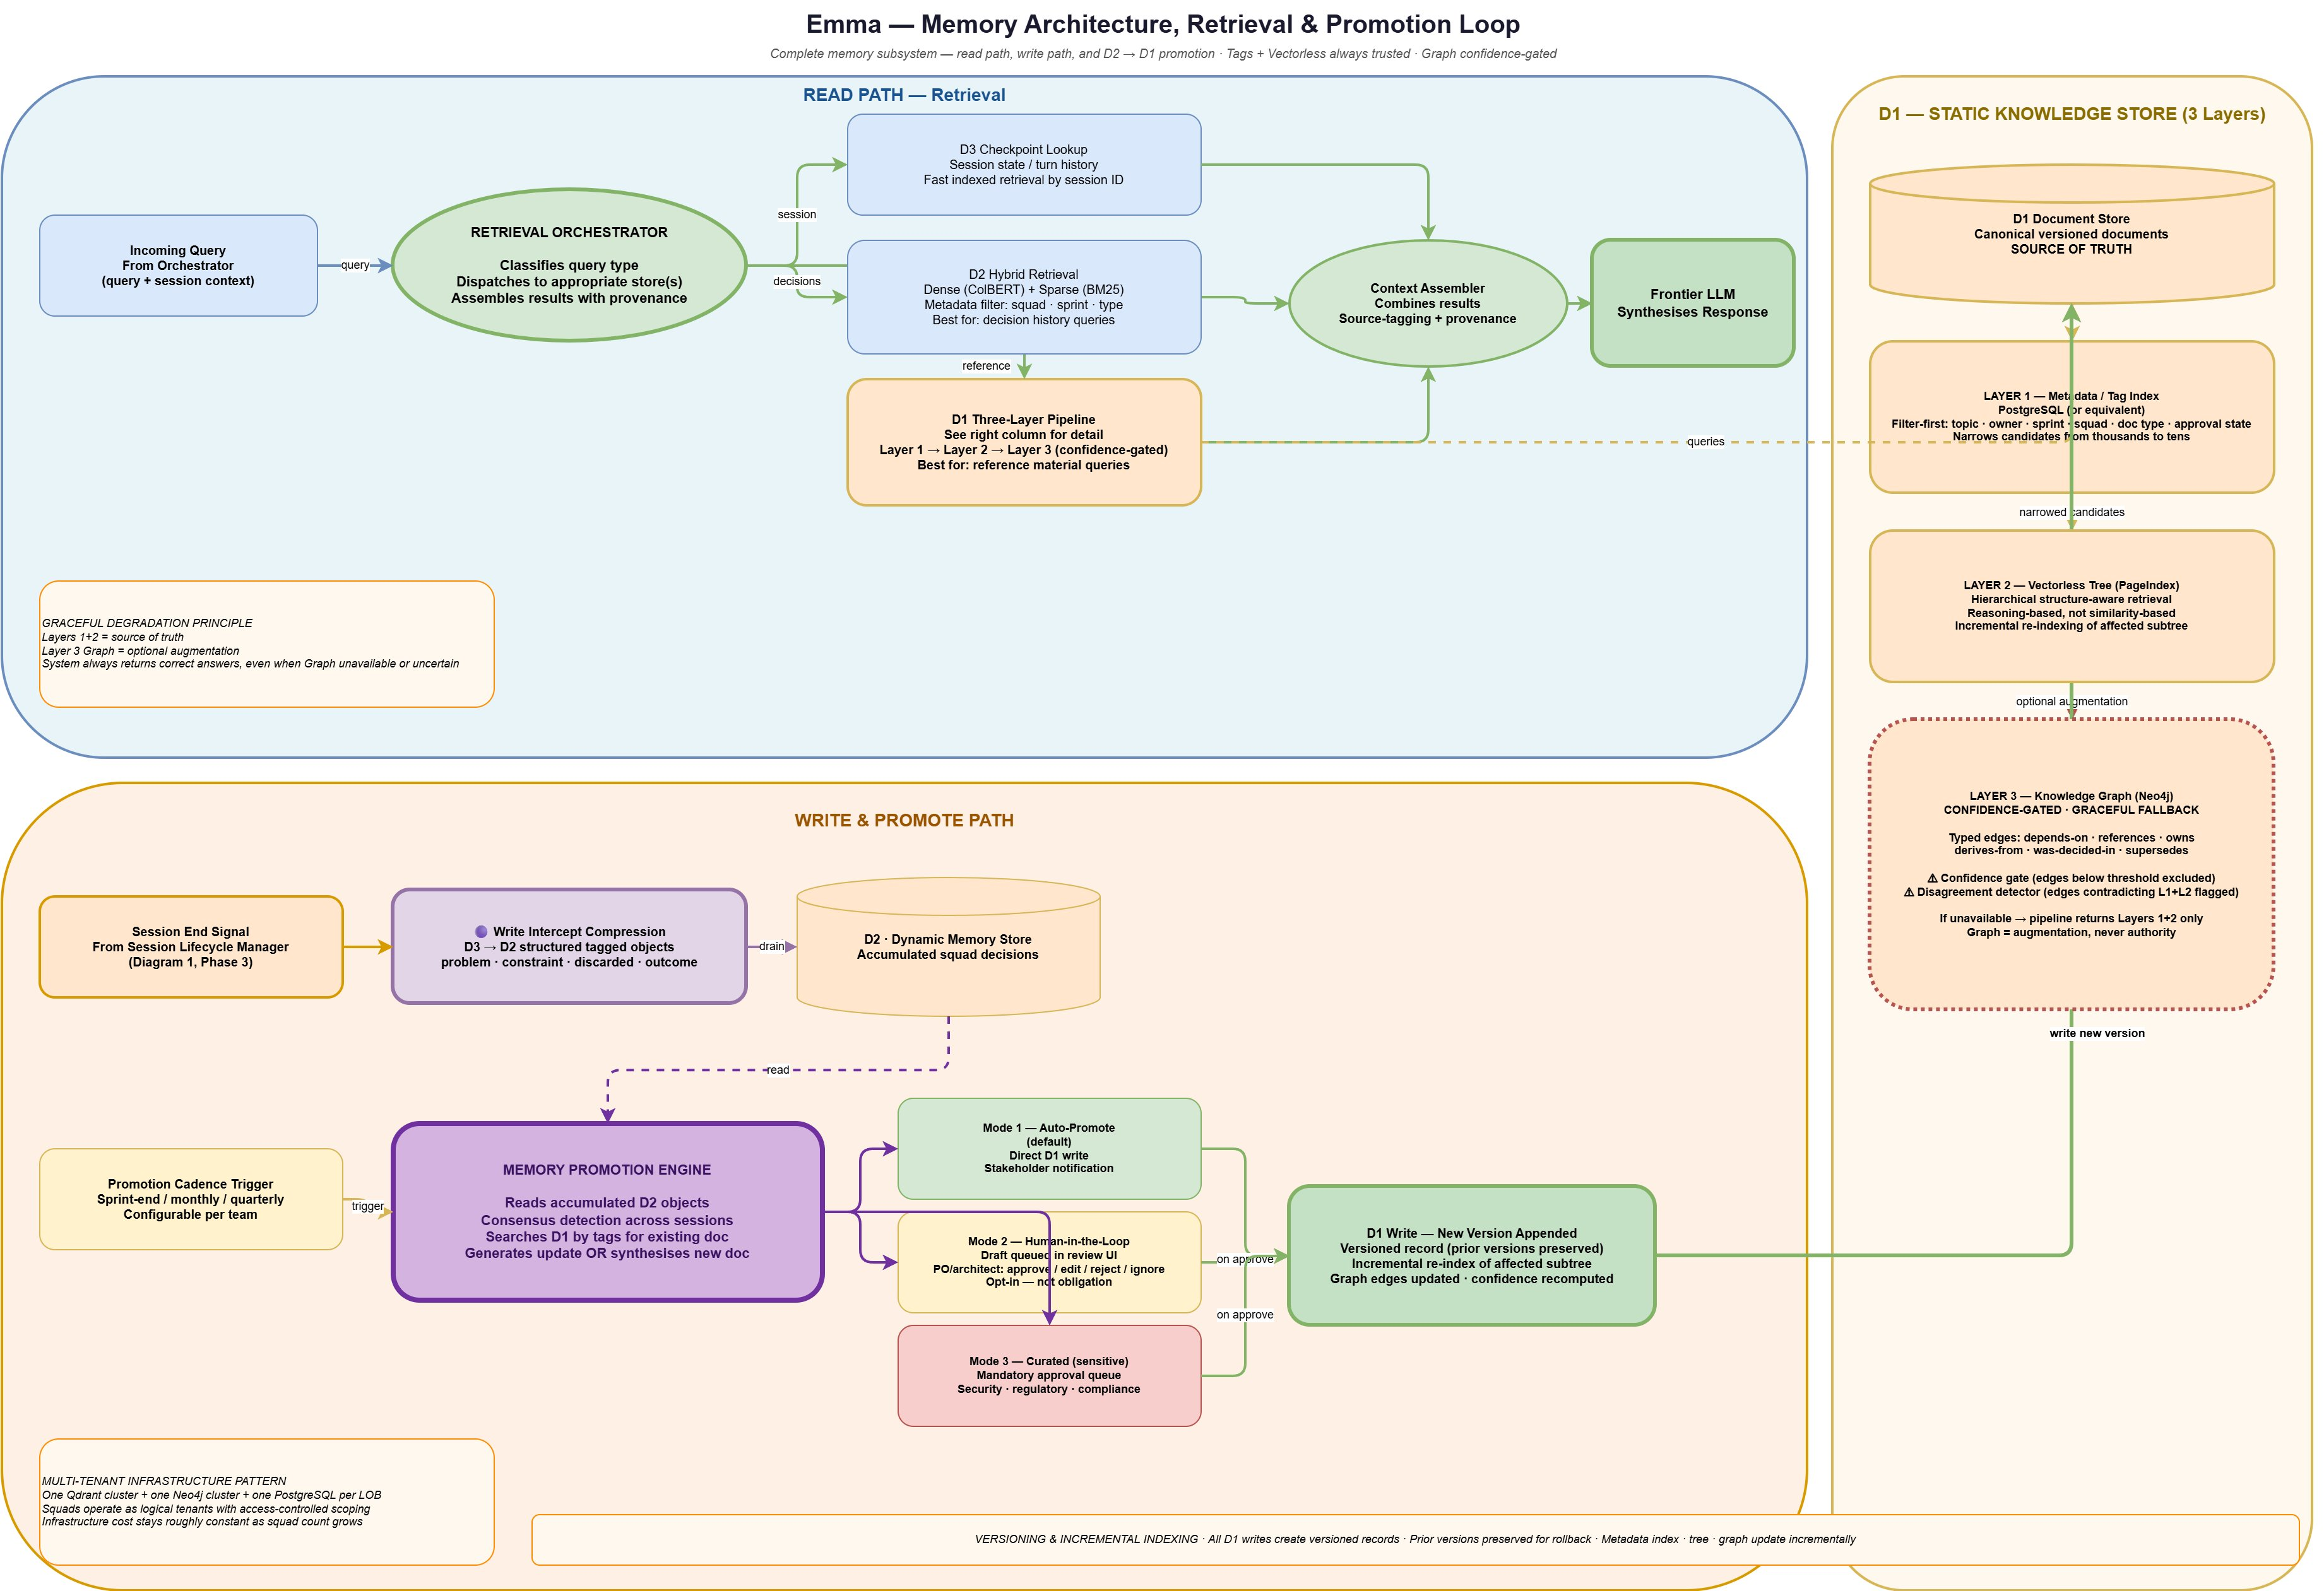

Components
Diagram 5 makes the complete memory subsystem inspectable in a single figure: the read path (retrieval), the write path (session-end compression and promotion), and the three internal layers of D1 that together constitute the team's authoritative reference material. The components below are the elements of that subsystem as shown in the figure.

Retrieval (Read Path)
- Retrieval Orchestrator - classifies incoming queries and dispatches to the appropriate retrieval path. Same component described in Diagram 1 (3.0a); Diagram 5 shows it operating across all three stores and assembling results with provenance for the Frontier LLM.
- D3 Checkpoint Lookup - fast indexed retrieval against session state by session ID and turn number. Used when the query references in-session history, tool results, or agent state.
- D2 Hybrid Retrieval - combines dense semantic retrieval (ColBERT or equivalent) with sparse lexical retrieval (BM25) and metadata filtering by squad, sprint, type, and topic. Best suited for decision-history queries - "have we decided this before?" - where structured tags plus semantic similarity together outperform either alone.
- D1 Three-Layer Pipeline - for reference-material queries, runs the three D1 layers in sequence: Layer 1 (Tags) narrows the candidate set, Layer 2 (Vectorless tree) navigates within selected documents, Layer 3 (Graph) optionally augments with relational context. See right column of the diagram for layer detail.
- Context Assembler - combines results from all active retrieval paths, tags each element with its source and provenance, and hands the assembled context to the Frontier LLM. The Frontier LLM sees where each piece of evidence came from and can cite sources in its response.

Write & Promote Path
- Session End Signal - triggered by the Session Lifecycle Manager described in Diagram 1. Initiates the compression cascade that preserves session knowledge in D2.
- Write Intercept Compression (D3 → D2) - same Write Intercept component described in Diagram 1. At session end, the accumulated D3 session state is compressed into structured tagged knowledge objects - problem, constraint, discarded, outcome - and drained into D2 with full metadata.
- Promotion Cadence Trigger - a separate, independently scheduled trigger - sprint-end, monthly, quarterly, or configured per team - that initiates the Memory Promotion Engine. Deliberately decoupled from session lifecycle: D1 consolidation should happen on its own rhythm as accumulated D2 reaches consensus, not on every session close.
- Memory Promotion Engine - reads accumulated D2 objects, performs consensus detection across multiple sessions, searches D1 by tags and metadata for an existing document on the topic, and either generates an incremental update to that document or synthesizes a new document if none exists. Operates in three configurable modes: (1) fully automated - synthesized updates promote directly to current version with stakeholder notification; (2) human-in-the-loop - synthesized updates land as draft versions in a review queue accessible to Product Owners or architects, who may review, approve, edit, reject, or ignore at their discretion (opt-in, not obligation); (3) curated - for sensitive documents such as security policies and regulatory references, updates require explicit human approval before promotion. Across all modes, prior versions are preserved with full provenance for reversibility and audit.
- D1 Write - New Version Appended - each promotion produces a new version of the target D1 document; prior versions are preserved. The metadata index, the vectorless tree structure, and the knowledge graph all update incrementally - only the affected subtree of the tree rebuilds, only the affected graph edges are recomputed - so update cost is proportional to change size rather than to the total size of the corpus.

D1 Static Knowledge Store - Three-Layer Detail
- D1 Document Store (Source of Truth) - the canonical versioned record of each document - architecture docs, runbooks, policies, coding standards. All other D1 layers are derived from this store and update incrementally when a new version is appended.
- Layer 1 - Metadata / Tag Index - structured store of document-level metadata (topic, owner, sprint, squad, document type, last-updated, approval state) supporting filter-first search. Narrows candidates from thousands to tens before any expensive retrieval runs. Implemented in any indexed metadata store such as PostgreSQL, shared multi-tenant across squads within a sub-LOB.
- Layer 2 - Vectorless Structure-Aware Retrieval - for each document, a hierarchical tree index (PageIndex / vectorless reasoning-based RAG) representing the document's natural section structure. Once candidate documents are selected via Layer 1, the Frontier LLM reasons over the tree structure to navigate to the precise section that answers the query, rather than retrieving by chunk-based vector similarity. Incremental re-indexing - only the affected subtree rebuilds when a document is updated - keeps maintenance cost proportional to change size.
- Layer 3 - Knowledge Graph (confidence-gated, graceful fallback) - typed relationships between documents, services, teams, decisions, people, and constraints. Edges carry types such as depends-on, references, owns, derives-from, was-decided-in, and supersedes. Each edge has a confidence score derived from extraction certainty, edge age, source provenance, and consistency checks against the source-of-truth layers. Below-threshold edges are excluded from retrieval context. When graph relationships disagree with Layers 1 and 2, the graph defers and the disagreeing edge is flagged for re-validation. If the graph layer is unavailable for any reason, the retrieval pipeline continues with Layers 1 and 2 alone - the user still receives a correct answer, possibly with reduced relational depth. This graceful-degradation pattern means the graph layer can fail at any time without producing incorrect results. Graph is treated as augmentation, never as authority.

End-to-End
The memory subsystem operates along two largely independent loops. The read path runs every time Emma needs to answer a question - whether in-session or during a Curated Session. A query arrives at the Retrieval Orchestrator, which inspects the query type (session-context, decision-history, reference-material, or comprehensive) and dispatches to the appropriate store. For comprehensive queries, multiple paths run in parallel. The Context Assembler collects results with source-tagging and provenance, and the Frontier LLM synthesizes the final response. The three D1 layers operate as a pipeline within the reference-material path: Tags narrow, Vectorless navigates, Graph optionally augments.
The write and promote path runs in two distinct rhythms. On every session close, the Session Lifecycle Manager Fires Write Intercept, which compresses D3 session state into tagged knowledge objects in D2. This is the fast, per-session rhythm. Separately, on a configurable cadence - typically sprint-end or monthly - the Memory Promotion Engine reads accumulated D2 objects and checks whether consensus has formed on any topic warranting a D1 document update. If so, the engine searches D1 by tags for an existing document on the topic; if found, it generates a revised version that preserves structure while updating only what has changed; if not found, it synthesises a new document. The update then routes through the configured mode - auto-promote, human-in-the-loop review, or curated approval - and on promotion writes a new version into D1. The metadata index, tree structure, and graph all update incrementally.
The two rhythms deliberately stay decoupled. D2 captures decisions at session speed; D1 consolidates them at a slower rhythm when genuine consensus has formed. Running promotion after every session would mostly produce empty cycles - consensus requires multiple sessions to form - and would couple session lifecycle to D1 maintenance, which is architecturally wrong. Keeping them separate keeps each loop optimised for its own time scale.

Flow

Read Path - Reference-Material Query
A developer asks: "What are our current coding standards for async error handling?" The Retrieval Orchestrator classifies this as a reference-material query and dispatches to the D1 pipeline. Layer 1 filters D1 documents by tags - topic: coding-standards; scope: async; approval-state: current - narrowing from several thousand D1 documents across the squad to three or four candidates. Layer 2 walks the vectorless tree of each candidate, identifying the specific sections that address async error handling. Layer 3 surfaces relational context - which services in the squad depend on these standards, which prior decisions in D2 supersede earlier coding patterns - provided its confidence on those edges exceeds threshold. If Layer 3 is unavailable or its edges low-confidence, the answer still comes back correctly from Layers 1 and 2 alone; the user simply gets slightly less relational depth. The Context Assembler combines results, the Frontier LLM synthesises, Emma answers.

Read Path - Decision-History Query
A developer asks: "Have we made a decision about Kafka consumer group rebalance timing?" This is a decision-history query, dispatched to D2 Hybrid Retrieval. Dense semantic retrieval (ColBERT) identifies D2 objects semantically related to consumer group rebalance; sparse lexical retrieval (BM25) catches exact terminology matches; metadata filtering scopes to the squad's own decisions and recent sprints. The top-ranked decision objects - outcomes, constraints, discarded approaches - return with full metadata. The Frontier LLM synthesises a response that says: yes, we encountered this in Sprint 11, the decision was to adjust heartbeat intervals, the discarded alternative was to add manual commit logic, the reasoning is attached with full provenance.

Write Path - Session-Close Compression
A refinement session ends. The Session Lifecycle Manager fires via its primary signals - webhook close event from the meeting platform plus audio silence timeout. Write Intercept runs compression on the accumulated D3 session state: conversational turns are classified into structured decision objects with full metadata, ephemera is discarded, and the resulting tagged objects drain into D2. The squad's memory is now permanent for the decisions made. In parallel, F13 Pre-Push Enrichment runs the LLM scrutiny pass that prepares the batch for upward flow to Nexus. Session spin-down completes. Nothing is promoted to D1 in this path - D1 updates wait for the Memory Promotion Engine's separate cadence.

Promote Path - D1 Consolidation
At sprint-end, the Promotion Cadence Trigger fires. The Memory Promotion Engine reads the D2 objects accumulated since the last promotion cycle and runs consensus detection: have multiple sessions across this sprint produced compatible decisions on any topic? For each topic where consensus has formed, the engine searches D1 by tags - "coding-standards/async-error-handling" - for an existing document. In this case a document exists, last updated two sprints ago. The engine retrieves the current version, compares against the accumulated D2 decisions, identifies three small additions (new patterns adopted, one deprecated approach) and generates a revised version preserving the document's structure. The team is configured for human-in-the-loop mode on coding standards; the revised version lands as a draft in the review queue. The team's architect reviews it at his convenience the next morning, approves two of the three changes, edits the third for precision, and approves. The revised document writes into D1 as a new version; prior versions are preserved; the vectorless tree re-indexes the affected subtree; the graph updates the edges that reference the document. No human has had to write documentation; the team's institutional knowledge has compounded by one sprint without anyone treating it as a task.

Worked Examples - End-to-End Scenarios
The following examples trace specific scenarios through the full system, showing how components interact to produce observable outcomes. Each example draws on the architecture described in Diagrams 1 through 5. The scenes are intentionally concrete - the kinds of situations that unfold in large engineering organizations every week - so that the system's behavior can be followed end-to-end in a form reviewers can recognize.

Example 1 - Knowledge Transfer When an Expert Leaves
A senior developer with six years on a Commercial Card squad is leaving the team. Over those six years she has been the principal architect of the squad's merchant validation service, the owner of the team's Kafka topology decisions, and the person most developers went to when onboarding into the codebase. Her departure is announced two weeks in advance. In a typical organization, these two weeks would be filled with ad-hoc hallway conversations, half-written Confluence pages, and the resigned acceptance that much of her context will be lost.
The squad lead initiates a Curated Session Trigger in knowledge-transfer mode. Emma spins up in a dedicated session with the departing developer and three squad members. The session runs over the squad's usual meeting platform - in this case a Teams call scheduled specifically for the knowledge transfer - with STT Module, Diarization Module, and Voice Emotion Module running continuously. Participant identity is resolved via Enterprise SSO. Emma hydrates context from D1 (architecture documents, runbooks) and D2 (prior decision history), so she already knows what the squad has captured before - and by extension, what has not been captured.
The session runs for ninety minutes. The departing developer walks through the merchant validation service architecture, the Kafka topology, the reasoning behind three controversial decisions from two years ago, the operational quirks she learned to work around, and the list of stakeholders outside the squad whose context matters. As she speaks, the Orchestrator classifies content and the Write Intercept Module tags and persists it to D2 in real time. Decisions are tagged as outcomes with reasoning. Architectural quirks are tagged as constraints. Approaches she tried and abandoned years earlier are tagged as discarded, with the reasoning attached. Linked entities - services, repositories, stakeholders, runbooks - are captured with metadata. Emma asks clarifying questions when reasoning is ambiguous, prompts her for the contextual constraints behind decisions, and confirms attribution before persisting.
At session close, the Write Intercept compression runs and drains D3 into D2 as structured tagged knowledge objects. A batch is pushed via F13 Push to Nexus so that other squads dependent on the merchant validation service are aware of the change of ownership and the newly documented context. The squad now carries forward the departing developer's reasoning in structured, retrievable form. Three sprints later, when a question arises about why the Kafka topology was configured a certain way, the squad's new joiner asks Emma directly - and Emma returns the answer from D2 with full provenance and reasoning attached. The knowledge did not leave with the person.

Example 2 - New Joiner Onboarding via Curated Session
A new developer joins the Merchant Onboarding squad. In a typical organization, her first four weeks are dominated by shadowing senior developers, reading stale Confluence pages, and asking basic questions in Slack that pull multiple team members out of focused work. Onboarding consumes roughly thirty percent of the senior developers' time for those weeks.
On her first day, the squad lead triggers a Curated Session for onboarding. Emma spins up in the medium most convenient for the developer - in this case, a direct audio interaction through her laptop and headset, with no meeting platform required. She could equally have joined via Teams or sat in a conference room with a shared microphone; the Session Lifecycle Manager handles session lifecycle identically across mediums. Emma hydrates from D1 (architecture, runbooks, policies) and D2 (the squad's decision history from prior sprints). The new developer begins by asking basic contextual questions: "What does this squad own?", "What are the main services?", "What are the current active workstreams?". The Orchestrator routes each question through hybrid retrieval against D1 and D2 and then to the Frontier LLM. Emma's responses combine architectural context, recent decisions, and active priorities. Where visual explanation helps, the Canvas Renderer draws service maps, flow diagrams, and data-flow visuals alongside Emma's spoken explanation, and Multi-Modal Link Dispatch sends a link the new developer can open on her laptop for detailed viewing.
Over the following days, she continues to query Emma. When she asks why a particular validator is custom-built rather than using an open-source library, Emma returns the reasoning from D2 - captured by the previous developer three sprints ago, tagged with constraint (latency at scale) and discarded (open-source library too slow). When she asks how a cross-squad integration works, the Orchestrator issues an F7 Pull to Nexus and returns the relevant cross-squad context. The senior developers on the squad are not pulled out of their work to explain the same concepts every new joiner asks.
Her ramp-up time drops from months to weeks. The senior developers reclaim their time. And critically, the questions she asks and the clarifications Emma provides are themselves captured into D2 via Write Intercept - building a library of onboarding context that improves the experience for every subsequent new joiner.

Example 3 - Developer Blocked Across Time Zones
A developer in Singapore is working at 11pm local time, finishing a merchant integration feature before the sprint commit window closes. He hits a blocker on a merchant validation edge case: an unusual phone number format from a specific regional carrier that fails the squad's validator. He needs to know whether the team has handled this case before, or whether the validator should be extended. The Product Owner in London will not be online for another seven hours.
He addresses Emma directly: "Hey Emma, have we handled Myanmar mobile number formats in our phone validator before?" The Wake Word Detection identifies the invocation. The Orchestrator routes the query through hybrid retrieval against D1 and D2. D2 returns two relevant prior decisions: one constraint tagged two sprints ago about unusual regional formats, and one discarded approach about adding region-specific validators. The Frontier LLM reasons over the retrieved context and produces a response - but Emma's confidence on the specific Myanmar case is below threshold; the prior constraint was about a different region.
The Escalation Dispatcher activates. Emma provides her best-attempt answer immediately via TTS: "The team has handled unusual regional formats before - a similar case was raised two sprints ago for a different region. The approach the team took was to extend the validator rather than add a region-specific one. I don't have specific coverage for Myanmar mobile formats, so I'm going to draft an escalation to the Product Owner with full context so she can confirm the approach when she's online." In parallel, the Escalation Dispatcher drafts an email to the Product Owner with the full question, the retrieved context from D2, Emma's best-attempt reasoning, and the specific confidence gap. The developer unblocks himself on the best-attempt answer and proceeds; he commits provisional code with a pending review flag.
Seven hours later, the Product Owner comes online in London and reads Emma's escalation email. She reviews the retrieved context, confirms that the validator-extension approach is correct, adds the Myanmar format handling specifics, and sends a reply. Emma receives the response, writes the resolution back to D2 via Write Intercept - tagged as outcome with the full reasoning - and notifies the developer. The PO's answer is now permanent team memory. The next developer who hits a similar question at 11pm Singapore time will get the answer from D2 directly. The same question never escalates twice.

Example 4 - Cross-Squad Duplication Caught at Refinement
A Merchant Onboarding squad (Squad 5) is in a backlog refinement session. The team is scoping out a new feature for Sprint 14 - phone number validation as part of the onboarding flow. The Product Owner proposes building a phone validator as part of the sprint: "We'll build our own phone number validator. Should be a couple of sprints of work."
Emma, listening continuously, recognizes a topic with potential cross-squad relevance. The Orchestrator issues an F7 Pull to the sub-LOB Nexus. The Nexus query path activates - the Query Frontier LLM retrieves relevant objects from the Cross-Squad Knowledge Store (D4). Within two seconds, Nexus returns: Squad 1 on the Payment Gateway team built a phone number validator six weeks ago. It is in production, handling international formats, located at /core/validators/phone. Squad 1 also tried and discarded an open-source library as too slow at scale. Both objects are tagged with full provenance.
Emma proactively speaks, interrupting the flow of the refinement before the team commits: "Quick note before we go further - Squad 1 on Payment Gateway shipped a phone number validator six weeks ago. It's in production at /core/validators/phone, handling international formats. They also tried an open-source library first and discarded it as too slow at scale. I'd recommend we use Squad 1's validator rather than build our own - saves you roughly two sprints of work and you get the battle-tested version. Want me to reach out to their PO for alignment?" The refinement pauses. The PO agrees. Emma drafts a coordination note to Squad 1's PO via the MCP Tools Layer, tags the decision in D2 as outcome (adopted cross-squad solution), and the refinement continues with a different feature.
In parallel, the sub-LOB Nexus batch cycle running that night picks up the signal through Duplication Detection (N2). The PO Alert Dispatcher sends an asynchronous notification to both POs confirming the alignment - Squad 5 will not rebuild what Squad 1 has already shipped. The duplication is caught before sprint commit. Two sprints of duplicated work are avoided. Multiply this across thirty squads in the sub-LOB every sprint cycle.

Example 5 - Discarded Approach Surfaced Before Adoption
A Fraud Detection squad (Squad 12) is in a design session discussing phone number validation for caller verification. The lead engineer, confident and well-intentioned, proposes: "Let's just pull in an open-source phone validation library - there's a popular one that handles all international formats. Should take a day to integrate." The team begins nodding.
The Orchestrator recognizes the topic and issues an F7 Pull to the sub-LOB Nexus. Discarded Decision Tracking (N4) at the Nexus has a direct match: Squad 1 on Payment Gateway tried that exact library six months ago and discarded it as too slow at scale. The reasoning and benchmark data are tagged on the discarded object. Within two seconds, the finding returns to Squad 12's Emma.
Emma speaks into the session: "Quick heads up before you commit to that. Squad 1 on Payment Gateway tried that library six months ago and discarded it - it hit latency limits at production scale. Their benchmark showed 400ms per validation at p95, which didn't meet their SLA. They built a custom validator instead, which is now in production at /core/validators/phone. Given your fraud detection use case has similar latency constraints, I'd recommend you use Squad 1's validator rather than repeat the same dead end." The lead engineer pauses, then agrees. The team pivots to adopting Squad 1's validator. The exchange writes back to D2 via Write Intercept - tagged as constraint (latency requirement), discarded (open-source library, too slow), outcome (adopted cross-squad solution). The squad avoids approximately one week of integration work followed by the painful discovery that the library fails at scale.
This pattern is the core value of the cross-squad memory layer. Without Nexus, Squad 12 would have discovered the latency problem themselves - the same discovery Squad 1 made six months earlier, costing the same time and the same effort. With Nexus, the prior discovery is surfaced in the two seconds it takes to run an F7 Pull. The organization’s learning compounds rather than resets.

Example 6 - Stand-Up Blocker Resolved via Cross-Squad Runbook
A daily stand-up begins. The Playbook Engine recognizes the ceremony structure - each developer reports in turn, blockers are surfaced, dependencies are mentioned. A developer reports: "I'm blocked on the Kafka partition issue - still haven't figured out why consumer 3 is getting duplicate messages. Been stuck on it since yesterday afternoon."
The Playbook triggers the Orchestrator to proactively respond to the blocker rather than wait to be asked. The Orchestrator queries D2 for prior Kafka-related issues on this squad - no direct matches. It then issues an F7 Pull to the sub-LOB Nexus. The Nexus query path returns fast enough for Emma to respond in-session: Squad 3 on Trades hit the same Kafka partition issue in Sprint 11; their root cause was consumer group rebalance timing; their fix is documented in the Trades team runbook at a specific location; and the fix includes a configuration change plus a monitoring guardrail to prevent recurrence.
Emma - proactively, without being addressed by name - speaks into the stand-up: "Quick input before we move on. Squad 3 on Trades hit exactly this issue in Sprint 11. Their root cause was consumer group rebalance timing - duplicate delivery during rebalance windows. Their fix is documented in the Trades runbook, and it includes a configuration change plus a monitoring guardrail. Want me to pull up the relevant section on Canvas?" The developer says yes. The Canvas Renderer renders the relevant portion of the Trades runbook in real time, synchronized with Emma's spoken explanation. Multi-Modal Link Dispatch sends a link to each stand-up participant via the meeting chat. Participants authenticate via Enterprise SSO and the diagram loads on their laptops. The Participant Engagement Tracker confirms the blocked developer has opened it.
The blocker resolves in the next twenty minutes - the developer applies the configuration change from Squad 3's runbook and the duplicate-message issue disappears. The exchange is written to D2 via Write Intercept as outcome (Kafka rebalance fix from Squad 3 applied), with linked entity to the Trades runbook section. The next time a squad within this sub-LOB hits the same issue, the answer is in local D2 - no Nexus round-trip required. The stand-up that would have continued with a blocked developer for another day instead resolves the blocker in real time, with knowledge from an entirely different LOB, without any human ever needing to know where to look.

What Makes This Combination Work
The individual technical components Emma and Nexus use are, for the most part, available in the field today. Streaming speech-to-text, voice emotion detection, frontier LLMs, vector databases, retrieval-augmented generation, knowledge graphs, meeting participation bots, and enterprise SSO integration are all established technologies. The following five mechanisms are highlighted as the novelty of the system - the specific combinations and capabilities that produce behavior not available from the individual components alone. A sixth characteristic - compounding institutional memory - emerges as a system-level outcome of the mechanisms working together.

Mechanism 1 - Emotion-Adaptive Response Routing (F3)
Voice-based emotion detection is not new. What is distinctive is using the detected emotion vector to route response generation directly - bypassing the full retrieval-plus-reasoning loop and changing the structure of the response itself based on the emotional state of the participant. Most systems that detect emotion log it as metadata. In this system, emotion is a control signal that changes how the reasoning pipeline executes: the response is delivered slower, broken into distinct steps, and structured for comprehension rather than density. This is integrated with the system's memory architecture - emotional context is captured and written to D2 alongside the decisions made under that emotional state, making it possible to reason about emotional dynamics across sprints.

Mechanism 2 - Structured Decision Capture via Write Intercept (F11/F12)
Meeting transcription is a solved problem. What distinguishes this system is the Write Intercept mechanism: during the meeting itself, the Orchestrator recognizes decision patterns in conversation and intercepts the content before persistence, classifying it into structured tags (problem, constraint, discarded, outcome) and enriching it with metadata (feature, sprint, squad, timestamp, reason, linked entities). The result is that memory compounds over time in a structured, retrievable form - not as a raw transcript that loses meaning, but as tagged knowledge objects that support semantic retrieval sprint over sprint. A decision made in Sprint 4 remains directly retrievable in Sprint 40 with its full context: what problem it addressed, what constraints it was bounded by, what approaches were discarded, what the actual outcome was. This structural capture during the live meeting - not as a post-meeting summarization step - is distinctive.

Mechanism 3 - Bidirectional Cross-Squad Memory via Nexus (F7/F13)
Cross-team knowledge sharing has been addressed by enterprise search, documentation platforms, and communities of practice. What distinguishes this system is the bidirectional, architecturally-integrated cross-squad memory loop. Each squad Emma pushes structured knowledge to the cross-squad layer (Nexus) at session close (F13). Each squad Emma pulls from Nexus during live sessions for cross-squad prior art (F7) with two to three second round-trip latency. Between those two directions, Nexus runs batch pattern detection across all accumulated squad knowledge - duplication, dependency, discarded decision, constraint resolution - and dispatches asynchronous alerts to impacted Product Owners before sprint commits lock in duplicated or conflicting work. The architectural uniformity of the Nexus layer at every level (squad to sub-LOB to LOB to enterprise) means the same mechanism produces cross-organizational intelligence at arbitrary scale without structural change. Emmas do not communicate directly with each other - they cannot, because Emma only exists during a session - so the continuously-available Nexus layer is the only path through which cross-squad memory flows. This necessity becomes an architectural strength: all cross-squad knowledge is routed through a consistent, tagged, queryable layer rather than through ad-hoc channels.

Mechanism 4 - Ceremony-Aware Proactive Agent (Playbook Engine)
Rule engines are not new. Voice AI agents are not new. What is distinctive is a voice-first agent whose proactive behavior is driven by an encoded structural model of the team's process - specifically, agile ceremonies in the initial implementation - and integrated with the same compounding memory architecture. The Playbook Engine defines, for each process type, what roles participate, what signals mark phase transitions, what artifacts are typically produced, and what actions the agent should proactively take at defined triggers. As a team works through a ceremony, the Playbook prompts the agent to engage at the right moments without waiting to be asked: summarizing acceptance criteria at the end of refinement, checking cross-squad prior art when a blocker is raised in stand-up, offering to write Jira tickets when decisions are reached. The mechanism is extensible - any recurring structured process with known participants, phases, and artifacts can be encoded, including architecture reviews, incident post-mortems, and research review cycles - broadening the system's applicability beyond software engineering.

Mechanism 5 - Closed-Loop Memory Promotion with Safe-Fallback Retrieval (Memory Promotion Engine + Three-Layer D1)
Document management systems are not new. Versioned document stores are not new. Knowledge graphs are not new. What is distinctive is the closed loop the system forms between dynamic decision capture (D2) and static reference material (D1), combined with a three-layer retrieval architecture that is defensively designed to never produce wrong answers. Three elements make this mechanism distinctive:
First, automated promotion from D2 decisions to D1 documents. The Memory Promotion Engine periodically reads accumulated D2 objects, detects consensus across multiple sessions, searches D1 for existing documents on the topic, and either updates them incrementally or synthesizes new ones. Documentation that would otherwise depend on humans having time to write stays current automatically as decisions stabilize. This directly addresses the "documentation goes stale" problem at an architectural level rather than through better documentation practices.
Second, three configurable promotion modes per document or per team - fully automated, human-in-the-loop with opt-in draft review, and curated requiring explicit approval for sensitive documents. Human involvement is an available capability rather than an obligation; a Product Owner or architect can engage with the review queue at their discretion or leave the engine to run autonomously. This preserves the autonomy of automated synthesis while respecting the reality that some documents (security policies, regulatory references) genuinely require human sign-off.
Third, a three-layer D1 retrieval architecture with graceful degradation. D1 is not a single store but three coordinated layers - a metadata/tag index for filter-first narrowing, a vectorless structure-aware tree (PageIndex) for reasoning-based within-document navigation, and a knowledge graph for relational context. Critically, the graph layer is confidence-gated: each edge carries a confidence score, below-threshold edges are excluded from retrieval context, disagreements with the source-of-truth layers cause the graph to defer, and if the graph layer is unavailable the pipeline continues with tags and vectorless alone. The user always receives a correct answer - the graph either adds relational depth when it can, or stays silent when it cannot. This defensive composition means the most ambitious layer (graph) can fail at any time without producing incorrect results, which is essential at enterprise scale where graph quality degrades with ontology drift and stale relationships.
The three elements together form a closed loop: dynamic decisions captured in D2 drive automatic synthesis of versioned D1 reference material, which in turn improves the quality of reference-material retrieval the next time a question is asked. Institutional reference material becomes a living artefact maintained by the system itself, with graceful fallback ensuring correctness at every retrieval. Neither element alone is novel; their composition as a closed, defensive, continuously-updating memory mechanism is.

Emergent Outcome - Compounding Institutional Memory
Taken together, the five mechanisms above produce an emergent system-level outcome: compounding institutional memory. Every meeting adds structured, retrievable knowledge to a team's local memory (via Write Intercept) and to the cross-squad intelligence layer (via Nexus). Knowledge does not degrade with attrition - when a senior developer leaves, the decisions they made, the constraints they operated under, the approaches they discarded, and the outcomes they produced remain in D2 and Nexus in structured tagged form. New joiners can query that memory directly through a Curated Session. Cross-team duplication and dependency risk decreases as Nexus accumulates more squad history. The ceremony-aware proactive behavior means the memory is captured actively during the meeting, not retrospectively after it. The Memory Promotion Engine keeps authoritative reference material current without depending on manual documentation work, and the confidence-gated graph layer ensures that retrieval at scale produces correct answers even when the most ambitious layer cannot contribute. The uniform architecture at every level means the same compounding behaviour operates at squad scope, sub-LOB scope, LOB scope, and enterprise scope - making institutional memory a first-class property of the organisation rather than an accidental byproduct. This system-level outcome is not produced by any individual component; it is produced by the combination of mechanisms described above operating within a consistent architecture at scale.

