# Document for Comp1036 – ALU Assignment

GAO Tianyi — 20028309 — scytg1@nottingham.edu.cn

## HDL files

|  |  |
| --- | --- |
| **cALU.hdl** | Main ALU chip |
| **Addo16.hdl** | A chip which can add two 16bit number and check overflow |
| **Mulo16.hdl** | A chip which can multiply two 16bit number and check overflow |
| **Or16Way.hdl** | A chip which receive 16bit number and do and or the every bit and output a 1bit number |
| **ShiftRight.hdl** | A chip which can shift 1bit right to right for every bit in a 16bit number |

## cALU implementation

The cALU chip receives two main numbers and other seven arguments, the detailed instruction for functions is in the form following:

|  |  |  |  |  |  |  |  |  |  |
| --- | --- | --- | --- | --- | --- | --- | --- | --- | --- |
| **Functions\Arguments** | **x** | **y** | **nx** | **zy** | **ny** | **no** | **cx** | **re** | **op** |
| **1) Negate the value of x** | x | NULL | 0 | 1 | 1 | 1 | 0 | 0 | 0 |
| **2) Increment the value of x** | x | NULL | 1 | 1 | 1 | 1 | 0 | 0 | 0 |
| **3) Decrement the value of x** | x | NULL | 0 | 1 | 1 | 0 | 0 | 0 | 0 |
| **4) Add x to y** | x | y | 0 | 0 | 0 | 0 | 0 | 0 | 0 |
| **5) Subtract y from x** | x | y | 1 | 0 | 0 | 1 | 0 | 0 | 0 |
| **6) Subtract x from y** | x | y | 0 | 0 | 1 | 1 | 0 | 0 | 0 |
| **7) Multiply x and y** | x | y | 0 | 0 | 0 | 0 | 0 | 0 | 1 |

## Gate diagram for optional 7th bit (Multiply)

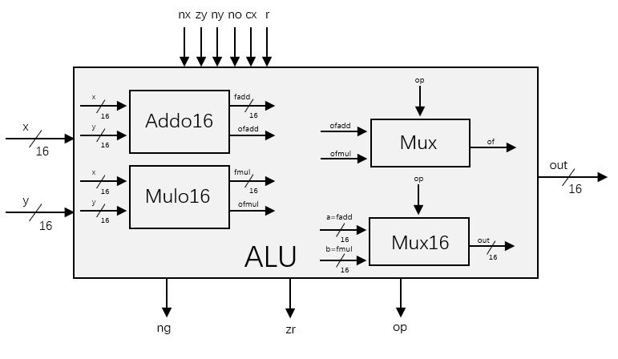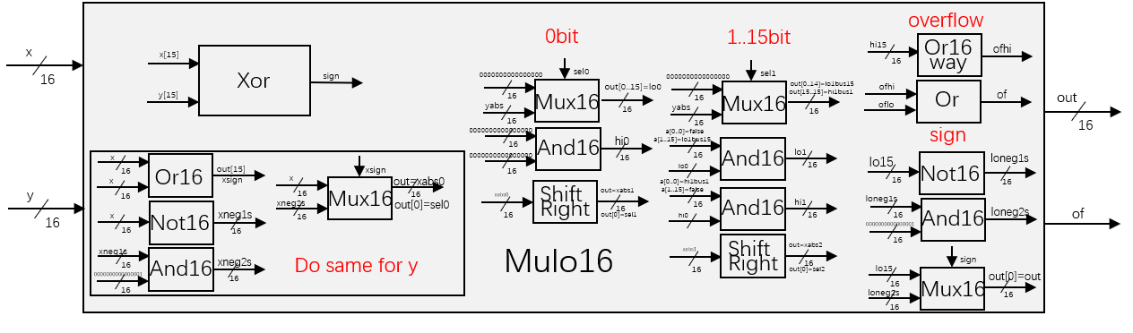

overflow