***business area:*** LI&AT – Platform Modernization and design

APPLICATION NAME: TARGET

PS00082: Solicitor Cover (English) / (French)

|  |
| --- |
| ***PRINT SPECIFICATION Document (ps)***  ***Version 2.0.0*** |

Table of Contents

1 Introduction 3

1.1 Purpose 3

1.2 Compliance with CIBC Technology Standards and Architecture 3

1.3 Referenced Documentation 3

2 Specification 4

2.1 General Print Attributes 4

2.2 Document(s) Description – English 5

2.3 Document(s) Description - French 8

3 Appendices 10

3.1 Sample Output 10

3.2 Appendix - French visualization of the letter. 10

Revision History 12

Remember to update the table of contents after all the other changes to the document have been made.

Do not remove any sections that come with this template. If there are any sections that do not apply to your initiative, mark them as “not applicable”, but do not remove them. This demonstrates that you’ve given consideration to the section, and haven’t merely forgotten about it.

# Introduction

This Solicitor’s Cover (English/French) is generated on-demand in Target.

Complete the purpose of the screen in layman’s terms. What is this PS intended to address.

## Purpose

You can add additional content but do not remove the following material without addressing them in some other way. You do not need to add any content here.

The purpose of this print specification is to provide information of the document send to the solicitors.

This is a reusable document, which is to be updated in the event of changes to the letter or the letter generation process. Any details related to other application functionalities must be documented in corresponding reusable documents such as Use Cases, User Interface Documents, Business Rules Catalogue etc. Any details related to project / initiative must be documented in the Detailed Business Requirements document.

Content for screens/sites/forms may need a separate Content Document providing final wording. This is especially important if the Content needs to be reviewed by Legal.

Please use this section to inidicate whether there was a specific purpose for the design (e.g.,”want to have the whole customer information in veiew for sales purpose”). If the information is not needed, put N/A for this section.

## Compliance with CIBC Technology Standards and Architecture

The provided solution shall comply with CIBC Technology Standards and Architecture.

Refer to [the technology standards site](http://w3.cms.cibc.com/NR/exeres/96ce396a-3b95-4836-b103-40ba26dfdd82.htm) for the most recent updates and more details on CIBC Technology Standards and Architecture, as well as how to apply for deviations from the standards, should you need to do so.

## Referenced Documentation

The PS should be read in conjunction with related Use Cases and other supporting documents (i.e. Style Guide, Data Elements Catalogue, etc.) as described below.

Document all referenced Use Cases, Style Guides, and other PS’s that are required to understand/complete this PS.

| Document Reference Reference here the name of associated documents, such as Use Case, Data Element Catalogue. | **Description/Comments**  Speak to why you are referencing the document unless it is self-apparent in the Document Reference (or title of the document) |
| --- | --- |
| Business Rules Catalogue | Universal reusable catalogue of business rules |
| Data Element Catalogue | Universal reusable catalogue of data elements |
| UC00031 | Generate Document in Target |
| UID00042 | Generate On-Demand Document in Target |

# Specification

For each of the screens covered in this PS provide:

* Document mock-up
* Document Description.

## General Print Attributes

Define such attributes as name, frequency, audience, availability here.

| **Attribute** | **Description** |
| --- | --- |
| **Language** | English/French |
| **Trigger** | No Change |
| **Copies**   * **# of Copies** * **Recipients** | No Change |
| **Production Rules** | No Change |
| **Frequency**  Provide:  time for daily document  day of the week for weekly  date for monthly or quarterly documents | No Change |
| **Method of Production**  Specify what format the documents will be produced in  Provide following info for such methods as:   * **hard copy** only * **images** * **to be accessed online through website** – name the website * **by e-mail** – name who it is distributed to | No Change |
| **Re-print Y/N** | No Change |
| **Anticipated Volume**  *Provide an approximate estimation of the volume of documents to be produced* | No Change |
| **Information Security Requirements**  Provide any other Specific Information Classification Requirements as per Security Standards that are applicable to this particular report and are not included in Detailed Non-Functional Requirements Document for the report generating application | No Change |

## Document(s) Description – English

**Designer Notes:**

1. The representation of the letter (Appendix A) may change during the construction of the form. Wording and data elements will remain the same. The letter look and feel will be standardized.
2. The representation of the letter (Appendix A) should be used for reference/visualization purposes only. It will not be 100% in sync with the requirements listed below.

Insert mock-up to show the general content of the document below.

Ensure that the variable fields are clearly shown. Use the data element identifiers as specified in the document description section.

|  |  |  |  |  |
| --- | --- | --- | --- | --- |
| **A. Print Attributes** | | | | |
| **Attribute** | | **Description** | | |
| **Business Name** | | Solicitor Cover (English) | | |
| **Technical Name** | | solicite.dot | | |
| **Language**  Specify language(s) for this version of the document [English/French/Other] | | English | | |
| **Page Layout/ Margins** | | No Change | | |
| **Other** | | ™ Must be added to the first instance of Simplii Financial as follows: Simplii Financial™ | | |
| **B. Document Description**  Document each field/value is separate lines | | | | |
| **Identifier / Section**  Use field label or annotation for group of data elements | **Print Rule**  Provide all Interaction Rules associated with the field identified, such as how information should be printed | | **Display Length**  if different from the Data Element Catalogue information | **Other Information** e.g., Business Rule, UC reference, or data element names as per Data Elements Catalogue |
| Header: | No Change | |  |  |
| Date: | No Change | |  |  |
| Solicitor Information: | No Change | |  |  |
| Salutation: | No Change | |  |  |
| Mortgage Details: | No Change | |  |  |
| Paragraph 1: Introduction | No Change | |  |  |
| Paragraph 1: Enclosed Documents | (a) our commitment letter to the applicant  (b) the Solicitors’ Interim Report on Title  I a Preauthorized Chequing application  (d) our Standard letter of instructions  (e) the Solicitors’ Final Report Form  (f) a set of standard Charge Terms  (g) a Disclosure Statement  (h) the Prepayment Schedule to be inserted into the mortgage  IF Conditions to generate MDID are satisfied as per BRUL00084  AND   1. Current Date is greater than or equal to January 1, 20i) the Mortgage Default Insurance Disclosure   END | |  | For (h) in the Enclosed Document list:  Prepayment Schedule is displayed for non-Ontario provinces.  In cases where the Prepayment Schedule is not displayed, the MDID will be listed as (h). |
| Paragraph 2 | No Change | |  |  |
| Closing | No Change | |  |  |
| Signature | No Change | |  |  |
| Funder Information | No Change | |  |  |

## Document(s) Description - French

**Designer Notes:**

1. The representation of the letter (Appendix B) may change during the construction of the form. Wording and data elements will remain the same. The letter look and feel will be standardized.
2. The representation of the letter (Appendix B) should be used for reference/visualization purposes only. It will not be 100% in sync with the requirements listed below.

Insert mock-up to show the general content of the document below.

Ensure that the variable fields are clearly shown. Use the data element identifiers as specified in the document description section.

|  |  |  |  |  |
| --- | --- | --- | --- | --- |
| **A. Print Attributes** | | | | |
| **Attribute** | | **Description** | | |
| **Business Name** | | Solicitor Cover (French) | | |
| **Technical Name** | | solicifr.dot | | |
| **Language**  Specify language(s) for this version of the document [English/French/Other] | | French | | |
| **Page Layout/ Margins** | | No change | | |
| **Other** | |  | | |
| **B. Document Description**  Document each field/value is separate lines | | | | |
| **Identifier / Section**  Use field label or annotation for group of data elements | **Print Rule**  Provide all Interaction Rules associated with the field identified, such as how information should be printed | | **Display Length**  if different from the Data Element Catalogue information | **Other Information** e.g., Business Rule, UC reference, or data element names as per Data Elements Catalogue |
| Header: | No Change | |  |  |
| Date: | No Change | |  |  |
| Solicitor Information: | No Change | |  |  |
| Salutation: | No Change | |  |  |
| Mortgage Details: | No Change | |  |  |
| Paragraph 1: Introduction | No Change | |  |  |
| Paragraph 1: Enclosed Documents | (a) Notre lettre d’engagement au(x) client(s)  (b) instructions standard au notair€(c) rapport préliminaire sur les titres  (d) rapport final du not€e  (e) accusé de réception, d irectives: produits de l’hypothèque, formule de prélèvement automatique, engagement  (f) déclaration solennelle  (g) **CÉDULE À INCORPORER ET À ENREGISTRER AVEC L’ACTE DE PRÊT(«Product», durée «Term» mois non assuré)**  (h) Copie de notre acte hypothécaire  IF Conditions to generate MDID are satisfied as per BRUL00084  AND Current Date is greater than or equal to January 1, 2011   1. Renseigneme’ts sur l'assurance prêt hypothécaire   END | |  | Add new document as (i) in the Enclosed Document list |
| Paragraph 2 | No Change | |  |  |
| Closing | No Change | |  |  |
| Signature | No Change | |  |  |
| Funder Information | No Change | |  |  |

# Appendices

Create a separate appendix for each informational or reference document to be attached for the purpose of clarifying the reading of the User Interface document. Each appendix gets its own title, set to the “appendix” style in MS Word.

## Sample Output



## Appendix - French visualization of the letter.

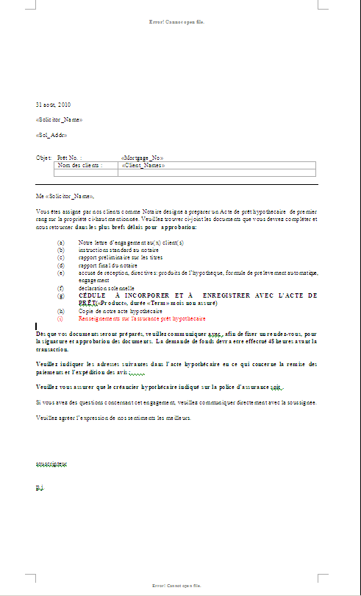

Document Control

Revision History

This table contains the document version history.

Note: Use the Reference column to describe what drove the change. This could be a project, a Change Request (CR), a Variance, etc. Please be as specific as possible.

|  |  |  |  |  |
| --- | --- | --- | --- | --- |
| **Version**  Note the version currently being worked on | **Issue Date**  Note the date the version is issued to others | **Author**  Names of all parties involved in the version | **Brief Description**  Describe the nature of the version, what drove the changes, etc. | **Reference**  Refer to any external documentation that may have influenced the changes for this version |
| V0.0.1 | 08/25/2010 | ***Owen Xu*** | ***Initial draft*** | Change Request Form #1_Aug 25.10.doc |
| V0.0.2 | 09/03/2010 | ***Owen Xu*** | ***Added French version and update upon Aug30 walkthrough*** | CR02_MIDR_French Translation of Various MDID Artifacts_Aug 26 2010.doc |
| V0.0.3 | 09/10/2010 | ***Owen Xu*** | ***Update upon feedback*** |  |
| V0.1.0 | 09/23/2010 | ***Owen Xu*** | ***Updated version based on sign-off and sign-off conditions*** |  |
| V1.0.0 | Jan 26, 2011 | ***Magesh Thyagarajan*** | ***Base-lined document*** | MIDR Project Implemented |
| V1.01 | April 28, 2017 | ***Candy Liang*** | ***Add the new mockup*** | PALMA |
| V1.0.2 | June 23, 2017 | ***Candy Liang*** | ***Update trademark requirement in 2.2 A.Print Attributes - Other Section*** | PALMA |
| V1.1.0 | August 3, 2017 | Candy Liang | Base-lined Sign-off: PALMA Project – Phase 1 | PALMA |
| V2.0.0 | November 17, 2017 | Candy Liang | * Remove Simplii Financial Letter mockup * Add “Sample Output” section for Simplii Financial Letter Sample * Base-lined Document: PALMA Project – Phase 1 Implemented | PALMA |

|  |
| --- |
| **About this document**:  New Print Specification Document Template currently in development by IRQ  Will be posted to the Requirement Quality Website once finalized and approved  <http://w3.cms.cibc.com/NR/exeres/9ee9e3fc-f9d6-4876-bb45-2b515e5ab535.htm> |