Login

Use the “Login Full” template for the login page.

<http://panel.berginformatik.ch/ProUI%203.0%20by%20pixelcave/01%20-%20ProUI%20Backend%20Template%20%28PHP%29/login_full.php>

Navigation

Set correct active state

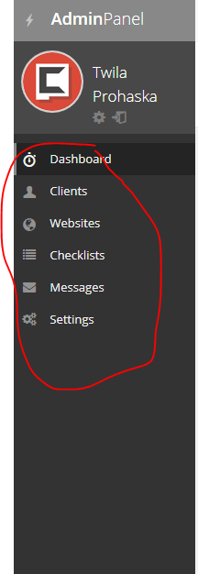

Dashboard

The date is wrong



Does not resize correctly

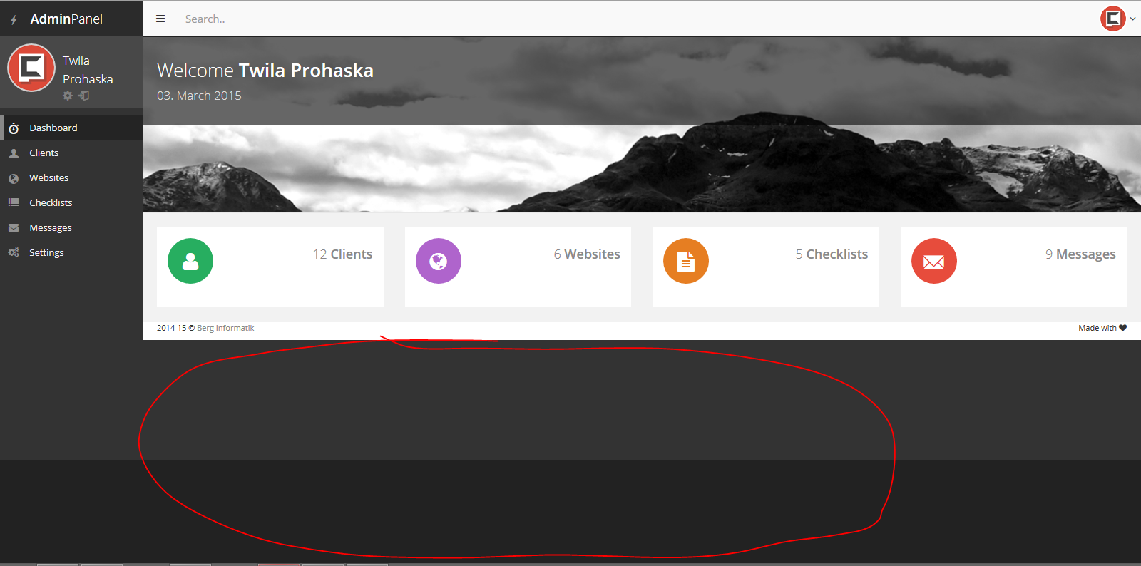

See: <http://panel.berginformatik.ch/>

Add correct data to the widgets

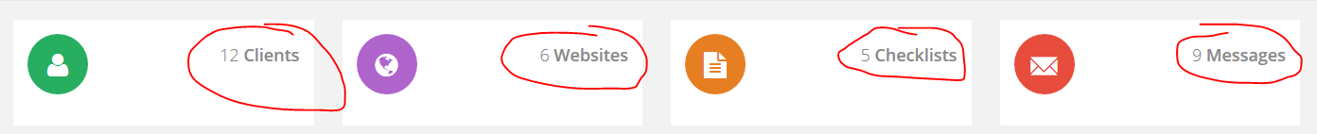

Clients

A-Z navigation should filter by first letter of company name



Set active class if button is active

Add possibility to cancel filtering on toggle button

Show correct count and combine these filters with the A-Z Navigation

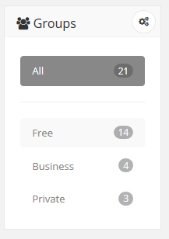

Add new client

Correct styles for Reminders widget

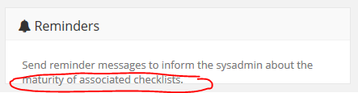

Every client has own activity.

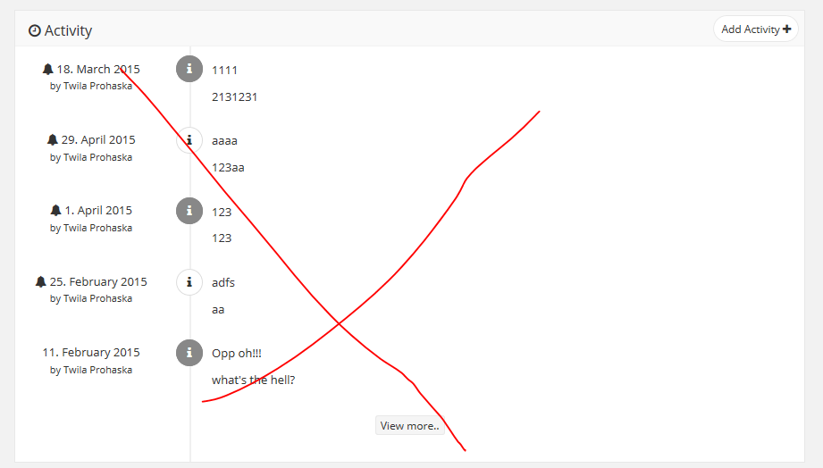

Every client has own notes.

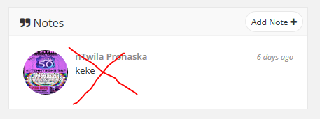

View more button should append older entries.

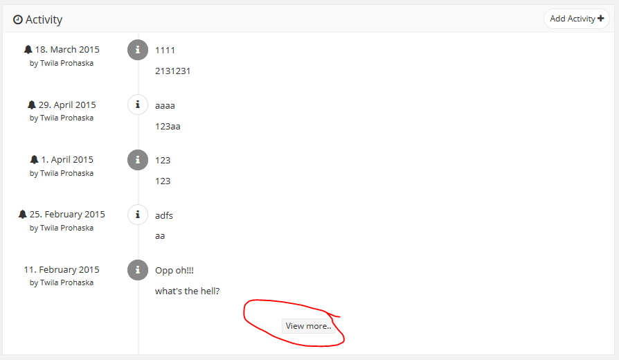

Add Delete/Edit buttons to activities.

Websites

A-Z navigation should filter by first letter of company name



Set active class if button is active

Add possibility to cancel filtering on toggle button

Add Website

Correct styles for Messages widget

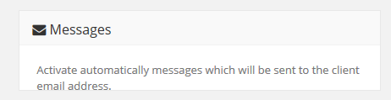

Every Website should have own notes.

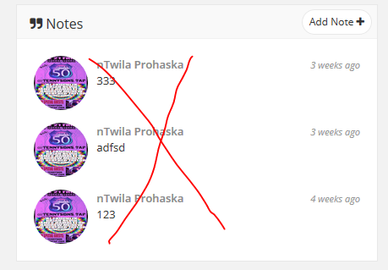

Edit Website

Send to client does not work.

