|  |  |  |
| --- | --- | --- |
|  | major block of navigation links  or Important navigation menu | Not important navigation menu |
| Convey meaning to browsers  In Common situations | <nav> | <div> |
| Convey meaning to screen readers and other assistive devices  for persons with disabilities | roll= "navigation" | empty |

above table demonstrate my assumption after reading the following video lesson

<http://168.119.85.43/html-essential-training-4/05-Linking%20and%20Navigation/03-Navigation.mp4>

in above table I try to say

roll="navigation" and <nav> are same with 1 difference

one for common guys

and another for guys with disabilities, indeed ONLY to obey the human rights of guys with disabilities, we add navigation roll attribute to our code

But I reached some unresolved conflicts if the above table is true!

I want to know your opinion regarding this problem

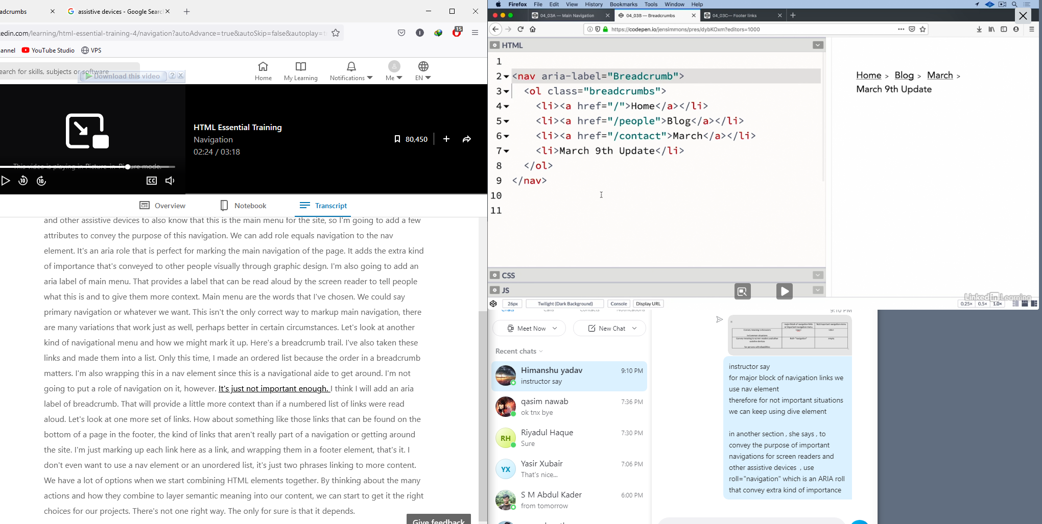

but how is it possible she doesn't use

roll= "navigation"

for this code snippet while has wrapped the <ol> inside <nav> element?!

it conveys this meaning

although this is important navigation for common peoples (BECAUSE OF USING <NAV> ELEMENT) but not so for other peoples with disabilities (BEACAUSE OF LACK OF USING NAVIGATION ROLE)

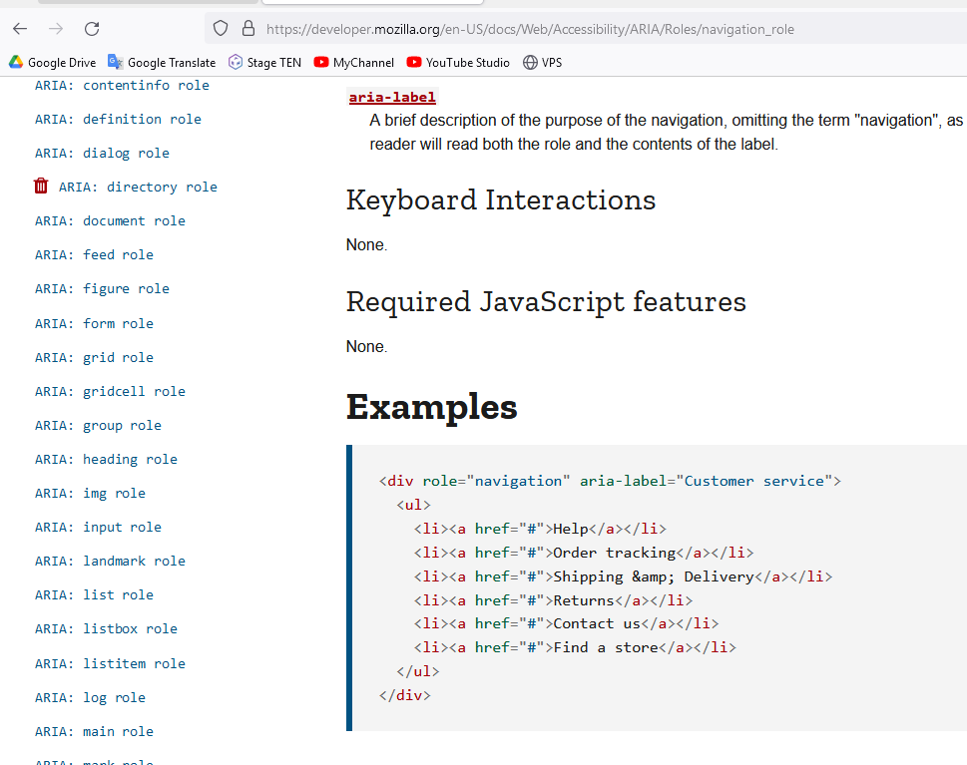

or for another example, why above article use

roll= "navigation"

without using <nav> elements

it conveys this meaning

although this is important navigation for peoples with disabilities (BECAUSE OF USING NAVIGATION ROLL) but not so for other common peoples (BEACAUSE OF LACK OF USING <NAV> ELEMENT)