

**Project:** Attendance and Leave Management System

**Course:** Software and Design Analysis

**Group Members:**

Mah Rukh (22L-6702)

Aansa Younus (22L-6596)

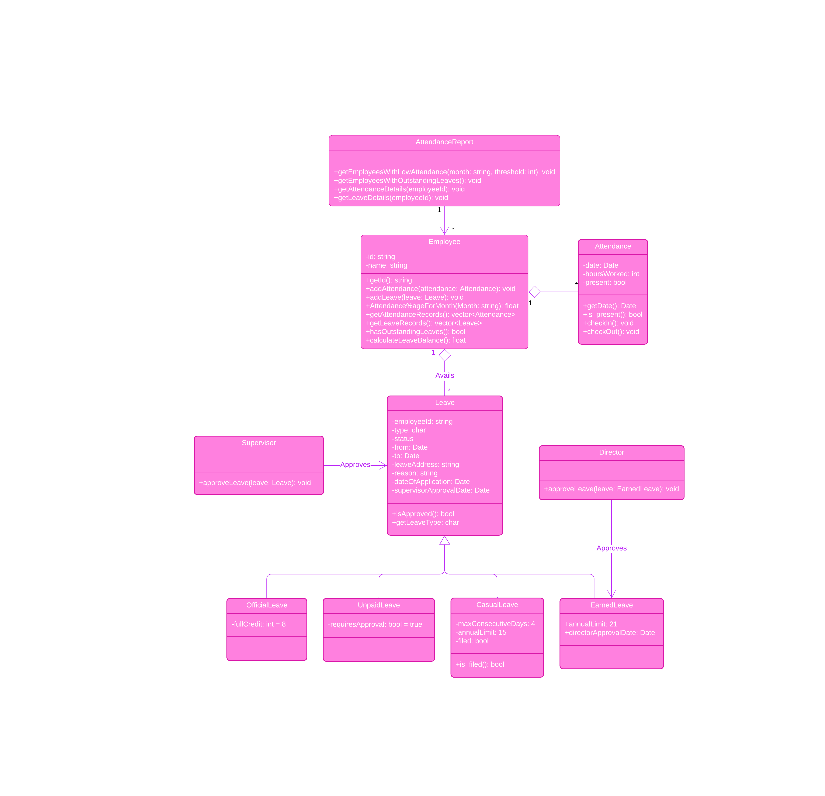

Class Diagram

Use Case Diagram

Sequence Diagram

Activity Diagram