**PARADOX**

A paradox is a statement or situation that seems contradictory or absurd, but in fact expresses a possible truth. Paradoxes are often used to challenge our assumptions and make us think outside the box. Paradoxes can be found in all areas of human thought, from philosophy to mathematics to science fiction.

One of the most famous paradoxes is the Ship of Theseus paradox. Imagine a ship that has been repaired over time, so that all of its original parts have been replaced. Is it still the same ship? This paradox challenges our understanding of identity and change.

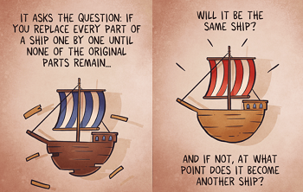

Source:- <https://www.britannica.com/topic/ship-of-Theseus-philosophy>

Another famous paradox is the Liar's paradox. This paradox is based on the statement "This statement is false." If the statement is true, then it is false. But if it is false, then it is true. This creates a logical loop that cannot be resolved.

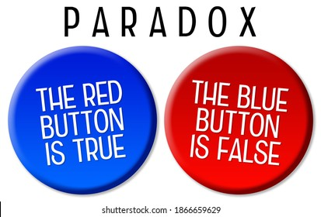

Source: <https://en.wikipedia.org/wiki/Liar_paradox>

Another famous paradox is The Monty Hall Problem paradox. A contestant is faced with three doors. Behind one of them is a sleek new car. Behind the other two are goats. The contestant picks a door, say Door 1. To build suspense, Monty opens one of the other two doors, say Door 3, revealing a goat. To build the suspense still further, he gives the contestant an opportunity either to stick with their original choice or to switch to the unopened door.

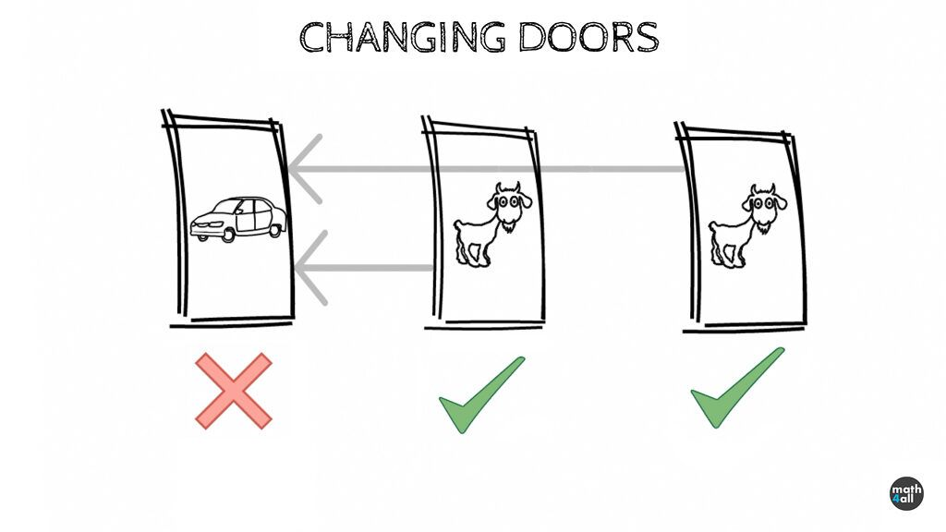

Source: <https://en.wikipedia.org/wiki/Paradox> , <https://www.youtube.com/watch?v=l90X2_mkMaI>

Paradoxes can be divided into two main categories:

1. Veridical paradoxes: These paradoxes are true, but they seem contradictory because they challenge our assumptions about the world.
2. Fallacious paradoxes: These paradoxes are false, but they appear to be true because they contain a logical fallacy.

**Here are some examples of veridical paradoxes:**

The paradox of Achilles and the tortoise: Achilles is the fastest runner in Greece, and the tortoise is the slowest. Achilles gives the tortoise a head start in a race, but he can never catch up to it. This paradox challenges our understanding of motion and infinity.

The paradox of the grandfather: Imagine that you travel back in time and kill your grandfather before he meets your grandmother. If your grandfather is dead, then you cannot be born. But if you are not born, then you cannot travel back in time and kill your grandfather. This paradox challenges our understanding of causality.

The paradox of Schrödinger's cat: Imagine a cat that is placed in a box with a vial of poison that has a 50% chance of being broken. If the vial is broken, the cat will die. But until the box is opened, the cat is both alive and dead at the same time. This paradox raises questions about the nature of reality and quantum mechanics.

**Here are some examples of fallacious paradoxes:**

The paradox of the barber: There is a barber in a town who shaves all the men who do not shave themselves, and only those men. Does the barber shave himself? If he shaves himself, then he is not one of the men who do not shave themselves, and he should not shave himself. But if he does not shave himself, then he is one of the men who do not shave themselves, and he should shave himself. This paradox is fallacious because it assumes that there can only be two types of men: those who shave themselves and those who do not. But there is a third type of man: the barber.

The paradox of the heap: Imagine a pile of sand. If you remove one grain of sand from the pile, is it still a pile of sand? If it is, then you can remove another grain of sand, and then another, and so on. Eventually, there will be no sand left in the pile, but it was still a pile of sand at every step along the way. This paradox is fallacious because it assumes that there is a sharp boundary between what is a pile of sand and what is not. But there is no such boundary.

**Here are some of the benefits of studying paradoxes:**

Paradoxes can be useful tools for learning and thinking. They can help us to challenge our assumptions, expand our understanding of the world, and come up with new ideas. However, it is important to be aware of the different types of paradoxes and to be able to distinguish between fallacious paradoxes and veridical paradoxes.

1. Paradoxes can help us to think critically. They force us to question our assumptions and to examine our beliefs from different angles.
2. Paradoxes can help us to develop our problem-solving skills. They challenge us to come up with creative solutions to difficult problems.
3. Paradoxes can help us to learn new things about the world around us. They can help us to see the world in new ways and to understand complex concepts.
4. Paradoxes can help us to become more open-minded. They can show us that there is often more to a situation than meets the eye.

**How to solve a paradox?**

There is no one-size-fits-all answer to this question, as the best way to solve a paradox will depend on the specific paradox in question.

However, some general tips for solving paradoxes include:

1. Identify the contradiction. What is it about the paradox that seems contradictory or absurd?
2. Examine your assumptions. Are there any assumptions that you are making that may be contributing to the paradox?
3. Consider different perspectives. Is there another way of looking at the paradox that might resolve the contradiction?
4. Be creative. Sometimes, the best way to solve a paradox is to come up with a new way of thinking about it.

Conclusion

Paradoxes are fascinating and thought-provoking statements that can help us to learn more about the world around us and ourselves. They can also be used to challenge our assumptions and to inspire new ideas.